Growth Manager Assignment (Vegas Bonanza)

1) Scope and assignment constraints
- Goal: optimize Sign-up -> First Purchase funnel for Vegas Bonanza.
- Required output: 3–6 hypotheses split into two categories:
  - Local Improvement: 1–3 ideas.
  - CR Improvement: 1–3 ideas.
- Mandatory structure per hypothesis:
  - Hypothesis statement.
  - Rationale.
  - Expected impact and metric.

2) Funnel snapshot and observed opportunities

2.1 Known funnel sequence (based on provided sources)
- Landing page.
- Registration (email + password).
- Verification steps (email/phone/location, based on available public references and assignment note).
- Welcome bonus claim.
- Coin store / first package purchase (FTD target action).

2.2 Constraints during analysis
- Direct access to site flow is geo-restricted from current location (US-only).
- Shared video links did not return transcript/details via direct fetch.
- Therefore, hypotheses are built from:
  - Assignment requirements.
  - Publicly available descriptions of Vegas Bonanza onboarding and offers.
  - Standard sweepstakes-casino conversion patterns.

2.3 Current friction assumptions to validate in product analytics
- Multi-step verification may create early drop-off before users reach first game session.
- First purchase value may be insufficiently anchored against the welcome free rewards.
- Possible mismatch between bonus promise and coin-store presentation hierarchy.
- Mobile users may face higher friction in verification and payment step transition.

3) Hypotheses backlog (prioritized shortlist)
- Prioritization framework used: Impact x Confidence / Effort.
- Final set below contains 6 hypotheses:
  - 3 Local Improvement.
  - 3 CR Improvement.

4) Local Improvement tests (UI/UX/copy level)

L1. Hero CTA copy test (short copy that fits button width)
- Hypothesis statement:
  - If we switch hero CTA from generic phrasing to stronger value wording, clicks into registration will increase.
  - Test variants:
    - A: Play Free Now
    - B: Claim Welcome Bonus
- Rationale:
  - Current CTA copy is readable but less benefit-specific.
  - Both variants are short enough for mobile CTA width and preserve visual balance.
- Expected impact:
  - Primary: increase Hero CTA CTR.
  - Secondary: increase Registration start rate.

L2. Reduce first-screen text noise around hero CTA
- Hypothesis statement:
  - If we reduce non-essential text density on the first screen while keeping the key value proposition, users will focus faster on the CTA and click more often.
- Rationale:
  - The CTA is already visible above the fold, so the main issue is attention dilution from adjacent text blocks.
  - This is a localized content prioritization test, not a flow change.
- Expected impact:
  - Primary: increase Hero CTA CTR.
  - Secondary: increase Registration start rate.

L3. Testimonials section with local in-section CTA
- Hypothesis statement:
  - If we add a direct CTA inside/under testimonials (instead of relying only on sticky bottom actions), more deep-scroll users will start registration.
- Rationale:
  - Testimonials currently provide trust but no immediate local continuation action.
  - Users at this section should not need to re-orient to another CTA region.
- Expected impact:
  - Primary: increase CTA CTR from testimonials viewport.
  - Secondary: increase Registration start rate for deep-scroll sessions.

5) CR Improvement tests (conversion logic and messaging)

C1. Make Categories functional (Top 4 with thumbnails -> catalog)
- Hypothesis statement:
  - If we replace non-clickable categories with 4 clickable popular categories that lead to catalog pages, registration conversion will improve due to stronger intent capture.
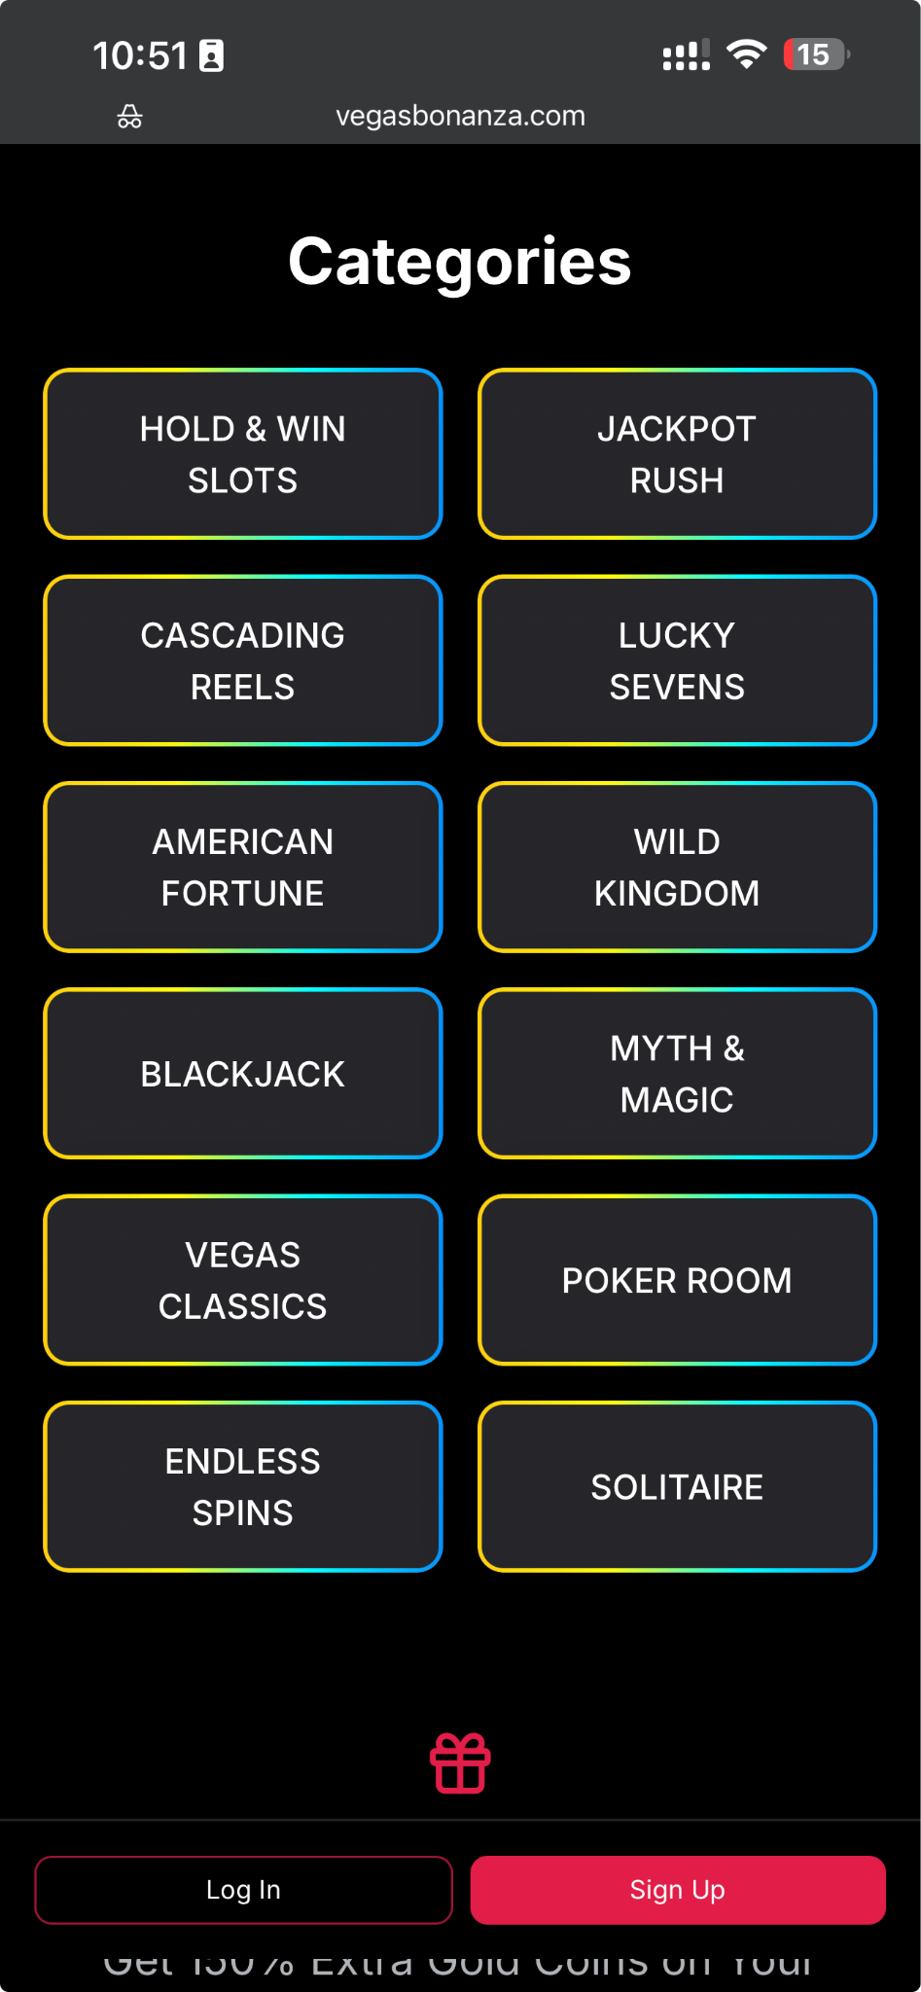
- Rationale:
  - Current categories look interactive but are not actionable.
  - Functional category cards can channel interest-driven users into a clearer pre-registration journey.
- Expected impact:
  - Primary: increase Registration completion rate.
  - Secondary: increase Category -> Catalog click-through.

C2. Free-to-paid narrative continuity with explicit assumptions
- Hypothesis statement:
  - If we connect free entry and first purchase in one coherent message flow (Start free -> explore -> optional first purchase with 150% extra), registration quality will improve.
- Rationale:
  - Users understand value progression better when free and paid experiences are framed as one path.
  - Assumption boundary for this test:
    - 150% welcome bonus offer is active.
    - Offer is compliance-approved for target states.
    - Offer economics are acceptable (no negative unit-economics impact).
- Expected impact:
  - Primary: increase Registration completion rate.
  - Secondary: increase Qualified post-signup users reaching store.

C3. Consistent offer architecture and CTA cadence for new users

  - Hypothesis statement:
- If we apply a consistent conversion architecture for cold users:
  - - a clear "New here" framing with one primary bonus claim,
  - - compact trust tiles before deep scroll (Safe, Fast redemption, No purchase needed),
- - and the same primary CTA repeated across hero, mid-page, and near-bottom (2-3 placements, no spam),
  - then registration outcomes will improve.
  - Rationale:
- Reduces ambiguity for first-time visitors by making the value proposition and next action immediately clear.
- Improves trust comprehension in a scannable format without overloading users with legal copy.
- Reinforces intent on mobile through consistent CTA repetition at key scroll depths.
Expected impact:
- Primary KPI: Registration completion rate.
- Secondary diagnostic: Registration start rate for cold traffic.

6) Experiment design details (how to run)

6.1 Event instrumentation required
- signup_started
- signup_submitted
- signup_completed
- verification_started
- verification_completed
- coin_store_viewed
- first_purchase_clicked
- first_purchase_completed

6.2 KPI map
- Local tests:
  - Main KPI: Hero CTA CTR and Registration start rate (test-specific).
  - Guardrails: bounce rate, scroll depth drop, time-to-first-interaction.
- CR tests:
  - Main KPI: Registration completion rate.
  - Downstream diagnostic only (not primary for these page tests): FTD rate.
  - Guardrails: compliance disclosure visibility, legal-link access rate, post-signup drop.

6.3 Sequencing recommendation
- Wave 1 (fast, low risk):
  - L1, L2, L3.
- Wave 2 (high business impact):
  - C1, C2, C3.
- Avoid running multiple tests that touch the same decision point simultaneously unless multivariate design is intentional.

7) Lightweight visualizations

7.1 Funnel map
flowchart LR
landingPage[LandingPage] --> signUp[SignUpForm]
signUp --> verification[Verification]
verification --> onboardingReady[OnboardingReady]
onboardingReady --> coinStore[CoinStore]
coinStore --> firstPurchase[FirstPurchaseCompleted]

7.2 Friction/optimization overlay
flowchart LR
signUp[SignUp] -->|FormErrors| drop1[DropOff1]
signUp -->|ClearValidation| verifyStep[Verification]
verifyStep -->|UnclearNextStep| drop2[DropOff2]
verifyStep -->|GuidedHandoff| offerWall[FirstPurchaseOfferWall]
offerWall -->|AnchoredValueMessage| ftd[FTD]

8) One-page defense version (3–5 min talking points)
- We target the exact requested funnel: signup -> first purchase.
- We split tests by assignment taxonomy: Local vs CR.
- Local tests remove onboarding friction and improve completion mechanics.
- CR tests improve value perception and first purchase decision architecture.
- Measurement is explicit: each hypothesis has a primary metric and guardrails.
- Rollout is staged: low-risk UX fixes first, then conversion mechanics for FTD growth.

