[Product / Feature Name]

Last Updated: Apr 3, 2023Overview
Purpose  [What is the purpose of the product/ feature you are building] | Audience  [Who are the audience? Age range, user roles, expertise, etc’]
What  [What are you building? A feature/a product that will be used to achieve your goal] | Why  [why are you doing it? Maybe to improve user satisfaction?]
How  [what is your general idea? without too much elaboration] | When  [The timeframe to start and complete the project]

Success Criteria
[How are you going to measure success? List the KPIs that will point that you are in the right direction. Use industry benchmarks or define wanted results from your existing data]

- KPI1
- KPI2
- KPI3

Assumptions and Knowledge

Knowledge
[your text here: write the thighs you KNOW, thighs you learned from your MVP or other conformations you got - existing data, research, surveys, interviews, competition…
For example, 90% of the users only use the mobile version of my product ]
- Knowledge 1
- Knowledge 2
- Knowledge 3

Assumptions
[your text here: write the thighs you ASSUM, thighs you believe are true for your audience and you couldn't verify]
- Assumption 1
- Assumption 2
- Assumption 3

General Product Behavior
[your text here: What does the product/feature generally do, if you want you can use some user stories here to help and explain the usage of the product]

Milestones
[your text here: list the different tasks that are needed to be done, you can also use the Gantt chart to define timeframes if you’d like or delete it]

- Task 1
- Task 2
- [For example, Design low-level design for UX purposes]
- [Prototype Testing]
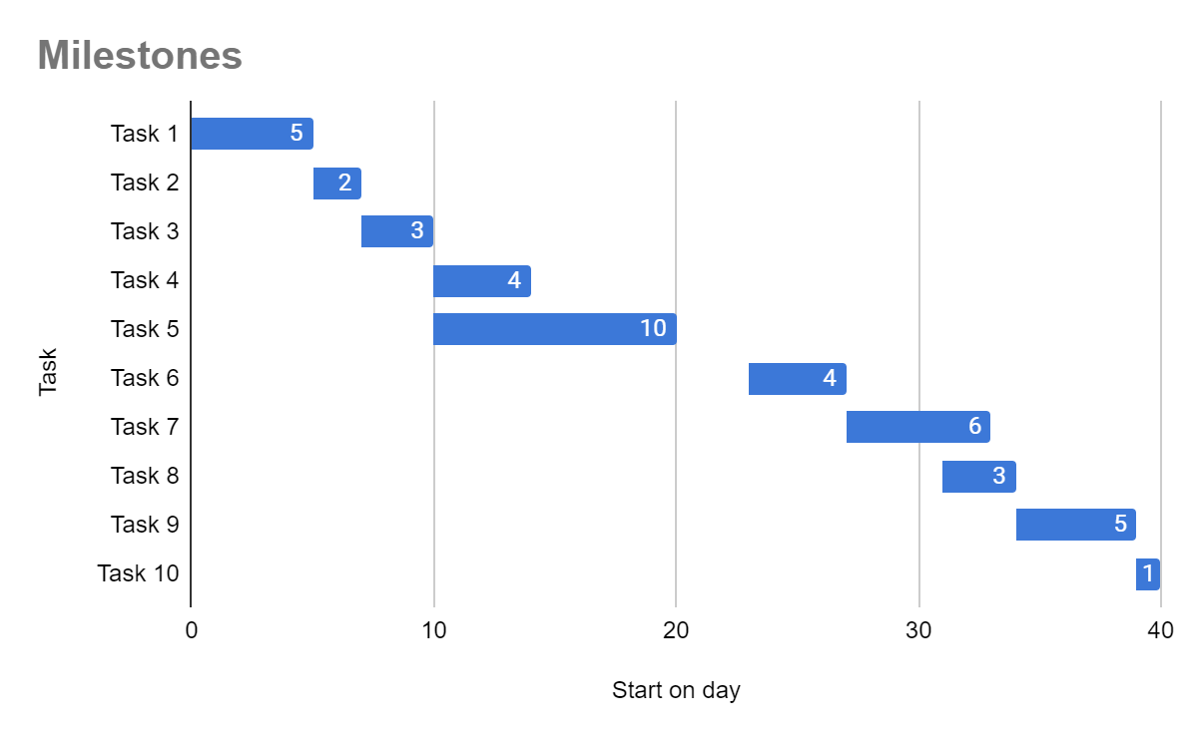
- [And so on…] to edit the table - just make a copy of it and paste it here!

Requirements
[Be very specific, as much as you can. List every button, define actions, errors, and usage.
If there is more than one feature in the current sprint or some kind of dependencies with other elements - make sure to prioritize correctly]

- On the home screen, the user should be able to do this:
1. Action 1
2. Action2
- On the second screen, the user should be able to do this:
1. Action 1
2. Action2, When they do this, the feature will respond like this:
- If there is an error - Option 1
- If there is no error - Option 2
Iv. On the Third screen, the user should be able to do…

Data Requirements
[ What data should your product/feature collect from users and in what format, if you don't know what formats are possible and how does it work - consult with your developers and analysts, but whatever you decide - you must collect data!]

While using the feature, collect the following data:
- Data point 1
- Data point 2
- Data point 3

Interaction & Design

User/Task Flows
[Use user flows to explain your product behavior (you can use other symbols and methods as long as it is understood easily), this is a basic structure for the doc but you can do it in a separate file using one of the dedicated tools: Draw.io, Flowmapp, Google Drawings or read more about task flow here]
Decision
Action
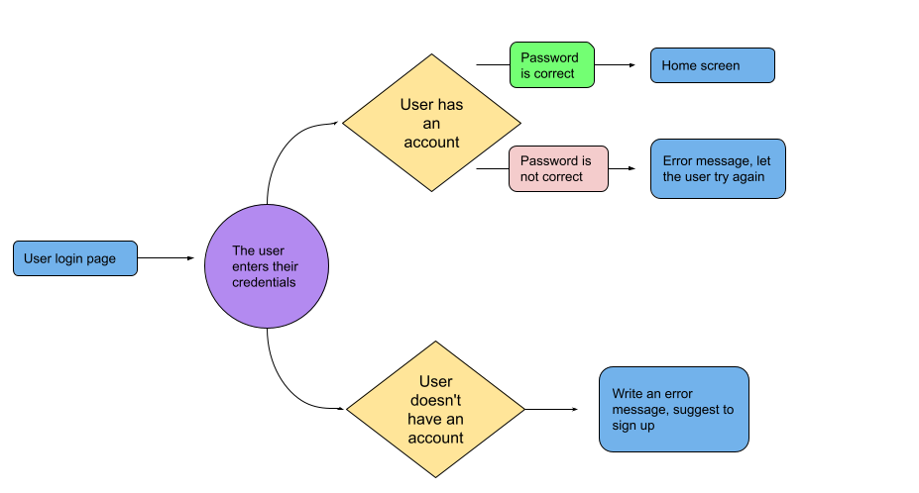
Display

Wireframes
[Use wireframes to show the developers what they are actually building - if you have a UX designer in your team, ask them to do it properly with you, they will need to complete the UI for the project later anyways. For most people using Figma is a great way to build wireframes but you can also use other tools such as Balsamiq, Mockflow, and more]
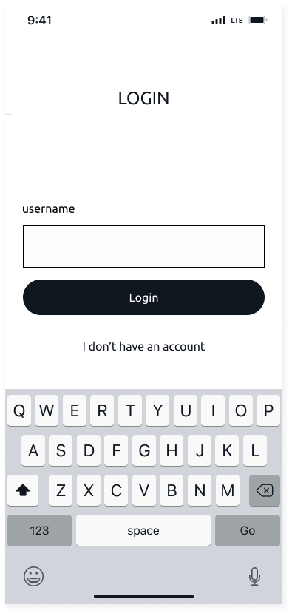

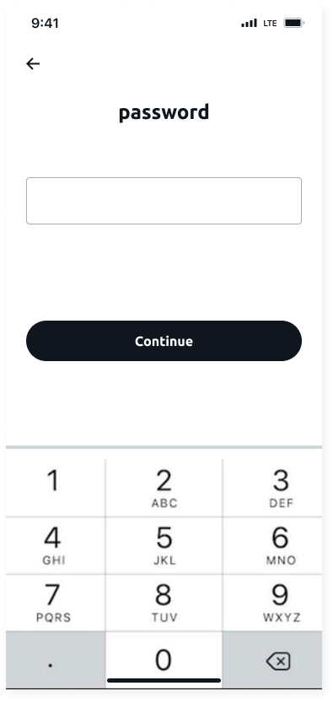
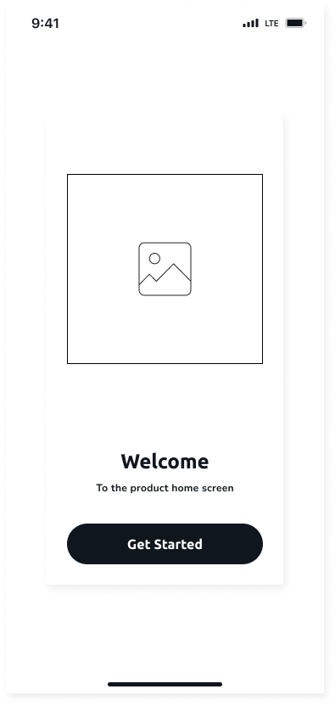

Out of scope
[Define what is out of scope for this project - Scope is a way to set boundaries on your project ]

Questions?
[This is the place to answer your team’s questions about the PRD or the product/feature themselves and document it so everybody will have the access to it ]

Question 1
Question 2
Question 3
Question 4

