

**Complete B2B SaaS Solution for Early Learning as per NEP 2020**

**Empowering Schools with Integrated Learning Resources – Physical & Digital**

Nalanda Learning offers a robust **B2B SaaS Platform** that combines the **best of print and digital** for preschools, kindergartens, and early education providers. Our ecosystem blends **age-appropriate books**, **interactive worksheets**, and a **state-of-the-art Learning Management System (LMS)** to deliver a seamless teaching and learning experience through a **Government of India Certified Pre-School Facilitators and Caregivers Training Program.**

  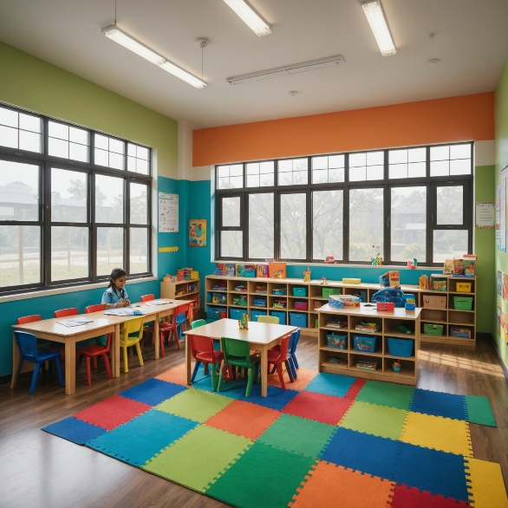

**1. Premium Early Learning Books**

|  |  |
| --- | --- |
|  | **NCF-FS & NIPUN Bharat Aligned** – ensuring compliance with national education standards (NEP 2020).  **Level-based Kits** (Playgroup, Nursery, Junior K.G., Senior K.G.) designed for **2–6 years**.  Rich visuals, engaging activities, and theme-based content to foster **cognitive, language, and motor skills**.  Bundled with **activity practice books** for reinforcement at home and in class.  Worksheets available in trilingual mode – English – Hindi – Bengali |

**2. Customisable Worksheets**

|  |  |
| --- | --- |
|  | **Printable and Digital Formats** for flexible classroom use.  Curriculum-linked exercises to **reinforce daily lessons**.  Adaptive worksheets that cater to **different learning paces and skill levels**.  Ready-to-use for **teachers to save preparation time** and focus on personalized learning.  **AI Driven Holistic Progress Report Card as per NCERT Guidelines** |

**3. Online Digital Platform – LMS + Content Engine**

* **Centralised Teacher Dashboard** – lesson plans, progress tracking, and resource sharing in one place.
* **Student Learning Space** – interactive videos, games, and activities for self-paced learning.
* **Content Engine** – continuously updated repository of books, worksheets, audio-visual content, and assessments across different publishers.
* **Repository of NN Videos and NN Interactive Games**
* **Analytics & Reports** – track engagement, identify learning gaps, and personalise intervention.
* Accessible on **mobile, tablet, laptop and desktop** for anytime, anywhere learning.

**For Schools & Education Partners:**

* Scale your teaching quality across multiple branches with **consistent content delivery**.
* Reduce operational hassle with **ready-to-use, high-quality resources**.
* Offer a blended learning experience that **parents value and students love**.

**Nalanda Learning’s B2B SaaS platform** is not just a product — it is a complete **Early Learning Enablement System**.

From **books that inspire** to **digital tools that engage**, we help your institution deliver **21st-century learning with ease**.

**FAQ Section**

**Placeholder for Testimonials**

(Video / References of Eduprenuers who are successful after adopting Nalanda Enrich B-2-B SaaS Platform)

**Placeholder for Contact Form ( As per discretion of developer )**