In the below picture, TABLE A has brand and then first.brand loan row contains total.

What I am want to do is create a desired table where the first.brand row value = first row current value – following rows value and if its not the first.brand then value as the current value as show in the table 2.

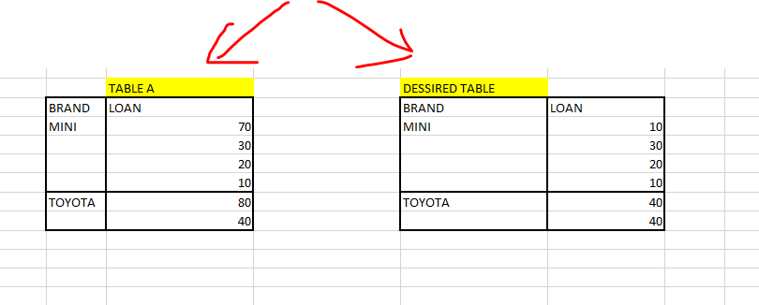

Regards

BMW