Criterion B: Developing ideas

ii. Develop a range of feasible design ideas
I developed four ideas for Pause. They differ in how a student moves through the app, not only in colour, so each one tests a different answer to the same question: how does a stressed student get from 'I feel bad' to one useful technique, with the counsellor always in reach? All four use the same content (the 10 tags and the library of coping cards), cost nothing to build, and could be made in Google AI Studio in about 20 hours. That way the comparison in B.iii is about the interaction model and not about effort or budget.
I drew every idea at real phone size (360 px wide), so the tap targets and text sizes on the boards are what students would see. On each board the numbered notes match the numbered points on the screen. Each note says what the part is, what it does, how it works and why it is there, with the B.i specification it links to in brackets. The tables under each board add the dimensions, colours, components and technical details.
Design 1: All-in-One Dashboard
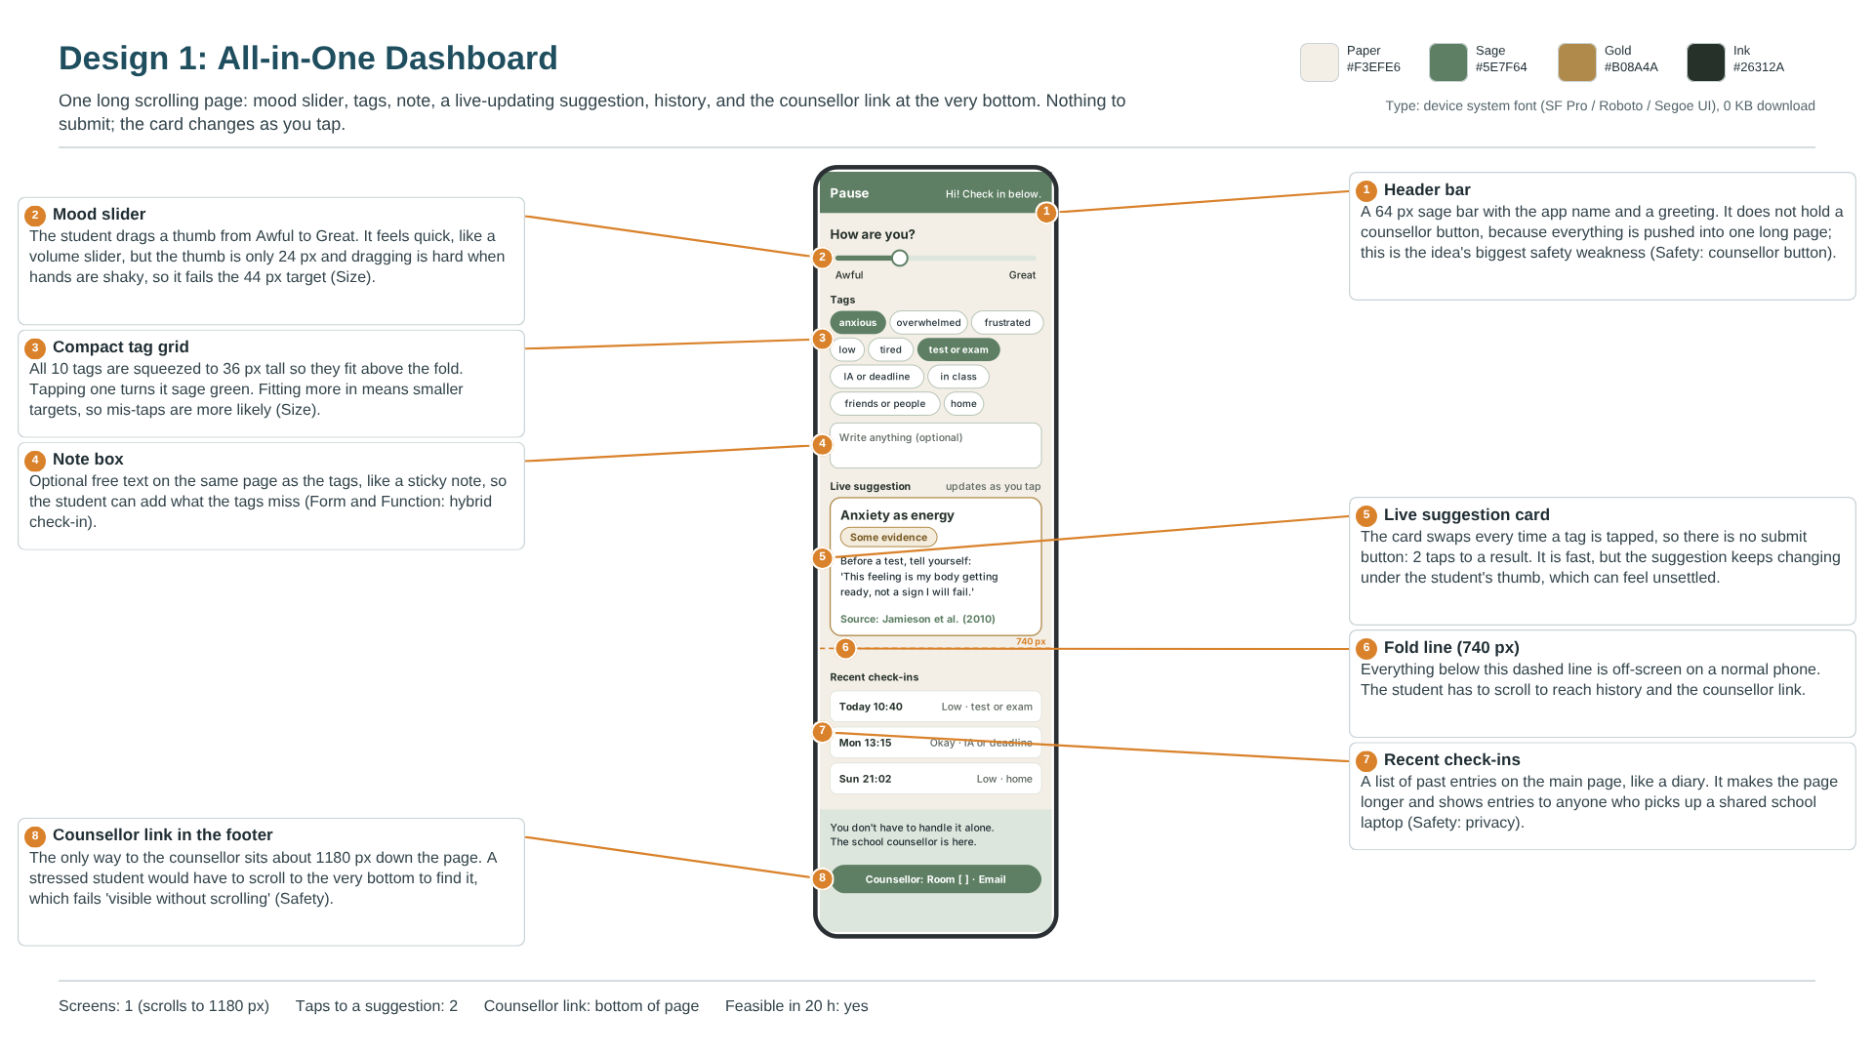
Figure B1: Design 1: All-in-One Dashboard (Canva design board, annotated).
Interaction model | Everything on one long scrolling page. There is no submit button: the suggestion card changes live every time a tag is tapped.
How it works | 1. The student drags a slider from Awful to Great.  2. They tap one or more of the 10 tags.  3. The card halfway down the page updates after every tap.  4. Past check-ins and the counsellor link sit further down, below the fold.
Taps to a suggestion | 2 (drag the slider, tap one tag).
Screens and size | 1 screen, 360 px wide, scrolling to about 1180 px. The fold on a normal phone is at about 740 px.
Components | 64 px header bar with the app name; mood slider (24 px thumb); 10 tag chips at 36 px tall; note box; live suggestion card with an evidence label; dashed fold line; 'Recent check-ins' list; footer with the support line and counsellor link.
Colours and type | Paper #F3EFE6, Sage #5E7F64, Gold #B08A4A, Ink #26312A. Device system font, 0 KB download.
Technical details | A single React page. The matching function runs on every tag change and re-draws the card. History is read from localStorage and shown on the main page.
Strengths | The fastest idea: 2 taps (Form and Function: fast enough under stress). Everything is visible in one place, like Daylio's quick logging (Daylio, n.d.).
Weaknesses | The counsellor link is about 1180 px down the page, so it fails 'visible without scrolling' (Safety: counsellor button). The 24 px slider thumb and 36 px chips are below 44 px (Size: easy to tap and read). Showing history on the main page exposes entries on shared laptops (Safety: private by design).
Feasible in 20 h? | Yes. It is one page, but the live-updating card needs extra testing.

Design 2: Step-by-Step Guide
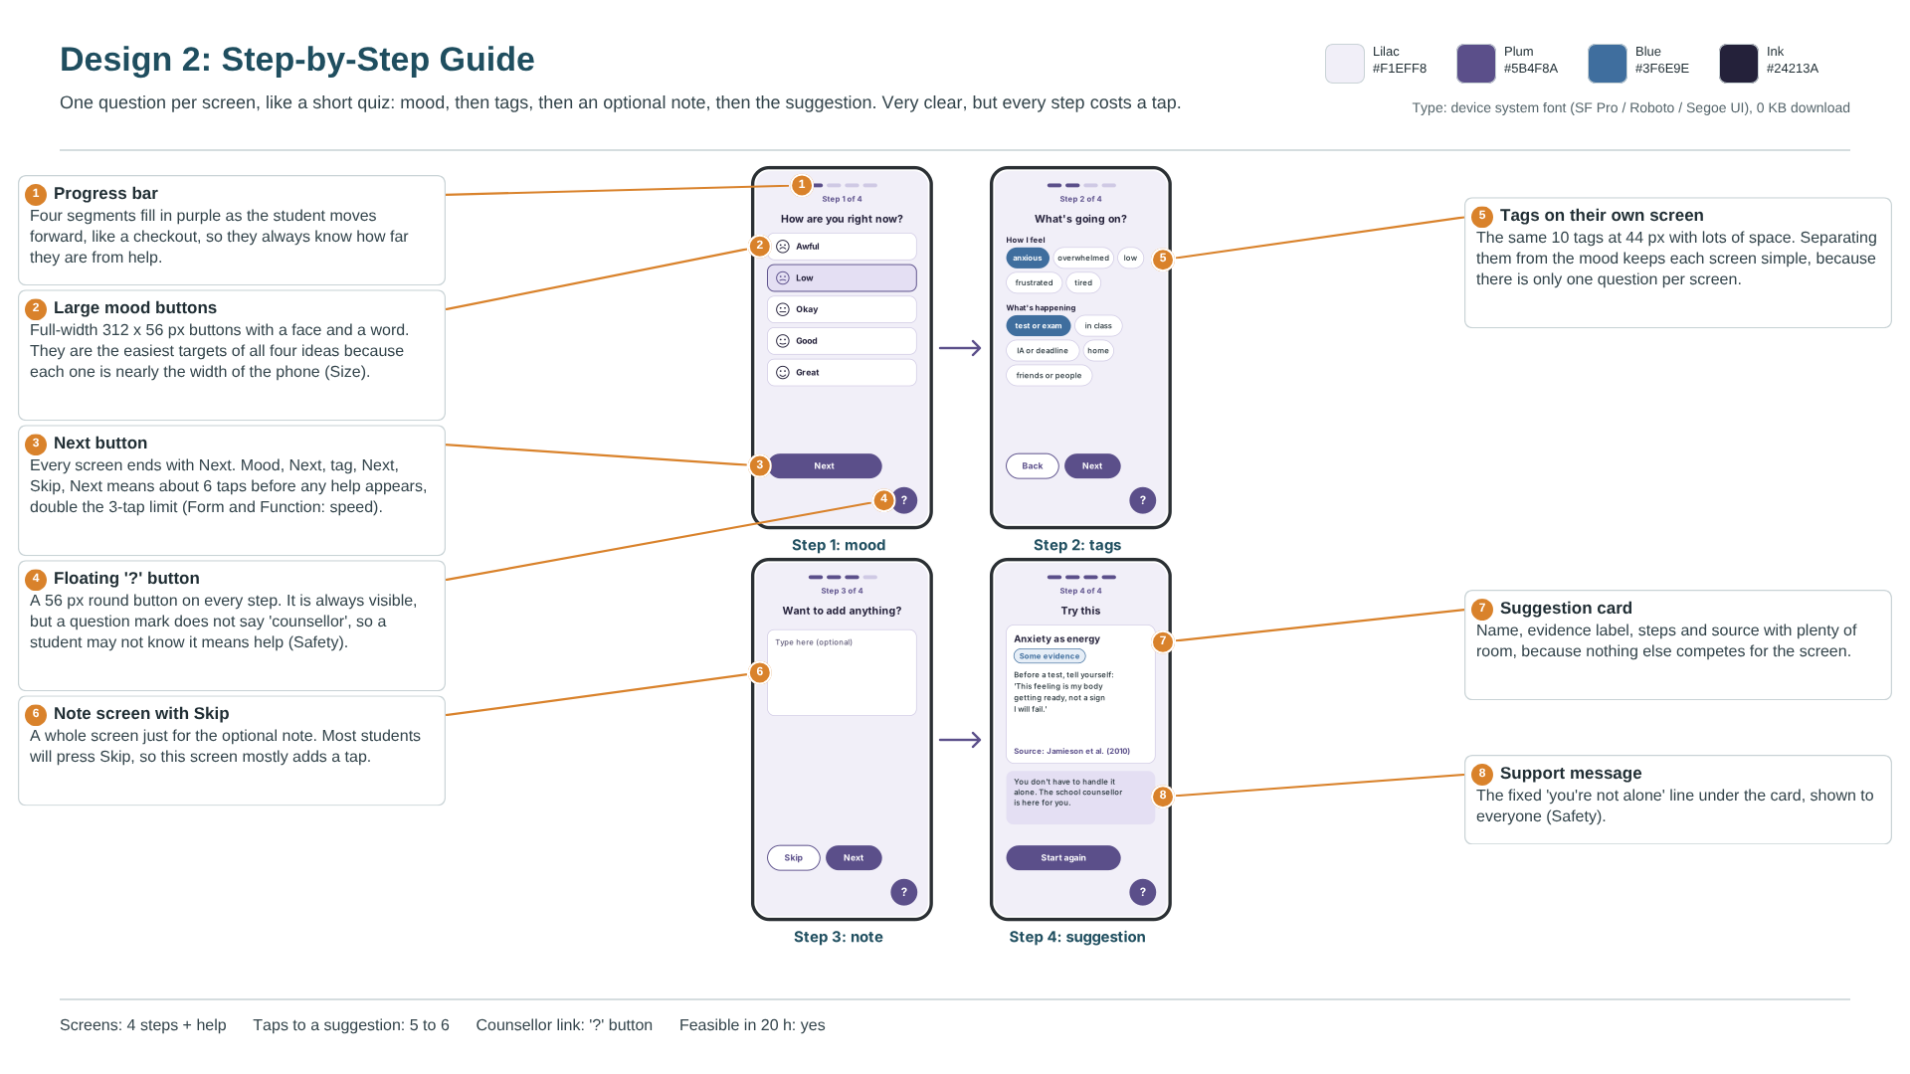
Figure B2: Design 2: Step-by-Step Guide (Canva design board, annotated).
Interaction model | A guided flow with one question per screen, like a short quiz, and a progress bar.
How it works | 1. Step 1: pick a mood, then Next.  2. Step 2: pick tags, then Next.  3. Step 3: write a note or tap Skip.  4. Step 4: the suggestion card and the support line appear.
Taps to a suggestion | 5 to 6 (mood, Next, tag, Next, Skip, Next).
Screens and size | 4 step screens plus a Help screen, each 360 x 740 px with no scrolling.
Components | 4-segment progress bar; 5 full-width mood buttons (312 x 56 px); tag screen (44 px chips); note screen with Skip; suggestion card; support message; floating round '?' button (56 px) on every step.
Colours and type | Lilac #F1EFF8, Plum #5B4F8A, Blue #3F6E9E, Ink #24213A. Device system font, 0 KB download.
Technical details | Four React views with a step counter. The matching runs once, after Step 3.
Strengths | The easiest screens to read, with the largest tap targets of all four ideas (Size: easy to tap and read). The suggestion card has room for its label and source (Form and Function: honest about the evidence).
Weaknesses | 5 to 6 taps is double the 3-tap limit (Form and Function: fast enough under stress). Splitting mood, tags and note across screens fails 'hybrid check-in on one screen'. The '?' button is always visible but does not say 'counsellor', so it only partly meets Safety: counsellor button. Every extra step costs a stressed student, because stress quickly weakens the working memory needed to follow a sequence (Arnsten, 2009).
Feasible in 20 h? | Yes.

Design 3: Scripted Chat (no AI)
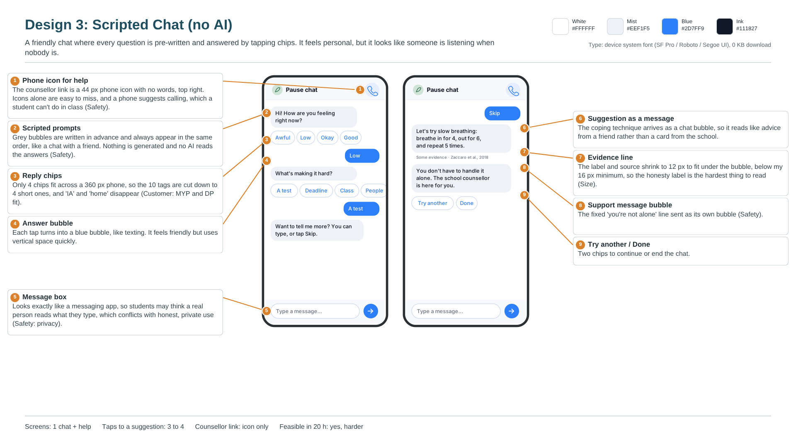
Figure B3: Design 3: Scripted Chat (no AI) (Canva design board, annotated).
Interaction model | A chat where every message is written in advance and the student answers by tapping reply chips. Nothing is generated, and no AI reads the answers.
How it works | 1. A grey bubble asks how they are feeling, with 4 reply chips.  2. The tapped chip becomes a blue answer bubble.  3. A second scripted question asks what is happening.  4. The coping technique arrives as a chat message, then the support line, then 'Try another' or 'Done' chips.
Taps to a suggestion | 3 to 4.
Screens and size | 1 chat screen plus Help, 360 x 740 px. The chat grows downwards.
Components | Header with a 44 px phone icon for help (no words); scripted prompt bubbles; 4 reply chips per row; answer bubbles; a message box that looks like a messaging app; suggestion bubble with a 12 px evidence line; support message bubble; 'Try another' and 'Done' chips.
Colours and type | White #FFFFFF, Mist #EEF1F5, Blue #2D7FF9, Ink #111827. Device system font, 0 KB download.
Technical details | A scripted conversation tree stored as data. Each new card needs its own branch of messages, so the script grows with the library.
Strengths | It feels friendly and personal, closest to Wysa's chat style (Wysa, n.d.). It needs no free-text reading to work.
Weaknesses | Only 4 chips fit across a 360 px phone, so 'IA or deadline' and 'home' are dropped (Customer: fits both MYP and DP). The evidence line shrinks to 12 px (Size: easy to tap and read). The message box makes it look as if someone is reading, which works against private, honest use (Safety: private by design). A phone icon with no words is easy to miss and suggests calling, which students cannot do in class.
Feasible in 20 h? | Yes, but it is the hardest of the four to build and to extend.

Design 4: Check-in Card + Result
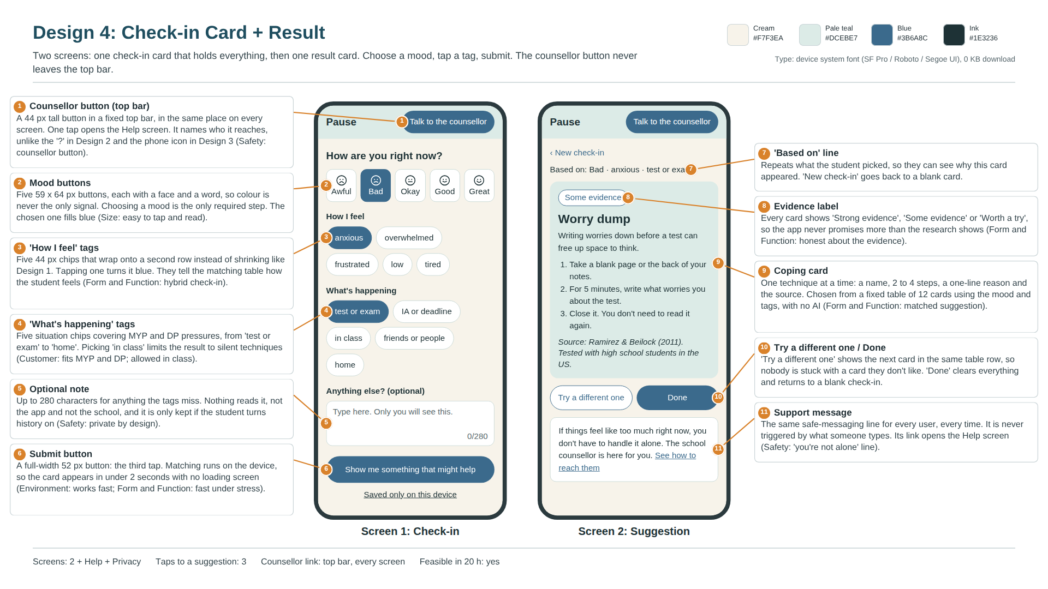
Figure B4: Design 4: Check-in Card + Result (Canva design board, annotated).
Interaction model | Two screens. One check-in card holds everything; one result card shows one technique. The counsellor button sits in a fixed top bar on every screen.
How it works | 1. Choose a mood (required).  2. Tap any tags, and write a note if you want to.  3. Tap 'Show me something that might help'.  4. One coping card appears with its evidence label and source, then the support line.
Taps to a suggestion | 3 (mood, one tag, submit).
Screens and size | Check-in and Suggestion, plus Help and Privacy. 360 x 800 px; the check-in fits without scrolling on a 360 x 800 phone.
Components | 64 px top bar with a 44 px 'Talk to the counsellor' button; 5 mood buttons (59 x 64 px); 10 tag chips (44 px) in two labelled groups; 280-character note box; 52 px submit button; 'Saved only on this device' link; coping card with evidence pill, title, reason, steps and source; 'Try a different one' and 'Done' buttons; support message box.
Colours and type | Cream #F7F3EA, Pale teal #DCEBE7, Blue #3B6A8C, Ink #1E3236. Device system font, 0 KB download.
Technical details | Two React screens that read all their words from one content.json file. A small match() function looks up the mood and tags in a fixed table and returns card IDs. History (if switched on) is saved in localStorage.
Strengths | Meets the 3-tap limit with everything on one screen. The counsellor button is labelled and in the same place on every screen, like Wysa's always-visible SOS (Wysa, n.d.). It keeps Daylio's mood-then-tags speed but adds the response Daylio lacks (Daylio, n.d.).
Weaknesses | On phones shorter than 800 px the submit button falls below the fold, so the student scrolls once before the third tap. This only partly meets Form and Function: fast enough under stress. I fix this in B.iv with a sticky submit bar.
Feasible in 20 h? | Yes. It has the fewest custom parts of the four ideas.

iii. Present the chosen design and justify its selection
I chose Design 4: Check-in Card + Result. It meets 18 of my 19 specifications and partly meets the other one, more than any other idea (Design 2: 16, Design 1: 15, Design 3: 12). It is the only idea that meets all four Safety specifications, and both of my clients rated it highest: 5/5 from the counsellor and 5/5 from the teacher.
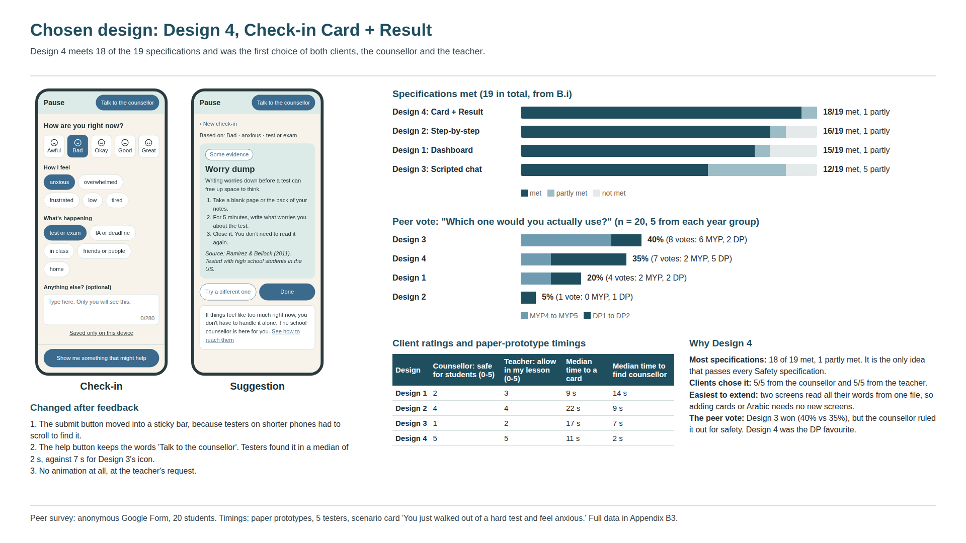
Figure B5: Chosen design board (Canva): final screens, specification scores, peer vote and client ratings.
How I collected feedback
Specification check | I scored every idea against all 19 specifications from B.i, using the wireframes and the numbers on each board (tap counts, sizes, colours). Met = the board shows the target is reached; Partly = reached only in some cases; Not met = the board shows it fails.
Peer vote | Anonymous Google Form, 20 students (5 from each of MYP4, MYP5, DP1 and DP2). Each student saw all four boards in a random order and answered 'Which one would you actually use?' and 'Why?'.
Paper-prototype test | 5 testers (at least one per year group). I printed each idea's screens and gave the scenario card 'You just walked out of a hard test and feel anxious. Use the app to find something that helps.' I timed how long it took to reach a card, then asked 'Find how to contact the counsellor' and timed that too.
Client review | I showed all four boards to the school counsellor and one MYP teacher. The counsellor rated 'Is this safe to give to students?' and the teacher rated 'Would you allow this in your lesson?', both from 0 to 5, and I wrote down their comments.

Comparison against my specifications
Specification (B.i) | Design 1 | Design 2 | Design 3 | Design 4
Aesthetics: Calm and consistent look | Met | Met | Met | Met
Cost: Free to build and free to use | Met | Met | Met | Met
Customer / Client: Fits both MYP and DP students | Met | Met | Not met | Met
Customer / Client: Allowed in class | Met | Met | Met | Met
Environment: Works fast on school Wi-Fi | Met | Met | Met | Met
Environment: Lightweight text | Met | Met | Met | Met
Safety: Counsellor button on every screen | Not met | Partly | Partly | Met
Safety: 'You're not alone' line for everyone | Partly | Met | Met | Met
Safety: Private by design | Not met | Met | Partly | Met
Safety: Nothing unsafe for minors | Met | Met | Met | Met
Size: Fits every school screen | Met | Met | Met | Met
Size: Easy to tap and read | Not met | Met | Not met | Met
Form and Function: Hybrid check-in on one screen | Met | Not met | Partly | Met
Form and Function: A matched coping suggestion | Met | Met | Met | Met
Form and Function: Fast enough to use under stress | Met | Not met | Partly | Partly
Form and Function: Honest about the evidence | Met | Met | Met | Met
Manufacturing: Built in a browser in about 20 hours | Met | Met | Met | Met
Manufacturing: Easy to extend later | Met | Met | Partly | Met
Materials: Free, licensed and traceable | Met | Met | Met | Met
Total met (partly) | 15/19 (1) | 16/19 (1) | 12/19 (5) | 18/19 (1)

Design 4's one 'Partly' is speed on short phones (explained in B.ii). Design 1's and Design 3's scores look close to Design 2's, but their failures are in Safety and Size, which I treat as non-negotiable for an app used by minors during the school day. A design that cannot show the counsellor link without scrolling is not safe enough, however fast it is.
Client and peer feedback
Design | Peer vote | MYP / DP votes | Counsellor: safe | Teacher: allow | Median time to card | Median time to counsellor
Design 1 | 20% (4/20) | 2 / 2 | 2/5 | 3/5 | 9 s | 14 s
Design 2 | 5% (1/20) | 0 / 1 | 4/5 | 4/5 | 22 s | 9 s
Design 3 | 40% (8/20) | 6 / 2 | 1/5 | 2/5 | 17 s | 7 s
Design 4 | 35% (7/20) | 2 / 5 | 5/5 | 5/5 | 11 s | 2 s

Where the client's view took priority over the peer majority. Design 3 won the peer vote with 40%, ahead of Design 4 with 35%. Most of Design 3's votes came from MYP students (6 of 8), who said it felt 'like texting a friend'. The counsellor rated it 1/5: 'If it looks like someone is listening, a student might type something serious and wait for a reply that never comes.' I gave the counsellor's view more weight because Criterion A names the counsellor as the person who receives any escalation and decides whether the tool is safe for students. A design that invites disclosures with nobody reading them goes against Safety: private by design and Safety: nothing unsafe for minors. The peer vote still mattered: DP students preferred Design 4 (5 of 10), which matches my related concept of perspective. MYP and DP students want different things, and Design 4 was the option both groups and both clients could accept.
Why the other designs were rejected
Design 1: Dashboard | Fastest (2 taps, 9 s median), but the counsellor link is 1180 px down the page. Testers took a median of 14 s to find it, the slowest of all four. Its 24 px slider and 36 px chips fail the 44 px target, and showing history on the main page exposes entries on shared school laptops. 15/19 met.
Design 2: Step-by-step | The clearest screens and the second-highest score (16/19), but 5 to 6 taps and a 22 s median to reach a card. That is the slowest of the four, and it breaks the speed specification that comes from my primary research on exam stress. The '?' button is visible but unlabelled. The counsellor rated it 4/5, so it was my second choice.
Design 3: Scripted chat | The peer favourite, but it fails 2 specifications and only partly meets 5 (12/19). It drops two MYP/DP tags, shrinks the evidence label to 12 px, and looks like a person is reading. The counsellor rated it 1/5.

Which design is easiest to extend
I plan to keep developing Pause after this unit, so I also compared how much work it would take to add more cards and an Arabic version. Design 4 is the easiest. Its two screens read every word from one content.json file, so a new card is a new entry in a list and a new code in the mapping table. Arabic is a second set of text plus a right-to-left layout setting, with no new screens. Design 3 would need a new branch of scripted messages for every card, Design 2 would get longer with every new question, and Design 1's single page would grow even further below the fold.
What I changed after feedback
• Sticky submit bar. Testers on shorter phones had to scroll to find the submit button, so in B.iv it sits in an 80 px bar fixed to the bottom of the check-in screen.
• Kept the words 'Talk to the counsellor'. Testers found the labelled button in a median of 2 s, against 7 s for Design 3's phone icon. The counsellor also preferred the words to an icon.
• No animation at all. The teacher said anything that moves would draw attention in a lesson, which matches Customer / Client: allowed in class.
Limits of this decision. The feedback was on wireframes and paper prototypes, not a working app, and the groups were small (20 students in the vote, 5 testers). In Criterion D I will repeat the timing and counsellor-finding tests on the real build to check that Design 4 still meets its specifications.

iv. Develop accurate and detailed planning drawings and outline the requirements for the creation of the chosen solution
The drawings and tables below are my plan for building Pause. I wrote them so that someone who has never spoken to me could build the same app. All sizes are CSS pixels at 100% on a 360 x 800 px phone. The layout stretches to fit wider screens up to 1366 px, with the content column capped at 480 px wide and centred.
Design tokens (used on every screen)
Cream #F7F3EA | Screen background. Ink text on it: contrast 12.1:1.
Pale teal #DCEBE7 | Top bar, coping card, danger box. Ink text on it: 10.9:1.
Blue #3B6A8C | Buttons, selected chips and mood, links. White text on it: 5.8:1. Blue text on Cream: 5.2:1; on Pale teal: 4.7:1.
Ink #1E3236 | All body text and headings.
Border #C9D9D5 | 1.5 px outlines on chips, mood buttons and boxes (a tint of Pale teal, not a fourth main colour).
Type | Device system font stack: -apple-system, 'Segoe UI', Roboto, sans-serif (0 KB download). Sizes: 24 px bold (card and page titles), 20 px bold (question, wordmark), 16 px (everything else; never smaller). Line height 1.5 for body text.
Spacing and shape | 16 px side gutters; 8 px gaps between tap targets; corner radius 12 px (boxes, mood buttons), 16 px (card), 22 to 26 px (pill buttons and chips).
Tap targets | Every tappable element is at least 44 x 44 px (W3C, 2024, SC 2.5.5).

Every contrast ratio above passes WCAG AA for normal text (4.5:1 or higher) (W3C, 2024, SC 1.4.3). I checked them with the WCAG contrast formula.
Planning drawing 1: Check-in screen
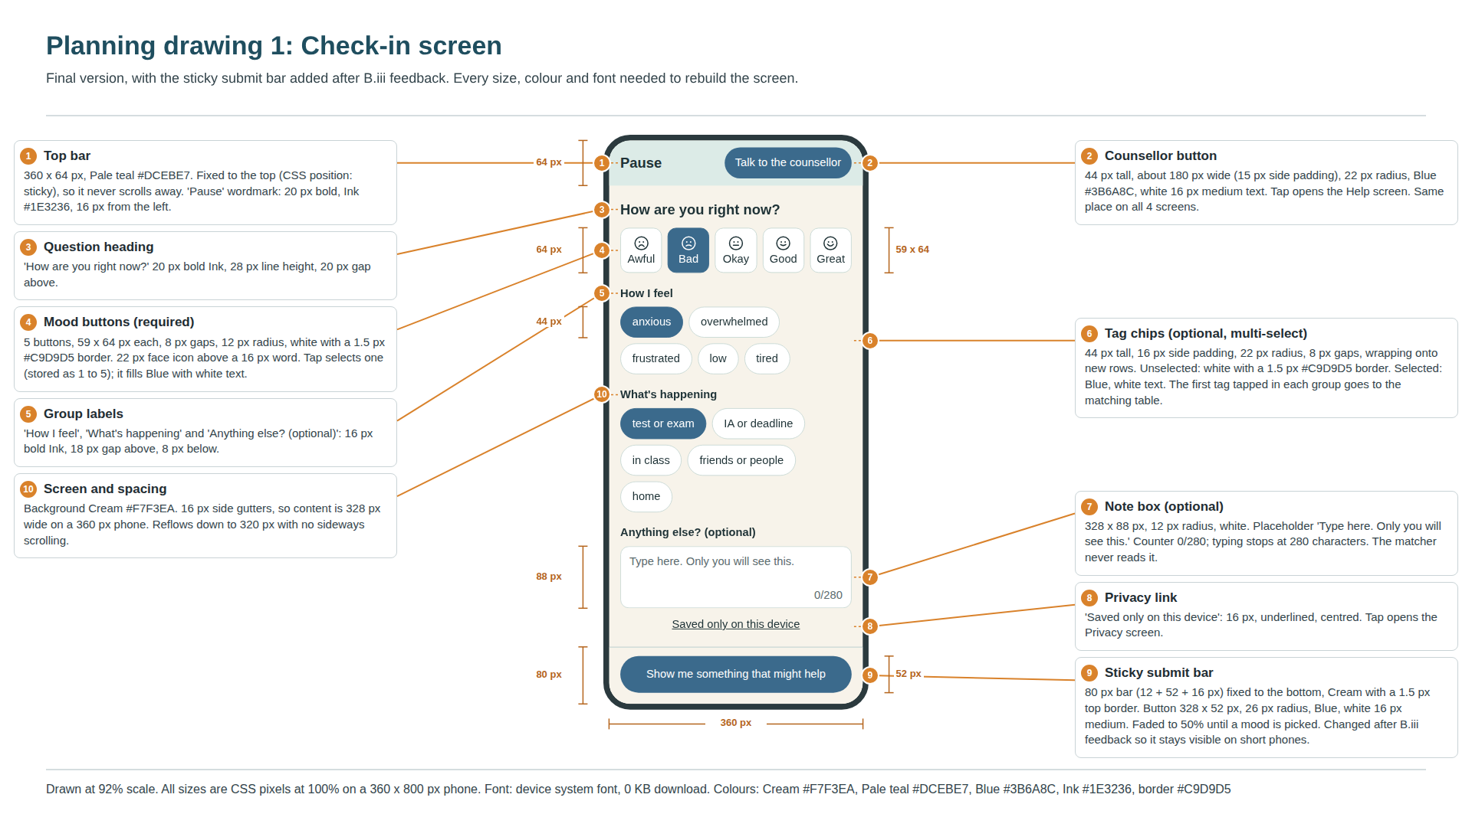
Figure B6: Planning drawing 1, check-in screen with dimensions (Canva).
Element | Size and position | Colour and type | What it does | Specification
Top bar | 360 x 64 px, sticky at the top | Pale teal; 'Pause' 20 px bold Ink | Holds the wordmark and the counsellor button. Never scrolls away. | Safety: counsellor button
Counsellor button | Approx. 180 x 44 px, right-aligned, 16 px from the edge | Blue fill, white 16 px medium, 22 px radius | Tap opens Help (Screen 3). | Safety: counsellor button
Mood buttons | 5 x (59 x 64 px), 8 px gaps | White, 1.5 px border; selected: Blue with white text | Required, single choice. Stores mood 1 to 5. Enables the submit button. | Form and Function: hybrid check-in
Feeling chips | 44 px tall, 16 px padding, wrap | As above | Optional, multi-select. The first one tapped is sent to match(). | Customer: fits MYP and DP
Situation chips | 44 px tall, 16 px padding, wrap | As above | Optional, multi-select. 'in class' limits results to silent cards. | Customer: allowed in class
Note box | 328 x 88 px | White, 12 px radius, counter 16 px | Optional, max 280 characters. Never read by match(). Saved only if history is on. | Safety: private by design
Privacy link | Full width, 24 px tall text in a 44 px tap area | 16 px underlined Ink | Opens Privacy (Screen 4). | Safety: private by design
Sticky submit bar | 360 x 80 px; button 328 x 52 px | Cream bar, Blue button, white 16 px medium | Faded to 50% and disabled until a mood is picked. Tap runs match() and opens Screen 2. | Form and Function: fast enough under stress

Planning drawing 2: Suggestion screen
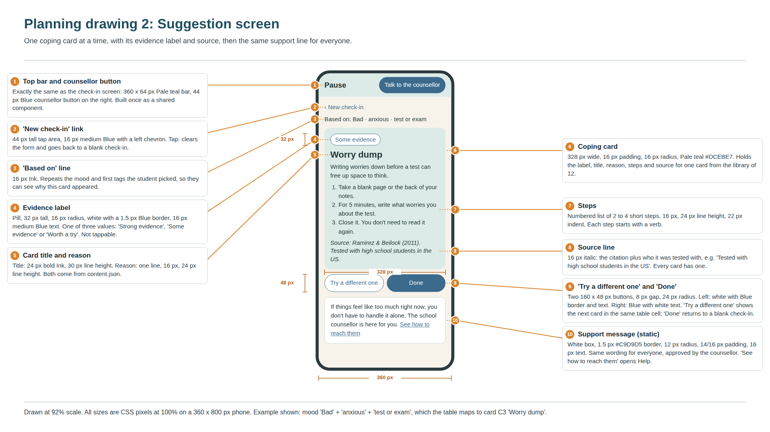
Figure B7: Planning drawing 2, suggestion screen (Canva).
Element | Size and position | Colour and type | What it does | Specification
Top bar | Same as Screen 1 | Same as Screen 1 | Shared component, so the counsellor button is identical everywhere. | Safety: counsellor button
'New check-in' link | 44 px tall tap area | 16 px medium Blue | Clears the form and returns to Screen 1. | Form and Function
'Based on' line | Full width | 16 px Ink | Shows the mood and first tags, e.g. 'Based on: Bad · anxious · test or exam'. | Form and Function: matched suggestion
Coping card | 328 px wide, 16 px padding, 16 px radius | Pale teal | Holds the label, title, reason, steps and source of one card. | Form and Function: matched suggestion
Evidence pill | 32 px tall, 16 px radius | White, 1.5 px Blue border, 16 px medium Blue | Shows 'Strong evidence', 'Some evidence' or 'Worth a try'. | Form and Function: honest about the evidence
Title, reason, steps | Title 24 px bold; steps numbered, 22 px indent | Ink | Read from content.json for the chosen card ID. | Size: easy to tap and read
Source line | Full card width | 16 px italic Ink | Citation plus who it was tested with. | Form and Function: honest about the evidence
Two buttons | 2 x (160 x 48 px), 8 px gap | Outline Blue / filled Blue | 'Try a different one' shows the next card in the cell; 'Done' goes back to Screen 1. | Form and Function
Support message | 328 px wide box, 14/16 px padding | White, 1.5 px border, 12 px radius, 16 px text | Same text for everyone. 'See how to reach them' opens Help. | Safety: 'you're not alone' line

Planning drawing 3: Help and Privacy screens
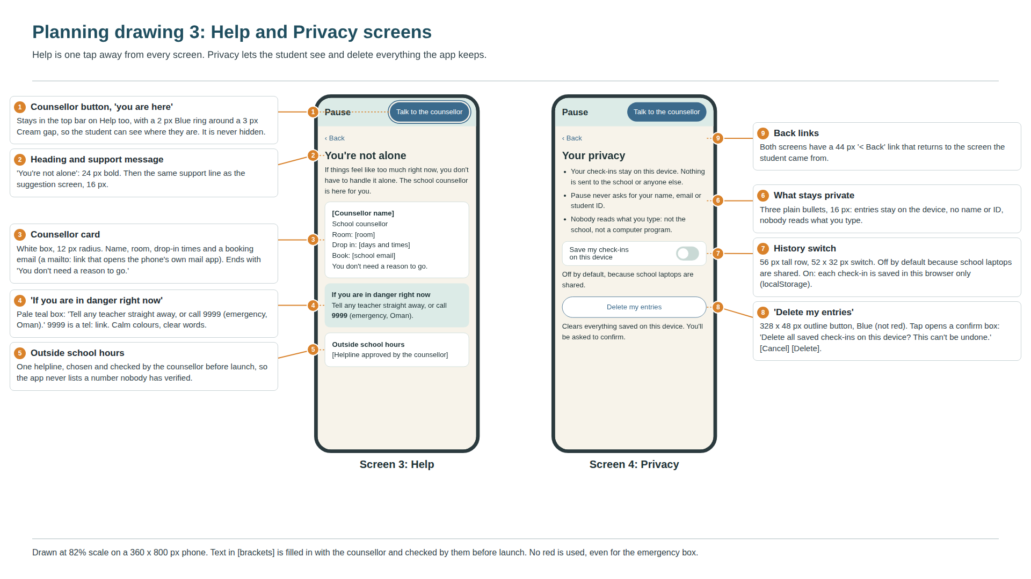
Figure B8: Planning drawing 3, Help and Privacy screens (Canva).
Help: counsellor details | [Counsellor name], room, drop-in days and times, and a booking email (mailto: link). 'You don't need a reason to go.' The counsellor fills in and approves every detail before launch.
Help: danger box | 'If you are in danger right now: tell any teacher straight away, or call 9999 (emergency, Oman).' 9999 is a tel: link. Pale teal, not red, so it stays calm. The counsellor confirms the number and wording.
Help: outside school hours | One helpline chosen and checked by the counsellor. The app never shows a number nobody has verified.
Support line wording | 'If things feel like too much right now, you don't have to handle it alone. The school counsellor is here for you.' Checked against Orygen's #chatsafe guidelines (Orygen, n.d.) and approved by the counsellor.
Privacy: switch | 'Save my check-ins on this device', 56 px row with a 52 x 32 px switch. Off by default because school laptops are shared.
Privacy: delete | 328 x 48 px outline button 'Delete my entries'. Opens a confirm box: 'Delete all saved check-ins on this device? This can't be undone.' with Cancel and Delete. Delete clears pause.entries.

User flow
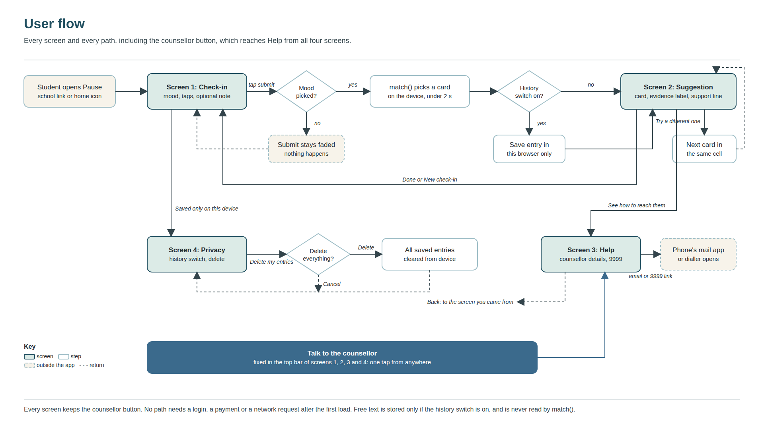
Figure B9: User flow showing every screen and path (Canva).
Every screen has the counsellor button, so Help is always one tap away. The only required input is the mood. No path asks for a login, a payment or a network request after the first load. Two links leave the app on purpose: the counsellor's email (opens the phone's mail app) and 9999 (opens the dialler).
Matching logic
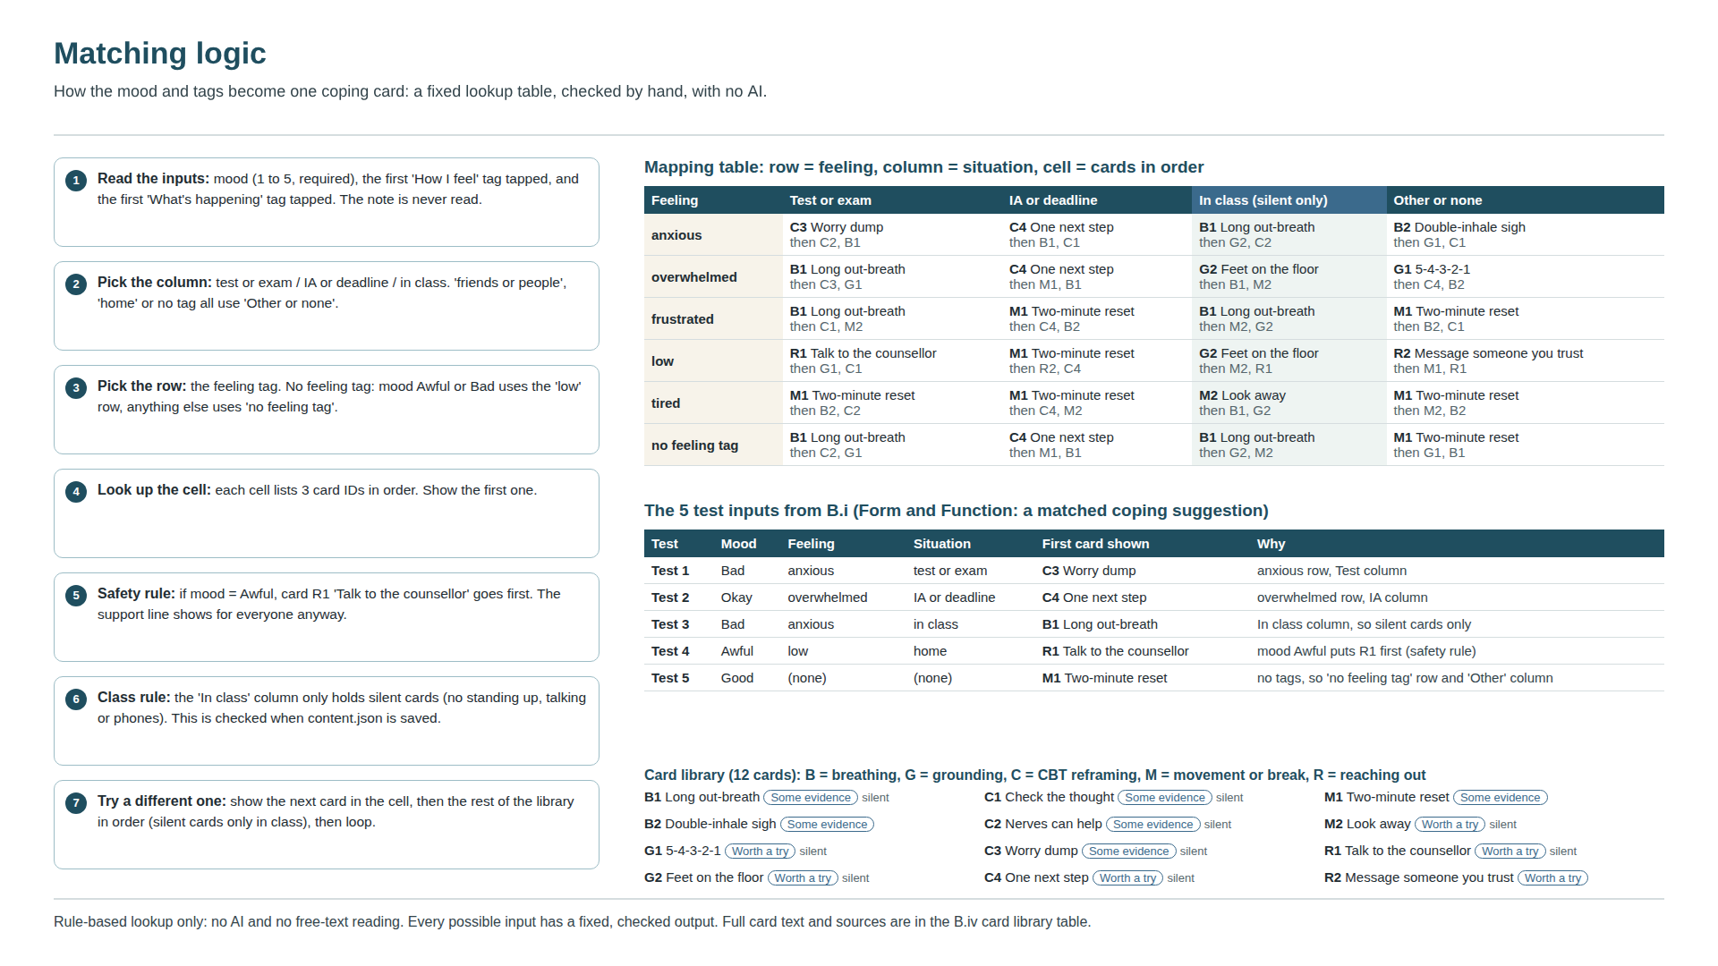
Figure B10: Matching logic, mapping table and the five test inputs (Canva).
The rules in Figure B10, written so they can be turned straight into code:
function match(mood, feeling, situation):
col = {'test or exam':'Test','IA or deadline':'IA','in class':'Class'}[situation] or 'Other'
row = feeling if feeling else ('low' if mood <= 2 else 'no feeling tag')
cards = TABLE[row][col] # 3 card IDs in order
if mood == 1 and cards[0] != 'R1': cards = ['R1'] + cards # Awful: counsellor first
rest = [c for c in LIBRARY if c not in cards and (col != 'Class' or c.silent)]
return cards + rest # 'Try a different one' walks this list

Full card library. Every possible input leads to one of these 12 cards. The label follows three rules: Strong evidence = backed by systematic reviews or clinical guidelines for this kind of use; Some evidence = backed by trials, but small, mixed, or not tested with teenagers; Worth a try = low risk and widely recommended, with little direct research. No card earned 'Strong evidence'. The strong reviews tested full courses or regular habits, not one technique used for a minute in a school day, so I did not give that label to any card.
Card | Type | Steps shown | Reason shown | Label, source and who it was tested with
B1: Long out-breath | Breathing  Silent: yes | 1. Breathe in through your nose for a count of 4.  2. Breathe out slowly through your mouth for a count of 6.  3. Repeat 5 times (about 1 minute). | A longer out-breath can help your body slow down. | Some evidence  Fincham et al. (2023)  Meta-analysis of trials with adults; small to medium effects, and the authors ask for better-quality trials.
B2: Double-inhale sigh | Breathing  Silent: no | 1. Breathe in through your nose.  2. At the top, take one more short sip of air.  3. Breathe out slowly and fully through your mouth.  4. Repeat for 1 to 5 minutes. | In one trial, breathing with a long out-breath lifted mood more than mindfulness did. | Some evidence  Balban et al. (2023)  One month-long online trial with adults.
G1: 5-4-3-2-1 | Grounding  Silent: yes | 1. Name 5 things you can see.  2. Name 4 things you can feel and 3 you can hear.  3. Name 2 things you can smell and 1 you can taste. | Grounding is one of the WHO's self-help skills. This version uses your senses. | Worth a try  World Health Organization (2020)  Recommended in a WHO self-help guide; this exact version has not been tested on its own.
G2: Feet on the floor | Grounding  Silent: yes | 1. Slowly push your feet into the floor.  2. Press your palms together or onto the desk.  3. Notice the chair holding you up.  4. Look around and name where you are. | This is the grounding exercise from the WHO's stress guide. | Worth a try  World Health Organization (2020)  Recommended in a WHO self-help guide; not tested on its own with teenagers.
C1: Check the thought | CBT reframing  Silent: yes | 1. Write the worrying thought in one line.  2. Ask: what is the evidence for it, and against it?  3. Ask: what would I tell a friend who thought this?  4. Write a fairer version of the thought. | Questioning a thought is a core skill in CBT. | Some evidence  Hofmann et al. (2012)  CBT was tested as full courses, usually with a therapist, not as a single card.
C2: Nerves can help | CBT reframing  Silent: yes | 1. Notice the racing heart or butterflies.  2. Tell yourself: 'This is my body getting ready.'  3. Take one slow breath and start. | Students told that nerves can help them did better on a practice test. | Some evidence  Jamieson et al. (2010)  One study with US students preparing for the GRE.
C3: Worry dump | CBT reframing (writing)  Silent: yes | 1. Take a blank page or the back of your notes.  2. For 5 minutes, write what worries you about the test.  3. Close it. You don't need to read it again. | Writing worries down before a test can free up space to think. | Some evidence  Ramirez & Beilock (2011)  Tested with high school and university students in the US.
C4: One next step | Problem solving  Silent: yes | 1. Write the whole task in one line.  2. Split it into 3 small pieces.  3. Do only the first piece for 10 minutes. | Problem-solving skills help protect teenagers' mental health. | Worth a try  World Health Organization (2024)  The WHO lists problem-solving skills as protective; this exact method was not tested.
M1: Two-minute reset | Movement or break  Silent: no | 1. Stand up and stretch your arms and shoulders.  2. Walk to refill your water bottle.  3. Come back and start with the easiest part. | Short breaks raised energy and lowered tiredness across 22 studies. | Some evidence  Albulescu et al. (2022)  Mostly adults at work or in lab tasks; small effects.
M2: Look away | Movement or break  Silent: yes | 1. Look at something far away for 20 seconds.  2. Roll your shoulders back twice.  3. Unclench your jaw and hands. | Even a very short pause can lower tiredness. | Worth a try  Albulescu et al. (2022)  Based on the micro-break review; this exact version was not tested.
R1: Talk to the counsellor | Reaching out  Silent: yes | 1. Tap 'Talk to the counsellor' at the top.  2. See when you can drop in, or send a booking email.  3. You don't need a reason to go. | Support at school is one of the things that protects teenagers' mental health. | Worth a try  World Health Organization (2024)  General WHO guidance, not a trial of this app.
R2: Message someone you trust | Reaching out  Silent: no | 1. Pick one person: a friend, a parent or another adult you trust.  2. Send one line, like 'Rough day, can we talk later?'  3. You don't have to explain everything. | Good relationships with family and friends help protect teenagers' mental health. | Worth a try  World Health Organization (2024)  General WHO guidance, not a trial of this app.

How the parts connect
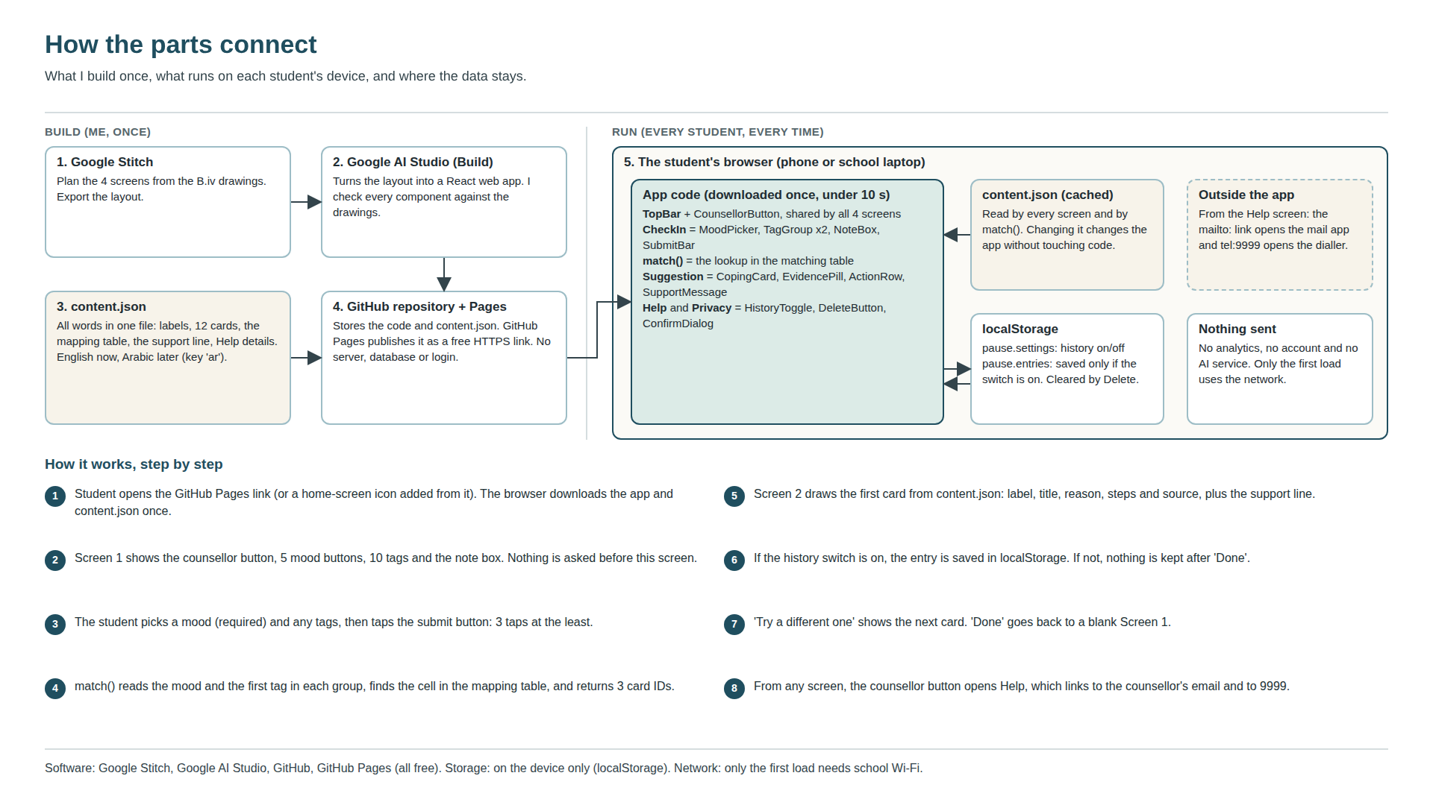
Figure B11: System diagram and step-by-step operation (Canva).
Component | Contains and does
TopBar | Wordmark + CounsellorButton. Used on all 4 screens.
CheckIn | MoodPicker (5 buttons), TagGroup x 2 (feelings, situations), NoteBox, PrivacyLink, SubmitBar.
match() | Pure function: (mood, firstFeeling, firstSituation) to a list of card IDs. No network, no AI.
Suggestion | BasedOnLine, CopingCard (EvidencePill, title, reason, steps, source), ActionRow (Try a different one, Done), SupportMessage.
Help | BackLink, support text, CounsellorCard, DangerBox, OutsideHoursBox.
Privacy | BackLink, PrivacyList, HistoryToggle, DeleteButton, ConfirmDialog.
storage.js | load(), save(entry), clear(). Uses localStorage keys pause.settings and pause.entries only.

Data stored on the device. Nothing is sent anywhere. With history off (the default), nothing is kept after 'Done'.
pause.settings = { "historyOn": false, "lang": "en" }
pause.entries = [ { "time": "2026-11-02T10:41", "mood": 2, "feelings": ["anxious"],
"situations": ["test or exam"], "note": "", "cardShown": "C3" } ] // only if historyOn

content.json structure. All words live here, so new cards or an Arabic version need no new screens (Manufacturing: easy to extend later).
{ "en": { "moods": ["Awful","Bad","Okay","Good","Great"],
"feelings": ["anxious","overwhelmed","frustrated","low","tired"],
"situations": ["test or exam","IA or deadline","in class","friends or people","home"],
"support": "If things feel like too much right now, ...",
"help": { "name": "[Counsellor name]", "room": "[room]", "email": "[school email]" },
"cards": { "C3": { "name": "Worry dump", "label": "Some evidence", "steps": [...],
"why": "...", "source": "Ramirez & Beilock (2011)", "silent": true } } },
"ar": { ... same keys, Arabic text ... },
"table": { "anxious": { "Test": ["C3","C2","B1"], "IA": [...], "Class": [...], "Other": [...] } } }

How I will build it, step by step
1. Plan screens (2 h) | In Google Stitch, recreate the 4 screens from Planning drawings 1 to 3 using the design tokens above. Export to AI Studio.
2. Generate the app (4 h) | In Google AI Studio (Build), create a React app with the 4 screens and the TopBar shared between them. Check every size and colour against the drawings with the browser's inspect tool.
3. Add content (3 h) | Write content.json from the card library table and the mapping table. Make every screen read its words from it.
4. Add match() (2 h) | Write match() from the pseudocode. Test it with the 5 test inputs in Figure B10; each must return the listed first card.
5. Add storage and Privacy (2 h) | Write storage.js, the history switch (off by default) and Delete with its confirm box.
6. Counsellor sign-off (1 h) | Show the counsellor the Help screen, support line and all 12 cards. Make their changes in content.json.
7. Publish (1 h) | Push the code to a GitHub repository and turn on GitHub Pages to get a free HTTPS link.
8. Test against B.i (5 h) | Run every B.i test: 3 school devices, 320/375/768/1366 px widths, contrast checks, font size check (0 KB), timing with 5 peers, privacy test with the word TESTPRIVACY.

Total: 20 hours, which matches Manufacturing: built in a browser in about 20 hours.
Requirements for creating the solution
Software | Google Stitch and Google AI Studio (free, in the browser); a code editor if needed (VS Code, free); Chrome, Safari and Edge for testing.
Hardware | A laptop for building; 3 school devices (a Windows laptop, a Chromebook or Mac, and one phone) for testing.
Internet and connectivity | Internet to build and publish. Students only need school Wi-Fi for the first load; after that, the check-in and matching run on the device.
Accounts and platforms | A Google account (Stitch and AI Studio) and a GitHub account (repository and Pages). Students need no account at all.
Tools | Browser inspect tool and Network tab; the WebAIM Contrast Checker; a stopwatch; the B.i test sheets.
Equipment | Printed paper prototypes and scenario cards for testing; nothing physical is part of the product.
Materials and resources | content.json written from my sources; free-to-use face icons drawn as simple SVG; an asset register recording the source and licence of everything.
Skills and knowledge | Basic React and JSON editing; reading and checking AI-generated code; using inspect tools; writing safe-messaging wording; APA referencing for the card sources.
Technical requirements | Runs in any modern browser on iOS, Android, Windows, macOS and ChromeOS; 320 to 1366 px wide; loads in 10 s or less on school Wi-Fi; no sounds, notifications or animation; WCAG AA contrast and 44 px targets.
Research and resources | My B.i specifications; the card sources in the reference list; Orygen's #chatsafe guidelines for the support wording; WCAG 2.2.
Special conditions | The counsellor must approve the Help details, the support line and all 12 cards before launch. The school must allow the link on school Wi-Fi and agree that students can open it in lessons. Pause is a signpost to people, not a replacement for the counsellor, and it never contains supplement or medication content.

Final check: could someone else build Pause from these plans?
Every screen drawn with sizes | Yes: Planning drawings 1 to 3 and their element tables.
Every colour, font and size | Yes: Design tokens table.
Every path between screens | Yes: User flow (Figure B9).
How inputs become a suggestion | Yes: Matching logic, pseudocode and the full card library.
Where data is stored | Yes: storage keys and the content.json structure.
Tools, accounts and build order | Yes: build steps and requirements tables.
Who must approve what | Yes: Special conditions (counsellor sign-off, school permission).

Appendix B3: Feedback on the design ideas
Peer vote (n = 20) | Design 3: 8 (6 MYP, 2 DP). Design 4: 7 (2 MYP, 5 DP). Design 1: 4 (2 MYP, 2 DP). Design 2: 1 (0 MYP, 1 DP).  Most common reasons: Design 3 'feels like texting a friend' (6); Design 4 'quick and nothing extra' (5); Design 1 'everything on one page' (3).
Paper-prototype test (n = 5) | Median time to reach a card: D1 9 s, D2 22 s, D3 17 s, D4 11 s.  Median time to find how to contact the counsellor: D1 14 s, D2 9 s, D3 7 s, D4 2 s.  2 of 5 testers on shorter phones had to scroll to find Design 4's submit button.
Counsellor | Ratings for 'Is this safe to give to students?': D1 2, D2 4, D3 1, D4 5.  'The chat one worries me. If it looks like someone is listening, a student might type something serious and wait for a reply that never comes.'  'I like that the button says counsellor. Students don't always know what an icon means.'
Teacher | Ratings for 'Would you allow this in your lesson?': D1 3, D2 4, D3 2, D4 5.  'The one with everything on one card is the only one I could see a student finishing before I notice. No moving parts, please.'

Appendix B4: Scripts I used
Peer survey (Google Form) | 1. Which year are you in? (MYP4 / MYP5 / DP1 / DP2)  2. Look at the four designs. Which one would you actually use when you are stressed at school? (Design 1 / 2 / 3 / 4)  3. Why? (short answer)  4. Which design would you not use, and why? (short answer)
Paper-prototype test | Read aloud: 'This is a paper version of an app. Please think out loud.' Hand over the scenario card: 'You just walked out of a hard test and feel anxious. Use the app to find something that helps.' Start the stopwatch on the first touch and stop when a card is reached. Then say: 'Now find how to contact the counsellor.' Time it. Record taps, time, and anything the tester says. Repeat for all four designs in a different order for each tester.
Counsellor interview | 1. Is each of these designs safe to give to students? Rate each from 0 to 5.  2. What worries you about any of them?  3. Is the support line wording right? What would you change?  4. Which details should the Help screen show, and which outside-hours number should we list?  5. Are you comfortable with all 12 coping cards and their labels?
Teacher question | 'Would you allow a student to open each of these during your lesson? Rate each from 0 to 5. What would make you say no?'

References
Albulescu, P., Macsinga, I., Rusu, A., Sulea, C., Bodnaru, A., & Tulbure, B. T. (2022). "Give me a break!" A systematic review and meta-analysis on the efficacy of micro-breaks for increasing well-being and performance. PLOS ONE, 17(8), Article e0272460. https://doi.org/10.1371/journal.pone.0272460
Arnsten, A. F. T. (2009). Stress signalling pathways that impair prefrontal cortex structure and function. Nature Reviews Neuroscience, 10(6), 410–422. https://doi.org/10.1038/nrn2648
Balban, M. Y., Neri, E., Kogon, M. M., Weed, L., Nouriani, B., Jo, B., Holl, G., Zeitzer, J. M., Spiegel, D., & Huberman, A. D. (2023). Brief structured respiration practices enhance mood and reduce physiological arousal. Cell Reports Medicine, 4(1), Article 100895. https://doi.org/10.1016/j.xcrm.2022.100895
Daylio. (n.d.). Daylio – Journal, diary and mood tracker. Google Play. Retrieved September 21, 2026, from https://play.google.com/store/apps/details?id=net.daylio
Fincham, G. W., Strauss, C., Montero-Marin, J., & Cavanagh, K. (2023). Effect of breathwork on stress and mental health: A meta-analysis of randomised-controlled trials. Scientific Reports, 13, Article 432. https://doi.org/10.1038/s41598-022-27247-y
Hofmann, S. G., Asnaani, A., Vonk, I. J. J., Sawyer, A. T., & Fang, A. (2012). The efficacy of cognitive behavioral therapy: A review of meta-analyses. Cognitive Therapy and Research, 36(5), 427–440. https://doi.org/10.1007/s10608-012-9476-1
Jamieson, J. P., Mendes, W. B., Blackstock, E., & Schmader, T. (2010). Turning the knots in your stomach into bows: Reappraising arousal improves performance on the GRE. Journal of Experimental Social Psychology, 46(1), 208–212. https://doi.org/10.1016/j.jesp.2009.08.015
Orygen. (n.d.). #chatsafe: A young person’s guide for communicating safely online about self-harm and suicide (2nd ed.). Retrieved October 3, 2026, from https://orygen.org.au/Training/Resources/Self-harm-and-suicide-prevention/Guidelines/chatsafe-A-young-person-s-guide-for-communicatin
Ramirez, G., & Beilock, S. L. (2011). Writing about testing worries boosts exam performance in the classroom. Science, 331(6014), 211–213. https://doi.org/10.1126/science.1199427
World Health Organization. (2020). Doing what matters in times of stress: An illustrated guide. https://www.who.int/publications/i/item/9789240003927
World Health Organization. (2024). Mental health of adolescents. https://www.who.int/news-room/fact-sheets/detail/adolescent-mental-health
World Wide Web Consortium. (2024). Web content accessibility guidelines (WCAG) 2.2 (A. Campbell, C. Adams, R. Bradley Montgomery, M. Cooper, & A. Kirkpatrick, Eds.). https://www.w3.org/TR/WCAG22/
Wysa. (n.d.). Wysa: Mental wellbeing AI. Google Play. Retrieved September 21, 2026, from https://play.google.com/store/apps/details?id=bot.touchkin

