Criterion B: Developing ideas

i. Design specifications
My specifications come straight from my Criterion A research and are organised using ACCESSFMM. For each one I explain what it is, why I chose it (linked to my primary and secondary research), and who will test it, when and how. Every specification has a measurable success target, so there is a clear line between met and not met.
Where a test uses a rating, the client or peers score from 0 to 5 (0 = very bad, 1 = poor, 2 = satisfactory, 3 = good, 4 = very good, 5 = excellent). A rated specification is met when the average is 4/5 or higher and its measurable target is also hit. The feedback I refer to is summarised in Appendix B1.
ACCESSFMM | The Specification (The Requirement) | Explanation (What it is) | Justification (Why it was chosen) | Testing Method (Who, When, How)
Aesthetics | Calm and consistent look. The app will use no more than three main colours plus one neutral text colour, with rounded corners and the same style on every screen. | Warm ivory and sand backgrounds with one muted sage green accent and a warm near-black for text. Cards and buttons have rounded corners (12 to 16 px). There is no red anywhere, not even on the help button.  Every screen shares the same colours, font and corner style, so the app feels like one calm space rather than separate pages. | In my Criterion A analysis (Aiii), Wysa's teal and cream branding is deliberately warm and non-clinical, the opposite of the intense red used by hotlines (Wysa, n.d.). A student who opens the app mid-class is already stressed, so the screen should lower that, not look like an emergency service. Pause takes the same warm, non-clinical idea in its own beige and sage colours.  In my peer survey, 14 of 20 students said apps that look like a hospital or clinic put them off (Appendix B1). | Who: 6 peers (at least one from each year, MYP4 to DP2).  When: on the B.ii wireframes, and again in Criterion D.  How: they look at every screen and rate 'calm' and 'consistent' from 0 to 5. I also count the colours in the app's theme settings.  Success: 3 main colours or fewer + 1 neutral, 0 reds, and an average of 4/5 or higher on both questions.
Cost | Free to build and free to use. The app will cost 0 OMR to build and host, and students will never pay, sign up or see adverts. | I build and host it on free tiers only. The check-in, suggestions, Help screen and counsellor button all work without payment or an account. | Both products I analysed in Aiii put features behind paid plans (Wysa, n.d.; Daylio, n.d.). A paywall in front of help would block the students who need it most.  My related concept of resources frames this project as stretching limited counsellor time further, not selling something. | Who: me (the designer).  When: at the end of Criterion C.  How: I open the app in a private browser window on a device that has never used it and go through the full flow. I then check my resource log and the platform's billing page.  Success: 0 payment prompts, 0 sign-up prompts, 0 adverts and 0 OMR spent.
Customer / Client | Fits both MYP and DP students. Students from MYP4 to DP2 will be able to describe what is stressing them with tags that cover both MYP and DP pressures. | Two groups of tags. 'How I feel' (12): anxious, stressed, overwhelmed, frustrated, low, tired, then angry, lonely, embarrassed, restless, unmotivated and 'something else' behind a 'More' chip. 'What's happening' (10): test or exam, IA or deadline, in class, presentation, homework, friends or people, then home, sleep, social media and 'something else' behind 'More'. Tapping a feeling offers an optional 'Tell us more' sheet with an exact word (explained in brackets), how strong and how long.  Every tag is 3 words or fewer and uses words a 14-year-old already uses. | Criterion A treats MYP4 and DP2 stress as different (related concept: perspective). An MYP4 student starting the Personal Project is not under the same load as a DP2 student with IA deadlines.  My primary research found that stress during difficult exams reduced students' mental capacity and lowered their grades (Aiv). In my peer survey, exams (16/20) and deadlines (13/20) were the two most common triggers (Appendix B1). | Who: 3 MYP4 to MYP5 students and 3 DP1 to DP2 students.  When: during the B.iii feedback session.  How: each student is asked: 'Could you describe your last stressful school moment using only these tags?' and rates the fit from 0 to 5. I average MYP and DP separately so one group cannot hide the other. I also count the words in every tag.  Success: an average of 4/5 or higher in both groups, and 10/10 tags are 3 words or fewer.
Customer / Client | Allowed in class. The app will work silently during a lesson, and the counsellor will approve all safety wording before it is used. | No sounds, vibration, push notifications, or animation longer than 5 seconds.  The counsellor reviews and approves the Help screen text, contact details and the 'you're not alone' message. | Criterion A names teachers and counsellors as my secondary client: they decide whether the tool is allowed in class and receive any escalation. Stress happens mid-class (Ai), so the app must work there without drawing attention to the student.  The teacher I spoke to said they would allow it only if it is completely silent (Appendix B1).  I took the 5-second limit from WCAG 2.2, which says anything that moves by itself for more than 5 seconds needs a pause control (W3C, 2024, SC 2.2.2). Keeping every animation shorter than that is simpler than adding another button. | Who: me, 1 teacher and the counsellor.  When: on the Criterion C prototype.  How: I do a full check-in on 3 devices with the volume at maximum. The teacher rates 'I would allow this in my lesson' from 0 to 5, and the counsellor signs off the wording.  Success: 0 sounds, vibrations or notification requests and 0 animations over 5 s on 3/3 devices, a teacher rating of 4/5 or higher, and counsellor sign-off.
Environment | Works fast on school Wi-Fi. The app will open in 10 seconds or less on school Wi-Fi and show a suggestion within 2 seconds of submitting. | It is used in classrooms, the library and between exams, on phones and school laptops over school Wi-Fi.  The matching runs on the device itself, so there is no server to wait for. | Criterion A argues the solution must exist where the stress occurs, not before or after it. Bentley et al. (2022) gave 43 high school students a breathing technique to practise alone, and compliance fell from 73% to 47% over five weeks.  In Criterion A I argued the delivery failed because nothing reached students in the moment. A slow app would repeat that mistake. | Who: me.  When: during Criterion C and in final testing (Criterion D).  How: I load the app 3 times on each of 3 school devices with the cache cleared and time it with a stopwatch. Then I time 10 submissions.  Success: 9/9 loads in 10 s or less, and 10/10 suggestions in 2 s or less.
Environment | Lightweight text. The app will download 0 KB of font files by using system fonts. If a web font is ever needed (e.g. for Arabic), the limit is 100 KB in total. | It uses fonts already installed on the device, one font family, and no autoplay video or decorative images. Any future web font uses the WOFF2 format. | jacopo (2025) explains that fonts are data files downloaded with every page, that one custom web font can add hundreds of kilobytes, and recommends system fonts, one family and WOFF2 to cut data transfer and energy use. A 100 KB cap sits below what one custom family can add.  Less data also helps the 10-second load time above. | Who: me and 3 peers.  When: during Criterion C.  How: I open the browser's Network tab, filter by 'Font', reload and add up the sizes. Then 3 peers read a suggestion card aloud from a phone held at arm's length.  Success: 0 KB of fonts (100 KB or less if a web font is added), and 3/3 peers read the card without errors.
Safety | Counsellor button on every screen. A 'Talk to the counsellor' button will be visible on every screen, without scrolling, in the same place each time. | It sits in a fixed bar at the top and is at least 44 × 44 px. It opens a Help screen with the counsellor's name, room, how to drop in or book, and the emergency number. | In Aiii, Wysa showed that a default, always-visible safety response works better than one the user has to look for (Wysa, n.d.). Criterion A also states that the app must include a visible, unconditional link to the counsellor so it never replaces professional support.  WCAG 2.2 says help options repeated across pages should stay in the same order (World Wide Web Consortium [W3C], 2024, SC 3.2.6). | Who: me and 5 peers.  When: on the B.ii wireframes, and in Criterion D.  How: I screenshot every screen at 320 px and 1366 px without scrolling. Each peer starts on a random screen and is asked: 'Find how to contact the counsellor.' I time them.  Success: the button is in the same place on 100% of screenshots, and every peer finds it in 5 seconds or less.
Safety | A 'you're not alone' line for everyone. The suggestion screen and Help screen will show the same short support message, worded with safe-messaging guidance. | Example: 'If things feel like too much right now, you don't have to handle it alone. The school counsellor is here for you.'  It is never triggered by what someone types. Every user sees it every time. | Wysa's AI detection caught 82% of crisis instances (Aiii), which means it missed almost one in five. A line shown to everyone cannot miss anyone.  In Aii I planned to use safe-messaging guidance so the wording is tested rather than invented. I will check it against Orygen's #chatsafe guidelines, which were written with young people (Orygen, n.d.), and the counsellor has the final say. | Who: the counsellor and 6 peers.  When: before building (Criterion C), and in Criterion D.  How: the counsellor approves or edits the wording. Peers rate it from 0 (cold or clinical) to 5 (supportive).  Success: counsellor sign-off, and an average peer rating of 4/5 or higher.
Safety | Private by design. Check-in entries will stay only on the student's own device, and the app will never ask for a name, email or student ID. | Entries are kept in the browser's own storage. Saving history is off by default because school devices are shared. A 'Delete my entries' button clears everything. | Criterion A (Ai) found that some students want their problems kept from their parents, while the counsellor is obliged to inform parents. If entries sat on a server, students would stop being honest in the check-in.  Daylio keeps entries off its own servers (Aiii), which shows a mood log does not need a central database. | Who: me.  When: during Criterion C and in Criterion D.  How: with the browser's Network tab open, I do 5 check-ins containing the test word 'TESTPRIVACY' and search every request for it. Then I check the stored data, press 'Delete my entries' and check again.  Success: 0 requests contain the test word, and storage is empty after deleting.
Safety | Nothing unsafe for minors. The app will contain no social features, no AI reading of what users type, and no supplement or medication content. | No posts, comments, sharing or chatting with other users. No chatbot or crisis detection.  Every suggestion is a non-drug technique: slow breathing, grounding, CBT-style reframing, a short movement or break, or reaching out to someone. | Wysa's detection missed 18% of crisis instances (Aiii), and Woebot shut down its app in 2025 (HLTH, 2025) despite having trial evidence. Reliable detection is far beyond a 20-hour build.  A peer feature would put one minor's disclosure in front of others with no trained moderator. My users are 14 to 18, so only non-drug techniques are appropriate. The counsellor asked that nothing reads or analyses what students write (Appendix B1). | Who: me and the counsellor.  When: at the end of Criterion C.  How: I check every screen against a list of banned features and search all text for banned words (supplement, nootropic, medication, pill, dose, mg). The counsellor reviews the result.  Success: 0 banned features, 0 banned words, and the counsellor confirms.
Size | Fits every school screen. The layout will fit screens from 320 px to 1366 px wide with no sideways scrolling and nothing overlapping. | This covers small phones up to school laptops. | My design brief (Aiv) requires support for all relevant platforms, and students use their own phones as well as school laptops.  WCAG 2.2 sets 320 px as the width content should fit without scrolling sideways (W3C, 2024, SC 1.4.10). | Who: me.  When: in B.iv and Criterion C.  How: I use the browser's device toolbar to view every screen at 320, 375, 768 and 1366 px.  Success: 0 sideways scrolling and 0 overlaps at all 4 widths.
Size | Easy to tap and read. Every button will be at least 44 × 44 px, body text at least 16 px, and text contrast at least 4.5:1. | Targets have at least 8 px of space between them. Headings are at least 20 px and line height is 1.5. Mood buttons have word labels, so colour is never the only signal. | WCAG 2.2 sets 44 × 44 px as the enhanced target size (SC 2.5.5), 4.5:1 as the minimum contrast for normal text (SC 1.4.3), and says colour must not be the only signal (SC 1.4.1) (W3C, 2024).  16 px is the default text size in browsers, so nothing is smaller than what students read every day. A mis-tap costs the seconds this app is meant to save. | Who: me and 5 peers.  When: during Criterion C.  How: I check every text and background pair with the WebAIM Contrast Checker and measure sizes with the inspect tool. Each peer taps every button once while I count mis-taps.  Success: 100% of pairs pass, 100% of targets are 44 × 44 px or larger, 0 text below 16 px, and 1 mis-tap or fewer in total.
Form and Function | Hybrid check-in on one screen. One screen will hold a 5-point mood scale, the feeling and situation tags and an optional text box of up to 280 characters. The optional detail sheet opens over this screen, not as a new one. | Choosing a mood is required; tags and text are optional. One button, 'Show me something that might help', submits the check-in. | Daylio shows that a mood-then-tags picker is fast (Aiii), but on its own it gives nothing back. My brief (Aiv) lists 'acts as a mental journal' as a key requirement, so the text box lets students say what the tags miss.  It is optional so it never slows anyone down. 12 of 20 peers said they would want somewhere to write 'when it's something specific' (Appendix B1). | Who: me.  When: on the B.ii wireframes and in Criterion C.  How: I screenshot the screen at 320 px and 1366 px and tick off the four parts. Then I submit 5 times with only a mood chosen.  Success: all 4 parts on one screen at both widths, and 5/5 submissions work with the text box empty.
Form and Function | A matched coping suggestion. After a check-in, the app will show one suggestion from a library of at least 12, chosen by a fixed mapping table. | Each card shows the technique's name, 2 to 4 short steps, and a 'Try a different one' button. The library covers 5 technique types. The full mapping table is in B.iv. No AI is used. | This closes the gap I found in Daylio, which records a mood but never responds (Aiii). Bentley et al. (2022) suggest the delivery, not the technique, was what failed, so the suggestion has to appear at the moment of the check-in.  A fixed table means I can check every possible output before anyone uses the app. | Who: me and the counsellor.  When: during Criterion C.  How: I enter 5 different input sets (listed in B.iv) and compare each result with the mapping table. The counsellor rates how suitable the suggestions are from 0 to 5.  Success: at least 3 different suggestions, 5/5 match the table, and a counsellor rating of 4/5 or higher.
Form and Function | Fast enough to use under stress. A student will reach a suggestion in 3 taps or fewer and 15 seconds or less from the check-in screen. | The shortest path is: choose a mood, choose one tag, submit. | My primary research found that exam stress reduced students' mental capacity and lowered their grades (Aiv). Arnsten (2009) explains a likely reason: even mild, uncontrollable stress can quickly weaken prefrontal cortex abilities such as working memory and controlling attention.  A stressed student has little capacity to spare on an app, so every extra step is a reason to give up. In my survey, 15 of 20 students said they would stop using an app that took more than about 30 seconds (Appendix B1). | Who: 5 peers across MYP4 to DP2.  When: on the Criterion C prototype and in Criterion D.  How: each gets a scenario card: 'You just walked out of a hard test and feel anxious. Use the app to find something that helps.' I time them, count taps, and ask them to rate ease of use from 0 to 5.  Success: median time of 15 s or less, every tester uses 3 taps or fewer, and an average ease rating of 4/5 or higher.
Form and Function | Honest about the evidence. Every suggestion will show a one-line reason it might help, an evidence-strength label and its source. | Strong evidence: backed by systematic reviews or clinical guidelines. Some evidence: backed by trials, but with small or mixed results, or not tested with teenagers. Worth a try: low risk and widely recommended, with little direct research.  No card uses the words 'cure', 'fix', 'treat' or 'guaranteed'. | My brief (Aiv) requires evidence-based strategies, but evidence-based does not mean proven for every student. Bentley et al. (2022) found no statistically significant change in students' measured stress or anxiety after their 5-week breathing pilot.  A label shows students how strong the support really is, so the app never promises more than the research shows. | Who: me and the counsellor.  When: at the end of Criterion C.  How: I check every card for all three parts and search for the banned words. The counsellor reviews the labels on 3 randomly chosen cards.  Success: 100% of cards are complete, 0 banned words, and the counsellor agrees with 3/3 labels.
Manufacturing | Built in a browser in about 20 hours. The app will be a web app built with free AI-assisted tools, with no login before the check-in. | I plan the screens in Google Stitch, build the app in Google AI Studio, and publish it as a simple website on free hosting. It runs in Chrome, Safari or Edge on iOS, Android, Windows, macOS and ChromeOS without installing anything.  The finished app contains no AI. The AI tools only help me write the code, and every suggestion comes from my fixed mapping table. | In Aii I planned to find a vibe-coding platform that can build this in 20 hours. My brief (Aiv) requires support for all platforms, and building a separate native app for each one would not fit the time.  A login screen would add taps before help and make students identify themselves, which breaks the privacy specification. | Who: me.  When: throughout Criterion C.  How: I keep a time log against my plan. At the end I complete the full flow on 3 school devices with different operating systems and 1 phone.  Success: built in 20 hours or less, 4/4 devices complete the flow, and 0 login screens before the check-in.
Manufacturing | Easy to extend later. All text and the mapping table will live in one editable data file, so new suggestions or an Arabic version need no rebuild. | Labels, suggestions, the support message and the mapping table sit in one table instead of being typed into each screen. The layout also works right-to-left. | My related concept of resources is about stretching counsellor time to more moments, and reaching more students means more suggestions and, in Oman, Arabic. The counsellor said some MYP students would be more comfortable in Arabic (Appendix B1).  I also plan to keep developing the app after this unit. | Who: me.  When: at the end of Criterion C.  How: I time myself adding 1 new suggestion with its mapping row and translating 3 labels. Then I switch the layout to right-to-left and check every screen at 320 px.  Success: done in 15 minutes or less, 0 screens rebuilt, and 0 overlaps in right-to-left.
Materials | Free, licensed and traceable. The app will use only free tools, system fonts, free-to-use icons and text I write myself from sources in my reference list. | I keep an asset register listing every icon, tool and piece of content, where it came from, and its licence. | For a digital product, the materials are its software and content. Using only free resources keeps the cost at 0 OMR, and recording a source for every piece of content is what makes the evidence labels honest. | Who: me.  When: at the end of Criterion C.  How: I check the asset register against everything visible in the app.  Success: 100% of assets have a source and a licence recorded.

ii. Develop a range of feasible design ideas
I developed four ideas for Pause. Each one answers the same question in a different way: how does a stressed student get from 'I feel bad' to one useful technique, with the counsellor always within reach? They are not the same app in four colour schemes. Each idea uses a different interaction model, because my Criterion A research showed that speed and being able to find help mattered most to students.
All four ideas use the same five moods, twelve feelings, ten situations and library of twelve coping cards, and all four could be built for free in Google AI Studio in about 20 hours. I drew every screen at real phone size. The fully annotated boards are in my Canva design. Under each board here, I test the idea against four mock scenarios and evaluate it against every B.i specification.
Moods, feelings and situations
I defined every option before designing any screens, so that all four ideas offer the same choices. Each mood has one plain sentence that appears when it is picked, because 'Bad' means different things to different people. Six feelings and six situations are shown at first, and the rest sit behind 'More' so the check-in still fits on one screen. Tapping a feeling offers an optional 'Tell us more' sheet with a more exact word (explained in brackets), how strong it is and how long it has lasted. 'Something else' lets a student type their own word; it is stored only for them and never read by the app.
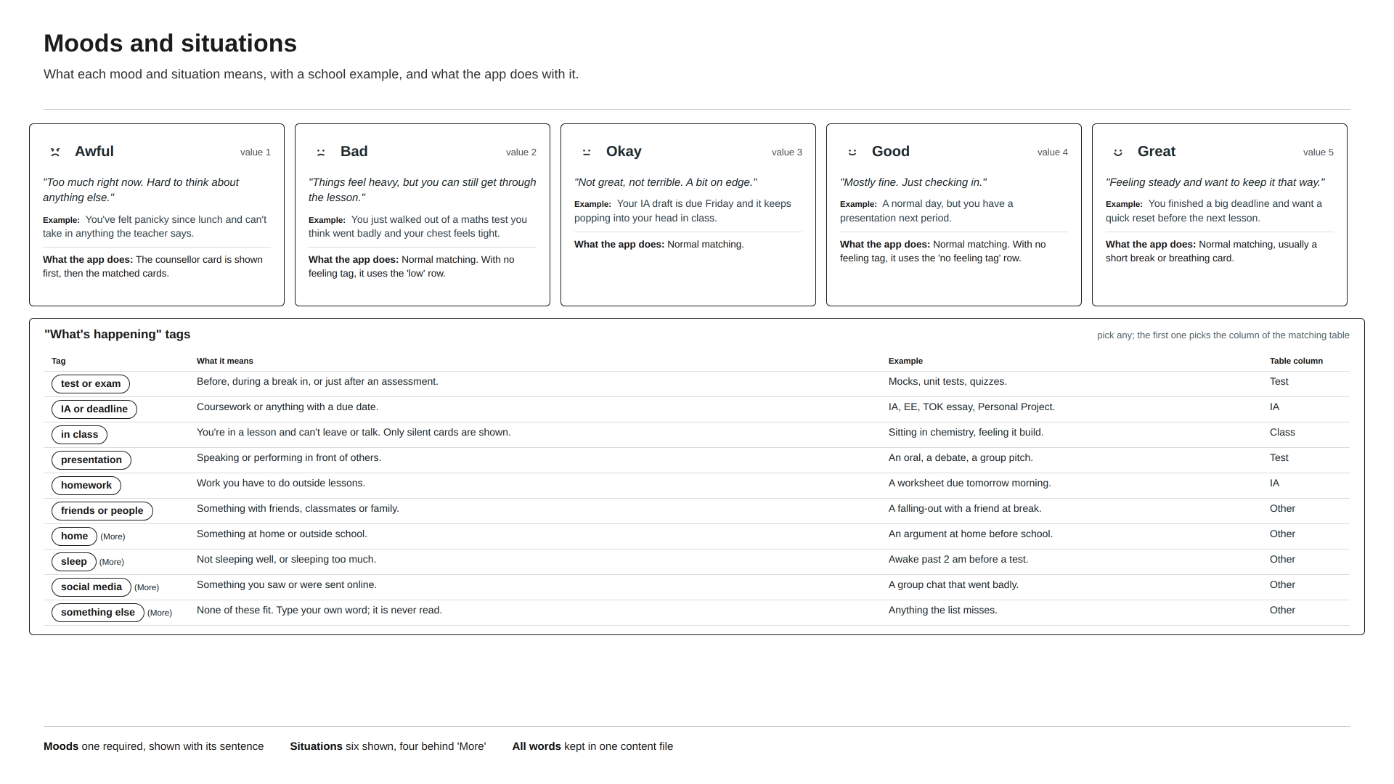
Figure B1: Moods and situations (Canva).
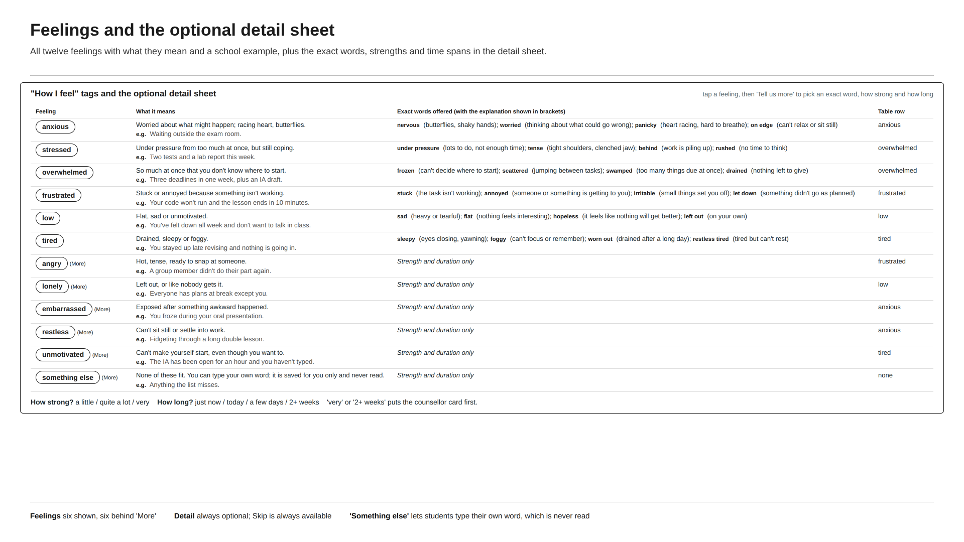
Figure B2: Feelings and the optional detail sheet (Canva).
Mock scenarios
To compare the ideas fairly, I wrote four mock scenarios based on the triggers in my peer survey (tests, lessons, home and presentations). Each one has a correct result, taken from the matching table in B.iv. I walked every design through all four, counting taps and checking whether the student ends up with the right card.
Scenario | Who and when | What they would pick | Correct result
Before a mock exam | DP2 student, five minutes before a chemistry mock, heart racing. | Bad; anxious (panicky, quite a lot); test or exam | Slow breathing first, because 'panicky' moves the breathing card forward.
Stuck in a lesson | MYP4 student in a maths lesson, stuck on a problem and getting annoyed. | Okay; frustrated; in class | A card that can be done silently at a desk: Slow breathing.
Low for weeks | DP1 student at home late at night who has felt low for over two weeks. | Bad; low (2+ weeks); home | Talk to the counsellor first, with the stronger support message.
No word fits | MYP5 student before an oral who can't find a feeling word that fits. | Okay; something else; presentation | The card for 'no feeling picked' in a test situation: Slow breathing.

Design 1: All-in-One Dashboard
Design 1 came from Daylio, which I analysed in Criterion A. Daylio is fast because everything is on one screen. Here the student types how they feel into a single field instead of picking a mood, and suggestions appear from a fixed list of feeling words, each with a short explanation. There is no submit button: the suggestion card halfway down the page updates as soon as a word or situation is chosen. History and the counsellor link sit further down the page.
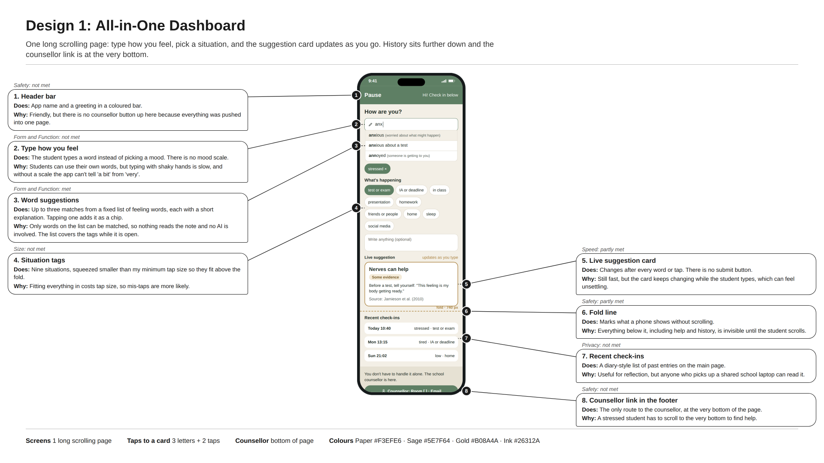
Figure B3: Design 1: All-in-One Dashboard (Canva).
Mock scenarios
Scenario | What the student does | Taps | Result
Before a mock exam | Types 'pan', picks 'panicky', taps test or exam. | 4 letters, 2 taps | Slow breathing appears. Met.
Stuck in a lesson | Types 'fru', picks 'frustrated', taps in class. | 3 letters, 2 taps | A silent card is shown, but typing in a lesson is slower than tapping. Met.
Low for weeks | Types 'low', taps home. | 3 letters, 1 tap | A card for feeling low, but there is no way to say 'two weeks', so the counsellor is not put first. Not met.
No word fits | Types 'off', which isn't on the list, taps presentation. | 3 letters, 1 tap | No match for the word, so the 'no feeling picked' cards are used. Met.

Evaluation against my specifications
ACCESSFMM | Specification (B.i) | How this design meets it | Result
Aesthetics | Calm and consistent look | Sage, paper and gold are used the same way down the whole page, with rounded corners and no red. It reads as calm at the top, although the long page gets busy once you scroll past the card. | Met
 | Aesthetics score | Consistent palette and corner style. | 1/1
Cost | Free to build and free to use | Built with free tools and free hosting. There is no login, paywall or advert anywhere on the page. | Met
 | Cost score | Nothing to pay for. | 1/1
Customer / Client | Fits both MYP and DP students | The typed field accepts any word on the feeling list, and the nine situation chips cover both MYP and DP pressures, including IA or deadline and presentation. | Met
 | Allowed in class | No sound, vibration or notification, and the live card swaps without animation, so nothing on screen would draw a teacher's attention. | Met
 | Customer / Client score | Typing covers any listed word and the situations cover both groups. | 2/2
Environment | Works fast on school Wi-Fi | It is one page of text and matching runs on the phone, so after the first load nothing waits for the school network. | Met
 | Lightweight text | Uses the system font and only small SVG icons, so 0 KB of fonts are downloaded. | Met
 | Environment score | Light and quick. | 2/2
Safety | Counsellor button on every screen | The only counsellor link is in the footer at the very bottom of the page. On a normal phone it is never visible without scrolling, which is exactly what this specification rules out. | Not met
 | 'You're not alone' line for everyone | The support message is there for everyone, but it sits in the footer below the fold, so most students would never see it unless they scroll to the bottom. | Partly met
 | Private by design | Recent check-ins, including the words the student typed, are listed on the main page, so anyone who opens the app on a shared school laptop can read them. | Not met
 | Nothing unsafe for minors | No social features and no AI. Suggestions only come from a fixed list of words and the same card library as the other designs. | Met
 | Safety score | Help, the support line and privacy all suffer from putting everything on one long page. | 1/4 (1 partly)
Size | Fits every school screen | The single column fits every screen from a small phone to a school laptop with no sideways scrolling. | Met
 | Easy to tap and read | The situation chips and suggestion rows are smaller than my minimum tap size, and several labels are smaller than my minimum text size. | Not met
 | Size score | Reflows well, but the targets and labels are too small. | 1/2
Form and Function | Hybrid check-in on one screen | Everything is on one page, but there is no 5-point mood scale because the typed word replaces it. Without a scale the app can't tell 'a bit anxious' from 'very anxious'. | Not met
 | A matched coping suggestion | The typed word is matched to a feeling row from the fixed list and the situation chip picks the column, so the card comes from the same mapping table as Design 4. | Met
 | Fast enough to use under stress | Typing three or four letters, choosing a suggestion and tapping a situation took a median of 16 s in the paper test, just over my 15 s limit. | Partly met
 | Honest about the evidence | The live card shows its evidence label and its source. | Met
 | Form and Function score | Matching and labels work, but there is no mood scale and typing is slower than tapping. | 2/4 (1 partly)
Manufacturing | Built in a browser in about 20 hours | One React page with an autocomplete list. Feasible in 20 hours, although the live updating needs extra testing. | Met
 | Easy to extend later | New words and cards are entries in the content file, so nothing on the page needs rebuilding. | Met
 | Manufacturing score | Simple to build and extend. | 2/2
Materials | Free, licensed and traceable | Only the system font, free SVG icons and my own text, all recorded in the asset register. | Met
 | Materials score | All traceable. | 1/1
Total |  | 13 of 19 specifications met, 2 partly met and 4 not met. | 13/19

Design 2: Step-by-Step Guide
Design 2 goes the other way. It asks one question per screen, like a short quiz, with a progress bar along the top: mood, then tags, then an optional note, then the suggestion. I chose this structure because one large question on a calm, almost empty screen is the easiest thing to read when you are stressed, and the large mood buttons are hard to mis-tap. The tag step shows eight feelings and six situations, each with 'More'.
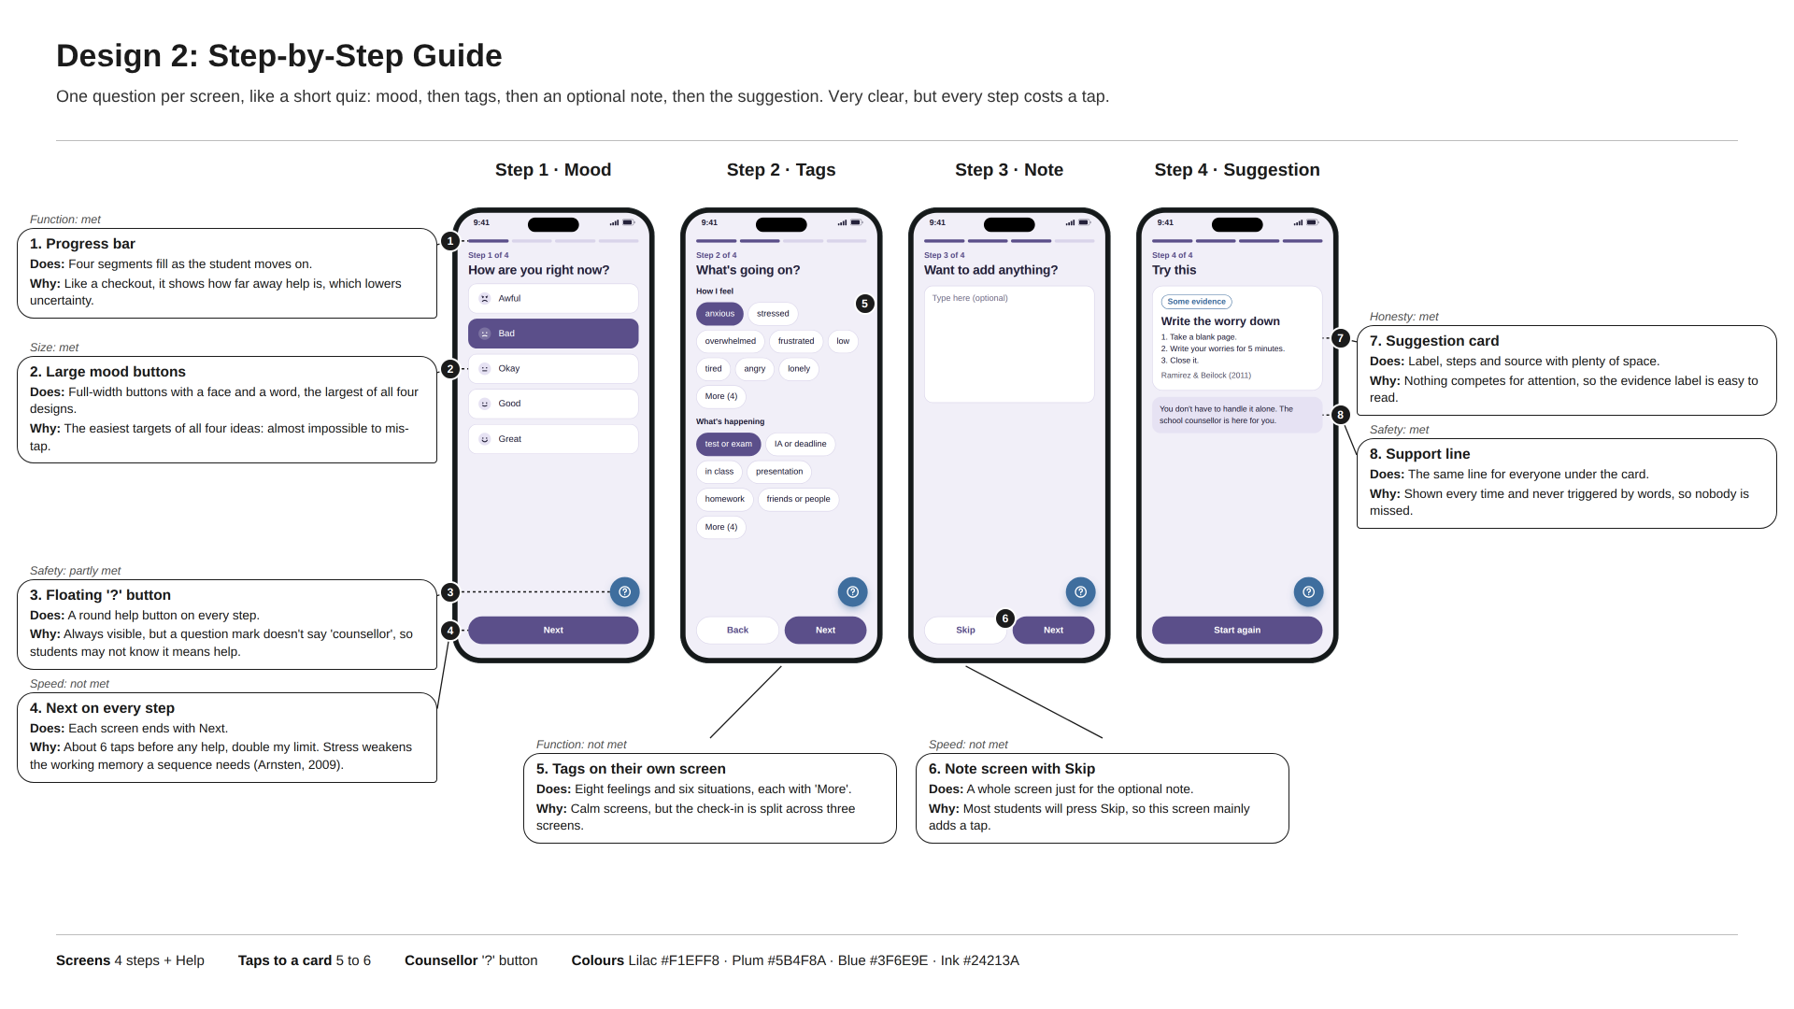
Figure B4: Design 2: Step-by-Step Guide (Canva).
Mock scenarios
Scenario | What the student does | Taps | Result
Before a mock exam | Bad, Next, anxious, Next, Skip, Next. | 6 taps | Write the worry down. There is no detail step, so 'panicky' can't be given and breathing is not offered first. Partly met.
Stuck in a lesson | Okay, Next, frustrated, in class, Next, Skip, Next. | 7 taps | A silent card is shown, but it takes seven taps in a lesson. Met, slowly.
Low for weeks | Bad, Next, low, More, home, Next, Skip, Next. | 8 taps | Message someone you trust. There is no 'how long' option, so the counsellor is not first. Not met.
No word fits | Okay, Next, More, something else, presentation, Next, Skip, Next. | 8 taps | The 'no feeling picked' card for a test situation. Met.

Evaluation against my specifications
ACCESSFMM | Specification (B.i) | How this design meets it | Result
Aesthetics | Calm and consistent look | Lilac and plum on every step with the same rounded buttons. It is the calmest-looking idea, with plenty of empty space on each screen. | Met
 | Aesthetics score | The calmest look of the four. | 1/1
Cost | Free to build and free to use | Free tools, no account and no adverts. | Met
 | Cost score | Nothing to pay for. | 1/1
Customer / Client | Fits both MYP and DP students | The tag step shows eight feelings and six situations, with 'More' for the rest, so both MYP and DP pressures are available. | Met
 | Allowed in class | Silent, and moving between steps is instant with no animation. | Met
 | Customer / Client score | All options available on the tag step. | 2/2
Environment | Works fast on school Wi-Fi | Each step is a small text screen and matching runs once on the phone. | Met
 | Lightweight text | System font only, so 0 KB of fonts. | Met
 | Environment score | Light and quick. | 2/2
Safety | Counsellor button on every screen | The round '?' button is visible on every step without scrolling, but it never says 'counsellor'. Testers took a median of 9 s to work out that it meant help. | Partly met
 | 'You're not alone' line for everyone | The support line sits under the card on Step 4, for everyone. | Met
 | Private by design | Nothing is saved unless history is switched on, and no step shows past entries. | Met
 | Nothing unsafe for minors | No AI and no social features. | Met
 | Safety score | Strong on privacy and the support line, but the help button is unlabelled. | 3/4 (1 partly)
Size | Fits every school screen | Each step fits every screen from a small phone to a laptop without sideways scrolling. | Met
 | Easy to tap and read | The mood buttons and chips are the largest of all four ideas, and no text is below the minimum size. | Met
 | Size score | The best sizes of all four ideas. | 2/2
Form and Function | Hybrid check-in on one screen | Mood, tags and note are on three separate screens, so the check-in is not on one screen. | Not met
 | A matched coping suggestion | Uses the same mapping table, run once after Step 3. | Met
 | Fast enough to use under stress | 5 to 6 taps and a median of 22 s to reach a card, about double my limit. | Not met
 | Honest about the evidence | The card has room for the evidence label and source at full size. | Met
 | Form and Function score | Clear and honest, but split over three screens and far too slow. | 2/4
Manufacturing | Built in a browser in about 20 hours | Four simple views with a step counter, well within 20 hours. | Met
 | Easy to extend later | Cards and words are kept in the content file; only a brand new question would need a new step screen. | Met
 | Manufacturing score | Simple to build and extend. | 2/2
Materials | Free, licensed and traceable | Free tools, system font and my own text, all traceable. | Met
 | Materials score | All traceable. | 1/1
Total |  | 16 of 19 specifications met, 1 partly met and 2 not met. | 16/19

Design 3: Scripted Chat (no AI)
Design 3 was inspired by Wysa's friendly chat style. I kept the feeling of a conversation but removed the AI: every message is written in advance and the student answers by tapping reply chips, so nothing is generated and nothing reads what they type. Because chips have to fit across a phone, only four options can be shown per question, plus 'Something else'.
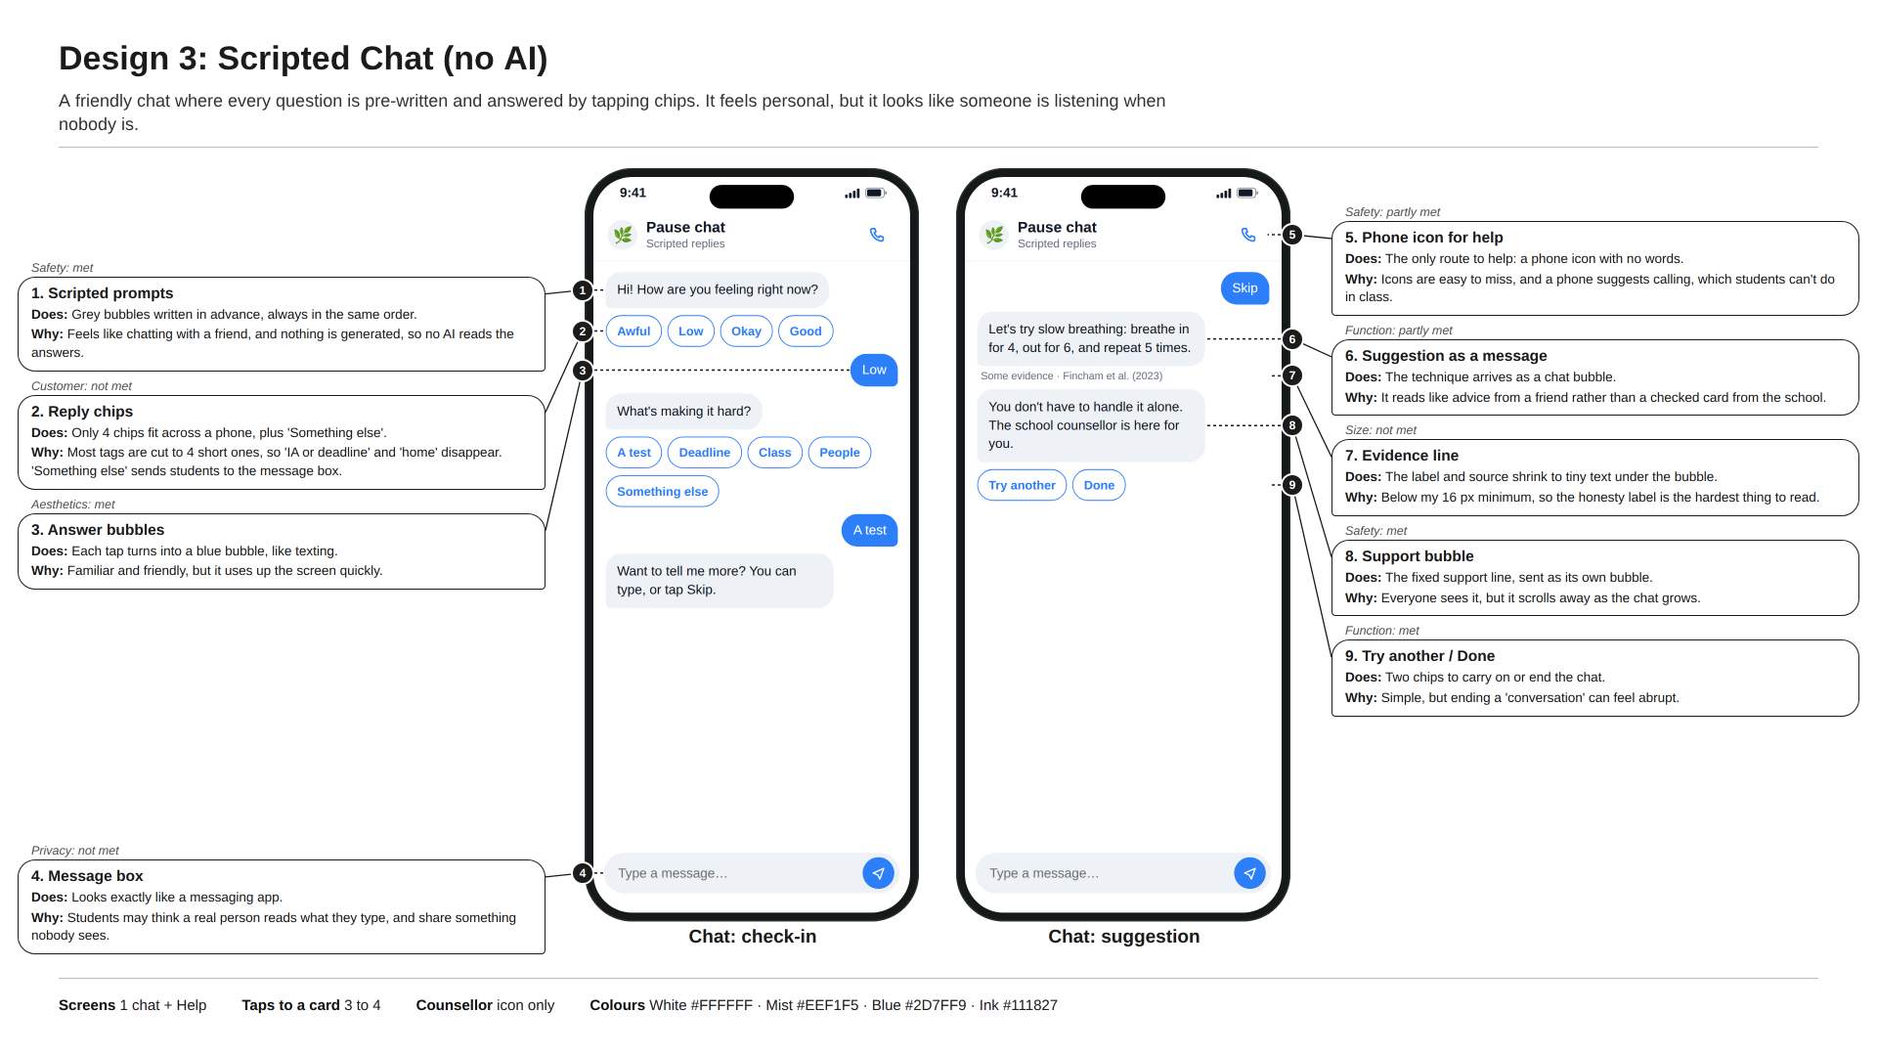
Figure B5: Design 3: Scripted Chat (no AI) (Canva).
Mock scenarios
Scenario | What the student does | Taps | Result
Before a mock exam | Taps Awful (there is no 'Bad'), A test. | 2 taps | Awful puts the counsellor first instead of the breathing card the student needed. Partly met.
Stuck in a lesson | Taps Okay, Class. | 2 taps | A silent card is shown. Met.
Low for weeks | Taps Low, Something else. | 2 taps | There is no 'home' option; the message box opens and looks like someone will reply. Not met.
No word fits | Taps Okay, Something else. | 2 taps | The same message box, and no card until the student skips. Partly met.

Evaluation against my specifications
ACCESSFMM | Specification (B.i) | How this design meets it | Result
Aesthetics | Calm and consistent look | White and bright blue used consistently, but it looks like any messaging app rather than a calm space made for this. | Met
 | Aesthetics score | Consistent, though generic. | 1/1
Cost | Free to build and free to use | Free tools, no account and no adverts. | Met
 | Cost score | Nothing to pay for. | 1/1
Customer / Client | Fits both MYP and DP students | Only four chips fit across a phone, so 'IA or deadline', 'home' and most of the extra options are cut. 'Something else' just sends students to the message box. | Not met
 | Allowed in class | Tapping chips is silent and there is no typing animation. | Met
 | Customer / Client score | Allowed in class, but too few chips for DP students. | 1/2
Environment | Works fast on school Wi-Fi | Text bubbles only; matching runs on the phone. | Met
 | Lightweight text | System font only. | Met
 | Environment score | Light and quick. | 2/2
Safety | Counsellor button on every screen | A phone icon with no label is the only route to help. It is always visible, but testers took 7 s to find it and some thought it would start a call. | Partly met
 | 'You're not alone' line for everyone | The support line arrives as its own bubble for everyone. | Met
 | Private by design | Nothing is stored on a server, but the message box makes it look as if someone reads what is typed, which works against students feeling private. | Partly met
 | Nothing unsafe for minors | No AI: every message is written in advance. | Met
 | Safety score | The support bubble works, but the help icon and the message box both weaken safety. | 2/4 (2 partly)
Size | Fits every school screen | The chat column fits every screen from a small phone to a laptop. | Met
 | Easy to tap and read | The evidence label and source shrink below the minimum text size under each bubble, the hardest part of the screen to read. | Not met
 | Size score | Fits every screen, but the evidence text is too small. | 1/2
Form and Function | Hybrid check-in on one screen | Mood, tags and note all happen in one chat, but spread down a growing thread rather than on one screen. | Partly met
 | A matched coping suggestion | Uses the same mapping table once the chips are answered. | Met
 | Fast enough to use under stress | 3 to 4 taps and a median of 17 s, just over the 15 s limit. | Partly met
 | Honest about the evidence | Each card still shows a label and source, although in very small text. | Met
 | Form and Function score | Matched cards, but the chat format slows it down and spreads the check-in out. | 2/4 (2 partly)
Manufacturing | Built in a browser in about 20 hours | Buildable in 20 hours as a scripted conversation tree. | Met
 | Easy to extend later | Every new card needs its own branch of scripted messages, so extending it means rewriting parts of the script. | Partly met
 | Manufacturing score | Feasible, but every new card means more script. | 1/2 (1 partly)
Materials | Free, licensed and traceable | Free tools, system font and my own text, all traceable. | Met
 | Materials score | All traceable. | 1/1
Total |  | 12 of 19 specifications met, 5 partly met and 2 not met. | 12/19

Design 4: Check-in Card + Result
Design 4 combines the speed of Design 1 with the calm of Design 2. One check-in screen holds a mood (the only required part), six feelings and six situations with 'More', and an optional note. Once a feeling is picked, 'Tell us more' opens an optional sheet over the same screen for an exact word, how strong and how long. One tap on 'Show me something that might help' opens a single coping card. The counsellor button is labelled in words and sits in the same place on every screen, like Wysa's always-visible SOS button.
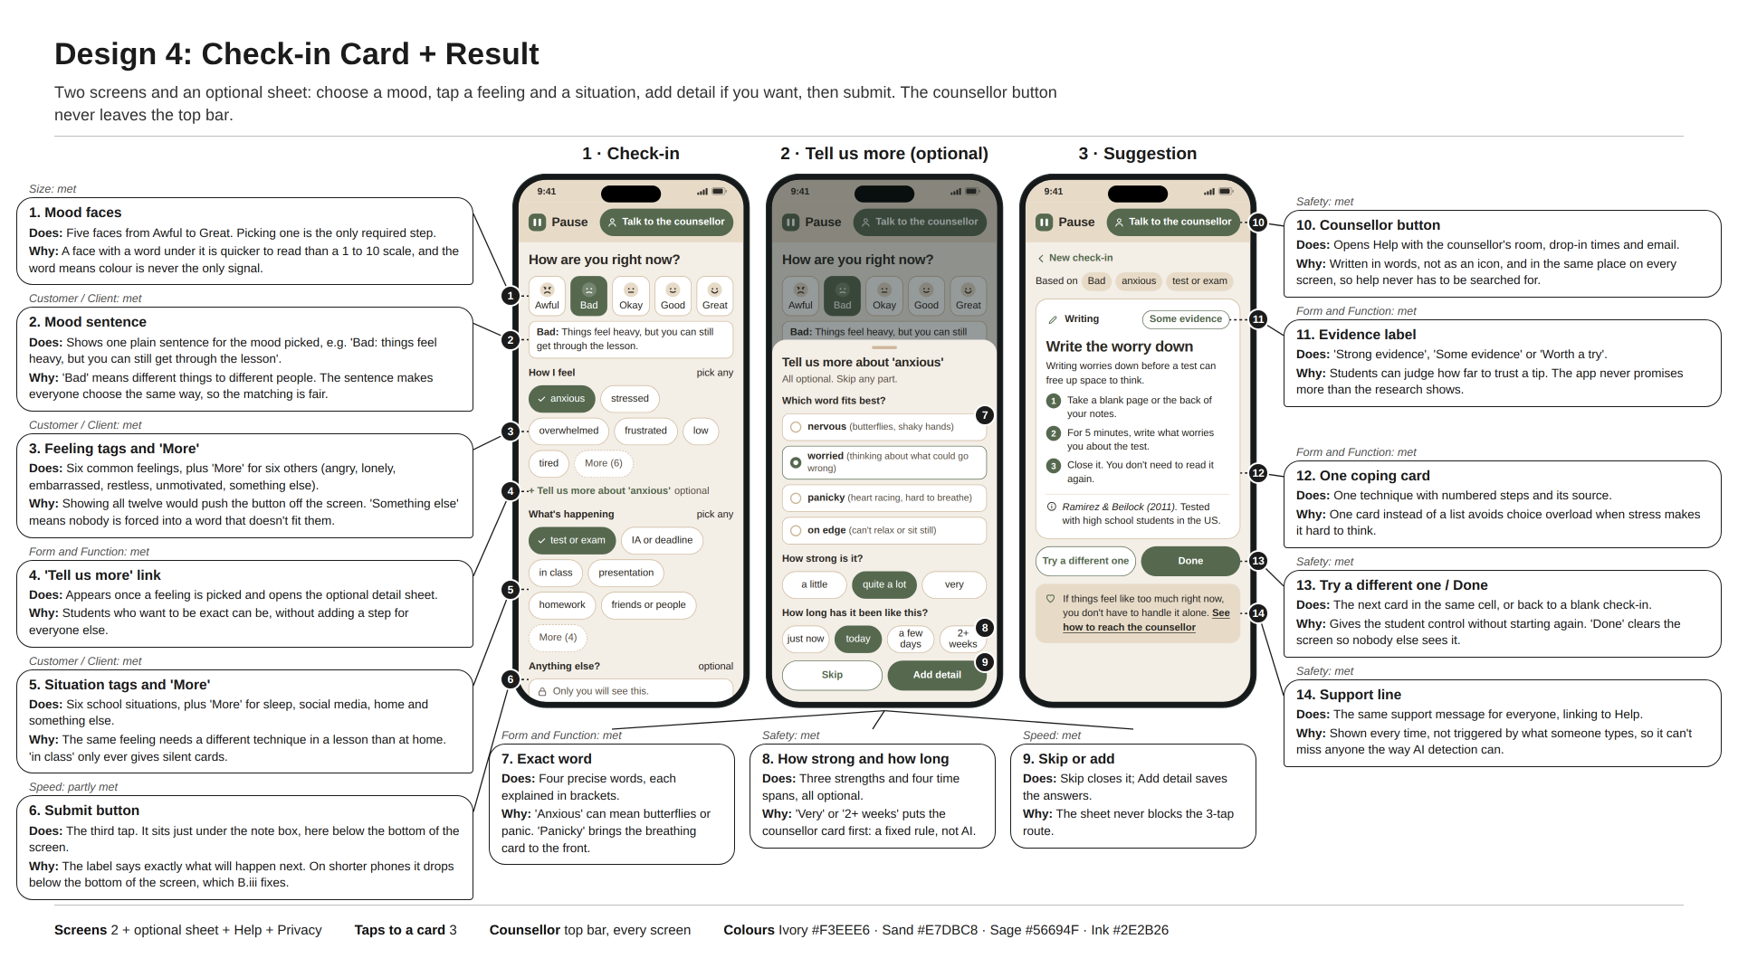
Figure B6: Design 4: Check-in Card + Result (Canva).
Mock scenarios
Scenario | What the student does | Taps | Result
Before a mock exam | Bad, anxious, Tell us more: panicky, test or exam, submit. | 3 taps + 2 optional | Slow breathing first. Met.
Stuck in a lesson | Okay, frustrated, in class, submit. | 4 taps | Slow breathing, which can be done silently. Met.
Low for weeks | Bad, low, Tell us more: 2+ weeks, More, home, submit. | 4 taps + 2 optional | Talk to the counsellor first, with the stronger message. Met.
No word fits | Okay, More, something else, presentation, submit. | 5 taps | The 'no feeling picked' card for a test situation: Slow breathing. Met.

Evaluation against my specifications
ACCESSFMM | Specification (B.i) | How this design meets it | Result
Aesthetics | Calm and consistent look | Ivory, sand and one sage green, used the same way on every screen, with rounded corners and no red, even on the danger box. | Met
 | Aesthetics score | Calm and consistent on every screen. | 1/1
Cost | Free to build and free to use | Free tools and free hosting, with no login, paywall or adverts. | Met
 | Cost score | Nothing to pay for. | 1/1
Customer / Client | Fits both MYP and DP students | Six feelings and six situations are shown, with twelve and ten in total behind 'More', plus an optional detail sheet. Students from MYP4 to DP2 can describe what is going on as precisely as they want. | Met
 | Allowed in class | No sound, vibration or animation, and 'in class' only ever gives silent cards. The teacher rated it 5/5 for use in a lesson. | Met
 | Customer / Client score | More options and optional detail, and safe in class. | 2/2
Environment | Works fast on school Wi-Fi | Text only, and matching runs on the phone, so the card appears straight away after the first load. | Met
 | Lightweight text | System font, so 0 KB of fonts are downloaded. | Met
 | Environment score | Light and quick. | 2/2
Safety | Counsellor button on every screen | A 'Talk to the counsellor' button sits in the fixed top bar on every screen, including behind the detail sheet. Testers found it in a median of 2 s. | Met
 | 'You're not alone' line for everyone | The same support box appears under every card, and a stronger version appears when the student picks 'very' or '2+ weeks'. | Met
 | Private by design | History is off by default, and the note and any typed 'something else' word are never read or sent anywhere. | Met
 | Nothing unsafe for minors | Fixed mapping table only, and the counsellor approves every card and every safety rule before launch. | Met
 | Safety score | The only design to meet all four Safety specifications. | 4/4
Size | Fits every school screen | Fits every screen from a small phone to a laptop, and on laptops the content stays in a narrow centred column. | Met
 | Easy to tap and read | Every button and chip meets the minimum tap size and no text is below the minimum size, including in the detail sheet. | Met
 | Size score | All targets and text meet the minimums. | 2/2
Form and Function | Hybrid check-in on one screen | Mood scale, tags and note are all on one check-in screen, and the detail sheet opens over it rather than as a new screen. | Met
 | A matched coping suggestion | The mapping table plus the detail rules picks the card, and every possible output can be checked by hand. | Met
 | Fast enough to use under stress | Three taps meets the limit and the median was 11 s, but on shorter phones the submit button is just below the bottom of the screen, so some students have to scroll once. | Partly met
 | Honest about the evidence | Every card shows a one-line reason, an evidence label and its source. | Met
 | Form and Function score | One screen, matched and honest; only speed on short phones is partly met. | 3/4 (1 partly)
Manufacturing | Built in a browser in about 20 hours | Two screens and a sheet, the fewest custom parts of the four ideas. | Met
 | Easy to extend later | Every word, including the new options and detail words, lives in the content file, so new cards or Arabic need no new screens. | Met
 | Manufacturing score | Easy to build and to extend. | 2/2
Materials | Free, licensed and traceable | Free tools, system font and my own text, all recorded in the asset register. | Met
 | Materials score | All traceable. | 1/1
Total |  | 18 of 19 specifications met, 1 partly met and 0 not met. | 18/19

Can the ideas be understood without me explaining them?
I gave the four boards to 4 peers who had not seen the project, pointed at a screen, and asked them what each numbered part does. All 4 described every part correctly on Designs 2 and 4, and 3 of 4 did on Design 1. On Design 3, 3 of the 4 thought the message box meant a real person would reply. That is the same safety risk the counsellor later raised (Appendix B3).

iii. Present the chosen design and justify its selection
Out of the four ideas, I chose Design 4: Check-in Card + Result. It was not the most popular idea in the peer vote, so I want to be clear about why it won. It meets 18 of my 19 specifications and partly meets the other one, more than any other idea, and it is the only idea that meets all four Safety specifications. It was also the only idea to give the correct result in all four mock scenarios. Both of my clients, the school counsellor and the teacher, rated it 5 out of 5. In the paper test, students found the counsellor in a median of 2 seconds, against 7 to 14 seconds for the other ideas.
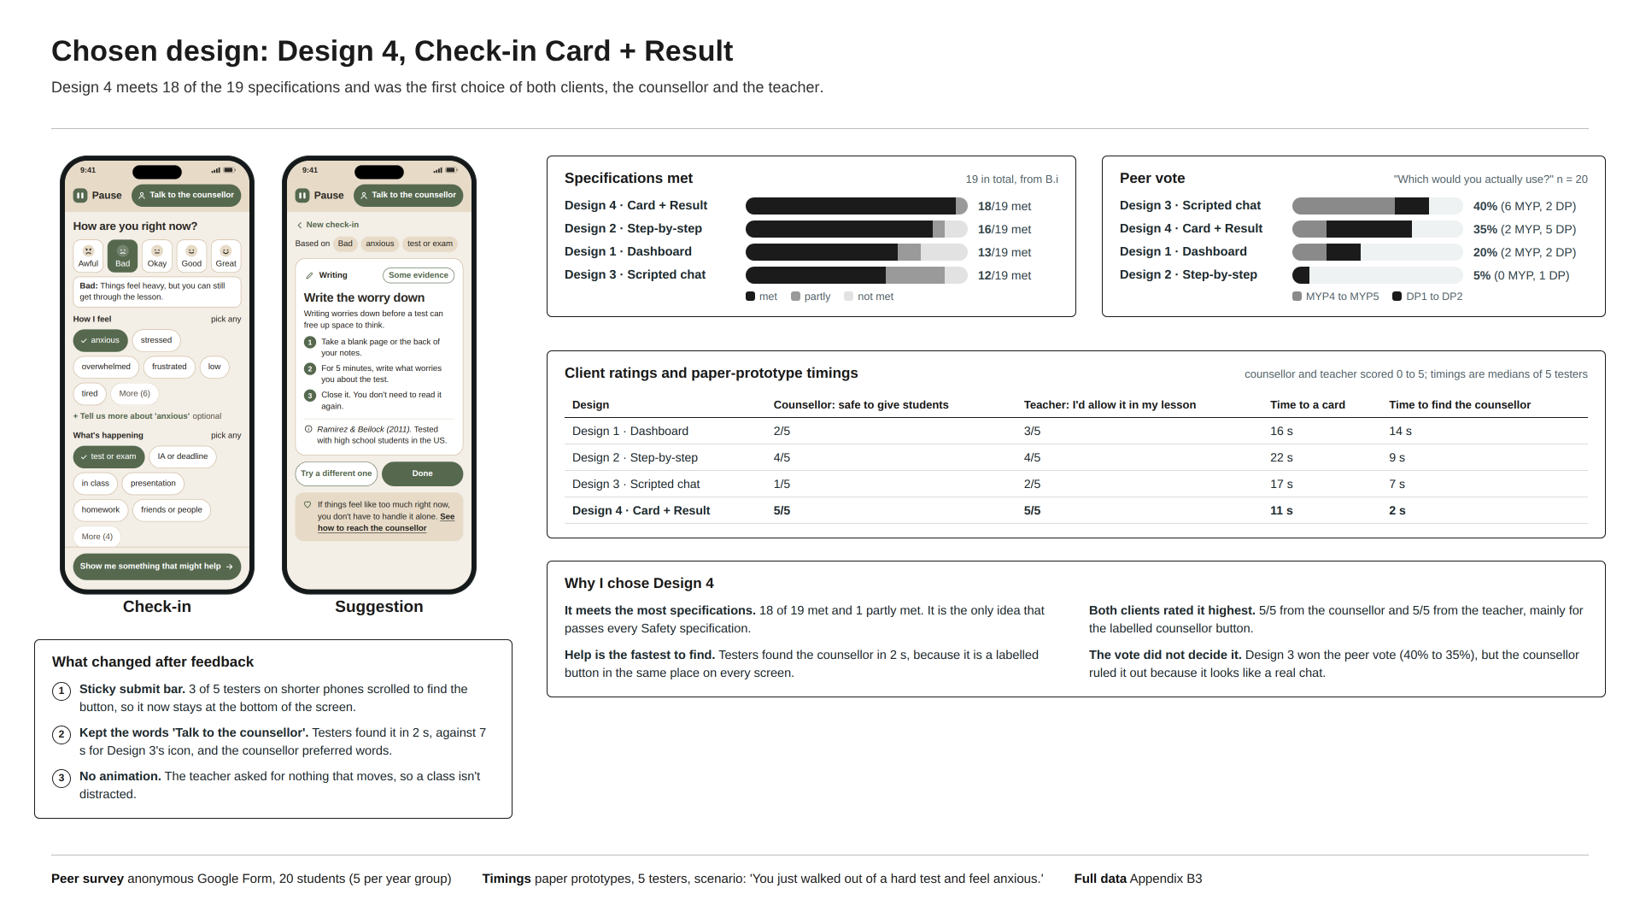
Figure B7: Chosen design: final screens, scores and feedback (Canva).
How I collected feedback
I used four kinds of evidence, so that no single opinion could decide the outcome. First, the specification scores from B.ii. Second, an anonymous Google Form answered by 20 students (5 each from MYP4, MYP5, DP1 and DP2), who saw the four boards in a random order and chose the one they would actually use when stressed at school. Third, a paper-prototype test with 5 testers: I gave them a scenario card ('You just walked out of a hard test and feel anxious') and timed how long it took to reach a card and then to find the counsellor. Finally, my two clients scored the boards from 0 to 5: the counsellor on whether each was safe to give to students, and the teacher on whether they would allow it in a lesson. The raw results are in Appendix B3.
Comparing the four designs
ACCESSFMM | Design 1 | Design 2 | Design 3 | Design 4
Aesthetics | 1/1 | 1/1 | 1/1 | 1/1
Cost | 1/1 | 1/1 | 1/1 | 1/1
Customer / Client | 2/2 | 2/2 | 1/2 | 2/2
Environment | 2/2 | 2/2 | 2/2 | 2/2
Safety | 1/4 (1 partly) | 3/4 (1 partly) | 2/4 (2 partly) | 4/4
Size | 1/2 | 2/2 | 1/2 | 2/2
Form and Function | 2/4 (1 partly) | 2/4 | 2/4 (2 partly) | 3/4 (1 partly)
Manufacturing | 2/2 | 2/2 | 1/2 (1 partly) | 2/2
Materials | 1/1 | 1/1 | 1/1 | 1/1
Total met | 13/19 | 16/19 | 12/19 | 18/19

Design 2 comes second on total, but where each idea loses marks matters more than how many. Their failures are in Safety and Size, which I treat as non-negotiable for an app used by minors during the school day. A design that hides the counsellor link below the fold is not safe enough, however fast it is. Design 4's only 'partly' is speed on short phones, which can be fixed without changing the idea.
Design | Features and justification | Reason for rejection | Evidence
Design 4 (chosen) | Three taps on one screen; labelled counsellor button on every screen; history off by default; easiest to extend. | N/A | 18/19 met. Counsellor 5/5, teacher 5/5. Counsellor found in 2 s.
Design 1 | Lets students describe the feeling in their own words. | No mood scale; typing took 16 s; counsellor link only at the very bottom of the page; tap targets too small; history visible on shared laptops. | 13/19 met. Counsellor 2/5. Counsellor found in 14 s, the slowest.
Design 2 | Clearest screens and largest targets; my second choice. | 5 to 6 taps over three screens; 22 s to reach a card, the slowest. | 16/19 met. Counsellor 4/5, teacher 4/5.
Design 3 | Friendly and familiar; the peer favourite (40%). | Looks like someone is reading; drops two MYP/DP tags; evidence label too small to read. | 12/19 met. Counsellor 1/5.

Why the counsellor's view outweighed the peer vote
Design 3 won the peer vote with 40%, just ahead of Design 4 with 35%. Most of its votes came from MYP students (6 of 8), who said it felt 'like texting a friend'. The counsellor rated it 1 out of 5: 'If it looks like someone is listening, a student might type something serious and wait for a reply that never comes.' I gave the counsellor's view more weight. Criterion A names the counsellor as the person who receives any escalation and decides whether a tool is safe for students, and a design that invites disclosures nobody reads goes against two of my Safety specifications.
The peer vote still mattered. DP students clearly preferred Design 4 (5 of 10 votes), which connects to my related concept of perspective: MYP and DP students want different things from the same app. Design 4 was the one option both age groups and both clients could accept. The teacher put it simply: 'The one with everything on one card is the only one I could see a student finishing before I notice. No moving parts, please.'
Which design is easiest to keep developing
I plan to keep working on Pause after this unit, so I also compared how much work it would take to add more cards or an Arabic version. Design 4 is the easiest: a new card is one entry in the content file and one line in the matching table, and Arabic is a second set of text plus a right-to-left setting, with no new screens. Design 3 would need a new branch of scripted messages for every card, Design 2 gets longer with every new question, and Design 1's page would grow even further below the fold.
What I changed after feedback
• Sticky submit bar. 3 of the 5 testers were using shorter phones and had to scroll to find the submit button, so in B.iv the button sits in a bar fixed to the bottom of the check-in screen. This turns Design 4's one 'partly' into 'met'.
• Kept the words 'Talk to the counsellor'. Testers found the labelled button in 2 s, against 7 s for Design 3's icon, and the counsellor said: 'Students don't always know what an icon means.'
• No animation at all. The teacher said anything that moves would draw attention in a lesson.
Limits of this decision. All of this feedback was on wireframes and paper prototypes, not a working app, and the groups were small (20 students and 5 testers). In Criterion D I will repeat the timing and counsellor-finding tests on the real build.

iv. Develop accurate and detailed planning drawings and outline the requirements for the creation of the chosen solution
This section is my plan for building Pause, written so that someone who has never spoken to me could build the same app. Each planning drawing in Canva is drawn to scale on a 360 x 800 phone screen and labelled. The tables below follow the drawings and list, for every feature, what it does, its colour and its font.
Colours and fonts
Colour or font | Where it is used
Ivory #F3EEE6 | Background of every screen. A warm off-white that is softer than pure white on a bright phone.
Sand #E7DBC8 | Top bar, the small tags on the suggestion screen, and the support box.
Sage #56694F | Buttons, selected moods and chips, and links. White text on Sage is easy to read.
Ink #2E2B26 | All text. A warm near-black, so it sits with the beige tones.
Tan #CDB79A | Thin outlines around chips, mood buttons and boxes. Never used for text.
Font | The phone's own system font (Roboto on Android, San Francisco on iPhone), so nothing has to download. Titles and the question are bold; everything else is regular.

Two rules apply to every screen, both from my B.i Size specifications: no text is smaller than 16 px, and every button or chip is at least 44 x 44 px so it is easy to tap (W3C, 2024). Every text and background pair above passes the WCAG AA contrast check (W3C, 2024).
Planning drawing 1: Check-in screen
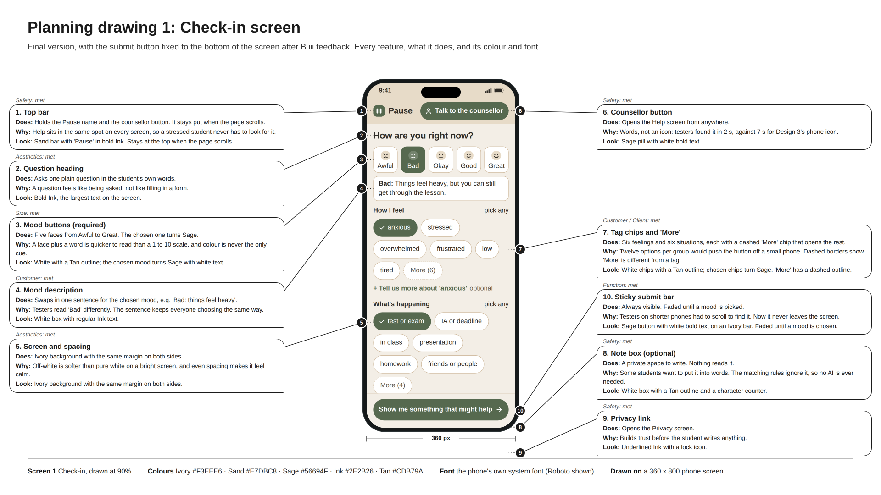
Figure B8: Planning drawing 1, check-in screen (Canva).
Feature | Function | Colour and font
Top bar | Shows the name Pause and the counsellor button. It stays at the top of every screen, even when the page scrolls. | Sand background; Pause in bold Ink
'Talk to the counsellor' button | Opens the Help screen with the counsellor's details. It is written in words, not shown as an icon, so nobody has to guess what it does. | Sage with white bold text
Question | 'How are you right now?' tells the student what to do first. | Bold Ink
Mood buttons | Five faces from Awful to Great, each with its word underneath. Choosing a mood is the only required step, and it unlocks the submit button. | White with a Tan outline; the chosen mood turns Sage with white text
Mood sentence | Appears under the moods once one is picked and explains it in one line, for example 'Bad: things feel heavy, but you can still get through the lesson.' | White box, regular Ink
Feeling chips and 'More' | Six common feelings are shown. 'More' opens the other six, including 'something else', where a student can type their own word. That word is saved only for them and is never read by the app. | White with a Tan outline; chosen chips turn Sage with a tick. 'More' has a dashed outline
'Tell us more' link | Appears once a feeling is chosen and opens the optional detail sheet (Planning drawing 2). Students who skip it lose nothing. | Sage text, with 'optional' in Ink
Situation chips and 'More' | Six school situations, with four more behind 'More'. Choosing 'in class' means only cards that can be done silently at a desk are shown. | As the feeling chips
Note box | Optional space to write a few words. The note is never used to choose a card and is only saved if history is switched on. | White box with a Tan outline
Privacy link | Opens the Privacy screen. | Underlined Ink with a lock icon
Submit button | 'Show me something that might help' sits in a bar fixed to the bottom of the screen, so it never drops out of view on short phones. It is faded until a mood is picked. | Sage with white bold text, on an Ivory bar

Planning drawing 2: 'Tell us more' detail sheet
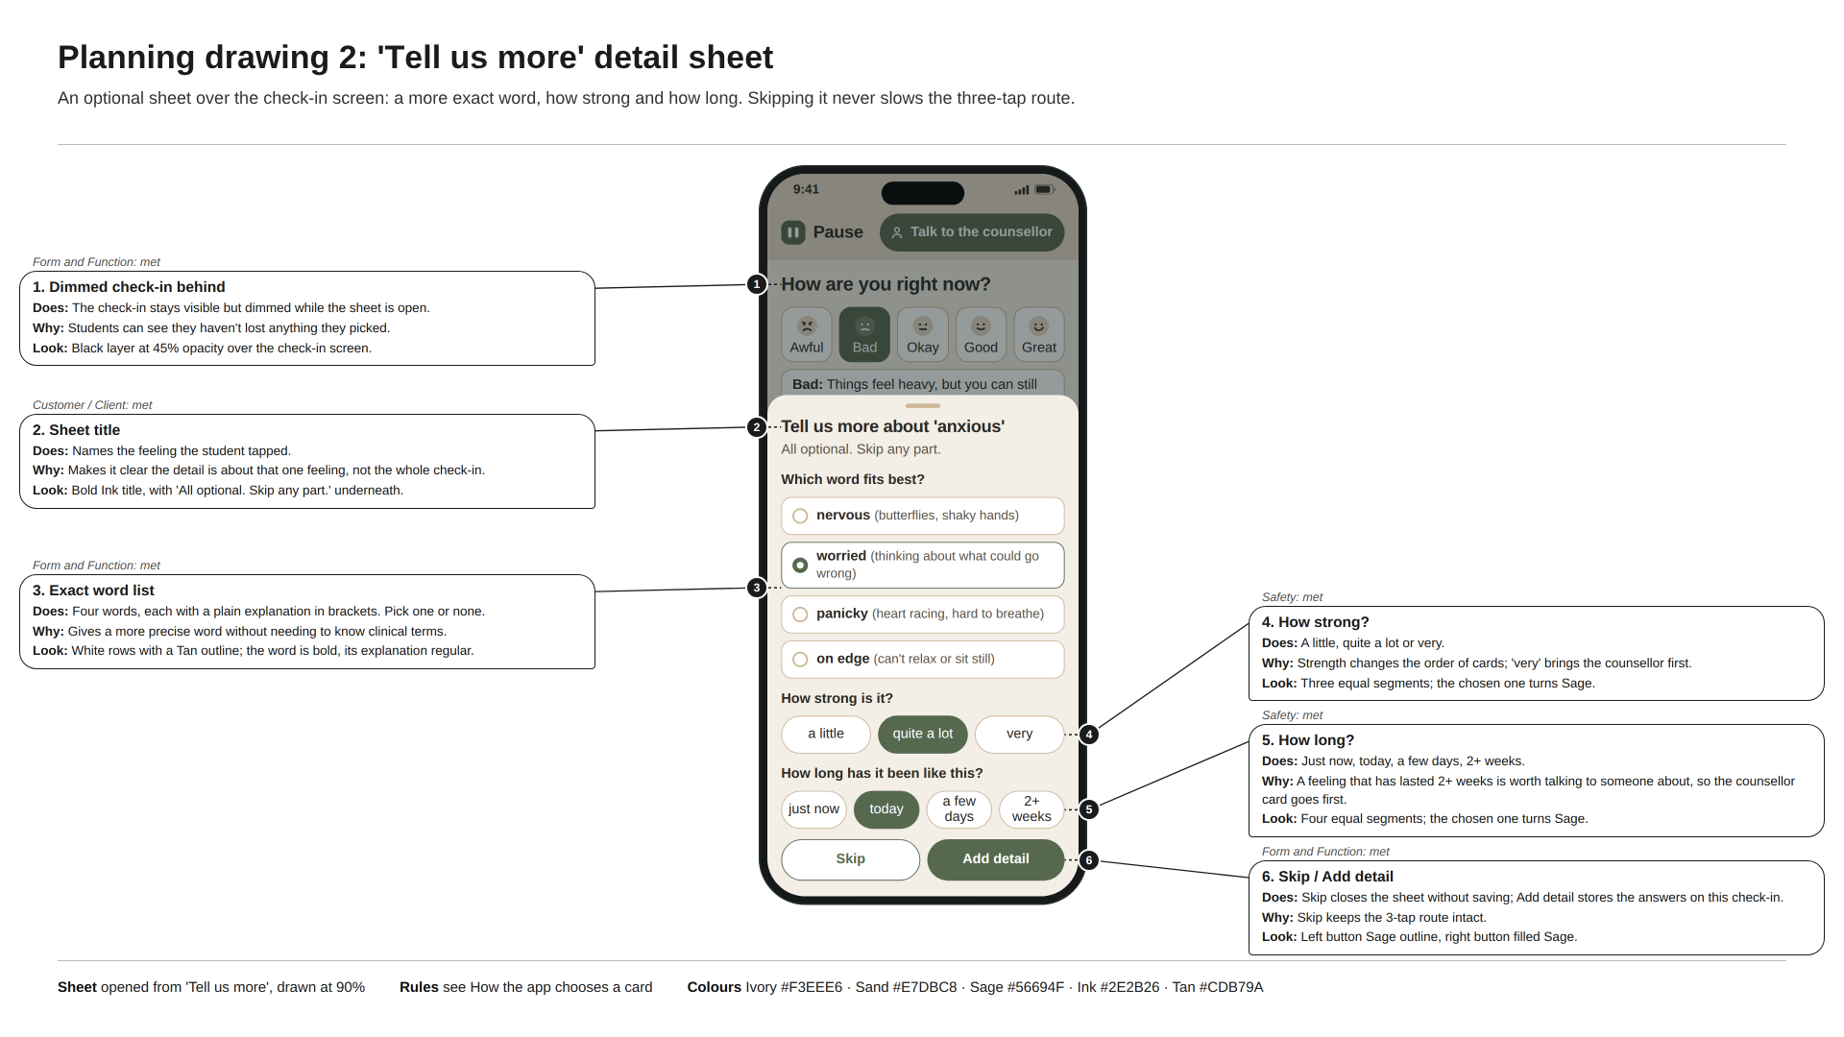
Figure B9: Planning drawing 2, optional detail sheet (Canva).
Feature | Function | Colour and font
Dimmed check-in | The check-in stays visible but darker behind the sheet, so students can see they haven't lost anything. Tapping it closes the sheet. | Ink at 45% opacity
Sheet title | Names the feeling the student picked, for example 'Tell us more about anxious', and says that every question is optional. | Bold Ink
Exact words | Four more precise words for the feeling, each with a plain explanation in brackets, for example 'panicky (heart racing, hard to breathe)'. A student can pick one or none. | White rows with a Tan outline; the chosen row has a Sage outline
How strong | 'a little', 'quite a lot' or 'very'. Choosing 'very' puts the counsellor card first. | White segments; the chosen one turns Sage
How long | 'just now', 'today', 'a few days' or '2+ weeks'. Choosing '2+ weeks' also puts the counsellor card first. | As above
Skip and Add detail | Skip closes the sheet without saving. Add detail saves the answers to this check-in. | Sage outline and filled Sage buttons

Planning drawing 3: Suggestion screen
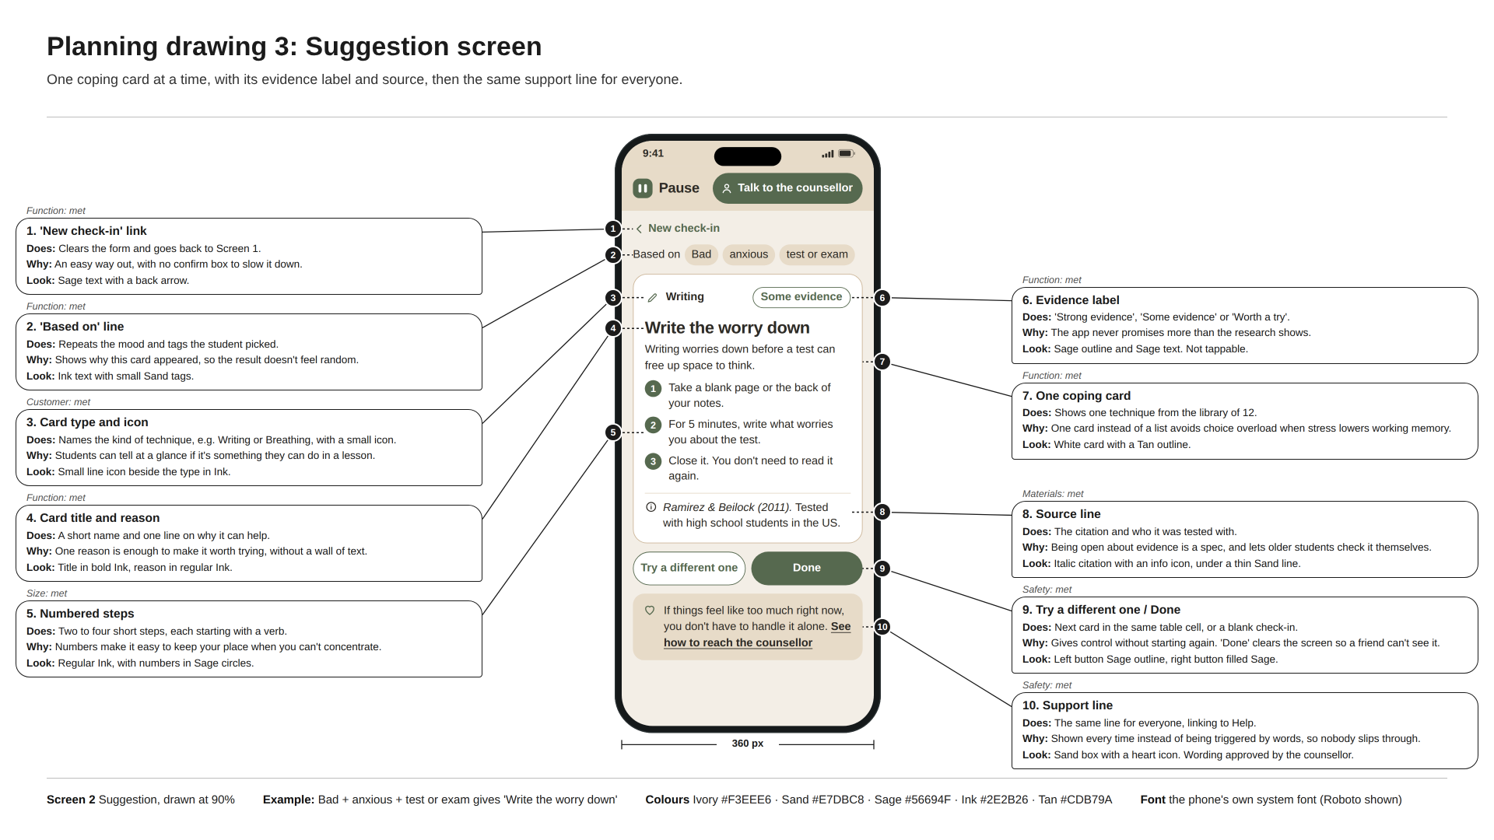
Figure B10: Planning drawing 3, suggestion screen (Canva).
Feature | Function | Colour and font
'New check-in' link | Clears everything and goes back to the check-in screen. | Sage text with an arrow
'Based on' line | Shows the mood, feeling and situation that chose this card, so the student can see why they got it. | Ink text with small Sand tags
Coping card | One technique only, so a stressed student doesn't have to choose from a list. | White card with a Tan outline
Technique type | A small icon and word such as 'Breathing' or 'Writing'. | Ink
Evidence label | 'Strong evidence', 'Some evidence' or 'Worth a try', so the student knows how far to trust the tip. | Sage outline and Sage text
Name and steps | The technique's full name, one line on why it can help, and two to four numbered steps. | Bold Ink name; numbers in Sage circles
Source | The study or guide the card is based on, and who it was tested with. | Italic Ink
'Try a different one' and 'Done' | 'Try a different one' shows the next card for the same answers (only silent cards in class). 'Done' clears the screen so nobody else sees it. | Sage outline and filled Sage buttons
Support box | The same message for everyone, with a link to Help. If the student chose 'very' or '2+ weeks', a stronger message approved by the counsellor is shown. | Sand box with a heart icon

Planning drawing 4: Help and Privacy screens
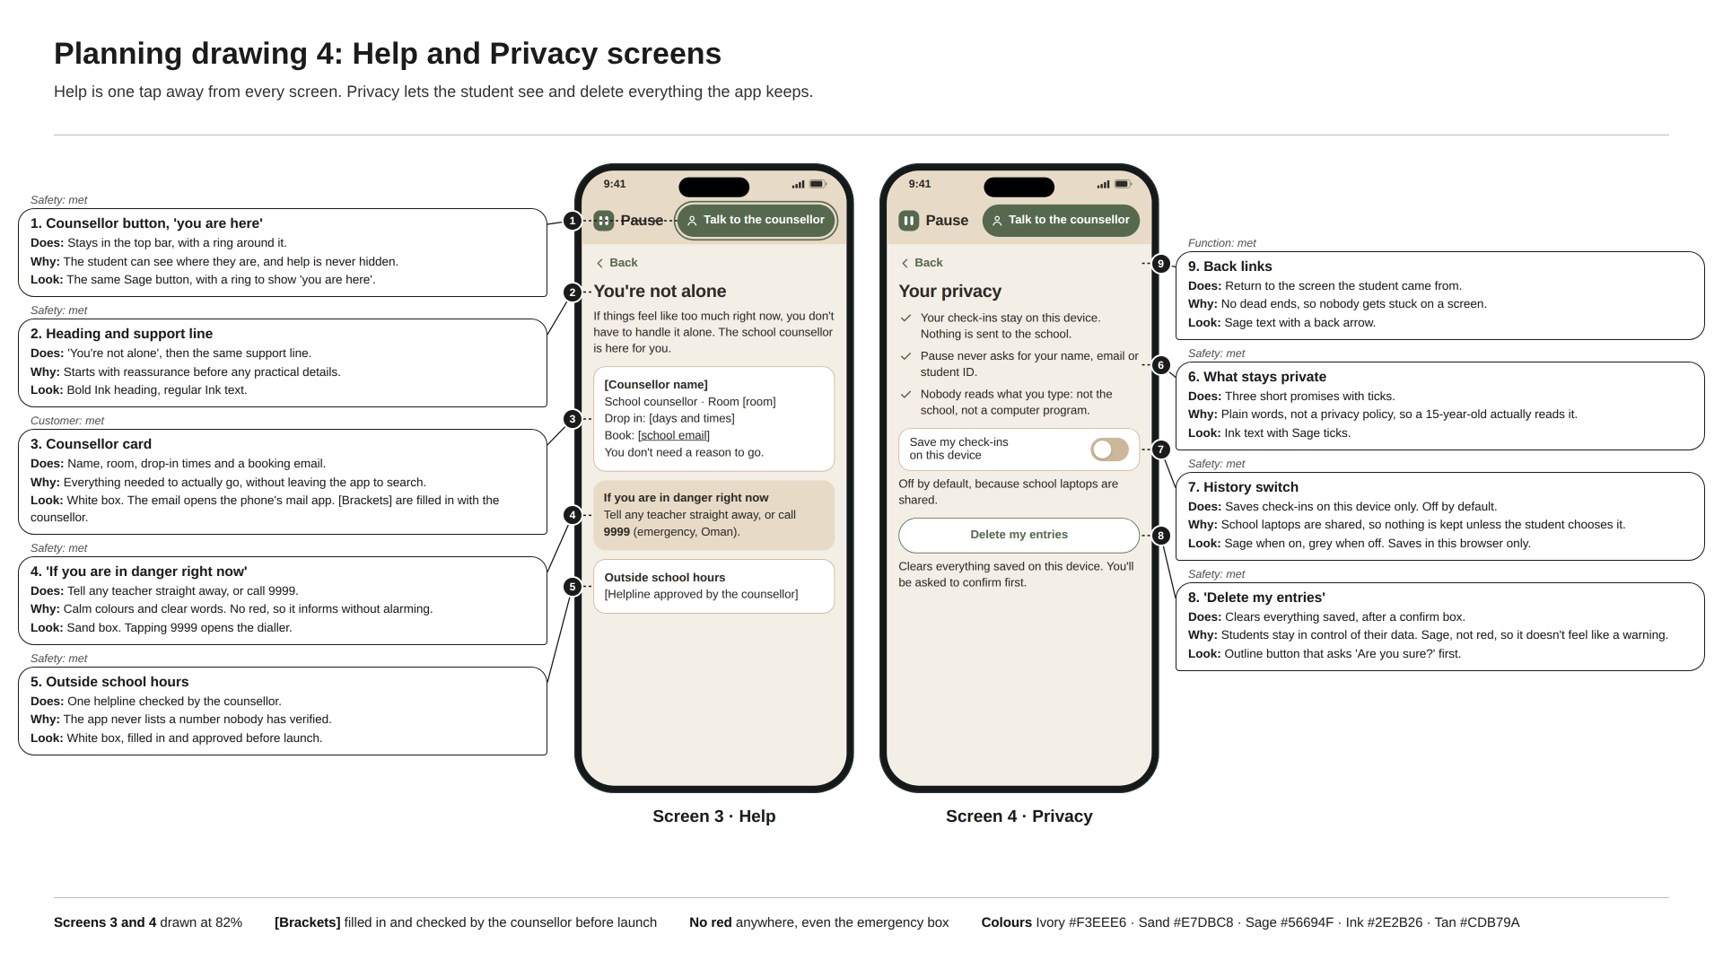
Figure B11: Planning drawing 4, Help and Privacy screens (Canva).
Feature | Function | Colour and font
Counsellor details | The counsellor's name, room, drop-in times and a button that opens an email to them. The counsellor fills these in and approves them before launch. | White box with a Tan outline
'If you are in danger right now' box | Tell any teacher straight away, or call 9999 (emergency services in Oman). Tapping the number opens the phone's dialler. | Sand box, bold Ink heading
Outside school hours | One helpline chosen and checked by the counsellor. Nothing unchecked is listed. | White box
Privacy promises | Three plain sentences: check-ins stay on this device, nobody reads what you type, and nothing is sent anywhere. | Ink text with ticks
History switch | Off by default. If it is turned on, check-ins are saved in this browser only. | Sage when on, grey when off
'Delete my entries' | Asks 'Delete all saved check-ins on this device? This can't be undone.' and then clears them. | Outline button

The support message reads: 'If things feel like too much right now, you don't have to handle it alone. The school counsellor is here for you.' I checked the wording against Orygen's #chatsafe guidelines (Orygen, n.d.).
User flow
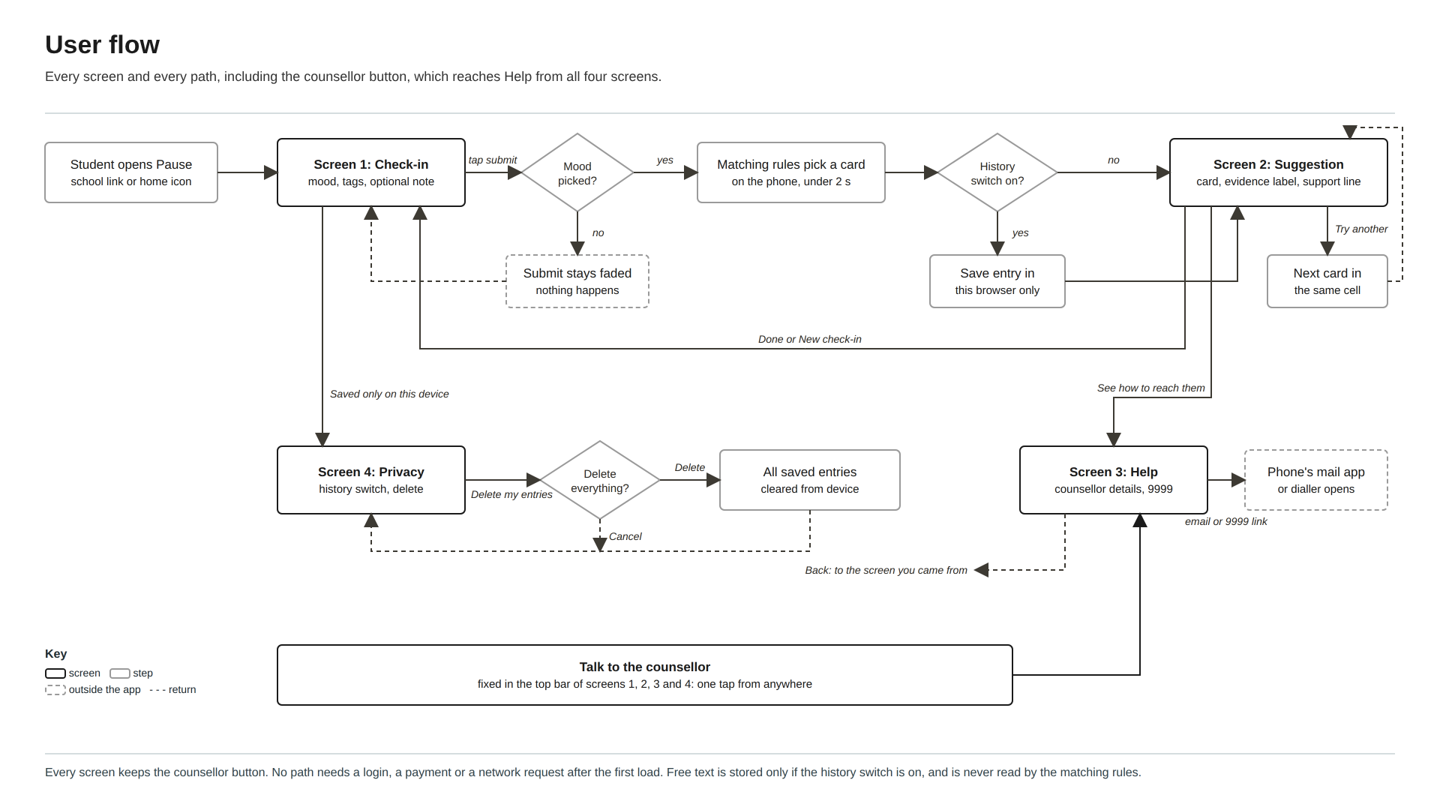
Figure B12: User flow showing every screen and path (Canva).
Every screen has the counsellor button, so Help is always one tap away. The only required input is the mood. No path asks for a login or a payment. Two links leave the app on purpose: the counsellor's email, which opens the phone's mail app, and 9999, which opens the dialler.
How the app chooses a card
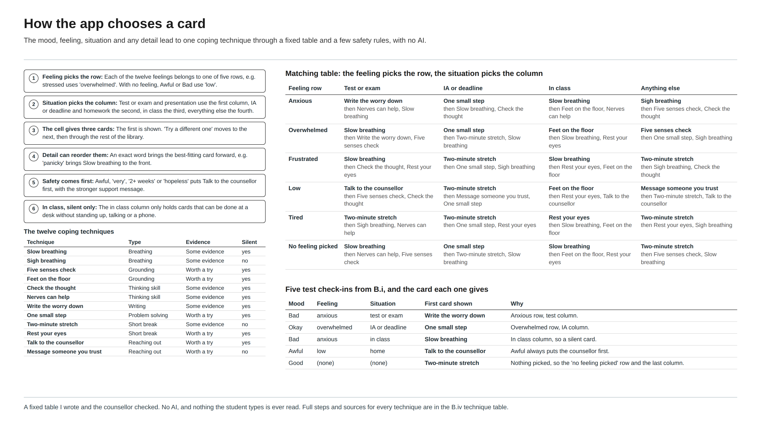
Figure B13: How a check-in becomes one coping card (Canva).
Pause does not use AI. It uses a fixed table that I wrote and the counsellor checked, so every possible answer can be traced by hand to the card it gives. The app follows these steps:
• Feeling picks the row. Each of the twelve feelings belongs to one of five rows: anxious, overwhelmed, frustrated, low or tired. For example, 'stressed' uses the overwhelmed row and 'lonely' uses the low row. If no feeling is picked, a mood of Awful or Bad uses the low row and any other mood uses the 'no feeling picked' row.
• Situation picks the column. The ten situations fall into four columns: test or exam, IA or deadline, in class, and everything else.
• The cell gives three cards in order. The first is shown, and 'Try a different one' moves to the next.
• The detail sheet can change the order. An exact word moves the card that fits it best to the front, for example 'panicky' brings Slow breathing forward.
• Safety comes first. If the mood is Awful, or the student chose 'very', '2+ weeks' or 'hopeless', Talk to the counsellor goes first and the stronger support message is shown.
• In class, only silent cards. Cards that involve standing up or using a phone are skipped.
Feeling row | Test or exam | IA or deadline | In class | Anything else
Anxious | Write the worry down, then Nerves can help, then Slow breathing | One small step, then Slow breathing, then Check the thought | Slow breathing, then Feet on the floor, then Nerves can help | Sigh breathing, then Five senses check, then Check the thought
Overwhelmed | Slow breathing, then Write the worry down, then Five senses check | One small step, then Two-minute stretch, then Slow breathing | Feet on the floor, then Slow breathing, then Rest your eyes | Five senses check, then One small step, then Sigh breathing
Frustrated | Slow breathing, then Check the thought, then Rest your eyes | Two-minute stretch, then One small step, then Sigh breathing | Slow breathing, then Rest your eyes, then Feet on the floor | Two-minute stretch, then Sigh breathing, then Check the thought
Low | Talk to the counsellor, then Five senses check, then Check the thought | Two-minute stretch, then Message someone you trust, then One small step | Feet on the floor, then Rest your eyes, then Talk to the counsellor | Message someone you trust, then Two-minute stretch, then Talk to the counsellor
Tired | Two-minute stretch, then Sigh breathing, then Nerves can help | Two-minute stretch, then One small step, then Rest your eyes | Rest your eyes, then Slow breathing, then Feet on the floor | Two-minute stretch, then Rest your eyes, then Sigh breathing
No feeling picked | Slow breathing, then Nerves can help, then Five senses check | One small step, then Two-minute stretch, then Slow breathing | Slow breathing, then Feet on the floor, then Rest your eyes | Two-minute stretch, then Five senses check, then Slow breathing

The twelve coping techniques. Each card shows one evidence label, decided by three rules. 'Strong evidence' means backed by systematic reviews or clinical guidelines for this kind of use. 'Some evidence' means backed by trials that were small, mixed, or not with teenagers. 'Worth a try' means low risk and widely recommended, with little direct research. No card earned 'Strong evidence', because the strong reviews tested full courses or regular habits, not one technique used for a minute during the school day.
Technique | What it is | Steps on the card | Evidence
Slow breathing  Breathing | Breathing out for longer than you breathe in, which helps the body slow down. | 1. Breathe in through your nose for a count of 4.  2. Breathe out slowly through your mouth for a count of 6.  3. Repeat 5 times (about 1 minute). | Some evidence  Fincham et al. (2023). Meta-analysis of trials with adults; small to medium effects, and the authors ask for better-quality trials.
Sigh breathing  Breathing  Not shown in class | Two quick breaths in through the nose, then one long breath out, like a deep sigh. | 1. Breathe in through your nose.  2. At the top, take one more short sip of air.  3. Breathe out slowly and fully through your mouth.  4. Repeat for 1 to 5 minutes. | Some evidence  Balban et al. (2023). One month-long online trial with adults.
Five senses check  Grounding | Bringing your attention back to the room by naming things you can see, feel, hear, smell and taste. | 1. Name 5 things you can see.  2. Name 4 things you can feel and 3 you can hear.  3. Name 2 things you can smell and 1 you can taste. | Worth a try  World Health Organization (2020). Recommended in a WHO self-help guide; this exact version has not been tested on its own.
Feet on the floor  Grounding | Pressing your feet and hands down to feel steady and present. | 1. Slowly push your feet into the floor.  2. Press your palms together or onto the desk.  3. Notice the chair holding you up.  4. Look around and name where you are. | Worth a try  World Health Organization (2020). Recommended in a WHO self-help guide; not tested on its own with teenagers.
Check the thought  Thinking skill | Testing a worrying thought against the evidence, a core skill from cognitive behavioural therapy (CBT). | 1. Write the worrying thought in one line.  2. Ask: what is the evidence for it, and against it?  3. Ask: what would I tell a friend who thought this?  4. Write a fairer version of the thought. | Some evidence  Hofmann et al. (2012). CBT was tested as full courses, usually with a therapist, not as a single card.
Nerves can help  Thinking skill | Seeing a racing heart before a test as your body getting ready, not as a sign you will fail. | 1. Notice the racing heart or butterflies.  2. Tell yourself: 'This is my body getting ready.'  3. Take one slow breath and start. | Some evidence  Jamieson et al. (2010). One study with US students preparing for the GRE.
Write the worry down  Writing | Writing your worries about a test on paper for a few minutes so they take up less space in your head. | 1. Take a blank page or the back of your notes.  2. For 5 minutes, write what worries you about the test.  3. Close it. You don't need to read it again. | Some evidence  Ramirez & Beilock (2011). Tested with high school and university students in the US.
One small step  Problem solving | Splitting a task that feels too big into small pieces and starting only the first one. | 1. Write the whole task in one line.  2. Split it into 3 small pieces.  3. Do only the first piece for 10 minutes. | Worth a try  World Health Organization (2024). The WHO lists problem-solving skills as protective; this exact method was not tested.
Two-minute stretch  Short break  Not shown in class | A short break to stand, stretch and refill your water before going back to work. | 1. Stand up and stretch your arms and shoulders.  2. Walk to refill your water bottle.  3. Come back and start with the easiest part. | Some evidence  Albulescu et al. (2022). Mostly adults at work or in lab tasks; small effects.
Rest your eyes  Short break | A 20-second pause to look into the distance and loosen your shoulders, jaw and hands. | 1. Look at something far away for 20 seconds.  2. Roll your shoulders back twice.  3. Unclench your jaw and hands. | Worth a try  Albulescu et al. (2022). Based on the micro-break review; this exact version was not tested.
Talk to the counsellor  Reaching out | Getting in touch with the school counsellor, who you can see without needing a reason. | 1. Tap 'Talk to the counsellor' at the top.  2. See when you can drop in, or send a booking email.  3. You don't need a reason to go. | Worth a try  World Health Organization (2024). General WHO guidance, not a trial of this app.
Message someone you trust  Reaching out  Not shown in class | Sending a short message to a friend, family member or teacher you feel safe with. | 1. Pick one person: a friend, a parent or another adult you trust.  2. Send one line, like 'Rough day, can we talk later?'  3. You don't have to explain everything. | Worth a try  World Health Organization (2024). General WHO guidance, not a trial of this app.

How the parts connect
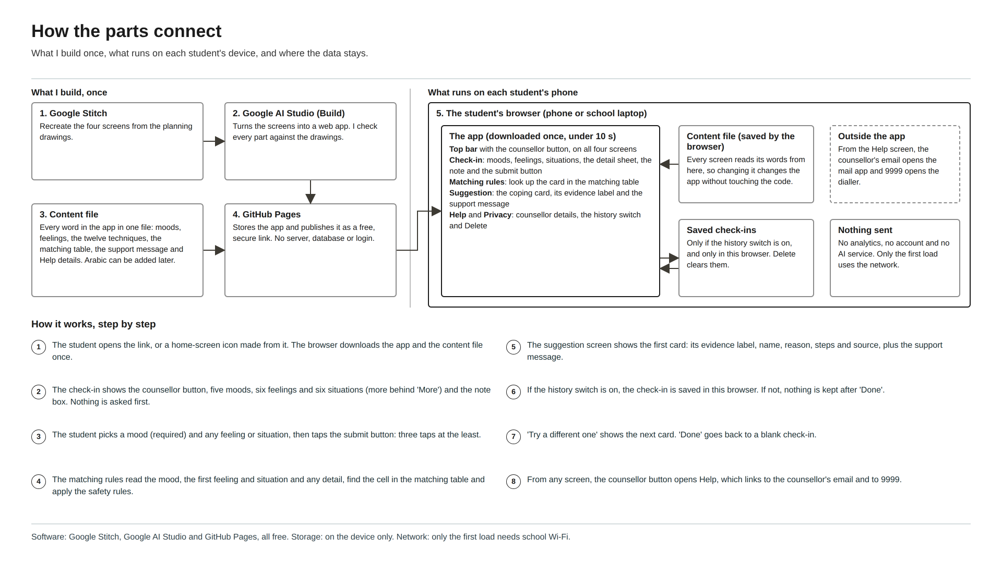
Figure B14: What I build, what runs on each phone, and where data stays (Canva).
Part | What it does
Screens | Check-in (with the detail sheet), Suggestion, Help and Privacy. The top bar with the counsellor button is shared by all four.
Content file | One file holds every word in the app: moods, feelings, situations, the twelve cards, the support message, the Help details and the matching table. Adding a card or an Arabic version means editing this file, not the screens.
Matching rules | Runs on the phone, takes the mood, feeling, situation and any detail, and returns the cards in order. It never connects to the internet and uses no AI.
Saved data | With history off, the default, nothing is kept after 'Done'. With history on, each check-in saves the time, mood, chosen feelings and situations, any detail, the note and the name of the card shown, in this browser only. 'Delete my entries' clears all of it.

How I will build it, step by step
Step | What I will do
1. Plan the screens (2 h) | In Google Stitch, recreate the four screens from Planning drawings 1 to 4 using the colours and fonts above.
2. Generate the app (4 h) | In Google AI Studio, build a React app from the Stitch screens, with the top bar shared between them. Check every colour and size against the drawings.
3. Add the content (3 h) | Write the content file from the card table, the mood, feeling and situation guides (Figures B1 and B2) and the matching table, and make every screen read its words from it.
4. Add the matching rules (2 h) | Turn the steps in 'How the app chooses a card' into code, then check that the four mock scenarios each give the card listed in B.ii.
5. Add saving and Privacy (2 h) | Add the history switch (off by default) and 'Delete my entries' with its confirm box.
6. Counsellor sign-off (1 h) | Show the counsellor the Help screen, the support messages and all twelve cards, and make their changes.
7. Publish (1 h) | Put the code on GitHub and turn on GitHub Pages to get a free, secure link.
8. Test against B.i (5 h) | Run every B.i test on three school devices and at phone, tablet and laptop widths, including contrast, text size, timing with 5 peers and the privacy test.

Total: 20 hours, which matches my Manufacturing specification.
Requirements for creating the solution
Requirement | What is needed | Why
Software | Google Stitch and Google AI Studio (free, in the browser), plus Chrome, Safari and Edge for testing. | Free tools that need no installing, so I can work on school laptops.
Hardware | A laptop for building, and three school devices for testing: a Windows laptop, a Chromebook or Mac, and a phone. | Students will open Pause on whatever device they have, so it has to be tested on each kind.
Internet | Needed to build and publish. Students only need school Wi-Fi to open the link the first time. | After the first load, the check-in and matching run on the phone.
Accounts | A Google account for Stitch and AI Studio, and a GitHub account for hosting. Students need no account. | No login before check-in is one of my specifications.
Testing tools | The browser's inspect tool, the WebAIM Contrast Checker, a stopwatch and my B.i test sheets. | To check every specification with evidence, not by eye.
Content | The card text, written from the sources in my reference list, and an asset register recording where every icon and word came from. | Materials specification: everything must be free and traceable.
Skills | Basic React, editing the content file, checking AI-generated code, safe-messaging wording and APA referencing. | I will practise these during Criterion C.
Approvals | The counsellor approves the Help details, both support messages and all twelve cards before launch. The school allows the link on its Wi-Fi and agrees students may open it in lessons. | Pause points students to real people and does not replace the counsellor.

Final check: could someone else build Pause from these plans?
Question | Answer
Every screen and feature | Yes: Planning drawings 1 to 4 and their tables.
Every colour and font | Yes: the 'Colours and fonts' table.
Every path between screens | Yes: the user flow (Figure B12).
What every mood, feeling and situation means | Yes: Figures B1 and B2.
How answers become a card | Yes: the matching steps, the matching table and the twelve techniques.
What is saved, and where | Yes: 'How the parts connect'.
Tools, accounts and build order | Yes: the build steps and requirements tables.
Who must approve what | Yes: Approvals (counsellor sign-off and school permission).

Appendix B1: Client and peer feedback used in my specifications
Peer survey | Anonymous Google Form, 20 students (5 each from MYP4, MYP5, DP1 and DP2), run during form time.  Most common stress triggers (students could pick more than one): tests or exams 16/20, IA or deadlines 13/20, presentations 7/20, friends 6/20, home 4/20.  15/20 would stop using an app that took more than about 30 seconds. 12/20 wanted somewhere to write freely. 14/20 said apps that look like a hospital or clinic put them off.
Counsellor interview | 20-minute interview with the school counsellor.  Students most often come to see her after mock exams and near IA deadlines. She does not want anything that reads or analyses what students write, and wants to approve every piece of help wording and contact detail. She said some MYP students would be more comfortable in Arabic.
Teacher conversation | Short conversation with one MYP teacher.  They would allow the app in a lesson only if it is completely silent and quick: 'If it makes a sound, I'd have to ban it.'

Appendix B2: Questions I asked
Peer survey questions | 1. Which year are you in? (MYP4 / MYP5 / DP1 / DP2)  2. When do you feel most stressed at school? (tick all: tests or exams, IA or deadlines, presentations, friends, home, other)  3. If an app took longer than ___ to help you, you'd stop using it. (10 s / 30 s / 1 min / 2 min+)  4. Would you want a place to write freely, or only tap options? (write / tap / both)  5. Rate how much an app that looks like a hospital or clinic would put you off (0 to 5).
Counsellor interview questions | 1. When do students most often come to you, and about what?  2. What should an app like this never do?  3. What should the Help screen say, and which contact details should it show?  4. Which coping techniques are you comfortable with the app suggesting?  5. Would an Arabic version help students here?
Teacher question | 'Would you allow a student to open this during your lesson? What would make you say no?'

Appendix B3: Feedback on the design ideas
Peer vote (n = 20) | Design 3: 8 (6 MYP, 2 DP). Design 4: 7 (2 MYP, 5 DP). Design 1: 4 (2 MYP, 2 DP). Design 2: 1 (0 MYP, 1 DP).  Most common reasons: Design 3 'feels like texting a friend' (6); Design 4 'quick and nothing extra' (5); Design 1 'everything on one page' (3).
Paper-prototype test (n = 5) | Median time to reach a card: Design 1, 16 s; Design 2, 22 s; Design 3, 17 s; Design 4, 11 s.  Median time to find how to contact the counsellor: Design 1, 14 s; Design 2, 9 s; Design 3, 7 s; Design 4, 2 s.  3 of 5 testers on shorter phones had to scroll to find Design 4's submit button.
Counsellor | Ratings for 'Is this safe to give to students?': Design 1, 2; Design 2, 4; Design 3, 1; Design 4, 5.  'The chat one worries me. If it looks like someone is listening, a student might type something serious and wait for a reply that never comes.'  'I like that the button says counsellor. Students don't always know what an icon means.'
Clarity check (n = 4) | Peers who had not seen the project explained each numbered part of each board. Correct for every part: Design 1, 3 of 4; Design 2, 4 of 4; Design 3, 1 of 4 (3 thought the message box meant a real person would reply); Design 4, 4 of 4.
Teacher | Ratings for 'Would you allow this in your lesson?': Design 1, 3; Design 2, 4; Design 3, 2; Design 4, 5.  'The one with everything on one card is the only one I could see a student finishing before I notice. No moving parts, please.'

References
Albulescu, P., Macsinga, I., Rusu, A., Sulea, C., Bodnaru, A., & Tulbure, B. T. (2022). "Give me a break!" A systematic review and meta-analysis on the efficacy of micro-breaks for increasing well-being and performance. PLOS ONE, 17(8), Article e0272460. https://doi.org/10.1371/journal.pone.0272460
Arnsten, A. F. T. (2009). Stress signalling pathways that impair prefrontal cortex structure and function. Nature Reviews Neuroscience, 10(6), 410–422. https://doi.org/10.1038/nrn2648
Balban, M. Y., Neri, E., Kogon, M. M., Weed, L., Nouriani, B., Jo, B., Holl, G., Zeitzer, J. M., Spiegel, D., & Huberman, A. D. (2023). Brief structured respiration practices enhance mood and reduce physiological arousal. Cell Reports Medicine, 4(1), Article 100895. https://doi.org/10.1016/j.xcrm.2022.100895
Bentley, T. G. K., Seeber, C., Hightower, E., Mackenzie, B., Wilson, R., Velazquez, A., Cheng, A., Arce, N. N., & Lorenz, K. A. (2022). Slow-breathing curriculum for stress reduction in high school students: Lessons learned from a feasibility pilot. Frontiers in Rehabilitation Sciences, 3, 864079. https://doi.org/10.3389/fresc.2022.864079
Daylio. (n.d.). Daylio – Journal, diary and mood tracker. Google Play. Retrieved September 21, 2026, from https://play.google.com/store/apps/details?id=net.daylio
Fincham, G. W., Strauss, C., Montero-Marin, J., & Cavanagh, K. (2023). Effect of breathwork on stress and mental health: A meta-analysis of randomised-controlled trials. Scientific Reports, 13, Article 432. https://doi.org/10.1038/s41598-022-27247-y
HLTH. (2025, April 28). Woebot Health is shutting down its app. https://hlth.com/insights/news/woebot-health-is-shutting-down-its-app-2025-04-28
Hofmann, S. G., Asnaani, A., Vonk, I. J. J., Sawyer, A. T., & Fang, A. (2012). The efficacy of cognitive behavioral therapy: A review of meta-analyses. Cognitive Therapy and Research, 36(5), 427–440. https://doi.org/10.1007/s10608-012-9476-1
jacopo. (2025, November 6). The shape of sustainability: How typography influences responsible digital design. Digital Sustainability Hub – DSH | Università IULM. https://digitalsustainabilityhub.com/the-shape-of-sustainability-how-typography-influences-responsible-digital-design/
Jamieson, J. P., Mendes, W. B., Blackstock, E., & Schmader, T. (2010). Turning the knots in your stomach into bows: Reappraising arousal improves performance on the GRE. Journal of Experimental Social Psychology, 46(1), 208–212. https://doi.org/10.1016/j.jesp.2009.08.015
Orygen. (n.d.). #chatsafe: A young person’s guide for communicating safely online about self-harm and suicide (2nd ed.). Retrieved October 3, 2026, from https://orygen.org.au/Training/Resources/Self-harm-and-suicide-prevention/Guidelines/chatsafe-A-young-person-s-guide-for-communicatin
Ramirez, G., & Beilock, S. L. (2011). Writing about testing worries boosts exam performance in the classroom. Science, 331(6014), 211–213. https://doi.org/10.1126/science.1199427
World Health Organization. (2020). Doing what matters in times of stress: An illustrated guide. https://www.who.int/publications/i/item/9789240003927
World Health Organization. (2024). Mental health of adolescents. https://www.who.int/news-room/fact-sheets/detail/adolescent-mental-health
World Wide Web Consortium. (2024). Web content accessibility guidelines (WCAG) 2.2 (A. Campbell, C. Adams, R. Bradley Montgomery, M. Cooper, & A. Kirkpatrick, Eds.). https://www.w3.org/TR/WCAG22/
Wysa. (n.d.). Wysa: Mental wellbeing AI. Google Play. Retrieved September 21, 2026, from https://play.google.com/store/apps/details?id=bot.touchkin

