Revised as of January 2015

Per CSC Resolution No. 1500088 Promulgated on Janua,y 23, 2015

# SWORN STATEMENT OF ASSETS, LIABILITIES AND NET WORTH

As of December 30, 2018

(Required by R.A. 6713)

**Note:** *Husband and wife who are both public ofj"icials and employees may file the required statements jointly or separately.*

0 *Joint Filing* □ *Separate Filing* □ *Not Applicable*

**DECLARANT:** Dela Cruz Juan **M.**

(Family Name) (First Name) (M.I.)

**ADDRESS:** 1 Rizal St., Sampaloc, Manila

**POSITION: AGENCY /OFFICE: OFFICE ADDRESS:**

Clerk V

Civil Service Commission CSC Bldg., IBP Road, Batasan Hills, *Quewn* City

**SPOUSE:**

Dela Cruz Juana M. **POSITION:**

Director II

(Family Name) (First Name) (M.l.)

**AGENCY/OFFICE: OFFICE ADDRESS:**

Civil Service Commission · CSC Bldg., IBP Road

Batasan Hills, Quezon City

**UNMARRIED CHILDREN BELOW EIGHTEEN (18) YEARS OF AGE LIVING IN DECLARANT'S HOUSEHOLD**

|  |  |  |
| --- | --- | --- |
| **NAME** | **DATE OF BIRTH** | **AGE** |
| Gabriel M. dela Cruz | 1/2/2005 | 13 |
| Michael M. dela Cruz | 5/2/2010 | 9 |
| Angelica M. dela Cruz | 10/11/2017 | 2 |

N/A N/A N/A

1. **ASSETS**

**ASSETS, LIABILITIES AND NETWORTH**

*(Including those of the spouse and unmarried children below eighteen (18) years of age living in declarant's household)*

* 1. **Real Properties\***

|  |  |  |  |  |  |  |  |
| --- | --- | --- | --- | --- | --- | --- | --- |
| **DESCRIPTION** | **KIND** | **EXACT** | **ASSESSED** | **CURRENT FAIR** | **ACQUISITION** | | **ACQUISITION** |
| (e.g. lot, house and **lot, condominium and improvements)** | (e.g. residential, **commercial, industrial,** agricultural and mixed  uoel | **LOCATION** | **VALUE** | **IIARKET VALUE** |  | | **COST** |
| **(As found in the Tax Declaration of**  Real Property) | | **YEAR** | **MODE** |
| House and Lot (mart.) | Residential | 1 Rizal St., Sampaloc. Manila | *PB00,000.00* | Pl,500,000.00 | 2003 | Sale with mortgage | P5,000,000.00 |
| Building  (1/3 co-owned) | Commercial | 1 Quezon Ave.,  Tandang Sora, Cavite | Pl,200,000.00 | P2,000,000.00 | 2000 | Deed of Sale | Pl ,500,000.00 |
| Farm lot | Agricultural | Brgy. Kaligayahan, Cavite | P900.000.00 | Pl,200,000.00 | 2010 | Inherited | 0 |
| Lot | Mixed use | Santa Fe Subd.,  Brgy. Ana, Quezon City | P600,000.00 | P800,000.00 | 2008 | Deed of Sale | Pl ,300,000.00 |

**Subtotal: P7,800,000.00**

* 1. **Personal Properties\***

|  |  |  |
| --- | --- | --- |
| **DE8CRIPTJON** | **YEARACQUJRED** | **ACQUJSlnON**  **COST/AM:OUNT** |
| Condominium Unit (contract to sell) | 2015 | P500,000.00 |
| Furniture | 2000-present | P150,000.00 |
| Appliances | 2000-present | P200,000.00 |
| Shares of stock | 2013 | P50,000.00 |

**Subtotal : P3,250,000.00**

\**Additional sheet/ s may be used, if necessary.*

**TOTAL ASSETS (a+b): Pll,050,(**

1. **LIABILITIES\***

|  |  |  |
| --- | --- | --- |
| **NATURE** | **NAIIE OF CREDITORS** | **OUTSTAKDING Bo\LANCE** |
| Personal debt | Eddie dela Cruz | P800,000.00 -- |
| Housing Loan | Pag-lBIG | P2,500,000.00 |
| Contract to Sell | DMCI | Pl,000,000.00 |
| GSIS Multipurpose loan | GS!S | ?60,000.00 |

**TOTAL LIABILITIES: P4,360,000.00**

**NET WORTH : Total Assets less Total Liabilities = P6,690,000.0CI**

* *Additional sheet/* s *may be used, if necessary.*

**BUSINESS INTERESTS AND FINANCIAL CONNECTIONS**

*(of Declarant I Declarant's spouse/ Unmarried Children Below Eighteen (18) years of Age Living in Declarant's Household)*

* *II We do not have any* business *interest or financial connection.*

|  |  |  |  |
| --- | --- | --- | --- |
| **NAME OF ENTITY/BUSINB88 ENTERPRISE** | **BUSINB88 ADDRBSS** | **NATURE OF BUSINB88**  **INTEREST &/OR FINANCIAL CONNECTION** | **DATE OF ACQUISITION OF INTEREST OR CONNJecTION** |
| Sea Travel and Tours | Agapito St., Sampaloc, Manila | Owner | 2015 |
| N/A | *NIA* | *NIA* | *NIA* |
| *NIA* | N/A | *NIA* | *NIA* |
| N/A | *NIA* | *NIA* | *NIA* |

**RELATIVES IN THE GOVERNMENT SERVICE**

*(Within the Fourth Degree of Consanguinity or l\ff"m.ity. Include also Bilas, Balae and Inso)*

* *II We do not know of any relative/* s *in the government service)*

|  |  |  |  |
| --- | --- | --- | --- |
| **l'IAIIB OF RELATIVE** | **RELATIONSHIP** | **POSITION** | **NAME OF AGENCY/OFFICE AND ADDRB88** |
| Nadine Lustre | sister | Attornev *V* | Deoartment of Education, Quewn Citf |
| James Reid | **cousin** | Prooertv Officer III | Deoartment of Public Works and Highway, Pasig |
| Anne Curtis | aunt | Health Officer | Municioalitv of Bukid, Batane:as |
| *NIA* | *NIA* | *NIA* | *NIA* |
| *NIA* | *NIA* | *NIA* | *NIA* |

I hereby certify that these are true and correct statements of my assets, liabilities, net worth, business interests and financial connections, including those of my spouse and unmarried children below eighteen (18) years of age living in my household, and that to the best of my knowledge, the above­ enumerated are names of my relatives in the government within the fourth civil degree of consanguinity or affinity.

I hereby authorize the Ombudsman or his/her duly authorized representative to obtain and secure from all appropriate government agencies, including the Bureau of Internal Revenue such documents that may show my assets, liabilities, net worth, business interests and financial connections, to include those of my spouse and unmarried children below 18 years of age living with me in my household covering previous years to include the year I first assumed office in government.

Date: 03/15/2019

jjF -Jf/,:.

·•·*(Signature of Declarant)*

Government Issued ID:

ID No.:

Date Issued:

CSC ID

123456

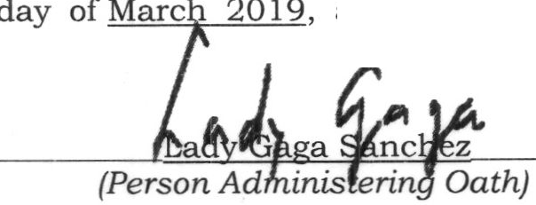01/02/2018

Government Issued ID: -=C:.::Sc..:C:_l:.::D:..

ID No.: _.::.9:::.87.:..c6:::.:5:...4:..

Date Issued: _;:_0.::.l,_/0::cS'-'-/--=2--=0--=l-'-8

**SUBSCRIBED AND SWORN** to before me this stated government issued identification card.

affiant exhibiting to me the a.hove-

Revised as of 20 I8

Per CSC Resolution No. 1500088

Promulgated on Janua1y 23, 20 I 5

# SWORN STATEMENT OF ASSETS, LIABILITIES AND NET WORTH

As of December 31, 20 18

## *(Additional sheet/ s for the declarant)*

**NAME:**  Dela Cruz Juan M.

**POSITION:**

Clerk V

(Family Name) (First Name) (M.1.) **AGENCY /OFFICE:** Civil Service Commission

1. **ASSETS**
   1. Real Properties

**ASSETS, LIABILITIES AND NET WORTH**

|  |  |  |  |  |  |  |  |
| --- | --- | --- | --- | --- | --- | --- | --- |
| **DBSCRIPTIOK** | **KI1'D** | **EXACT** | **ASSESSED** | **CURRENT FAIR** | **ACQUISfflOK** | | **ACQUISITION** |
| {e.g. lot, house and lot, condominium and improvements) | (e.g. residential, commercial, industrial,  agricultural and mixed uael | **LOCATION** | **VALUE** | **MARKET VALUE** |  | | **COS,T** |
| (As found in the Tax Declaration of Real Property) | | **YEAR** | **MODE** |
| condominium | residential | SM Prima Towers, EDSA, Mandaluyong City | Pl,000,000.00 | Pl,750,000.00 | 2016 | donation | 0 |
| N/A | N/A | N/A | N/A | N/A | N/A | N/A | N/A |
| N/A | N/A | N/A | N/A | N/A | N/A | N/A | N/A |
| N/A | N/A | N/A | N/A | N/A | N/A | N/A | N/A |

* 1. **Personal Properties**

**Subtotal:**

**P_h p O _**

--

|  |  |  |
| --- | --- | --- |
| **DE8CRIPJ10N** | **YEAR ACQUIRED** | **ACQUISl110N**  **COST/All:OOlff** |
| Jewelry | 2000-present | p 100,000.00 |
| Mitsubishi Montero | 2010 | Pl,200,000.00 |
| Hand gun (Glock) | 2012 | p 50,000.00 |
| Cash in bank | 2000- present | P 800,000.00 |
| Cash on hand | 2018 | P 200,000.00 |

1. 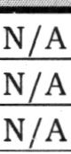**LIABILITIES**

**Subtotal** : **Php 2,350,000.00 TOTAL ASSETS (a+b): Php 2,350,**

**A Clt**

|  |  |  |
| --- | --- | --- |
| **NATURE** | **NAME OF CREDITORS**  NA | **OUTSTANDING B**  N/A |
|  | N/A | NA |
|  | N/A | N/A |

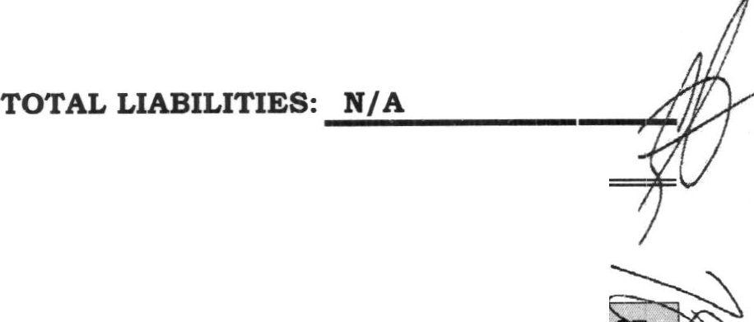

**BUSINESS INTERESTS AND FINANCIAL CONNECTIONS**

**NAIR OF Bl'fTlTY/BU811'ESS**

**BUSI1'ES8 ADDRESS**

**NATURE OF BUSDl'l!:88**

**DATE OF ACQUI8ITIUN** - ""

[\

|  |  |  |  |
| --- | --- | --- | --- |
| **BIITBRPRISB** |  | **INTEREST &/OR FINANCIAL**  **CONNECTION** | **INTEREST OR CONNECTION** f |
| *NIA* | N/A | N/A | *NIA* |
| *NIA* | *N1A* | N/A | *NIA* |
| *NIA* | N/A | N/A | *NIA* |
| *NIA* | *NIA* | *NIA* | *NIA* |

Revised as of 20 18

Per CSC Resolution No 1500088

Promulgated on Janua·:y 23, 2015

**STATEMENT OF ASSETS, LIABILITIES AND NET WORTH**

As of December 31, 2018

## *(Additional sheet/ s for the exclusive properties of the declarant's spouse and unmarried children* below eighteen ( 18) years of age living in declarant's household)

**NAME:**  Dela Cruz Juan **M. POSITION:**

Clerk 111

(Family Name) (First Name) **(M.I.)**

**AGENCY /OFFICE:**

Civil Service Commission

1. **ASSETS**
   1. **Real Properties**

**ASSETS, LIABILITIES AND NET WORTH**

|  |  |  |  |  |  |  |  |
| --- | --- | --- | --- | --- | --- | --- | --- |
| **DESCRIPTJOR** | **rmm** | **EXACT** | **ASSESSED** | **CURRENT FAIR** | **ACQUISITION** | | **ACQUISITION** |
| (e.g. lot. houae and lot. condominium and im.prm,,:mcnta) | (e.g. reaidcntlal, commercial, industrial, agricultural and mixed  uoel | **LOCATION** | **VALUE** | IIIARKET **VALUE** |  | | **COS/I'** |
| (As found in the Tax Declaration of Real Property) | | **YEAR** | **MODE** |
| lot | agricultural | Brgy. Kaligayahan, Sto. Tomas,  Batane:as | PlS0,000.00 | P2JO,OOO.OO | 2018 | donation | 0 |
| N/A | N/A | N/A | N/A | N/A | N/A | N/A | N/A |
| N/A | N/A | N/A | N/A | N/A | N/A | N/A | N/A |
| N/A | N/A | N/A | N/A | N/A | N/A | N/A | N/A |

* 1. **Personal Properties**

|  |  |  |
| --- | --- | --- |
| **DE8CRIP'l10N**  .. | **YEAR ACQUIRF.D** | **ACQtJISl11ON**  **COlff/ AllotJNT** |
| N/A | N/A | N/A |
| N/A | N/A | N/A |
| N/A | N/A | N/A |
| N/A | N/A | N/A |

1. **LIABILITIES**

|  |  |  |
| --- | --- | --- |
| **NATURE** | **NAME OF CREDITORS** | **OUTSTANDING BALANCE** |
| N/A | N/A | N/A |
| N/A | N/A | N/A |
| N/A | N/A | N/A |
| N/A | N/A | N/A |

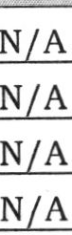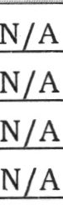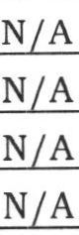**BUSINESS INTERESTS AND FINANCIAL CONNECTIONS**

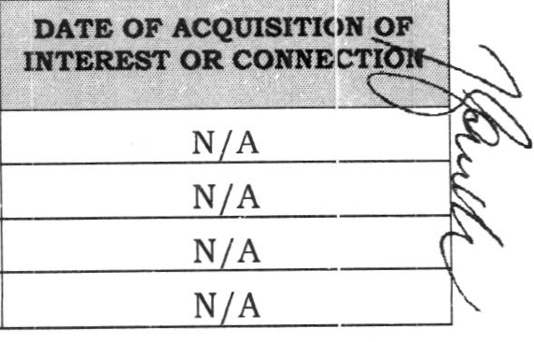

*7J*

r

|  |  |  |
| --- | --- | --- |
| **NAME OF BNTrrY/BUSI1'E8S**  **ERTBRPRISB** | **BUSI1'ESS ADDRBSS** | NATURE OF BUSINESS  INTEREST &/OR FINANCIAL CONNECTION |
|  |  |  |
|  |  |  |
|  |  |  |
|  |  |  |