Bayesian Editor Help

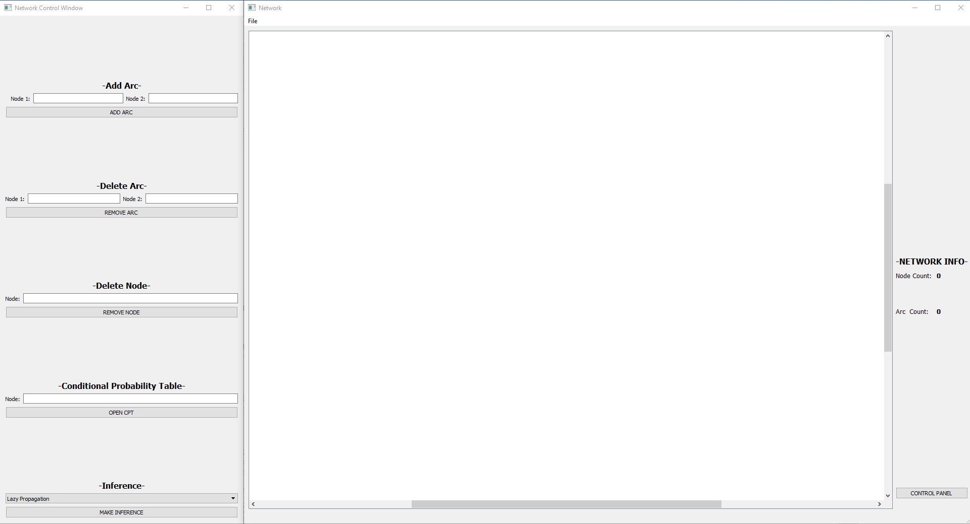

Figure 1: Bayesian Editor Layout

LAYOUT:

When first opening the project two windows appear. The left window is a control panel and the right is split into two sections, one empty white section for the network itself and another section for displaying data about the network.

Control Panel

The control panel on the left allows the user to edit numerous elements of the network, however it is not necessary for controlling the network as all the actions on the panel can be implemented using key commands in the network area.

Network Area

The white network area is where the graphical representation of the network appears. Nodes and edges are added to and deleted from this area. The user interacts directly with this window in order to add nodes and all other operations can be performed using special key commands within the network area.

Network Data Panel

The panel to the far right is the data panel. It contains the number of nodes and edges in the network. On top of the panel there’s a FILE menu from which Import/Export of the Network can be done and this help file can be accessed. Close to the bottom of the panel is a button labeled CONTROL PANEL that can be used to open the control panel to the left if it was previously closed.

NETWORK COMMANDS:

Add Node

To add a node simply left click somewhere within the white network area. After left clicking, a dialog box will appear requesting the name of the node. Input a node name between 1 and 10 characters in the dialog’s text area and either press OK in the box or simply hit ENTER on the keyboard. An orange node will now appear at the location that was originally clicked with the input name.

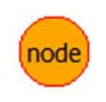

Figure 2: Node

Select/Deselect Node

Some commands require that nodes are selected. To select a node simply move the cursor over an existing node and right click on the mouse. When the node is selected it will turn red. To deselect a node simply right click over a selected node and it will turn back to orange.



Figure 3: Selected node

Add Edge

Control Panel: To add an edge from the control panel go to the text boxes directly under the label -Add Edge-. In the first two text boxes input the names of the existing nodes that the added edge will connect. In the third box input the numerical weight value of the desired edge. To add the described edge click the ADD EDGE button.

Key Command: To add an edge without the control panel simply select two nodes in the network by right clicking over them and then hit ENTER. A dialog will appear requesting a numerical weight value. Input a number and either click OK or hit ENTER again. An edge of the given weight will then appear between the selected nodes.



Figure 4: Directed edge from X to Y

Remove Node

Control Panel: To remove a node from the control panel go to the text box directly under the label -Delete Node-. Input the name of the node to be deleted and then click the REMOVE NODE button.

Key Command: To remove a node without the control panel simply right click select all the nodes to be deleted and hit the BACKSPACE key. The nodes and any connected edges will then be deleted.

Remove Edge

Control Panel: To remove an edge from the control panel go to the text boxes directly under the label -Delete Edge-. In the two text boxes input the names of the existing nodes between which the edge exists. To remove the described edge click the REMOVE EDGE button.

Key Command: To remove an edge without the control panel simply select two nodes in the network by right clicking over them and then hit the DELETE button on the keyboard. As long as an edge existed between the two selected nodes it will be removed from the network.

Condition Probability Table

Control Panel: To display the CPT of a node from the control panel go to the text box directly under the label -Condition Probability Table-. Input the name of the node to be deleted and then click the OPEN CPT button.

Key Command: To display the CPT of a node without the control panel simply right click select the node in the network. Hit the UP ARROW button on the keyboard and the CPT will be displayed.

Inference

Control Panel: In order to make inference on the given network, be sure to select which algorithm you want to use fromt he combo box (Lazy Propagation, Shafer Shenoy, Variable Elimination). After the algorithm is chosen, click the MAKE INFERENCE button.

IMPORT/EXPORT OF THE NETWORK:

Import BN

To import a previously created BN, open the File menu and click on “Import BN” and then select the .bif file of the network you want to import. Make sure to have the the relative _LOC.txt in the same folder of the .bif file, otherwise, if the _LOC.txt isn’t found, the nodes will be placed manually.

Export BN

To export the current BN, open the File menu and click on “Export BN” and then select where you want to save the .bif file. In the same folder will be created a related _LOC.txt which will be necessary for importing the network without manually place the nodes on the editor.