Name:-santosh PRUSTI

REG. NO: 2301292560

SEC:A

-:PYTHON:-

Graph

**How to plot a graph in Python?**

There are various ways to do this in Python. here we are discussing some generally used methods for plotting matpotlib in Python. those are the following.

* Plotting a Line
* Plotting Two or More Lines on the Same Plot
* Customization of Plots
* Plotting Matplotlib Bar Chart
* Plotting Matplotlib Histogram
* Plotting Matplotlib scatter plot
* Plotting Matplotlib Pie-chart
* Plotting Curves of Given Equation

**Plotting a line**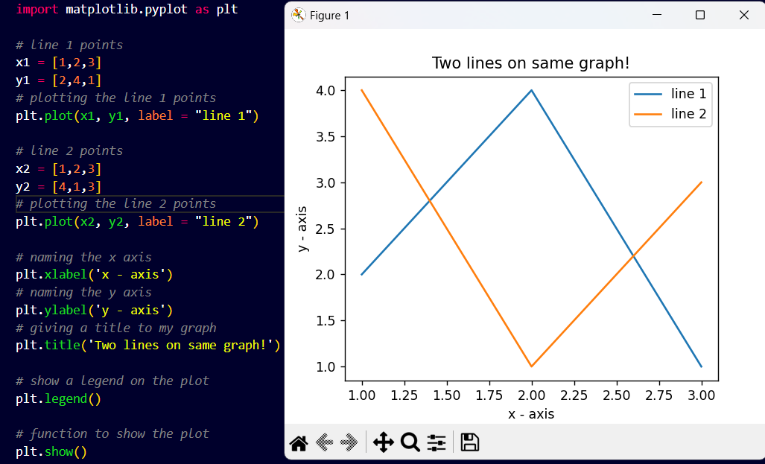

**Customization of Plots**

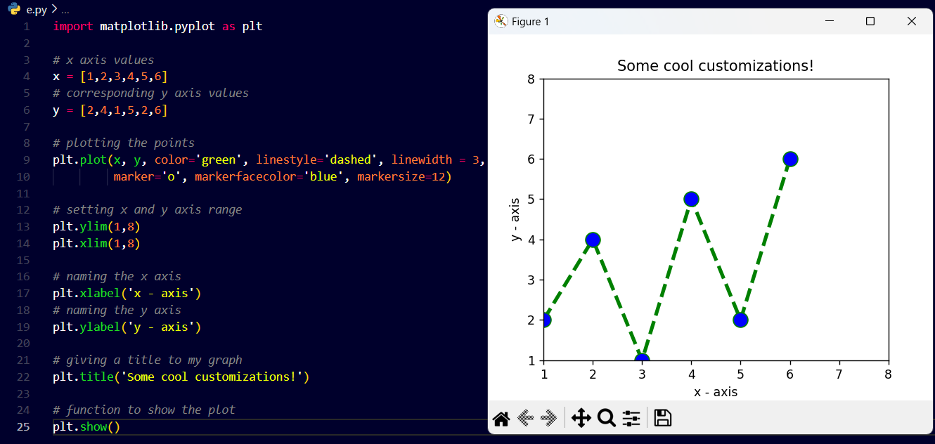

**Plotting Matplotlib using barchart** 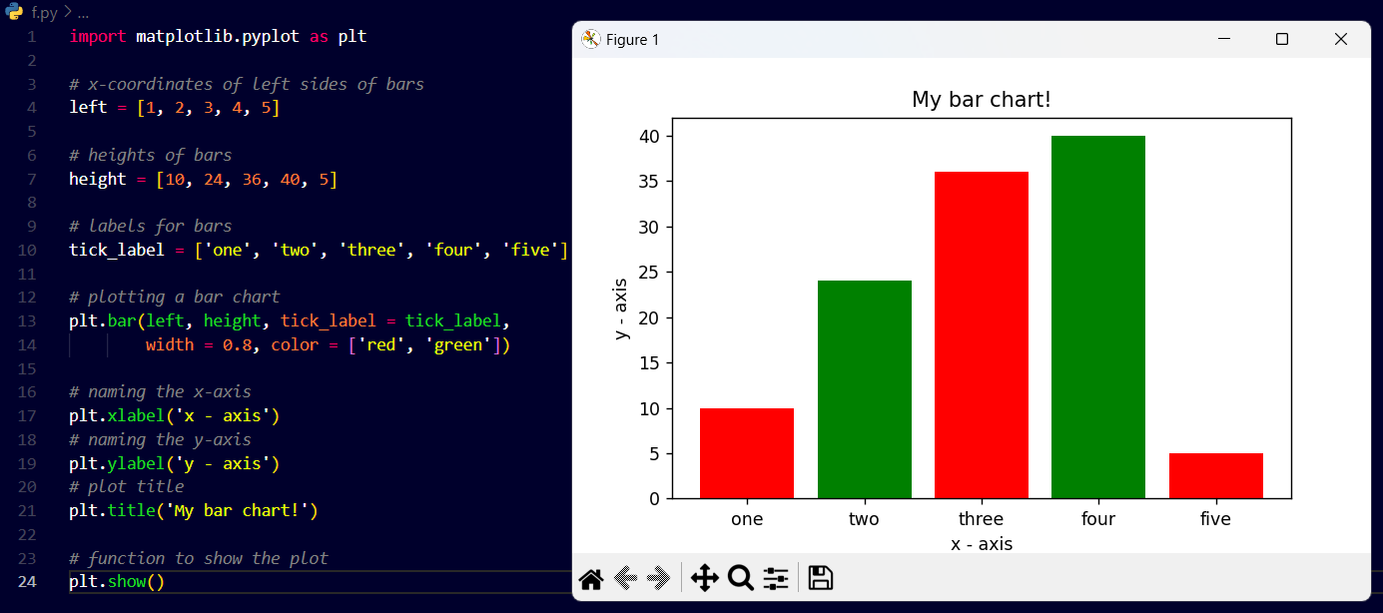

**Plotting Matplotlib Using Histogram**

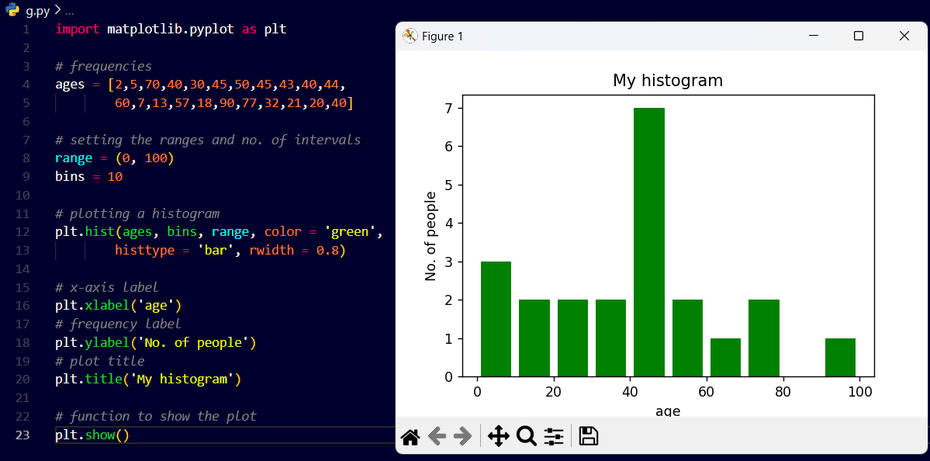

**Plotting Matplotlib Using Scatter Plot**

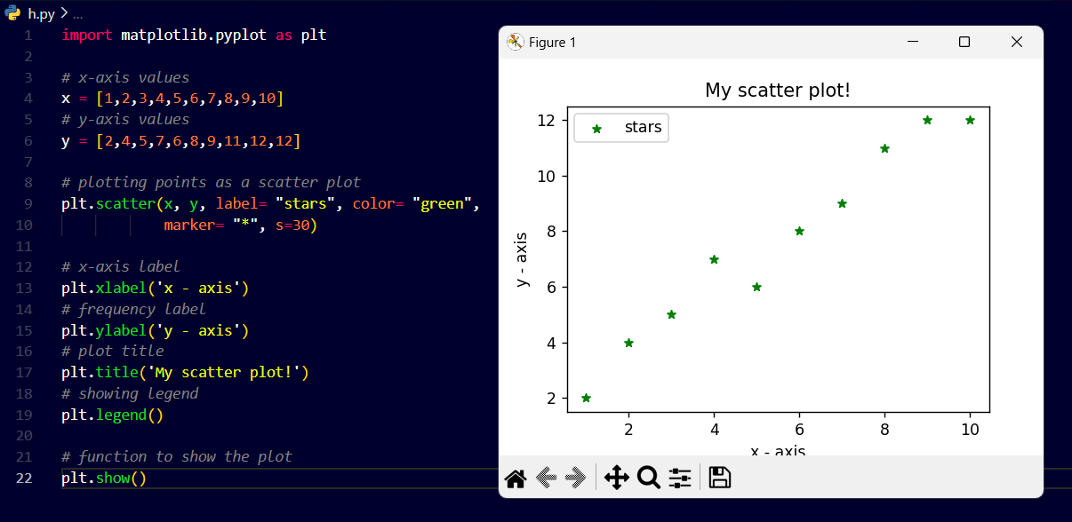

**Plotting Matplotlib Using Pie-chart**

