**UI/UX Design**

Semester- VII

Summer Internship Report

Submitted by

**Name: Astha Dilipbhai Patel**

**Enroll No: 190170107086**

**COMPUTER ENGINEERING DEPARTMENT**

**VISHWAKARMA GOVERNMENT ENGINEERING COLLEGE**

**CHANDKHEDA**



External Guide: Internal Guide:

Aditya Lakkad Prof. J. M. Shroff

Project Association Assistant Professor

Divine System VGEC, Chandkheda

Gujarat Technological University

Academic Year 2022-23

Vishwakarma Government Engineering College, chandkheda

Computer Department

CERTIFICATE



Date:

This is to certify that the Summer Internship Report entitled summer internship Submitted by EnrollNo : **190170107086** Name: **Astha Dilipbhai Patel** towards the fulfillment of Subject: Summer Internship (3170001) of Gujarat Technological University is the record of work carried out by him under our supervision and guidance in the Academic Year 2022-23.

Internal Guide Head of Department

Prof J. M. Shroff Prof M. T. Savaliya

Assistant Professor Associate Professor

VGEC Chandkheda VGEC Chandkheda

**Offer Letter**

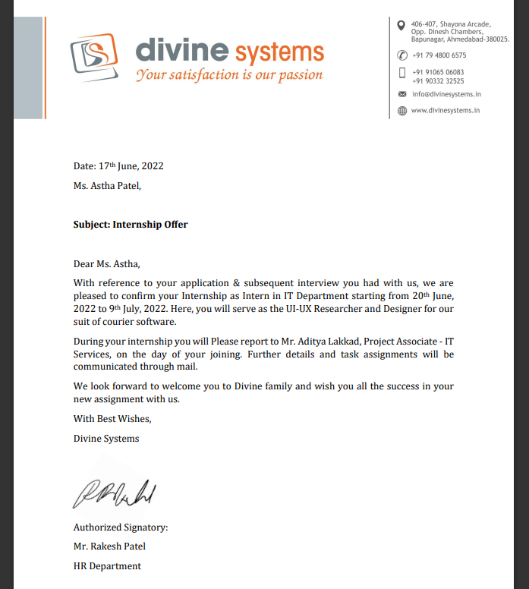

**Completion Certificate**

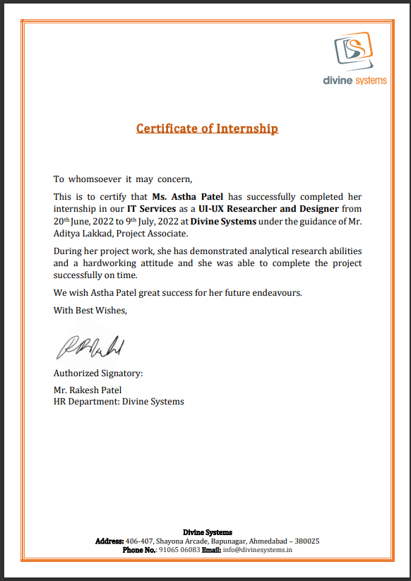

**Acknowledgement**

Apart from my efforts, the success of any project depends on the encouragement and guidelines of many others like mentors, colleagues etc. I take this opportunity to express my gratitude to the people who have been instrumental in the successful completion of this internship. I express my sincere regard and indebtedness to my internship external guide **Aditya Lakhkad** for his valuable time, guidance, encouragement, support and cooperation throughout the duration of my internship. I would sincerely like to thank Computer Department for giving me the opportunity to work on enhancing my technical skills while undergoing this internship. I would like to thank to my internal guide Prof. **Jaimin M. Shroff**. In this Internship I learn about the importance of UI/UX Design for Web-designing.

Finally, I would like to thank our friends and family for their support and patience, and other faculty members of the department for his everlasting willingness to extend his support and help in the completion of this work. Especially to our parents, without their encouragement and financial support, this would not have been possible.

I would like to thank **Prof. M.T.Savaliya**, HOD CE Department and whole of department for their constant support.

Your Sincerely,

Astha Dilipbhai Patel

(190170107086)

# **Abstract**

* **The user interface (UI) is the space where interactions between humans and machines occur.** UI is an integral aspect of user experience (UX) that consists of two major parts: visual design, which conveys the look and feel of a product; and interaction design, which is the functional and logical organization of elements. The goal of **user** [**interface design**](https://xd.adobe.com/ideas/process/ui-design/)is to create a user interface that makes it easy, efficient, and enjoyable for users to interact with a product.
* **UI/UX** uses different platform for its implementation like Figma, Flutter, HTML/CSS etc.
* UI design prioritizes the user’s visual experience. A good user interface is functional, reliable, and enjoyable to use. In UI design designer tries to provide good visual experience to their target audience.
* The most important elements of UI design are:
* Place users in control of the interface
* Make it comfortable to interact with a product
* Reduce cognitive load
* Make user interfaces consistent

# **List of Figures**

Fig.1 Wireframe……………………………………………………………………………..11

Fig.2 Use Case Diagram…………………………………………………………………….15

Fig.3 Zero Level Data Flow Diagram……………………………………………………….16

Fig.4 Level One Data Flow Diagram……………………………………………………….16

Fig.Level Two Data Flow Diagram……………………………………………………….17

Fig.6 Level Three Data Flow Diagram……………………………………………………….17

Fig.7 Snapshots of Project…………………………………………………………………………18

# **Table of Content**

Acknowledgement................................................................................................................

Abstract.................................................................................................................................

List of Figures......................................................................................................................

Table of Content..................................................................................................................

Chapter 1: Introduction......................................................................................................

Chapter 2: System Analysis...............................................................................................

Chapter 3: System Modeling...........................................................................................…

3.1 Use Case Diagram………………………………………………………..

Chapter 4: Implementation..................................................................................................

4.1 Snapshots of Project.....................................................................………..

Conclusion and Future scope..............................................................................................

References...........................................................................................................................

# **Chapters**

1. **Introduction :**

Management of a residential housing society is a very hectic and trouble-taking task if it comes to on a particular person to handle. The efficient method to deal with this kind of situation is online sources like website of housing society management system.

This report is regarding the Project on UI/UX designing titled “BUMA” (residential housing society management System). This particular project has been created by using Figma. Figma is a very efficient and user friendly platform for freshy students who are interested in web designing.

1. **System Analysis:**

This system acknowledges user about the management system of a residential or housing society. The website provides user friendly interface. It enlists the features provided by the Application. It also tries to interact with user regarding their feedback about the application. This is basically front end project.

**2.1 Study Of Current System :**

This project consists of following modules:-

**Models:-**

1. **Home**:- This page contains briefing about all the other pages.
2. **Login**:- This page contains login credentials.
3. **Product**:- This page contains different features provided by the application.
4. **Contact Us**:- This page provides the information about the developer and also asks the feedback of the user.
5. **Client**:- This page provides information of the clients associated with the developer.
6. **Pricing**:-This page provides the details about the pricing structure of the society.

**2.2 Problems and weakness of Current System:**

* For this system internet must be required without internet we can not use this system.
* Ability to manage multiple customers
* Dependency on human resources

**2.3 System Requirement specification:**

**2.3.1 Objective:**

1. Reliability
2. User friendly
3. Efficient
4. Easy maintenance
5. Easy access

**2.3.2 System Requirements: Non-Functional Requirements:**

Reliability: This ensures that the website is reliable.

User friendly: The website is user friendly as user can interact with the website without any queries.

Efficient: It is efficient in cost matter and useability.

Easy maintenance: It is easy to maintain.

Easy access: Those who are given access to the website can access it without any difficulty.

Design Requirement: Design requirements are usually collected and documented using three main formats that morph into one another.

Wireframes: Wireframes are low-fidelity graphic structures of a website or an app. They help map different product pages with sections and interactive elements.

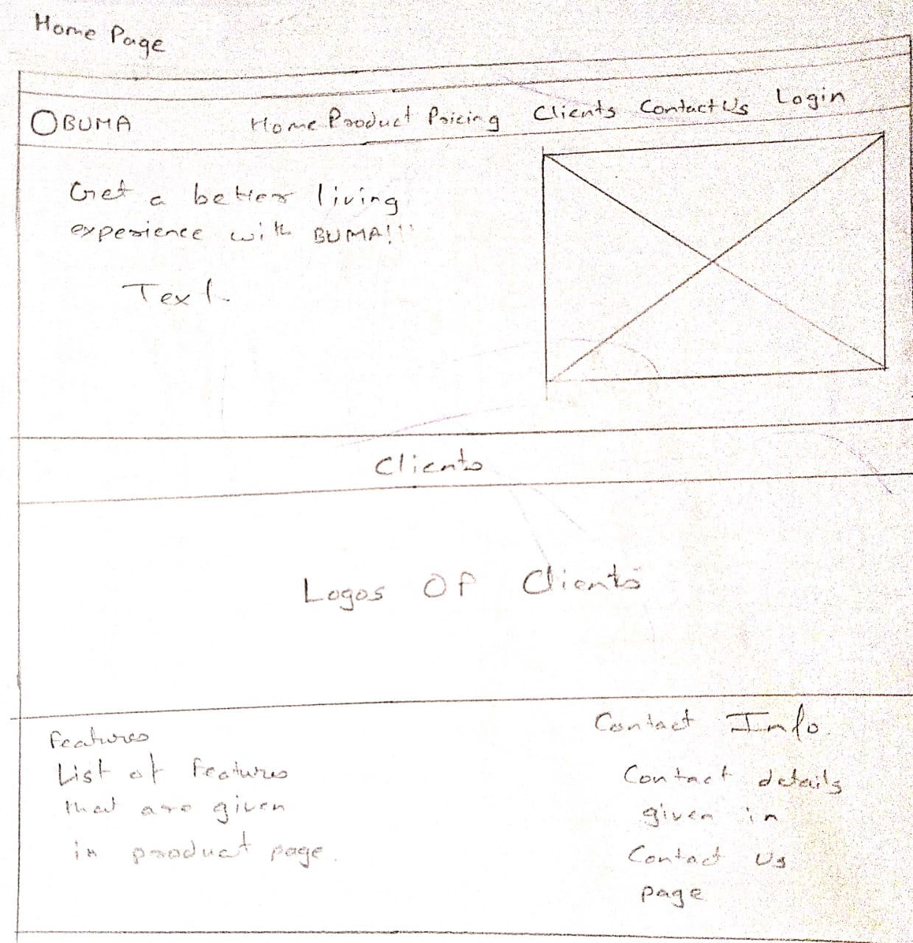

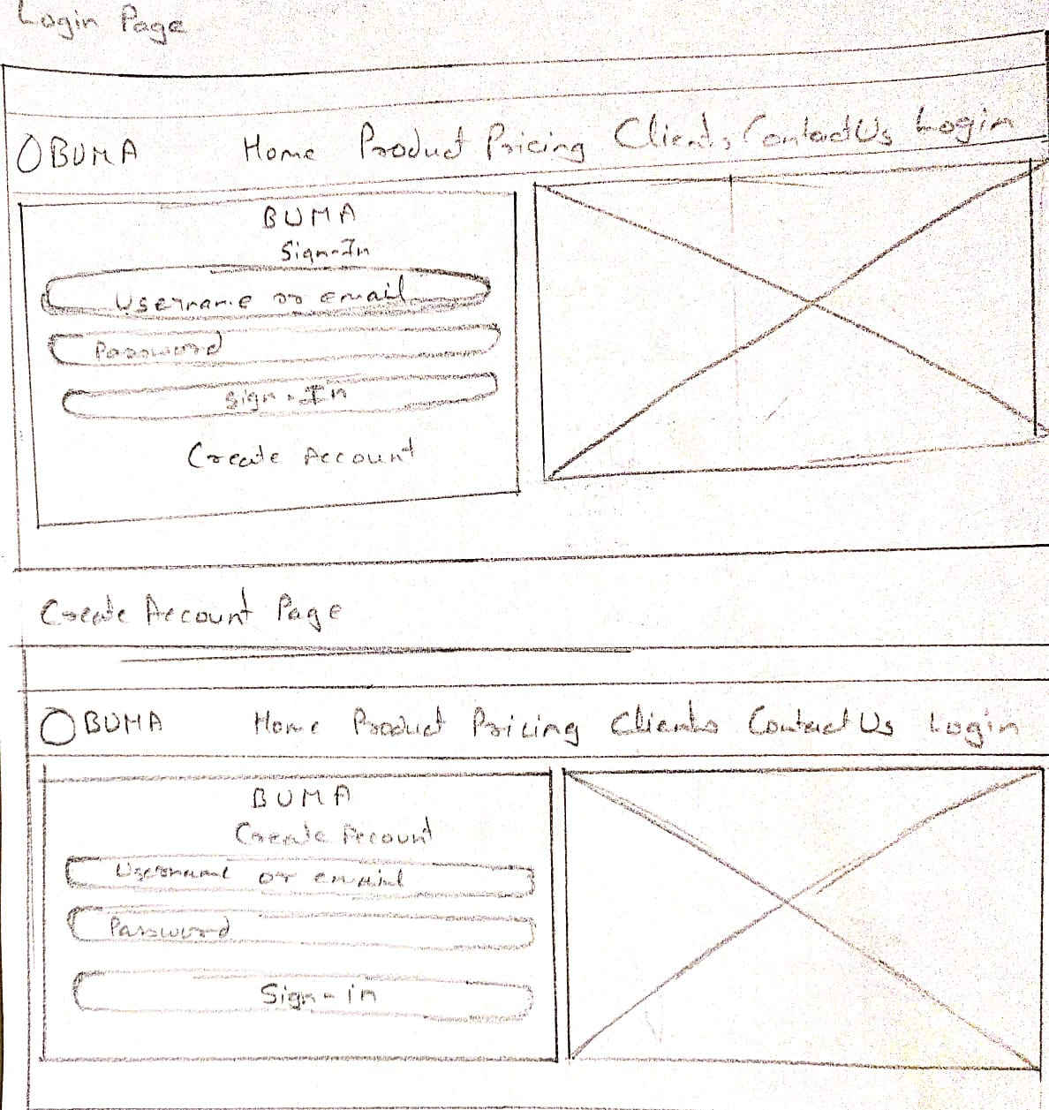

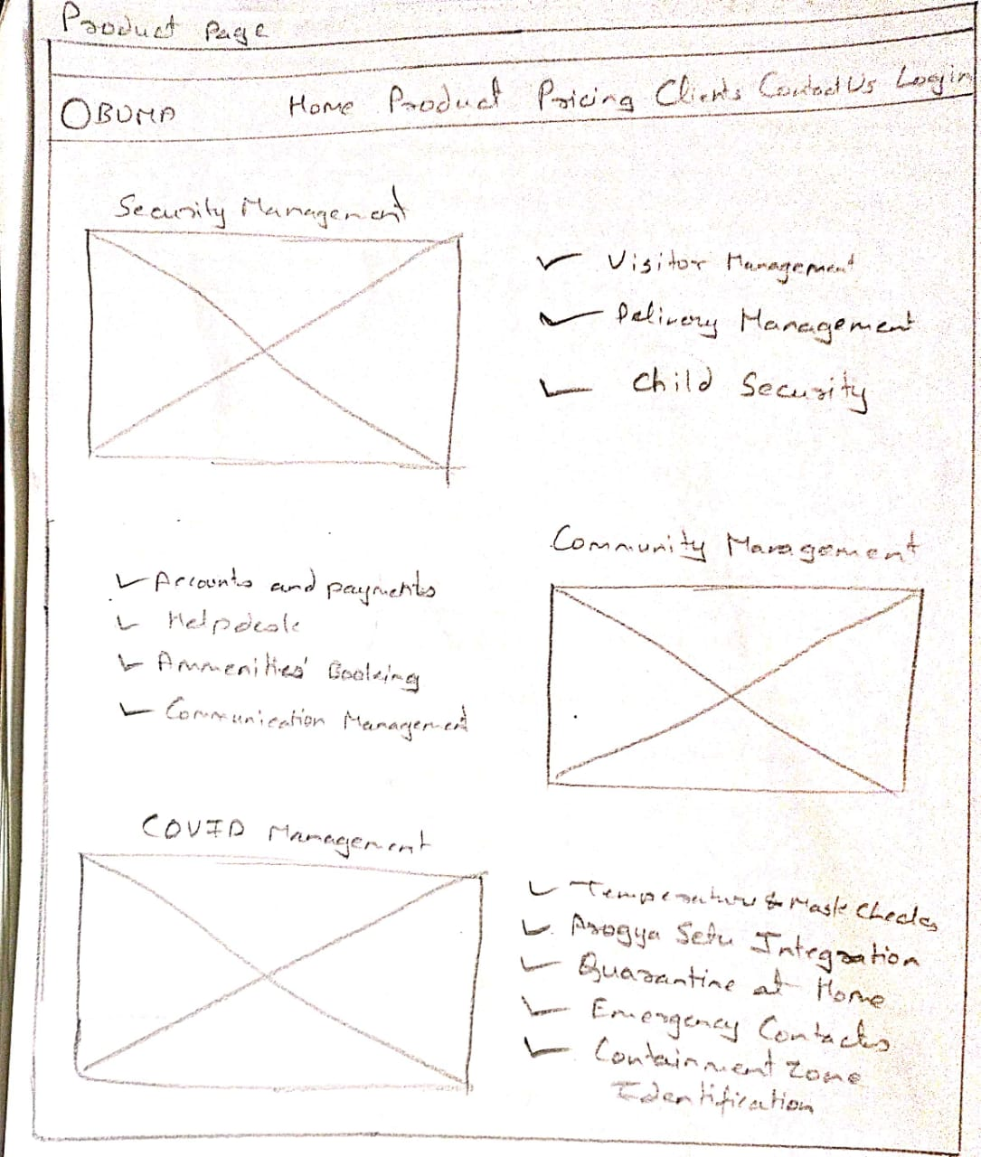

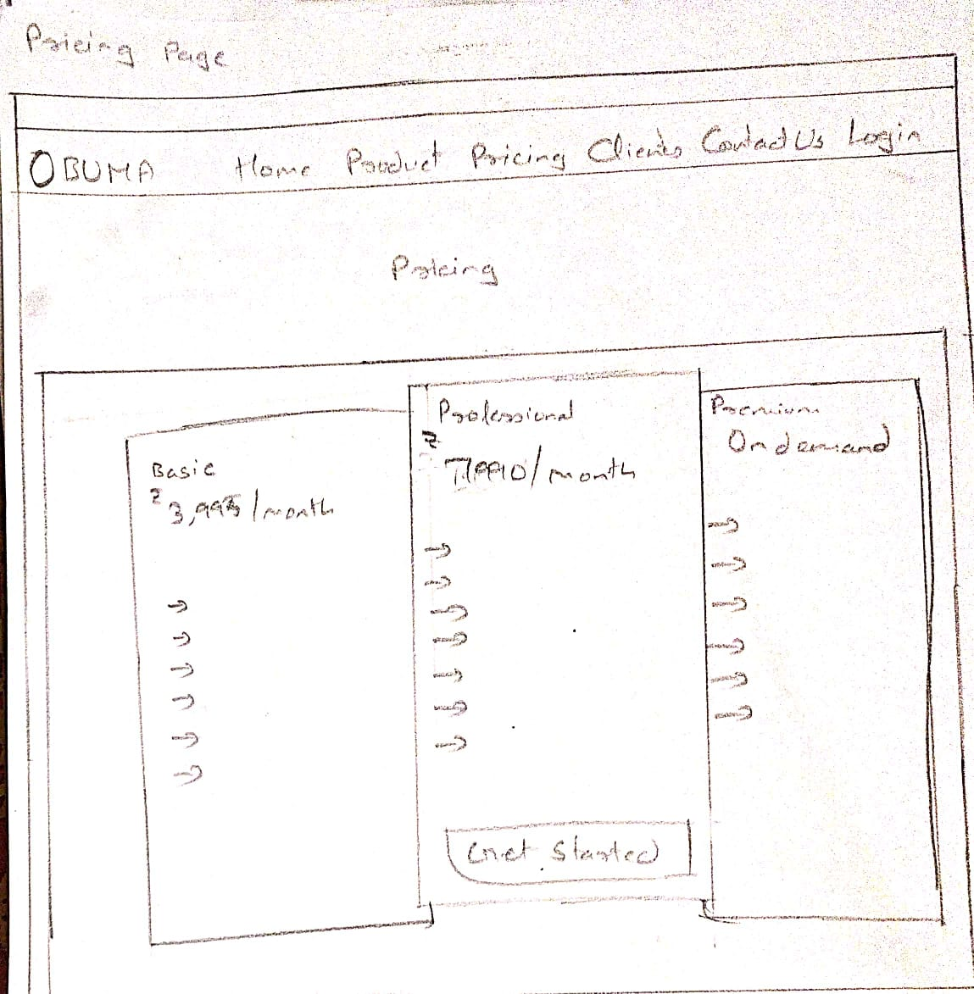

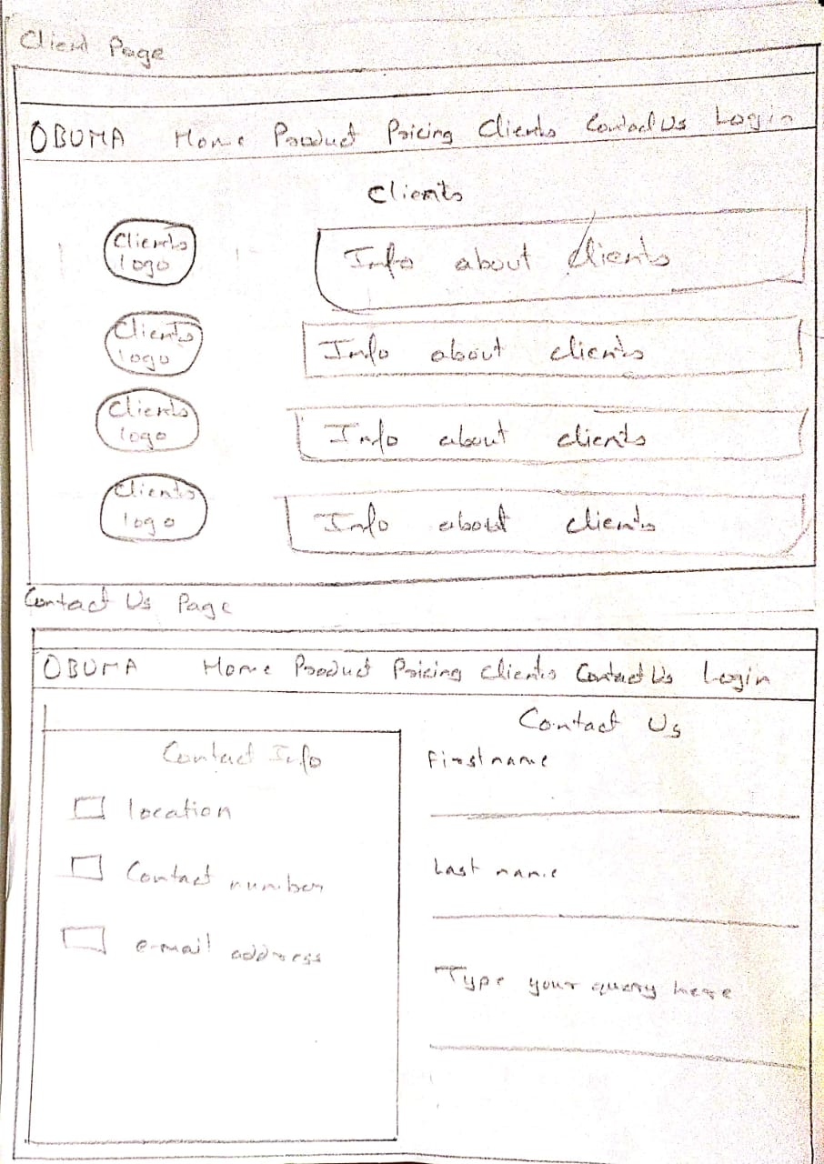

**Mockups:** Once wireframes are ready, they are turned into mockups, visual designs that convey the look and feel of the final product. Eventually, mockups can become the final design of the product.

**Design prototypes:** These documents contain visuals and allow for some interface interactions, like scrolling, clicking on links, or filling in forms. Design prototypes can be built from scratch using HTML and CSS, but most UX teams use prototyping services.

**Prototype link :** https://www.figma.com/file/CQO1ATLpbobTlvwBM2WbN5/BUMA-Page1?node-id=0%3A1

**System Modelling:**

**3.1 Use Case Diagram:**

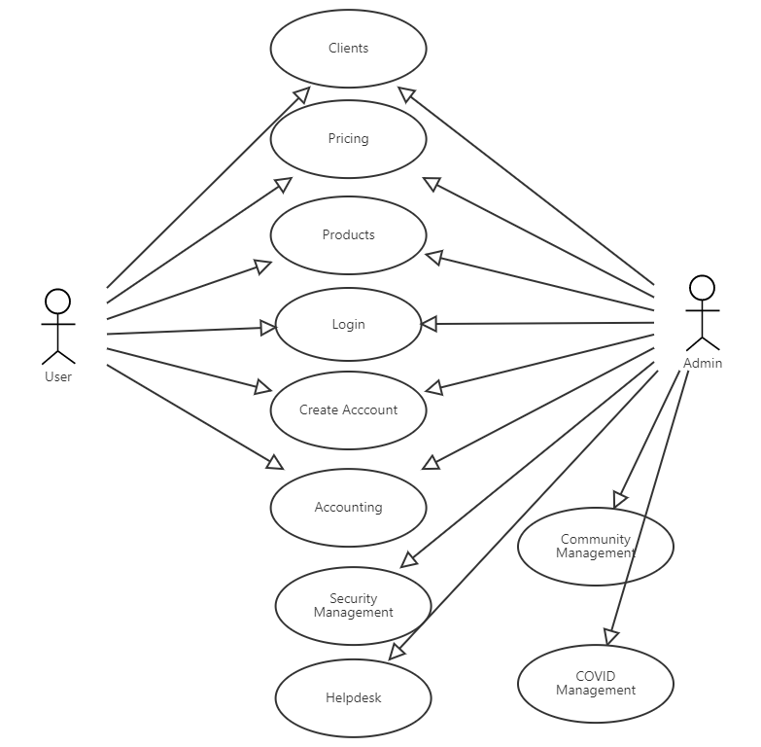

Fig Use Case Diagram

**3.2 Zero Level Data Flow Diagram:**

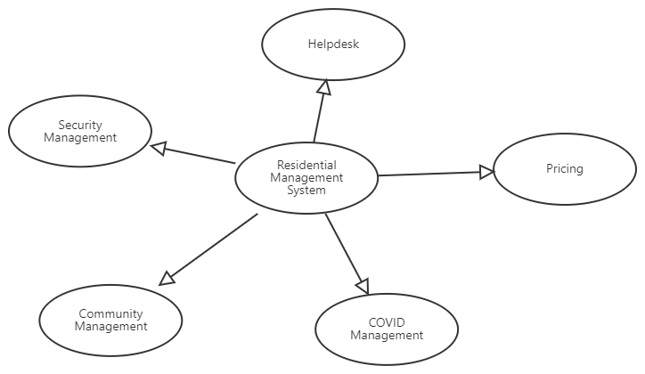

Fig Zero Level Data Flow Diagram

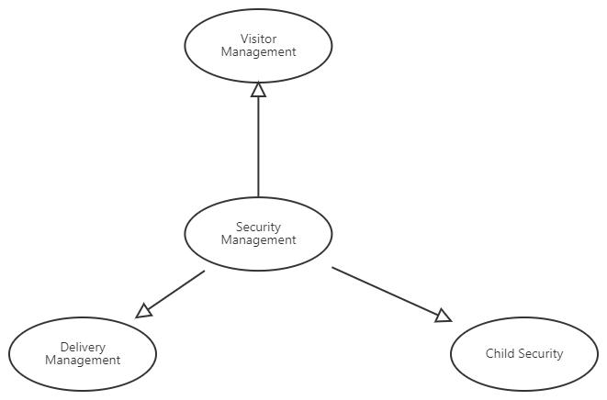

Fig. Level One Data Flow Diagram

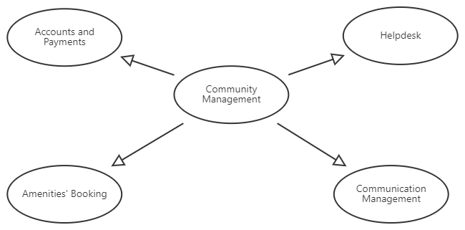

Fig. Level Two Data Flow Diagram

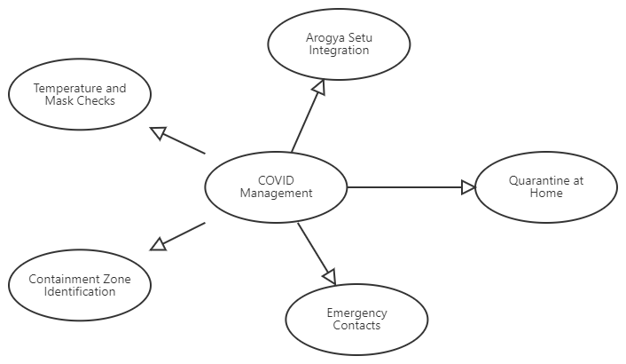

Fig. Level Three Data Flow Diagram

1. **Implementation:**

**4.1** **Snapshots:**

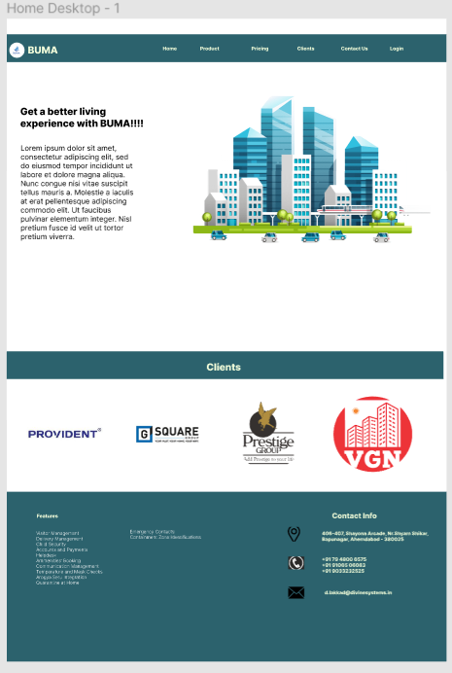

Home Page

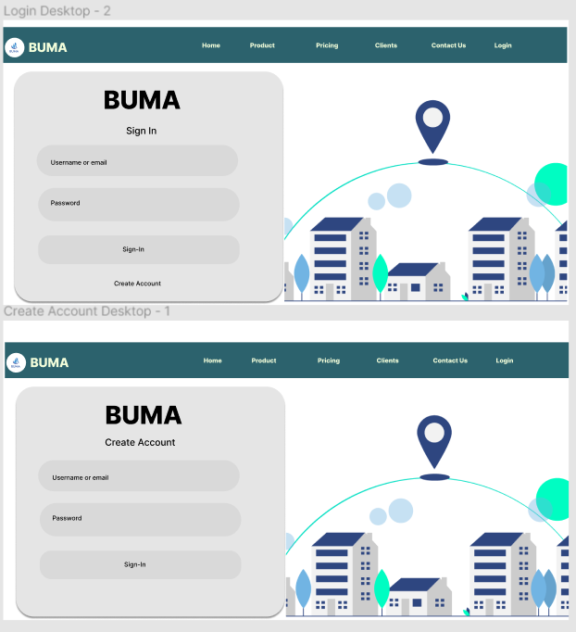

Login and Create Account Page

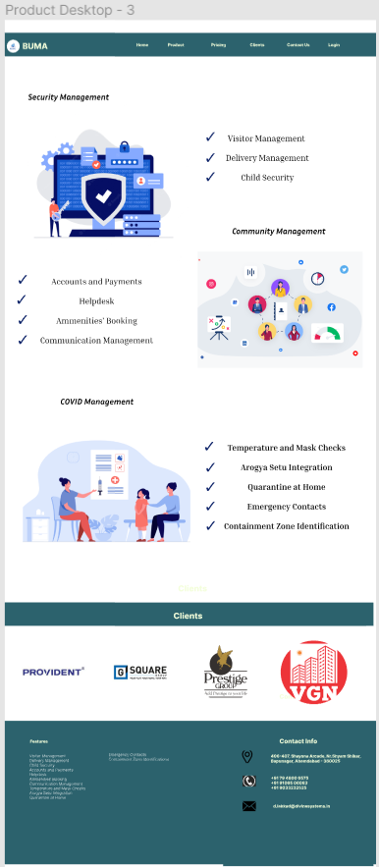

Product Page

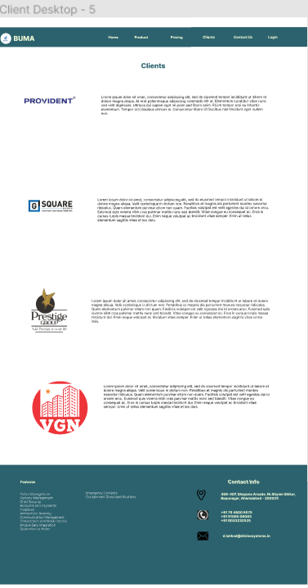

Clients Page

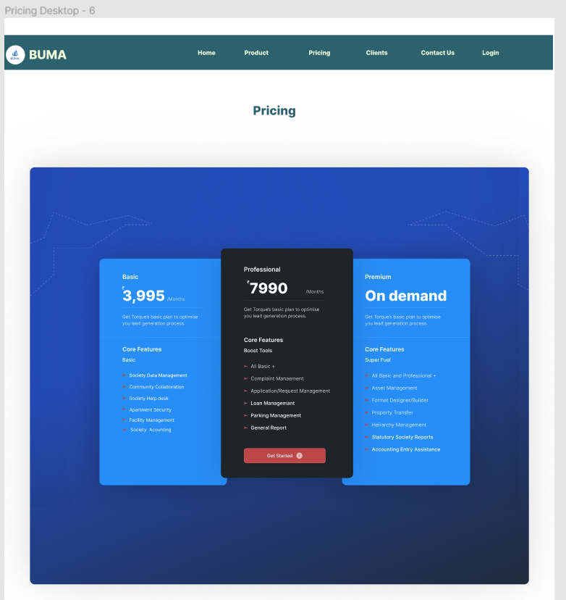

Pricing Page

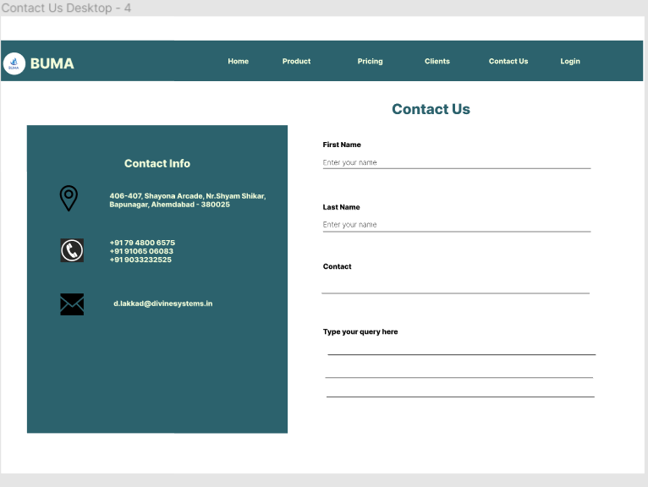

Contact Us Page

**Conclusion and Future scope:**

The universal user interface is will soon be the way of communication around the world. The government and private industries are leading the way in this effort. This means that in order for any organization to continue to have the success they will need to be on board. Not to say this is a bad thing, and it may sound like big brother is forcing little brothers’ hand. It’s the fact that technology is always working to get better and to reach as many customers as possible. The demand of society often plays a key role in the direction technology is headed the needs and wants of the consumer because the consumers want to have access to everything. The application provides a very user friendly interface to consumers so that it is easily accessible.

**References:**

<https://www.tpcindia.com/>

<https://www.shreemaruticourier.com/>

<https://www.fedex.com/global/choose-location.html>

<https://www.ijraset.com/research-paper/apartment-management-system>

<https://www.researchgate.net/publication/297658847_Residential_Building_Management_System_Features_and_Underlying_Factors>

<https://mygate.com/housing-society-management->