**Steps to be followed**

1) Create your own virtual environment

2) Install all the packages mentioned in requirements file using pip

3) Create **Training_own_yolo** directory in the site packages and place **yolo_helper.py** inside it

**TRAINING PHASE** (“Training_yolo_using_ annotations.ipynb to be used”)

1. First we generate “data_train.txt” file using the “Annotations-export.csv” placed inside Directory “vott-csv-export”
2. Define the path till “vott-csv-export”(this complete directory is shared) in Vott_folder_path variable

NOTEBOOK SNAP:



NOTE: Path will change depending on where “vott-csv-export” directory is placed in the local setup

1. Define the path where you want your “data_train.txt” file to be generated

NOTEBOOK SNAP:

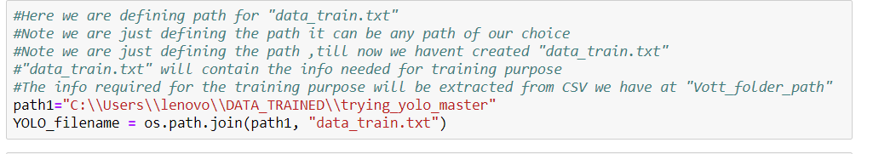

NOTE: path1 mentioned in above snap can be of your choice

1. Further defining the paths which will be used

NOTEBOOK SNAP:

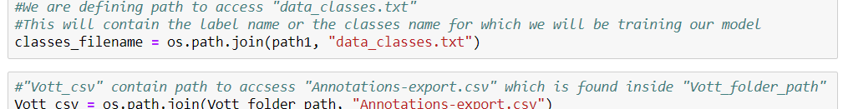

1. Once all above paths are defined you can execute cells of notebook as it is before the second the second markdown in notebook to generate “data_train.txt” file which will be used for the code under second markdown .
2. TRAINING OF MODEL for custom object in this case it is “fidget_spinner”
3. Importing libraries as it is as mentioned in the notebook
4. Defining paths

NOTEBOOK SNAP :

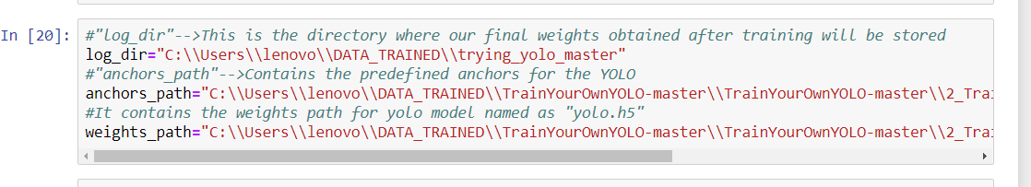

log_dir is the path where we want our weights to be stored after training the model

anchors_path is the path where “yolo_anchors.txt” file will be there on your setup and it is placed under ”anchors” directory which is shared

weights_path is the path of yolo weights i.e “yolo.h5” placed under “yolo_weights” directory which is shared

1. Now follow the notebook as it is till the end .
2. Finally weights will be stored as “trained_weights_final.h5” in log_dir path defined in above step. For the purpose of trying directly the prediction “trained_weights_final.h5” is shared and placed in “custom_weights”

**PREDICTION PHASE** (“yolo_cus_tom_object_detection.ipynb to be used”)

1. Import all the packages and function as it is mentioned in the notebook
2. Define the paths

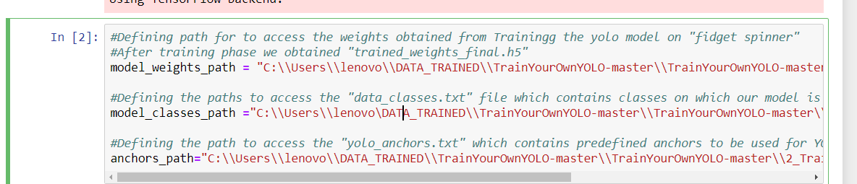

model_weights_path is the path of the weights obtained from previous notebook, aslo shared the weights obtained after training the phase and placed under “custom_weights”

model_classes_path is the “data_classes.txt” file generated from the previous notebook, also shared the “data_classes.txt” file which is placed in “classes” directory so that we can directly skip the training part and do the prediction on “fidget_spinner”

anchors_path is the path to the “yolo_anchors.txt” file placed under “anchors” directory which is shared

NOTE : It is mandatory to run the previous notebook i.e Training_yolo_using_ annotations.ipynb in case you are trying on some other custom object of your choice

1. Now run the notebook cells as it is till 13th cell
2. In 14th cell

NOTEBOOK SNAP



GetFileList is the function which takes path of the test images on which prediction needs to be done ,test images are placed under “ test_images” directory which is shared

Returns: The path of all the test images in the form of list

1. Now run the cells as it is
2. For “fidget_spiner” detection in video use any video of your choice, placed the sample video inside “Test_Video” directory which is shared

--------------------------------END OF DOC-------------------------------------------------------------------------