1-Create a directory "exercise" inside your home directory and create nested(dir1/dir2/dir3) directory structure inside "excerise" with single command.

mkdir -p exercise/dir1/dir2/dir3

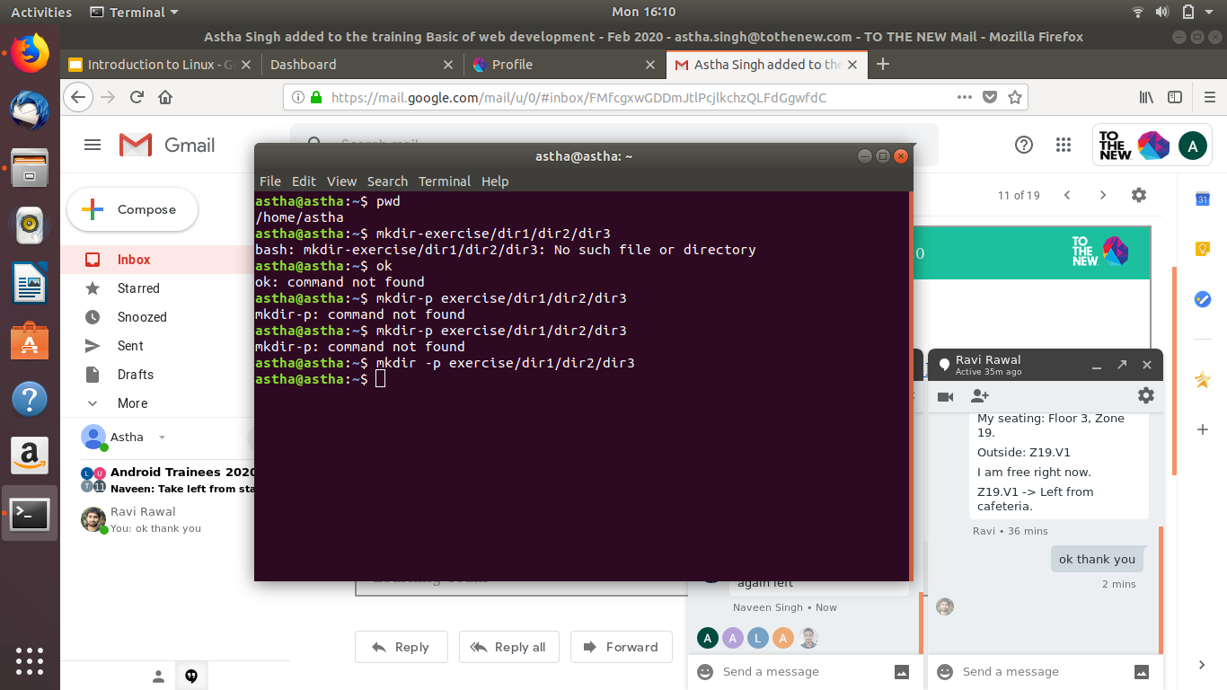

2-Create two empty files inside dir2 directory: emptyFile1,emptyFile2 in single command

touch emptyfile1,emptyfile2
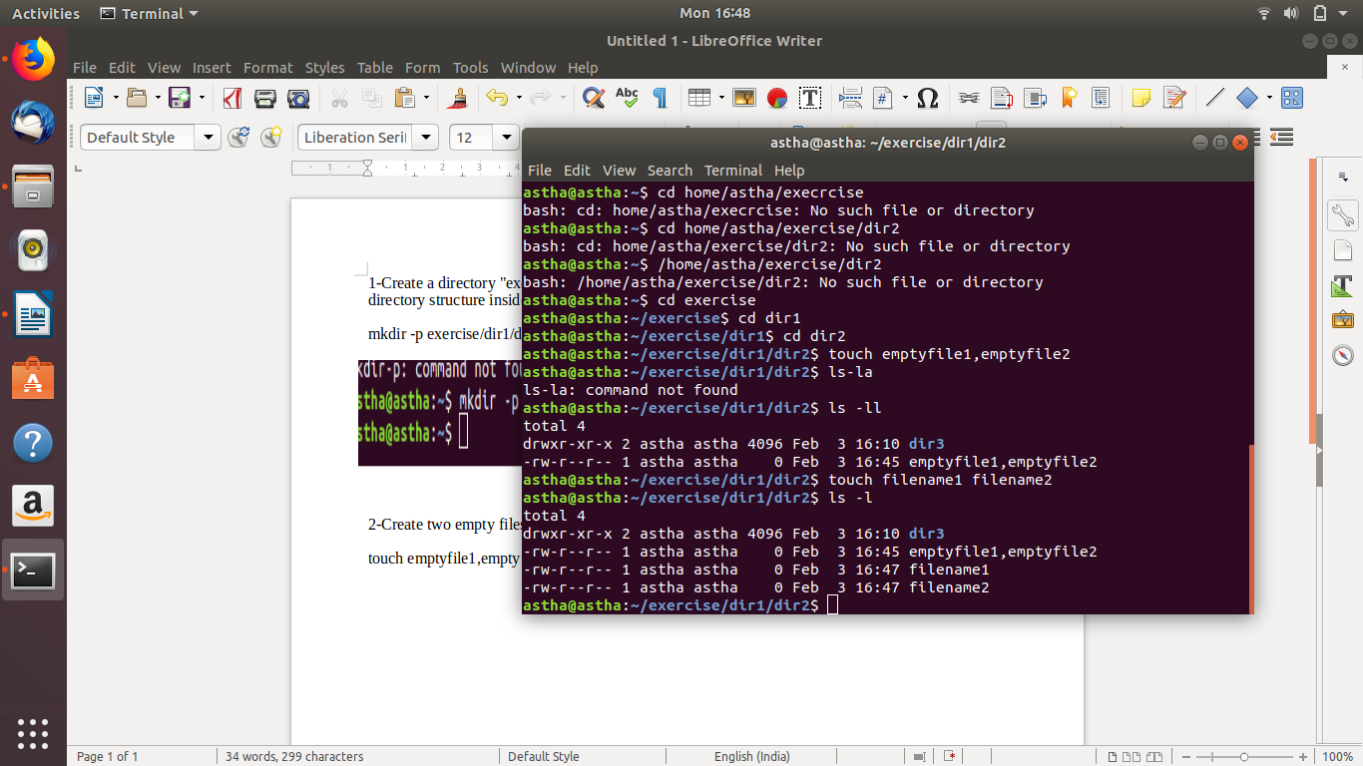

3 Create one file file1.txt containing text "hello world" and save it.

Touch file1.txt
echo “hello world” file1.txt
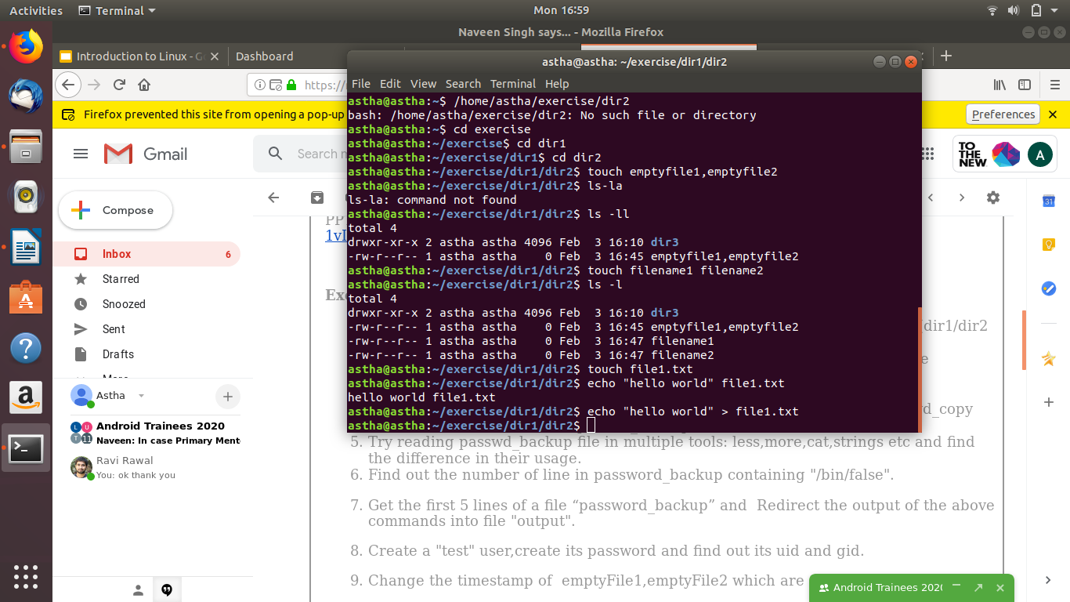

4 Find a "passwd" file using find command inside /etc. copy this files as passwd_copy and then rename this file as passwd_backup.
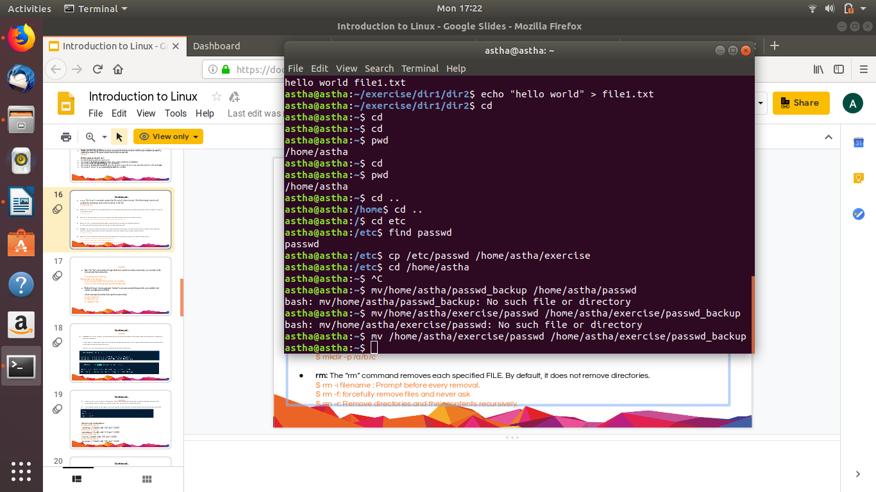
Mv home/astha/exercise/passwd homeastha/exercise/passwd_backup

5 Try reading passwd_backup file in multiple tools: less,more,cat,strings etc and find the difference in their usage.
Less passwd_backup
more passwd_backup
cat passwd_backup
strings passwd_backup

6 Find out the number of line in password_backup containing "/bin/false".
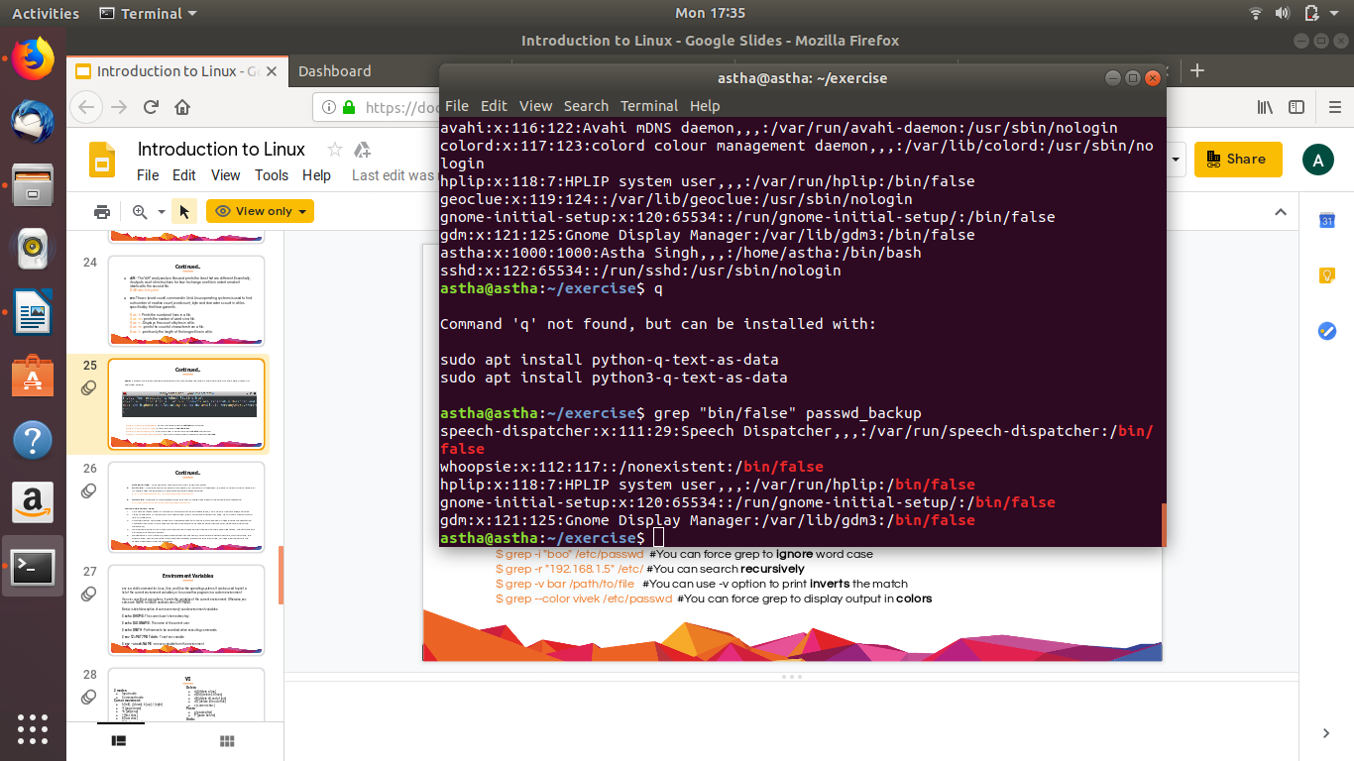
Grep “bin/false” passwd_backup

7 Get the first 5 lines of a file “password_backup” and Redirect the output of the above commands into file "output".

head -n 5 password_backup

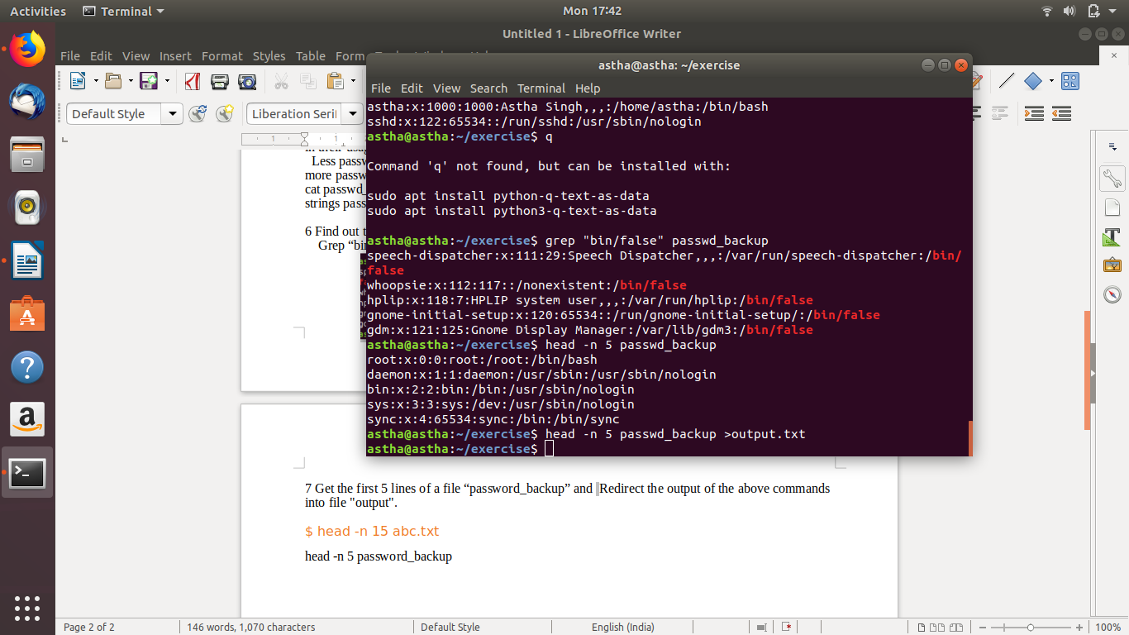

8 Create a "test" user,create its password and find out its uid and gid.
Sudo useradd test
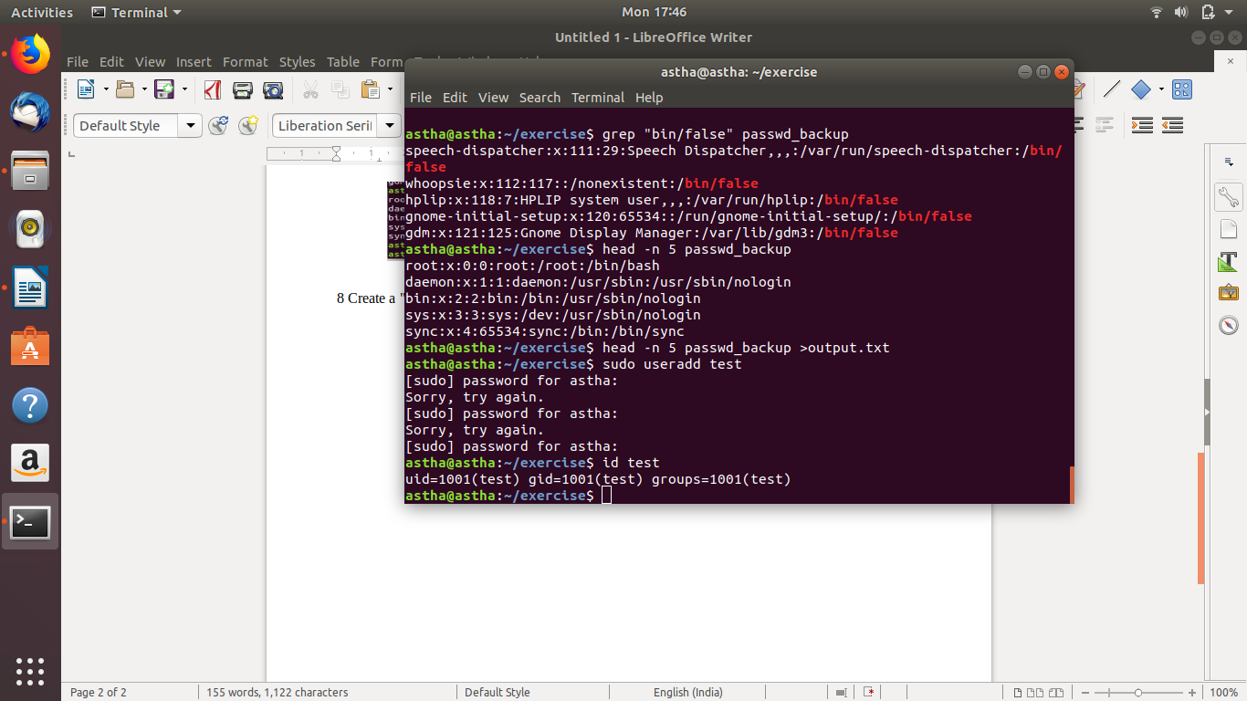
id test

9 Change the timestamp of emptyFile1,emptyFile2 which are exist in dir2

touch ~myfile1 myfile2

10 Login as test user and edit the "output" file created above. Since the permission wont allow you to save the changes. Configure such that test user can edit it.
- Add group owner of the "output" file as the secondary group of testuser and check/change the "output" file permission if it is editable by group. Once done revert the changes
- Make the file editable to the world so that test user can access it. Revert the changes after verification
- Change the ownership to edit the file.
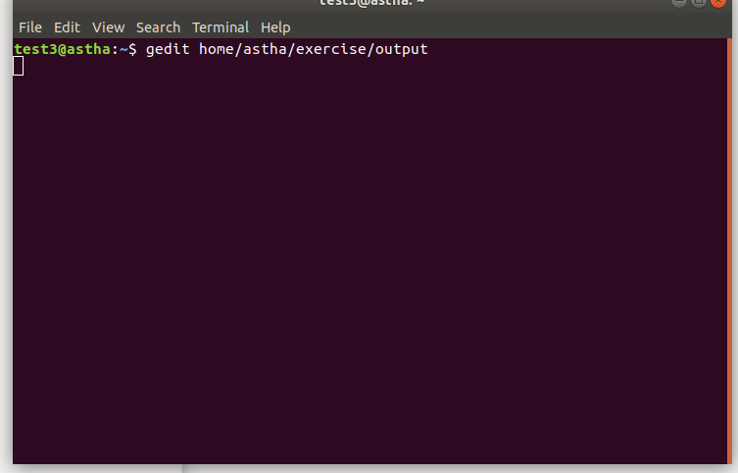
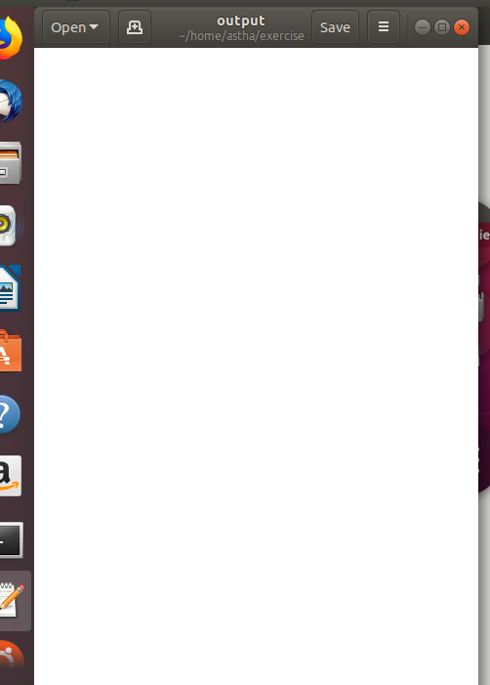

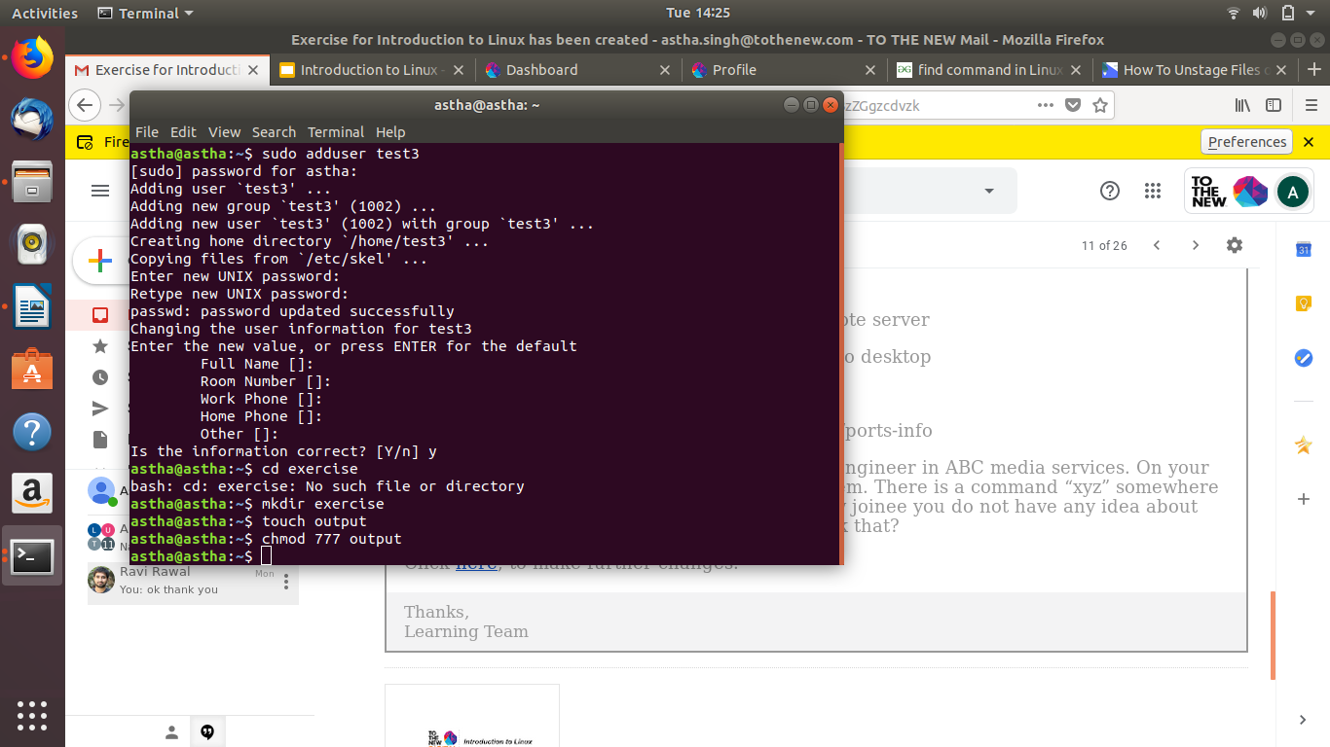

sudo chown test3 file(to change ownership)
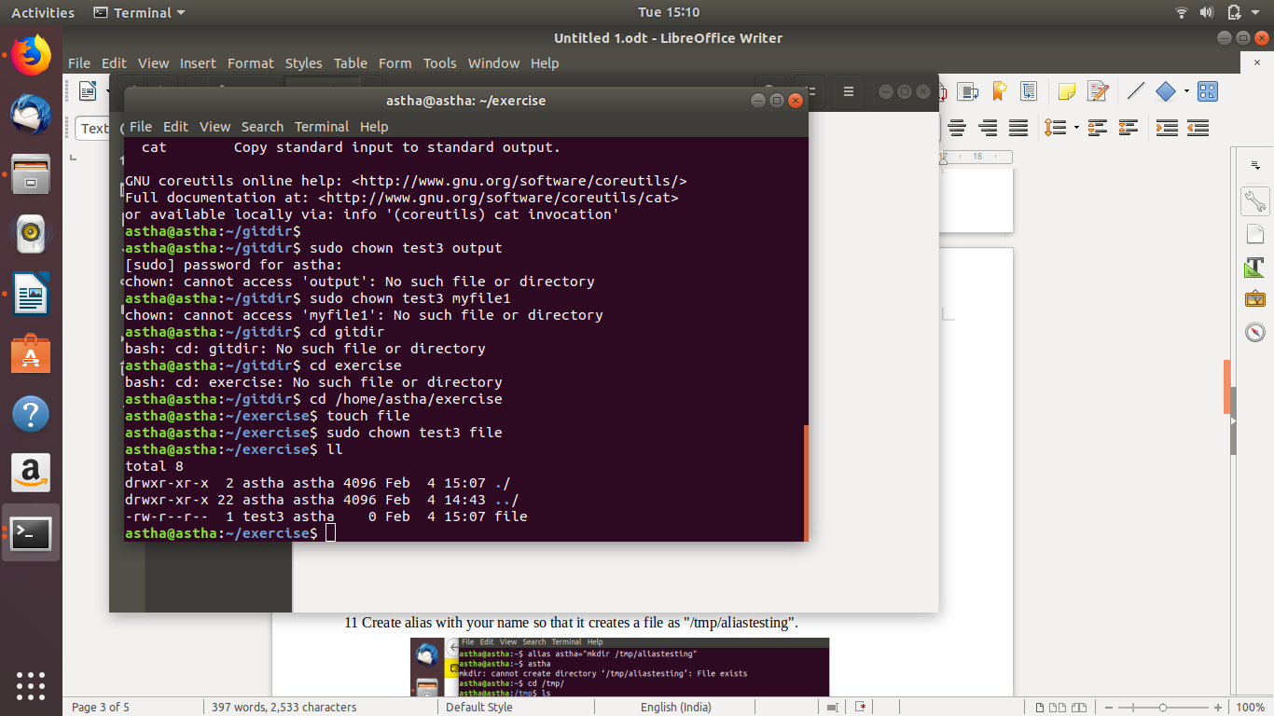

11 Create alias with your name so that it creates a file as "/tmp/aliastesting".
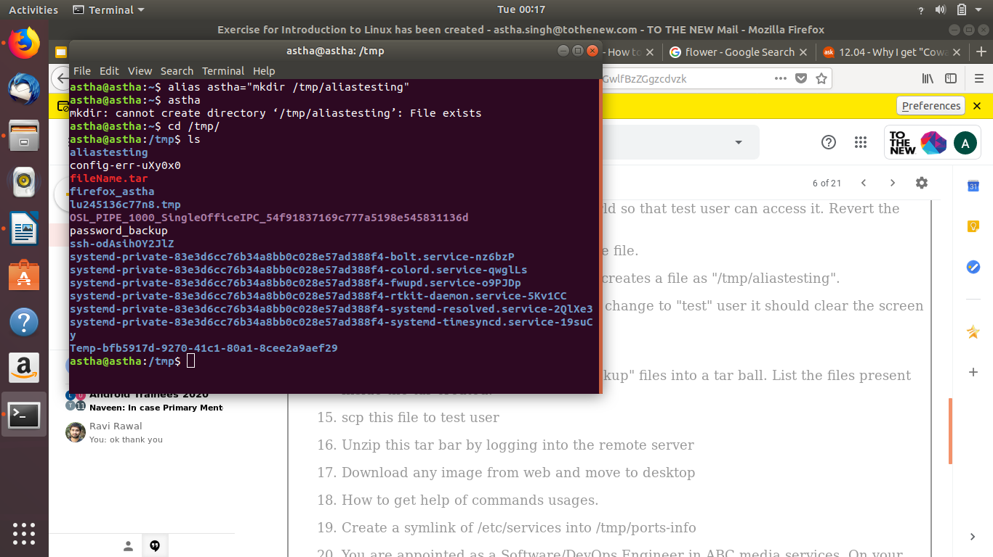

1

12 Edit ~/.bashrc file such that when you change to "test" user it should clear the screen and print "Welcome".

vim~/.bashrc
clear
echo “welcome”
su test3

13 Install “zip” package.
sudo apt install zip
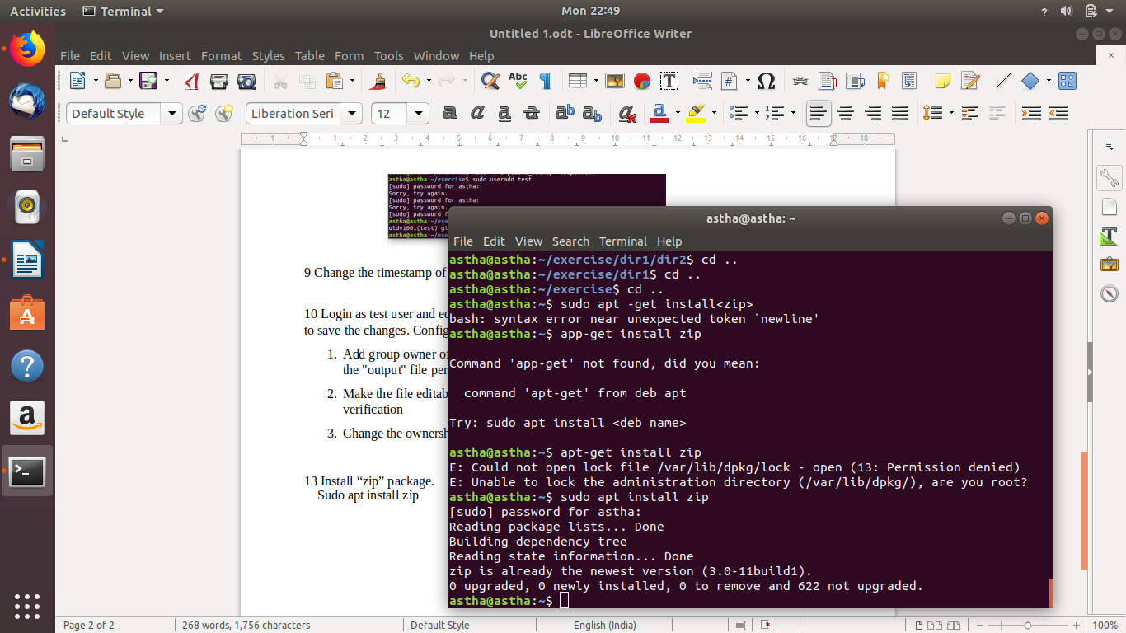

14 Compress "output" and "password_backup" files into a tar ball. List the files present inside the tar created.
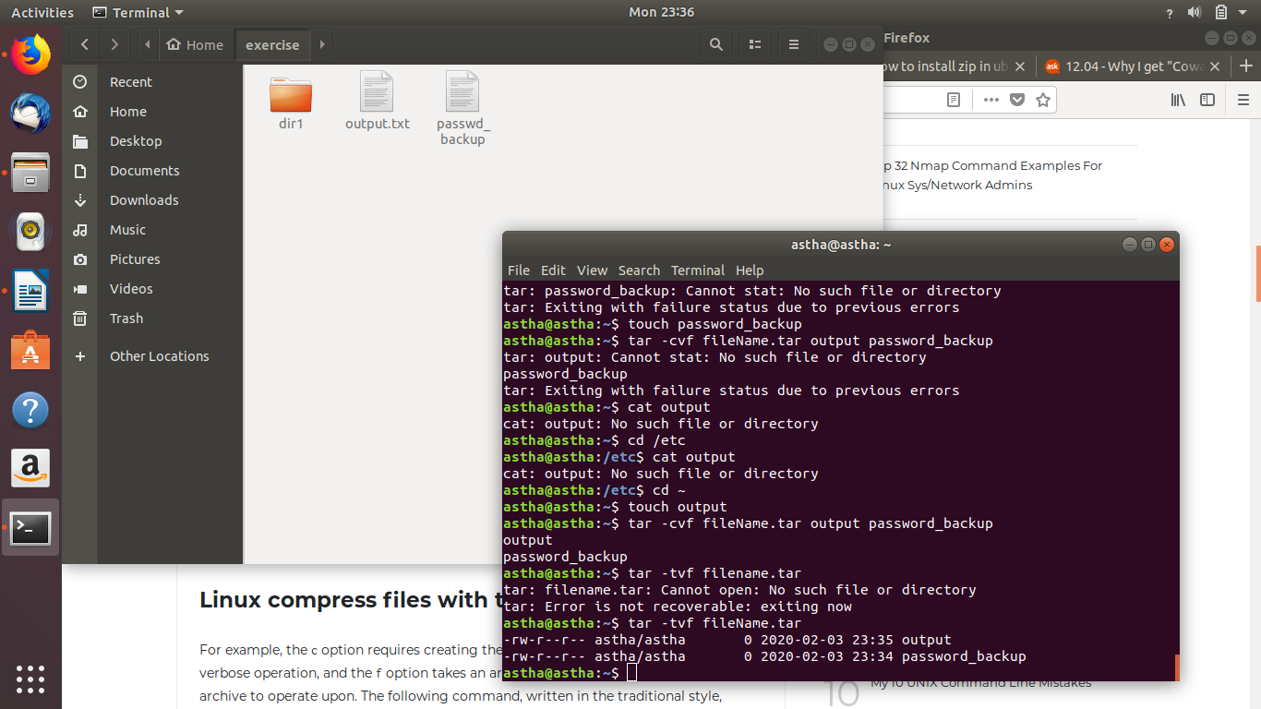

17 Download any image from web and move to desktop
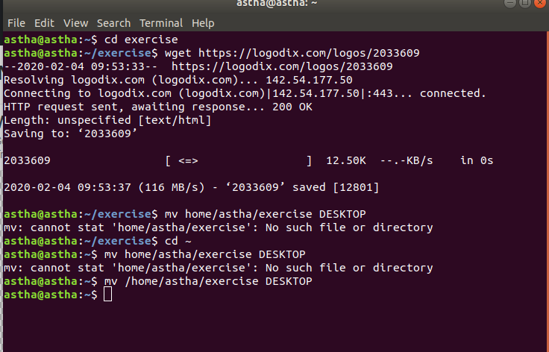
wget https://logodix.com/logos/2033609
mv /home/astha/exercise DESKTOP

18 How to get help of commands usages.

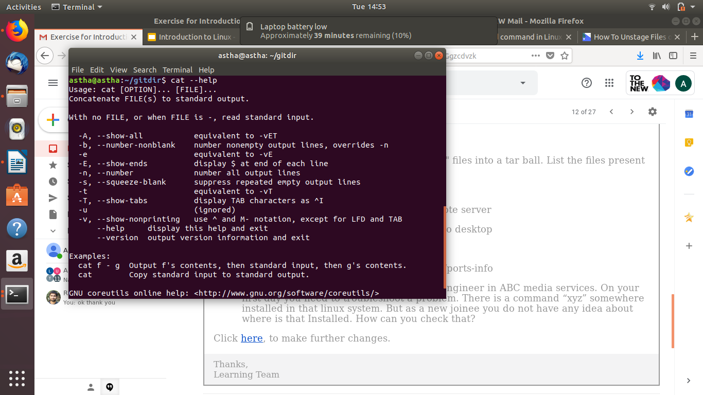

19 Create a symlink of /etc/services into /tmp/ports-info
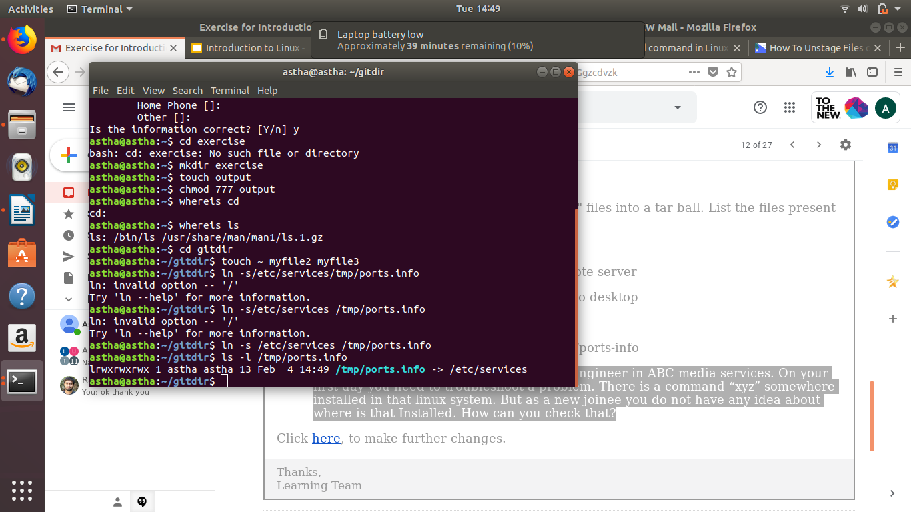

20 You are appointed as a Software/DevOps Engineer in ABC media services. On your first day you need to troubleshoot a problem. There is a command “xyz” somewhere installed in that linux system. But as a new joinee you do not have any idea about where is that Installed. How can you check that?

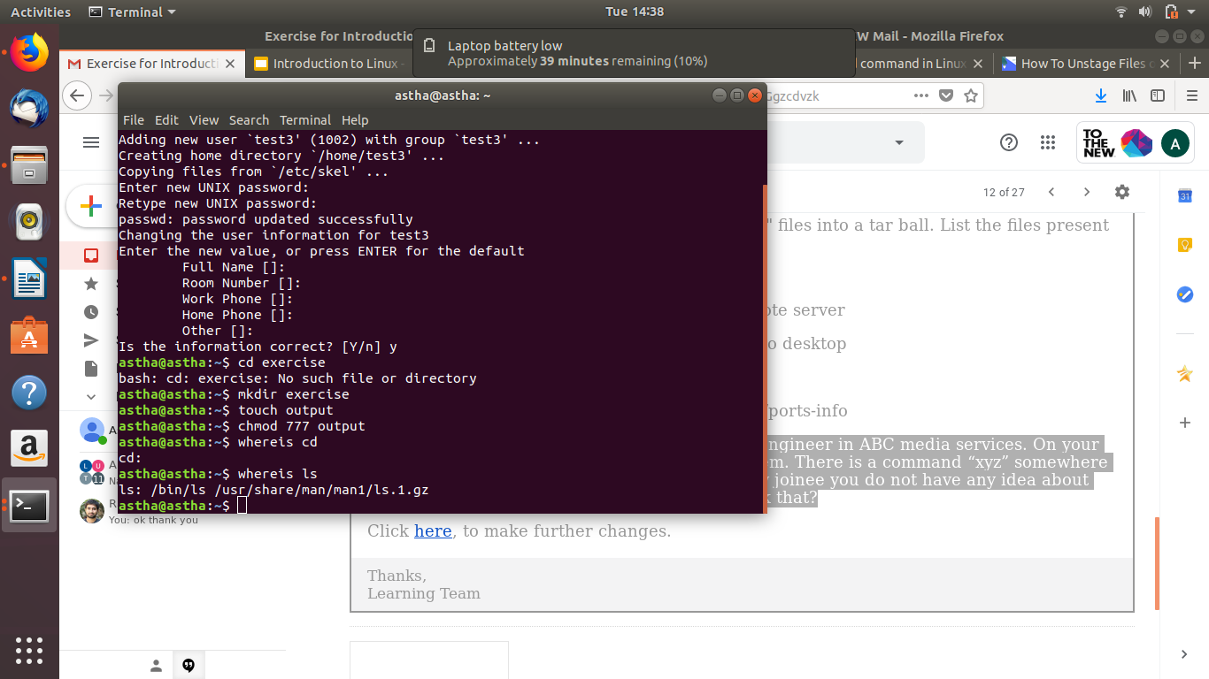
whereis ls

