DATA-DRIVEN RETAIL SALES OPTIMIZATION
Adventure Works Retail Analytics

Prepared by:
Astha Singh
Role: Data Engineering Intern
Department: Application and Data Modernization and Migration,
Technology and Transformation

Year: 2026

- INTRODUCTION
Adventure Works Retail Analytics is a data analytics project designed to analyze retail sales performance for Adventure Works, a bicycle manufacturing company that sells products through direct online sales and business-to-business (B2B) resellers.
The project focuses on integrating sales data from different sources into a centralized MySQL data warehouse. Python is used for data exploration, cleaning, transformation, and preparation, while SQL is used to store and analyze the data. Power BI is used to create interactive dashboards that present sales performance, product trends, territory performance, and customer insights.
The project combines data engineering and business intelligence techniques to transform raw sales data into meaningful information. The analysis helps identify high-performing products and territories, understand customer purchasing patterns, and explore customer segments based on occupation, annual income, and age group.
The overall aim is to support data-driven decision-making by providing a structured and accessible view of retail sales performance.

- PROBLEM STATEMENT
Adventure Works generates sales data through two major channels: direct online sales and reseller sales. Analyzing these datasets separately can make it difficult to obtain a consolidated view of overall business performance.
The project addresses the following challenges:
- Fragmented Data: Sales information is stored across multiple datasets and requires integration for comprehensive analysis.
- Limited Sales Visibility: Identifying trends across sales channels, products, and territories can be difficult without centralized reporting.
- Customer Analysis: Understanding customer purchasing patterns based on occupation, annual income, and age group requires structured analysis.
- Reporting Difficulties: Manual analysis can make it harder to compare business performance consistently and efficiently.
To address these challenges, the project uses Python for data preparation, MySQL for centralized data storage, SQL for business analysis, and Power BI for interactive reporting. The resulting solution provides a consolidated view of sales performance and supports more informed business decisions.

3. PROJECT OBJECTIVES AND SCOPE
3.1 Project Objectives
The main objectives of the Adventure Works Retail Analytics project are:
- To explore and understand the available sales and dimension datasets.
- To clean, transform, and prepare the data using Python and Pandas.
- To develop a centralized MySQL data warehouse for storing processed data.
- To perform SQL-based analysis of internet sales, reseller sales, products, territories, and customers.
- To develop interactive Power BI dashboards for visualizing sales performance.
- To identify useful business insights from sales trends and customer segmentation.
3.2 Project Scope
The project covers the complete data analytics workflow, from raw Excel datasets to interactive business intelligence dashboards. It includes data exploration, data quality checks, ETL processing, data warehouse creation, SQL analysis, DAX measures, and Power BI visualization.
The analysis focuses on sales channel comparisons, product and category performance, sales territory comparisons, customer occupation and annual income, and customer age groups under 50. The project aims to support business reporting and data-driven decision-making using the available historical data.

- TOOLS AND TECHNOLOGIES USED
The project uses the following tools and technologies to implement the data analytics workflow.
1. Python
Python is used for data exploration, cleaning, transformation, validation, and automation of the ETL process.
2. Pandas and NumPy
Pandas is used to read, manipulate, clean, and transform the Excel datasets. NumPy supports numerical operations and data processing where required.
3. MySQL and MySQL Workbench
MySQL is used to create the centralized data warehouse and store the processed dimension and fact tables. MySQL Workbench provides an interface for executing SQL scripts, managing tables, and inspecting query results.
4. SQL
SQL is used to retrieve, aggregate, and analyze sales data. Queries are developed to examine sales performance, product categories, customer segments, and sales territories.
5. Power BI Desktop
Power BI is used to develop interactive dashboards that present key performance indicators, sales trends, product analysis, territory comparisons, and customer segmentation.
6. DAX
Data Analysis Expressions (DAX) is used to create measures for total sales, channel sales, average order value, customer counts, and sales from customers under 50.
7. Visual Studio Code
Visual Studio Code is used to write, edit, and execute the Python scripts and manage the project files.
8. GitHub
GitHub is intended to host the complete project source code and supporting files so that the implementation can be accessed and reviewed through a repository link.

- DATASET DESCRIPTION
The project uses three Excel workbooks containing sales transaction data and supporting dimension tables from the Adventure Works dataset. These datasets provide information about customers, products, employees, geography, sales territories, resellers, and sales transactions.
5.1 Source Files
1. DimTables.xlsx
This workbook contains the dimension tables used to describe business entities. These include customer, product, reseller, employee, geography, and sales territory information.
2. FactInternetSales.xlsx
This file contains online sales transaction records, including product and customer keys, sales order details, order dates, sales amounts, product costs, discounts, and freight.
3. FactResellerSales.xlsx
This file contains reseller sales transactions, including product and reseller keys, order information, dates, sales amounts, costs, and other transaction details.
5.2 Dataset Overview
The initial exploration identified the following record counts:
- DimCustomer: 18,484 records
- DimEmployee: 21 records
- DimGeography: 655 records
- DimProduct: 397 records
- DimReseller: 701 records
- DimSalesTerritory: 11 records
- FactInternetSales: 60,398 records
- FactResellerSales: 60,899 records before cleaning
The datasets contain both descriptive dimension data and transactional sales data. The dimension tables provide context for analysis, while the fact tables contain the sales transactions used to calculate business performance measures.

- PROJECT WORKFLOW AND ARCHITECTURE
The project follows a structured data analytics workflow that transforms raw sales data into meaningful business insights. Python is used for data exploration and ETL, MySQL stores the processed data, SQL performs business analysis, and Power BI presents the results through interactive dashboards.
6.1 Workflow Steps
Step 1: Data Extraction
The source Excel workbooks are read using Python and Pandas to access the sales and dimension tables.
Step 2: Data Exploration
The datasets are examined to understand their structure, column names, data types, record counts, and data quality issues.
Step 3: Data Cleaning and Transformation
Missing values, duplicate records, inconsistent text, date formats, and data types are handled as required. Additional customer age and age-group fields are also created.
Step 4: Data Warehouse Loading
The processed CSV files are loaded into the MySQL database adventure_works_dw, which contains dimension and fact tables.
Step 5: SQL Analysis
SQL queries calculate sales totals, average order values, product performance, territory comparisons, monthly trends, and customer segmentation metrics.
Step 6: Power BI Visualization
Power BI connects to MySQL and uses DAX measures to create a five-page interactive report covering executive sales performance, territories, products, customer segmentation, and customers under 50.
6.2 Architecture Summary
The workflow can be summarized as:
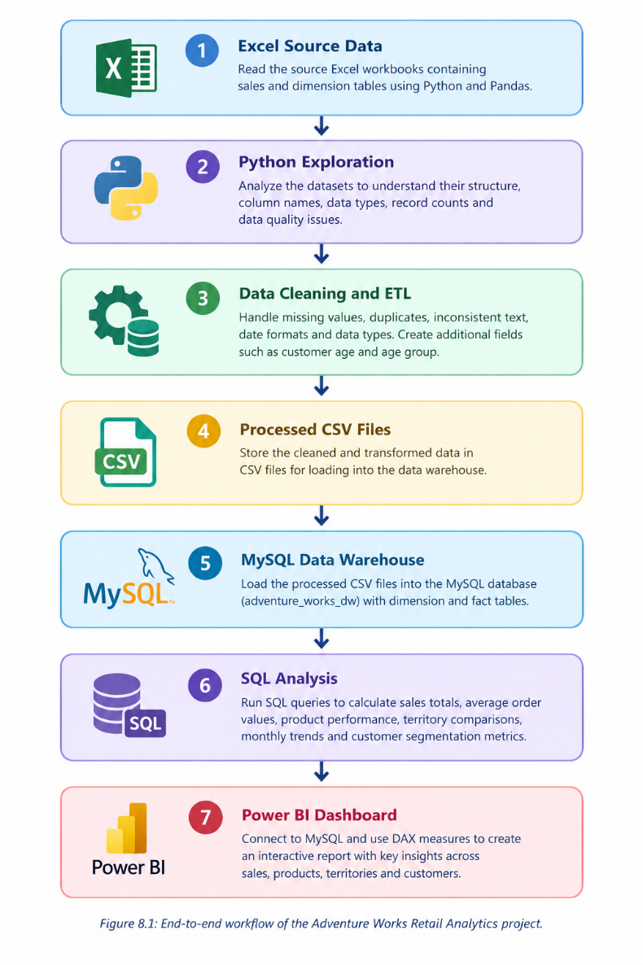
Figure: End-to-end workflow of the Adventure Works Retail Analytics project
- DATA EXPLORATION USING PYTHON
Data exploration is an important initial stage of the Adventure Works Retail Analytics project. Before cleaning or transforming the data, the source datasets were examined to understand their structure, contents, and quality. Python and the Pandas library were used to automate this process and inspect the Excel workbooks.
The project uses three source files: DimTables.xlsx, FactInternetSales.xlsx, and FactResellerSales.xlsx. These files contain descriptive business information and transactional sales records required for the subsequent data warehouse and analytical stages.
7.1 Reading and Inspecting the Datasets
The Python exploration script reads the Excel workbooks and loads their data into Pandas DataFrames. Each DataFrame represents a dataset in a tabular format, allowing its columns, rows, and values to be examined programmatically.
The script inspects the dimensions of the datasets, which indicate the number of records and columns available for analysis. It also examines column names and data types to understand the information stored in each field. For example, customer and product keys are used to connect records, date columns support time-based analysis, and sales amount columns provide the numerical values needed for business calculations.
This step helps identify the structure of the source data before designing the cleaning and transformation procedures.
7.2 Dataset Structure and Record Counts
The exploration identified six major dimension tables and two sales fact tables. The dimension tables describe customers, products, resellers, employees, geographical locations, and sales territories. The fact tables contain transactional records for online and reseller sales.
The initial record counts were:
- DimCustomer: 18,484 records
- DimEmployee: 21 records
- DimGeography: 655 records
- DimProduct: 397 records
- DimReseller: 701 records
- DimSalesTerritory: 11 records
- FactInternetSales: 60,398 records
- FactResellerSales: 60,899 records
The Internet Sales dataset contained 60,398 transactions, while the Reseller Sales dataset initially contained 60,899 records. These counts provided a baseline for checking whether records were retained or removed during ETL processing.
7.3 Missing Values and Duplicate Records
The exploration script checks the datasets for missing values and duplicate records. Missing values can affect calculations and data relationships, while duplicate records may cause sales amounts to be counted more than once.
The inspection identified missing values in selected fields, including ParentEmployeeKey in the employee dimension and Color in the product dimension. The reseller sales dataset also contained incomplete records that required further investigation.
The results were used to determine which issues could be corrected through transformation and which records needed to be excluded because essential information was unavailable. These issues were handled during the data cleaning and ETL stage rather than being addressed indiscriminately during exploration.
7.4 Importance of Data Exploration
Data exploration established an understanding of the source data before it was loaded into the data warehouse. It helped identify the fields required for analysis, highlighted data quality problems, and provided initial record counts for subsequent validation.
The findings guided the development of the ETL script and helped ensure that the processed datasets were suitable for MySQL storage, SQL analysis, and Power BI reporting.
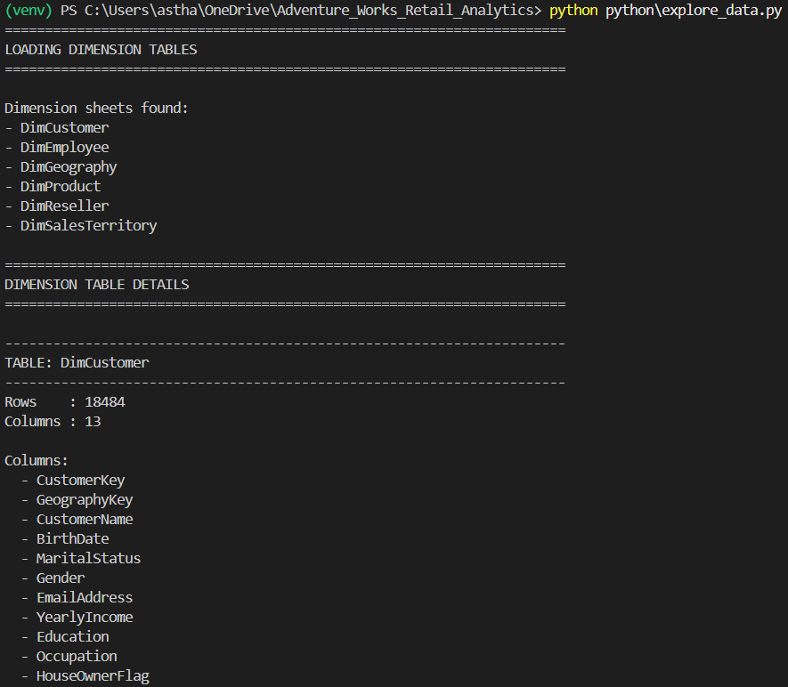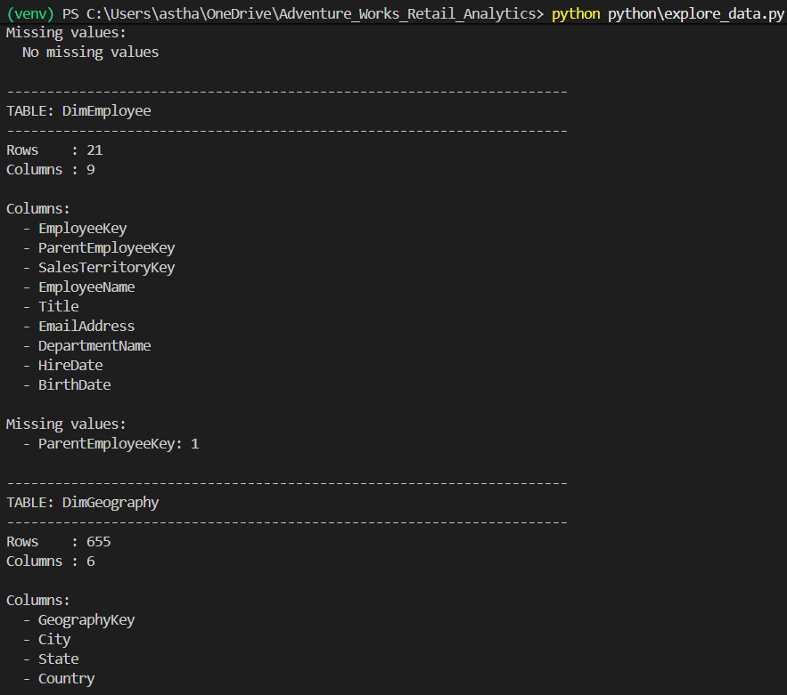
Figure: Dataset Structure and Dimensions
The screenshot shows the structure and dimensions of the Adventure Works datasets loaded using Python and Pandas. It helps identify the number of records and columns in each dataset before data cleaning and transformation.
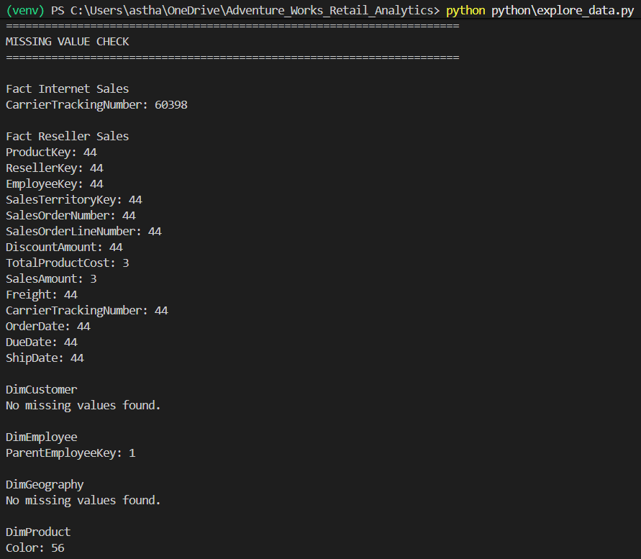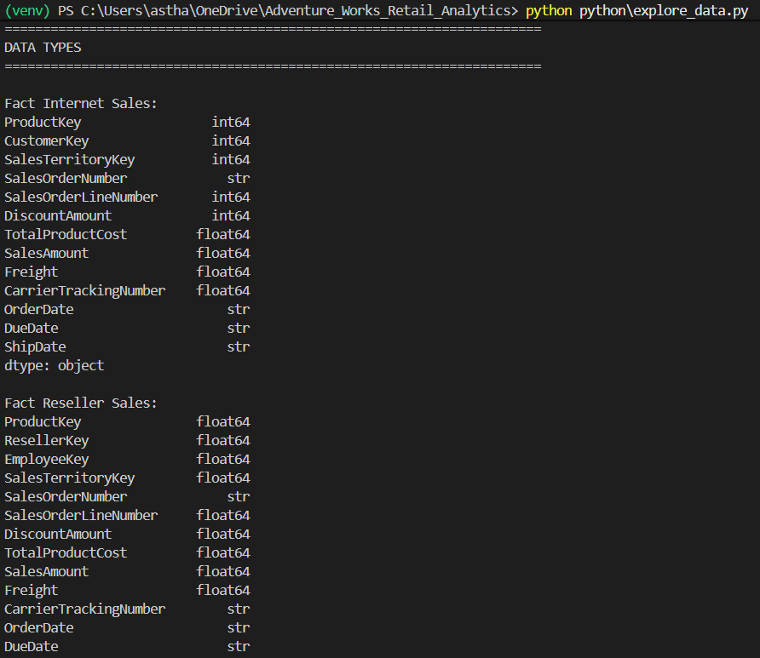
Figure: Missing Values and Data Quality
The screenshot presents the missing-value analysis performed on the source datasets. It identifies fields requiring attention before loading the data into the data warehouse, helping improve data quality and reliability.

8. DATA CLEANING AND ETL USING PYTHON
8.1 Introduction to Data Cleaning and ETL
The ETL (Extract, Transform, Load) process was implemented using Python and the Pandas library to prepare the Adventure Works datasets for analysis. The process involves extracting the source data, cleaning and transforming the records, and saving the processed datasets for loading into the MySQL data warehouse.
The main objective is to improve data consistency, handle incomplete records appropriately, standardize data formats, and create additional attributes required for customer analysis.
8.2 Data Extraction
The source data was extracted from three Excel workbooks stored in the project's data folder: DimTables.xlsx, FactInternetSales.xlsx, and FactResellerSales.xlsx.
Pandas was used to load six dimension tables and two sales fact tables into DataFrames. These DataFrames provide a convenient structure for inspecting, cleaning, and transforming the source data using Python.
8.3 Cleaning Dimension Tables
The dimension tables were cleaned according to the characteristics of their individual columns. In the employee table, ParentEmployeeKey was converted to a nullable integer type, while its missing value was preserved because a top-level employee may not have a parent employee.
In the product table, missing values in the Color column were replaced with Unknown. Similarly, missing descriptive values in the sales territory table were replaced with Unknown to maintain consistency in the categorical information.
8.4 Cleaning Sales Fact Tables
The Internet Sales dataset was checked for exact duplicate rows, and any duplicates found were removed. Its order, due, and shipping date columns were converted to date formats, while the relevant identifiers and sales-related fields were converted to numeric types.
The Reseller Sales dataset was cleaned by removing records with missing essential fields, including ProductKey, ResellerKey, SalesOrderNumber, and OrderDate. Exact duplicate rows were then removed, and its date and numeric columns were standardized for further processing.
8.5 Text Cleaning and Column Removal
A reusable Python function was created to clean text columns across all dimension and fact tables. It converts these columns to a consistent string representation and removes unnecessary leading and trailing spaces.
The CarrierTrackingNumber column was removed from both sales fact tables because it was not required for the project's main analytical requirements. This reduced unnecessary data in the processed datasets.
8.6 Customer Age and Age Group Creation
The customer dataset was enhanced with an Age column calculated from BirthDate, using 31 December 2014 as the reference date. The calculation also accounts for whether the customer's birthday had occurred by that date.
An AgeGroup column was then created using predefined age ranges, including Under 25, 25–30, 30–35, 35–40, 40–45, 45–50, 50–60, and 60+. These attributes support customer segmentation and age-based analysis in Power BI.
8.7 Saving the Processed Datasets
After the cleaning and transformation operations, the indexes of the processed DataFrames were reset. The six dimension tables and two fact tables were then exported as CSV files to the project's processed_data folder.
The script prints the number of rows saved for each table and displays a final ETL summary. These processed files are subsequently used by the MySQL loading script to populate the data warehouse.
8.8 ETL Execution and Validation
The ETL script provides status messages throughout its execution, including the number of records loaded, incomplete reseller rows removed, duplicate rows removed, and records saved to the processed files.
The final summary displays the row counts of all eight processed tables and confirms successful completion when the script finishes without errors. These outputs help verify that the extraction, transformation, and file-saving stages have completed.
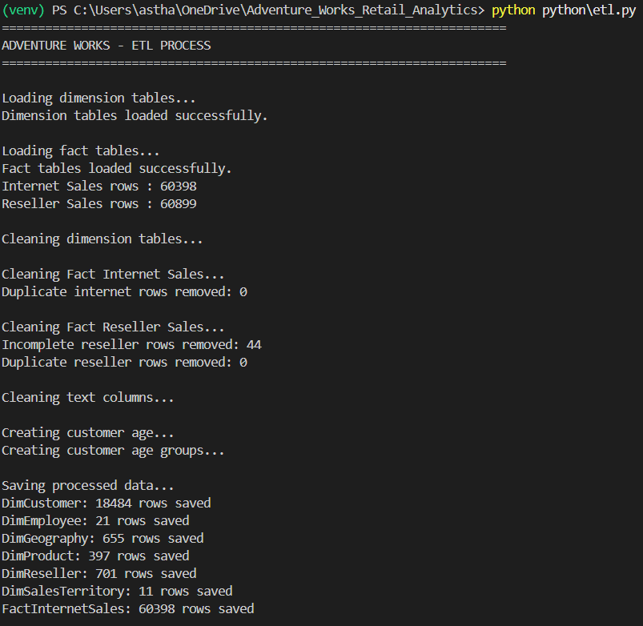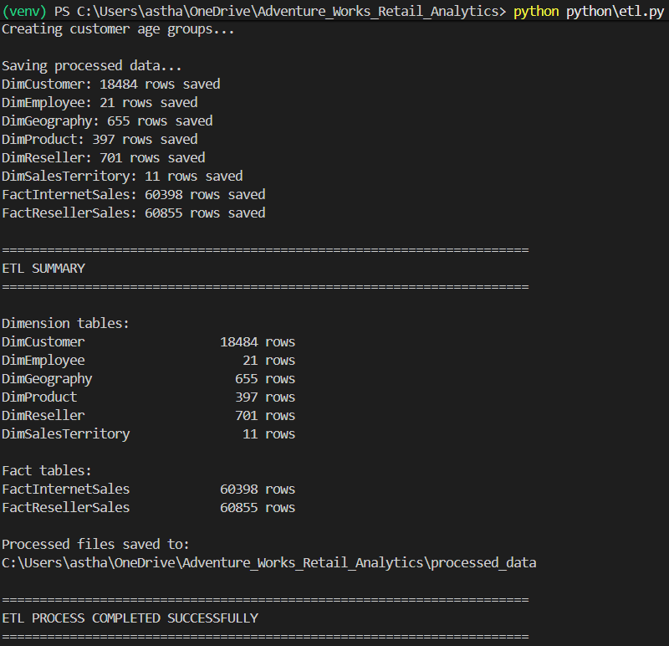
Figure: Execution Output of the ETL Process
The screenshot shows the successful execution of the Python ETL script, including the data-cleaning and transformation operations performed on the six dimension tables and two fact tables. The final summary displays the number of records saved in each processed dataset and confirms that the ETL process has been completed successfully.

9. LOADING DATA INTO MYSQL DATA WAREHOUSE
9.1 Introduction
After completing the data cleaning and transformation process, the processed datasets were loaded into the MySQL data warehouse named adventure_works_dw. This stage stores the cleaned data in structured database tables, making it accessible for SQL queries, analytical calculations, and business reporting.
The data warehouse contains six dimension tables and two fact tables. The dimension tables store descriptive information about customers, employees, geography, products, resellers, and sales territories. The fact tables store Internet Sales and Reseller Sales transactions, which form the basis for analyzing sales performance across different business categories.
9.2 MySQL Connection and Configuration
The data loading script uses SQLAlchemy and the MySQL Connector to establish a connection between Python and the MySQL database. The connection configuration specifies the database username, host, port, and database name. The password is requested securely at runtime using Python's getpass module rather than being directly written into the script.
Before loading any records, the script tests the database connection by executing a simple SQL query. If the connection fails, the script displays an error message and stops execution. This preliminary check helps prevent the loading process from continuing without a working database connection.
9.3 Mapping Processed Files to Database Tables
The script defines a mapping between the eight processed CSV files and their corresponding MySQL table names. Each dimension dataset is assigned to its appropriate dimension table, while the two sales datasets are mapped to fact_internet_sales and fact_reseller_sales.
This mapping ensures that the processed files are loaded into the intended database tables. The script also checks whether each required CSV file exists in the processed_data folder before proceeding, preventing the loading process from continuing when a source file is missing.
9.4 Checking Existing Data Before Loading
Before inserting records, the script reads each processed CSV file and compares its expected row count with the number of records already present in the corresponding MySQL table. This check helps determine whether the table is empty, already loaded, or contains only part of the expected data.
If a table is empty, it is selected for loading. If its existing row count matches the expected count, the script skips that table to avoid inserting the same dataset again. If the counts differ, the script stops and displays a warning rather than risking duplicate or incomplete data. This provides a basic safeguard when rerunning the loading script.
9.5 Data Type Conversion and Loading
Before inserting the records, the script converts applicable date columns into date values and selected identifier and age columns into nullable integer types. These conversions help maintain consistency between the processed CSV files and the database schema.
The Pandas to_sql() method is then used to insert each dataset into its designated MySQL table. The script uses append mode and processes records in batches of 1,000 rows. This allows the prepared datasets to be transferred to MySQL without attempting to insert the entire dataset in a single batch.
9.6 Row Count Validation
After each table is loaded, the script queries MySQL to retrieve the table's current row count. The result is displayed alongside the name of the table, providing an immediate check of the loading operation.
At the end of the process, the script performs a final row count check for all eight tables. It displays the number of records present in each table and prints a completion message when execution reaches the end successfully. These checks help verify that the expected data is present in the database.
9.7 Importance of the Loading Process
Loading the processed datasets into MySQL establishes a centralized data warehouse for the Adventure Works Retail Analytics project. It separates data preparation from data storage and provides a structured foundation for querying sales transactions alongside their related dimension tables.
The completed data warehouse is subsequently used for SQL-based analysis and Power BI reporting. This enables the project to examine sales performance, compare Internet and Reseller Sales, analyze products and territories, and present business insights through interactive dashboard visualizations.
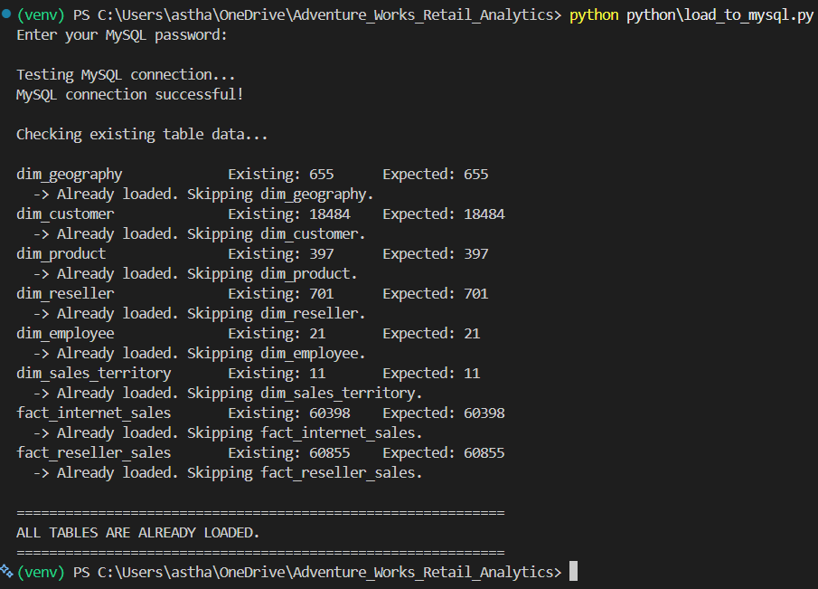
Figure: Execution Output of the MySQL Data Loading Process
The screenshot displays the execution of the Python data loading script and the final row count validation performed on the MySQL data warehouse tables. The output confirms the number of records present in each dimension and fact table and indicates successful completion of the loading process.

10. SQL-BASED DATA ANALYSIS
10.1 Introduction to SQL Analysis
After loading the cleaned datasets into the MySQL data warehouse, SQL was used to analyze the Adventure Works retail sales data. The analysis was performed using the adventure_works_dw database, which contains six dimension tables and two fact tables.
The main objective of this stage was to transform transaction-level data into meaningful business information. SQL queries were developed to examine revenue, compare sales channels, evaluate product performance, analyze customer segments, and understand geographical sales distribution.
10.2 Query Development and Execution
Twenty SQL queries were developed and organized in the analysis.sql file. These queries were executed using MySQL Workbench, which allows SQL statements to be written, executed, and inspected through result grids.
The queries use aggregate functions such as SUM(), COUNT(), and ROUND(), along with joins, subqueries, grouping, sorting, and conditional expressions. These operations help combine related information from different tables and calculate the summaries required for business analysis.
10.3 Overall Sales Performance Analysis
The first three queries calculate total Internet Sales, total Reseller Sales, and combined sales across both channels. The SUM() function is used to calculate sales amounts, while ROUND() formats the resulting totals to two decimal places.
These calculations establish an overview of the business's sales performance. Separating the two channels also makes it possible to compare direct Internet Sales with sales generated through resellers.
10.4 Sales Territory and Geographical Analysis
The territory analysis calculates combined sales for different sales territories by aggregating Internet Sales and Reseller Sales separately and then combining their totals. The results are sorted to identify territories with higher sales contributions.
The country-level analysis follows a similar approach to compare sales across countries. In addition, a separate query sorts territories from the lowest to the highest total sales, helping identify territories that may require further investigation.
10.5 Average Order Value Analysis
Average Order Value is calculated separately for Internet Sales and Reseller Sales by dividing total sales by the number of distinct sales orders. This provides an indication of the average sales value associated with an order in each channel.
Another query calculates average order value by sales territory. These results help compare the average order values across geographical regions and complement the total sales figures when evaluating territory performance.
10.6 Sales Channel and Product Analysis
The sales channel comparison query uses UNION ALL to present Internet Sales and Reseller Sales as separate results in a common output. This makes the contribution of each channel easier to compare.
Product analysis examines total sales by category and identifies the ten products with the highest sales values. The queries combine the product dimension with sales records from both fact tables, allowing product performance to be evaluated across the two sales channels.
10.7 Customer Occupation and Income Analysis
Customer analysis examines Internet Sales according to customer occupation and yearly income. The occupation query calculates total sales, the number of distinct customers, and average sales per customer for each occupation group.
For income-based analysis, a conditional CASE expression divides customers into five yearly income ranges: below 30,000; 30,000–60,000; 60,000–90,000; 90,000–120,000; and 120,000 or above. These groups help compare customer counts and sales performance across different income levels.
10.8 Age-Based Customer Segmentation
The age-based queries use the AgeGroup attribute created during the Python ETL process. They calculate the number of customers, total Internet Sales, and average sales per customer for each age group.
A separate query focuses on the selected age groups from 25–30 through 45–50. This supports the project's analysis of customers under 50 and helps compare sales performance among the selected age segments.
10.9 Combined Customer Segmentation
The customer segmentation query combines occupation and yearly income group into a single analysis. Customers are grouped by both attributes, allowing sales totals, customer counts, and average sales per customer to be examined for each combination.
This approach provides a more detailed view of customer purchasing patterns than analyzing occupation or income independently. The results can support comparisons between customer segments in the project's analytical dashboard.
10.10 Monthly Sales Trend Analysis
Two queries examine monthly sales trends separately for Internet Sales and Reseller Sales. The YEAR() and MONTH() functions extract the year and month from each order date, while GROUP BY summarizes sales for each period.
The results are ordered chronologically to make changes in monthly sales easier to examine. These summaries provide the data needed to study sales trends over time and support the monthly sales visualizations in Power BI.
10.11 Top Customers by Sales
The final query identifies the ten customers with the highest total Internet Sales. It joins the customer dimension with the Internet Sales fact table and groups the records by customer details.
The results include customer name, occupation, yearly income, and total sales. Sorting the results in descending order and limiting the output to ten records highlights the customers contributing the highest Internet Sales within the dataset.
10.12 Summary of SQL Analysis
The twenty queries cover overall sales, sales channels, average order value, geographical performance, product categories, customer characteristics, age groups, and monthly sales trends. Together, they demonstrate how SQL can transform stored transaction data into structured summaries for business analysis.
The results also support the Power BI reporting stage, where relevant measures and comparisons are presented through charts, cards, and other visualizations. This connects the MySQL data warehouse with the project's goal of developing a data-driven understanding of retail sales performance.
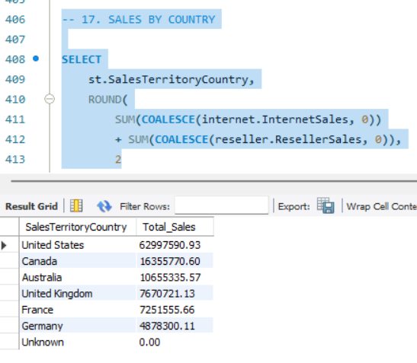
Figure: SQL Query Execution and Analysis Results
The screenshot shows the execution of a SQL query that calculates combined Internet and Reseller Sales for each country. The results provide a comparison of geographical sales performance and demonstrate how SQL aggregation and joins can be used to generate business insights from the data warehouse.

11. POWER BI DASHBOARD DEVELOPMENT
11.1 Introduction
Microsoft Power BI was used to create an interactive dashboard for the Adventure Works Retail Analytics project. The dashboard converts the structured data stored in the MySQL data warehouse into visual reports that help analyze sales performance, geographical distribution, product performance, and customer behavior.
The report consists of five dashboard pages, each designed to focus on a different aspect of retail analytics. KPI cards, bar charts, a donut chart, trend charts, and other visualizations were used to present the results in an understandable format.
11.2 Data Connection and Data Model
Power BI was connected to the adventure_works_dw database in MySQL. Six dimension tables and two fact tables were imported to provide the data required for analysis.
Relationships between the dimension and fact tables allow the visualizations to display sales information according to different categories, including customers, products, geography, and sales territories. DAX measures were also created to calculate key metrics such as Total Sales, Internet Sales, Reseller Sales, Average Order Value, and Number of Customers.
11.3 Executive Sales Overview
The Executive Sales Overview page provides a summary of the overall sales performance. KPI cards display Total Sales, Internet Sales, Reseller Sales, and Total Average Order Value.
The page also includes a monthly Internet Sales trend chart, a donut chart comparing Internet and Reseller Sales, and a visualization of Total Sales by Sales Territory. These visuals provide an overview of sales performance and the contribution of the two sales channels.
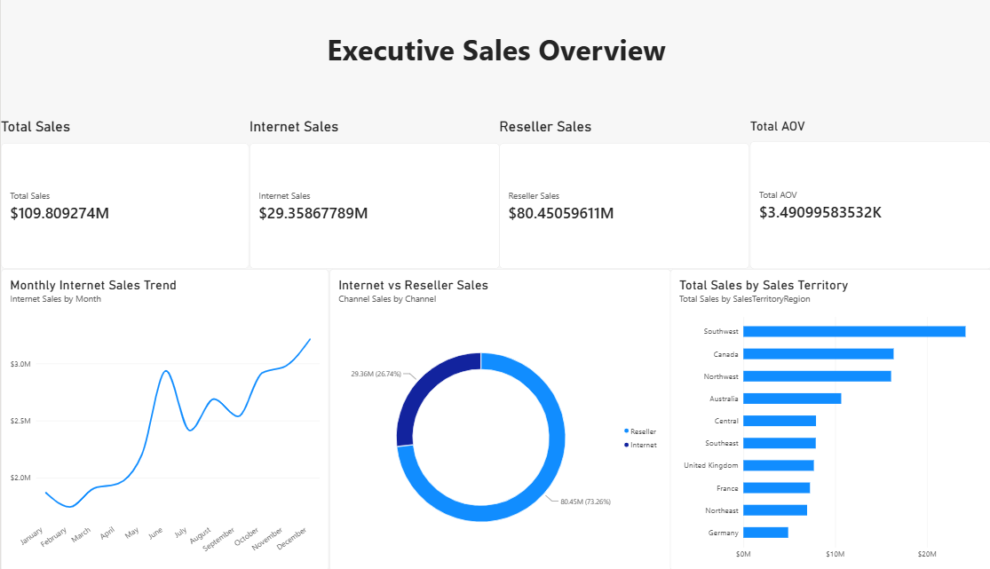
Figure: Executive Sales Overview Dashboard
The screenshot displays the main sales KPIs, monthly Internet Sales trend, sales channel comparison, and territory-level sales. It provides a consolidated overview of retail sales performance.
11.4 Sales Territory Performance
The Sales Territory Performance page focuses on comparing sales across different territories. It includes a combination chart showing Total Sales and Total Average Order Value by territory, a bar chart comparing Total Sales, and another bar chart displaying Average Order Value by territory.
A KPI card presents Total Sales Across Territories. These visualizations help identify differences in sales performance and order value between geographical areas.
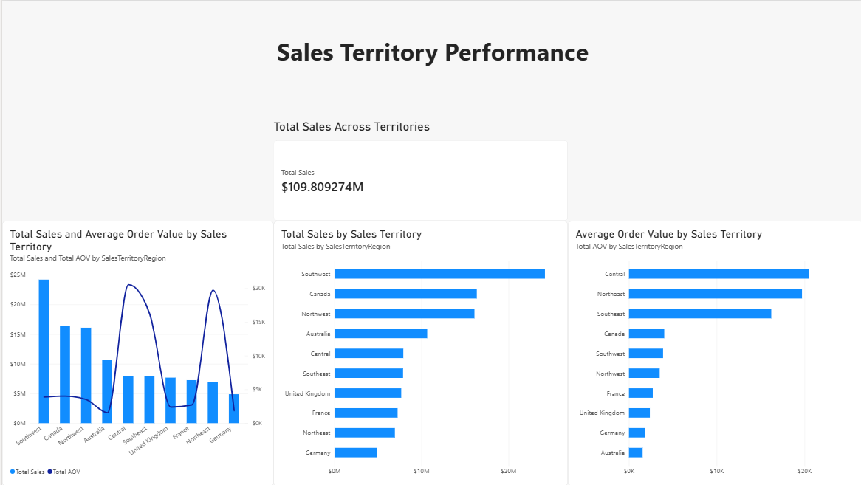
Figure: Sales Territory Performance Dashboard
The screenshot presents sales and Average Order Value comparisons across territories. It helps highlight geographical differences in retail performance.
11.5 Product and Category Analysis
The Product and Category Analysis page examines sales performance at different product levels. It includes Total Sales by Product Category, the Top 10 Products by Total Sales, and Total Sales by Product Subcategory.
A KPI card displays the Number of Products included in the analysis. Together, these visuals help compare product groups and identify individual products that contribute significantly to sales.
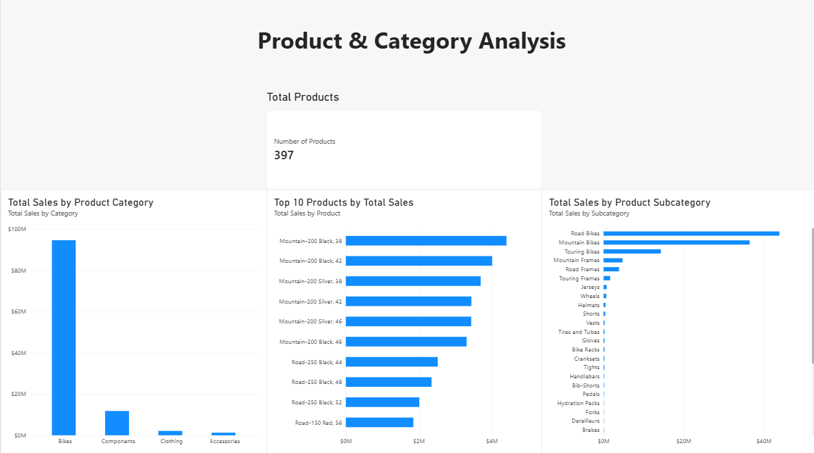
Figure: Product and Category Analysis Dashboard
The screenshot displays category-wise and subcategory-wise sales, along with the top ten products by sales. It supports the identification of important product groups and high-performing products.
11.6 Customer Segmentation
The Customer Segmentation page analyzes Internet Sales across different customer groups. The visualizations compare Average Sales per Customer by occupation and annual income, Average Sales per Customer by occupation, and Average Sales per Customer by annual income.
A customer count chart provides an additional view of the distribution of customers by occupation. These comparisons help examine how purchasing patterns vary across the available customer segments.
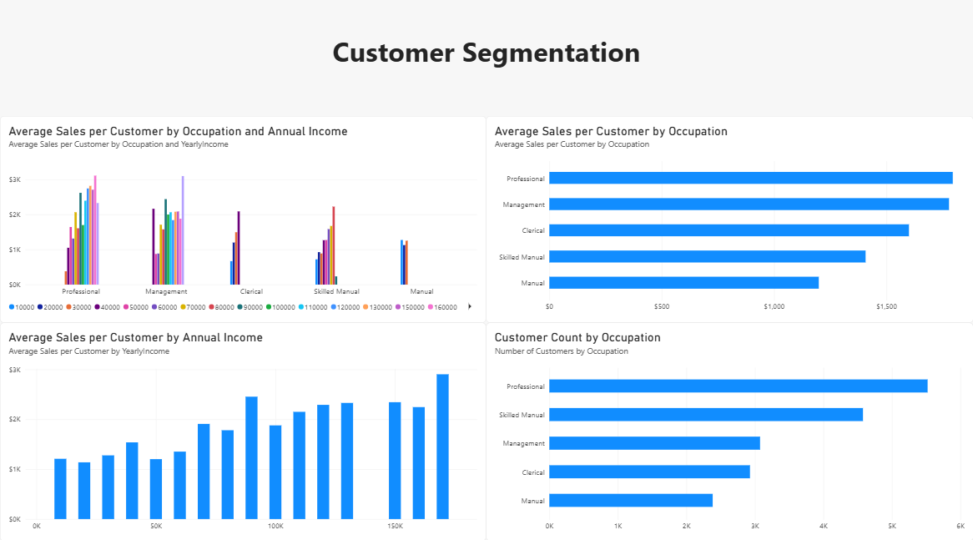
Figure: Customer Segmentation Dashboard
The screenshot presents customer sales comparisons based on occupation and annual income, along with customer counts. It supports the analysis of differences between customer segments.
11.7 Target Customers Under 50
The Target Customers Under 50 page focuses on customer groups below 50 years of age. It includes a KPI card showing the number of customers under 50, a sales visualization by age group for the selected customer groups, and a chart showing customer counts by age group.
These visuals provide a focused view of Internet Sales and customer distribution among the selected age groups. The results can support further analysis of purchasing patterns within these segments.
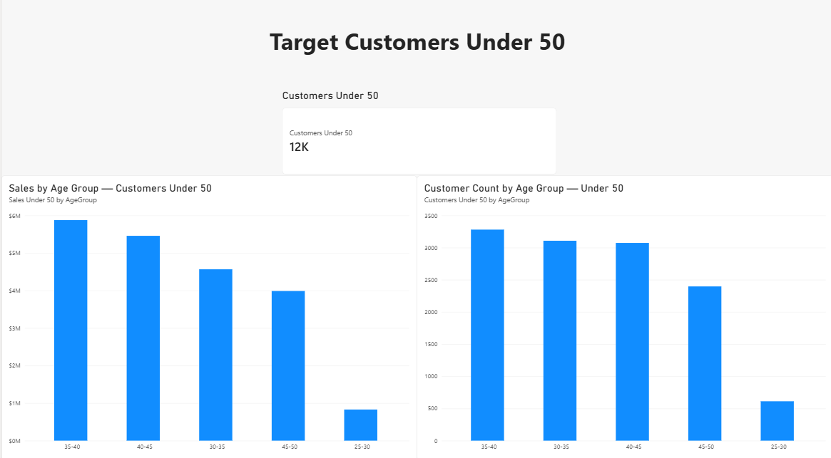
Figure: Target Customers Under 50 Dashboard
The screenshot displays customer counts and Internet Sales across the selected age groups below 50. It provides a focused view of the customer segments included in this analysis.
11.8 Summary
The five Power BI dashboard pages present complementary views of retail sales performance. The Executive Sales Overview summarizes the business, while the remaining pages focus on territory performance, products, customer segmentation, and customers under 50.
The dashboard completes the visualization stage of the project by presenting the results of the data preparation, MySQL data warehouse, and SQL analysis in a visual reporting environment. It makes the analyzed information easier to interpret and supports data-driven business decisions.

12. KEY FINDINGS AND BUSINESS INSIGHTS
12.1 Overall Sales Performance
The project combines Internet Sales and Reseller Sales to provide an overall view of retail performance. Comparing these two channels helps explain their respective contributions to total sales and provides a clearer understanding of the business's sales structure.
12.2 Geographical Performance
The SQL analysis identified the United States as the largest contributor to combined sales, with approximately 63.00 million in sales. Canada followed with approximately 16.36 million, while Australia contributed approximately 10.66 million.
These results demonstrate the importance of geographical analysis in understanding differences between markets. Sales territory comparisons can help identify stronger-performing regions and areas that may require further investigation.
12.3 Product Performance
The product analysis examines sales across product categories, subcategories, and individual products. The Top 10 Products query ranks products according to their combined Internet and Reseller Sales.
This analysis helps identify products that contribute significantly to revenue and provides a basis for further investigation into product demand and category-level performance.
12.4 Customer Segmentation
Customer segmentation examines Internet Sales by occupation, annual income, and age group. These comparisons help identify differences in purchasing patterns across customer segments.
The analysis of customers under 50 provides an additional perspective on selected age groups. Such segmentation can support more focused marketing analysis and customer engagement decisions.
12.5 Sales Trends and Average Order Value
The monthly sales queries examine Internet Sales and Reseller Sales over time, helping reveal changes in sales performance across months. Average Order Value calculations provide another perspective by measuring sales per distinct order within each channel.
Together, these analyses allow sales performance to be examined using both total revenue and order-level measures.
12.6 Overall Project Outcomes
The project integrates Python-based data preparation, a MySQL data warehouse, SQL-based analysis, and Power BI dashboards into a structured analytics workflow.
The final analysis covers geographical sales distribution, product performance, customer segmentation, monthly sales trends, and Average Order Value. These outputs demonstrate how data engineering and business intelligence techniques can transform raw retail data into useful information for business analysis.

13. CONCLUSION
- The Adventure Works Retail Analytics project demonstrates the use of data engineering and business intelligence techniques to analyze retail sales data.
- Python and Pandas were used for data exploration, cleaning, transformation, and preparation of the source datasets.
- A MySQL data warehouse was created with six dimension tables and two fact tables to organize the processed data for analysis.
- SQL queries were developed to analyze overall sales, geographical performance, product contributions, Average Order Value, monthly sales trends, and customer segmentation.
- Microsoft Power BI was used to create five interactive dashboard pages covering executive sales performance, sales territory performance, product and category analysis, customer segmentation, and target customers under 50.
- The project provided practical experience in Python, Pandas, MySQL, SQL, data warehousing, data modeling, and Power BI.
- Overall, the project demonstrates how raw retail data can be transformed into structured and meaningful information to support business analysis and data-driven decision-making.

14. PROJECT REPOSITORY
The complete source code and project files for Adventure Works Retail Analytics will be maintained in a GitHub repository. The repository will contain the Python scripts, SQL queries, processed data files, and other relevant project resources.
The repository provides a convenient way to access the implementation details and understand the complete workflow, from data exploration and ETL processing to data warehousing, SQL analysis, and Power BI visualization.
GitHub Repository Link:

