HEALTHCARE PATIENT ANALYTICS & PREDICTION
Data Analytics and Predictive Modeling Project

Prepared by:
Astha Singh
Role: Data Engineering Intern
Department: Application and Data Modernization and Migration,
Technology and Transformation

Year: 2026

1. Introduction
Healthcare organizations generate large amounts of patient information through admissions, vital measurements, treatments, and follow-up records. Analyzing this information can help hospitals understand admission patterns and identify patients who may require closer monitoring.
This project focuses on Healthcare Patient Analytics and Prediction using patient, admission, vital, treatment, and readmission-risk data. The project combines Python-based data processing, SQL-based analytics, machine learning models, and Power BI visualization to create an end-to-end healthcare analytics solution.
The case study is based on MediCare Hospital, where the key challenges include delayed identification of high-risk cases, limited real-time analytics, and manual tracking of patient follow-up. The proposed solution integrates healthcare data, performs predictive analysis, and presents the results through interactive dashboards.

2. Problem Statement
MediCare Hospital faces challenges in managing and analyzing patient information effectively. The case study identifies delayed identification of high-risk patients, lack of real-time analytics, and manual tracking of patient information and follow-up activities as key problems.
The project addresses these challenges by combining healthcare data from patients, admissions, vital measurements, treatments, and readmission-risk information into an analytics workflow. Python is used for data preparation and transformation, SQL is used for structured analysis and data warehousing, machine learning is used for readmission-risk prediction, and Power BI is used to present the results through interactive dashboards.
The overall aim is to provide a data-driven approach that can help identify potentially high-risk cases earlier and support better monitoring and follow-up of patients.

3. Project Objectives
The main objectives of the Healthcare Patient Analytics and Prediction project are:
- Analyze patient admission and discharge data to understand hospital activity and patient patterns.
- Integrate healthcare data from patients, admissions, vital measurements, and treatment records into a structured analytics system.
- Clean and transform healthcare data using Python and Pandas so that it can be used reliably for analysis and prediction.
- Identify high-risk patients by developing machine learning models based on relevant patient and admission characteristics.
- Analyze readmission risk and compare predicted risk categories with actual 30-day readmission outcomes.
- Monitor patient vitals and treatment patterns to identify useful trends within the available dataset.
- Create interactive Power BI dashboards for admission trends, readmission risk, patient information, clinical measurements, treatments, and doctor specialization.
- Support data-driven decision-making by presenting important healthcare insights in an understandable visual format.
These objectives are aligned with the case study's focus on early high-risk identification, post-discharge monitoring, analytics, and improved healthcare efficiency.

4. Project Scope
The project focuses on analyzing healthcare data from MediCare Hospital to understand patient admissions, clinical measurements, treatments, and readmission risk.
The scope includes the following activities:
- Data Integration: Organizing patient, admission, doctor, vital, and treatment data into a structured system.
- Data Processing: Cleaning, transforming, and preparing the datasets using Python and Pandas.
- Data Warehousing: Storing the processed healthcare data in a MySQL database for analysis.
- Predictive Analytics: Developing machine learning models to estimate the likelihood of 30-day readmission.
- Risk Analysis: Categorizing predicted risk scores into Low, Medium, and High levels for analytical reporting.
- Dashboard Development: Creating Power BI dashboards to visualize admission trends, patient characteristics, vital measurements, treatments, and readmission risk.
The project is limited to the datasets provided for the case study. The predictions and risk categories are intended for academic analysis and should not be treated as clinical diagnoses or validated medical recommendations.
5. Technologies and Tools Used
The project uses a combination of programming, database, machine learning, and visualization technologies.
5.1 Python
Python is used for data exploration, cleaning, transformation, feature engineering, machine learning, and generation of prediction results.
5.2 Pandas and NumPy
Pandas is used to load and manipulate the CSV datasets, handle missing values, transform columns, merge datasets, and create analytical datasets. NumPy supports numerical operations during data processing and machine learning preparation.
5.3 Scikit-learn
Scikit-learn is used for preparing the machine learning data, feature scaling, model training, evaluation, and performance measurement.
5.4 XGBoost
XGBoost is included as one of the machine learning algorithms used for readmission prediction and is compared with Logistic Regression and Random Forest.
5.5 MySQL
MySQL is used to create the healthcare_dw data warehouse. The processed healthcare data is stored in related tables and SQL queries are used to perform analytical analysis.
5.6 Power BI
Power BI is used to create interactive dashboards for hospital admissions, readmission risk, patient and clinical analysis, and treatment and doctor analysis.
5.7 Development Environment
The project was developed using Visual Studio Code, PowerShell/terminal, a Python virtual environment, MySQL Workbench, and Power BI Desktop.
5.8 GitHub
GitHub will be used to store and share the complete project source code, datasets/scripts structure, and supporting project files. The repository link will be provided at the end of the report.

6. Dataset Description
The project uses five CSV datasets representing different aspects of the hospital's healthcare information. These datasets were used for data exploration, cleaning, transformation, database loading, predictive modeling, and dashboard development.
6.1 Patients Dataset
The Patients dataset contains 1,690 records and 8 columns. It includes patient identification and demographic information such as patient ID, name, date of birth, gender, contact number, address, and chronic conditions.
There were 240 missing values in the chronic conditions field. These values were handled during the ETL process by assigning the category "None Reported".
6.2 Admissions Dataset
The Admissions dataset contains 3,324 records and 7 columns. It contains admission ID, patient ID, admission and discharge dates, diagnosis, doctor ID, and room number.
This dataset forms the central part of the project because it connects patients and doctors with clinical and treatment information.
6.3 Doctors Dataset
The Doctors dataset contains 40 records and 5 columns. It includes doctor ID, name, specialization, and contact information.
6.4 Vitals Dataset
The Vitals dataset contains 33,148 records and 7 columns. It contains repeated vital measurements associated with hospital admissions, including heart rate, blood pressure, oxygen level, temperature, and recording time.
6.5 Treatments Dataset
The Treatments dataset contains 8,329 records and 6 columns. It records treatments associated with admissions, including treatment date, procedure, medication, and dosage.
Dataset Quality
Initial data exploration showed no duplicate records in the five source datasets. Foreign-key validation also confirmed that the admission, doctor, vital, and treatment relationships could be successfully established.

7. Project Workflow
The project follows an end-to-end data analytics workflow that converts the raw healthcare datasets into meaningful analytical and predictive results.
7.1 Overall Workflow
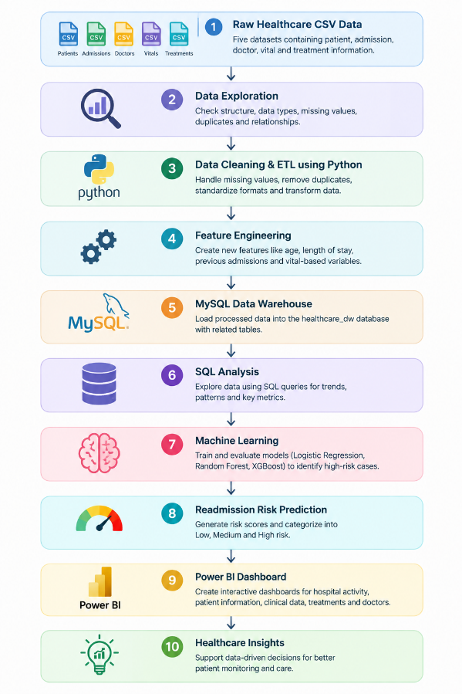
The workflow demonstrates the complete data pipeline used in the project, starting from raw healthcare data and progressing through Python-based ETL, MySQL storage, SQL analysis, machine learning, and Power BI visualization. This provides an end-to-end approach to healthcare analytics and readmission-risk analysis.
7.2 Workflow Description
1. Raw Data:
Five CSV datasets containing patient, admission, doctor, vital, and treatment information are used as the source data.
2. Data Exploration:
Python scripts inspect the datasets for their structure, missing values, duplicate records, data types, and relationships.
3. Data Cleaning & ETL:
Python and Pandas are used to standardize columns, handle missing values, convert dates and times, remove duplicates, and create derived analytical fields.
4. Feature Engineering:
Additional variables such as patient age, previous admissions, length of stay, vital statistics, and readmission-related features are generated for analysis and machine learning.
5. MySQL Data Warehouse:
The processed data is loaded into the healthcare_dw database using related tables for Doctors, Patients, Admissions, Vitals, Treatments, and Readmission_Risk.
6. SQL Analysis:
SQL queries are used to analyze admission patterns, diagnoses, treatments, vital measurements, risk levels, and actual readmissions.
7. Machine Learning:
Logistic Regression, Random Forest, and XGBoost are trained and evaluated to identify patterns associated with 30-day readmission.
8. Risk Prediction:
The selected analytical approach generates a risk score and assigns each admission to a project-defined Low, Medium, or High risk category.
9. Power BI:
The processed MySQL data is connected to Power BI to create interactive dashboards covering hospital activity, readmission risk, patient/clinical information, and treatments/doctors.

8. Data Exploration and Initial Analysis
8.1 Data Loading
The healthcare datasets were first loaded into Python using the Pandas library. The five datasets used in the project were Patients, Admissions, Doctors, Vitals, and Treatments. Initial exploration was performed to understand the structure, size, data types, missing values, and duplicate records before applying the ETL process.
8.2 Initial Data Quality Analysis
The exploration identified the following characteristics:
- Patients: 1,690 records and 8 columns
- Admissions: 3,324 records and 7 columns
- Doctors: 40 records and 5 columns
- Vitals: 33,148 records and 7 columns
- Treatments: 8,329 records and 6 columns
No duplicate records were found in the five datasets. The only missing values identified were in the chronic_conditions column of the Patients dataset, with 240 missing records.
8.3 Relationship Validation
The relationships between the datasets were also checked using their primary and foreign keys. The validation confirmed that all admission records were linked to valid patients and doctors, while all vital and treatment records were linked to valid admissions.
This validation was important before creating the data warehouse because the case study defines relationships between Patients, Admissions, Vitals, Treatments, Readmission_Risk, and Doctors.
8.4 Exploratory Findings
Initial exploration showed that the Vitals dataset contains the largest number of records because multiple vital measurements can be recorded for a single admission. Similarly, each admission can have multiple treatment records.
The exploration stage provided the foundation for the next stage of the project, where the data was cleaned, transformed, and additional analytical features were created using Python.
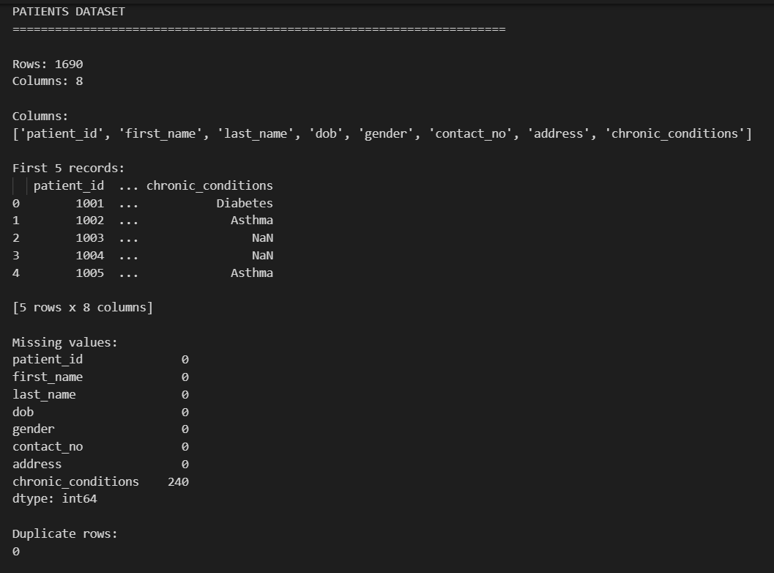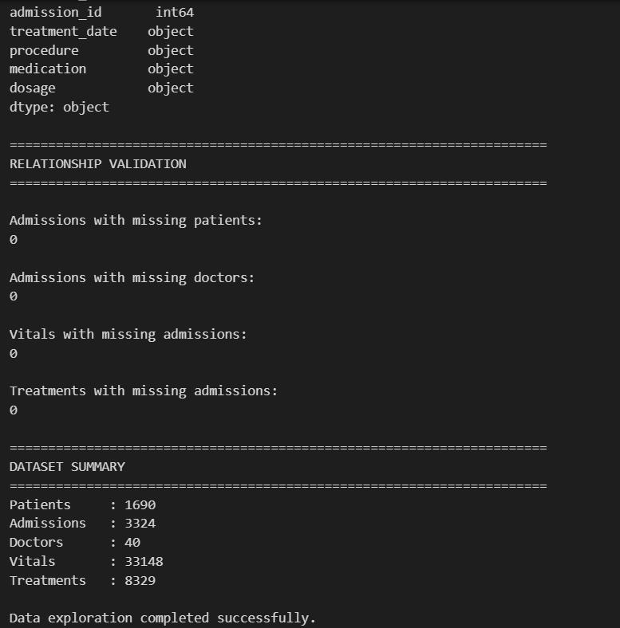
Figure: Initial Data Exploration Output
The Python exploration script was used to examine the structure and quality of the healthcare datasets. It provided information about dataset size, columns, missing values, and duplicate records before the ETL process.

9: Data Cleaning and ETL
9.1 Data Cleaning
The raw datasets were cleaned using Python, Pandas, and NumPy before loading them into the data warehouse. The cleaning process included standardizing column names, removing duplicate records, handling missing values, and converting date and time fields into appropriate formats.
The missing values in the chronic_conditions field of the Patients dataset were replaced with “None Reported” so that the field could be used consistently during analysis.
9.2 Data Transformation
Several transformations were performed to make the data suitable for analytics and machine learning.
The admission data was enhanced with calculated fields such as:
- Age of the patient at admission
- Length of Stay
- Previous Admissions
- Repeat Patient Flag
- Chronic Condition Flag
The blood pressure values from the Vitals dataset were separated into systolic and diastolic blood pressure components. Additional analytical indicators were also created for heart rate, oxygen level, and temperature.
Vital and treatment records were then aggregated at the admission level so that information from multiple records could be used for patient-level analysis.
9.3 Feature Engineering
Additional features were created for the predictive analysis. These included:
- Average, minimum, and maximum heart rate
- Average systolic and diastolic blood pressure
- Average and minimum oxygen level
- Average and maximum temperature
- Number of vital records
- High heart-rate count
- Low-oxygen count
- High-temperature count
- Abnormal-vital count and rate
- Previous admission information
These features were later used as inputs for the machine-learning models.
9.4 Readmission Target Preparation
For the predictive analysis, a 30-day readmission target was created. A subsequent admission was considered a 30-day readmission when it occurred after the previous admission had been discharged and within 30 days of discharge.
This approach was used to avoid counting overlapping admissions as readmissions and provided the target variable required for the predictive models.
9.5 ETL Output
After cleaning and transformation, the processed datasets were saved as CSV files in the output folder. The main analytical dataset contained 3,324 admission records and was used for subsequent machine-learning and SQL analysis.
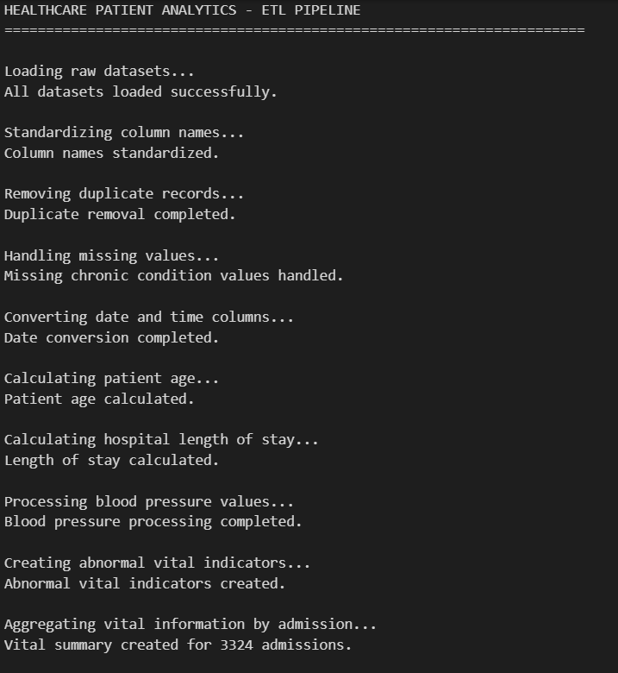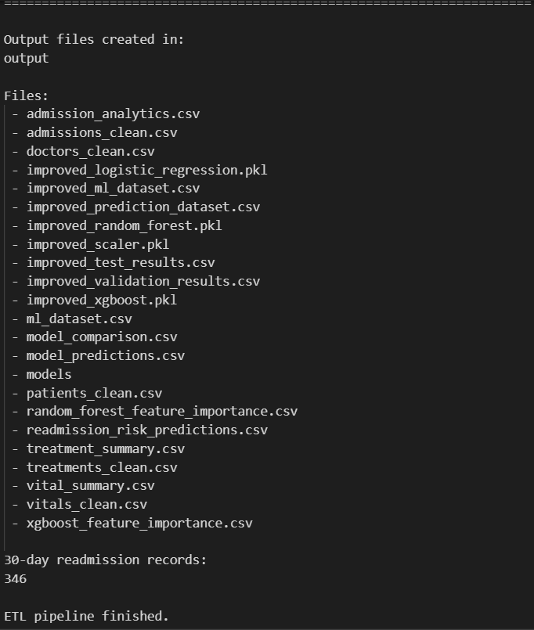
Figure: Python ETL Process Output
The ETL script successfully loaded, cleaned, transformed, and validated the healthcare datasets. The final analytical admission dataset contained 3,324 records, with the required patient and doctor relationships successfully validated.

10: Data Warehouse Design
10.1 Data Warehouse Overview
After the ETL process, the cleaned healthcare data was loaded into a MySQL data warehouse named healthcare_dw. The data warehouse provides a structured environment for storing patient, admission, doctor, vital, treatment, and readmission-risk information.
The case study specifies these main entities: Patients, Admissions, Vitals, Treatments, Readmission_Risk, and Doctors.
For this project, MySQL was used as the implementation of the warehouse instead of the Google BigQuery platform proposed in the original case study.
10.2 Warehouse Tables
The following tables were created:
- Patients – stores patient demographic and chronic-condition information.
- Doctors – stores doctor details and specialization.
- Admissions – stores admission, discharge, diagnosis, and stay information.
- Vitals – stores heart rate, blood pressure, oxygen level, and temperature measurements.
- Treatments – stores medications and procedures.
- Readmission_Risk – stores the predicted risk score, risk level, and actual 30-day readmission result.
The relationships between these tables were implemented using primary keys and foreign keys.
10.3 Data Loading
The processed data was loaded into MySQL using a Python script with the mysql-connector-python library.
The final warehouse contained:
Table | Records
Doctors | 40
Patients | 1,690
Admissions | 3,324
Vitals | 33,148
Treatments | 8,329
Readmission_Risk | 3,324
All major foreign-key validation checks returned zero invalid relationships, confirming that the loaded data was successfully connected across the warehouse tables.
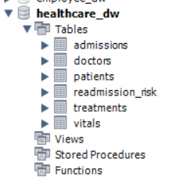
Figure: Healthcare Data Warehouse Tables in MySQL Workbench
The cleaned healthcare data was loaded into the healthcare_dw MySQL database. The warehouse contains six interconnected tables that support SQL analysis, predictive modelling, and Power BI reporting.

11: Machine Learning and Prediction
11.1 Prediction Objective
The project uses machine learning to identify admissions that may have a higher likelihood of 30-day readmission.
The case study specifically proposes Logistic Regression, Random Forest, and XGBoost for readmission-risk prediction.
The prepared dataset contained 3,324 admission records. The target variable was:
- 0 → No 30-day readmission
- 1 → 30-day readmission
The dataset contained 360 readmission cases and 2,964 non-readmission cases.
11.2 Features Used
The predictive dataset was created using demographic, admission-history, and vital-sign information.
Important features included:
- Patient age
- Gender
- Chronic-condition indicator
- Previous admissions
- Days since previous admission
- Repeat-patient indicator
- Average heart rate
- Maximum and minimum heart rate
- Average systolic and diastolic blood pressure
- Average and minimum oxygen level
- Average and maximum temperature
- Abnormal vital indicators
These features were selected because they provide information about the patient's history and recorded clinical measurements.
11.3 Machine Learning Models
Three machine-learning algorithms were trained:
Logistic Regression
Logistic Regression was used as a baseline classification model. It estimates the probability of a patient belonging to the readmission class.
Random Forest
Random Forest combines multiple decision trees to identify patterns in the data. It can capture nonlinear relationships between patient characteristics and readmission outcomes.
XGBoost
XGBoost is a gradient-boosting algorithm that builds multiple decision trees sequentially. It was included as another classification approach for comparison.
The data was divided into training, validation, and test sets using stratified sampling so that the readmission class was represented across the datasets.
11.4 Model Evaluation
The models were evaluated using:
- Accuracy
- Precision
- Recall
- F1-score
- ROC-AUC
For this project, recall is particularly important because missing a patient who actually experienced a readmission is more important than simply achieving high overall accuracy.
Test Results
Use this table in the report:
Model | Accuracy | Precision | Recall | F1-Score | ROC-AUC
Logistic Regression | 45.26% | 13.32% | 73.61% | 22.55% | 59.65%
Random Forest | 64.06% | 9.27% | 26.39% | 13.72% | 56.91%
XGBoost | 79.85% | 10.26% | 11.11% | 10.67% | —
Note: The relatively high accuracy of some models is influenced by the imbalance between readmission and non-readmission cases. Therefore, accuracy alone was not used to select the preferred model.
11.5 Model Selection
Based on the test results, Logistic Regression was selected as the primary risk-screening model for this project because it achieved the highest recall of 73.61% and the highest F1-score among the three models.
However, the model performance is moderate and should not be interpreted as a clinically validated prediction system. The model was developed for academic analytics using the supplied dataset.
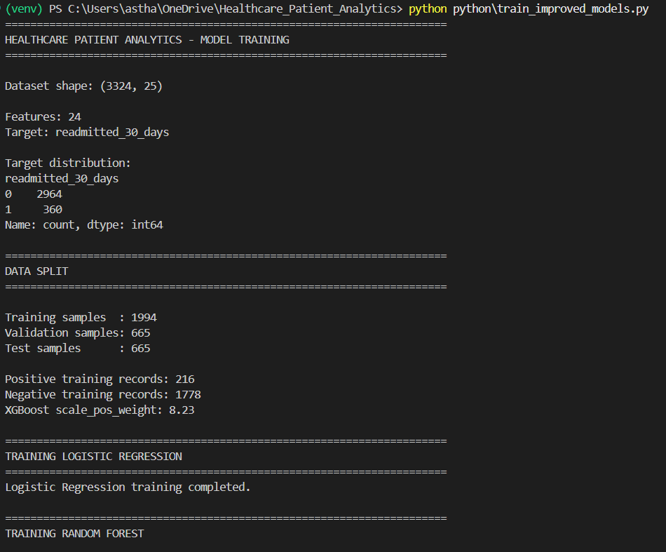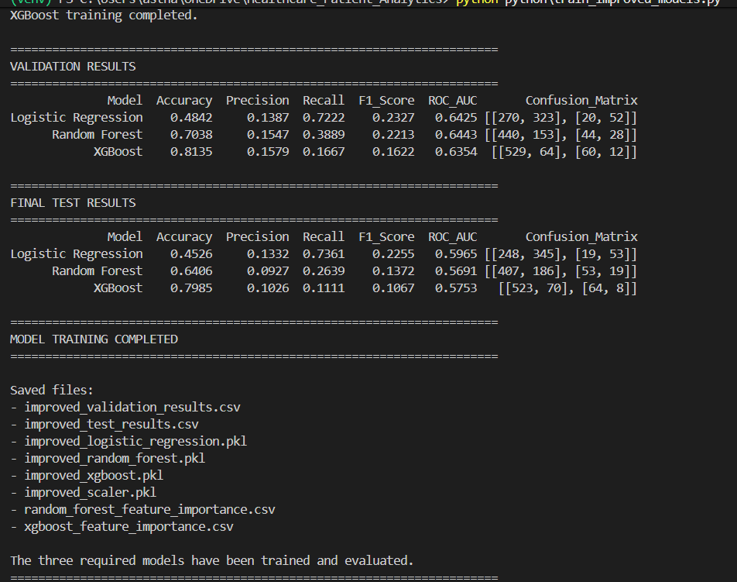
Figure: Machine Learning Model Evaluation
Three machine-learning models were trained and evaluated for 30-day readmission prediction. Logistic Regression provided the highest recall on the test dataset, making it the selected model for the project's risk-screening analysis.

12: Readmission Risk Analysis
12.1 Risk Score Generation
After selecting the Logistic Regression model for risk screening, prediction probabilities were generated for all 3,324 admissions.
The predicted probabilities were converted into a project-defined risk score ranging from 0 to 100. Based on this score, admissions were classified into three analytical categories:
Low Risk: Score < 30
Medium Risk: Score 30 to < 60
High Risk: Score ≥ 60
These thresholds were defined specifically for this project for analytical and visualization purposes. They are not clinical risk thresholds.
12.2 Risk Distribution
The resulting risk categories were:
Risk Level | Admissions | Percentage
Low | 536 | 16.13%
Medium | 2,101 | 63.21%
High | 687 | 20.67%
Total | 3,324 | 100%
The majority of admissions were classified as Medium Risk, while 687 admissions were classified as High Risk.
12.3 Predicted Risk vs Actual Readmission
The predicted risk categories were compared with the actual 30-day readmission results.
Risk Level | Admissions | Actual Readmissions | Observed Readmission Rate
Low | 536 | 3 | 0.56%
Medium | 2,101 | 238 | 11.33%
High | 687 | 119 | 17.32%
The observed readmission rate increased from the Low-Risk group to the High-Risk group. This indicates that the risk categories provide a useful analytical separation within the supplied dataset.
However, these results should not be interpreted as proof of clinical effectiveness because the model was developed using the supplied academic dataset and has moderate predictive performance.
12.4 Overall Readmission Rate
There were 360 actual 30-day readmissions among 3,324 admissions, resulting in an overall observed readmission rate of:
10.83%
This value represents the result obtained from the project dataset.
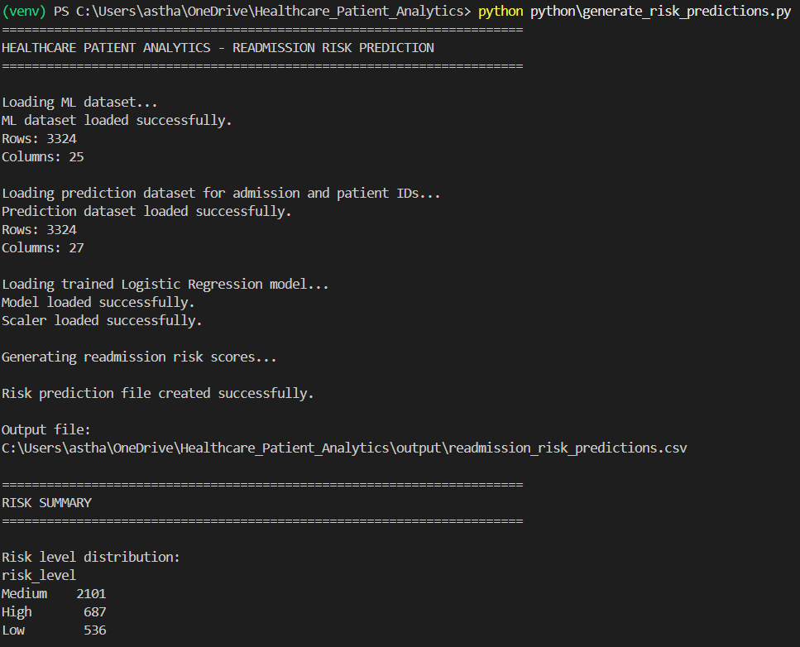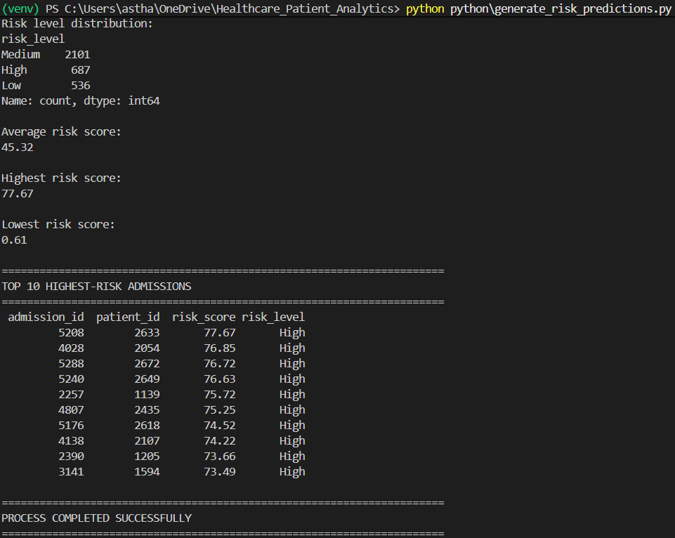
Figure: Generated Readmission Risk Predictions
The prediction script generated risk scores and assigned each admission to a Low, Medium, or High risk category. The output contained 3,324 admission-level predictions and was subsequently loaded into the MySQL warehouse for analysis and Power BI reporting.

13: SQL Analysis
13.1 SQL-Based Healthcare Analysis
After loading the cleaned data into the healthcare_dw MySQL database, SQL queries were used to analyze hospital admissions, patient characteristics, vital measurements, treatments, and readmission risk.
The SQL analysis helped convert the stored healthcare data into meaningful business and clinical analytics.
The analysis covered:
- Overall admission statistics
- Admissions by gender and diagnosis
- Doctor specialization analysis
- Average length of hospital stay
- Chronic-condition analysis
- Repeat-patient analysis
- Vital-sign analysis
- Treatment and medication analysis
- Readmission-risk distribution
- High-risk admission analysis
- Actual 30-day readmission rate
- Predicted risk versus actual readmission
13.2 Important SQL Findings
Overall Hospital Activity
The analysis identified:
- 3,324 total admissions
- 1,690 unique patients
- 5.97 days average length of stay
- 0.65 average previous admissions per admission
Admission Patterns
The most common diagnoses were:
- Hypertension — 746 admissions
- Respiratory Infection — 689
- Chest Pain — 485
- Heart Failure — 473
- Pneumonia — 454
The largest number of admissions was associated with Pulmonology, followed by Cardiology and General Medicine.
Treatment Analysis
There were 8,329 treatment records across the 3,324 admissions.
The most frequently recorded medications were:
- Amoxicillin
- Aspirin
- Metoprolol
- Salbutamol
- Atorvastatin
Readmission Analysis
The SQL analysis identified 360 actual 30-day readmissions, giving an overall observed readmission rate of 10.83%.
The observed readmission rates also increased across the project-defined risk groups:
- Low Risk — 0.56%
- Medium Risk — 11.33%
- High Risk — 17.32%
This provides an important analytical finding because admissions classified as High Risk had a higher observed readmission rate than the other groups.
13.3 SQL Validation
SQL was also used to validate the warehouse after loading the data. Foreign-key checks confirmed that there were no missing patient, doctor, admission, vital, treatment, or risk relationships.
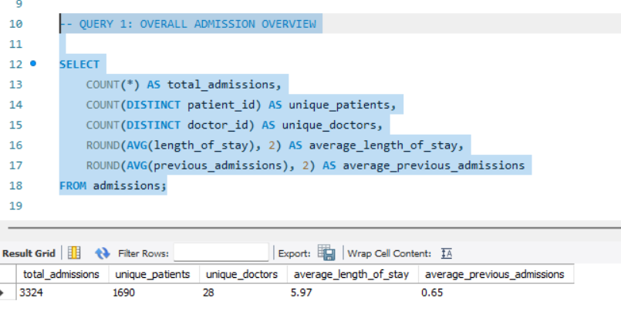
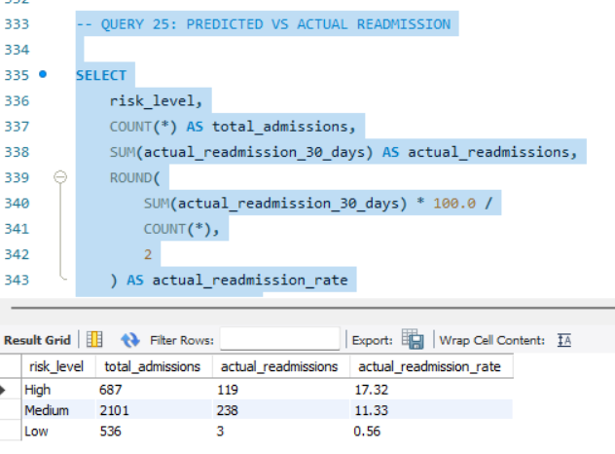
Figure: SQL Analysis Results in MySQL Workbench
SQL queries were used to analyze hospital activity, patient characteristics, treatments, and readmission outcomes. The analysis provided the numerical results used later in the Power BI dashboard and final project findings.

14: Power BI Dashboard
14.1 Power BI Integration
The processed healthcare data stored in the MySQL healthcare_dw database was connected to Power BI Desktop for interactive visualization and reporting.
The following six tables were imported into Power BI:
- Patients
- Doctors
- Admissions
- Vitals
- Treatments
- Readmission_Risk
Relationships were created between the tables using their primary and foreign keys. This allowed the dashboard visuals to respond consistently to filters and selections.
14.2 Key Performance Indicators
Several DAX measures were created to calculate important healthcare metrics, including:
- Total Admissions
- Total Patients
- Readmission Rate
- High-Risk Admissions
- Average Length of Stay
- Average Risk Score
- Total Vital Records
- Total Treatments
- Average Treatments per Admission
These measures provide summarized information that can be used across different dashboard pages.
14.3 Healthcare Hospital Overview
The first dashboard page provides an overall view of hospital activity.
It contains:
- Total Admissions
- Total Patients
- Readmission Rate
- High-Risk Admissions
- Average Length of Stay
- Monthly Admission Trend
- Admissions by Diagnosis
The dashboard allows users to quickly understand admission volume and identify the most common diagnoses.
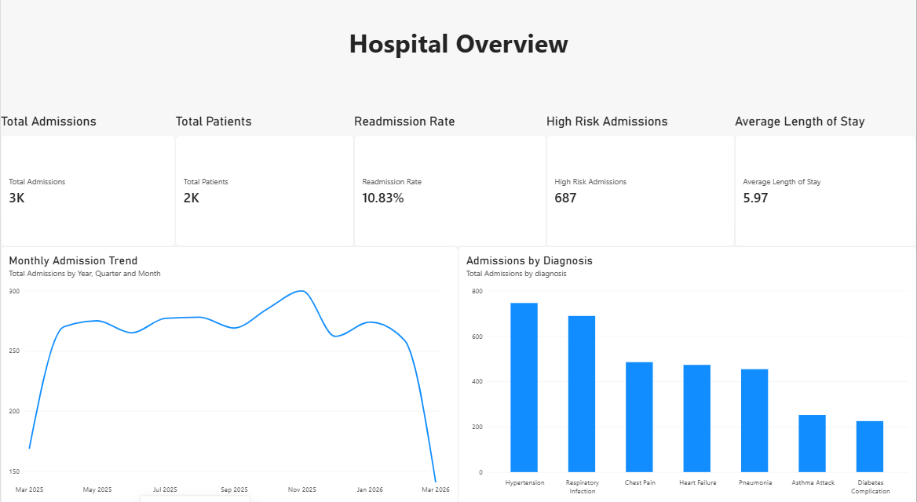
Figure: Healthcare Hospital Overview Dashboard
The hospital overview dashboard summarizes the major admission and patient metrics. Charts for monthly admission trends and diagnosis distribution provide a quick view of overall hospital activity.
14.4 Readmission Risk Analysis
The second dashboard page focuses on predictive risk analysis.
It contains:
- High-Risk Admissions
- Average Risk Score
- Risk Distribution
- Actual Readmissions by Predicted Risk Level
- Average Risk Score by Diagnosis
- High-Risk Admissions by Diagnosis
This page helps compare predicted risk categories with actual readmission outcomes.
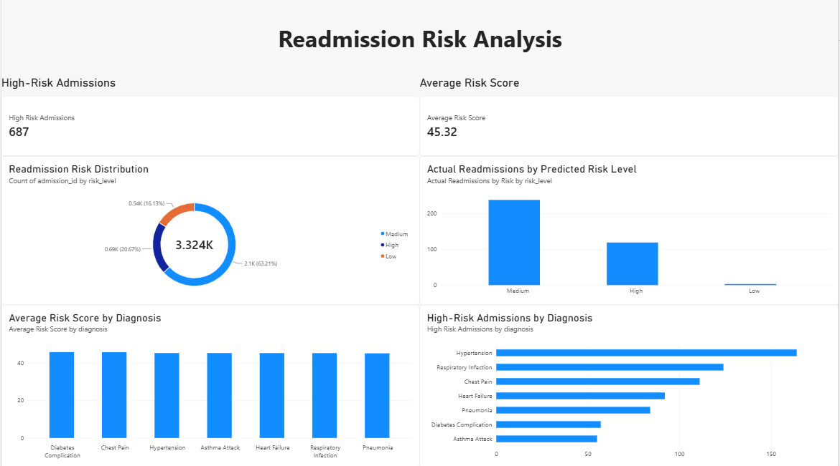
Figure: Readmission Risk Analysis Dashboard
The readmission risk dashboard visualizes the distribution of predicted risk levels and compares them with actual readmission outcomes. It also highlights diagnoses associated with higher numbers of high-risk admissions.
14.5 Patient and Clinical Analysis
The third page focuses on patient demographics and vital measurements.
It includes:
- Total Patients
- Average Heart Rate
- Average Oxygen Level
- Average Temperature
- Patients by Chronic Condition
- Admissions by Gender
- Repeat vs Non-Repeat Admissions
- Low Oxygen Records
- High Heart Rate Records
- High Temperature Records
This page provides a combined view of patient characteristics and recorded vital measurements.
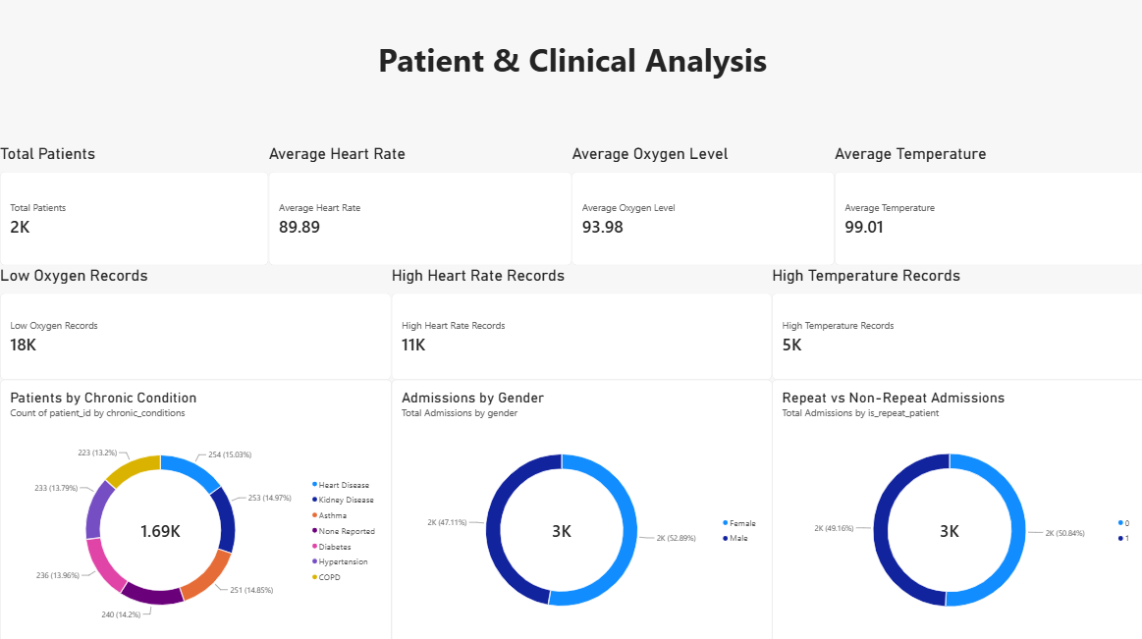
Figure: Patient and Clinical Analysis Dashboard
The patient and clinical dashboard presents demographic information together with aggregated vital measurements. It also highlights repeat admissions and records meeting the project's analytical vital thresholds.
14.6 Treatment and Doctor Analysis
The fourth dashboard page focuses on treatments and doctor specializations.
It contains:
- Total Treatments
- Average Treatments per Admission
- Treatments by Medication
- Treatments by Procedure
- Admissions by Doctor Specialization
- High-Risk Admissions by Doctor Specialization
This allows treatment patterns and admission workload across medical specializations to be explored.
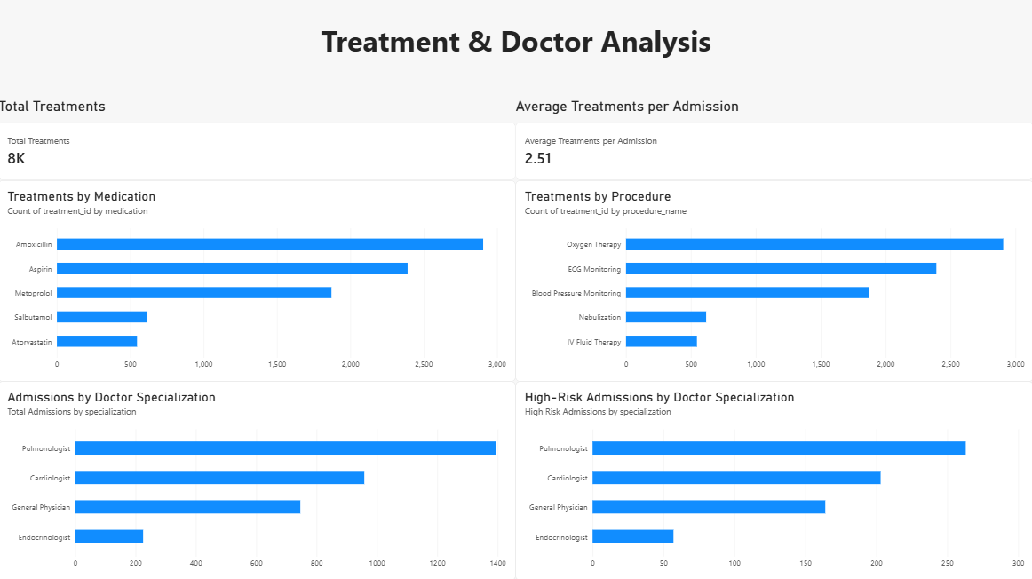
Figure: Treatment and Doctor Analysis Dashboard
The treatment and doctor dashboard summarizes medication and procedure patterns along with admission volume by medical specialization. It also shows the distribution of high-risk admissions across specializations.
14.7 Dashboard Summary
The four Power BI pages provide an interactive analytical layer over the healthcare data warehouse. Together, they allow hospital admission trends, patient characteristics, treatments, vital measurements, and readmission risk to be explored from different perspectives.

15: Key Findings
15.1 Major Findings
The analysis of the healthcare dataset produced the following key findings:
- Hospital Activity
The dataset contains 3,324 admissions from 1,690 unique patients, with an average hospital stay of approximately 5.97 days.
- Admission Patterns
Hypertension was the most frequently recorded diagnosis with 746 admissions, followed by Respiratory Infection and Chest Pain.
- Patient History
The analysis identified 1,634 repeat-patient admissions, showing that previous hospital visits were an important part of the patient history analysis.
- Treatment Activity
A total of 8,329 treatment records were recorded across the admissions, covering medications and medical procedures.
- Readmission Rate
There were 360 actual 30-day readmissions, resulting in an observed readmission rate of 10.83%.
- Risk Analysis
The predictive analysis classified 687 admissions as High Risk, 2,101 as Medium Risk, and 536 as Low Risk using the project's defined risk-score thresholds.
- Risk vs Actual Outcome
The observed readmission rate was 17.32% for the High-Risk group, compared with 11.33% for Medium Risk and 0.56% for Low Risk.
- Dashboard Insights
The Power BI dashboards provide an interactive way to explore admission trends, patient characteristics, vital measurements, treatments, doctor specializations, and readmission risk.
Overall, the project demonstrates how healthcare data can be transformed from raw CSV files into a structured analytical solution using Python, MySQL, machine learning, SQL, and Power BI. The results provide useful analytical insights into hospital admissions and readmission risk while demonstrating the potential of data-driven healthcare analytics.

16: Challenges and Limitations
16.1 Challenges Faced
During the development of the project, several challenges were encountered while preparing the data and building the predictive analytics workflow.
1. Missing Data
The chronic_conditions field in the Patients dataset contained missing values. These records were handled during the ETL process by assigning the value “None Reported”.
2. Data Integration
The project involved multiple related datasets. Maintaining correct relationships between patients, admissions, doctors, vitals, and treatments required foreign-key validation before loading the data into MySQL.
3. Class Imbalance
The readmission target contained considerably fewer positive readmission cases than non-readmission cases. Therefore, accuracy alone could not be used to judge model performance, and metrics such as recall, precision, F1-score, and ROC-AUC were considered.
4. Timestamp Inconsistencies
Some of the supplied vital and treatment timestamps did not consistently align with admission dates. Because of this, the project avoided presenting the model as a strict real-time or first-24-hour clinical prediction system.
5. Model Performance
The machine-learning models produced moderate predictive performance. Logistic Regression provided better recall than the other tested models, but the results are not sufficient to claim clinical validation.
16.2 Project Limitations
This project was developed using the provided academic datasets, rather than live hospital EHR data. Therefore, the results should be considered analytical/project findings rather than real-world clinical recommendations.
The risk-score thresholds used to classify Low, Medium, and High Risk were defined for this project and are not medical or clinical standards.
In addition, the case study proposes Google BigQuery as the cloud data warehouse, while this implementation uses MySQL as the project's data warehouse platform.
These limitations were considered while interpreting the results. Despite them, the project demonstrates a complete healthcare analytics workflow from data exploration and ETL to data warehousing, machine learning, SQL analysis, and interactive visualization.

17: Conclusion
The project successfully developed a complete healthcare analytics and prediction workflow. The major outcomes are:
- Data Processing: Healthcare datasets were explored, cleaned, transformed, and validated using Python, Pandas, and NumPy.
- Data Warehouse: The processed data was organized into a structured MySQL healthcare data warehouse containing patients, doctors, admissions, vitals, treatments, and readmission-risk information.
- SQL Analysis: SQL queries were used to analyze admission patterns, diagnoses, treatments, patient history, vital measurements, and readmission outcomes.
- Predictive Analytics: Logistic Regression, Random Forest, and XGBoost were evaluated for 30-day readmission prediction.
- Risk Analysis: Admissions were classified into Low, Medium, and High risk categories using project-defined analytical thresholds.
- Power BI Dashboard: Four interactive dashboards were created to visualize hospital activity, readmission risk, patient and clinical information, and treatment/doctor analysis.
- Key Result: The dataset contained 3,324 admissions, with 360 actual 30-day readmissions, giving an observed readmission rate of 10.83%.
- Overall Outcome: The project demonstrates how Python, SQL, MySQL, Machine Learning, and Power BI can be integrated to transform raw healthcare data into meaningful analytical insights.

18. Future Scope
The project can be further improved in the following ways:
- Real-Time Healthcare Data: Integrate the solution with live EHR systems so that patient information and vital measurements can be analyzed continuously.
- Cloud Data Warehouse: The implementation can be migrated from MySQL to Google BigQuery, as proposed in the original case study, to support scalable cloud-based analytics.
- Improved Prediction Models: Additional machine-learning and deep-learning techniques could be tested to improve prediction performance.
- Real-Time Risk Monitoring: A real-time system could continuously update patient risk scores whenever new clinical information becomes available.
- Post-Discharge Tracking: A dedicated follow-up module could be added to track appointments, follow-up activities, and patient status after discharge.
- Advanced Power BI Analytics: More interactive dashboards, drill-through pages, alerts, and additional KPIs could be added for hospital management.
- Better Data Quality: Future versions could use standardized healthcare data formats and more consistent timestamps to improve prediction reliability.
- Clinical Validation: Before real-world use, the predictive models would require validation using larger, representative clinical datasets and evaluation by qualified healthcare professionals.

19. GitHub Repository
The complete project source code, Python scripts, SQL queries, data-processing files, and supporting project materials are maintained in a GitHub repository. The repository provides a structured and accessible location for reviewing the implementation of the Healthcare Patient Analytics & Prediction project.
GitHub Repository:
The repository contains the Python ETL and machine learning scripts, SQL analysis queries, project output files, and other relevant resources used during the development of the project.

