RETAIL SALES & CUSTOMER INSIGHTS DASHBOARD
Real-Time Capstone Project
Data Engineering & Business Intelligence

Technology Used: Python | MySQL | SQL | Power BI | DAX

Prepared by:
Astha Singh
Role: Data Engineering Intern
Department: Application and Data Modernization and Migration,
Technology and Transformation

Year: 2026

Abstract
This project presents an end-to-end Retail Sales and Customer Insights solution designed to analyze sales performance, customer purchasing behavior, product performance, regional trends, and sales growth. The solution integrates sales, customer, and product datasets and transforms them into a structured analytical data warehouse.
Python is used for data extraction, cleaning, transformation, and data quality validation. A MySQL-based star schema is then used to store the transformed data through fact and dimension tables. SQL queries are used to calculate key business metrics such as total sales revenue, transaction count, average transaction value, product performance, regional sales, sales growth, customer purchase frequency, and historical customer value.
Power BI is used to create an interactive dashboard consisting of Executive Overview, Sales Analysis, and Customer Insights pages. The dashboard provides KPI cards, trend analysis, product and regional comparisons, customer analysis, and interactive filters.
The completed solution demonstrates a complete data engineering and analytics workflow from raw source data through ETL, data warehousing, SQL analysis, and business intelligence visualization.

Table of Contents

Sl. No. | Topic | Page no.
1. | Introduction
2. | Project Objectives
3. | Source Data Description
4. | Technology Stack
5. | System Architecture
6. | Data Understanding and Profiling
7. | Python ETL and Data Cleaning
8. | Data Warehouse Design
9. | SQL Analysis and Business KPIs
10. | Power BI Development
11. | Dashboard and Visualizations
12. | Data Quality and Testing
13. | Key Findings
14. | Data Privacy and Security
15. | Project Limitations
16. | Future Enhancements
17. | Conclusion
18. | References
19. | Appendix

1. Introduction
The retail industry generates large volumes of transactional, customer, and product-related data. When this information is stored across different sources and formats, it can become difficult to analyze consistently and efficiently. A structured data engineering and analytics solution is therefore required to transform raw data into reliable information that can support business analysis.
This project focuses on developing a Retail Sales and Customer Insights Dashboard using an end-to-end data engineering and business intelligence approach. The project integrates three primary datasets representing sales transactions, customer information, and product information. These datasets are processed, cleaned, transformed, validated, and organized into a centralized analytical data warehouse.
The project begins with raw CSV and JSON source files. Python is used to perform the initial extraction, data cleaning, transformation, and data quality validation. The processed data is then structured according to a star-schema data warehouse consisting of a central sales fact table and supporting customer, product, and date dimensions.
MySQL is used as the data warehouse and analytical SQL environment. SQL queries are developed to examine sales performance, product performance, regional trends, customer purchasing behavior, and changes in sales over time. Important business metrics such as total sales revenue, total transactions, total quantity sold, average transaction value, sales growth, customer purchase frequency, and historical customer value are calculated from the warehouse data.
The final analytical layer is developed using Microsoft Power BI. The Power BI solution connects to the MySQL data warehouse and provides interactive dashboards containing key performance indicators, charts, customer analysis, product analysis, regional analysis, and time-based trends. Slicers and filters allow users to interact with the data and examine specific customer, product, regional, and time-period segments.
The complete workflow can therefore be represented as:
Source Data → Python ETL → Data Quality Validation → MySQL Data Warehouse → SQL Analysis → Power BI Dashboard
The project demonstrates how raw operational data can be transformed into a structured analytical solution through data engineering, database management, SQL analysis, and business intelligence techniques.
1.1 Project Background
The project was developed as a data engineering and analytics capstone focused on understanding retail sales and customer behavior. The available data contains transaction-level sales information along with customer and product attributes. By integrating these datasets, the project provides a consolidated view of sales activity and enables analysis across multiple business dimensions.
A key aspect of the project is the transformation of raw and inconsistent source data into a reliable analytical dataset. The customer data contains variations in gender and region values, while the sales data requires validation of important transactional fields. These issues are addressed during the Python-based ETL process before the data is loaded into the warehouse.
The resulting data warehouse provides a consistent foundation for SQL analysis and Power BI reporting. This approach separates data preparation and storage from visualization, making the overall solution easier to validate, analyze, and extend.
1.2 Scope of the Project
The scope of this project covers the complete flow from source data preparation to business intelligence reporting. It includes data extraction, data cleaning, transformation, validation, dimensional modeling, MySQL data warehouse development, SQL-based analysis, DAX-based KPI calculations, and Power BI dashboard development.
The analytical scope includes sales revenue, transaction volume, quantity sold, average transaction value, product performance, regional performance, monthly sales trends, sales growth, customer purchase frequency, customer demographics, and historical customer value.
The project focuses on the data and capabilities available in the provided source datasets. Metrics requiring additional source information, such as product return rate and cost of goods sold, are outside the implemented analytical scope.

2. Project Objectives
The primary objective of this project is to develop an end-to-end retail sales analytics solution that transforms raw sales, customer, and product data into a structured and interactive analytical environment. The project combines data engineering, database management, SQL analysis, and business intelligence to provide meaningful insights into sales performance and customer behavior.
2.1 Primary Objectives
The major objectives of the project are as follows:
- Data Integration
To integrate sales, customer, and product datasets available in different source formats into a unified analytical workflow.
- Data Cleaning and Transformation
To clean raw data, handle missing and inconsistent values, remove duplicates, standardize attributes, and convert data into appropriate formats using Python.
- Data Quality Validation
To validate the processed data by checking record counts, uniqueness, valid sales values, valid quantities, and relationships between customers, products, and sales transactions.
- Data Warehouse Development
To design and implement a centralized MySQL data warehouse using a star-schema architecture consisting of fact and dimension tables.
- SQL-Based Analysis
To use SQL queries to analyze sales revenue, transaction volume, product performance, regional trends, customer purchasing frequency, and sales growth.
- KPI Development
To calculate important business metrics such as Total Sales Revenue, Total Transactions, Total Quantity Sold, Average Transaction Value, Sales Growth, and historical Customer Lifetime Value.
- Power BI Dashboard Development
To develop an interactive Power BI dashboard that presents the analyzed information through KPI cards, charts, slicers, and other visual elements.
- Customer and Product Insights
To analyze customer purchasing behavior, customer demographics, product performance, and regional sales patterns.
- Interactive Business Reporting
To provide users with an interactive reporting environment where sales information can be explored using filters such as region, gender, product category, and year.
- End-to-End Data Engineering Implementation
To demonstrate a complete workflow from raw data ingestion through ETL, data warehousing, SQL analysis, and business intelligence visualization.
2.2 Expected Outcomes
The expected outcome of the project is a reliable and structured analytical solution that can transform raw retail datasets into actionable business information. The completed solution provides a centralized MySQL data warehouse, validated analytical datasets, SQL-based business analysis, and an interactive Power BI dashboard.
The project also demonstrates the practical application of data engineering concepts including ETL processing, data quality validation, dimensional modeling, relational database design, analytical SQL, DAX measures, and business intelligence reporting.

3. Source Data Description
The project uses three primary source datasets representing sales transactions, customer information, and product information. The datasets are provided in different file formats and contain information required for developing the retail sales analytical solution.
The three source datasets are:
- Sales Data — sales 1.csv
- Customer Data — customers.json
- Product Data — products.csv
These datasets are first loaded into the Python ETL process, where data quality issues are identified and addressed before the transformed data is prepared for the MySQL data warehouse.
3.1 Sales Data
The sales dataset is provided in CSV format through the file sales 1.csv. It contains transaction-level information representing individual retail sales activities.
The dataset initially contains 10,000 records and six columns.
Column | Description | Role in Project
SaleID | Unique identifier for a sales transaction | Transaction identifier
ProductID | Identifier of the purchased product | Product reference
CustomerID | Identifier of the customer associated with the transaction | Customer reference
SalesAmount | Monetary value associated with the transaction | Sales metric
Quantity | Number of units involved in the transaction | Quantity metric
Timestamp | Date and time associated with the transaction | Time analysis
The Sales dataset forms the primary source for the fact_sales table in the data warehouse. During ETL processing, the sales data is subjected to data type conversion, duplicate checking, validation of critical fields, and referential-integrity checks against the customer and product datasets.
Records with missing or invalid critical sales information are excluded from the final analytical dataset. After processing, 9,397 valid sales records are available for the fact table.
3.2 Customer Data
Customer information is provided through the customers.json file in JSON format. The dataset initially contains 1,100 customer records.
The available customer attributes are:
Column | Description
CustomerID | Unique customer identifier
FirstName | Customer's first name
LastName | Customer's last name
Gender | Customer gender information
Region | Customer region
SSN | Social Security Number present in the source
The customer dataset contains several data-quality inconsistencies. Gender values appear in different forms, such as M, Male, male, F, Female, and female. Region values also contain spelling variations and abbreviations, including variations associated with Ohio, New York, California, and Texas.
Missing customer attributes are also present in the source data. These inconsistencies are handled during the Python transformation stage so that equivalent values are represented consistently in the analytical warehouse.
The SSN field is not required for the project's sales or customer analytics. Therefore, it is excluded from the analytical data warehouse to avoid unnecessarily carrying sensitive personal information.
After transformation and duplicate removal, 1,000 unique customer records are loaded into dim_customer.
3.3 Product Data
Product information is provided through products.csv in CSV format. The source contains 50 product records.
The dataset contains the following attributes:
Column | Description
ProductID | Unique product identifier
ProductName | Name of the product
Category | Product category
The product dataset is used to create the dim_product dimension in the data warehouse. Product identifiers are converted to the appropriate numeric data type and product attributes are validated before loading.
After ETL processing, all 50 product records are retained in the product dimension.
3.4 Initial Dataset Summary
The following table summarizes the source datasets and their corresponding records before and after ETL processing.
Dataset | Source Format | Initial Records | Final Records | Target
Sales | CSV | 10,000 | 9,397 | fact_sales
Customers | JSON | 1,100 | 1,000 | dim_customer
Products | CSV | 50 | 50 | dim_product
Dates | Derived from Sales | — | 181 | dim_date
The reduction in sales and customer records is a result of the data-cleaning and validation rules applied during ETL. The objective is not simply to retain every source record, but to create a consistent and reliable analytical dataset.
The Date dimension is generated from the timestamps present in the cleaned sales data. It contains 181 dates covering the available transaction period.
3.5 Source-to-Target Flow
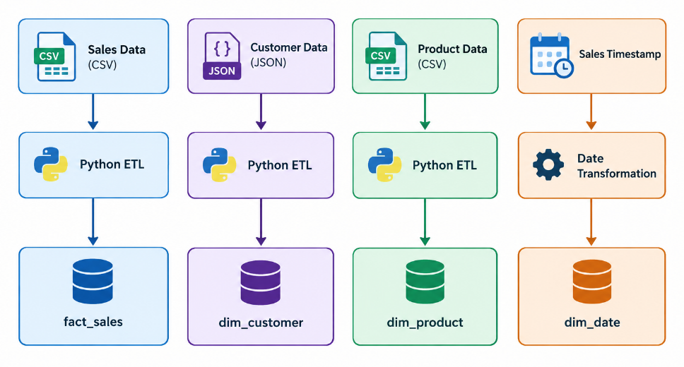
The source-to-target process ensures that each source dataset is transformed according to the requirements of the analytical data model. Business identifiers such as ProductID and CustomerID are mapped to warehouse dimension keys, while the sales timestamp is used to establish the relationship between transactions and the Date dimension.
4. Technology Stack
The project uses a combination of programming, database, data analysis, and business intelligence technologies to implement the complete data engineering and reporting workflow. Each technology is used for a specific stage of the project, from raw data processing to interactive visualization.
4.1 Technologies Used
Technology | Purpose in the Project
Python | Data extraction, cleaning, transformation, and validation
Pandas | Reading, manipulating, cleaning, and transforming datasets
MySQL | Storage and management of the analytical data warehouse
SQL | Business analysis, aggregations, joins, KPIs, and analytical queries
Power BI | Interactive dashboards and business visualizations
DAX | Creation of analytical measures and KPI calculations
CSV | Source format for sales and product data
JSON | Source format for customer data

4.2 Python
Python is used as the primary data-processing and ETL programming language in the project. The etl.py script is responsible for extracting the source datasets, performing data cleaning and transformation, validating the processed data, and generating the datasets required by the data warehouse.
Python was used to handle tasks such as:
- Reading CSV and JSON files.
- Converting columns to appropriate data types.
- Removing duplicate records.
- Handling missing values.
- Standardizing customer gender values.
- Standardizing inconsistent region values.
- Validating ProductID and CustomerID references.
- Generating dimension keys.
- Creating the Date dimension.
- Producing cleaned output files for the warehouse.
Python therefore acts as the main transformation layer between the raw source data and the structured analytical data model.
4.3 Pandas
Pandas is the primary Python library used for data manipulation. It provides DataFrame-based functionality that makes it possible to load, inspect, transform, filter, merge, and export the project datasets.
Pandas is used during the ETL process to perform operations such as:
- Reading CSV files using read_csv().
- Reading JSON data.
- Converting numeric and datetime columns.
- Identifying missing values.
- Removing duplicate records.
- Filtering invalid records.
- Merging sales data with customer and product information.
- Creating the Date dimension.
- Exporting transformed datasets as CSV files.
4.4 MySQL
MySQL is used as the centralized data warehouse for the project. The database is named retail_dw.
The warehouse contains four main tables:
- fact_sales
- dim_customer
- dim_product
- dim_date
The database provides a structured environment for storing the transformed datasets and supports SQL-based analytical queries.
Primary keys and foreign keys are used to maintain relationships between the fact and dimension tables. Indexes are also created on the main foreign-key columns of the fact table to support efficient querying.
4.5 SQL
SQL is used to analyze the data stored in the MySQL data warehouse. Analytical queries combine the fact and dimension tables using joins and aggregation functions to generate business metrics.
SQL analysis performed in the project includes:
- Total sales revenue.
- Total transactions.
- Total quantity sold.
- Average transaction value.
- Sales by product category.
- Sales by region.
- Monthly and quarterly sales.
- Monthly sales growth.
- Top-selling products.
- Customer purchase frequency.
- Historical customer value.
SQL provides the analytical foundation used to validate the Power BI results.
4.6 Power BI
Microsoft Power BI is used as the business intelligence and visualization layer of the project. Power BI connects to the MySQL data warehouse and uses the processed fact and dimension tables to create interactive reports.
The dashboard contains three primary report pages:
- Executive Overview
- Sales Analysis
- Customer Insights
The visualizations include KPI cards, line charts, bar charts, donut charts, slicers, and interactive filtering.
4.7 DAX
Data Analysis Expressions (DAX) is used within Power BI to create calculated measures for the dashboard.
Important measures developed for the project include:
- Total Sales
- Total Transactions
- Total Quantity
- Average Transaction Value
- Customers
- Previous Period Sales
- Sales Growth %
- Customer Purchase Frequency
- Customer Lifetime Value
These measures allow the dashboard to dynamically calculate metrics based on the selected filters and dimensions.
4.8 Source Data Formats
The project uses two primary source-data formats:
CSV (Comma-Separated Values): Used for the sales and product datasets. CSV provides a tabular structure suitable for loading into Pandas and subsequently transforming into warehouse tables.
JSON (JavaScript Object Notation): Used for the customer dataset. JSON provides a structured representation of customer records and demonstrates the ability of the ETL process to work with a non-tabular source format.
The Python ETL process brings these different formats into a common tabular structure before loading them into MySQL.
4.9 Technology Workflow
The technologies work together as a sequential pipeline. Python and Pandas perform the extraction and transformation activities, MySQL stores the structured warehouse data, SQL performs analytical processing, and Power BI with DAX provides the final visualization and reporting layer.
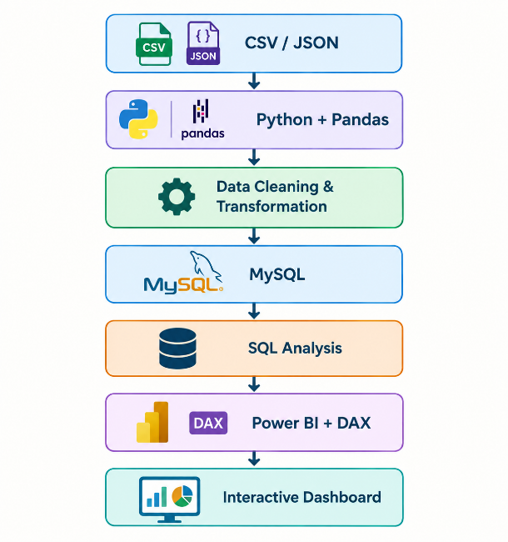
5. System Architecture
The system architecture of the Retail Sales and Customer Insights Dashboard follows an end-to-end data engineering and business intelligence workflow. The architecture is designed to transform raw source data into structured, validated, and analysis-ready information.
The overall solution consists of several processing layers: source data, ETL and transformation, data warehouse, SQL analytics, and business intelligence visualization. Each layer performs a specific function and passes the processed information to the next stage.
5.1 Overall Architecture
The complete architecture can be represented as follows:
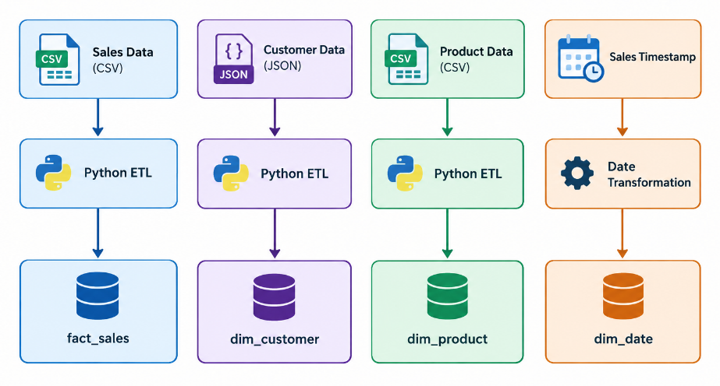
Figure 5.1: Source-to-Target Data Transformation Architecture
The source datasets are first processed using Python. Sales, customer, and product information undergo data cleaning and transformation before being prepared for the warehouse. The sales timestamp is also transformed into a dedicated Date dimension.
The transformed datasets are then stored as fact and dimension tables in the MySQL data warehouse. These tables form the analytical foundation for SQL queries and Power BI reporting.
5.2 Data Flow Architecture
The complete data flow implemented in the project is:
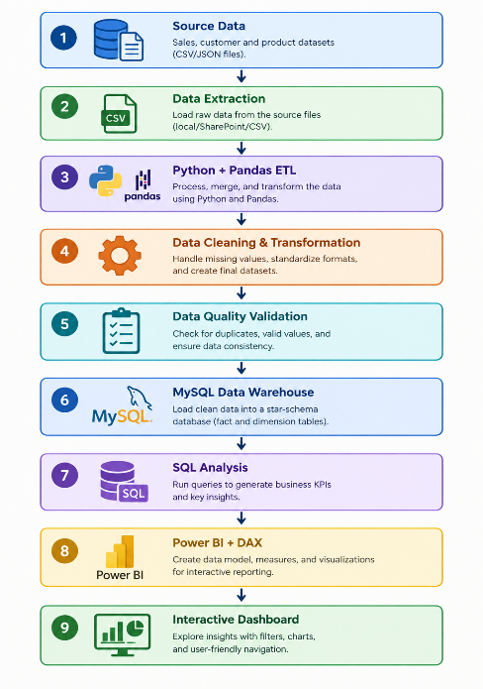
5.2.1 Source Data
The source layer consists of the three provided datasets: sales 1.csv, customers.json, and products.csv. These datasets contain transactional, customer, and product information respectively.
5.2.2 Data Extraction
Python is used to read the source files and load their contents into Pandas DataFrames. This creates a common processing environment despite the differences between CSV and JSON formats.
5.2.3 ETL and Transformation
The ETL layer performs data cleaning and transformation. This includes duplicate removal, missing-value handling, data type conversion, standardization of gender and region values, validation of identifiers, and creation of warehouse keys.
5.2.4 Data Quality Validation
Before loading the final datasets, validation checks are performed to ensure that the transformed data satisfies the required quality conditions. These checks include uniqueness, valid sales amounts, valid quantities, valid customer and product references, and expected record counts.
5.2.5 Data Warehouse
MySQL is used to store the transformed analytical datasets. The warehouse follows a star-schema design containing one central fact table and three dimension tables.
5.2.6 SQL Analysis
SQL queries are executed against the warehouse to calculate business metrics and analyze sales, products, customers, regions, and time-based trends.
5.2.7 Power BI
Power BI connects to the MySQL warehouse and provides the final visualization layer. DAX measures are used to calculate dynamic KPIs, while charts, cards, slicers, and filters provide interactive analysis.
5.3 Architectural Layers
Layer | Component | Main Responsibility
Source Layer | CSV / JSON | Provides raw data
ETL Layer | Python + Pandas | Cleans and transforms data
Validation Layer | Python Tests | Validates data quality
Warehouse Layer | MySQL | Stores structured analytical data
Analytics Layer | SQL | Calculates business metrics
BI Layer | Power BI + DAX | Visualizes and analyzes results

This layered architecture separates data preparation, storage, analysis, and visualization responsibilities. Such separation makes the solution easier to understand, validate, maintain, and extend.
5.4 End-to-End Processing
The final processing sequence can be summarized as:
Raw Data → Extraction → Transformation → Validation → Data Warehouse → SQL Analysis → Power BI → Business Insights
This architecture enables the project to move from raw and potentially inconsistent source data to a structured analytical solution while maintaining validation checkpoints throughout the process.
6. Data Understanding and Profiling
Before beginning the ETL process, the available datasets were examined to understand their structure, contents, data types, record counts, and potential data quality issues. This profiling stage helped identify inconsistencies and missing values that needed to be handled before the data could be loaded into the analytical data warehouse.
6.1 Initial Dataset Overview
The project uses three main source datasets: sales data, customer data, and product data. The sales dataset contains transaction-level information, the customer dataset contains customer and demographic information, and the product dataset contains product and category information.
The initial sales dataset contained 10,000 records, the customer dataset contained 1,100 records, and the product dataset contained 50 records. The datasets were provided in CSV and JSON formats and were processed using Python and Pandas.
6.2 Sales Data Profiling
The sales dataset contains information required to analyze individual customer transactions. The main attributes include SaleID, ProductID, CustomerID, SalesAmount, Quantity, and Timestamp.
During profiling, the sales data was examined for missing values, duplicate transactions, incorrect data types, and invalid numerical values. SalesAmount and Quantity were converted into appropriate numeric formats, while Timestamp was converted into a standard date-time format.
Duplicate SaleID values and records with missing or invalid critical transaction information were identified and handled during the subsequent ETL process.
6.3 Customer Data Profiling
The customer dataset initially contained 1,100 records and included CustomerID, FirstName, LastName, Gender, Region, and SSN.
During profiling, inconsistencies were identified in categorical values. Gender was represented using multiple formats, including values such as M, Male, male, F, Female, and female.
Similar inconsistencies were found in the Region field. Examples included different spellings and abbreviations for locations such as Ohio, New York, California, and Texas. Some customer records also contained missing names or region information.
These inconsistencies were identified during profiling and were standardized during the Python transformation stage.
The SSN field was not required for sales analytics and was therefore excluded from the analytical warehouse to avoid unnecessary handling of sensitive personal information.
6.4 Product Data Profiling
The product dataset contained 50 product records with ProductID, ProductName, and Category attributes.
The ProductID values were checked for validity and uniqueness. Product names and categories were also examined for missing or inconsistent values. The product data was then prepared for integration with the sales transactions during the ETL process.
6.5 Data Quality Issues Identified
The profiling process identified several data quality issues that required treatment before loading the warehouse:
- Duplicate sales transactions were checked and removed.
- Missing or invalid critical sales values were handled.
- Numeric fields were converted into appropriate data types.
- Customer gender values were standardized.
- Inconsistent region names and spellings were standardized.
- Missing customer attributes were represented as Unknown where appropriate.
- Duplicate CustomerID records were removed.
- Sales records were checked against valid customer and product identifiers.
- The SSN field was excluded because it was not required for analytical purposes.
6.6 Data Profiling Results
After cleaning and validation, the sales data was reduced from 10,000 raw records to 9,397 valid sales transactions. The customer dataset was reduced from 1,100 records to 1,000 unique customer records, while all 50 product records were retained.
A separate date dimension containing 181 date records was generated from the transaction timestamps. These cleaned datasets were subsequently used to create the fact and dimension tables in the MySQL data warehouse.
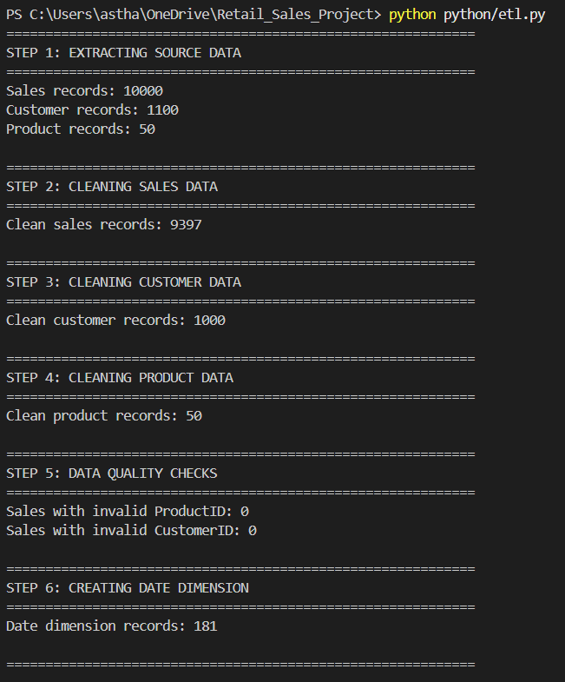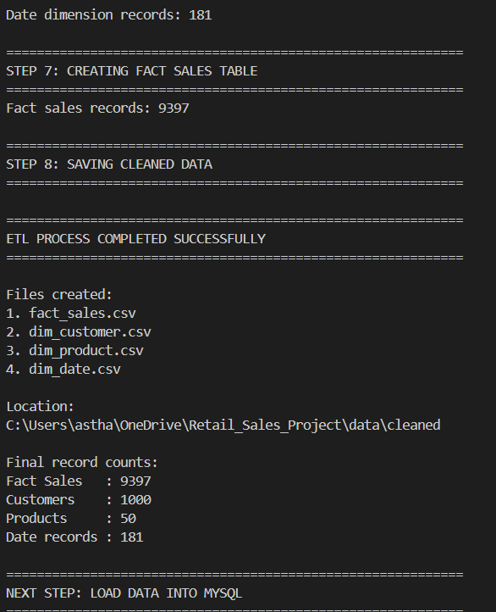
6.7 Profiling and ETL Relationship
The data profiling stage provided the foundation for the ETL process. The issues identified during profiling were converted into specific transformation and validation rules in Python.
The overall flow was:
Raw Data → Data Profiling → Cleaning and Transformation → Data Quality Validation → MySQL Data Warehouse
7. Python ETL and Data Cleaning
7.1 Overview of the ETL Process
Python was used to perform the main Extract, Transform, and Load preparation activities for the project. The ETL process converted the raw sales, customer, and product datasets into clean and structured datasets suitable for storage in the MySQL data warehouse.
The Python implementation used the Pandas library for reading, cleaning, transforming, and validating the datasets.
The ETL process consisted of three major stages:
Extract → Transform → Prepare for Load
7.2 Data Extraction
The raw datasets were loaded into Python from their respective source files.
The sales CSV file was read using Pandas, the customer JSON file was loaded as customer records, and the product CSV file was loaded into a Pandas DataFrame.
At this stage, the original data was retained separately so that the transformation process could be performed without modifying the raw source files.
7.3 Data Transformation
Several transformation operations were performed to prepare the data for the warehouse.
For the sales data, duplicate transactions were removed and important fields were converted to appropriate data types. SalesAmount was converted to a numeric format, Quantity was converted to an integer, and Timestamp was converted into a standard date-time format.
Customer data required additional standardization. Gender values such as M, Male, male, F, Female, and female were converted into consistent categories. Region names containing spelling variations or abbreviations were also standardized.
Missing customer attributes were handled using Unknown where appropriate.
Product data was cleaned by validating ProductID values and ensuring that product names and categories were available for analysis.
7.4 Data Integration
After individual datasets were cleaned, relationships between the datasets were established using ProductID and CustomerID.
The sales records were matched with valid products and customers. Records containing invalid references were removed before loading the final fact table.
Surrogate keys were also generated for the customer and product dimensions. A DateKey was generated from transaction timestamps to support time-based analysis.
7.5 Data Quality Validation
Data quality checks were performed after transformation to ensure that the resulting datasets were suitable for the warehouse.
The validation process checked:
- Duplicate customer and product identifiers
- Valid sales amounts
- Valid quantities
- Valid customer references
- Valid product references
- Successful creation of the required dimension and fact files
- Correct number of cleaned sales records
The final ETL process produced 9,397 valid fact sales records, 1,000 customer records, 50 product records, and 181 date records.
7.6 ETL Output
The Python ETL process generated four cleaned datasets:
- fact_sales.csv
- dim_customer.csv
- dim_product.csv
- dim_date.csv
These files were then used to populate the MySQL data warehouse.
8. Data Warehouse Design
8.1 Overview
A MySQL-based data warehouse was developed to store the cleaned and transformed data generated by the Python ETL process. The warehouse provides a centralized structure for performing SQL analysis and connecting the data to Power BI.
A star schema was selected for the warehouse because it provides a simple structure for analytical queries and separates measurable business transactions from descriptive information.
8.2 Star Schema Design
The warehouse consists of one central fact table and three dimension tables:
- fact_sales – stores individual sales transactions and measurable values such as SalesAmount and Quantity.
- dim_customer – stores customer information such as CustomerID, name, gender, and region.
- dim_product – stores product information such as ProductID, ProductName, and Category.
- dim_date – stores date-related information used for time-based analysis.
The fact_sales table is connected to the customer, product, and date dimensions through their respective keys.
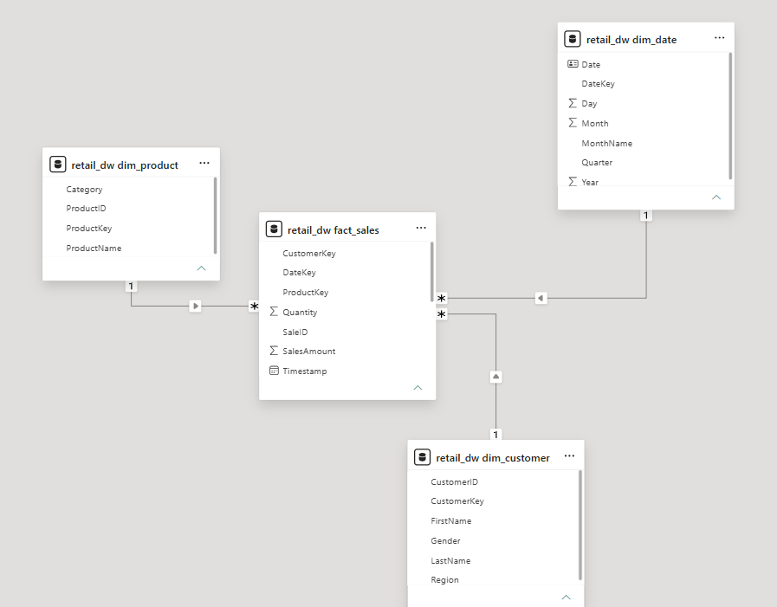
8.3 Fact Table
The fact_sales table is the central table of the warehouse. Each record represents a valid sales transaction.
Important fields include:
- SaleID
- ProductKey
- CustomerKey
- DateKey
- SalesAmount
- Quantity
- Timestamp
SalesAmount and Quantity are the primary measures used for business analysis.
8.4 Dimension Tables
The customer dimension provides descriptive information about customers and enables analysis based on customer demographics and regions.
The product dimension provides product names and categories, allowing sales performance to be analyzed at product and category levels.
The date dimension was generated from the transaction timestamps and contains attributes such as date, year, quarter, month, month name, and day. It supports monthly, quarterly, and yearly sales analysis.
8.5 Relationships and Referential Integrity
Relationships were established between the dimension tables and the fact table using primary and foreign keys.
Each sales transaction is linked to a valid customer, product, and date record. Referential integrity checks were performed during the ETL and database-loading process to ensure that invalid references were not introduced into the fact table.
8.6 Warehouse Benefits
The completed warehouse provides a structured foundation for:
- Sales performance analysis
- Product and category analysis
- Regional analysis
- Customer purchase analysis
- Time-based sales trends
- Power BI reporting and visualization
The warehouse therefore acts as the central analytical layer between the Python ETL process and the Power BI dashboard.
9. SQL Analysis and Business KPIs
9.1 Overview
After loading the cleaned data into MySQL, SQL queries were developed to analyze sales performance, product performance, regional trends, customer behavior, and sales growth.
The SQL analysis was performed using the fact and dimension tables created in the data warehouse. The results were also used as the basis for several Power BI dashboard visuals and KPI cards.
9.2 Overall Sales Performance
The analysis calculated the overall sales revenue, number of transactions, total quantity sold, and average transaction value.
The completed dataset produced:
- Total Sales Revenue: 13,507,295.52
- Total Transactions: 9,397
- Total Quantity Sold: 237,086
- Average Transaction Value: 1,437.41
These metrics provide an overall view of the sales performance represented in the dataset.
9.3 Product Performance Analysis
SQL queries were used to identify products generating the highest sales revenue. The analysis grouped transactions by product and calculated total revenue and quantity sold.
The Action Figure generated the highest product revenue at approximately 645,659.24, followed by products such as Swing, Board Game, Doll, and Stuffed Animal.
Category-level analysis showed that Toys generated approximately 5.82 million in sales, followed by Electronics at approximately 5.00 million.
This analysis was used to support the product and category visuals in the Power BI dashboard.
9.4 Regional Sales Analysis
Sales were also analyzed according to customer region.
The dataset recorded approximately:
- New York: 5.19 million
- Texas: 2.63 million
- Ohio: 2.39 million
- California: 2.38 million
- Unknown: 0.91 million
The Unknown category represents customer records where regional information was unavailable in the source data.
9.5 Sales Trend and Growth Analysis
Monthly sales were calculated using the transaction date and the date dimension.
Sales increased from approximately 2.03 million in June 2024 to approximately 2.67 million in August 2024. September showed a decline compared with August, followed by an increase in October.
Month-over-month growth was also calculated using SQL. The observed changes included approximately 8.10% growth in July, 21.42% growth in August, and a decline of approximately 21.90% in September.
These calculations were later represented through the sales trend and sales growth visuals in Power BI.
9.6 Customer Analysis
Customer-level SQL queries were used to analyze purchasing frequency and customer value.
Customer Purchase Frequency was calculated using the number of distinct transactions associated with each customer. Historical customer value was calculated using the total sales revenue generated by each customer.
For this project, the Customer Lifetime Value metric represents historical revenue generated by a customer in the available dataset. It should not be interpreted as a predictive lifetime-value model.
The analysis was used to identify customers with higher transaction frequency and higher historical revenue contributions.
9.7 Business KPIs
The SQL analysis provided the main metrics required for the dashboard, including:
- Total Sales Revenue
- Total Transactions
- Total Quantity
- Average Transaction Value
- Sales Growth
- Sales by Product Category
- Sales by Region
- Customer Purchase Frequency
- Historical Customer Value
These SQL results formed the analytical foundation for the Power BI dashboard developed in the next stage.
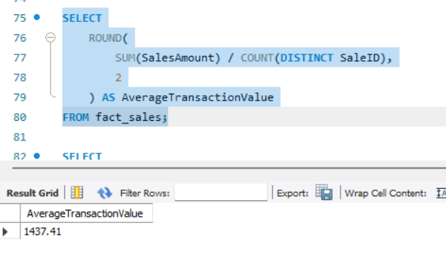
10. Power BI Development
10.1 Overview
Power BI was used to transform the analyzed warehouse data into an interactive business intelligence dashboard. The cleaned data stored in MySQL was connected to Power BI, where the data model, measures, visualizations, and interactive filters were developed.
The dashboard was designed to provide a clear view of sales performance, product trends, regional performance, and customer behavior.
10.2 Data Connection and Model
The four warehouse tables were imported into Power BI from the MySQL database:
- fact_sales
- dim_customer
- dim_product
- dim_date
The existing relationships between the fact and dimension tables were established in the Power BI model. The dim_date table was also configured as the date table to support time-based calculations.
The resulting model follows the same star-schema structure as the MySQL warehouse.
10.3 DAX Measures
DAX measures were created to calculate important business metrics dynamically within Power BI.
The main measures include:
- Total Sales
- Total Transactions
- Total Quantity
- Average Transaction Value
- Customers
- Previous Period Sales
- Sales Growth %
- Customer Purchase Frequency
- Customer Lifetime Value
These measures allow the dashboard visuals and KPI cards to respond dynamically when users apply filters or slicers.
10.4 Dashboard Pages
Three main report pages were developed:
Executive Overview
The Executive Overview provides a high-level summary of the business performance. It contains KPI cards for total sales, transactions, quantity, average transaction value, and customers.
It also includes sales trends, category performance, regional sales, top products, and sales growth.
Sales Analysis
The Sales Analysis page focuses on product, category, regional, and time-based sales performance. It allows users to examine how sales vary across products and regions and how sales change over time.
Customer Insights
The Customer Insights page focuses on customer purchasing behavior. It includes customer purchase frequency, historical customer value, customer demographics, and customer distribution by region.
10.5 Interactive Features
Slicers were added to allow users to filter the dashboard according to:
- Region
- Gender
- Product Category
- Year
A page navigator was also added to make it easier to move between the Executive Overview, Sales Analysis, and Customer Insights pages.
These interactive features allow users to explore the data according to different business requirements rather than relying only on static reports.
10.6 Dashboard Design
The dashboard was designed with a simple and business-oriented layout. KPI cards are positioned prominently so that important metrics can be viewed quickly, while charts provide detailed analysis below them.
The use of consistent page titles, charts, slicers, and navigation improves the usability of the report and makes the analytical results easier to interpret.
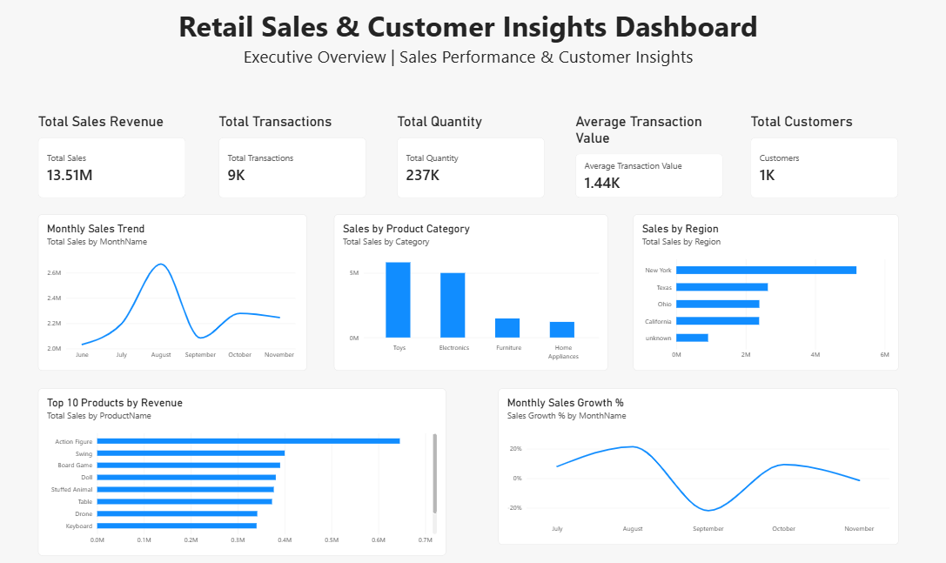
11. Dashboard and Visualizations
11.1 Executive Overview
The Executive Overview page provides a consolidated view of the overall retail business performance. KPI cards are used to display the key metrics at the top of the page, including total sales, total transactions, total quantity, average transaction value, and number of customers.
The page also includes visualizations for monthly sales trends, sales by product category, sales by region, top-selling products, and monthly sales growth. These visuals allow users to quickly understand overall performance and identify changes in sales over time.
11.2 Sales Analysis Dashboard
The Sales Analysis page provides a more detailed view of sales performance.
The page includes visualizations for product performance, category-level sales, regional sales, and monthly sales trends. A Top 10 product view was also created to identify the products generating the highest revenue.
The analysis shows that Toys generated the highest category-level revenue, while New York recorded the highest regional sales in the available dataset. The Action Figure was the highest-revenue individual product.
11.3 Customer Insights Dashboard
The Customer Insights page focuses on customer purchasing behavior and demographics.
The page contains a Top 10 Customers by Purchase Frequency visualization and a Top 10 Customers by Historical Customer Value visualization. These visuals help identify customers with frequent transactions and customers who generated higher revenue within the available dataset.
Additional visuals show customer distribution by gender and region. Slicers allow users to examine customer information based on region, gender, product category, and year.
11.4 Interactive Filtering and Navigation
Interactive slicers were incorporated into the dashboard to allow users to dynamically filter the displayed information.
The available filters include Region, Gender, Product Category, and Year. A page navigator was also added to allow users to move between the Executive Overview, Sales Analysis, and Customer Insights pages.
These features make the dashboard interactive and allow users to examine the same dataset from different analytical perspectives.
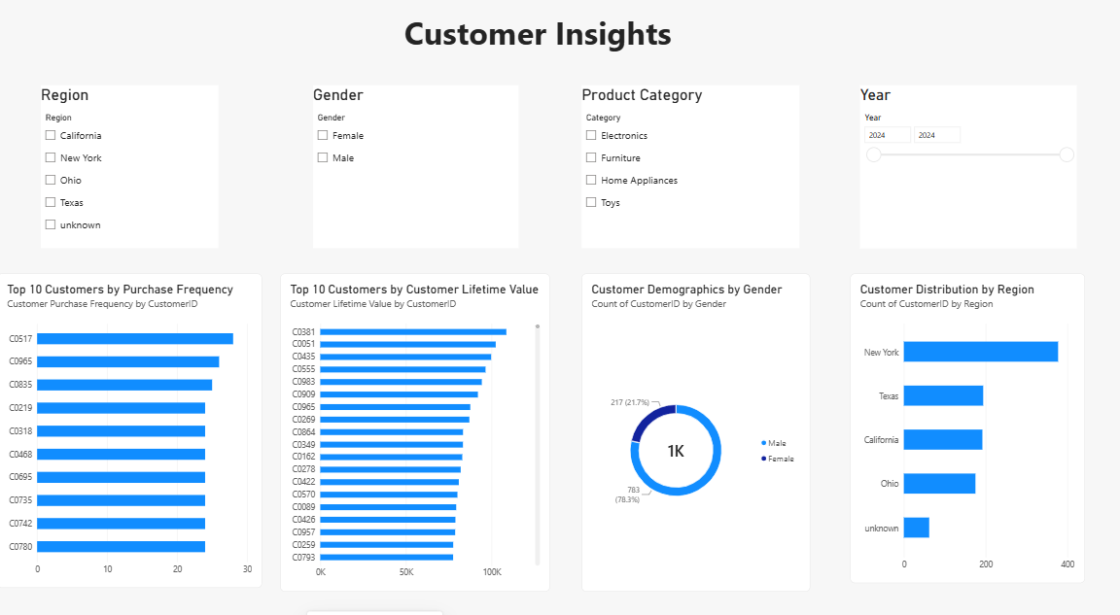
12. Data Quality and Testing
12.1 Data Quality Validation
Data quality checks were performed throughout the ETL process to ensure that the final analytical data was accurate, consistent, and suitable for reporting.
The validation process checked for duplicate identifiers, valid sales amounts, valid quantities, valid customer and product references, and successful creation of the required fact and dimension datasets.
The ETL process successfully produced 9,397 valid sales transactions, with 1,000 unique customers, 50 products, and 181 date records.
12.2 Automated ETL Testing
A Python test script was created to validate the generated datasets automatically. The tests checked whether the required files existed, whether the fact table contained records, whether customer and product identifiers were unique, and whether sales amounts and quantities contained valid values.
The final validation produced:
10/10 tests passed successfully.
This confirmed that the cleaned datasets generated by the ETL process satisfied the defined data quality checks before being used in the MySQL warehouse and Power BI dashboard.
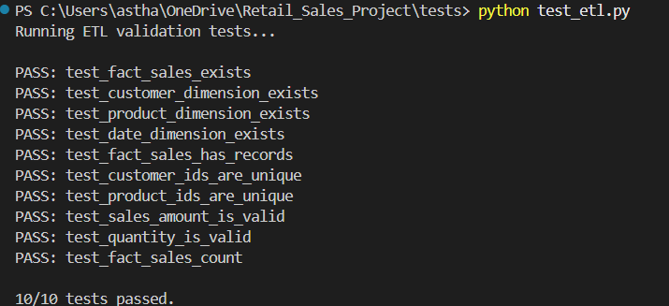
13. Key Findings
The analysis of the retail sales data produced several important findings related to sales performance, products, regions, and customer behavior.
13.1 Overall Sales Performance
The completed analytical dataset generated total sales revenue of approximately 13.51 million across 9,397 transactions. A total of 237,086 units were sold, with an average transaction value of approximately 1,437.41.
These metrics provide an overall summary of the sales activity represented in the dataset.
13.2 Product and Category Performance
The analysis showed that Toys generated the highest category-level sales, with approximately 5.82 million in revenue. Electronics followed with approximately 5.00 million.
At the individual product level, Action Figure generated the highest revenue at approximately 645,659.
These results demonstrate how product-level and category-level analysis can be used to understand revenue contribution.
13.3 Regional Performance
Among the available regions, New York recorded the highest sales revenue at approximately 5.19 million.
Texas, Ohio, and California also contributed significant sales, while some transactions were associated with an Unknown region because regional information was missing from the original customer data.
13.4 Sales Trends
Monthly analysis showed changes in sales throughout the available period from June to November 2024.
Sales reached their highest monthly value in August 2024, at approximately 2.67 million. August also recorded approximately 21.42% month-over-month growth compared with July.
The analysis also showed a decline in September followed by an increase in October.
13.5 Customer Insights
Customer-level analysis identified differences in purchasing frequency and historical revenue contribution.
The dashboard highlights the customers with the highest number of transactions as well as customers generating the highest historical revenue.
These insights demonstrate how transaction-level data can be used to identify important customer segments and understand customer contribution to overall sales.
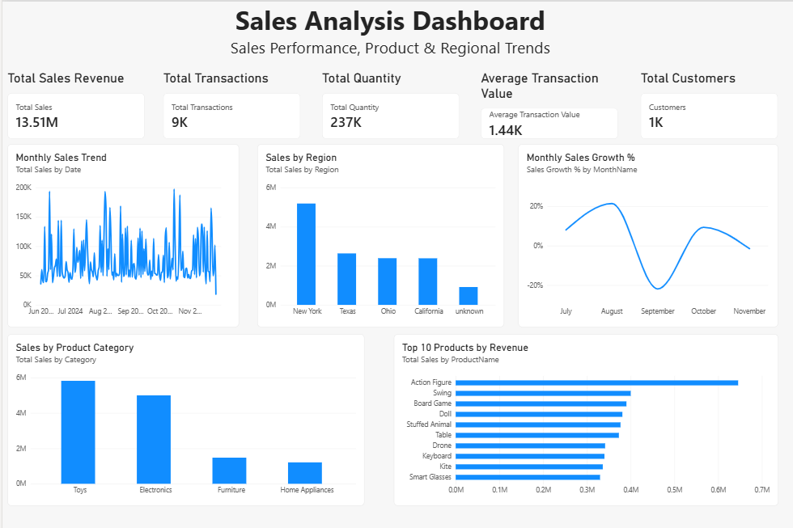
14. Data Privacy and Security
The project involved customer-related information, including personally identifiable information (PII) present in the original customer dataset. During the ETL process, only the information required for business analysis was retained in the analytical warehouse.
The SSN field was excluded because it was not required for sales, customer, or regional analysis. This reduced unnecessary exposure of sensitive information within the analytical environment.
The Power BI dashboard also focuses on aggregated business information rather than displaying sensitive personal information.
Appropriate handling of customer data is important when developing analytical systems because data should be limited to what is necessary for the intended business purpose.
15. Project Limitations
Although the project successfully implements an end-to-end retail analytics pipeline, some limitations exist.
- The available sales data covers a limited time period, so long-term seasonal trends cannot be established from this dataset alone.
- The source data does not contain sufficient information to calculate an actual Product Return Rate.
- Cost information was not available, so metrics such as COGS and profit could not be calculated.
- The Customer Lifetime Value used in this project represents historical revenue generated by each customer, rather than a predictive CLV model.
- The actual product source provided for the project was a CSV file. Therefore, the implementation does not demonstrate a live SharePoint extraction.
- Missing regional information in the source customer data resulted in an Unknown region category.
These limitations identify areas where additional business data would be required for a more advanced analytical solution.
16. Future Enhancements
The project can be extended in several ways to make the solution more comprehensive.
Future improvements could include:
- Adding real-time sales data ingestion.
- Integrating additional data sources such as inventory and marketing data.
- Adding product returns and refund information.
- Adding product cost data to calculate profit and COGS.
- Developing predictive customer lifetime value models.
- Implementing customer segmentation using machine learning.
- Adding sales forecasting models.
- Implementing automated ETL scheduling.
- Deploying the Power BI dashboard for wider business access.
These enhancements would allow the solution to move from historical reporting toward more advanced predictive and operational analytics.
17. Conclusion
The Retail Sales and Customer Insights project successfully demonstrates an end-to-end data engineering and business intelligence workflow.
The project began with raw sales, customer, and product datasets and used Python and Pandas for data extraction, cleaning, transformation, and validation. The processed data was organized into a MySQL star-schema data warehouse consisting of fact and dimension tables.
SQL was then used to analyze sales revenue, transactions, product performance, regional performance, sales trends, and customer behavior. Finally, Power BI and DAX were used to create interactive dashboards containing KPIs, charts, customer insights, filters, and navigation.
The final solution provides a structured approach for converting raw retail data into meaningful business insights while demonstrating practical skills in Python, SQL, MySQL, data warehousing, ETL, Power BI, and DAX.
Overall, the project demonstrates how an integrated data pipeline can support data-driven analysis and business decision-making.
18. References
The following resources and tools were used during the development of the project:
- Python documentation and Pandas documentation for data processing and transformation.
- MySQL documentation for database creation, table design, relationships, and SQL queries.
- Microsoft Power BI documentation for data modeling, visualization, filters, and dashboard development.
- DAX documentation and references for creating calculated measures and business KPIs.
- Project-provided sales, customer, and product datasets.
- Project requirement and capstone documentation provided by the instructor.
19. Appendix
The appendix contains supporting material related to the implementation and validation of the project.
Appendix A – Python ETL
The Python ETL script used for data extraction, cleaning, transformation, validation, and generation of the final analytical datasets is included in the project repository.
Appendix B – SQL Scripts
The SQL scripts used to create the MySQL data warehouse and perform business analysis are included with the project implementation.
Appendix C – Data Quality Testing
The ETL validation tests confirmed that the generated datasets satisfied the defined quality checks.
Final result: 10/10 tests passed successfully.
Appendix D – Power BI Dashboard
The Power BI implementation contains three main pages:
- Executive Overview
- Sales Analysis
- Customer Insights
The dashboard includes KPI cards, product and category analysis, regional analysis, sales trends, customer analysis, slicers, and page navigation.
Appendix E – Project Repository
The complete source code and supporting implementation files will be provided through the project's GitHub repository.
GitHub Repository:
[GitHub link will be added after repository creation]

