SUPPLY CHAIN AND INVENTORY MANAGEMENT
A Data-Driven Analysis Using Python, SQL and Data Warehousing

Prepared by:
Astha Singh
Role: Data Engineering Intern
Department: Application and Data Modernization and Migration,
Technology and Transformation

Year: 2026

1. Introduction
Supply chain and inventory management play an important role in ensuring that products are available when required while avoiding unnecessary inventory costs. ABC Supermarket faces challenges related to stock imbalances, including stockouts and overstocking, which can increase costs and negatively affect profitability.
This project focuses on developing a data-driven Supply Chain and Inventory Management solution for ABC Supermarket. The project uses sales, inventory, supplier, and purchase-order data to analyze inventory conditions and support better supply chain decisions.
The solution combines Python-based data processing and analysis, SQL-based business analysis, and a MySQL data warehouse. Historical sales data is used for demand forecasting, inventory data is used to calculate reorder requirements, and supplier information is analyzed using clustering techniques based on lead time and order frequency.
The overall aim is to balance stock levels, improve demand forecasting, optimize reorder strategies, and reduce unnecessary inventory and carrying costs.

2. Problem Statement and Objectives
2.1 Problem Statement
ABC Supermarket experiences inventory imbalances in the form of stockouts and overstocking. These issues can increase inventory-related costs and affect the availability of products. The project therefore aims to use historical sales, inventory, supplier, and purchase-order data to support better inventory and supply-chain management.
2.2 Objectives
The main objectives of the project are:
- Balance stock levels by identifying products that require replenishment.
- Improve demand forecasting by using historical sales data to estimate future product demand.
- Optimize reorder strategies by calculating reorder points using demand and supplier lead-time information.
- Reduce waste and carrying costs by improving inventory planning and supplier evaluation.
The project combines SQL analysis, Python-based analytics, and a data warehouse to achieve these objectives.

3. Dataset Description and Technologies Used
3.1 Dataset Description
The project uses four datasets provided for the ABC Supermarket case study. These datasets contain information about sales transactions, inventory levels, suppliers, and purchase orders.
Dataset | Main Information
Sales Data | Sale ID, Product ID, Store ID, Sale Date, Quantity Sold and Revenue
Inventory Data | Product ID, Store ID, Warehouse ID, Stock Level, Reorder Level and Last Updated
Supplier Data | Supplier ID, Supplier Name, Product ID, Lead Time and Order Frequency
Purchase Orders | Order ID, Product ID, Supplier ID, Order Date, Quantity and Arrival Date
The datasets are used throughout the project for data exploration, cleaning, SQL analysis, demand forecasting, reorder-point calculation, supplier clustering, and data-warehouse development.
3.2 Dataset Size
The available datasets contain:
- Sales: 5,000 records
- Inventory: 200 records
- Suppliers: 50 records
- Purchase Orders: 1,000 records
3.3 Technologies Used
The following technologies and libraries were used to implement the project:
Python: Used for data exploration, cleaning, ETL, demand forecasting, reorder-point calculation, supplier clustering, and visualization.
Pandas: Used for reading, cleaning, transforming, grouping, and analyzing the datasets.
NumPy: Used for numerical calculations during data analysis.
Matplotlib: Used to generate visualizations for the analytical results.
Scikit-learn: Used for Linear Regression in demand forecasting and K-Means clustering for supplier analysis.
MySQL: Used to create and manage the data warehouse and perform SQL-based business analysis.
MySQL Workbench: Used to execute SQL scripts, create the warehouse tables, load data, and perform analysis.
3.4 Project Environment
The project was developed using Python with a virtual environment and MySQL as the database management system. CSV files were used as the source data, while the cleaned datasets and analytical outputs were stored in the project output directory.

4. Project Workflow
The project follows a structured data-processing and analytics workflow that transforms the raw datasets into useful supply-chain insights.
4.1 Workflow
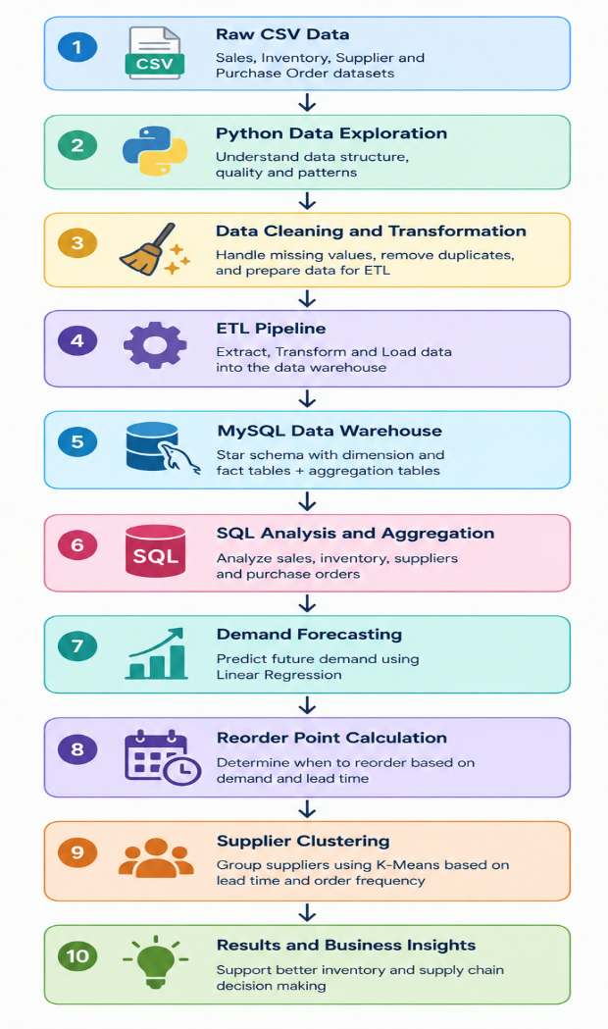
4.2 Workflow Description
The raw sales, inventory, supplier, and purchase-order datasets are first explored using Python to understand their structure and data quality. The data is then cleaned and transformed through an ETL process before being loaded into a MySQL data warehouse.
The warehouse follows a star-schema-based structure containing dimension and fact tables along with aggregation tables. SQL queries are then used to analyze sales movement, inventory status, supplier lead times, and purchase-order performance.
Python analytics are subsequently applied to forecast product demand, calculate reorder points, and group suppliers using K-Means clustering based on lead time and order frequency. The final results provide information that can support inventory and supply-chain management decisions.

5. Data Exploration
5.1 Overview
Data exploration is the first practical stage of the Supply Chain and Inventory Management project. Before performing data cleaning, transformation, database loading, or analytical processing, it is necessary to understand what information is available in the source datasets and whether the data is suitable for further processing.
The project uses four primary datasets provided for ABC Supermarket: Sales Data, Inventory Data, Supplier Data, and Purchase Order Data. These datasets contain information about product sales, current stock levels, suppliers and their lead times, and purchase orders respectively.
Python and the Pandas library were used to perform the initial exploration. The purpose of this stage was not to modify the data, but to examine its structure and identify important characteristics or potential quality issues that could affect later stages of the project.
The exploration focused on the following areas:
- Number of records and columns in each dataset
- Column names and data types
- Sample records from each dataset
- Missing values
- Duplicate records
- Date ranges
- Number of unique products, stores, and suppliers
- Basic numerical statistics
- Overall sales and revenue
- Existing inventory reorder status
- Supplier lead-time information
This initial examination provided a clear understanding of the source data before the ETL process was performed.
5.2 Dataset Loading and Structure Examination
The explore_data.py Python script was developed to load all four CSV files from the project's data directory using Pandas. Each dataset was stored in a separate DataFrame so that its structure could be examined independently.
The script first displayed the size of each dataset. This helped verify that the expected source files had been loaded correctly and provided an initial understanding of the volume of data being processed.
The datasets contained the following records:
- Sales Data: 5,000 records and 6 columns
- Inventory Data: 200 records and 6 columns
- Supplier Data: 50 records and 5 columns
- Purchase Order Data: 1,000 records and 6 columns
The script also displayed the column names and data types. This step was important because later ETL operations depend on fields such as dates, quantities, revenue, product identifiers, supplier identifiers, and inventory levels being interpreted correctly.
Sample records were also examined to understand how the information was represented in the original source files. This provided a preliminary view of the relationships between products, stores, suppliers, inventory, and purchase orders.
5.3 Data Quality Examination
After examining the structure of the datasets, the next step was to check their data quality. The script checked each DataFrame for missing values and duplicate complete records.
Missing-value analysis is important because incomplete records can cause incorrect calculations or failures during later processing. For example, a missing product identifier could prevent a sales record from being correctly connected to the product dimension in the data warehouse.
Duplicate detection was also performed to determine whether identical records were present more than once. Duplicate transactional records could artificially increase sales quantities, revenue, inventory counts, or purchase-order quantities.
The exploration identified no missing values and no duplicate complete records across the four source datasets. This provided a reliable starting point for the subsequent data cleaning and transformation stage.
5.4 Date and Business-Attribute Exploration
Date fields were examined to understand the time period represented by the datasets. The Sales data covered dates from 2024-01-01 to 2037-09-08, while the Inventory data covered 2024-02-01 to 2024-08-18. The Purchase Order data covered 2024-01-01 to 2026-09-26.
The different date ranges were identified during exploration and were retained as characteristics of the source data rather than being artificially changed.
The script also examined important business attributes. The Sales dataset contained 5 unique products and 4 unique stores, while the Supplier dataset contained 50 unique suppliers and information for the products they supply.
This examination was useful for understanding the scale of the business entities that would later be represented in the data warehouse dimensions.
5.5 Initial Business Metrics
Basic numerical calculations were performed to obtain an initial understanding of the business data.
The total quantity sold across the Sales dataset was 1,292,122 units, while the total recorded revenue was 125,870,014.00. The average quantity per sales record was approximately 258.42 units, and the average revenue per sales record was approximately 25,174.00.
The supplier data showed an average lead time of approximately 6.22 days. Supplier lead time is particularly important in inventory management because it affects how early a purchase order needs to be placed to prevent stockouts.
The existing inventory records were also examined against their supplied reorder levels. Out of the 200 inventory records, 54 records were classified as requiring reorder, while 146 records were classified as stock sufficient.
These initial metrics provided useful business context for the later SQL analysis and Python-based reorder-point calculation.
5.6 Data Exploration Output
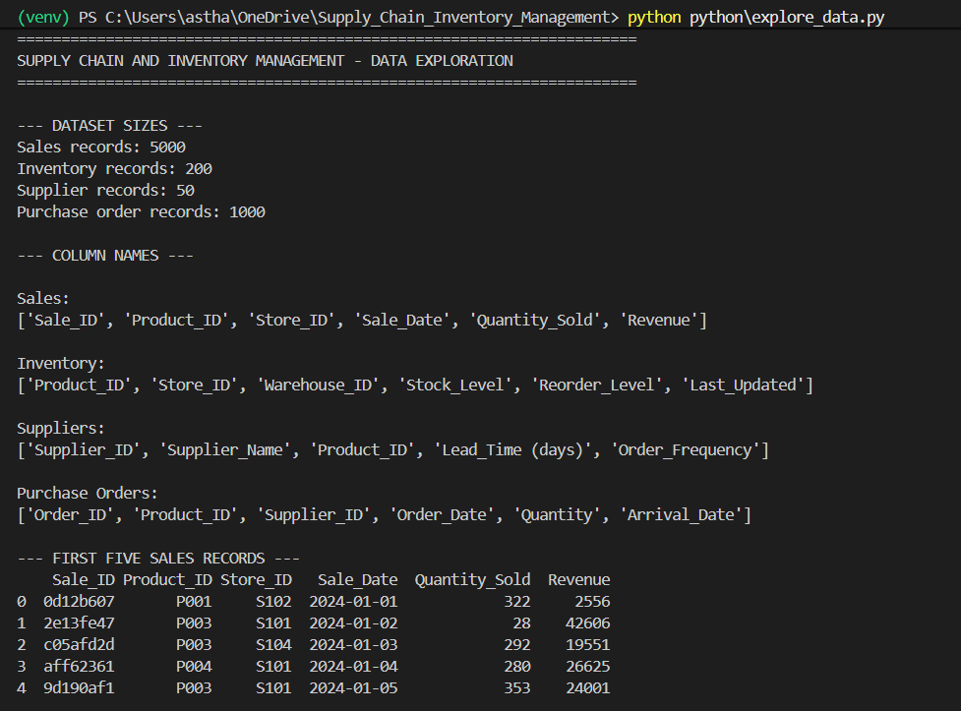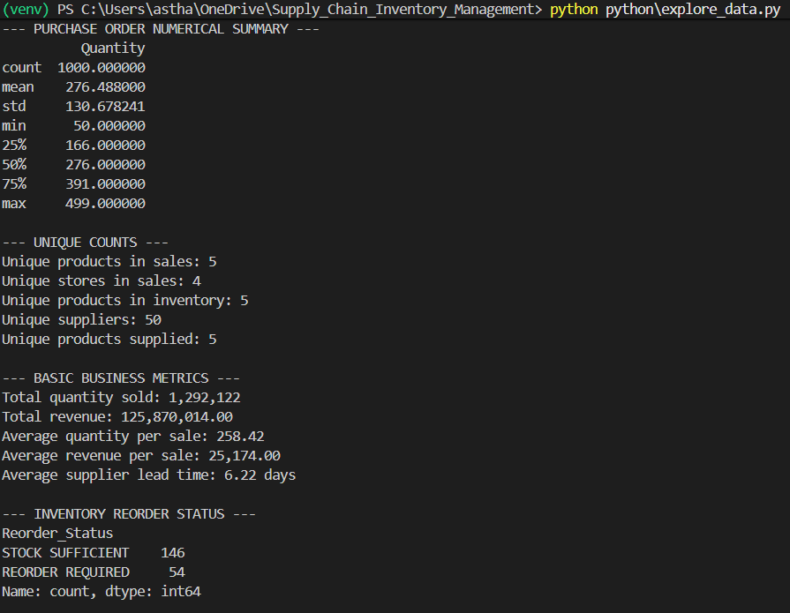
Figure 5.1: Data Exploration Script Output
The screenshot demonstrates the successful loading and examination of all four source datasets. It shows the dataset dimensions, structural information, data-quality checks, and key statistical results generated during the exploration stage.
The output confirmed that the source files were successfully read and that no missing values or duplicate complete records were detected. The information obtained here was subsequently used to design the cleaning rules, transformations, and warehouse structure.
5.7 Outcome of Data Exploration
The data exploration stage established a baseline understanding of the ABC Supermarket datasets before any transformations were applied. It confirmed the availability of the required sales, inventory, supplier, and purchase-order information and identified the main attributes required for subsequent analysis.
The exploration also highlighted the key business areas that would be investigated later in the project, including product sales performance, inventory levels, supplier lead times, demand forecasting, and reorder decisions.
The complete explore_data.py implementation is maintained in the project's GitHub repository. The report focuses on the methodology and results, while the repository provides the complete source code for reproducibility.

6. DATA CLEANING AND ETL
6.1 Overview
After completing the initial exploration, the next stage of the project was data cleaning and ETL (Extract, Transform, Load). The purpose of this stage was to prepare the source data for analytical processing and loading into the MySQL data warehouse.
The ETL process was implemented using Python and Pandas. The four source datasets were extracted from the CSV files, transformed into a consistent structure, validated for data-quality issues, and stored as cleaned datasets for subsequent database loading.
The main objective was to ensure that the data used in the warehouse was consistent, correctly formatted, and suitable for relationships between products, stores, suppliers, warehouses, dates, sales, inventory, and purchase orders.
6.2 Data Extraction
The first step of the ETL process was to extract the four source datasets into Pandas DataFrames. The datasets included Sales, Inventory, Suppliers, and Purchase Orders.
Each dataset was loaded independently so that the appropriate transformations could be applied according to its structure. The original source data was preserved separately, while the transformed datasets were written to the project's output directory.
This approach keeps the original data available for reference while providing a separate set of cleaned files for database loading and analysis.
6.3 Data Standardization
The next step was to standardize the structure and naming of the datasets. Column names were converted into a consistent snake_case format.
For example, fields such as Product_ID, Sale_Date, Quantity_Sold, and Lead_Time (days) were transformed into consistent names such as product_id, sale_date, quantity_sold, and lead_time_days.
This standardization makes the data easier to work with in Python and SQL and provides consistent naming across the different stages of the project.
Text-based identifiers such as product IDs, store IDs, warehouse IDs, and supplier IDs were also standardized so that the same entities could be matched reliably during the warehouse loading process.
6.4 Data Type Conversion
Appropriate data types were assigned to important fields during the transformation stage.
Date columns such as sales dates, inventory update dates, order dates, and arrival dates were converted into proper date formats. Numerical fields such as quantities, revenue, stock levels, reorder levels, and supplier lead times were converted into appropriate numeric types.
Correct data types are important because subsequent calculations depend on them. For example, dates are required for monthly sales analysis and forecasting, while numerical fields are required for revenue calculations, inventory analysis, and reorder-point calculations.
6.5 Duplicate and Missing-Value Handling
The ETL process also performed data-quality validation after the initial exploration.
Exact duplicate records were identified and removed where necessary. Missing-value checks were performed on the transformed datasets to ensure that important fields required for analysis and database relationships were populated.
The final ETL validation showed that all four datasets retained their expected record counts:
- Sales: 5,000 records
- Inventory: 200 records
- Suppliers: 50 records
- Purchase Orders: 1,000 records
No missing values or duplicate complete records remained in the cleaned datasets.
6.6 Derived Fields and Transformations
Additional fields were created during the transformation stage to support later analysis.
For the Sales dataset, fields such as sale year, sale month, month name, and revenue per unit were derived. These fields simplify time-based analysis and provide additional measures for examining sales performance.
For the Inventory dataset, a reorder status field was created to classify records as either REORDER REQUIRED or STOCK SUFFICIENT based on the existing stock and reorder levels. A stock_difference field was also generated to show the difference between current stock and the defined reorder level.
For the Purchase Order dataset, actual lead time in days was calculated from the order date and arrival date. This provides a useful measure for evaluating supplier and purchase-order performance.
6.7 Validation and Referential Integrity
After the transformations were completed, additional validation checks were performed.
The ETL process checked that numerical fields contained valid values and that relationships between related entities could be established correctly. Product IDs, supplier IDs, store IDs, and warehouse IDs were validated before the data was loaded into the warehouse.
Referential integrity is particularly important in this project because the final warehouse follows a dimensional structure in which fact tables reference dimension tables. Ensuring consistent identifiers during ETL helps prevent unmatched records during database loading.
6.8 Cleaned Data Output
The final transformed datasets were saved in the output directory as:
- cleaned_sales.csv
- cleaned_inventory.csv
- cleaned_suppliers.csv
- cleaned_purchase_orders.csv
These files became the standardized input for the MySQL data warehouse.
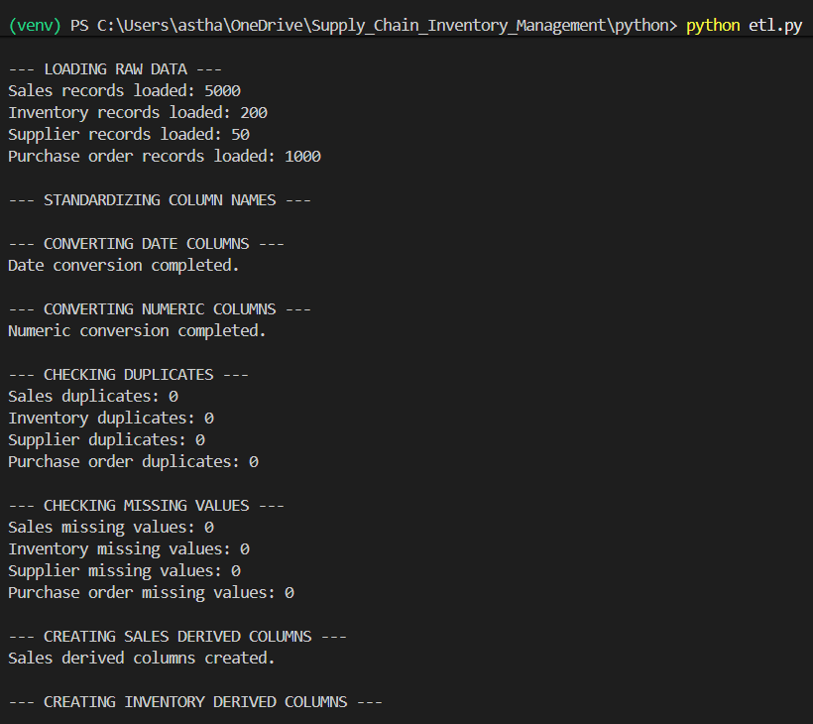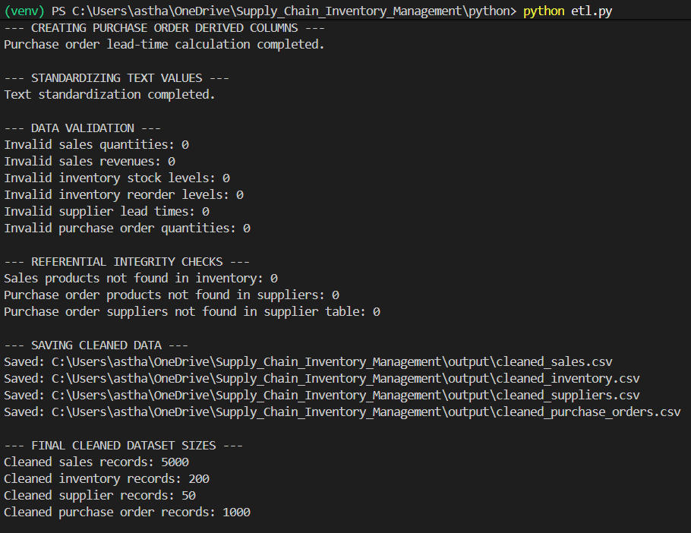
Figure 6.1: ETL Execution Output
The screenshot demonstrates the successful completion of the ETL pipeline and the validation of the cleaned datasets. The output confirms that the expected records were retained and that the major data-quality checks were completed successfully.
6.9 ETL Outcome
The ETL stage transformed the raw source files into a consistent and validated form suitable for database loading and analysis. It also added useful derived attributes required by the later SQL and Python analytical processes.
The cleaned datasets therefore provided a reliable bridge between the original CSV files and the MySQL data warehouse. The complete ETL implementation is maintained in the project's GitHub repository, while the report presents the major transformation steps and their results.

7. DATA WAREHOUSE AND STAR SCHEMA
7.1 Overview
After the data cleaning and ETL stage, the cleaned datasets were loaded into a MySQL data warehouse named supply_chain_dw. The purpose of the data warehouse is to organize the operational data into a structured format that makes supply-chain analysis easier, more consistent, and more efficient.
The warehouse was designed using a star-schema approach, as specified in the project case study. In this structure, descriptive information is stored in dimension tables, while measurable business events are stored in fact tables. This separation allows sales, inventory, and purchase-order information to be analyzed using common business dimensions such as product, store, supplier, warehouse, and date.
The data warehouse also contains aggregation tables that store summarized information for frequently required reporting and analysis.
7.2 Star Schema Design
The central part of the warehouse consists of three major fact tables:
- fact_sales
- fact_inventory
- fact_purchase_orders
These fact tables are connected to dimension tables that provide descriptive information about the business entities.
The main dimension tables created were:
- dim_product
- dim_store
- dim_warehouse
- dim_supplier
- dim_date
The overall design allows a transaction or inventory record to be connected to the relevant product, store, warehouse, supplier, and date information through foreign-key relationships.
7.3 Dimension Tables
The Product Dimension (dim_product) stores the unique products involved in the supply-chain process. A surrogate product_key is used as the primary key, while the original product_id is retained as the business identifier.
The Store Dimension (dim_store) contains the unique stores associated with sales and inventory records. It allows sales performance and inventory information to be analyzed at the store level.
The Warehouse Dimension (dim_warehouse) stores warehouse identifiers associated with inventory records. This provides a separate business dimension for analyzing stock distribution across warehouses.
The Supplier Dimension (dim_supplier) stores supplier information such as supplier ID, supplier name, lead time, and order frequency. These attributes are particularly important for supplier evaluation and later clustering analysis.
The Date Dimension (dim_date) provides a consistent time reference for sales, inventory, and purchase-order records. It contains fields such as the full date, year, month, month name, and quarter, allowing time-based analysis without repeatedly deriving these attributes from transactional dates.
7.4 Fact Tables
The Sales Fact Table (fact_sales) stores individual sales transactions. It contains references to the product, store, and date dimensions along with measures such as quantity sold, revenue, and revenue per unit.
The Inventory Fact Table (fact_inventory) stores inventory information for products across stores and warehouses. It contains stock level, reorder level, stock difference, and reorder status along with references to the relevant dimensions.
The Purchase Order Fact Table (fact_purchase_orders) records purchase-order transactions. It connects products and suppliers with order and arrival dates and stores measures such as order quantity and actual lead time.
Using separate fact tables allows the project to analyze different business processes without mixing unrelated measures.
7.5 Supplier–Product Relationship
A separate bridge_supplier_product table was created to represent the relationship between suppliers and products.
This structure is useful because a product can be associated with multiple suppliers. Instead of assuming a one-to-one relationship, the bridge table records the valid supplier-product combinations.
This relationship is later used in the SQL analysis to identify alternative suppliers for products and compare supplier lead times.
7.6 Aggregation Tables
Two aggregation tables were also created to support faster reporting and repeated analysis:
- agg_monthly_sales
- agg_product_inventory
The agg_monthly_sales table stores product-level monthly sales quantities and revenue. It reduces the need to repeatedly aggregate individual sales transactions when monthly performance is required.
The agg_product_inventory table summarizes product-level inventory information, including total stock, average reorder level, and the number of inventory records requiring reorder.
These aggregation tables support the data-warehouse requirement of providing summarized information for efficient reporting.
7.7 Data Loading
The cleaned CSV files generated during the ETL stage were loaded into staging tables before being transformed into the final warehouse dimensions and fact tables.
The staging approach provides an intermediate layer between the cleaned files and the final warehouse. Data can therefore be validated and matched against dimension records before being inserted into the fact tables.
Foreign-key relationships were established between the fact and dimension tables to maintain consistency within the warehouse.
7.8 Data Warehouse Output
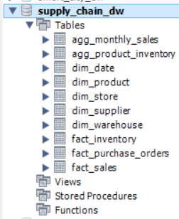
Figure 7.1: MySQL Data Warehouse Tables and Loading Output
The screenshot demonstrates the successful creation and loading of the supply_chain_dw database. It shows the warehouse tables generated for dimensions, facts, and aggregations, confirming that the cleaned data was successfully organized into the planned warehouse structure.
7.9 Outcome of Data Warehouse Design
The completed warehouse provides a structured foundation for the project's analytical requirements. Sales, inventory, supplier, and purchase-order information can now be analyzed using common dimensions while maintaining clear relationships between business entities.
The star-schema design also separates descriptive information from measurable transactions, making the subsequent SQL analysis easier to understand and maintain. The complete database creation and loading scripts are maintained in the project's GitHub repository.
8. SQL ANALYSIS
8.1 Overview
After the data warehouse was successfully created and populated, SQL was used to analyze the supply-chain data and answer the business questions defined in the project case study.
The SQL analysis focuses on product movement, inventory status, supplier performance, purchase-order performance, sales trends, and overall business performance. The analysis was performed directly on the structured warehouse tables rather than on the original raw CSV files.
The SQL analysis was designed to support the project's main objectives of identifying stock-related issues, understanding product demand, evaluating suppliers, and providing information that can be used to improve inventory and purchasing decisions.
8.2 Product Sales Movement
The first part of the analysis identifies fast-moving and slow-moving products.
Fast-moving products are identified by examining products with higher sales quantities and revenue during the most recent three-month period represented in the sales data. These products indicate comparatively stronger demand and may require closer inventory monitoring to reduce the possibility of stockouts.
Slow-moving products are identified using the corresponding lower sales quantities and revenue. Such products may require different inventory strategies because excessive stock of products with relatively lower movement can contribute to higher carrying costs.
The analysis uses aggregated sales information from the fact_sales table and groups the results by product.
8.3 Inventory Reorder Analysis
The next analysis identifies products whose current stock is at or below the existing reorder level.
This analysis compares the stock_level and reorder_level values in the inventory fact table. Products that meet the reorder condition are flagged for further attention, while products with sufficient stock are classified separately.
The analysis provides a direct view of the inventory records that may require replenishment under the existing inventory policy.
8.4 Inventory Status Summary
A separate summary groups inventory records according to their reorder status.
This provides an overall view of how many inventory records are currently classified as requiring reorder and how many have sufficient stock. Such a summary is useful for quickly assessing the current inventory position across the available products and stores.
The analysis also provides product-level inventory summaries containing total stock, average reorder level, and reorder-related information.
8.5 Supplier Lead-Time Analysis
Supplier performance was analyzed using the supplier dimension and purchase-order information.
The analysis examines supplier lead times to identify suppliers with comparatively longer delivery periods. Longer lead times can affect purchasing decisions because orders may need to be placed earlier to maintain sufficient inventory.
Supplier-level summaries provide information such as average lead time and order frequency, allowing supplier characteristics to be compared using consistent measures.
8.6 Alternative Supplier Analysis
The project case study specifically requires analysis of supplier alternatives. To support this requirement, the bridge_supplier_product table was used to establish the relationship between suppliers and products.
The SQL analysis identifies products that are associated with multiple suppliers and compares the lead times of those suppliers. This makes it possible to identify alternative suppliers for a product instead of relying on a single supplier relationship.
The analysis does not automatically select a supplier. Instead, it provides the relevant supplier and lead-time information that can be considered when evaluating procurement alternatives.
8.7 Lowest Lead-Time Supplier by Product
Another query compares suppliers for each product and identifies the supplier with the lowest recorded lead time.
This provides a product-level view of supplier delivery performance and can support further procurement analysis. Lead time is considered as one measurable supplier characteristic rather than the only factor in supplier selection.
Other considerations such as order frequency, cost, availability, and supplier reliability would require additional business information beyond the available datasets.
8.8 Purchase Order Performance
Purchase-order data was analyzed to examine ordering activity and actual supplier delivery times.
The analysis uses the order date, arrival date, order quantity, and calculated actual lead time stored in the purchase-order fact table. This provides information about how long purchase orders took to arrive and supports evaluation of supplier delivery behavior.
The results can be used alongside the supplier lead-time analysis when considering inventory replenishment strategies.
8.9 Monthly Sales Analysis
Monthly sales analysis was performed to examine sales quantity and revenue over time.
The query groups sales by year and month and calculates the total quantity sold and total revenue. This provides a time-based view of sales activity and establishes a foundation for understanding demand patterns.
Monthly sales information is also relevant to the Python forecasting stage, where historical demand is used to estimate future product demand.
8.10 Product and Store Performance
Product-level sales summaries were generated to compare total quantity sold and revenue across products.
Store-level analysis was also performed to compare sales activity across the available stores. These summaries provide additional business context by showing how sales are distributed across products and locations.
Together, these analyses help identify differences in sales performance that may be relevant when considering inventory allocation and replenishment.
8.11 Overall Business Summary
The final SQL query provides an overall summary of the available business data.
The summary combines key measures such as total sales quantity, total revenue, transaction counts, and inventory-related information. This provides a concise overview of the dataset after it has been loaded into the warehouse.
8.12 SQL Analysis Output
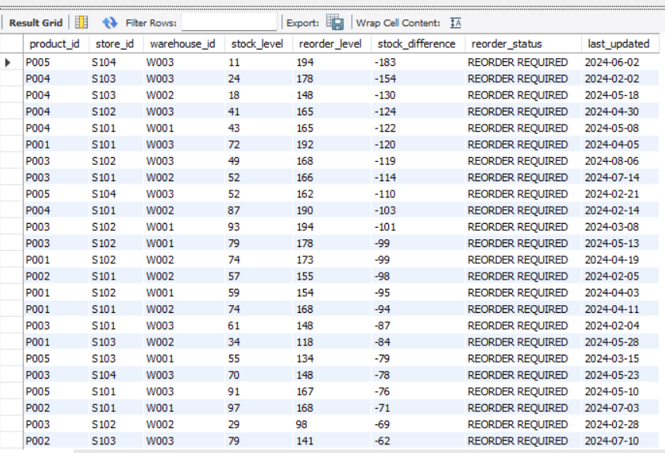
Figure 8.1: SQL Analysis Output
The screenshot demonstrates the successful execution of the SQL analysis against the MySQL data warehouse. The query identifies inventory records where the current stock level is at or below the defined reorder level, helping identify products that may require replenishment.
The complete analysis.sql file contains the full set of analytical queries and is maintained in the project's GitHub repository. The report presents the purpose and interpretation of the analyses while the repository provides the complete SQL implementation.
8.13 Outcome of SQL Analysis
The SQL stage converted the structured warehouse data into business-oriented information that can support supply-chain decisions. It addressed the main SQL requirements of the case study, including fast- and slow-moving products, inventory below reorder level, supplier lead-time analysis, and alternative supplier identification.
The results from this stage also provide an important foundation for the Python analytics that follow, particularly demand forecasting and reorder-point calculation.

9. DEMAND FORECASTING
9.1 Overview
Demand forecasting was performed to estimate the quantity of each product that may be required in the next month. Forecasting is an important part of inventory management because historical sales information can be used to anticipate future demand and support better replenishment decisions.
The forecasting process was implemented in Python using Pandas, NumPy, and Scikit-learn. The cleaned Sales dataset generated during the ETL stage was used as the input for the forecasting process.
The objective was to generate a separate next-month demand estimate for each product available in the sales data.
9.2 Preparation of Historical Sales Data
The cleaned Sales dataset was first loaded into the forecasting script. The sale_date field was converted into a date format so that the transactions could be organized chronologically.
The sales quantities were then grouped by month and product. This converted the individual sales transactions into monthly demand observations.
Monthly aggregation was important because the objective of the forecasting stage was to predict next-month demand, rather than the quantity associated with an individual transaction.
For each product, the resulting monthly sales history was arranged chronologically and assigned a sequential month number. This month index was used as the independent variable for the forecasting model.
9.3 Forecasting Method
A Linear Regression model from Scikit-learn was used to estimate the relationship between the progression of time and monthly product demand.
For each product, the model was trained using its historical monthly demand values. The model then used the next sequential month as the input to generate a forecast for that product.
The forecasting process was repeated separately for each product so that every product received its own demand estimate.
The predicted values were also constrained so that negative demand values would not be produced. The resulting forecasts were then stored in a separate output file for further use.
9.4 Forecasting Results
The forecasting process generated the following next-month demand estimates:
Product | Forecast Month | Predicted Demand
P001 | 2037-10 | 1,481.32
P002 | 2037-09 | 1,684.44
P003 | 2037-10 | 1,448.19
P004 | 2037-10 | 1,586.28
P005 | 2037-10 | 1,590.78
The forecast months reflect the dates present in the supplied Sales dataset. Since the Sales data extends through September 2037, the forecasting script naturally generated forecasts based on the latest available historical observations rather than changing the source dates.
The results indicate the estimated demand level for each of the five products in the next forecast period. These estimates can be used as an additional input when planning inventory replenishment.
9.5 Forecast Output
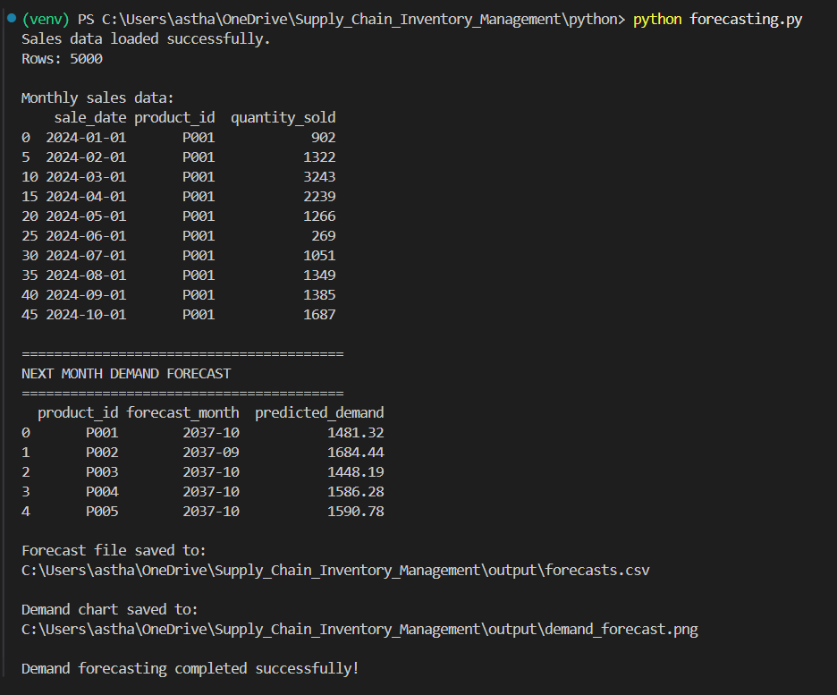
Figure 9.1: Demand Forecasting Script Output
The screenshot shows the successful execution of the forecasting process and the generation of product-level demand forecasts. The output confirms that the model produced a next-month demand estimate for each product and saved the results for subsequent analysis.
9.6 Forecast Output File
The forecasting results were saved as:
output/forecasts.csv
A visualization was also generated as:
output/demand_forecast.png
The CSV file provides the numerical forecast results, while the generated visualization provides a graphical representation of the forecasting output.
9.7 Role of Forecasting in Inventory Management
The forecasting stage provides a forward-looking component to the project. The earlier SQL analysis primarily examined historical sales and current inventory conditions, whereas demand forecasting uses historical sales patterns to estimate future requirements.
These estimates can help provide a more informed basis for inventory planning. Products with higher predicted demand may require closer monitoring so that replenishment decisions can be made before available stock becomes insufficient.
Forecasting should be considered an analytical estimate rather than a guaranteed future value. The accuracy of the results depends on the historical sales data and the forecasting method used.
9.8 Outcome of Demand Forecasting
The demand forecasting stage successfully generated product-level next-month demand estimates using historical monthly sales data and Linear Regression.
The forecasts provide an additional input for the project's inventory-management objectives and are particularly useful when considered together with the reorder-point calculations performed in the next stage.
The complete forecasting.py implementation and generated output files are maintained in the project's GitHub repository.

10. REORDER POINT CALCULATION
10.1 Overview
After estimating future demand, the next stage of the project was to calculate a reorder point for each product. The reorder point represents the approximate inventory level at which replenishment should be considered so that expected demand during the supplier lead time can be covered.
This analysis directly supports the project objective of optimizing reorder strategies. Instead of relying only on the predefined reorder levels present in the inventory dataset, the Python analysis calculates a new reorder point using historical demand variability and supplier lead-time information.
The calculation was implemented using Python, Pandas, and NumPy.
10.2 Input Data
Three cleaned datasets were used for the calculation:
- cleaned_sales.csv – used to determine historical product demand.
- cleaned_suppliers.csv – used to determine supplier lead times.
- cleaned_inventory.csv – used to compare the calculated reorder point with current inventory levels.
The Sales data was converted from individual transactions into daily product demand. This provided a basis for calculating both the average demand and the variability of demand for each product.
10.3 Average Daily Demand
The first calculation was the average daily demand for each product.
Daily sales quantities were grouped by product and date. The average of these daily quantities was then calculated for each product.
Average daily demand provides an estimate of how many units of a product are normally consumed per day. This value is important because a supplier may require several days to deliver a replenishment order.
10.4 Demand Variability
The standard deviation of daily demand was calculated for each product to measure how much daily demand varies around its average.
A product with greater demand variability requires a larger safety margin because actual demand may exceed its average level during the supplier's delivery period.
The standard deviation therefore provides the demand-variability component used in the safety-stock calculation.
10.5 Supplier Lead Time
The supplier dataset was used to determine the average lead time associated with each product.
Supplier lead time represents the expected number of days between placing an order and receiving the replenishment. A longer lead time increases the amount of stock that may be required to cover demand while waiting for the order to arrive.
The average lead times obtained from the data were approximately 6 days to 6.67 days, depending on the product.
10.6 Safety Stock Calculation
Safety stock was calculated using demand variability and supplier lead time.
The calculation used in the Python analysis was:
Safety Stock = Demand Standard Deviation × √Average Lead Time
Safety stock provides an additional buffer above the expected demand during the supplier lead-time period. This helps account for fluctuations in daily demand.
10.7 Reorder Point Calculation
The reorder point was calculated using the expected demand during the supplier lead time together with the safety-stock component.
The formula used was:
Reorder Point = (Average Daily Demand × Average Lead Time) + Safety Stock
This calculation produces a product-specific threshold. When available inventory reaches or falls below this calculated level, replenishment should be considered.
10.8 Comparison with Current Inventory
After calculating the reorder point for each product, the result was compared with the average current stock level available in the inventory dataset.
The analysis classified a product as:
- REORDER REQUIRED – when average current stock was less than or equal to the calculated reorder point.
- STOCK SUFFICIENT – when average current stock was greater than the calculated reorder point.
This provides a demand-based inventory assessment that is different from simply checking the predefined reorder_level in the original inventory data.
10.9 Reorder Point Results
The analysis produced the following results:
Product | Average Daily Demand | Average Lead Time | Safety Stock | Reorder Point | Average Current Stock
P001 | 249.33 | 6.25 | 352.61 | 1,910.90 | 231.22
P002 | 264.34 | 6.67 | 372.03 | 2,134.31 | 247.21
P003 | 254.38 | 6.00 | 353.78 | 1,880.08 | 225.12
P004 | 262.57 | 6.00 | 344.55 | 1,919.99 | 221.67
P005 | 261.86 | 6.00 | 344.28 | 1,915.47 | 195.29
The calculated reorder points are substantially higher than the average current stock levels for all five products. Based on this calculated threshold, all five products were classified as REORDER REQUIRED.
This result should not be confused with the earlier SQL inventory analysis. The SQL analysis compared current stock against the existing reorder levels provided in the dataset, whereas this Python analysis calculates a new demand-based reorder point using average demand, demand variability, and supplier lead time.
10.10 Reorder Point Output
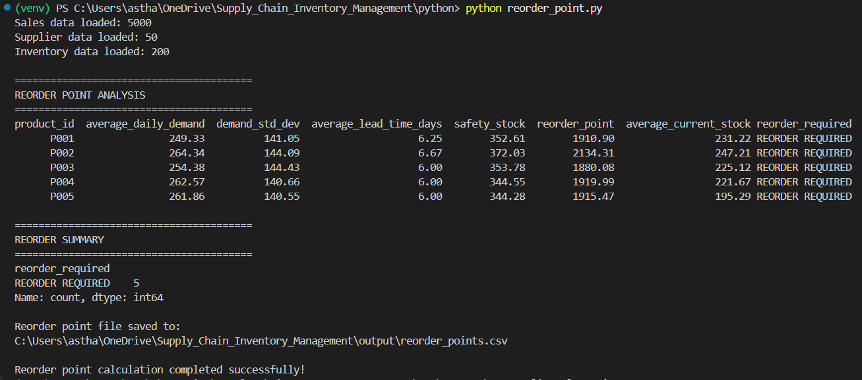
Figure 10.1: Reorder Point Calculation Output
The screenshot shows the calculated demand, demand variability, supplier lead time, safety stock, reorder point, and current stock for each product. The output demonstrates that the Python-based reorder calculation was successfully completed for all five products.
10.11 Output File
The calculated results were saved as:
output/reorder_points.csv
This file provides a structured record of the calculated inventory thresholds and reorder decisions. It can be used for further analysis or as a reference when evaluating replenishment requirements.
10.12 Outcome of Reorder Point Analysis
The reorder-point analysis provides a more dynamic approach to inventory planning than using a fixed threshold alone. It considers both how much demand occurs and how variable that demand is, while also accounting for the time required by suppliers to deliver replenishment orders.
The results indicate that the current average stock levels are considerably below the calculated reorder points for all five products. Therefore, based on the methodology used in this project, all five products require replenishment attention.
The complete reorder_point.py implementation and generated output are maintained in the project's GitHub repository.

11. SUPPLIER CLUSTERING
11.1 Overview
Supplier clustering was performed to group suppliers according to similar operational characteristics. The purpose of this analysis was to provide a structured way of comparing suppliers based on the two supplier attributes available in the project data: lead time and order frequency.
The case study specifies supplier clustering using K-Means or Hierarchical Clustering based on supplier lead time and order frequency. For this project, the K-Means clustering algorithm was implemented using Scikit-learn.
The analysis helps organize the suppliers into groups with similar characteristics rather than examining all suppliers individually.
11.2 Supplier Data Preparation
The cleaned supplier dataset was used as the input for the clustering process. Each supplier record contains information such as supplier ID, supplier name, product ID, lead time, and order frequency.
For clustering, two numerical features were selected:
- Lead Time (days)
- Order Frequency per Week
Lead time represents the number of days generally required for a supplier to deliver an order. Order frequency indicates how frequently orders are placed with a supplier.
These two features were selected because they directly represent supplier responsiveness and ordering frequency, which are relevant to supply-chain planning.
11.3 Converting Order Frequency
The original order_frequency field contains categorical values such as Daily, Weekly, Biweekly, and Monthly.
To use this information in K-Means clustering, the frequencies were converted into approximate numerical values representing orders per week:
- Daily → 7 orders/week
- Weekly → 1 order/week
- Biweekly → 0.5 orders/week
- Monthly → 0.25 orders/week
This transformation converted the categorical frequency information into a numerical feature that could be processed by the clustering algorithm.
11.4 Feature Scaling
Before applying K-Means, the selected features were standardized using Scikit-learn's StandardScaler.
Scaling was necessary because lead time and order frequency are measured on different numerical scales. Without scaling, a feature with larger numerical values could have a disproportionate effect on the distance calculations used by K-Means.
Standardization places the features on a comparable scale and allows the clustering algorithm to consider both supplier characteristics more consistently.
11.5 K-Means Clustering
The K-Means algorithm was configured to create three clusters of suppliers.
K-Means works by assigning each supplier to the cluster whose center is closest to its standardized feature values. The algorithm then repeatedly updates the cluster centers and supplier assignments until the groups stabilize.
A fixed random state was used so that the clustering process could be reproduced consistently when the script is executed again.
11.6 Clustering Results
The analysis was performed on 50 suppliers and produced three supplier groups.
The resulting cluster summary was:
Cluster | Supplier Count | Average Lead Time (Days) | Average Order Frequency (Per Week)
0 | 20 | 4.60 | 0.375
1 | 19 | 6.74 | 1.000
2 | 11 | 8.27 | 0.409
The clusters show that suppliers are distributed into groups with different combinations of lead time and order frequency.
Cluster 0 contains 20 suppliers and has the lowest average lead time among the three groups, along with a relatively lower average order frequency.
Cluster 1 contains 19 suppliers and has an average lead time of approximately 6.74 days and an average order frequency of 1 order per week.
Cluster 2 contains 11 suppliers and has the highest average lead time of the three groups, with an average order frequency of approximately 0.409 orders per week.
These groupings provide a compact way of examining supplier characteristics across the dataset.
11.7 Supplier Clustering Output
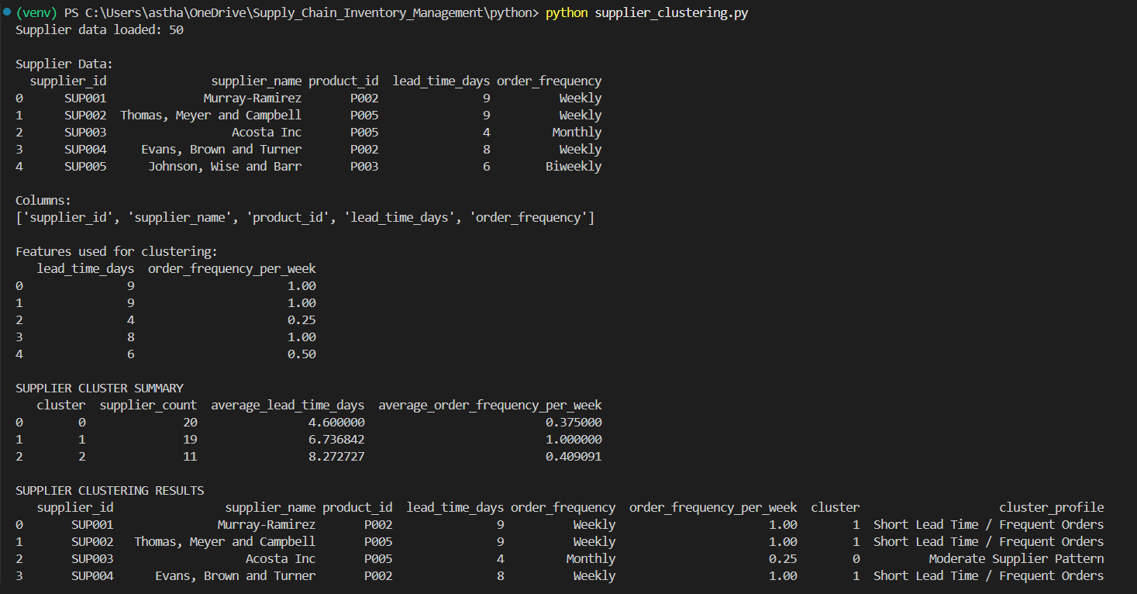
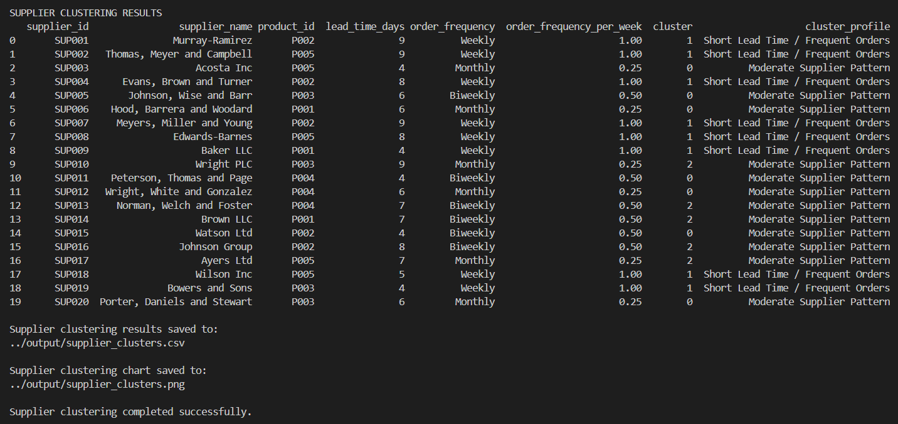
Figure 11.1: Supplier Clustering Script Output
The screenshot shows the supplier features used for clustering and the resulting cluster summary. It demonstrates that all 50 suppliers were processed successfully and assigned to one of the three generated clusters.
11.8 Clustering Visualization
A supplier-clustering visualization was also generated by the Python script and saved as:
output/supplier_clusters.png
The visualization provides a graphical representation of the supplier groups based on the selected clustering features. It can be used to visually examine how suppliers are distributed according to lead time and order frequency.
11.9 Role of Supplier Clustering in the Project
Supplier clustering provides a data-driven method for segmenting suppliers based on their observed operational characteristics.
The resulting groups can help the business identify suppliers with different combinations of delivery lead time and ordering frequency. This information can be considered alongside other procurement factors when evaluating supplier relationships and inventory replenishment strategies.
The clustering does not by itself determine which supplier should be selected. Instead, it provides an analytical grouping that can support further supplier evaluation.
11.10 Outcome of Supplier Clustering
The supplier clustering stage successfully processed all 50 suppliers and grouped them into three clusters using lead time and order frequency.
This analysis complements the SQL supplier analysis by providing a machine-learning-based view of supplier characteristics. While SQL was used to examine individual supplier performance and lead times, K-Means provides broader group-level patterns across the supplier dataset.
The complete supplier_clustering.py implementation and generated clustering output are maintained in the project's GitHub repository.

12. RESULTS AND FINDINGS
The project produced the following key results:
- The four datasets were successfully explored, cleaned, validated, and prepared for analysis.
- The final datasets contained 5,000 sales records, 200 inventory records, 50 suppliers, and 1,000 purchase orders.
- Total recorded sales quantity was 1,292,122 units, with total revenue of 125,870,014.00.
- SQL analysis identified fast- and slow-moving products, inventory requiring reorder, supplier lead times, alternative suppliers, purchase-order performance, and sales trends.
- Demand forecasting generated next-month demand estimates for all five products, ranging from approximately 1,448 to 1,684 units.
- The calculated reorder points ranged from approximately 1,880 to 2,134 units.
- Based on the calculated demand-based reorder points, all five products were classified as requiring replenishment attention.
- Supplier clustering successfully grouped 50 suppliers into three clusters based on lead time and order frequency.
- The project demonstrated how Python, SQL, and data warehousing can be combined to support inventory and supply-chain analysis.
13. CONCLUSION
The Supply Chain and Inventory Management project successfully developed a data-driven approach for analyzing the inventory and procurement activities of ABC Supermarket.
Key Conclusions
- The source datasets were successfully cleaned, validated, and organized into a structured MySQL data warehouse.
- The star-schema design provided a structured foundation for supply-chain analysis.
- SQL analysis helped identify product movement, inventory conditions, supplier characteristics, and purchase-order information.
- Demand forecasting provided estimates of future product requirements using historical sales data.
- The reorder-point analysis incorporated demand variability and supplier lead time to calculate product-specific replenishment thresholds.
- K-Means clustering grouped suppliers according to their lead time and order-frequency characteristics.
- The combined approach provides useful analytical support for inventory monitoring, demand planning, replenishment decisions, and supplier evaluation.
- The complete project implementation, including Python scripts, SQL scripts, cleaned data, and supporting files, will be made available through the project's GitHub repository.
Overall, the project demonstrates the practical application of Python, SQL, data warehousing, and machine-learning techniques to a real-world supply-chain management problem.

14. PROJECT REPOSITORY
The complete project implementation is available in the GitHub repository. The repository contains the Python scripts, SQL scripts, cleaned datasets, generated outputs, and supporting project files used during the development of the Supply Chain and Inventory Management project.
GitHub Repository:

