**Javascript Assignment - 1**

P1:- Return true if given variable is divisible by 5 else return 5

**Input**

//Return true if given variable is divisible by 5 else return 5

function myFunction(a) {

if (a % 5 == 0) {

return true;

} else {

return 5;

}

}

console.log(myFunction(10));

console.log(myFunction(13));

**Output**

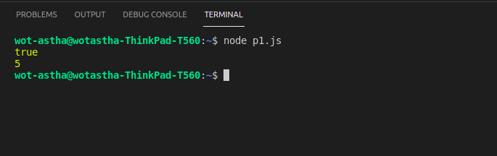

P2:- Return True if given variable is string else return False

**Input**

//Return True if given variable is string else return False

function isString(value) {

if (typeof value === "string") {

return true;

}

else {

return false;

}

}

console.log(isString("Astha"));

console.log(isString(123));

**Output**

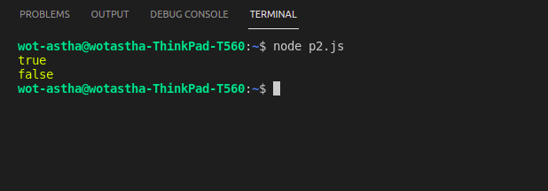

P3:- Return True if given variable is float else return False

**Input**

// Return True if given variable is float else return False

function isFloat(num){

if (Number(num)==num && num%1!==0) {

return true;

}

else {

return false;

}

}

console.log(isFloat(10.3546));

console.log(isFloat(25));

console.log(isFloat(59.20));

**Output**

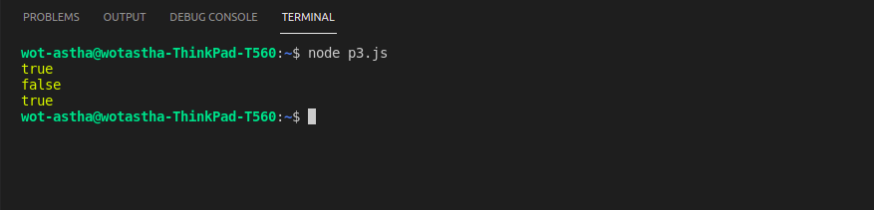

P4:- Build a calculator

**Input**

**//Build a calculator**

**var a=5, b=10;**

**function add(a,b) {**

**return a+b;**

**}**

**function subtract(a,b) {**

**return a-b;**

**}**

**function multiply(a,b) {**

**return a*b;**

**}**

**console.log(add(a,b));**

**console.log(subtract(a,b));**

**console.log(multiply(a,b));**

**Output**

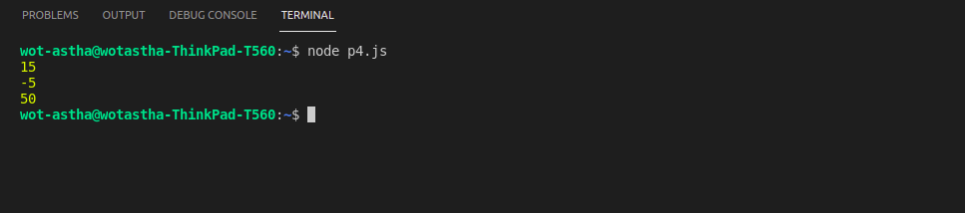

P5:- Find Minimum element from 2 elements

**Input**

//Find Minimum element from 2 elements

var x = "Method_1";

console.log(x);

var num1 = 3, num2 = 5;

var min = Math.min(num1,num2);

console.log(min);

//Find Minimum element from 2 elements

var y = "Method_2";

console.log(y);

function myFunction(a,b) {

if (a>b) {

return b;

}

else {

return a;

}

}

console.log(myFunction(10,2));

console.log(myFunction(4,8));

**Output**

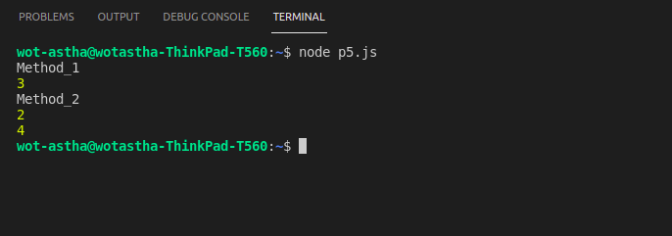

P6:- Return True if element 1 is divisible 2 and vice versa else False

**Input**

//Return True if element 1 is divisible 2 and vice versa else False

function myFunction(a,b) {

if (a % b == 0 || b % a == 0) {

return true;

}

else {

return false;

}

}

console.log(myFunction(5,10));

console.log(myFunction(15,5));

console.log(myFunction(15,10));

**Output**

