**Javascript Assignment - 2**

P1:- Give Result of asin(x) + acos(x)

Code

//Give Result of asin(x) + acos(x)

let x = Math.asin(0.5);

let y = Math.acos(0.5);

console.log(Math.floor(x+y));

Output

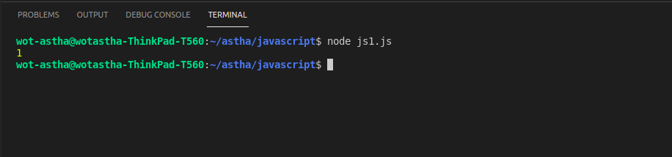

P2:- Give Result of abs(x)*x

Code

//Give Result of abs(x)*x

let x = -7;

var a;

a = Math.abs(x)*x;

console.log(a);

Output

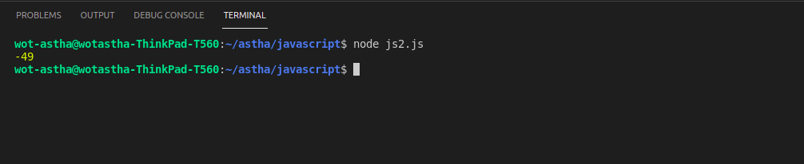

P3:- Write program for given formula in attached image



Code

//Write program for given formula in attached image

let a=1, b=5, c=4;

let d = (b*b) - (4*a*c);

if (d>0) {

p = (-b + Math.sqrt(d))/(2*a);

q = (-b - Math.sqrt(d))/(2*a);

console.log("For positive: " +p);

console.log("For negative: " +q);

}

Output

