Javascript Assignment - 3

P1:- Find if given substring is in string

Code

//Find if given substring is in string

const string = "abcabc";

const substring = "ab";

console.log(string.includes(substring));

Output

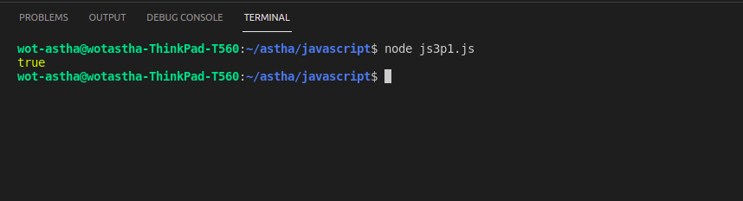

P2:- Print all the elements of the array

Code

//Print all the elements of the array

const colors = ["Red", "Blue", "Green", "Yellow", "White"]

for (let i = 0; i < colors.length; i++) {

console.log(colors[i]);

}

Output

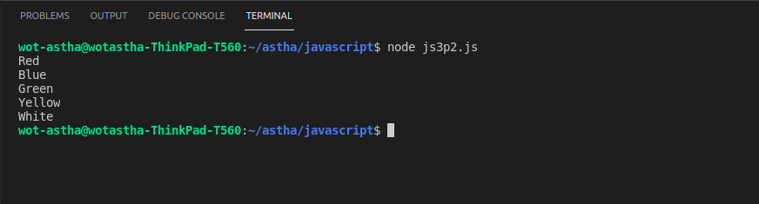

P3:- Create 2D array of array and print all the element with it’s indexes

Code

//Create 2D array of array and print all the element with it’s indexes

const array = [[21, 22], [23, 24]];

for (let i = 0; i < array.length; i++) {

for (let j = 0; j < array.length; j++) {

console.log(array[i][j] + " " + [i] + [j]);

};

}

Output

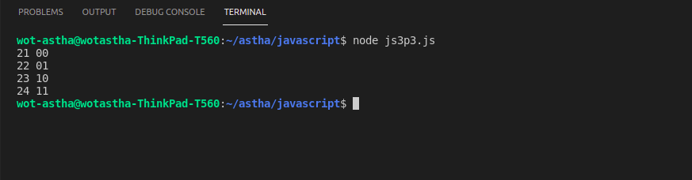

P4:- Do multiplication elements of two array with same length and create 3rd array

Code

//Do multiplication elements of two array with same length and create 3rd array

const array1 = [2, 4, 8, 1];

const array2 = [3, 5, 7, 9];

const array3 = [];

for (let i = 0; i < array1.length; i++) {

for (let j = 0; j < array2.length; j++) {

if (i == j) {

array3.push(array1[i] \* array2[j]);

}

}

}

console.log("Multiplication of two array is:");

console.log(array3);

Output

