Javascript Assignment-4

P1: Write a program to draw a pattern given below from 0-100.  
E.g. if n==5



**Code**

//P1: Write a program to draw a pattern given below from 0-100 where n=5

var n = 5;

var string = "";

for (i = 0; i < n; i++) {

for (j = 0; j < n; j++) {

string += "*";

}

string += "\n"

}

console.log(string);

**Output**

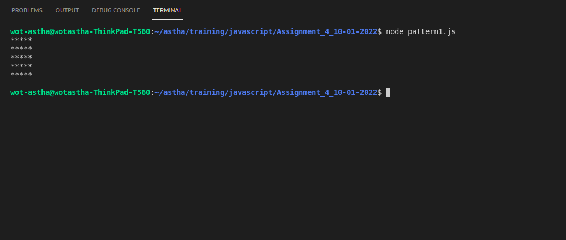

P2: Write a program to draw a pattern given below from 0-9.  
E.g. if n==5



**Code**

//P2: Write a program to draw a pattern given below from 0-9 where n=5

var n = 5;

var string = "";

for (i = 1; i <= n; i++) {

for (j = 1; j <= n; j++) {

string += j;

}

string += "\n"

}

console.log(string);

**Output**

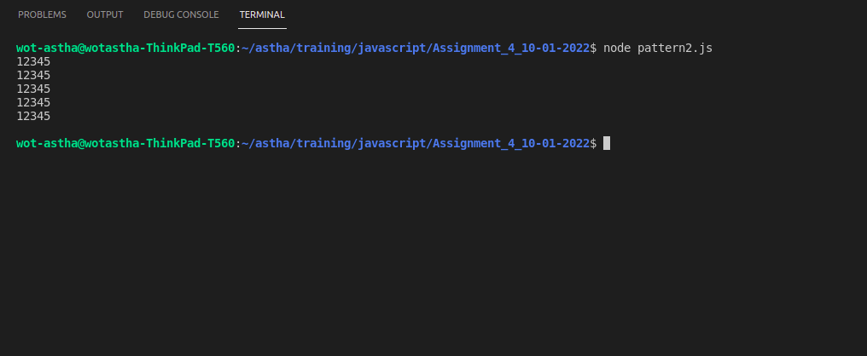

P3: Write a program to draw a pattern given below from 0-9.   
E.g. if n==5



**Code**

//P3: Write a program to draw a pattern given below from 0-9 where n=5

var n = 5;

var string = "";

for (i = 1; i <= n; i++) {

for (j = 1; j <= n; j++) {

string += i;

}

string += "\n"

}

console.log(string);

**Output**

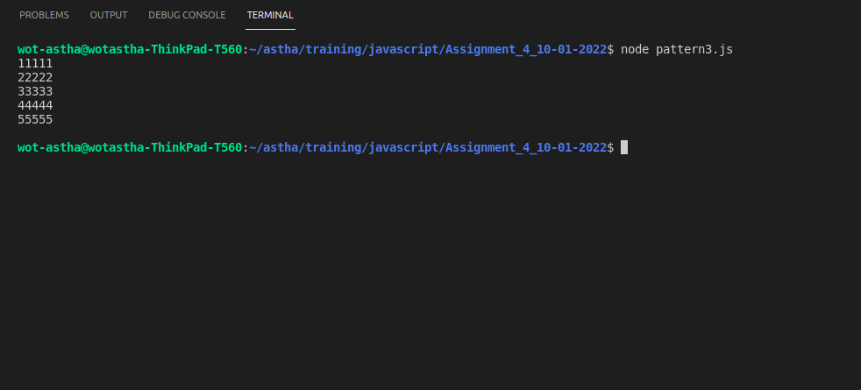

P4: Write a program to draw a pattern given below from 0-9.  
E.g. if n==5



**Code**

//P4: Write a program to draw a pattern given below from 0-9 where n=5

var n = 5;

var string = "";

for (i = 1; i <= n; i++) {

for (j = 1; j <= i; j++) {

string += "*";

}

string += "\n"

}

console.log(string);

**Output**

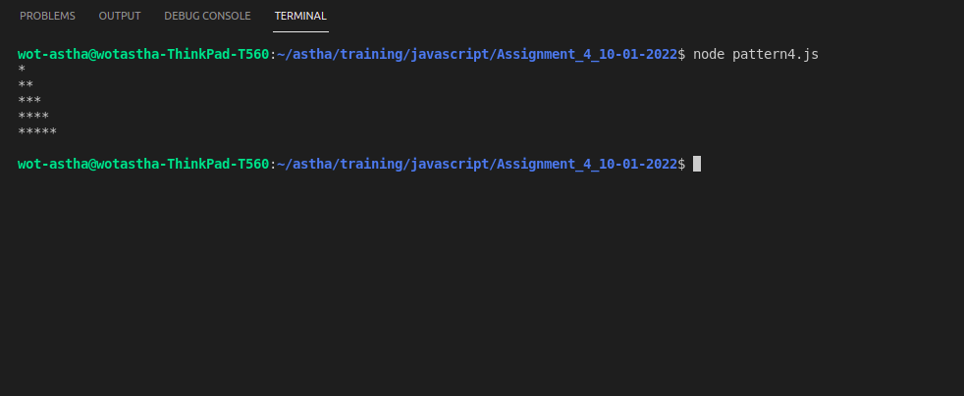

P5: Write a program to draw a pattern given below from 0-9.    
E.g. if n==5



**Code**

//P5: Write a program to draw a pattern given below from 0-9 where n=5

var n = 5;

var string = "";

for (i = 1; i <= n; i++) {

for (j = 1; j <= n; j++) {

if (i + j <= n) {

string += " ";

}

else {

string += "*";

}

}

string += "\n"

}

console.log(string);

**Output**

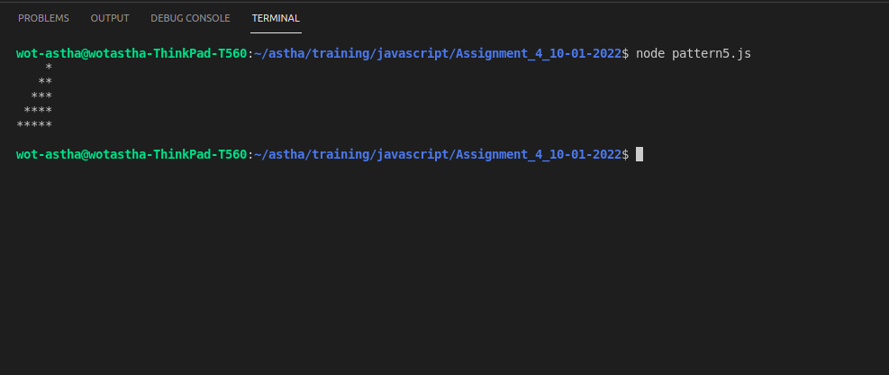

P6: Write a program to draw a pattern given below from 0-9.

E.g. if n==5

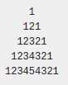

**Code**

//P6: Write a program to draw a pattern given below from 0-9 where n=5

var n = 5;

var string = "";

for (i = 1; i <= n; i++) {

for (j = 1; j <= n - i; j++) {

string += " ";

}

for (k = 1; k <= i; k++) {

string += k;

}

for (l = i - 1; l >= 1; l--) {

string += l;

}

string += "\n"

}

console.log(string);

**Output**

