Javascript Assignment - 5

**P1:-** Write a program to draw a pattern given below from 0-9. (max 2 loop allowed)

E.g. if n==5

# * * * #

* # * # *

* * # * *

* # * # *

# * * * #

**Code**

//P1:- Write a program to draw a pattern given below from 0-9. (max 2 loop allowed)

var n = 5;

var string = "";

for (i = 0; i < n; i++) {

for (j = 0; j < n; j++) {

if (i === j || (i + j === n - 1)) {

string += "#";

}

else {

string += "*";

}

}

string += "\n"

}

console.log(string);

**Output**

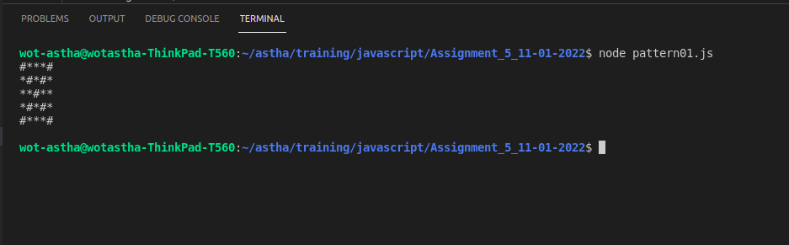

**P2:-** Write a program to draw a pattern given below from 0-9. (max 2 loop allowed) [Don't Reveal this one pre handed]

E.g. if n==5

@

@@

@@@

@@@@

@@@@@

@@@@@

@@@@

@@@

@@

@

**Code**

//P2:- Write a program to draw a pattern given below from 0-9. (max 2 loop allowed) [Don't Reveal this one pre handed]

let n = 5;

let string = "";

for (let i = -n; i <= n; i++) {

if (i==0) {

continue;

}

for (let j = -n; j <= n; j++) {

if (j==0) {

continue;

}

if(Math.abs(i)+Math.abs(j)<=n+1 && (Math.sign(i)==Math.sign(j)))

{

string += "@";

}

else {

string += " ";

}

}

string += "\n";

}

console.log(string);

**Output**

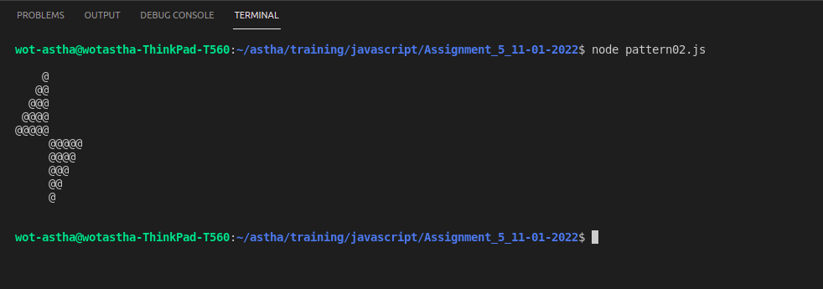

**P3:-** Write a program to draw a pattern given below from 0-9. (max 2 loop allowed) [Don't Reveal this one pre handed]

E.g. if n==5

\ - - - /

| \ / |

| o |

| / \ |

/ - - - \

**Code**

//P3:- Write a program to draw a pattern given below from 0-9. (max 2 loop allowed)

var n = 5;

var string = "";

for (i = 0; i < n; i++) {

for (j = 0; j < n; j++) {

if (i == (n-1)/2 && j == (n-1)/2) {

string += "o";

}

else if (i == j) {

string += "\\";

}

else if (i + j === n - 1) {

string += "/";

}

else if (i == 0 || i == n-1) {

string += "-";

}

else if (j == 0 || j == n-1) {

string += "|";

}

else {

string += " ";

}

}

string += "\n"

}

console.log(string);

**Output**

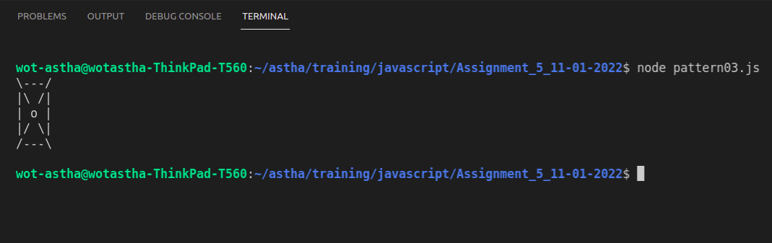

**P4:-** Write a program to draw a pattern given below from 0-9. (max 2 loop allowed) [Don't Reveal this one pre handed]

E.g. if n==5

0 0 0 0 0 0 0 0 0 0 0 0 0

0 a b c d e f 5 4 3 2 1 0

0 a b c d e 4 3 2 1 0

0 a b c d 3 2 1 0

0 a b c 2 1 0

0 a b 1 0

0 a 0

0 1 b a 0

0 1 2 c b a 0

0 1 2 3 d c b a 0

0 1 2 3 4 e d c b a 0

0 1 2 3 4 5 f e d c b a 0

0 0 0 0 0 0 0 0 0 0 0 0 0

**Code**

//P4:- Write a program to draw a pattern given below from 0-9. (max 2 loop allowed) [Don't Reveal this one pre handed]

let n = 5;

let string = "";

for (let i = -n-1; i <= n+1; i++) {

for (let j = -n-1; j <= n+1; j++) {

if (Math.abs(i) == n+1 || Math.abs(j) == 6) {

string += "0";

}

else if (Math.abs(i) - Math.abs(j) >= 0) {

if ((i < 0 && j > 0) || (i > 0 && j < 0)) {

string += Math.abs(i) - Math.abs(j) + 1;

}

else {

string += String.fromCharCode(Math.abs(i) - Math.abs(j) + 97);

}

}

else {

string += " ";

}

}

string += "\n";

}

console.log(string);

**Output**

