Javascript exam

P1:- Write a program to draw a pattern given below from 0-9 (odd). (max 2 loop allowed)

E.g. if n==3 {Take it as a challenge and solve for 0-99, Solution will be rewarded}

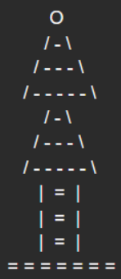

**Code**

//Write a program to draw a pattern given below from 0-9. (max 2 loop allowed)

var n = 3;

var string = "";

for (let i = 0; i < 1; i++) {

for (let j = -n; j <= 0; j++) {

if (i == 0 && j == 0) {

string += "o\n";

}

else {

string += " ";

}

}

}

for (let l = 0; l < n-1; l++) {

for (let i = 0; i < n; i++) {

for (let j = -n; j <= n; j++) {

if (i+j == -1) {

string += "/";

}

else if (j-i == 1) {

string += "\\";

}

else if ((Math.abs(i)-Math.abs(j)) < n && (Math.abs(i)-Math.abs(j)) >= 0) {

string += "-";

}

else {

string += " ";

}

}

string += "\n";

}

}

for (let i = 0; i < n; i++) {

for (let j = -n; j <= n; j++) {

if (j == 0) {

string += "=";

}

else if (Math.abs(j)==2) {

string += "|";

}

else {

string += " ";

}

}

string += "\n";

}

for (let i = 0; i < 1; i++) {

for (let j = 0; j < 2*n +1; j++) {

string += "=";

}

}

console.log(string);

**Output**

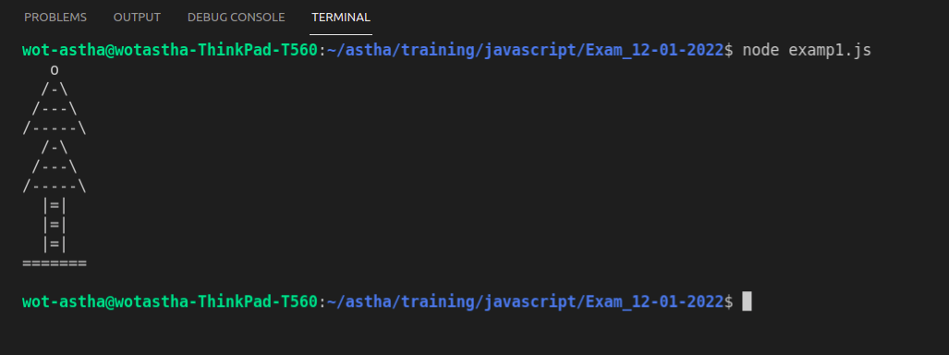

P2:- Write a program to draw a pattern given below from 0-9. (max 2 loops allowed)

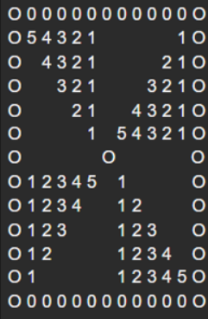

**Code**

//Write a program to draw a pattern given below from 0-9. (max 2 loop allowed) [Don't Reveal this one pre handed]

let n = 5;

let string = "";

for (let i = -n-1; i <= n+1; i++) {

for (let j = -n-1; j <= n+1; j++) {

if (i==0 && j==0) {

string += "o"

}

else if (j==(n+1) || j==-(n+1)) {

string += "o"

}

else if (i==(n+1) || i==-(n+1)) {

string += "0";

}

else if ((Math.sign(i)!=Math.sign(j)) && (Math.abs(i)-Math.abs(j)<=0) && i!=0) {

string += n - Math.abs(j) +1;

}

else if ((Math.sign(i)==Math.sign(j)) && (Math.abs(i)-Math.abs(j)>=0))

{

string += Math.abs(j);

}

else {

string += " ";

}

}

string += "\n";

}

console.log(string);

**Output**

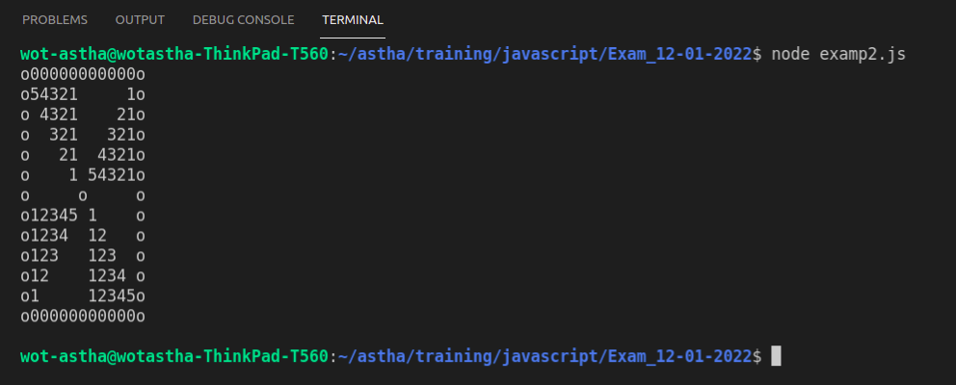

P3:- Write a program to draw a pattern given below from 0-9. (max 2 loops allowed)

**Code**

//Write a program to draw a pattern given below from 0-9. (max 2 loop allowed) [Don't Reveal this one pre handed]

let n = 5;

let string = "";

for (let i = -(n + 1); i <= n + 1; i++) {

for (let j = -(n + 1); j <= n + 1; j++) {

if (j == -(n + 1) || j == n + 1) {

string += "|";

}

else if (i == -(n + 1) || i == n + 1) {

string += "=";

}

else if (i == 0 && j == 0) {

string += "x";

}

else if (j == 0 || i == 0) {

string += "0";

}

else if (i == j) {

string += "\\";

}

else if (Math.abs(i) == Math.abs(j)) {

string += "/";

}

else if (Math.sign(i) == Math.sign(j) && Math.abs(i) - Math.abs(j) >= 0) {

string += Math.abs(j);

}

else if (Math.sign(i) != Math.sign(j) && Math.abs(i) - Math.abs(j) <= 0 && i != 0) {

string += n - Math.abs(j) + 1;

}

else if (Math.sign(i) != Math.sign(j) && Math.abs(i) - Math.abs(j) >= 1) {

string += String.fromCharCode(Math.abs(j) + 97);

}

else if (Math.sign(i) == Math.sign(j) && Math.abs(i) - Math.abs(j) <= 1) {

string += String.fromCharCode(n- Math.abs(j) + 97 + 1);

}

else {

string += " ";

}

}

string += "\n";

}

console.log(string);

**Output**

