**ASSIGNMENT: 1**

* Install **Power BI Desktop** and share the final screenshot of the report view page which appears when power desktop starts:

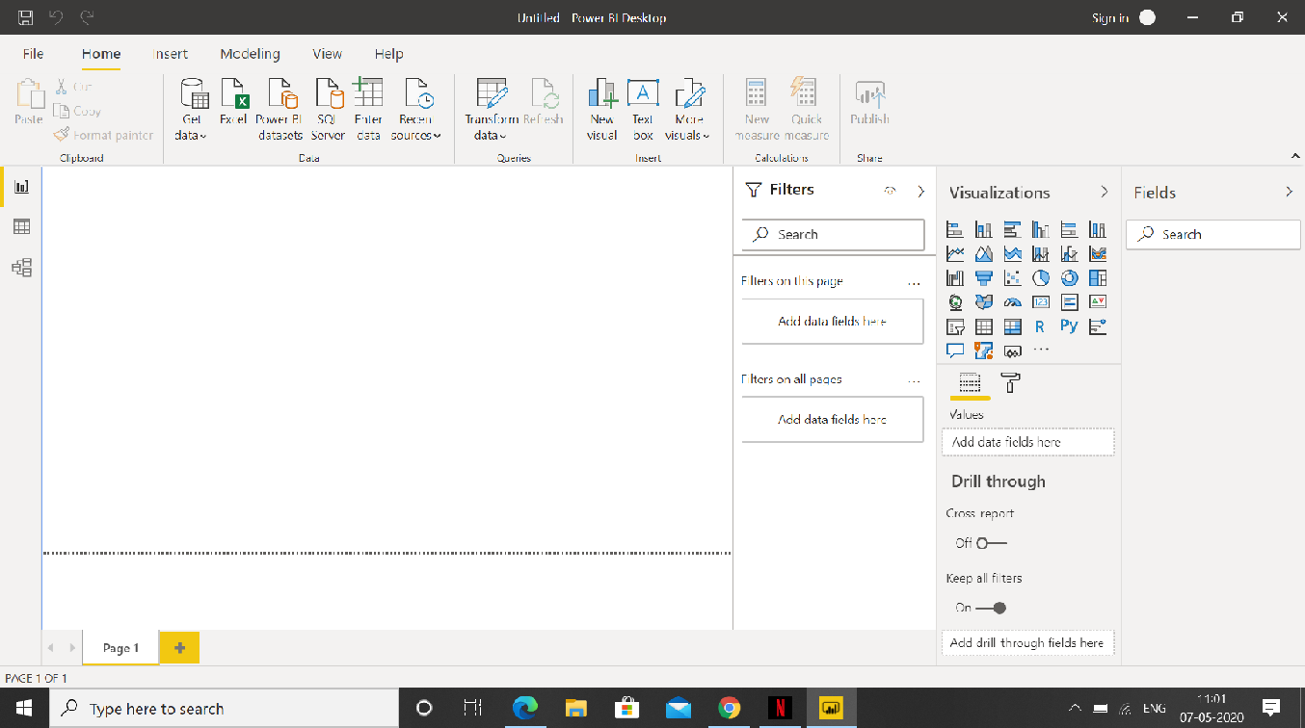

* **Prepare a document and with the following screenshot:**

Report view:

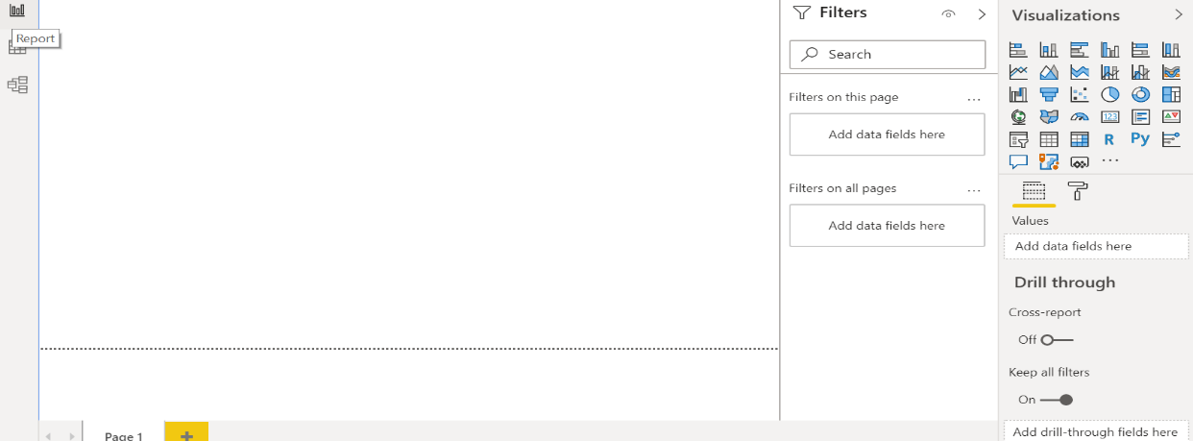

Data View:



Model View:

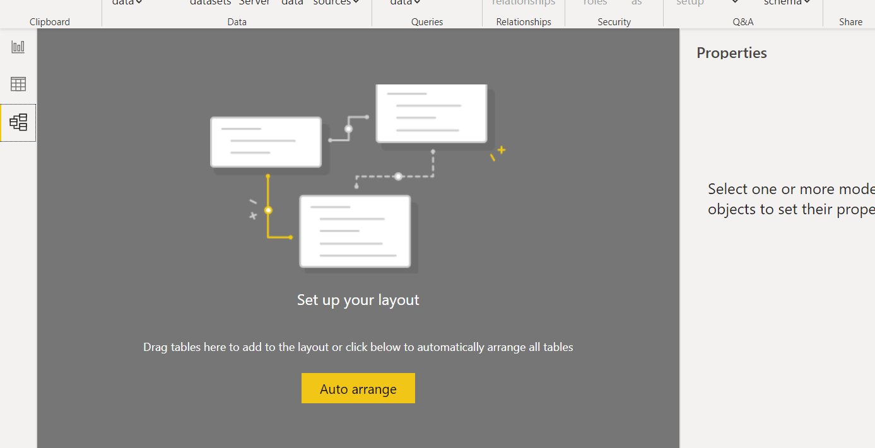

Power Query Editor:

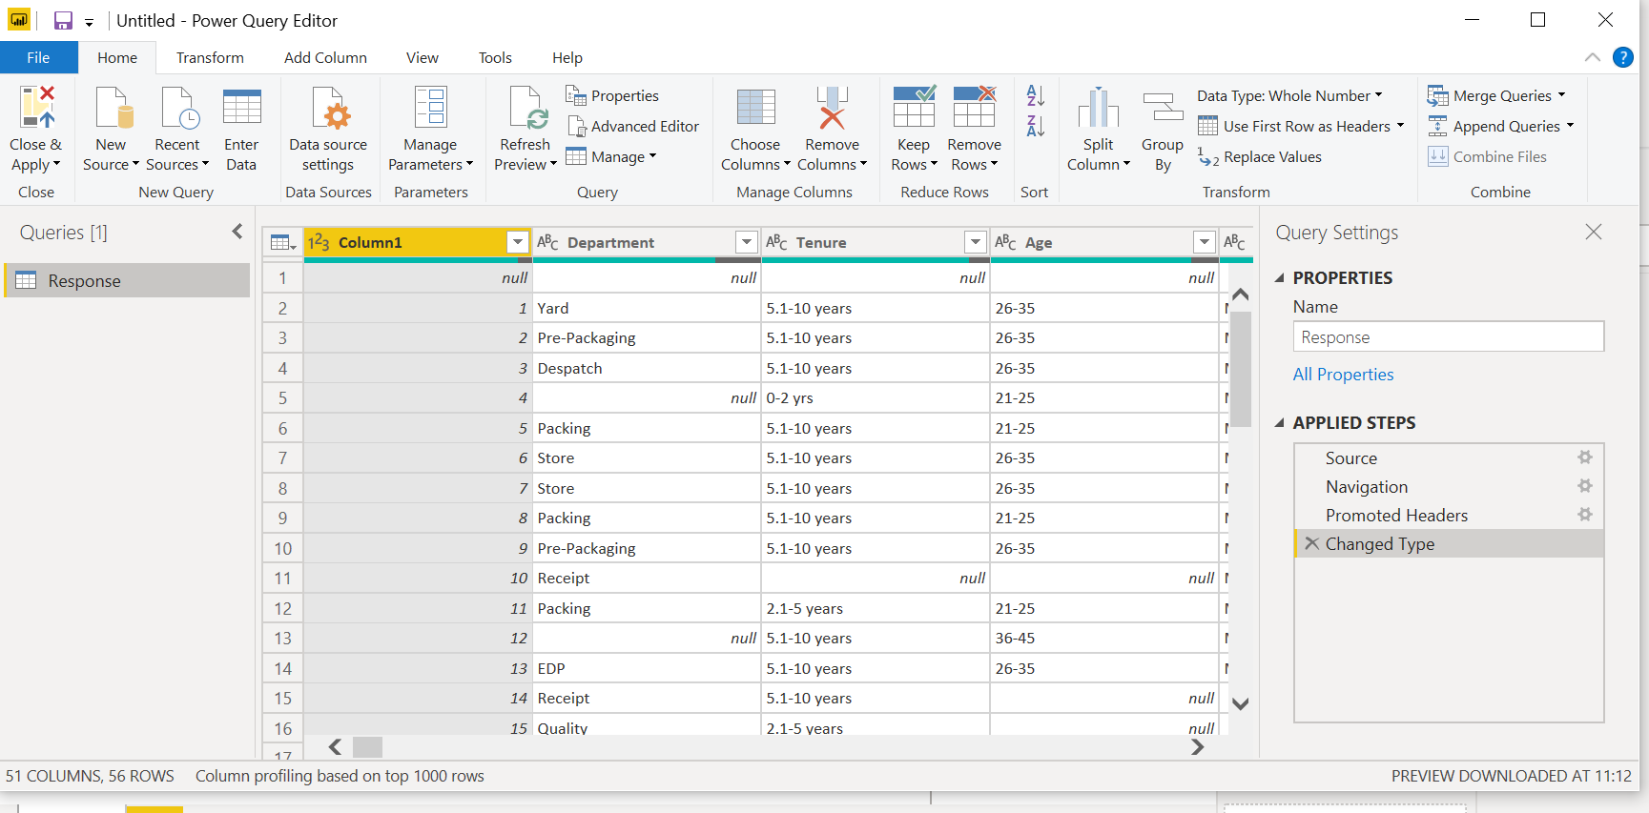

Advance Editor:

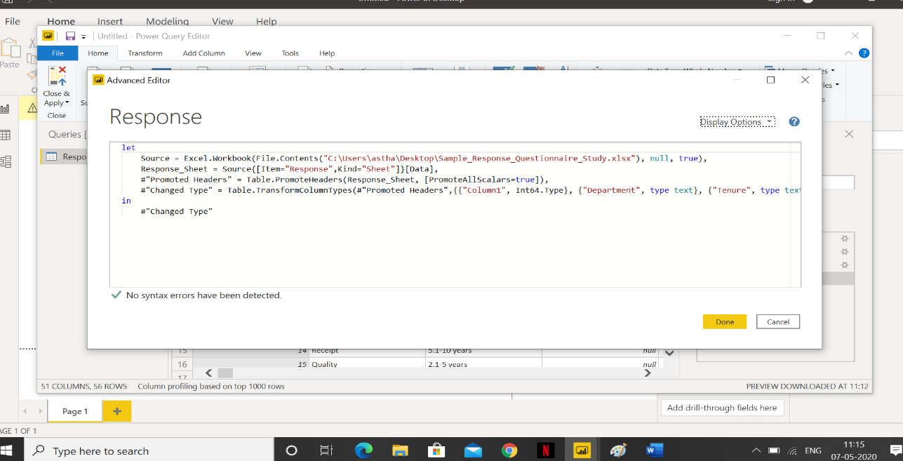

* **Prepare a document with details of the following along with their price:**

− Power BI Desktop: Power BI Desktop is a free application you install on your local computer that lets you connect to, transform, and visualize your data. This data model lets you build visuals, and collections of visuals you can share as reports, with other people inside your organization. Price: Free

− Power BI Pro: Power BI Pro is an individual user license that lets users read and interact with reports and dashboards that others have published to the Power BI service. Users with this license type can share content and collaborate with other Power BI Pro users. Price: $9.99/user/month. NOTE: Users can try it a free trial for 60 days before purchasing the subscription.

− Power BI Premium: Power BI Premium is a capacity-based offering that includes: Flexibility to publish reports broadly across an enterprise, without requiring recipients to be licensed individually per user. Greater scale and performance than shared capacity in the Power BI service. Price: The Premium plan starts at $4,995 a month per dedicated cloud compute and storage resource.

Power BI Premium is a great offering. It comes with lower pricing for enterprise scale customers, and with many features such as dedicated server, higher data set size, higher frequency of data refresh.