**TABLEAU ASSIGNMENT**

ASSIGNMENT 1- (inside_Sales.csv)

1. Percentage of Sales(actual) coming from region of different products:

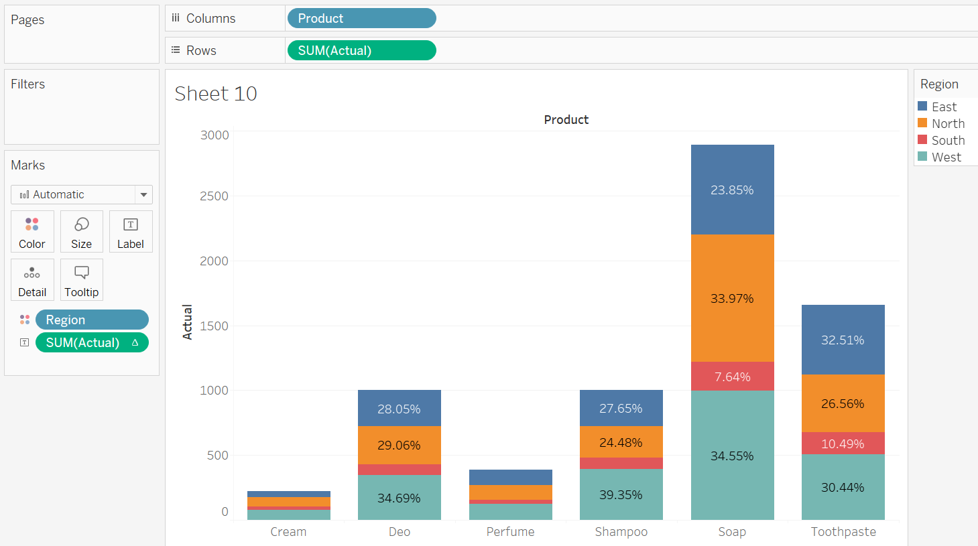

1. 100% Stacked bar:

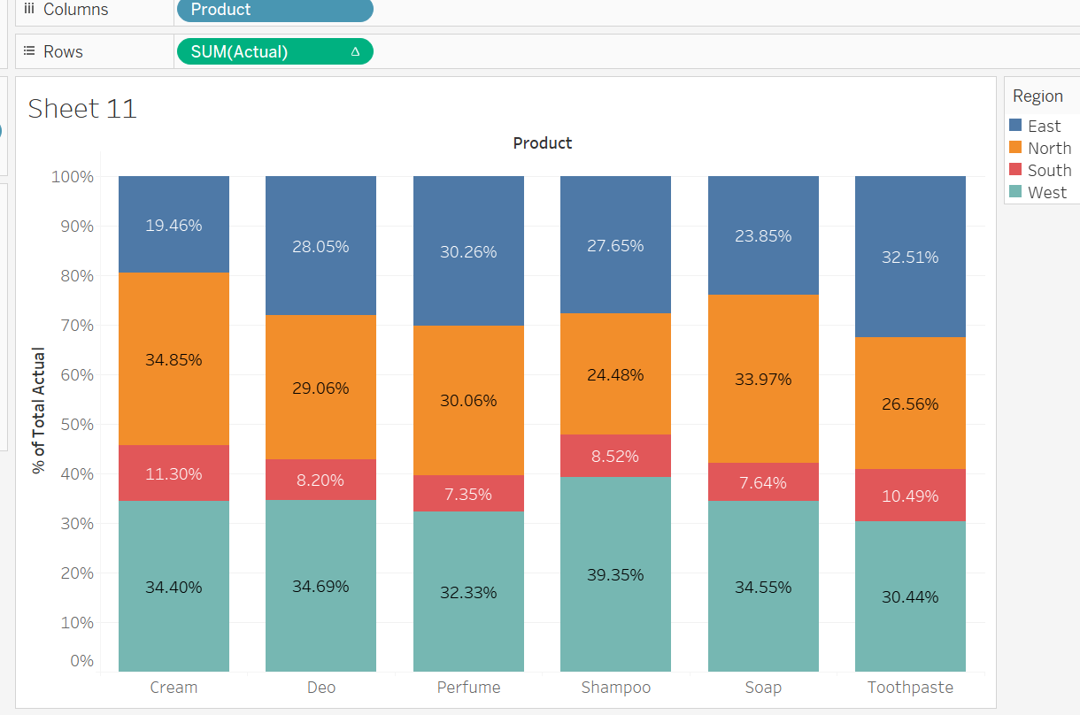

1. Side by side bar for actual and target sales:

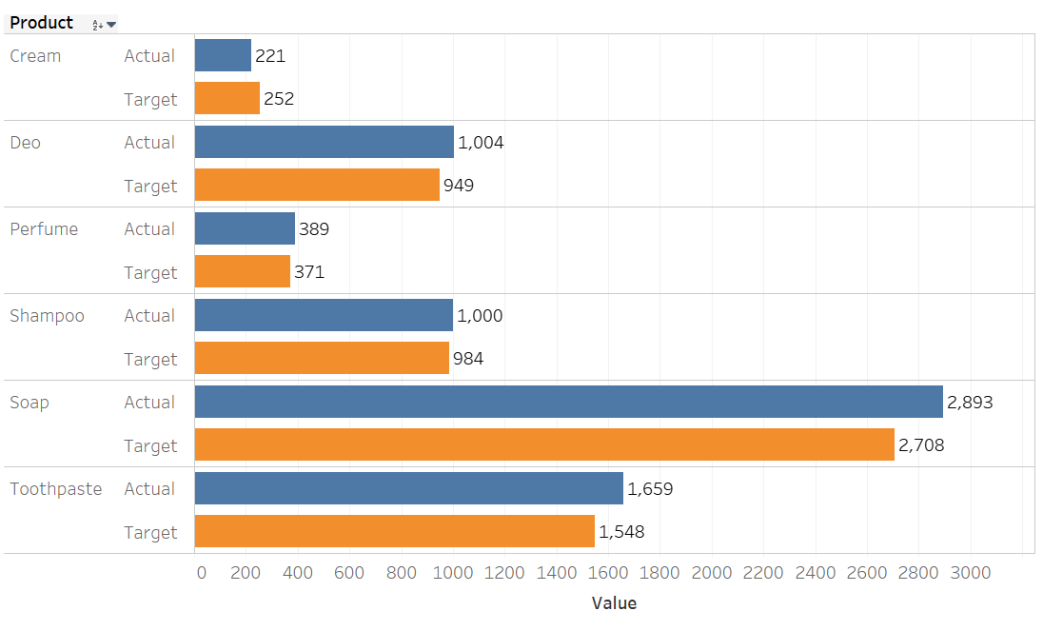

1. Tree Map showing largest selling regions:

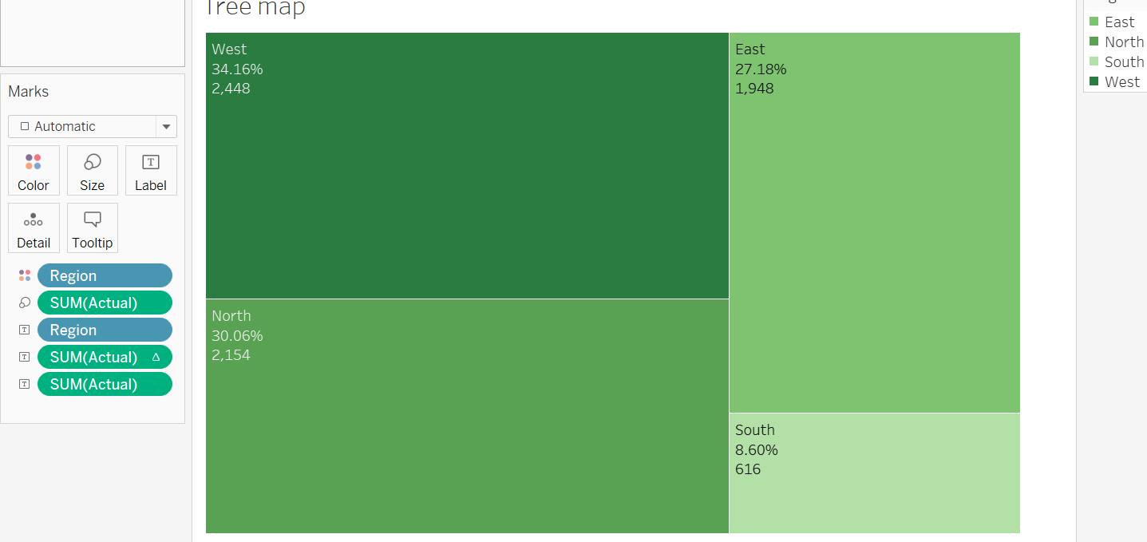

1. Bubble chart to show product sales:

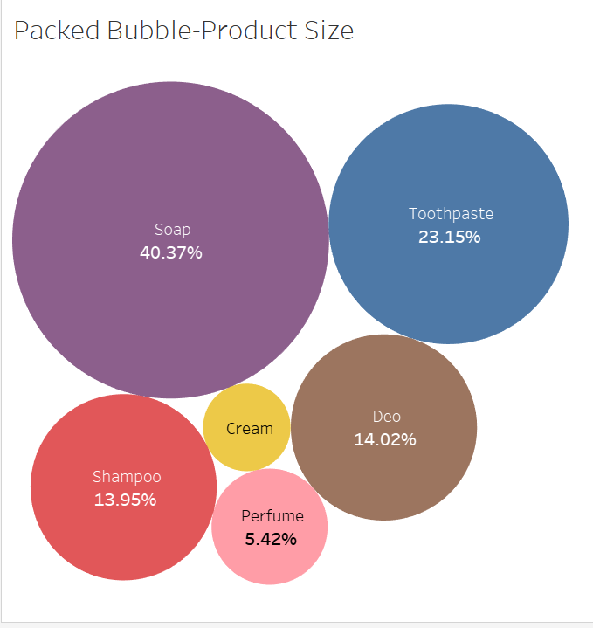

1. Actual vs Target side by side (Scatter):

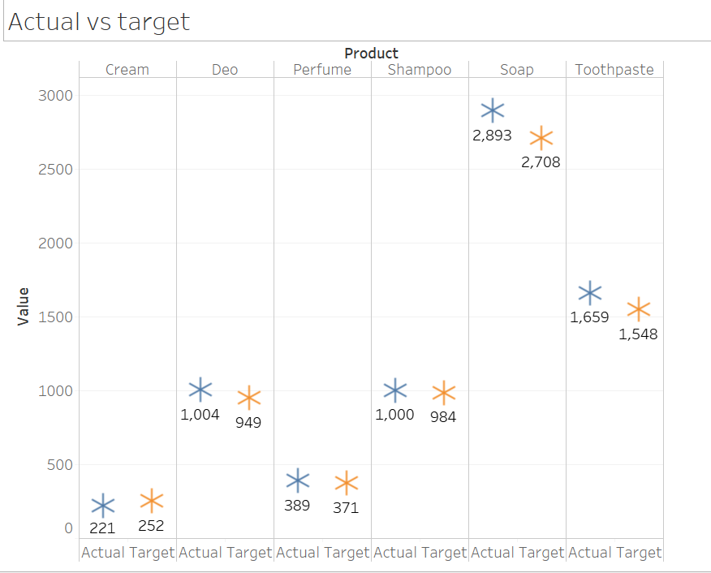

ASSIGNMENT 2 – (Superstore_Canada.csv)

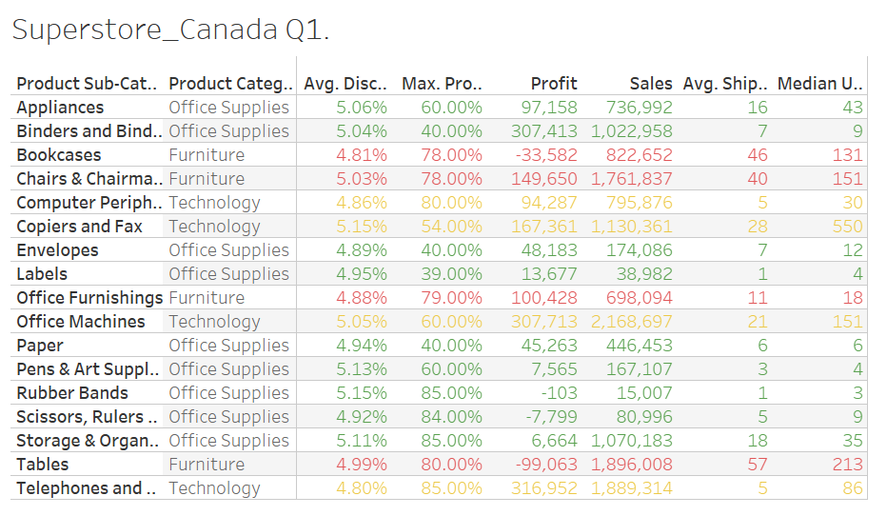

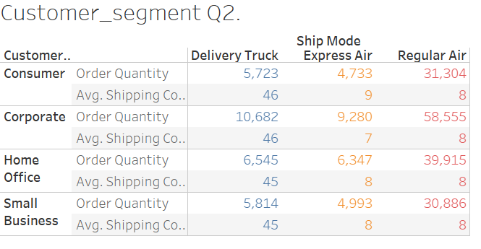

**QUIZ ANSWERS:**

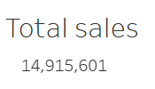

**B.**

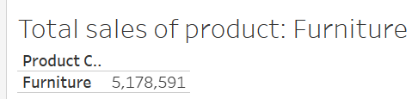

**C.**



**D.**

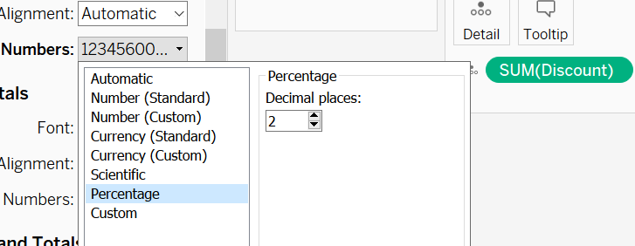

**E.**

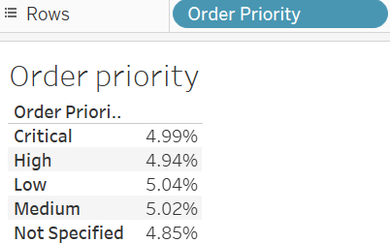

**QUIZ ANSWERS:**

1. **Express air**

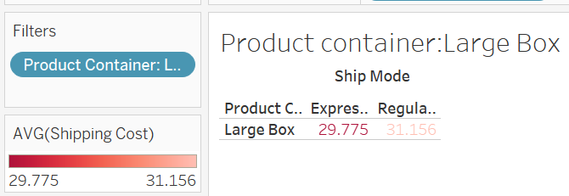

1. **Regular air**

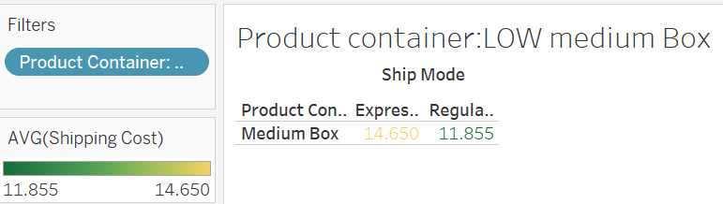

1. **Delivery Truck**

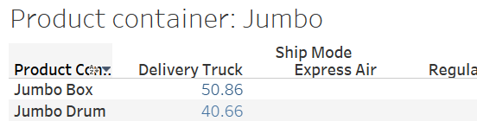

1. **Express Air**

