ZOMATO RESTAURANT DATA ANALYSIS
PROJECT REPORT

Prepared By: Astha Parekh
Tools Used: Python, Pandas, Matplotlib, Seaborn and Google Colab

CERTIFICATE
This is to certify that the project titled “Zomato Restaurant Data Analysis” is a data analysis project completed using Python and data visualization techniques. The project focuses on cleaning restaurant data, performing exploratory data analysis, and finding useful insights from restaurant ratings, customer votes, costs, online ordering, table booking, and restaurant types.

ACKNOWLEDGEMENT
I would like to thank my mentors and instructors for providing guidance and support during this project. This project helped me understand the complete data analysis workflow, including data cleaning, data exploration, analysis, and visualization.

ABSTRACT
The Zomato Restaurant Data Analysis project focuses on understanding restaurant data and identifying useful patterns from different variables. The dataset contains information about restaurant names, online ordering availability, table booking availability, customer ratings, number of votes, approximate cost for two people, and restaurant categories.
The project follows a complete data analysis workflow. First, the dataset is inspected to understand its structure and columns. Data cleaning is then performed by checking missing values, duplicate records, data types, column names, unique values, and invalid values. After cleaning the data, Exploratory Data Analysis (EDA) is performed using statistical analysis and visualizations.
The project demonstrates how raw data can be cleaned, analyzed, and visualized to generate meaningful insights and support data-driven understanding.

TABLE OF CONTENTS
1. Introduction
2. Project Objectives
3. Dataset Overview
4. Tools and Libraries Used
5. Project Workflow
6. Data Cleaning Process
7. Exploratory Data Analysis
7.1 Distribution of Restaurant Ratings
7.2 Most Common Restaurant Type
7.3 Online Ordering and Ratings
7.4 Table Booking and Ratings
7.5 Average Cost by Restaurant Type
7.6 Top Restaurants by Votes
7.7 Relationship Between Ratings and Votes
7.8 Highest Average Rating by Restaurant Type
8. Overall Findings
9. Final Conclusion
10. Future Improvements

1. INTRODUCTION:
The restaurant industry generates a large amount of data related to customer preferences and restaurant performance. Restaurant data can be analyzed to understand customer satisfaction, popularity, pricing, and service availability. Zomato restaurant data provides useful information that can be explored using data analysis techniques.
In this project, Restaurant information is analyzed using Python. The main focus is to clean the dataset and use Exploratory Data Analysis (EDA) to answer important business questions. Different visualizations are used to make the results easy to understand.

2. PROJECT OBJECTIVES:
- To understand the structure and information available in the dataset.
- To clean the dataset and prepare it for analysis.
- To analyze restaurant ratings and customer satisfaction.
- To identify the most common restaurant categories.
- To compare ratings based on online ordering and table booking.
- To analyze the approximate cost for two people across restaurant types.
- To identify popular restaurants based on customer votes.
- To understand the relationship between restaurant votes and ratings.

3. DATASET OVERVIEW:
The dataset contains information about restaurants and their customer-related and service-related features. The main columns used in this project are:
- Name – Name of the restaurant.
- Online Order – Whether online ordering is available.
- Book Table – Whether table booking is available.
- Rating – Customer rating of the restaurant.
- Votes – Number of customer votes received.
- Approximate Cost – Approximate cost for two people.
- Listed In – Restaurant category or type.

4. TOOLS AND LIBRARIES USED:
- Python – Used as the main programming language.
- Pandas – Used for Data Cleaning and Data Manipulation.
- Matplotlib – Used for creating Visualizations.
- Seaborn – Used for Statistical and attractive Visualizations.
- Google Colab – Used to write and execute Python code.

5. PROJECT WORKFLOW:
The project followed the following workflow:
- Step 1: Load the dataset into a Pandas DataFrame.
- Step 2: Understand the dataset using functions such as shape, info, and describe.
- Step 3: Clean the data by checking missing values, duplicates, and data types.
- Step 4: Rename and organize columns for easier analysis.
- Step 5: Check unique values and identify invalid data.
- Step 6: Convert required columns into the correct data type.
- Step 7: Perform Exploratory Data Analysis using grouping, sorting, and statistical analysis.
- Step 8: Create charts to understand patterns and relationships.
- Step 9: Write conclusions based on the results.

6. DATA CLEANING PROCESS:
Data cleaning is an important part of data analysis because raw datasets may contain missing values, duplicate rows, incorrect data types, or inconsistent formats. Before performing analysis, the dataset was checked and prepared carefully.
- Checked the number of rows and columns in the dataset.
- Checked the dataset information and data types.
- Checked for missing values.
- Checked for duplicate records.
- Reviewed and renamed column names where required.
- Checked unique values in categorical columns such as online ordering and table booking.
- Cleaned the rating column and converted it into numeric format.
- Checked important numeric columns for invalid values.
- Prepared the final cleaned dataset for Exploratory Data Analysis.

7. EXPLORATORY DATA ANALYSIS:

7.1 Q1. What is the distribution of restaurant ratings?
This analysis was performed to understand whether most restaurants have high, average, or low customer ratings.
Figure 1: Distribution of Restaurant Ratings
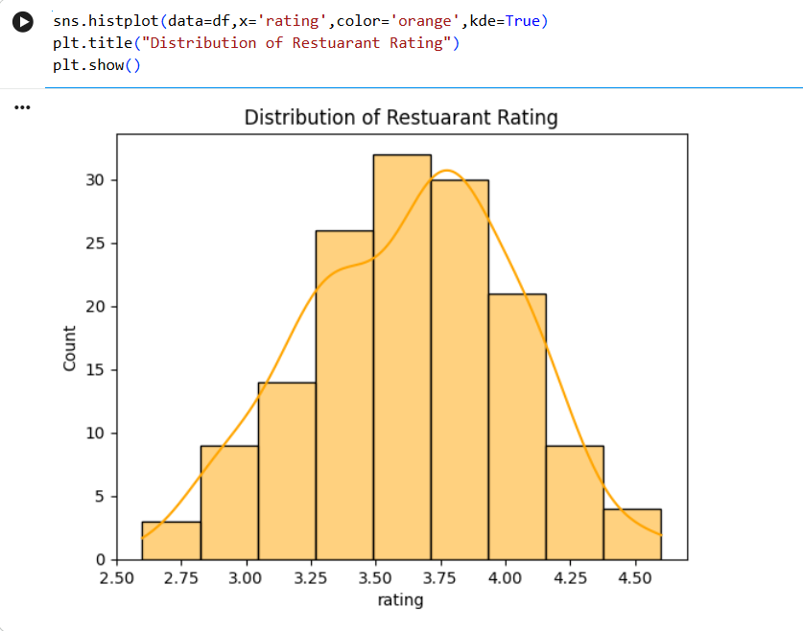
Conclusion: Most restaurant ratings are between 3.3 and 4.0, showing generally good customer ratings.

7.2 Q2. Which restaurant type is the most common?
This analysis counts the number of restaurants in each category.
Figure 2: Restaurant Type by Number
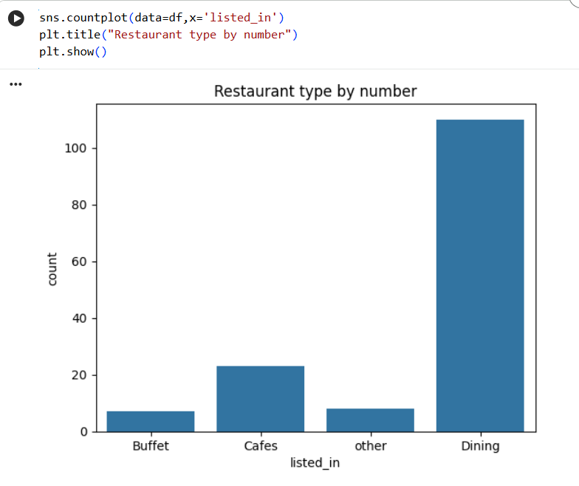
Conclusion: Dining is the most common restaurant type, followed by Cafes.

7.3 Q3. Does online ordering affect restaurant ratings?
The average rating was compared between restaurants that offer online ordering and restaurants that do not.
Figure 3: Rating by Online Order Availability
Conclusion: Restaurants with online ordering generally have higher ratings than restaurants without online ordering.

7.4 Q4. Does table booking affect restaurant ratings?
The average rating was compared between restaurants that offer table booking and restaurants that do not.
Figure 4: Rating by Table Booking
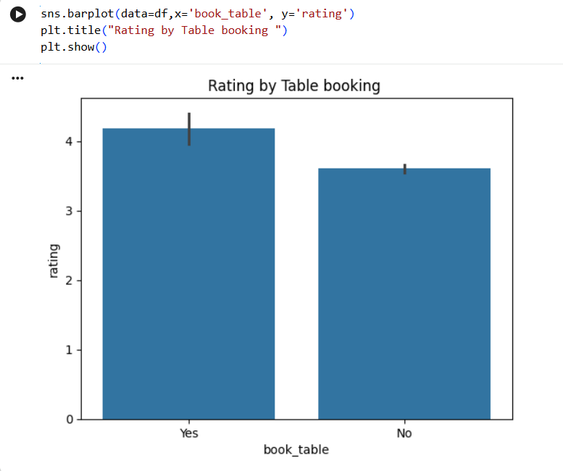
Conclusion: Restaurants that offer table booking generally have higher ratings than those that do not.

7.5 Q5. Which restaurant type has the highest average cost for two people?
This analysis compares the average approximate cost for two people across different restaurant categories.
Figure 5: Cost by Restaurant Type
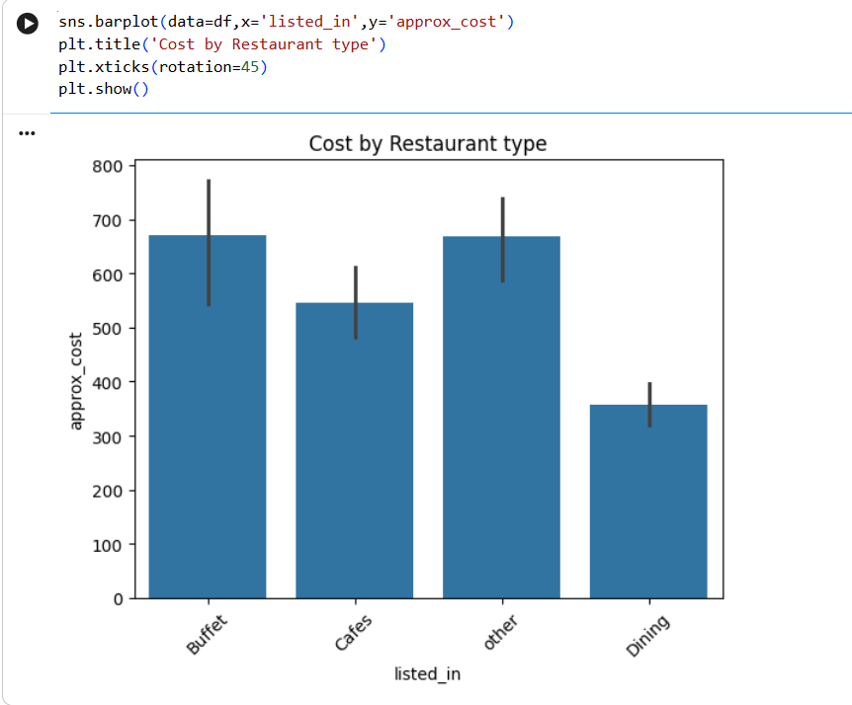
Conclusion: Buffet and other restaurant types have the highest average cost for two people, while Dining has the lowest average cost.

7.6 Q6. Which are the top restaurants with the highest number of votes?
The restaurants were sorted according to the number of customer votes to identify the most popular restaurants.
Figure 6: Top Restaurants by Votes
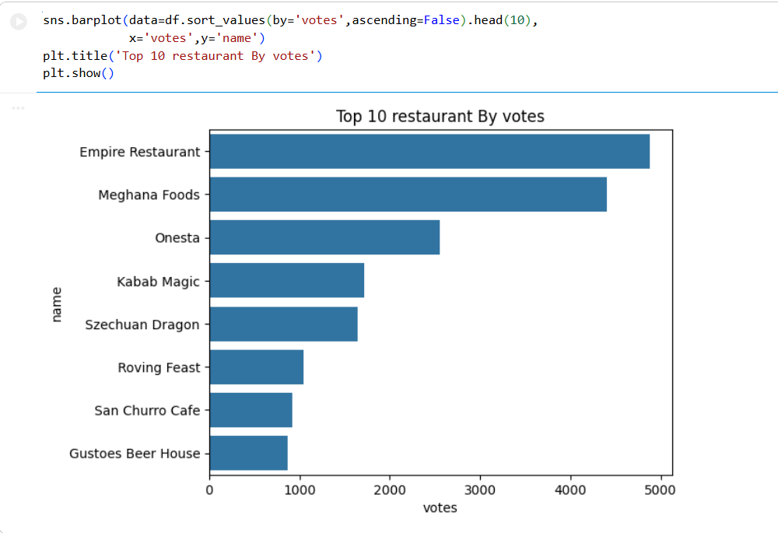
Conclusion: Empire Restaurant has the highest number of votes, followed by Meghana Foods and Onesta.

7.7 Q7. Is there a relationship between restaurant ratings and votes?
A scatter plot was used to compare the number of votes received by restaurants with their customer ratings.
Figure 7: Votes and Restaurant Ratings
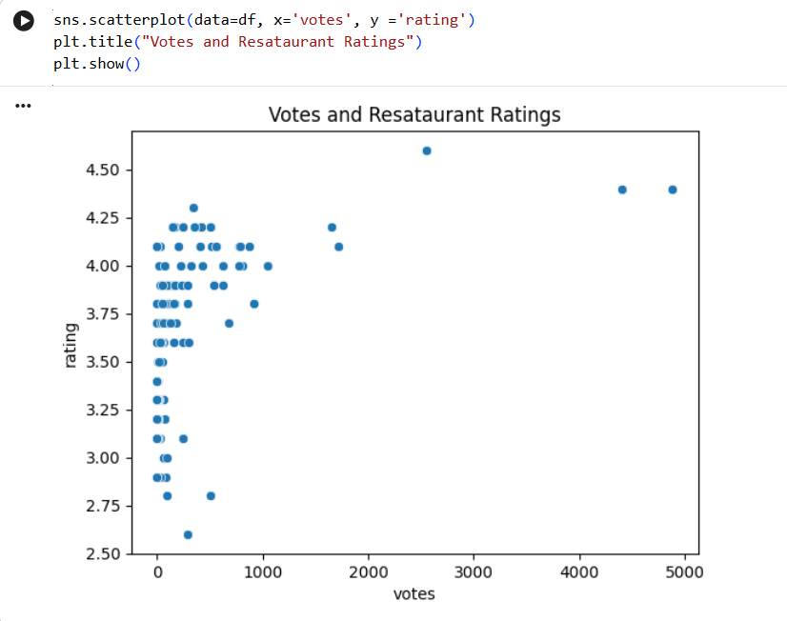
Conclusion: Restaurants with higher votes usually have good ratings, but this is not true for every restaurant.

7.8 Q8. Which restaurant type has the highest average rating?
The average rating was compared across different restaurant categories.
Figure 8: Average Rating by Restaurant Type
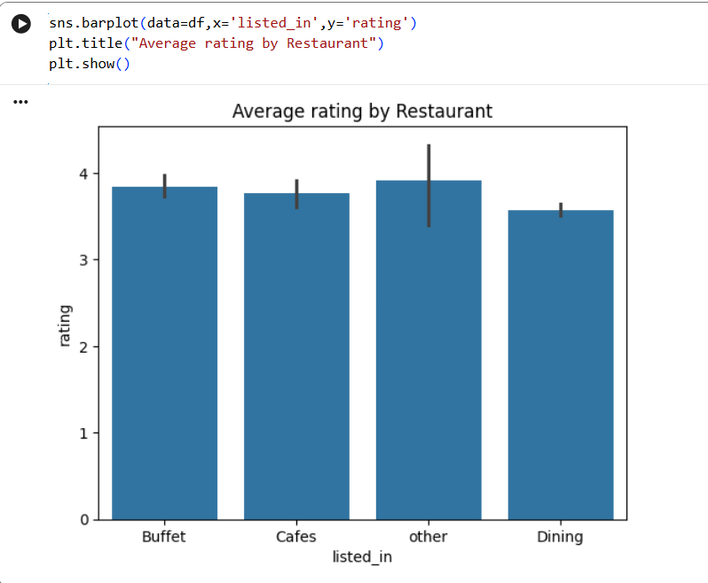
Conclusion: The other restaurant type has the highest average rating, followed by Buffet and Cafes.

8. OVERALL FINDINGS:
- Most restaurants in the dataset have generally good customer ratings.
- Dining is the most common restaurant category.
- Restaurants with online ordering have a higher average rating in this dataset.
- Restaurants offering table booking also have a higher average rating.
- The approximate cost for two people differs across restaurant categories.
- Empire Restaurant received the highest number of votes among the displayed top restaurants.
- Restaurant votes and ratings show a positive pattern, but higher votes do not always mean higher ratings.
- The other restaurant category has the highest average rating.

9. FINAL CONCLUSION:
This project analyzed Zomato Restaurant Data to understand ratings, restaurant types, online ordering, table booking, costs, and customer votes. The dataset was first cleaned by checking missing values, duplicates, data types, column names, and unique values. Exploratory Data Analysis and data visualizations were then performed to identify important patterns and relationships.
The project shows how Python and data analysis libraries can be used to transform raw restaurant data into useful insights. It also provides practical experience in the complete data analysis workflow, from data cleaning to visualization and conclusion writing.

10. FUTURE IMPROVEMENTS:
- Analyze a larger dataset containing more restaurants and cities.
- Include customer reviews for sentiment analysis.
- Create an interactive dashboard using Power BI or Tableau.
- Perform predictive analysis using machine learning.
- Analyze cuisine types and location-based restaurant performance.

