MOVIE DATA ANALYSIS
PROJECT REPORT

Prepared By: Astha Parekh
Tools Used: Python, NumPy, Pandas, Matplotlib, Seaborn and Google Colab

CERTIFICATE
This is to certify that the project titled “Movie Data Analysis” is a data analysis project completed using Python, NumPy, Pandas, Matplotlib and Seaborn. The project focuses on cleaning movie data, performing exploratory data analysis, studying budget, popularity, runtime, profit, revenue and genres, and finding useful insights from the TMDB Movies dataset.

ACKNOWLEDGEMENT
I would like to thank my mentors and instructors for providing guidance and support during this project. This project helped me understand the complete data analysis workflow, including data cleaning, data exploration, analysis, visualization, and conclusion writing.

ABSTRACT
The Movie Data Analysis project focuses on understanding movie data and identifying useful patterns from different variables. The TMDB Movies dataset contains information about movie popularity, budget, revenue, runtime, genres, vote counts, ratings, cast, director and release year.
The project follows a complete data analysis workflow. First, the dataset is inspected to understand its structure and columns. Data cleaning is then performed by checking missing values, duplicate records, data types, unnecessary columns and invalid values. After cleaning the data, Exploratory Data Analysis (EDA) is performed using statistical analysis and visualizations.
The project demonstrates how raw movie data can be cleaned, analyzed, and visualized to generate meaningful insights about popularity, profit, revenue, runtime, genres and release trends.

TABLE OF CONTENTS
1. Introduction
2. Project Objectives
3. Dataset Overview
4. Tools and Libraries Used
5. Project Workflow
6. Data Cleaning Process
7. Exploratory Data Analysis
7.1 Initial Data Exploration
7.2 Budget and Popularity
7.3 Runtime and Popularity
7.4 Popularity and Profit
7.5 Top 10 Revenue Movies
7.6 Most Popular Genres
7.7 Movies Released Each Year
8. Overall Findings
9. Final Conclusion
10. Future Improvements

INTRODUCTION:
The movie industry generates a large amount of data related to audience interest, movie performance, budgets, revenue and release trends. Movie data can be analyzed to understand what factors are associated with popularity and financial performance.
In this project, movie information is analyzed using Python and data analysis libraries. The main focus is to clean the dataset and use Exploratory Data Analysis (EDA) to answer important questions. Different visualizations are used to make the results easy to understand.

2. PROJECT OBJECTIVES:
- To understand the structure and information available in the movie dataset.
- To clean the dataset and prepare it for analysis.
- To analyze the relationship between budget and popularity.
- To identify the runtime range associated with higher popularity.
- To understand the relationship between popularity and profit.
- To identify common characteristics of the top 10 revenue movies.
- To identify the most frequently occurring movie genres.
- To analyze the trend in the number of movies released each year.

3. DATASET OVERVIEW:
The TMDB Movies dataset contains 10,866 records and 21 columns. The main variables used in this project are:
- Popularity – Popularity score associated with the movie.
- Budget – Production budget of the movie.
- Revenue – Revenue generated by the movie.
- Original Title – Original title of the movie.
- Cast – Cast information.
- Director – Director of the movie.
- Runtime – Length of the movie in minutes.
- Genres – Genre or genres associated with the movie.
- Vote Count – Number of votes received.
- Vote Average – Average movie rating.
- Release Year – Year in which the movie was released.

4. TOOLS AND LIBRARIES USED:
- Python – Used as the main programming language.
- NumPy – Used for numerical operations and data handling.
- Pandas – Used for data cleaning, manipulation and analysis.
- Matplotlib – Used for creating visualizations.
- Seaborn – Used for statistical and attractive visualizations.
- Google Colab / Jupyter – Used to write and execute Python code.

5. PROJECT WORKFLOW:
- Step 1: Load the dataset into a Pandas DataFrame.
- Step 2: Understand the dataset using shape, info, unique values and descriptive statistics.
- Step 3: Check and handle missing values.
- Step 4: Remove unnecessary columns and prepare useful fields.
- Step 5: Replace budget value 0 with missing values for meaningful median analysis.
- Step 6: Check and remove duplicate records.
- Step 7: Create a calculated column using Profit = Revenue − Budget.
- Step 8: Perform Exploratory Data Analysis using grouping, sorting and statistical analysis.
- Step 9: Create charts to understand patterns and relationships.
- Step 10: Write conclusions based on the analysis results.

6. DATA CLEANING PROCESS:
Data cleaning is an important part of data analysis because raw datasets may contain missing values, duplicate rows, unnecessary columns, incorrect data types, or invalid values. Before performing analysis, the movie dataset was checked and prepared carefully.
- Checked the number of rows and columns in the dataset.
- Checked the dataset information, column names and data types.
- Checked unique values and descriptive statistics.
- Checked for missing values.
- Dropped id, imdb_id, homepage and overview columns.
- Filled missing text fields with a missing value.
- Replaced budget value 0 with missing values for meaningful median analysis.
- Checked and removed duplicate records.
- Prepared the cleaned dataset for Exploratory Data Analysis.

7. EXPLORATORY DATA ANALYSIS:

7.1 Q1. What does the initial distribution of movie data show?

Histograms were created for the dataset variables to understand how popularity, budget, revenue, runtime and other numerical variables are distributed.
Figure 1: Initial Distribution of Movie Data
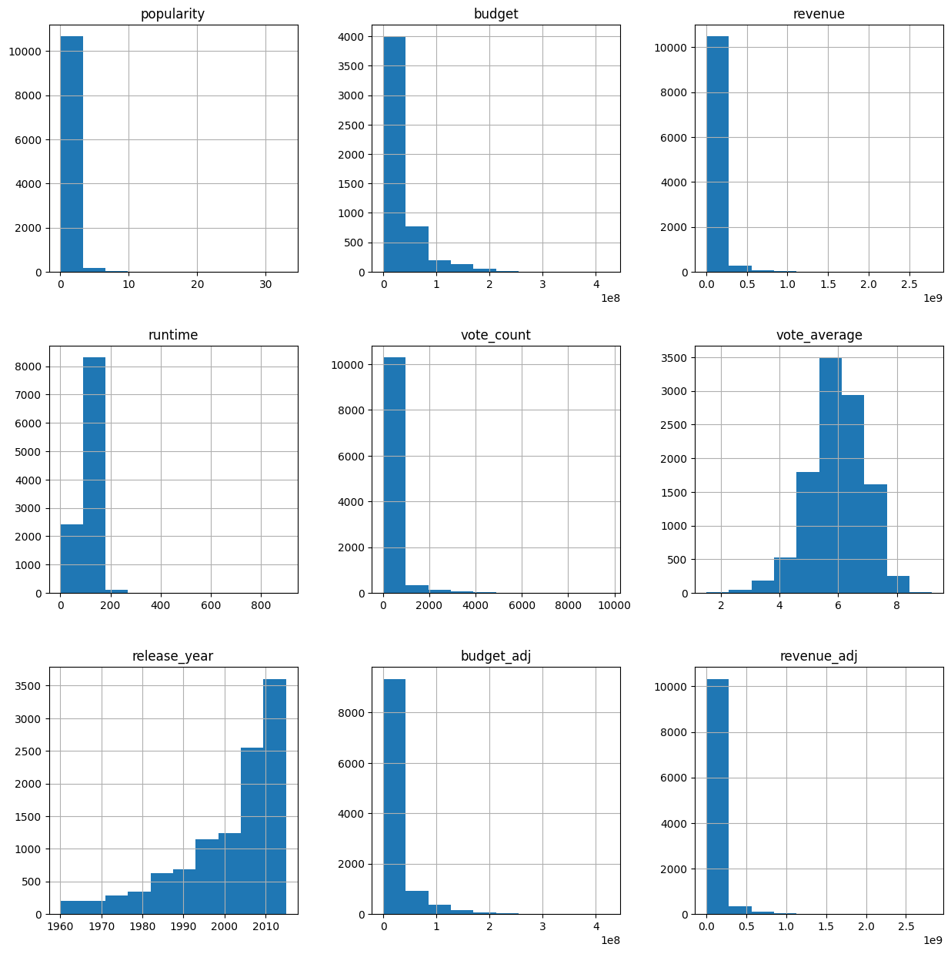
Conclusion: The distributions provide an initial overview of the movie dataset and show that numerical variables have different ranges and patterns.

7.2 Q2. Does higher budget mean higher popularity?
A scatter plot was used to study the relationship between budget and popularity. The graph suggests that a higher budget does not always guarantee higher popularity and the relationship is weak.
Figure 2: Budget and Popularity
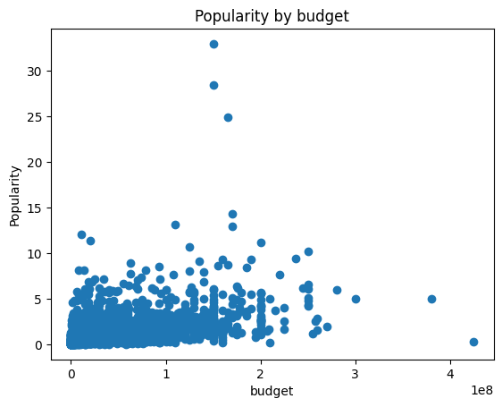
The dataset was then divided into low-budget and high-budget groups using the median budget. Average popularity was calculated for both groups and displayed in a bar chart.

Figure 3: Average Popularity by Budget Group
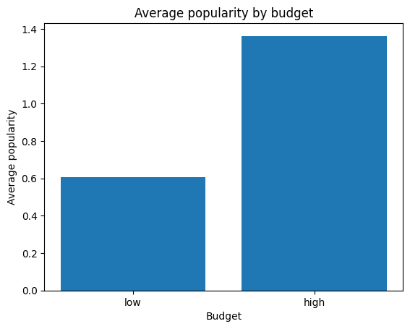
Conclusion: High-budget movies have higher average popularity than low-budget movies, but the relationship is not very strong because some low-budget movies are also popular.

7.3 Q3. What length will receive the highest popularity?
The project divided movies into runtime groups and calculated their average popularity. A bar chart was created to compare popularity by runtime, followed by a scatter plot of runtime versus popularity.
Figure 4: Popularity by Runtime Group
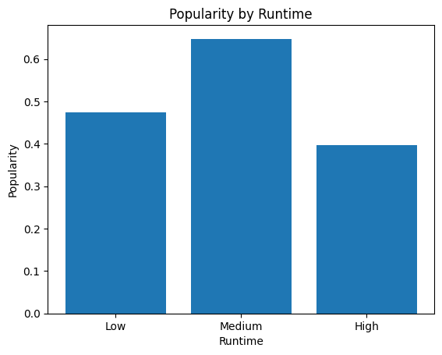

Figure 5: Runtime and Popularity
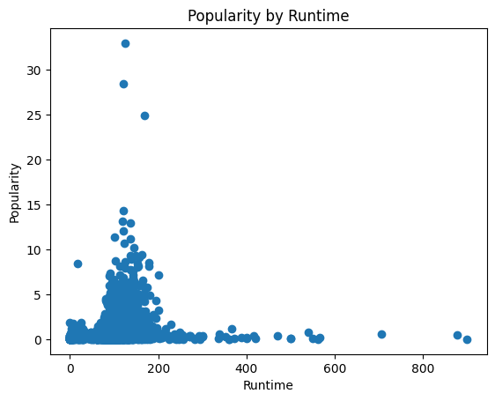
Conclusion: Movies should not be too short or too long. According to this project analysis, medium-length movies show better average popularity.

7.4 Q4. Does higher popularity mean higher profit?
A new profit column was created using Profit = Revenue − Budget. Movies were divided into lower-popularity and higher-popularity groups using the median popularity value. Their average profits were then compared using a bar chart.
Figure 6: Average Profit by Popularity Group
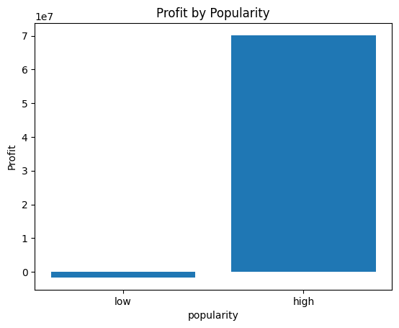
Conclusion: Higher popularity means higher average profit in this dataset. Therefore, popularity appears to have a positive association with movie profit.

7.5 Q5. What features are associated with the Top 10 Revenue Movies?
The top 10 movies were selected using the highest revenue values. A histogram visualisation was created to examine the characteristics of these successful movies.
Figure 7: Characteristics of Top 10 Revenue Movies
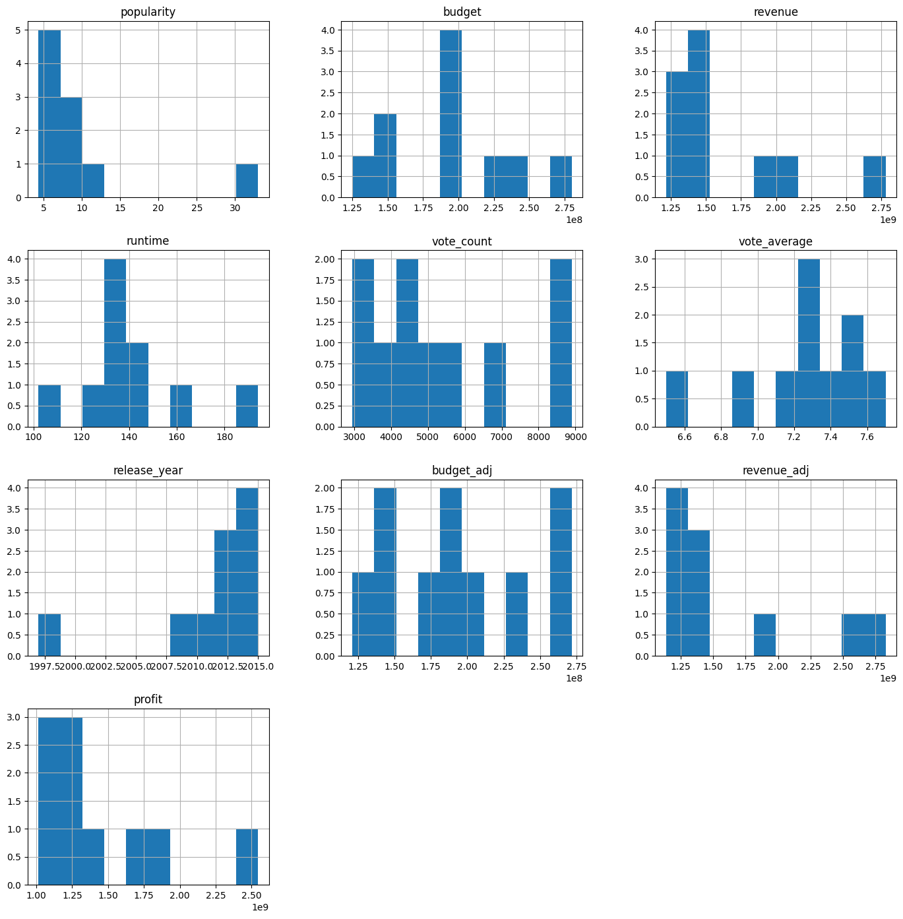
Conclusion: The top 10 highest-revenue movies generally have high budgets, good popularity, high vote counts and good ratings. Many of these movies also have runtimes around 110–150 minutes.

7.6 Q6. Which genres are most popular?
Because a movie can belong to more than one genre, the genre column was split using the separator and each genre occurrence was counted. A horizontal bar chart was then created.
Figure 8: Movie Genres
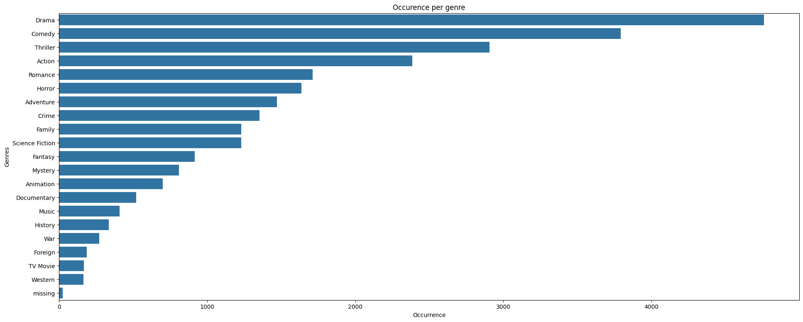
Conclusion: Drama is the most popular and most frequently occurring genre in the dataset, followed by Comedy and Thriller.

7.7 Q7. How has the number of movies released changed over the years?
The number of movies released in each year was counted and displayed using a line chart. This chart helps understand the overall release trend across years.
Figure 9: Movies Released Each Year
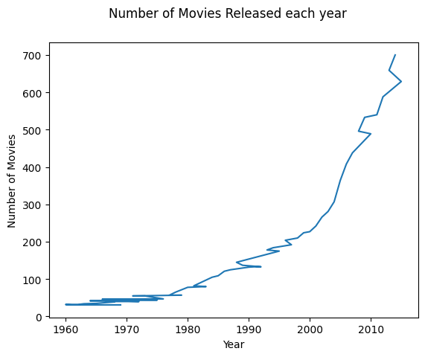
Conclusion: The number of movies generally increased over the years, although some years show variation in the number of releases.

8. OVERALL FINDINGS:
- High-budget movies had higher average popularity, although the relationship was not strong.
- Medium-length movies showed better popularity in the project grouping.
- Higher popularity was associated with higher average profit.
- Top revenue movies generally had strong budgets, popularity, votes and ratings.
- Drama was the most frequently occurring genre, followed by Comedy and Thriller.
- The number of movies generally increased over the years, with variation in some years.

9. FINAL CONCLUSION:
This project analyzed TMDB Movie Data to understand budget, popularity, runtime, profit, revenue, genres and release trends. The dataset was first cleaned by checking missing values, duplicates, unnecessary columns, data types and invalid budget values. Exploratory Data Analysis and data visualizations were then performed to identify important patterns and relationships.
The project shows how Python and data analysis libraries can be used to transform raw movie data into useful insights. It also provides practical experience in the complete data analysis workflow, from data cleaning and calculated columns to visualization and conclusion writing.

10. FUTURE IMPROVEMENTS:
- Analyze a larger and more recent movie dataset.
- Include audience reviews for sentiment analysis.
- Create an interactive dashboard using Power BI or Tableau.
- Perform predictive analysis using machine learning.
- Analyze individual genres, directors and actors in more detail.
- Study the relationship between movie release year, budget, revenue and popularity.

