BOSTON HOUSING DATA ANALYSIS
PROJECT REPORT

Prepared By: Astha Parekh
Tools Used: Python, Pandas, Matplotlib, Seaborn and Google Colab

CERTIFICATE
This is to certify that the project titled “Boston Housing Data Analysis” is a data analysis project completed using Python and data visualization techniques. The project focuses on analyzing housing prices, room counts, relationships between housing variables, and useful patterns through exploratory data analysis.

ACKNOWLEDGEMENT
I would like to thank my mentors and instructors for providing guidance and support during this project. This project helped me understand the complete data analysis workflow, including data cleaning, data exploration, statistical analysis, correlation analysis, and visualization.

ABSTRACT
The Boston Housing Data Analysis project focuses on understanding housing data and identifying useful patterns from different variables. The dataset contains housing-related variables such as house price value (MEDV), average number of rooms (RM), LSTAT, DIS, and CHAS. The project follows a complete data analysis workflow. First, the dataset is inspected to understand its structure and columns. Data cleaning is then performed by checking duplicates, data types, and the dataset structure. After cleaning, numerical analysis and Exploratory Data Analysis (EDA) are performed using Pandas, NumPy, Matplotlib, and Seaborn. The project demonstrates how raw housing data can be analyzed and visualized to generate meaningful insights.

TABLE OF CONTENTS
1. Introduction
2. Project Objectives
3. Dataset Overview
4. Tools and Libraries Used
5. Project Workflow
6. Data Cleaning Process
7. Exploratory Data Analysis
7.1 Average House Price
7.2 Median House Price
7.3 Minimum and Maximum House Price
7.4 Average Number of Rooms
7.5 Houses with More Than 7 Rooms
7.6 Houses with MEDV Greater Than 30
7.7 Standard Deviation of House Prices
7.8 Correlation Between RM and MEDV
7.9 Correlation of Variables with MEDV
7.10 Houses with More Than 6 Rooms
7.11 Visualizations 1–10
8. Overall Findings
9. Final Conclusion
10. Future Improvements

1. INTRODUCTION:
Housing datasets contain valuable information about properties and their characteristics. Data analysis can be used to understand typical house prices, price variation, the number of rooms, and relationships between different housing variables. The Boston Housing dataset provides a useful environment for practicing these concepts.
In this project, housing information is analyzed using Python. The main focus is to inspect and prepare the data, answer numerical questions using Pandas, and create visualizations using Matplotlib and Seaborn. The charts make the relationships and distributions easier to understand.

2. PROJECT OBJECTIVES:
- To understand the structure and information available in the dataset.
- To inspect and prepare the dataset for analysis..
- To calculate average, median, minimum, maximum, and standard deviation of house prices.
- To analyze the average number of rooms in houses.
- To filter houses according to price and room-count conditions.
- To study the relationship between RM and MEDV.
- To identify variables with strong positive and negative relationships with MEDV.
- To create meaningful visualizations and write conclusions from the results.

3. DATASET OVERVIEW:
- The dataset contains housing-related variables. The main columns used in this project include:
- MEDV – House price value used as the target variable.
- RM – Average number of rooms per dwelling.
- LSTAT – Socio-economic variable included in the housing dataset.
- DIS – Distance to employment centres.
- CHAS – Charles River indicator.
- Other numerical variables – Additional housing and neighbourhood characteristics used in correlation analysis.

4. TOOLS AND LIBRARIES USED:
- Python – Used as the main programming language.
- NumPy – Used for numerical operations and array-based computation.
- Pandas – Used for data loading, cleaning, filtering, statistics, grouping, and correlation analysis.
- Matplotlib – Used for histograms, scatter plots, line charts, and bar charts.
- Seaborn – Used for statistical visualizations such as boxplots.
- Google Colab – Used to write and execute Python code.

5. PROJECT WORKFLOW:
The project followed the following workflow:
- Step 1: Load the dataset into a Pandas DataFrame.
- Step 2: Understand the dataset using shape, columns, info, and descriptive statistics.
- Step 3: Check for duplicate records and remove duplicates.
- Step 4: Review the available numerical variables.
- Step 5: Perform numerical analysis using mean, median, min, max, standard deviation, filtering, and correlation.
- Step 6: Create charts using Matplotlib and Seaborn.
- Step 7: Interpret the charts and numerical outputs.
- Step 8: Write conclusions based on the analysis.

6. DATA CLEANING PROCESS:
Data cleaning is an important part of data analysis because duplicate records or incorrect data structures can affect the results. Before analysis, the dataset was inspected and duplicate records were removed.
- Checked the dataset structure and column names.
- Checked the number of rows and columns.
- Checked for duplicate records.
- Reviewed the available data types.
- Checked the dataset for duplicate records.
- Removed duplicate records using drop_duplicates().
- Checked important numeric columns for invalid values.
- Prepared the cleaned DataFrame for numerical analysis and visualization.

7. EXPLORATORY DATA ANALYSIS:
7.1 Q1. Find the average house price (MEDV).
The average house price value is approximately 22.53.

Figure 1: Distribution of House Prices

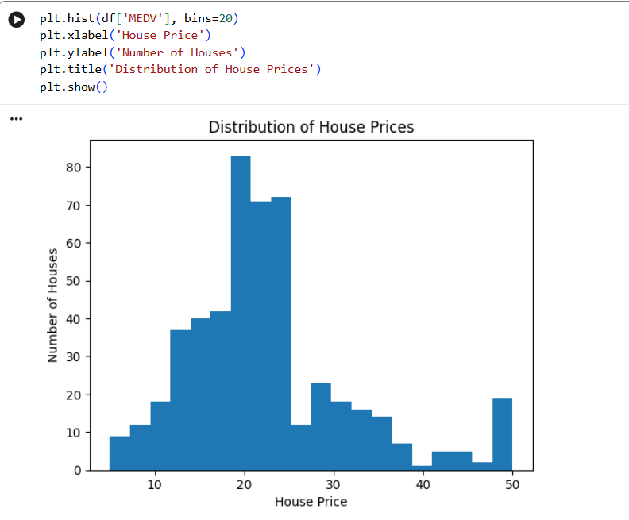
Conclusion: The histogram shows that house prices are distributed across different price ranges, with many observations concentrated around the middle range.

7.2 Q2. Which restaurant type is the most common?
The median house price is 21.2.
Figure 2: Rooms vs House Price
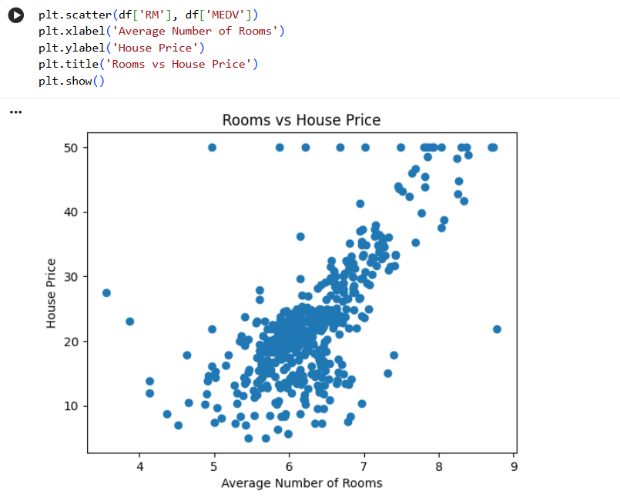

Conclusion: The chart shows a positive relationship. Generally, houses with more rooms have higher house prices.

7.3 Q3. Find the minimum and maximum house price.
The minimum MEDV is 5.0, while the maximum is 50.0.

Figure 3: LSTAT vs House Price
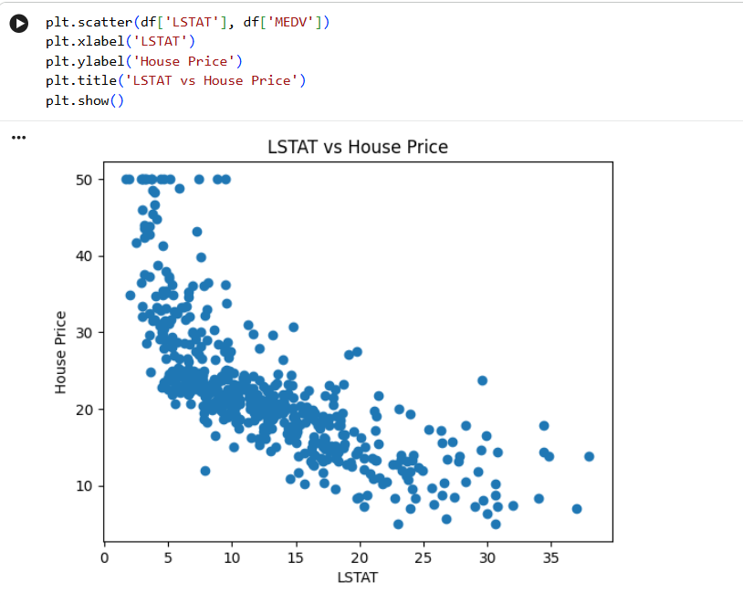

Conclusion: The chart shows a negative relationship. As LSTAT increases, house prices generally decrease.

7.4 Q4. Create a line chart for the first 30 house prices.
The average number of rooms is approximately 6.28.
Figure 4: First 30 House Prices
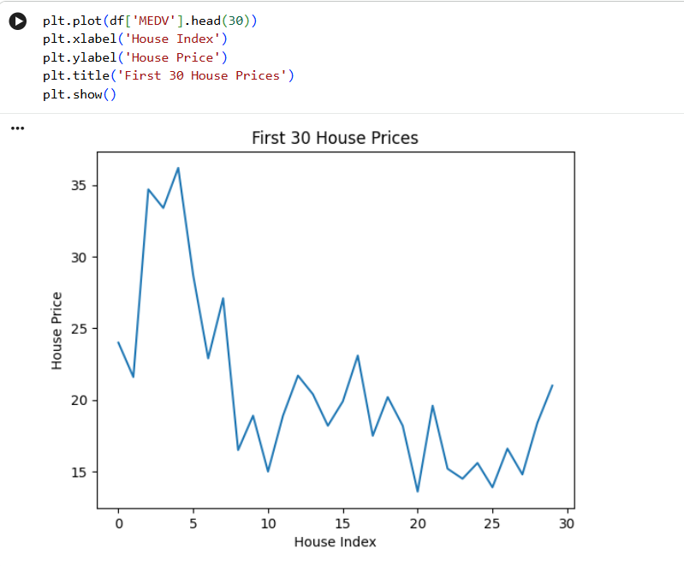

Conclusion: The line chart shows that house prices vary considerably across the first 30 observations.

7.5 Q5. Create a boxplot for house prices.
The filter df[df['RM'] > 7] returns all houses where the average number of rooms is greater than 7.
Figure 5: Boxplot of House Prices
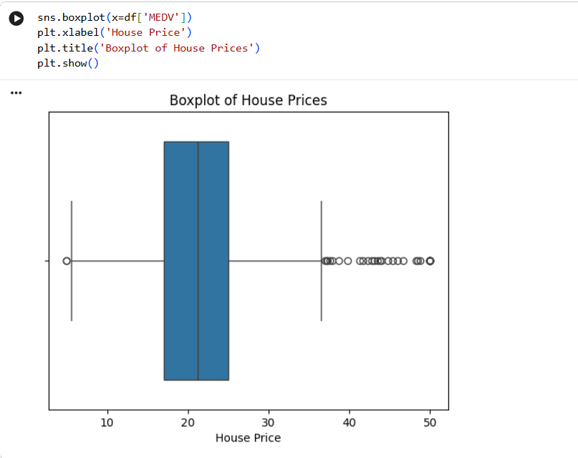

Conclusion: The boxplot shows the spread, median and possible outliers in house prices.

7.6 Q6. Create a histogram of the average number of rooms (RM).
The analysis counts the observations where MEDV is greater than 30; the result is 84 houses.
Figure 6: Distribution of Number of Rooms
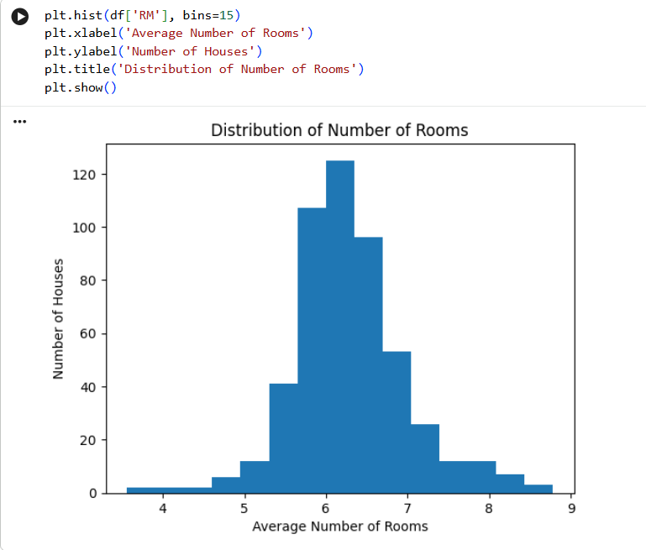

Conclusion: The histogram shows the distribution of the average number of rooms. Most houses have a room count around the middle range, while very high or very low values occur less frequently.

7.7 Q7. Create a scatter plot between DIS and MEDV.
The standard deviation of MEDV is approximately 9.20.
Figure 7: DIS vs House Price
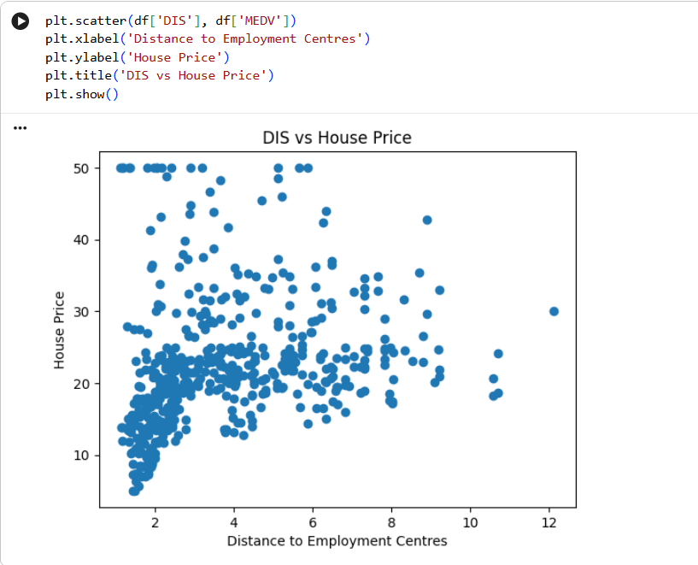

Conclusion: The scatter plot shows the relationship between distance to employment centres and house prices. The points are spread across the chart, indicating that the relationship is not very strong.

7.8 Q8. Create a boxplot of house prices based on CHAS.
The correlation between RM and MEDV is approximately 0.70 (0.69536).
Figure 8: House Price by CHAS
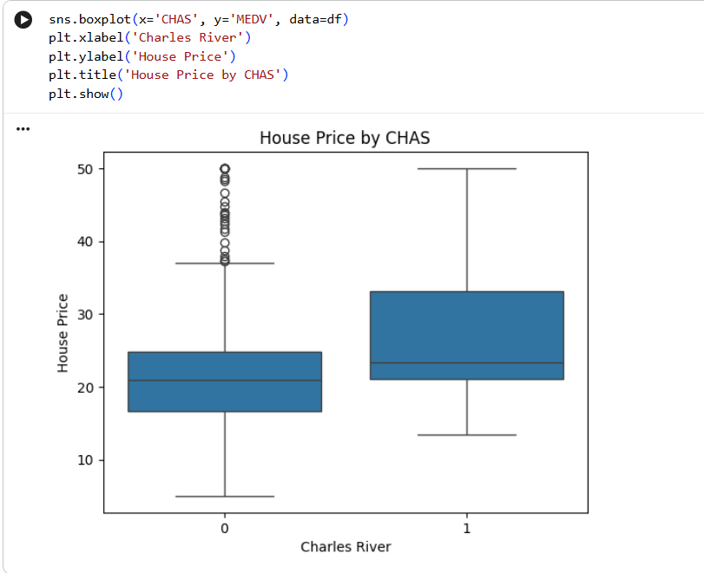

Conclusion: The chart compares house prices for properties located near the Charles River and properties that are not near it.

7.9 Q9. Create a bar chart showing the average MEDV for CHAS categories.
The correlation output helps identify variables with the strongest positive and negative relationships with MEDV. RM has a strong positive relationship, while LSTAT has a strong negative relationship.
Figure 9: Average House Price by CHAS
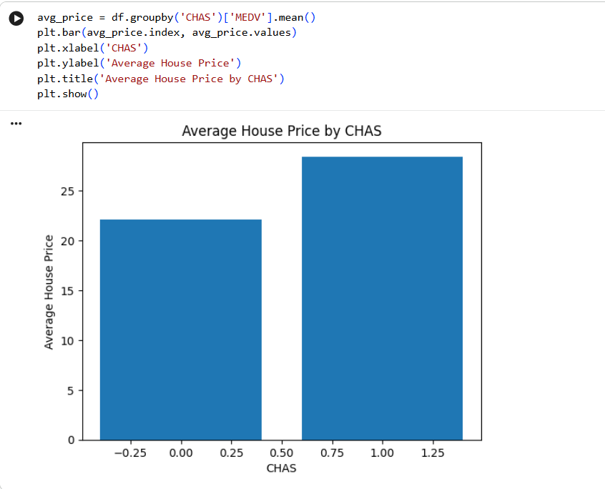

Conclusion: The bar chart compares the average house prices for properties based on their CHAS category. It helps us see whether properties near the Charles River have different average prices.

7.10 Q10. Create a boxplot for RM (average number of rooms).
The result is 333 houses.
Figure 10: Distribution of Average Number of Rooms
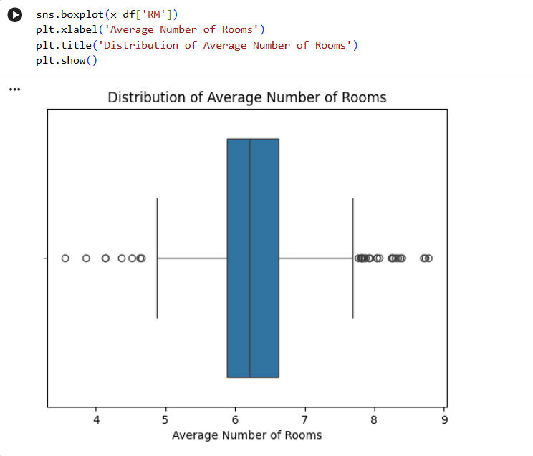

Conclusion: The boxplot shows the median, spread, and possible outliers in the average number of rooms. Most houses are concentrated around the middle range of room counts.

8. OVERALL FINDINGS:
- The average MEDV is approximately 22.53, while the median is 21.2.
- The analyzed MEDV values range from 5.0 to 50.0.
- The average number of rooms is approximately 6.28.
- There are 84 houses with MEDV greater than 30.
- The standard deviation of MEDV is approximately 9.20, indicating noticeable price variation.
- RM has a strong positive correlation with MEDV, approximately 0.70.
- LSTAT shows a strong negative relationship with MEDV in the correlation analysis.
- There are 333 houses with more than 6 rooms.
- The visualizations make distributions, relationships, variation, and category comparisons easier to understand.

9. FINAL CONCLUSION:
This project analyzed Boston Housing Data to understand house prices, room counts, and relationships between important housing variables. The dataset was first inspected and cleaned by checking its structure and duplicate records. Numerical analysis was then performed using Pandas, followed by data visualization using Matplotlib and Seaborn.
The project shows that house prices vary considerably across the dataset. The average number of rooms has a strong positive relationship with house price, while LSTAT has a strong negative relationship. The combination of numerical analysis and charts provides a clear and practical understanding of the housing data.

10. FUTURE IMPROVEMENTS:
- Build an interactive dashboard using Power BI or Tableau.
- Perform deeper outlier analysis and treatment.
- Study additional relationships among the housing variables.
- Build and evaluate a machine-learning model for house-price prediction.
- Compare multiple models and evaluate their performance using suitable metrics.

