# IDEATION PHASE

## Problem Statement

|  |  |
| --- | --- |
| **Date** | 10 April 2025 |
| **Team ID** | SWTID1742907331 |
| **Project Name** | MaitriLok : Social Media App |
| **Maximum Marks** | 2 Marks |

**Customer Problem Statement:**

|  |  |  |  |  |  |
| --- | --- | --- | --- | --- | --- |
| **Problem Statement (PS)** | **I am (Customer)** | **I’m trying to** | **But** | **Because** | **Which makes me feel** |
| PS-1 | New user | Register and explore the app | I don’t see an easy signup process or social login | Only email/password registration is available | Frustrated and less motivated |
| PS-2 | Regular user | Customize my theme or look and feel | There is no color selection or theme toggling | The UI is fixed | Less in control of my experience |
| PS-3 | Social user | Chat with my network | Messages are delayed or don’t update live | Chat lacks real-time functionality | Disconnected |
| PS-4 | Content creator | Share a post | The editor is basic and lacks formatting features | There’s no rich text or media options | Limited and less expressive |
| PS-5 | New user | Find friends or users I know | The search bar doesn’t give relevant results | It doesn’t support name suggestions or filtering | Annoyed and helpless |
| PS-6 | Curious user | View someone’s profile | Profile pages look incomplete or outdated | Users can’t edit all profile info | Less connected to others |
| PS-7 | Daily user | Check recent posts from my network | My feed isn’t updated in real-time | There’s no smart post refresh logic | Out of sync |
| PS-8 | Mobile user | Use the app smoothly | Some components break on small screens | The layout isn’t fully responsive | Irritated while browsing |
| PS-9 | Privacy-conscious user | Control who sees my posts | There are no privacy settings per post | Feature is not implemented yet | Vulnerable |
| PS-10 | Regular user | Save some important posts | I don’t see any option to bookmark or save | The post save feature is missing | Disappointed |

## 2.2 Empathy Map Canvas:

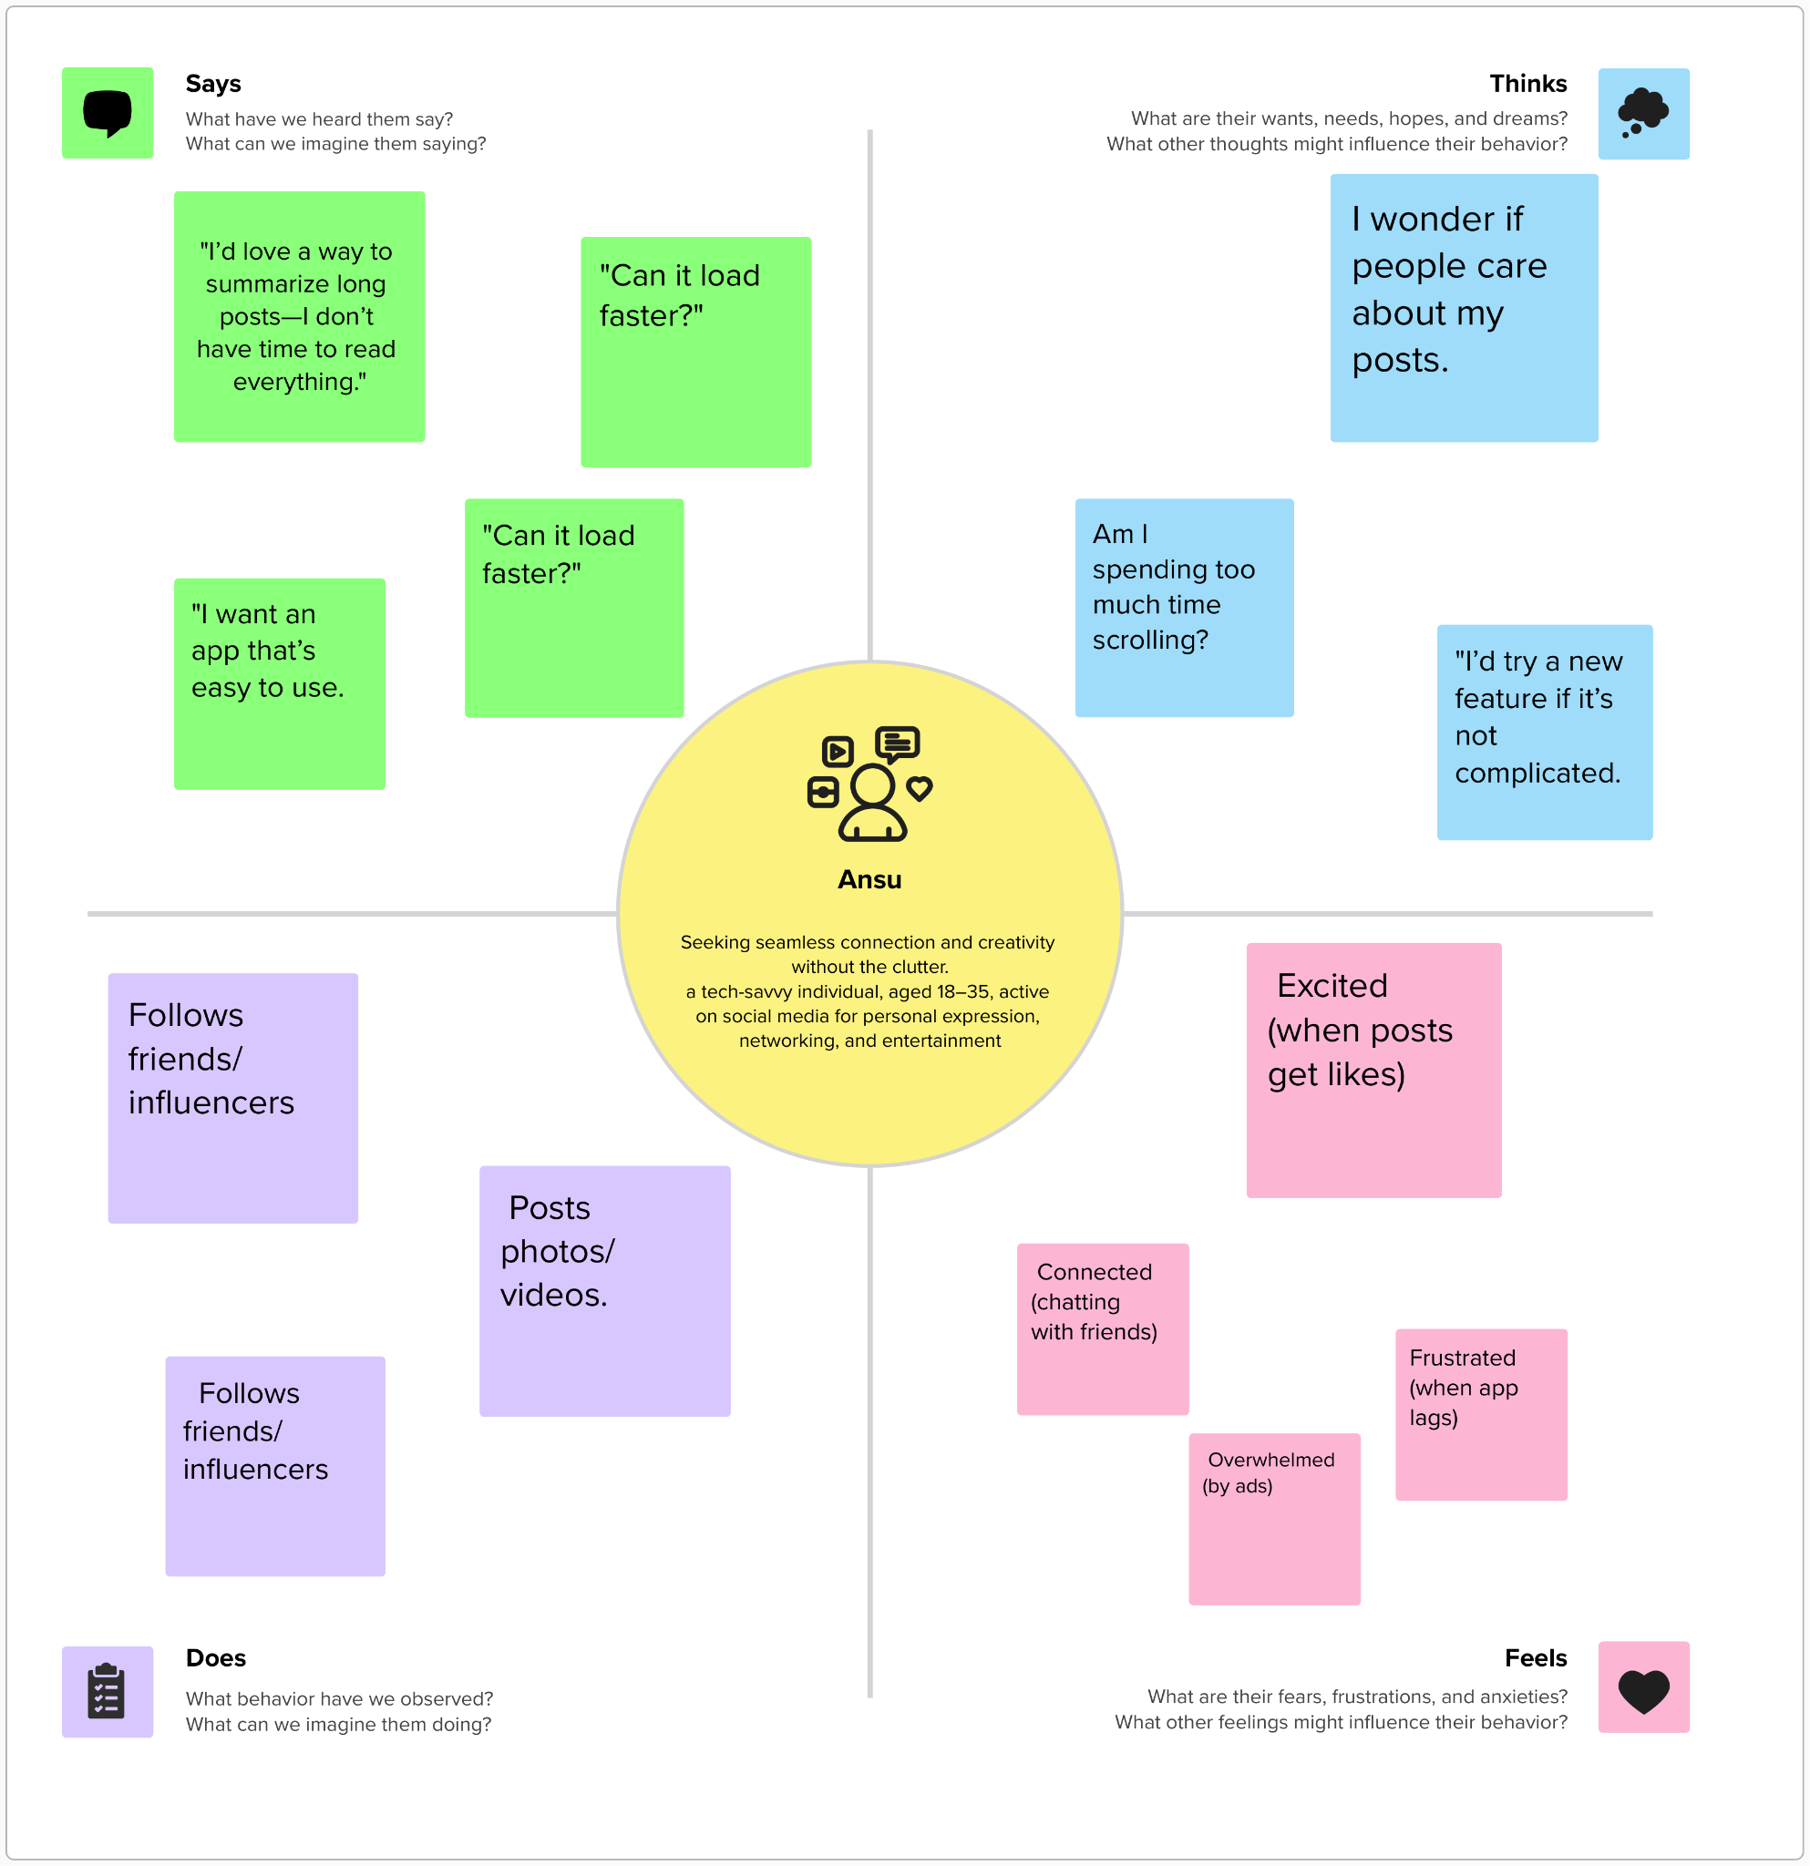

## 2.3 Brainstorming

**Step-1: Team Gathering, Collaboration and Select the Problem Statement**

Our team began by forming a collaborative environment where every member could freely share ideas and expectations. Through regular discussions and brainstorming sessions, we identified common interests and goals. After evaluating various real-world challenges, we selected the idea of building a MERN stack-based social media application, aiming to enhance user interaction and digital connectivity in a secure and modern interface.

**Step-2: Brainstorm, Idea Listing and Grouping**

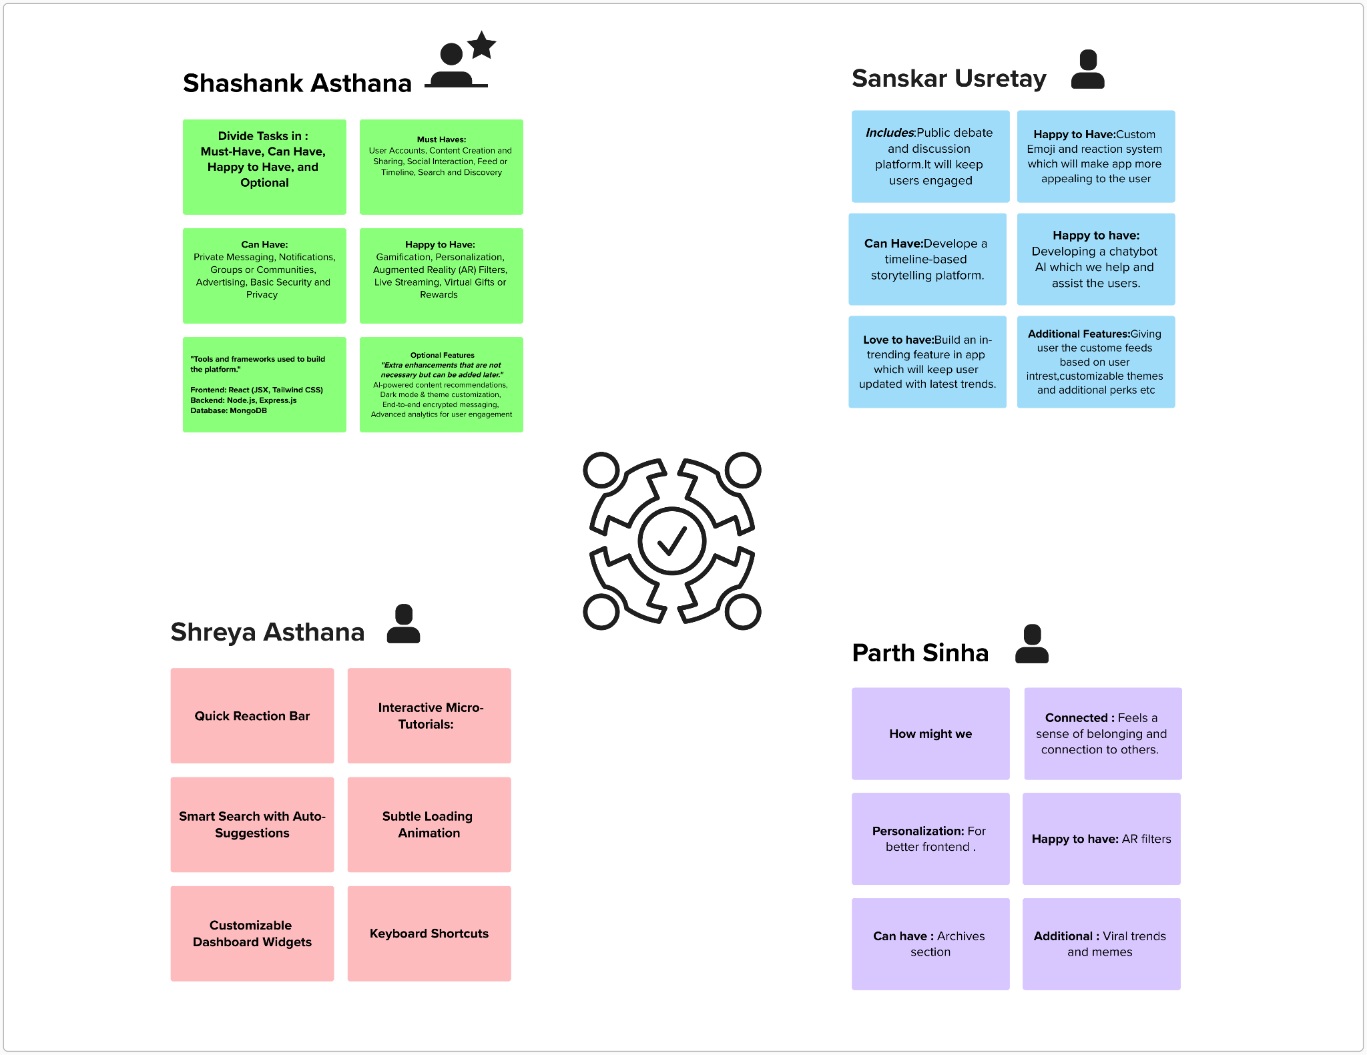

**Step-3: Idea Prioritization**

