Overview of EFS

* Amazon Elastic File System (EFS) is a fully managed, scalable, and server less file storage service provided by AWS for use with AWS Cloud services and on-premises resources. It offers a simple, elastic file system that automatically scales to meet application needs without requiring manual provisioning or capacity management. EFS is designed for shared file storage, enabling multiple instances, containers, or users to access the same file system concurrently

Key features of EFS

* Scalability: Automatically scales storage capacity up or down as files are added or removed, supporting petabytes of data and thousands of concurrent connections

Shared Access: Provides a common file system for multiple Amazon EC2 instances, AWS Lambda functions, containers, or on-premises servers, with consistent low-latency performance

Fully Managed: No hardware provisioning, maintenance, or patching required; AWS handles the infrastructure

performance Modes

General Purpose: Optimized for latency-sensitive applications like web servers or content management systems.

Max I/O: Suited for high-throughput workloads like big data analytics or media processing.

Storage Classes

Standard: For frequently accessed data with low-latency access.

Infrequent Access (IA): Cost-optimized for less frequently accessed files, with lifecycle policies to move data automatically

Common Use Cases:

Content Management: Hosting media files, websites, or CMS platforms

Big Data and Analytics: Shared storage for data processing workloads

Container and Serverless Applications: Persistent storage for Kubernetes, ECS, or Lambda

.Home Directories and Enterprise Applications: Centralized file storage for user directories or enterprise software

**Lab Steps**

Step 1: Set Up a Security Group for EFS

Log in to the AWS Management Console at <https://console.aws.amazon.com>

.Navigate to VPC > Security Groups.

Click Create Security Group

.Name: EFSAccess

Description: Security group for EFS access

VPC: Select your default VPC

.Add an Inbound Rule:

Type: NFS

Protocol: TCP

Port Range: 2049

Source: Anywhere (0.0.0.0/0) or a specific CIDR for security (e.g., your VPC’s CIDR)

.Click Create Security Group and note the security group ID.

**Step : 2 Create an EFS File System**

In the AWS Console, navigate to EFS > File Systems > Create File System.

2. Configure File System

:Name: MyEFSLab

VPC: Select your default VPC

.Availability and Durability: Choose Regional (Standard) for multi-AZ durability or One Zone for cost savings

.Encryption: Enable encryption at rest (uses AWS KMS by default).

Performance Mode: Select General Purpose for low-latency workloads

.Throughput Mode: Choose Bursting for most use cases

3.Click Next and assign the EFSAccess security group to all mount targets in your VPC’s Availability Zones

4.Review and click Create. Note the File System ID (e.g., fs-12345678 ]

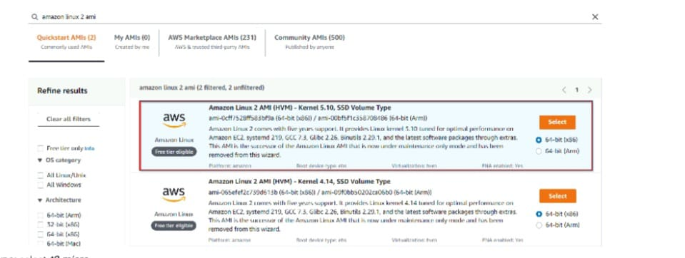

**Step 3: Launch an EC2 Instance**

1. Navigate to EC2 > Instances > Launch Instances.
2. Configure Instance

* **AMI:** Choose Amazon Linux 2 AMI.
* **Instance Type:** Select t2.micro (Free Tier eligible).
* **Key Pair:** Select an existing key pair or create a new one.
* **Network:** Use your default VPC and a public subnet.
* **Security Group:** Create a new security group or use an existing one with:
* **SSH:** TCP, Port 22, Source: Your IP or Anywhere (0.0.0.0/0).
* **NFS:** TCP, Port 2049, Source: EFS Access security group ID.

1. Launch the instance and note its Public IP.

Step 4: Mount the EFS File System on the EC2 Instance

1. Connect to the EC2 Instance:

* Use SSH (e.g., ssh -i <your-key.pem> ec2-user@<public-ip>)

1. Install the EFS Mount Helper:

* sudo yum install -y amazon-efs-utils

1. Create a Mount Point:

* sudo mkdir /mnt/efs

1. Mount the EFS File System:

* In the EFS Console, under your file system, click Attach to get the mount command.
* Example command:
* sudo mount -t efs -o tls fs-12345678:/ /mnt/efs
* Replace fs-12345678 with your File System ID.

1. Verify the mount:

* df -h

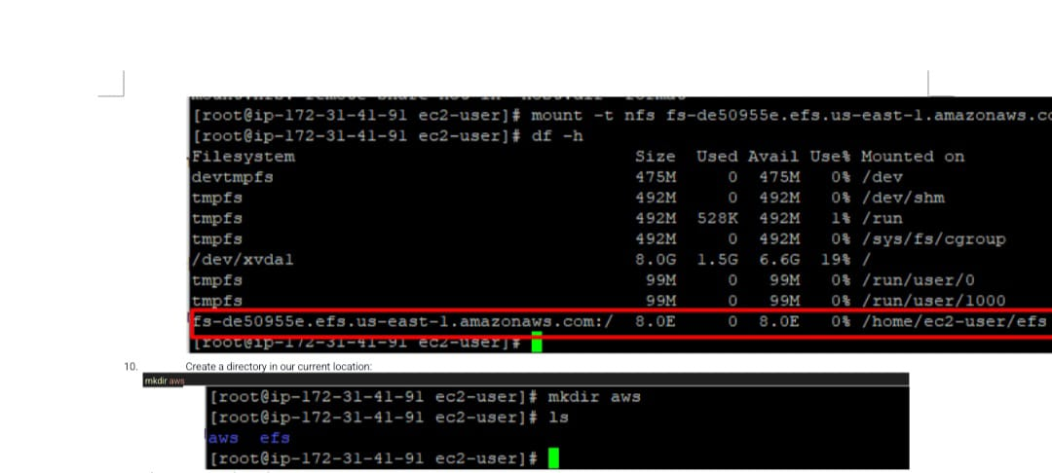

**Look for the EFS file system in the output (e.g., fs-12345678:/ mounted on /mnt/efs).**

**Step 5: Mount the File System to MyEC2-2 Instance**

1. **Select the MyEC2-2 Instance and copy the IPv4 Public IP.**
2. **SSH into the EC2 Instance**

* **Please follow the steps in SSH into EC2 Instance.**

1. **Switch to root user**

* **sudo -s**

Run the updates using the following command:

* **yum -y update**

Install the NFS client as amazon-efs-utils.

* **yum -y install amazon-efs-utils**

Create a directory with the name efs

* **mkdir efs**

We have to mount the file system in this directory.

To do so, navigate to the AWS console and click on the created file system. On the top-right corner, click on Attach

* **Copy the command of Using the EFS mount helper.**

sudo mount -t efs -o tls fs-2ad0a9a8:/ efs

* **Note1: fs-2ad0a9a8**is file system id in my case, it could be different in your case, make sure to replace it.
* **Note2:**In the above command we see, it starts with **"sudo"**since you are already a super-user, it's ok, if you don't remove sudo.
* To display information for all currently mounted file systems, we'll use the command

**df -h**

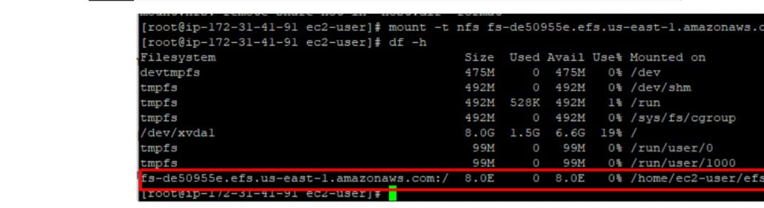

**Step 6: Testing the File System**

1 SSH into both instances in a side-by-side view on your machine, if possible.

2 Switch to root user

**sudo -s**

3 Navigate to the efs directory in both the server using the command

**cd efs**

Create a file in any one server**.**

**touch hello.txt**

Check the file using the command

**ls -ltr**

Now go to the other server and give the command

**cd efs**

You can see the file created on this server as well. This proves that our EFS is working.

You can try creating files (touch command) or directories (mkdir command) on other servers to continue to grow the EFS implementation.

