TECHNICAL DOCUMENTATION

ON

EMPLOYEE MANAGEMENT SYSTEM

1. **Introduction :**

The Employee Management System (EMS) is a web-based application designed to streamline and automate employee data management within an organization. It provides HR personnel with a user-friendly interface for adding, viewing, and deleting employee details. Utilizing technologies such as HTML5, CSS3, Bootstrap, JavaScript, and jQuery, the system ensures efficient handling of employee information. This technical documentation outlines the project's technology stack, features screen shots of the system, highlights JavaScript topics used, provides the GitHub repository URL, discusses roles and responsibilities, and suggests potential future enhancements for continued system development.

**b. Technologies / Libraries / Tools**

The Employee Management System is built using the following technologies, libraries, and tools:

* HTML5 (HyperText Markup Language):HTML5 is the latest version of HTML, the standard markup language for creating web pages. It provides the structure and content of web pages using a variety of elements and tags.
* CSS3 (Cascading Style Sheets):CSS3 is the latest version of CSS, a stylesheet language used for describing the presentation of a document written in HTML. It enables the styling and layout of web pages, enhancing their visual appeal.
* Bootstrap 4.0.0: Bootstrap is a popular open-source CSS framework that simplifies the process of designing responsive and mobile-first web pages. It provides a collection of pre-designed components and styles to enhance the overall user experience.
* JavaScript (ES6+): JavaScript is a versatile scripting language that adds dynamic behaviour to web pages. The ECMAScript 6 (ES6) version introduces modern features and syntax for writing more maintainable and efficient code.
* jQuery: jQuery is a fast and lightweight JavaScript library designed to simplify HTML document traversal and manipulation, as well as event handling. It facilitates the development of interactive and dynamic web pages with less code.
* SweetAlert2: SweetAlert2 is a JavaScript library that provides attractive and customizable alert dialogs. It enhances the user experience by replacing the default browser alerts with more visually appealing and user-friendly pop-up messages.
* Font Awesome: Font Awesome is a scalable vector icons library that provides a collection of icons and symbols. It allows for easy integration of visually appealing icons in web applications, improving overall design aesthetics.
* Visual Studio: Used for coding and debugging.
* GitHub: Version control and source code management.

**c. Screenshots:**

**1. UI**

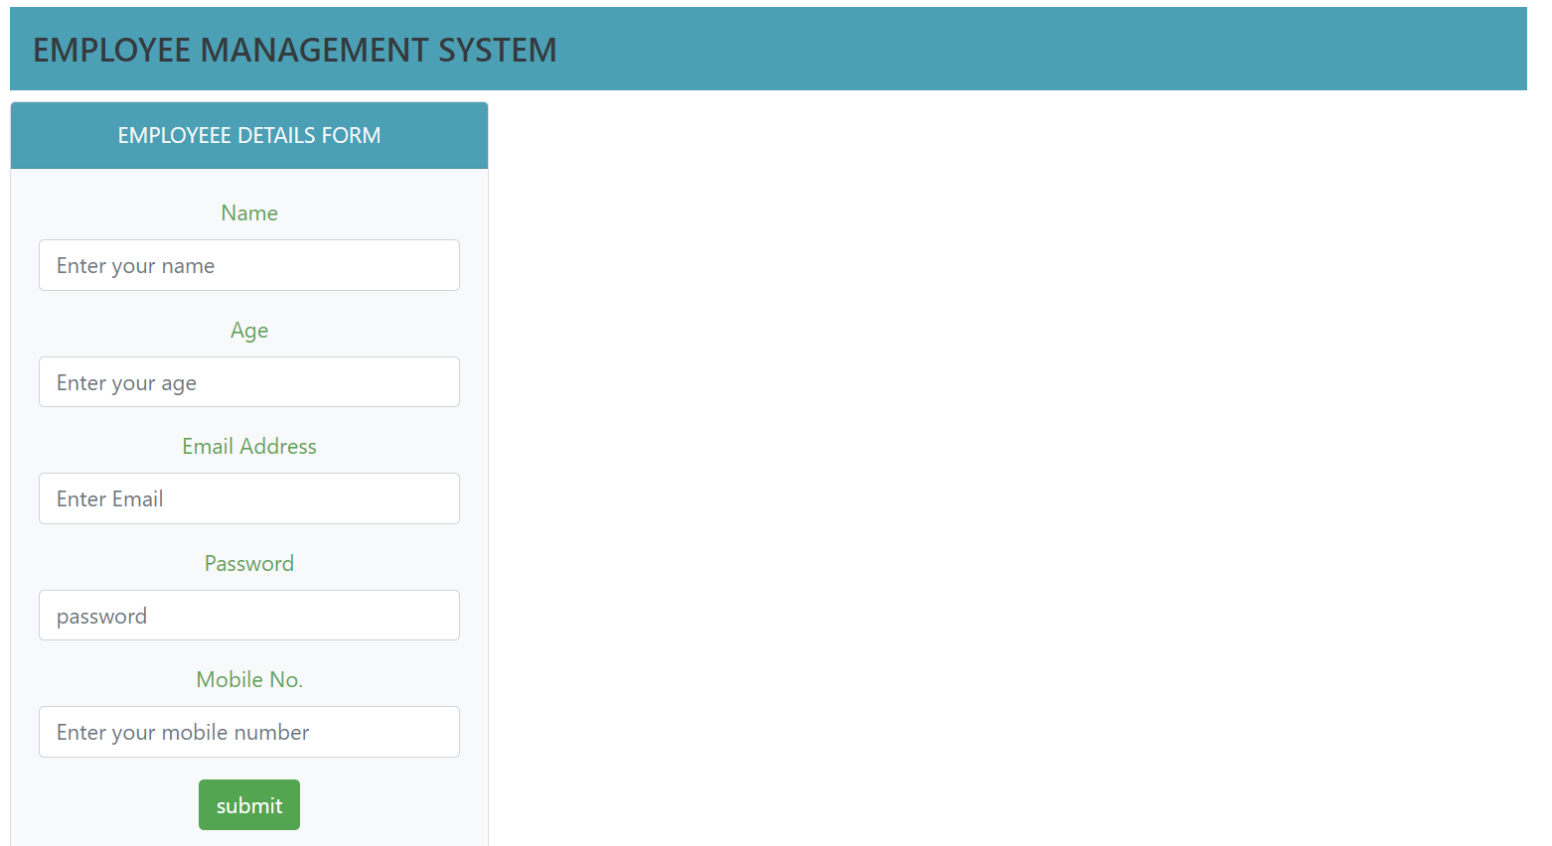

2. when user does not enter any details and press the submit button.

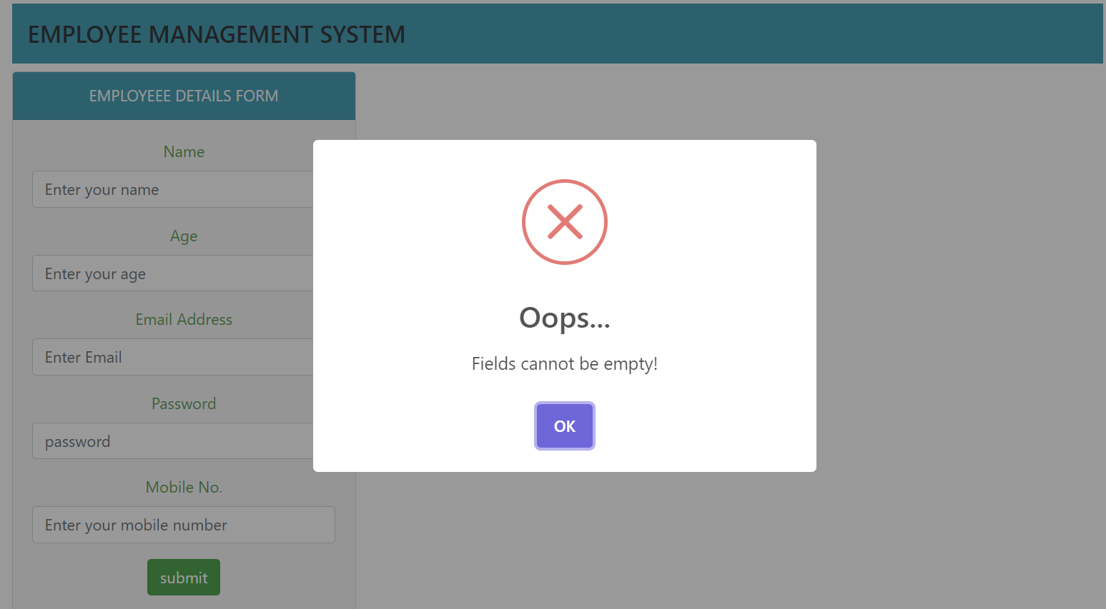

3. when user enters all valid details.

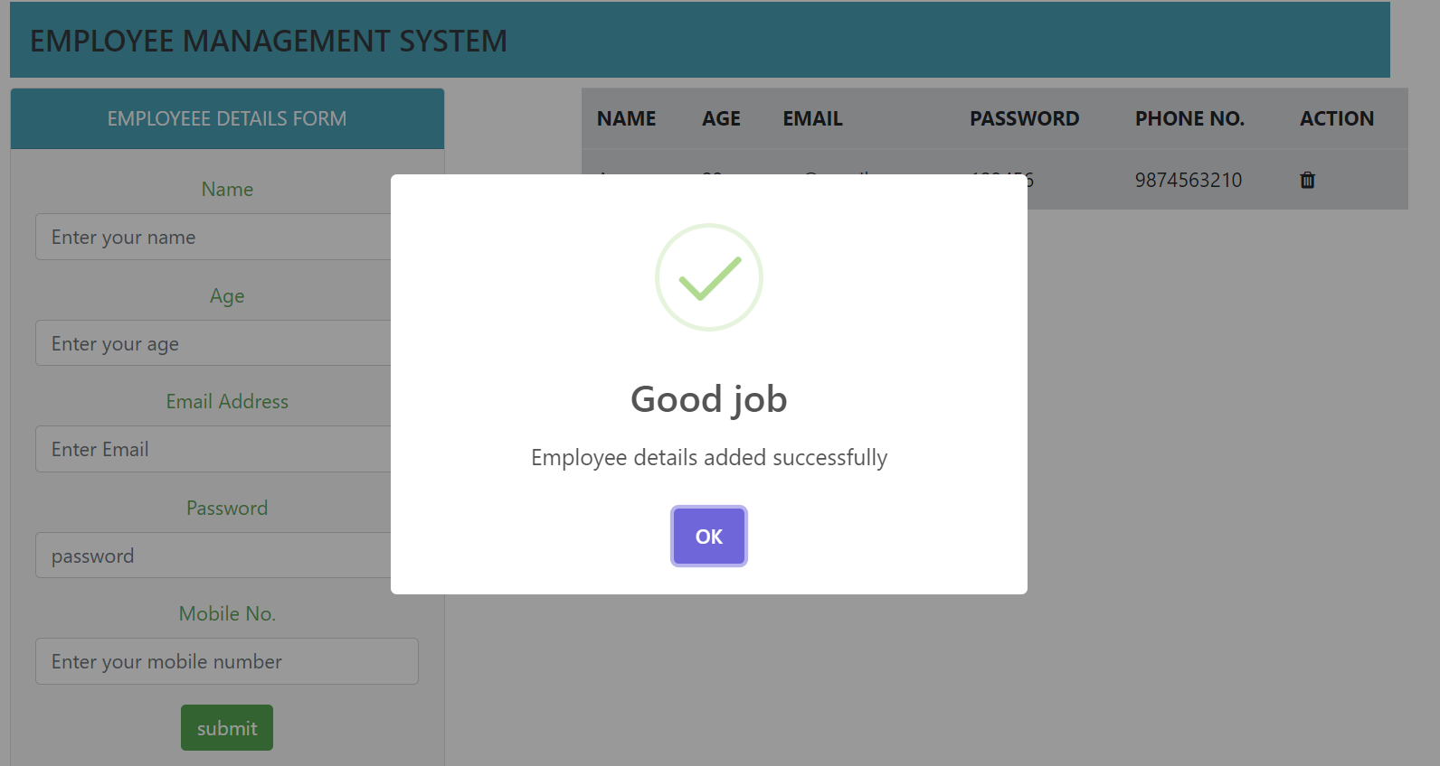

4. when the data is submitted it will be shown in the table at the same page.

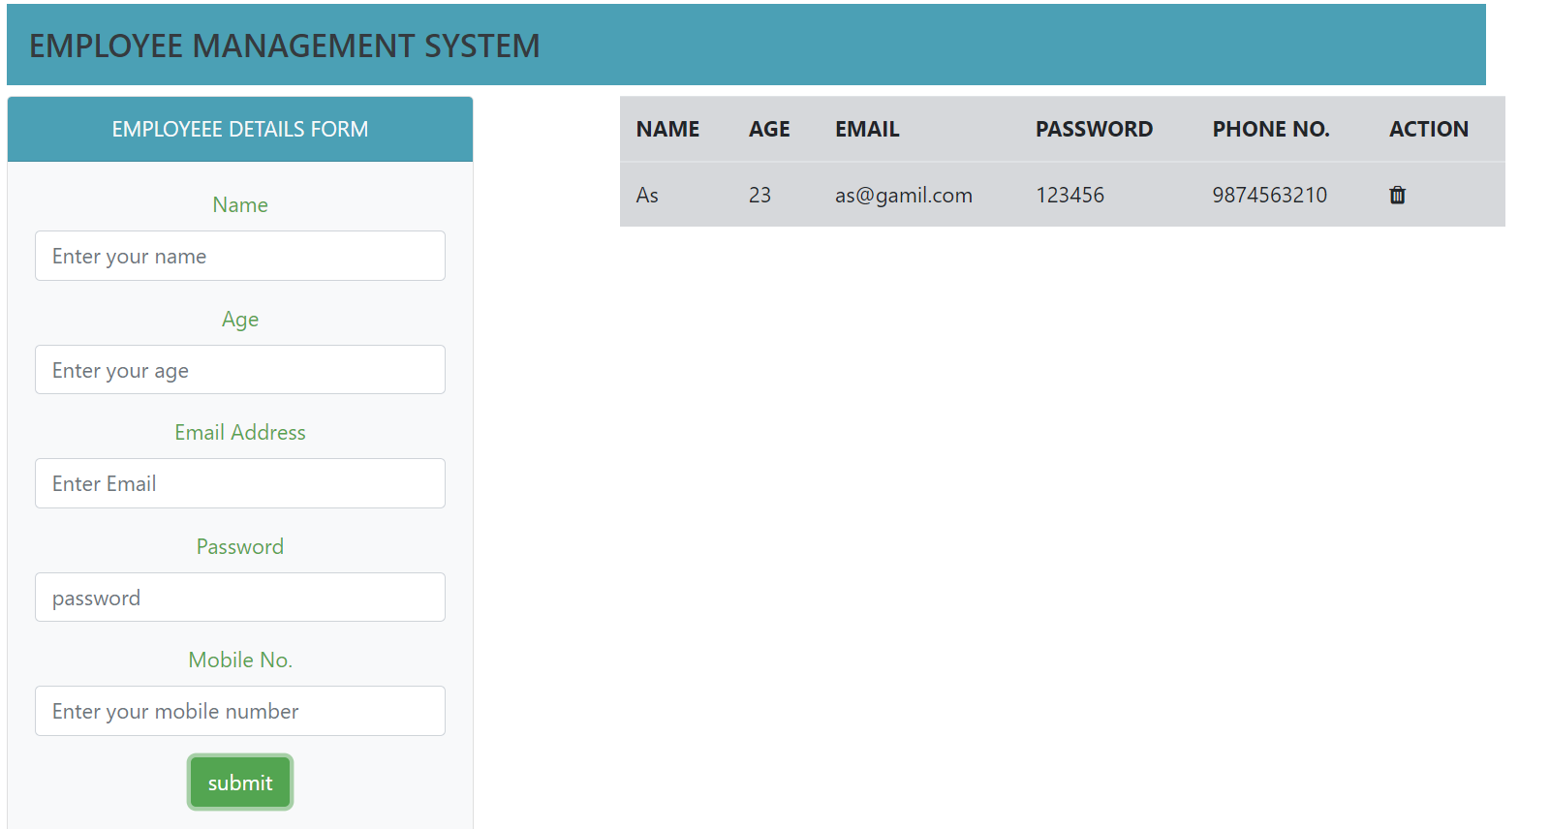

5. If user want to delete any record, then click on the delete button.

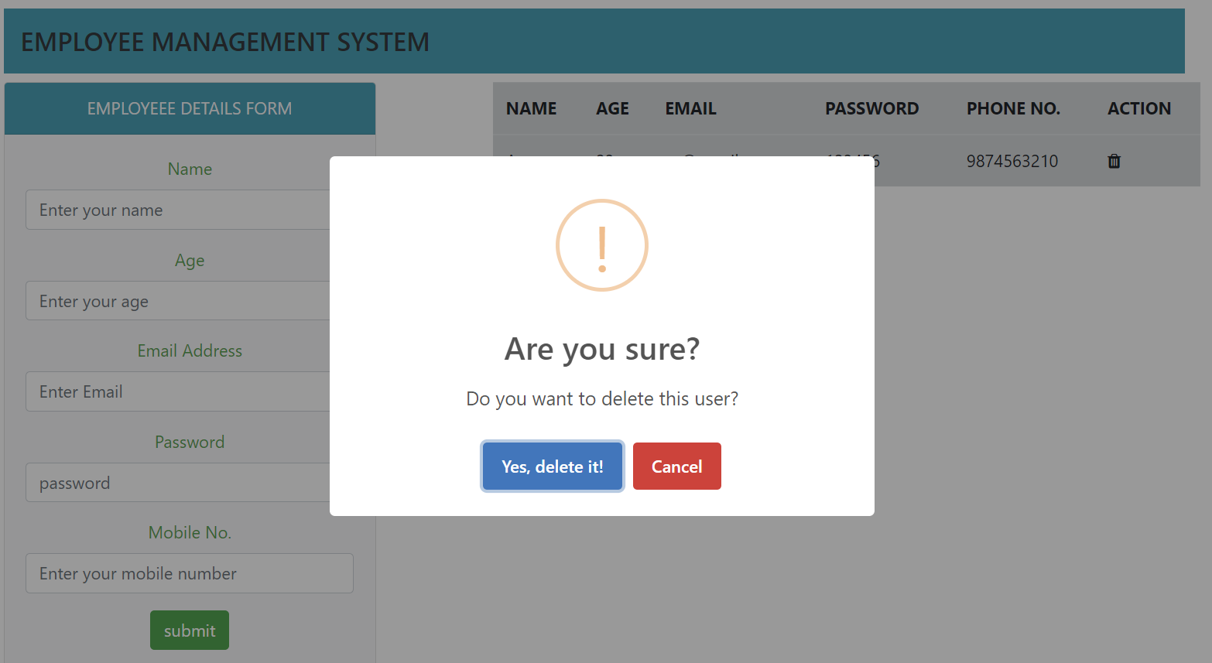

6. when user will click on **yes, delete it** the record from the table will be deleted.



**d. Topics/Technologies of JS Learned from this project**

* DOM Manipulation: Accessing and modifying HTML elements dynamically.
* Event Handling: Responding to user actions, such as button clicks.
* Form Validation: Checking user input for completeness and correctness.
* Asynchronous Operations: Assuming backend operations are asynchronous, as evidenced by the use of SweetAlert2 for displaying alerts.
* jQuery: A JavaScript library that simplifies DOM manipulation and event handling.

**e. GitHub URL**

**f. Roles and Responsibilities**

My roles and responsibilities in the development of the Employee Management System included:

* Frontend Development: Implementing the user interface using HTML, CSS, and JavaScript.
* Integration: Integrating Bootstrap for responsive design and SweetAlert2 for interactive alerts.
* Collaboration: Collaborating with the backend development team (assuming separate) to ensure smooth integration.

**g. Future Scope**

The Employee Management System has potential for further enhancements and features. Some ideas for the future scope of the project include:

* User Authentication: Implement user authentication to secure access to the system.
* Enhanced UI/UX: Improve the user interface for a more intuitive and visually appealing experience.
* Data Visualization: Incorporate charts and graphs to visualize employee data trends.
* Search and Filter: Add functionality to search and filter employee data for quicker access.
* Role-Based Access Control: Implement role-based access control to restrict certain functionalities based on user roles.

These enhancements aim to make the Employee Management System more robust, secure, and user-friendly, catering to the evolving needs of the organization.