MINI PROJECT - 2

RECORD MANAGEMENT SYSTEM

FINAL REPORT



Institute of Engineering & Technology

Submitted By :-

Astik Singh 181500158


Divyanshu Mittal 181500227

Submitted To :-

Mr. Pankaj Kapoor

(Assistant Professor)

ACKNOWLEDGEMENT

Presentation, inspiration and motivation have always played a key role in success of any venture.

I pay my deep sense of gratitude to Mr. Sharad Gupta Sir, who encouraged all our team members to the highest peak and provided us the opportunity to work on this project.

I would also like to express my sincere thanks to our project mentor and Assistant Professor Mr. Pankaj Kapoor Sir, who in spite of being busy with their duties, took time to give valuable advice and guidance throughout the development of this project. In addition, we are immensely obliged to our friends for their constant support, elevating inspiration and encouragement throughout this project.

Finally, I would also like to thank other faculty members who provided me with moral support during the course of this project.

Last, but not the least, our parents are also our inspiration. So, with due regards, we express our gratitude to them also.
ABSTRACT

Record Management System is a distributed application, developed to maintain the details of employees working in any organization. It maintains the information about the personal details of their employees, also the details about the payroll system which enable to generate the pay slip.

It is simple to understand and can be used by anyone who is not even familiar with simple employees system. It is user friendly and just asks the user to follow step by step operations by giving him few options. It is fast and can perform many operations.

This software package has been developed using PHP at Front End and MySQL Server at Back End. The software is very user friendly. The package contains different modules like Employee details. This version of the software has multi-user approach. For further enhancement or development of the package, user’s feedback will be considered.

CONTENTS

- INTRODUCTION

- OBJECTIVES AND SCOPE

- SYSTEM SPECIFICATION

- Requirement Analysis
- SRS
- Hardware and Software Requirements

- TOOLS AND PLATFORM USED

- SYSTEM DESIGN

- Data Flow Diagrams
- Design Phase
- Form Layouts

6. TESTING

7. IMPLEMENTATION, EVALUATION AND MAINTENANCE

8. CONCLUSION

9. BIBLIOGRAPHY

INTRODUCTION TO THE PROJECT

Employee Record Management system is an application that enables users to create and store Employee Records. The application also provides facilities of a payroll system which enables user to generate Pay slips too. This application is helpful to department of the organization which maintains data of employees related to an organization.
PHP is a server scripting language, and a powerful tool for making dynamic and interactive Web pages.
PHP is a widely-used, free, and efficient alternative to competitors such as Microsoft's ASP. Its created applications can be used on a standalone machine as well as on distributed network. More over applications developed in PHP can be extended to Internet based applications.
Thus PHP was chosen as background to design this application.

OBJECTIVE OF THE PROJECT

In this world of growing technologies everything has been computerized. With large number of work opportunities the Human workforce has increased. Thus there is a need of a system which can handle the data of such a large number of employees in an organization. This project simplifies the task of maintaining the records due to its user friendly nature.

SYSTEM SPECIFICATIONS

Software Engineers have been trying various tools, methods and procedures to control the process of software development in order to build high quality software with high productivity. This method provides “how it is” for building the software while the tools provide automated or semi automated support for the methods. They are used in all stages of software development process, namely, planning, analysis, design, development and maintenance. The software development procedure integrates the methods and tools together and enables rational and timely development of the software system.
Software Development
Procedures
Methods
Tools

A successful system must: -

- Satisfy the user requirements
- Be easy to understand by user and operator
- Be easy to operate
- Have a good user interface
- Be easy to modify
- Be expandable
- Have adequate security control against the misuse of data
- Handle the errors and exceptions satisfactorily
- Be delivered on schedule within the budget

Software Life Cycle Model

The series of stages depicting the various tasks involved in development process is called Software Life Cycle Model. The model implemented by us is Waterfall Model, which is most widely used in procedure-oriented development. This model attempts to break up the identifiable activities into series of actions, each of which must be completed before the next begins. The activities include problem definition, requirement analysis, design, coding, testing, maintenance. Further refinements to this model include iteration back to previous stages in order to incorporate any changes or missing links.
The phases and the outputs of the waterfall model at each phase are summarized below in tabular format.

PHASE | Output
Problem Description | Feasibility Report
Analysis | SRS
Design | Detailed Design Report
Coding | Complete Source Code
Testing | Test plan, report and manual
Installation | Installation Report

Problem Definition
Analysis
Testing
Coding
Design

Maintenance

ITERATIVE WATERFALL MODEL

Software development life cycle process specifies a method of developing the software. Each software development projects starts with some needs and ends with some software that satisfies those needs. A software development life cycle specifies the set of activities that should be preformed to go from user needs to final products. There are different models of SDLC process and each model specifies the activities and the order in which they should be preformed. Depending on the nature of project, a suitable model is chosen and the entire process of software requirement analysis, design, coding, testing and maintenance is preformed accordingly.

Various life cycle models are present, but our system is based on WATER FALL MODEL, which is most widely used in procedure oriented development. This model attempts to break up the identifiable activities into series of action, each of which must be completed before the next begins. The activities include Problem definition, Requirement Analysis, Design, Coding, Testing and maintenance.

An initial investigation culminates in a proposal that determines whether a system is feasible or not. It determines its workability, impact on the organization, ability to meet user needs, and effective user resources. The objective of feasibility study is not solving the problem but to acquire a sense of its scope. During the study, the problem definition is crystallized and aspects of the problem to be included in the system are determined. Consequently, cost and benefits are estimated with greater accuracy at this stage. This is a bridge in between the User Requirements and the output that he can avail under a set of given constraints, inputs and outputs.

The main steps are:

. Statement of constraints
. Identification of specific system objectives
. Description of outputs

SOFTWARE REQUIREMENT SPECIFICATION (SRS)

The aim of the system is to develope “EMPLOYEE RECORD MANAGEMENT SYSTEM” software, which should automate the process to create and store employee details. The system is supposed to be used as a subsystem in a large office system, which could be manual system or a computerized one. Therefore, the proposed system must be able to function under both circumstances.
The proposed system is not a freeware and due to the usage of swings, becomes user interactive.
- The project demand a page of employee details that include:
- Employee’s personal details.
- Employee’s salary, allowances, deductions.

Software Requirements

- Operating System - Windows 7 or above

- Developing Language - PHP, HTML, CSS, JAVASCRIPT

- DATABASE - MySQL

TOOLS AND PLATFORM USED

Front End:

The programming has been done using the language PHP an. It is easy to use, efficient and flexible. This language is preferred because one can build a program with less effort than with any other programming language. It’s a natural language for building database applications, owing to the level and sophistication of the tools included with the language.

Back End:

MySQL Server is one of the leading database management systems available on the market today. It is easy to use and administer, and it comes with tools and wizards that make it easy to develop applications. The database itself has been redesigned to automatically perform many tuning functions, leaving you free to focus on most important tasks.

Platform Used:

The Accounts Automation System is targeted at Microsoft Windows platforms.

WINDOWS 10

Windows (Operating System)

- Window derived from its name from the on-screen “WINDOWS” that it used to display information.

- Windows 10 is a multi-user operating system.

- When a computer is switch on for working, it needs the operating system because all the activities of a system are supervised by the operating system.

The features of the operating system are:-

  - Provides an interactive environment.

  - Graphical user interfaces.

- The Commands are displayed on the screen and we don’t have to remember all commands.
- GUI makes it easy to work with disks and directories. It can display tree like diagram of directories, directories sub-0 directories on hard disk.

  - Point and Click.

  - User friendly.

SYSTEM DESIGN

Process Diagram
LOGIN SCREEN
ADD EMPLOYEE
MENU SCREEN
VIEW DETAILS
Name
EMPLOYEE LIST
EXIT
Address
Experience
Post
Salary
Edit
BACK
OK

DELETE

DATA FLOW DIAGRAMS

LEVEL 0 DFD:

AddEmp Operator EmpDetail Operator

Emp info Emp detail Modification
Entry

Administrator
EMS

For login user, password Emp Payroll SliGeneration

Emp detail report
Generation
EmpList Exit

ENTITY RELATIONSHIP DIAGRAM:

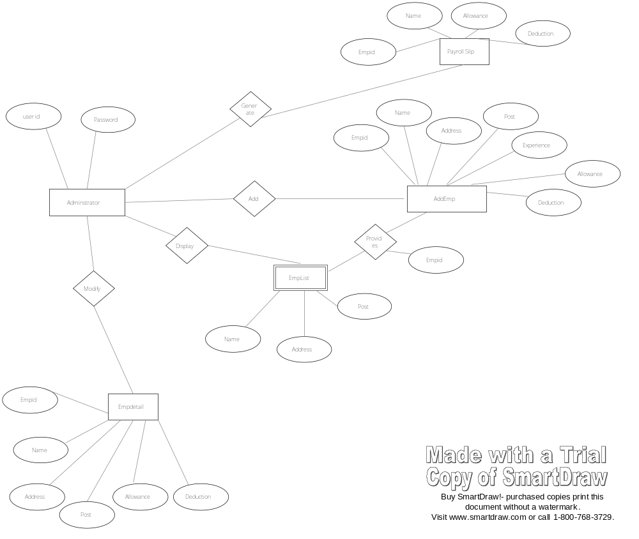

FORMS LAYOUT

Package employeeManagement

Class Summary
AddEmp | This class provides code for Addition of Employee to the Firm
EmpDetail | Provides code to view Employee Details and also to Delete/Modify Accounts
EmpList | Provides the code to show the List of employees in the Firm
EmpSlip | Provides codes for Salary Slip Generation
Intro | Contains code for Welcome/Login Page of the project
Main | The Base class which has the code to show the First/Login Screen
Menuscrn | This class has code which represents the Screen which shows the Buttons for Selection of Different Tasks

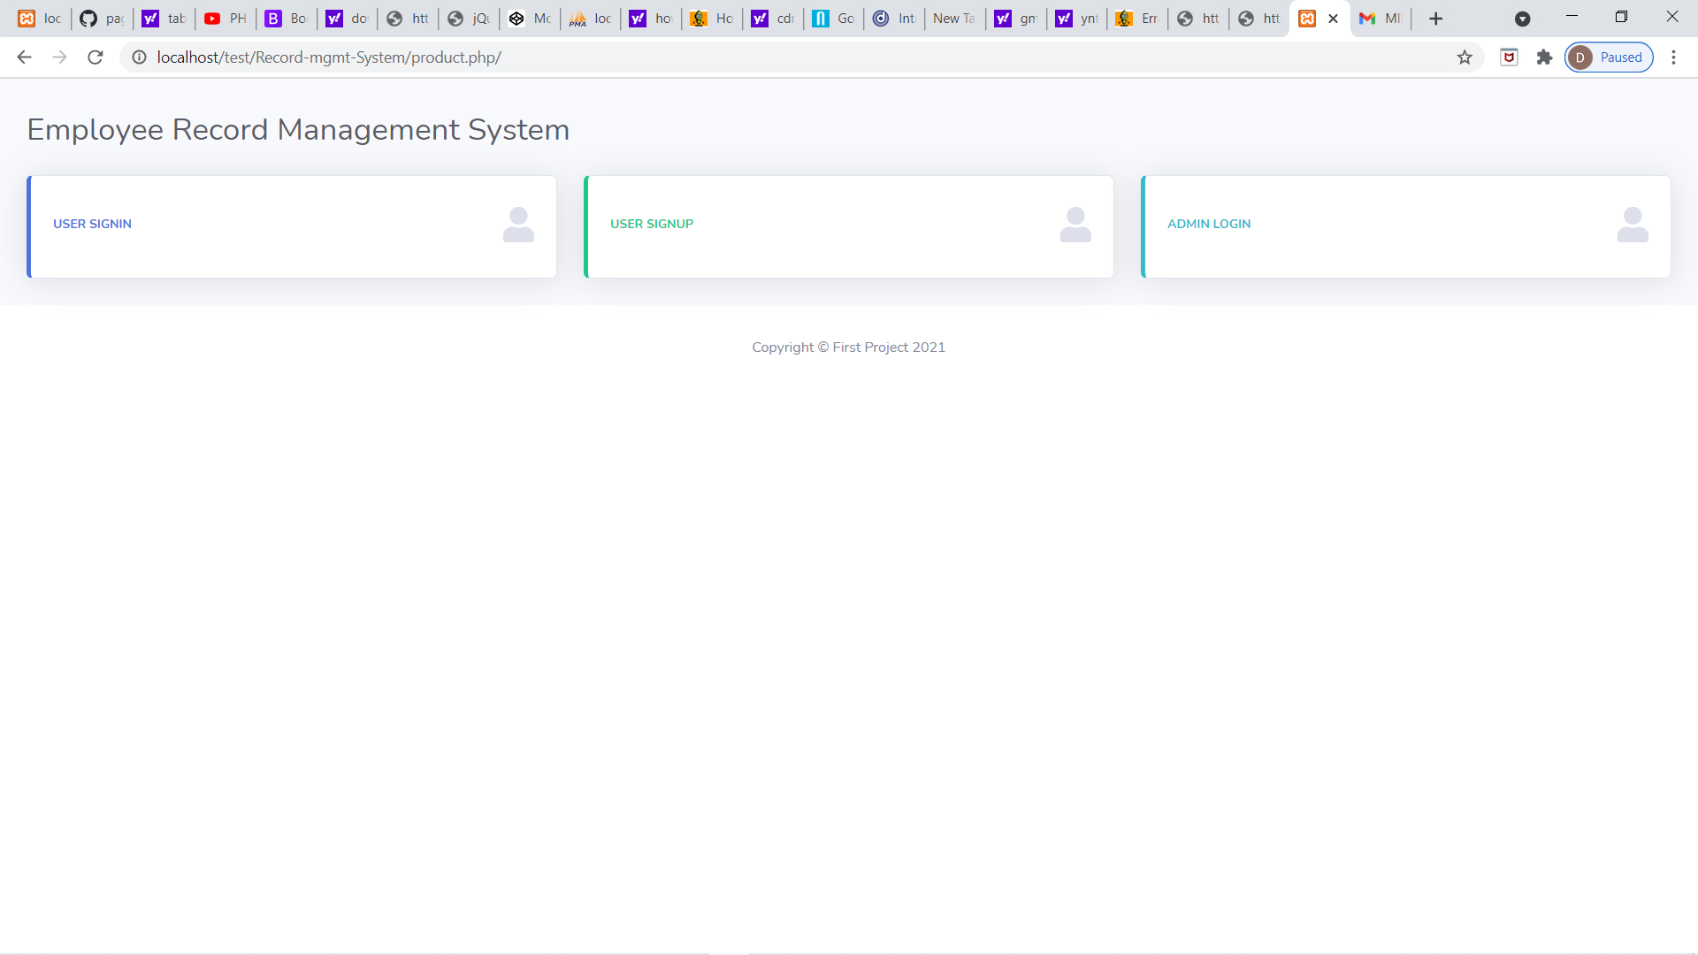

Contains code for username /Password Authentication. When user enters correct login and password It opens Main form otherwise it gives an error message. You can exit by clicking the “X” button on the right top corner of the window.

Press Admin Login button to Login request as Admin and can manage records.
Press User Signin button to Login request as Employee and can manage our own records.
Press User Signup button to to create new employee account.

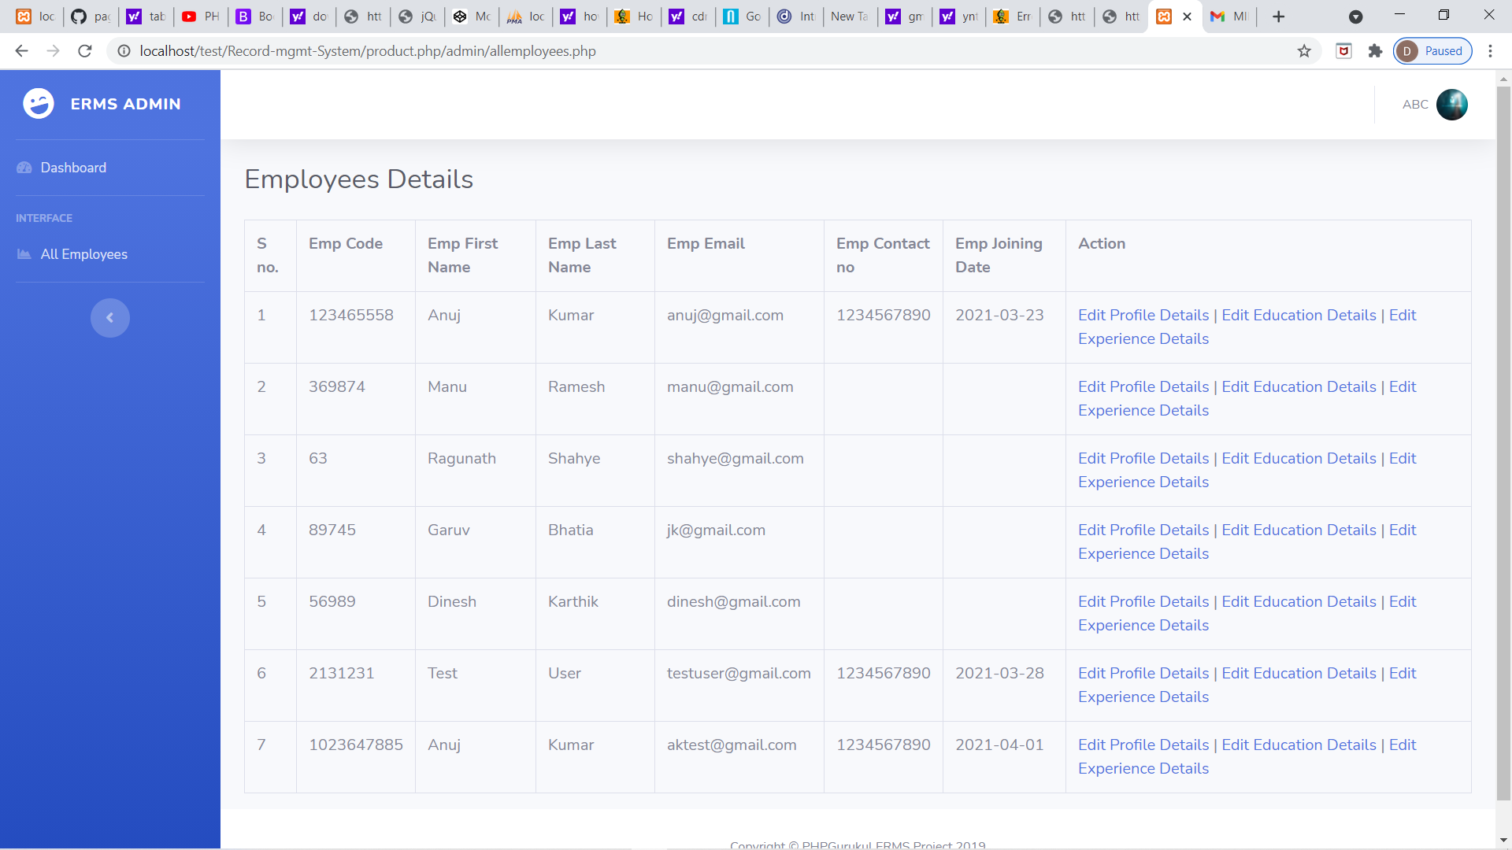

Using Add employee you can add employee . Clicking on user signin it opens the add employee window.

Clicking on Employee List shows the list of employees in the firm. It calls the EmpList .

By Clicking onEdit Prifile Details / Edit Education Details / Edit Experience Details of the employees. It calls EmpDetail.

On clicking Logout The Application exits.

Note: You cannot exit using Logout button in this window.

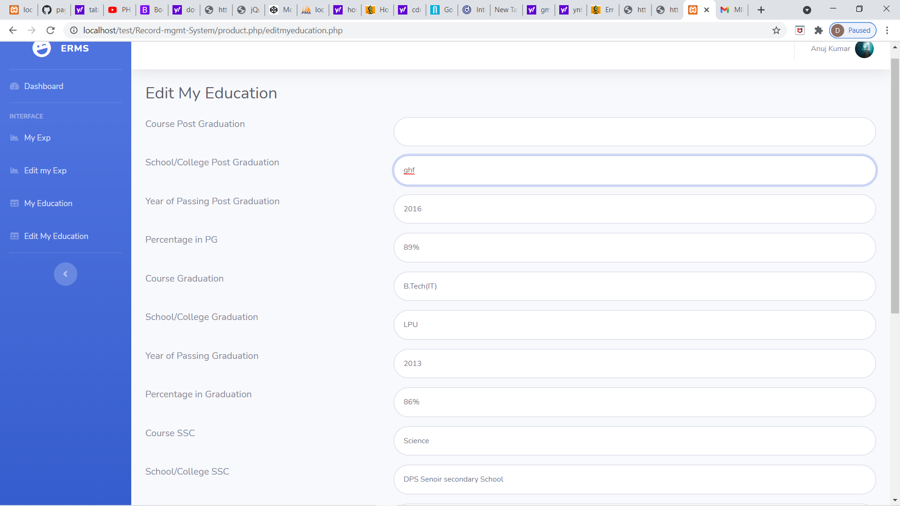

Clicking over any particular field to edit particular details.

Clicking Submit submits the records.

Clicking Clear Clears the Fields

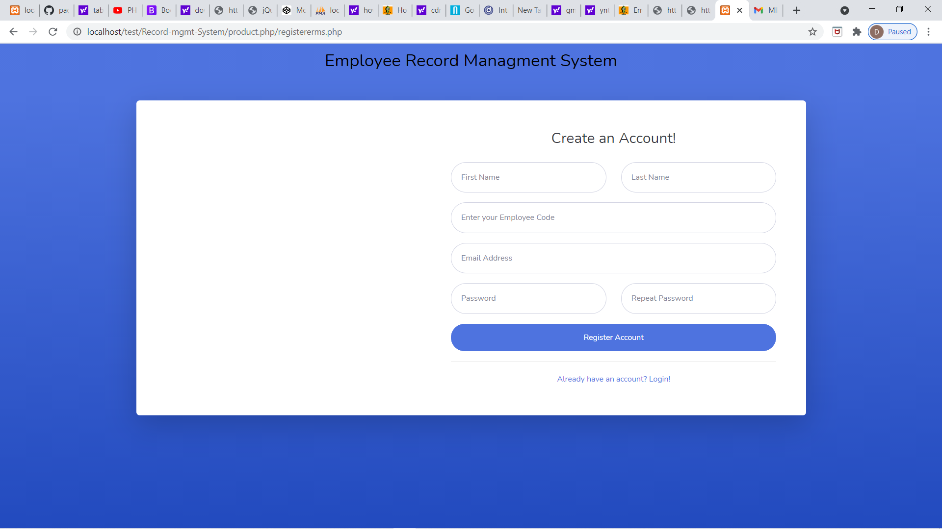

After filling all the details in these new employee can make their account and can manage thir own records.

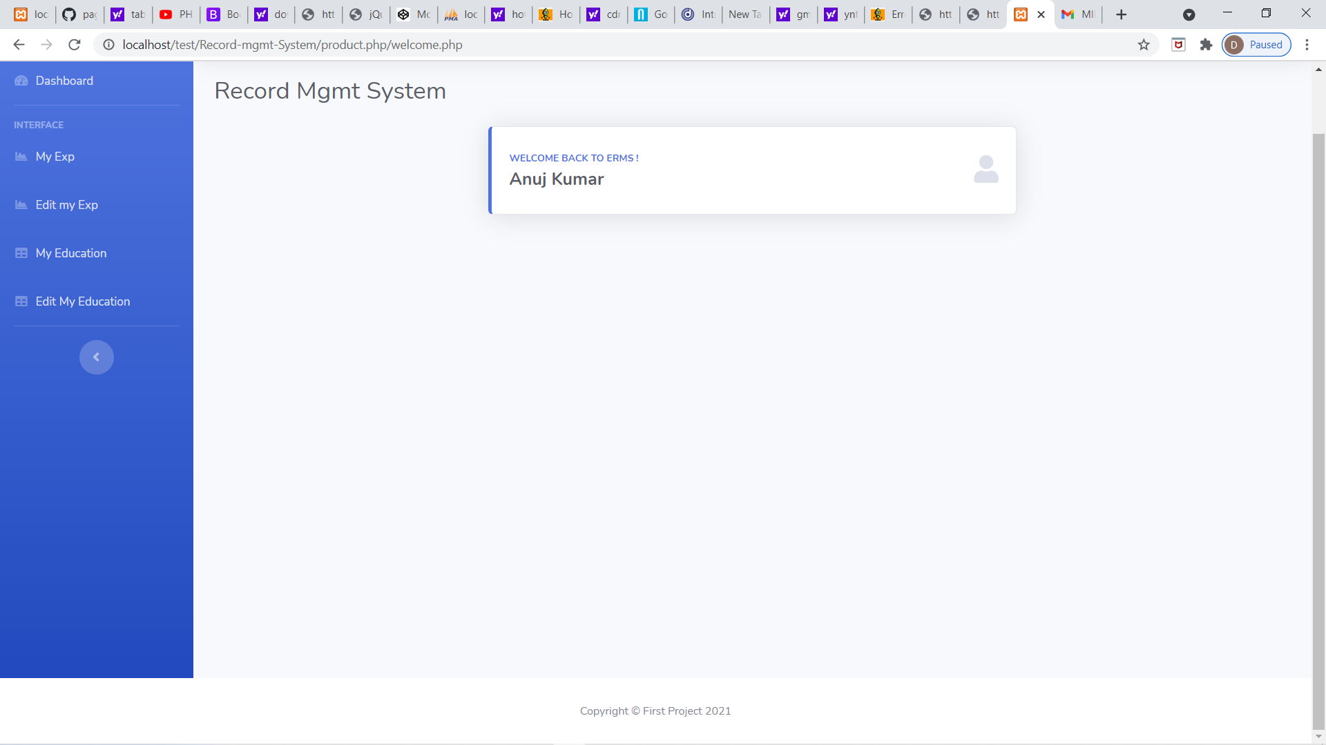

This is a dashboard of a particular who successfully created their account and can manage all her details and can see their salary

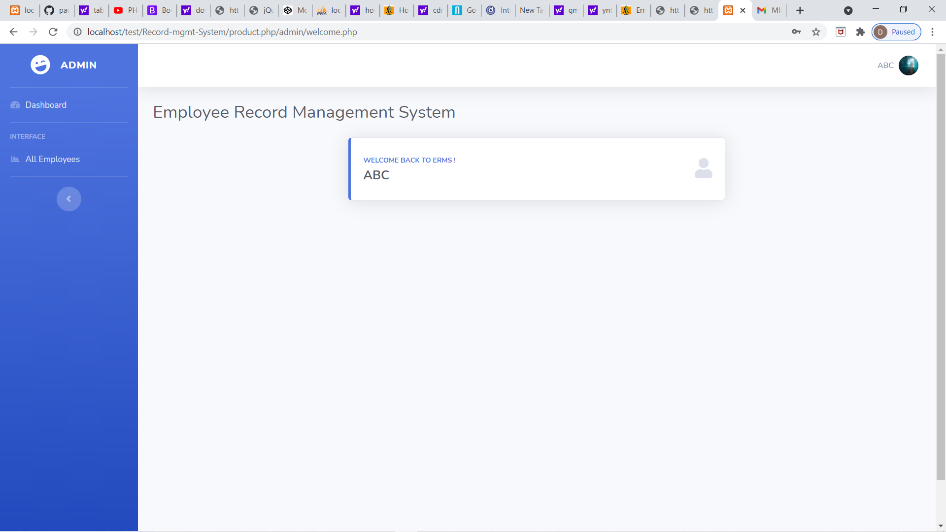

This is a dashboard for admin and he can manage and can see all employee details and manage their account and can manage their salary of all employees.

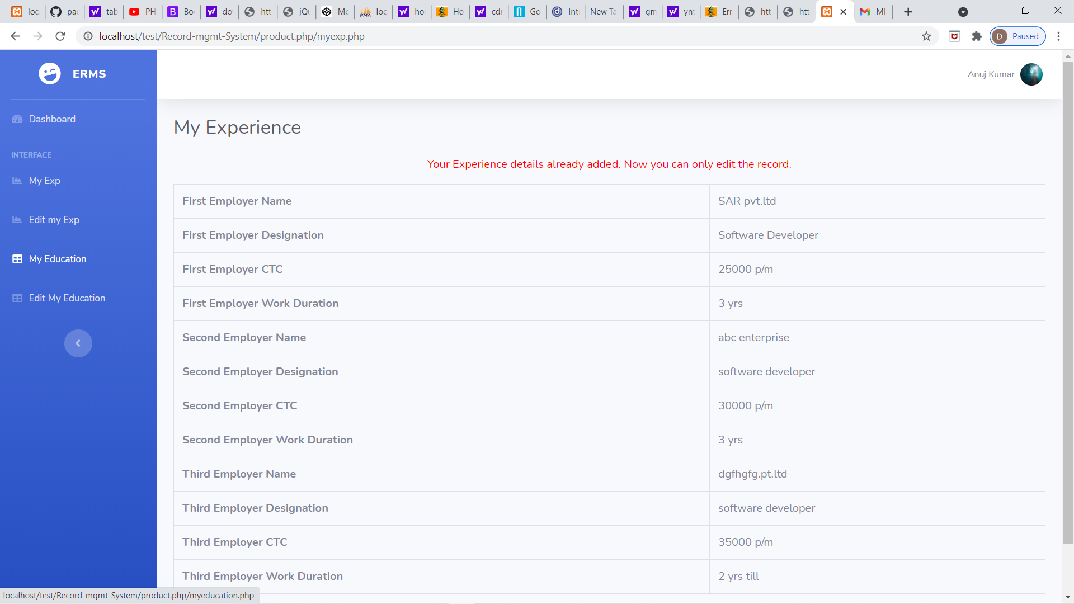

After save your details you can also edit them.

Press Back to go back after compltere

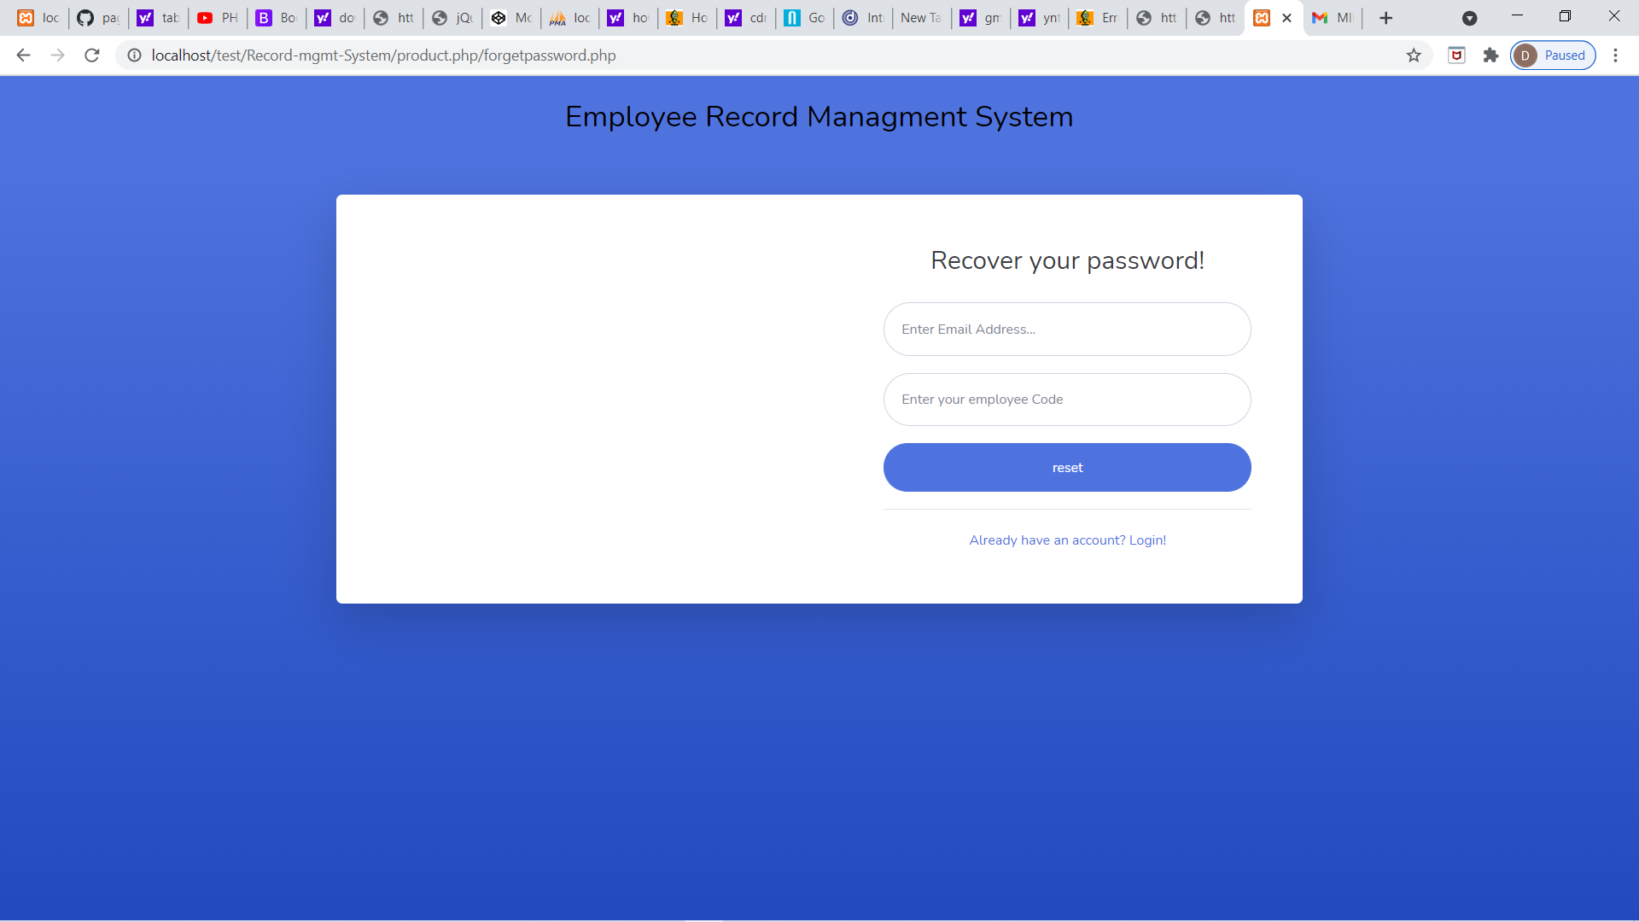

If any employee forgot then he/she can recover their password by their email id and can employee code given by compony and press Reset.

SYSTEM TESTING

During systems testing, the system is used experimentally to ensure that the software does not fail. In other words, we can say that it will run according to its specifications and in the way users expect. Special test data are input for processing, and the results examined. A limited number of users may be allowed to use the system so that analyst can see whether they try to use it in unforeseen ways. It is desirable to discover any surprises before the organization implements the system and depends on it.

Software modules are tested for their functionality as per the requirements identified during the requirements analysis phase. To test the functionality of the file transfer and chat application, a Quality Assurance (QA) team is formed. The requirements identified during the requirements analysis phase are submitted to the QA team. In this phase the QA team tests the application for these requirements. The development team submits a test case report to the QA team so that the application can be tested in the various possible scenarios.

The software development project, errors can be injected at any stage during development i.e. if there is an error injected in the design phase then it can be detected in the coding phase because there is the product to be executed ultimately on the machine, so we employ a testing process.

During the testing the program to be tested is executed with certain test cases and output of these test cases is evaluated to check the correctness of the program. It is the testing that performs first step in determining the errors in the program.

Test Cases and Test Criteria

During Test Cases that are good at revealing the presence of faults is central to successful testing. The reason for this is that if there is a fault in the program, the program can still provide the expected behavior on the certain inputs. Only for the set of inputs the faults that exercise the fault in the program will the output of the program devise from the expected behavior. Hence, it is fair to say that testing is as good as its test case.

The number of test cases used to determine errors in the program should be minimum. There are two fundamental goals of a practical testing activity:-
- maximize the number of errors detected and,
- minimize the number of test cases.

As these two goals are contradictory so the problem of selecting test cases is a complex one. While selecting the test cases the primary objective is to ensure that if there is an error or fault in the program, it is exercised by one of its test cases. An ideal test case is one which succeeds (meaning that there are no errors, revealed in its execution) only it there are no errors in the program one possible set of ideal test cases is one which includes all the possible inputs to the program. This is often called "exhaustive testing", however it is impractical and infeasible as even a small program can have an infinite input domain.

So to avoid this problem we use "test criteria" in selection of the test cases. There are two aspects of the test case selection:-

- specifying a criteria for evaluating the test cases
- generating the set of cases that satisfy a given criteria.

The fully automated process of generating test criteria has not been yet found rather guidelines are only the automated tool available to us previously. The two fundamental properties for a testing criterion are:-

- Reliability:- a criterion is reliable if all the sets that satisfy the criteria detect the same error. .
- Validity :- a criterion is valid if for any error in the program there is some set satisfying the criteria that will reveal the error.

The fundamental theorem of testing is that if a testing criterion is valid and reliable, if a set satisfying criteria succeeds then the program contains no errors.

Approaches oF Testing

There are two fundamental approaches of testing:

Functional Testing/Black Box Testing:

In functional testing the structure of the program is not considered. Test cases are solely determined on the basis of requirement or specification of the program or module. Internals of the modules and the programs are not considered for selection of test cases. Due to this nature it is also called "black box testing".

The most obvious functional testing procedure is "exhaustive testing", which is impractical.

The other criteria for generating the test case are to generate them "randomly" this strategy has a little chance of resulting in a test case that is close to optimal.

There is no appropriate criterion for developing the test case so we have certain heuristic approaches:-

a) Equivalence Class Partitioning: in which the domain of all inputs is divided into a set of equivalence classes, so that if any test in that class succeeds, then every test in that class will succeed i.e. the success of one set element implies the success of the other.

b) Boundary Value Analysis: It has been observed that programs work correctly for a set of values in an equivalence class fail on certain values. These values generally lie on the boundary of equivalence class. So in the boundary value analysis we chose an input for a test case from an equivalence class, such that input lies on the edge of equivalence class. Boundary value test cases are also called "extreme cases".

c) Cause-Effect Graphing: The problem with the prior approaches is that they consider each input separately i.e. both concentrate on classes and conditions of one input. The combination of inputs is not considered which is used in many cases. One way to exercise the combination of various input conditions is to consider all the valid combinations of the equivalence class of the input conditions. The technique starts with identifying the causes and the effect of system under testing.

Structural Testing:

In the structural approach the test cases are generated an the basis of the actual code of the program or the module to be tested, This structural approach is sometimes called "glass box testing". This testing is concerned with the implementation of the program. The content is not to exercise the various input conditions rather different programming structures and data structures used in the program.

There are three different approaches to structural testing they are- :

Control flow based criteria:-

Most common structure based criteria use control flow based testing in which the control flow graph of the program is considered and coverage of various aspects of graph are specified as criteria. The various control flow based strategies are
- statement coverage,
- branch coverage and
- all path coverage

b) Data Flow based testing:-

The basic idea behind the data flow based testing is to make sure that during testing, the definitions of variables and their subsequent use is tested. To implement the data flow based testing the data flow graph is first made from the control flow graph.

Mutation Testing:-

In the above two testing techniques the focus is on which path to be executed, but mutation testing is not a path-based approach. The mutation testing requires that the set of test cases must be such that they can distinguish between the original programs and is mutants. In software world there is no fault model as in hardware so most of the techniques do guess work regarding where the fault must lie and then select the test cases to reveal those faults. In Mutation testing faults of some pre-decided types are introduced in the program being tested. Then those faults are found in the mutants.

Implementation, Evaluation And Testing

Implementation is the process of having systems personnel check out and put new equipment into use, train users, install the new application and construct any files of data needed to use it. This phase is less creative than system design. Depending on the size of the organization that will be involved in using the application and the risk involved in its use, systems developers may choose to test the operation in only one area of the firm with only one or two persons. Sometimes, they will run both old and new system in parallel way to compare the results. In still other situations, system developers stop using the old system one day and start using the new one the next.

Evaluation of the system is performed to identify its strengths and weaknesses. The actual evaluation can occur along any of the following dimensions:

- Operational Evaluation: Assessment of the manner in which the system functions, including case of use, response time, overall reliability and level of utilization.

- Organizational Impact: Identification and measurement of benefits to the organization in such areas as financial concerns, operational efficiency and competitive impact.

- User Manager Assessment: Evaluation of the attitudes of senior and user manager within the organization, as well as end-users.

- Development Performance: Evaluation of the development process in accordance with such yardsticks as overall development time and effort, conformance to budgets and standards and other project management criteria.

Maintenance is necessary to eliminate errors in the working system during its working life and to tune the system to any variations in its working environment often small system deficiencies are found as a system is brought into operations and changes are made to remove them. System planners must always plan for resource availability to carry out these maintenance functions. The importance of maintenance is to continue to bring the new system to standards.

CONCLUSION

Since this project has been designed exclusively as a project, certain complexities that we do face by any real life manual problem like total no. of employee, address redundancy etc. are considered in this project. But enhancement to the project can easily be made without changing the current design and programming structure.

BIBLIOGRAPHY

  - WWW.GOOGLE.COM
  - WWW.WIKIPEDIA.COM
  - WWW.W3Schools.COM

