## Challenge - GOT Snapchat Filter?

## GOT Snapchat Filter?

#### Making cool face filters for GOT Characters & yourself!

In this problem, you will be building snapchat like face filters - eyeglasses and moustache for popular Game Of Throne Characters Tyrion Lannister and Jaime.

You will be given an input image and two image templates(one for sunglasses & moustache , you task is to overlay the eyeglasses and moustache on the given character. A sample input output is show below. To detect the facial keypoints like position of eyes and nose, we also provide you with haarcascade xml files in the training data. 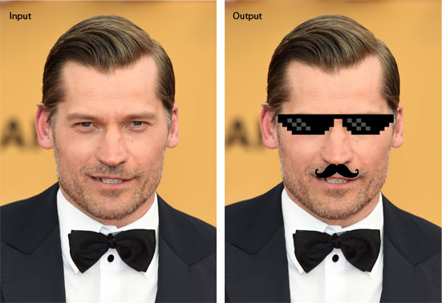

**Bonus** - Try to place these filters in LIVE stream taken from your webcam and display it :)

**Submission Format** For the given input image, submit a CSV file where each ith row contains the RGB pixel values for the ith pixel of modified image.

## Scoring

Total score will be based upon percentage of pixel values correctly predicted. You should flatten the image into shape(-1,3) before creating CSV.