ASSIGNMENT

Name: Astitva Sharma

Class: Bca IB

Q1)**Create a table called employee with the following structure?**

**a. Add a column commission with domain to the Employee table.**

**b. Insert any five records into the table.**

**c. Update the column details of job**

**d. Rename the column of Employ table using alter command.**

**e. Delete the employee whose empno is 19.**

Ans1)

Create table employee



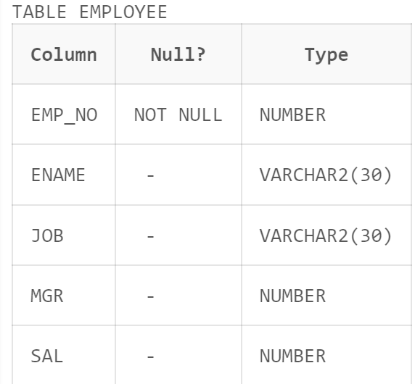

b.Insert any five records into the table.

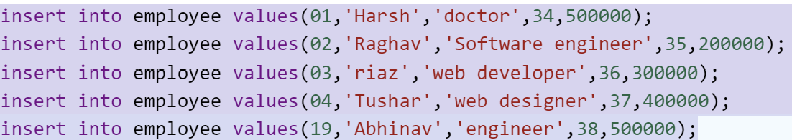

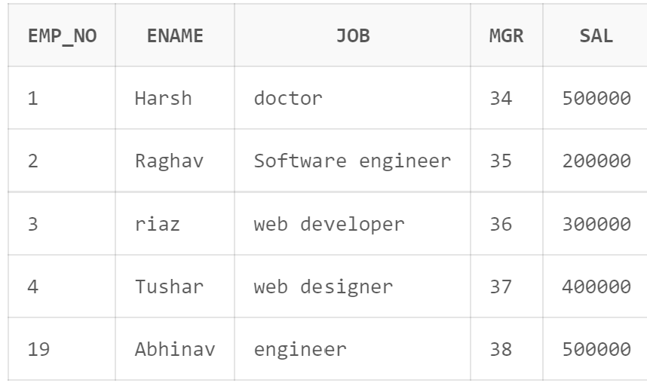

1. **Add a column commission with domain to the Employee table.**

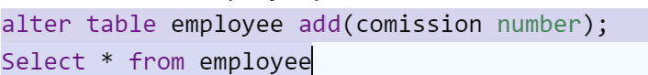

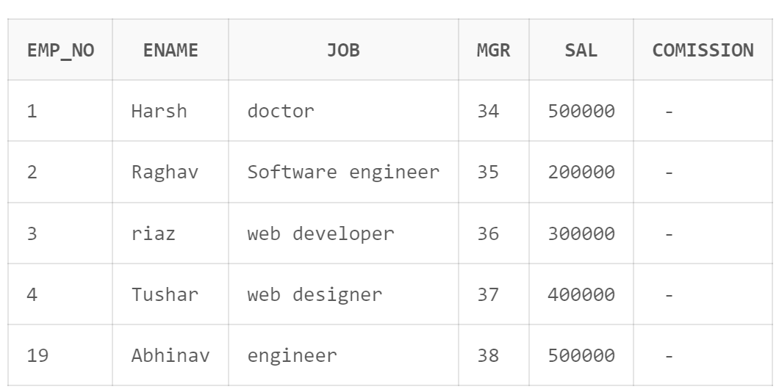

**c.Update the column details of job**



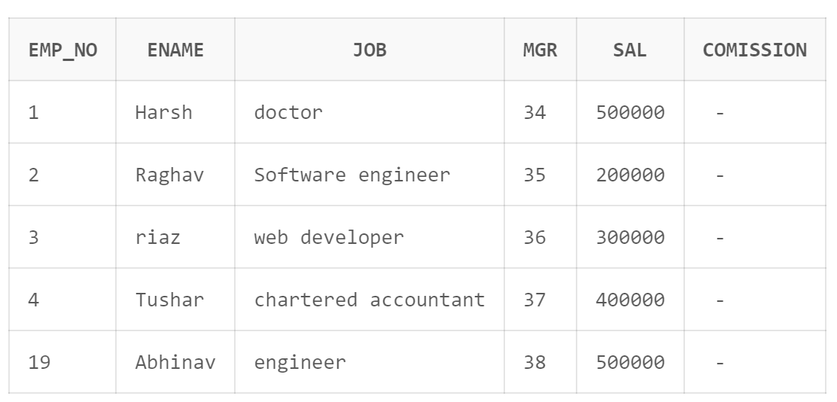

**d.**

**Rename the column of Employ table using alter command.**



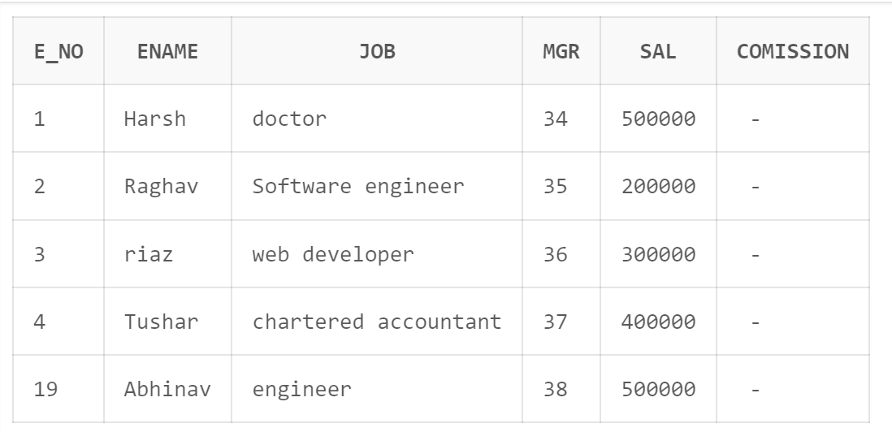

**e. Delete the employee whose empno is 19.**

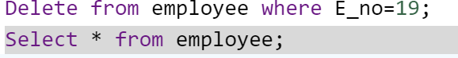

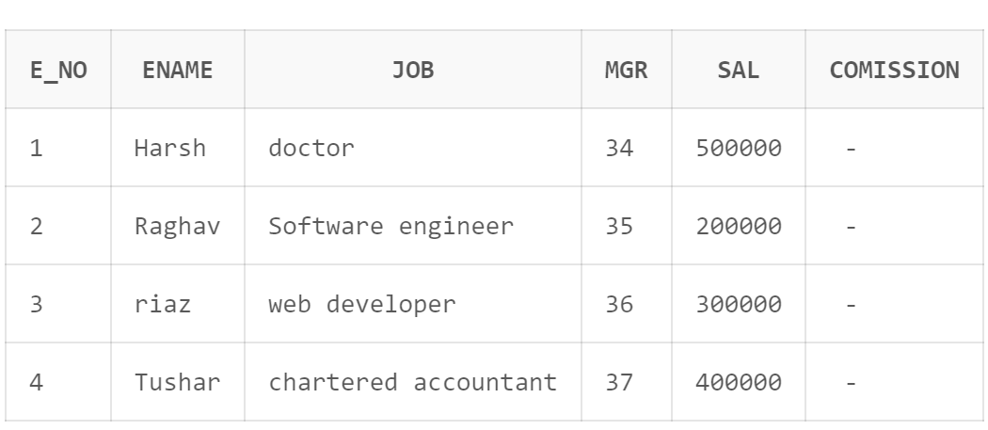

**Q2) Create department table with the following structure?**

**1.add table designation to the department table.**

**2. insert values into the table**

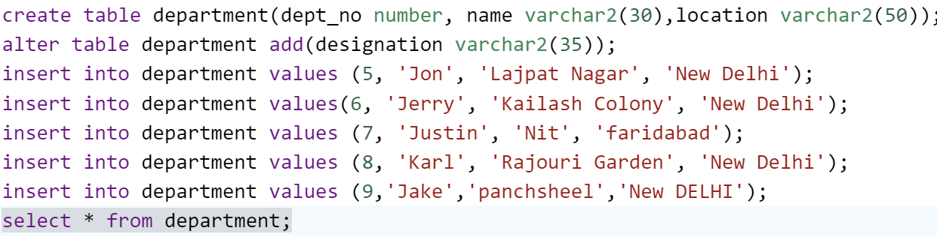

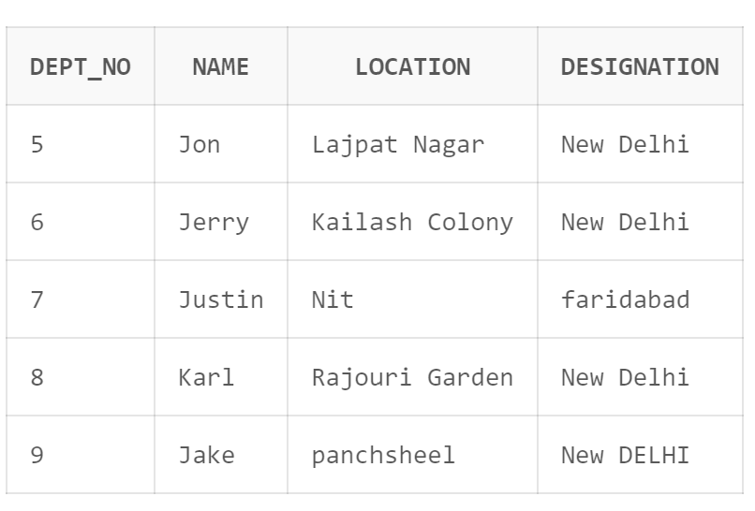

**3.list the table of department list by department no.**



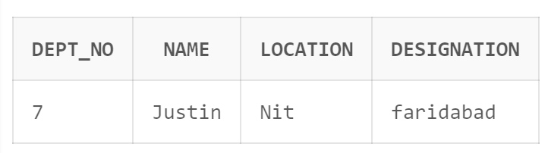

**4.update the record where department no is 9.**



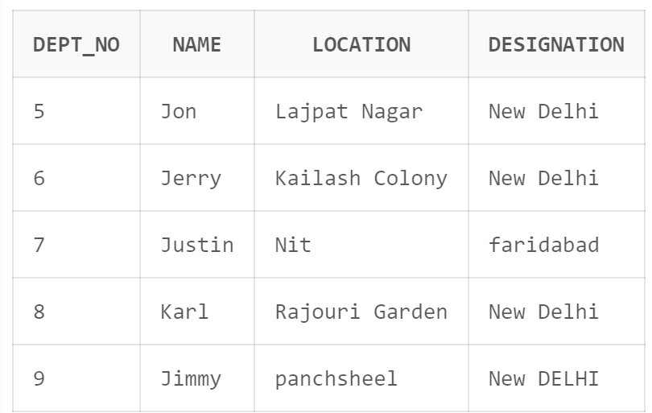

**5.** **Delete any column data from table.**

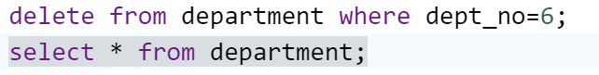

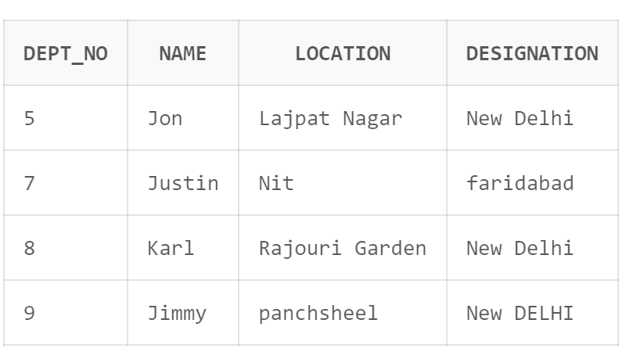

**Q3)Create a table called customer table.**



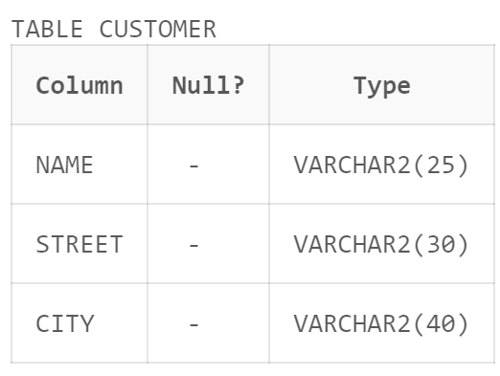

1. **Insert records into the table.**

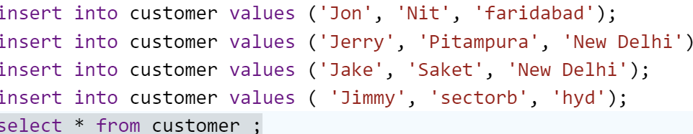

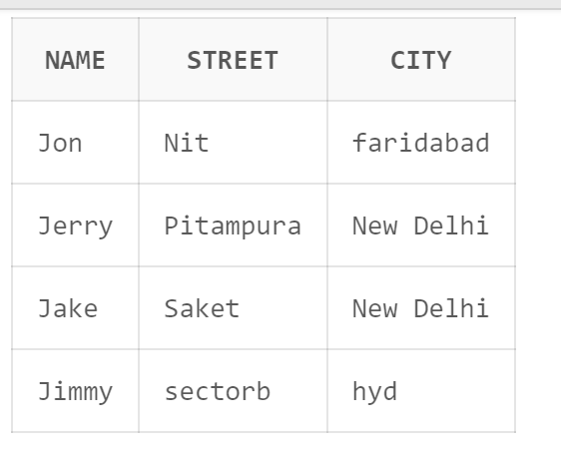

**C)Alter the table column domain.**



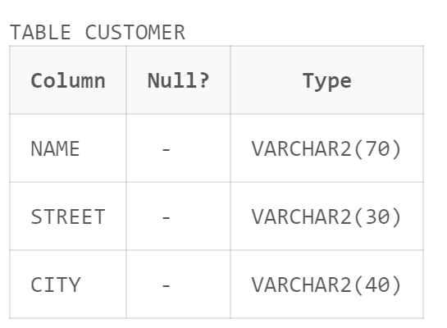

**d)Drop salary column of the customer table.**

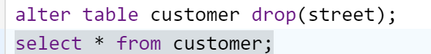

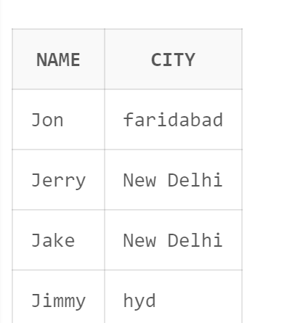

**e)Delete the rows of customer table whose cust_city is 'hyd'.**

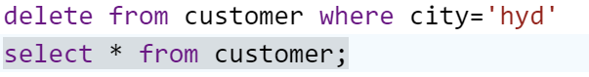

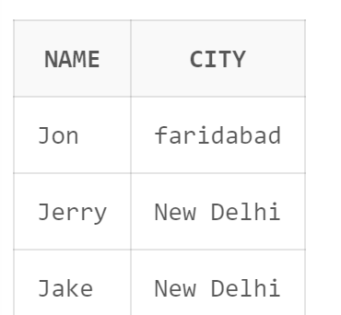

**Q4)Create a table called branch table.**

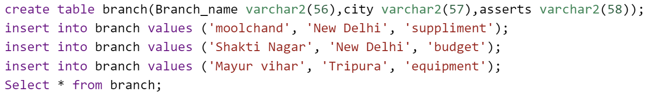

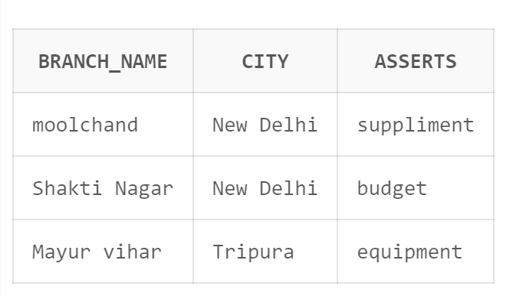

**c)Increase the size of data type for asserts to the branch.**

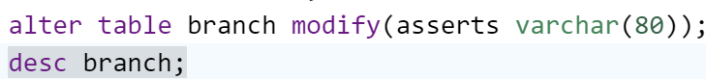

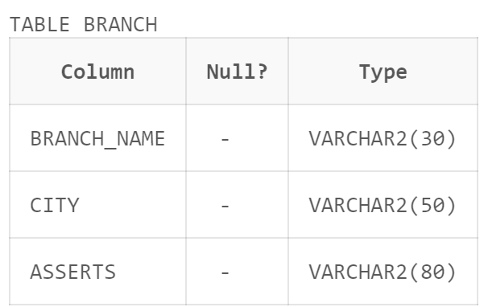

**b)Add and drop a column to the branch table.**

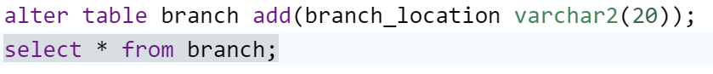

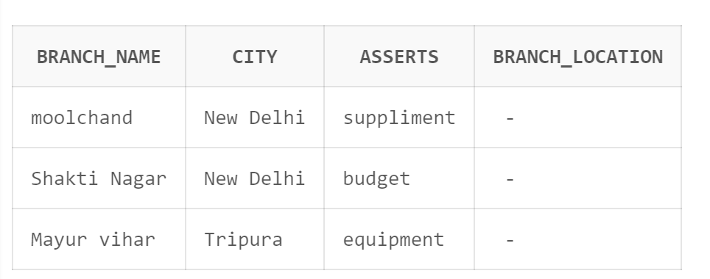

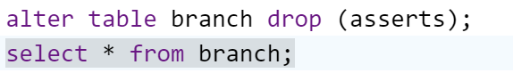

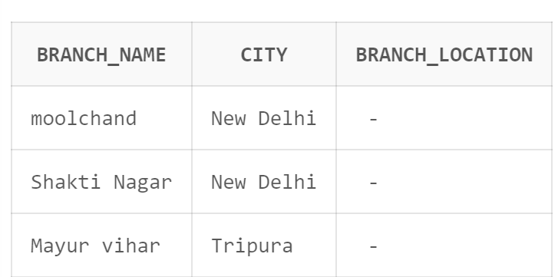

**c)Insert values to the table.**





**d)Update the branch name column.**



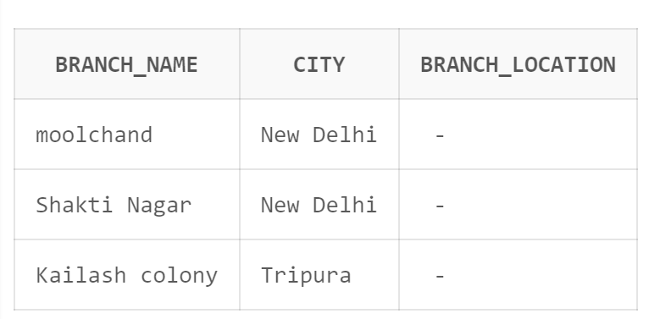

**e)Delete any two columns from the table.**



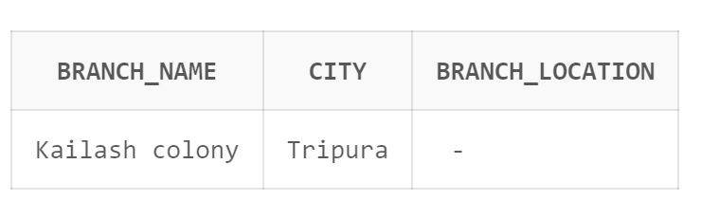

**Q5)Create a table called sailor table?**

**a)Add column age to the sailor table.**

**b)** **Insert values into the sailor table.**

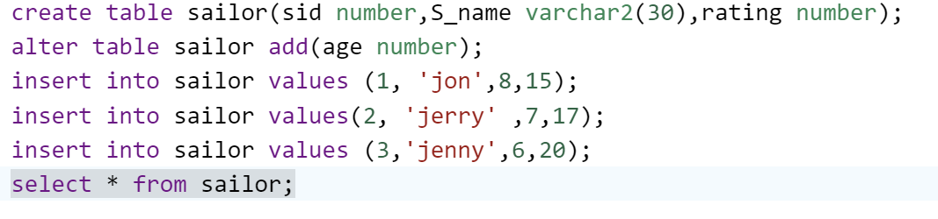

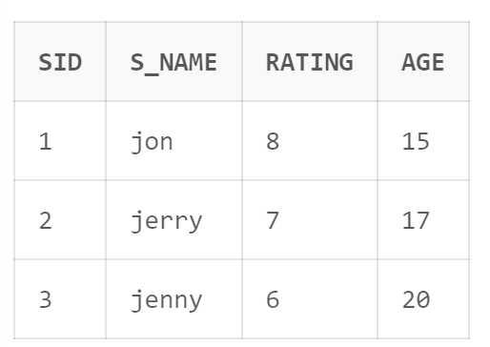

**c)Delete the row with rating >8.**

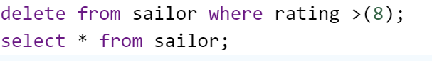

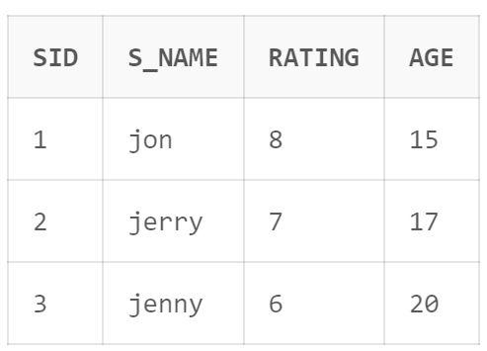

**d)** **.Update the column details of sailor.**

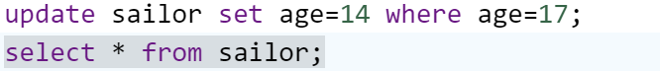

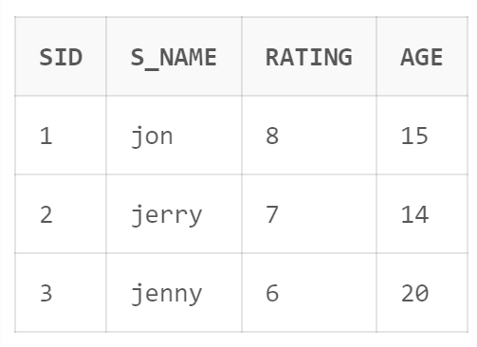

**e)** **Insert null values into the table.**

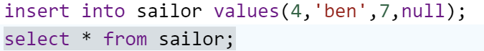

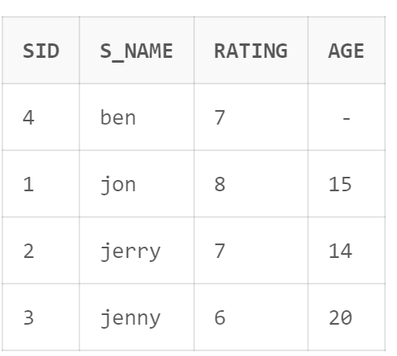

**Q6. Create a table called reserves table.**

1. **Insert values into the reserves table.**

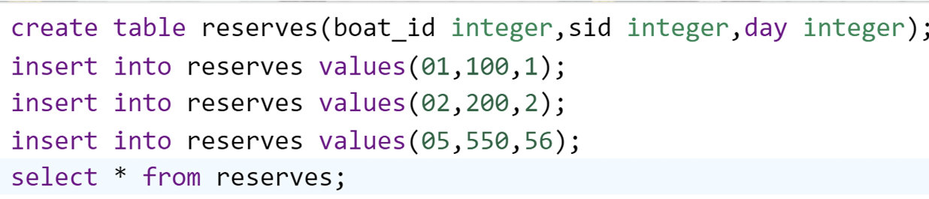

1. **Add column to the reserves table.**

