Product Design

|  |  |
| --- | --- |
| **Team** | **TEAM NUMBER- 25**  **TEAM MEMBERS:**  **1.Sachin Kumar Danisetty**  **2.Astitva Gupta**  **3.Trusha Sakharkar**  **4.Vivek Pamnani** |

# **Design Overview.**

## **Architectural** D**esign**

We have the following modules:

1. User - It has the ‘login’ method where user sign in is done. Also the searches done by the particular user are stored in the user database via some handler function.
2. UI - The UI framework in node-js are coded here.All UI related activities are looked after here.
3. Search-The search module has methods to call database queries,trigger crawling and all inputs related to previous searches.
4. NLP Tool - The NLP tool is used while crawling the web for text summarisation.

We may add new modules as required.This is for the design as of now.Methods from different modules will be called.Like whatever output the NLP tool gives is stored in the database via some handler function to the ‘Search’ module for database queries.

Also the modularity reduces confusion and long written codes.Efficiency increases and error analysis is easy.

## **System interfaces**

### **User Interface**

* + 1. Initial page will be a user login page. The user must sign-in with the different options provided to enter. There will also be an option for new user registration, which will require the user to set-up his credentials for future logins.
    2. The next page shows a search phrase for the type of ‘General Institutions’ for example ‘School Management Systems’ or a Startup working on a particular domain. The user may enter the type of institution, number of employees or also its geographical location. Also, there will be a search button which will begin the search query and after the search query is processed the results are displayed in tabular format.
    3. All the past searches can be accessed by going to the previous searches page from the navigation bar. On clicking a particular search, all its search results are displayed in tabular format.

### **APIs**

We don’t provide any API to interact with the system.

## **Model**

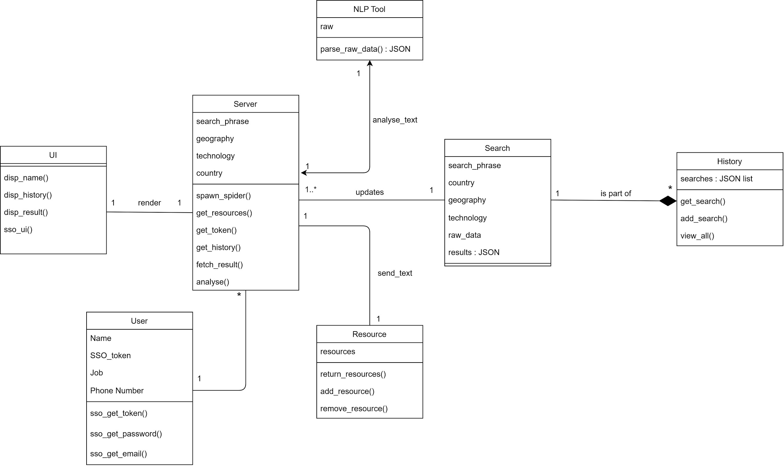

|  |  |
| --- | --- |
| History | Class state:   * This class has all the previous searches, all the users have done stored in a database.   Class behavior:   * A search handler method exists here. * For each unique user, a method will return all the previous searches made by that user. * All the database queries are called from here. |
| User | Class state:   * All the users that have registered with the software are stored in a database.   Class behavior::   * A search handler method exists here. * User profile details of each user are stored in the database and a method in this class returns all these values. * All the database queries are called from here. |
| Search | Class state   * The data fetching part is handled here via the means of web scraping and web crawling and the result is subsequently stored in the PreviousSearches_Database.   Class behavior   * This will load up the crawler and the scraper to find the related query on web and add this to the PreviousSearches_Database. * A method to add to the database is called from here. |
| UI and HTML | Class state   * This class handles the front end part of the application.   Class behavior   * The front end files are present in this class. * Various static and dynamic tasks are handled from here. |
| Server | Class state   * This module handles the back-end part of the application.   Class behavior   * The methods here implement the structure of the application and provide server support. |
| NLP Tool | Class state   * For text summarisation used to get news snippets related to a particular institution.   Class behavior   * A method to summarise the news article into small snippet or gist of the news. |

# **Sequence Diagram(s)**

# **Design Rationale**

There is nothing to mention right now. This is the very first design and we will consider changes in the coming days.