**Project Synopsis/Project Concept Document**

|  |  |
| --- | --- |
| Project number | 34 |
| Project Title | Build a list of prospective customers and contacts based on Ideal Customer Profile. |
| Document | DASS Project Concept Document |
| Creation date | 10-01-20 |
| Created By | Astitva Gupta  Sachin Kumar Danisetty  Trusha Sakharkar  Vivek Pamnani |
| Client | Mr. Sreedhar Peddineni, Stealth Mode |

**Description**

Software system to crawl the web and profile prospective customer businesses fitting a given Ideal Customer Profile. Apart from gathering raw data from the web, the software system would clip and summarize relevant articles while attempting to appropriately categorize them. The resulting database can be navigated/searched using a UI.

**Profile of Users**

Users can be Entrepreneurs, Sales division, Investors, Market Researchers, Recruiting Startups etc.

**Entrepreneurs :**

Person or group of people who are setting up a business or businesses.

**Sales Division:**

Activities related to selling or services sold in a given targeted time period. These people take care where the company should sell its products and is it profitable to do business with another company.

**Investors :**

Person or other entity who commits capital with the expectation of receiving financial returns or to gain an advantage.

**Market Researchers :**

People that help to strategize the company’s projects and maintain a steady base of customers for the business.

**Usage Model and Diagrams (if any)**

**Entrepreneurs :**

. To check various business fields and the revenue they are making to check their position in the market sales.

. To make a decision before starting a business by checking similar business companies status in the market.

. Segment the businesses and rate them in their particular segment to show the entreprenuers how the segments are profitable.

. Custom searches help you find active investors in your space that match your ideal criteria, whether that be sector, exit count, or location.

**Sales :**

. Narrow down companies within a particular headquarters location, investment stage, or category with our tools.

. Import a list of your leads to let you know when they attain funding or do something of note.

. View where the competitors are selling and the comparison with the competitors.

**Investors :**

. To check the business's status they are investing and decide to continue investing or not.

. Can use this platform to narrow down a new investment based on headquarters, category, investment size, and more.

**Market Researchers :**

. To help with their research by providing market sales status and to provide research insights in respective industries.

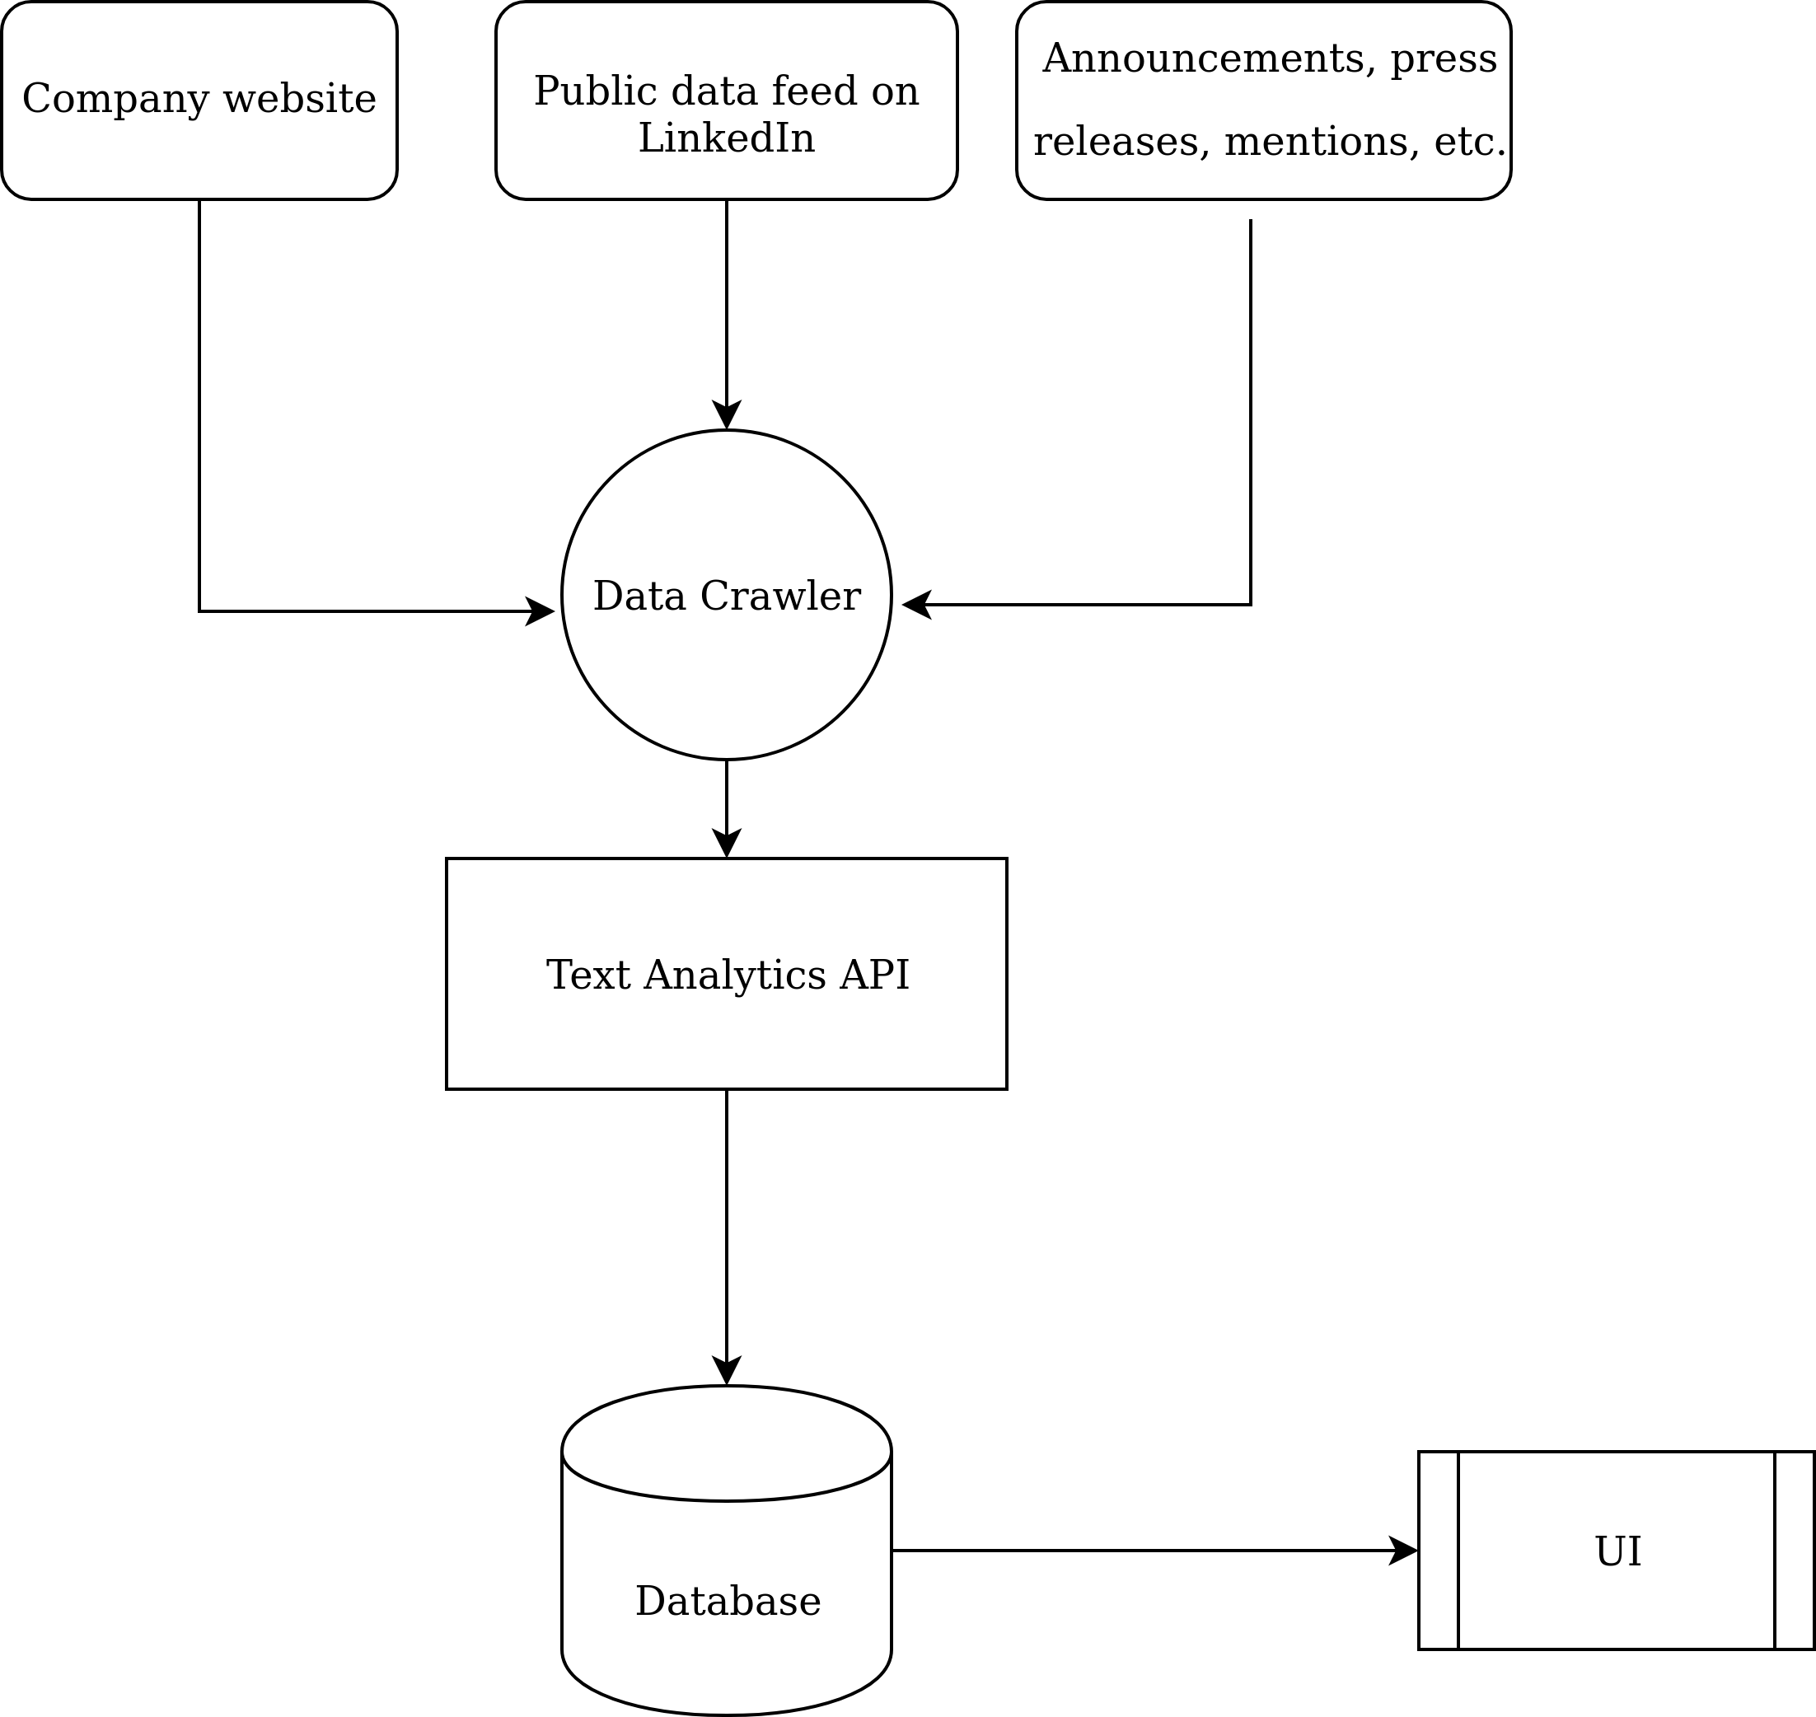. To see how much companies in a certain category are raising and who are the leading players with our global coverage on companies ranging from pre-seed to late-stage.