**Software Requirements Specification (SRS) Document**

|  |  |
| --- | --- |
|  | Build a prospective list of customers based on Ideal Customer Profile  Team 25  Astitva Gupta  Sachin Kumar Danisetty Trusha Sakharkar Vivek Pamnani |

# Brief problem statement

Software system to crawl the web and profile prospective customer businesses fitting a given Ideal Customer Profile. Apart from gathering raw data from the web, the software system would clip and summarize relevant articles while attempting to appropriately categorize them. The resulting database can be navigated/searched using a UI.

# System requirements

Operating System : Any rudimentary system is sufficient to interact with UI.

Browsers : supports all popular browsers, including Internet Explorer 9 and above, although [some polyfills are required](https://reactjs.org/docs/javascript-environment-requirements.html) for older browsers such as IE 9 and IE 10.

An Internet connection.

Technologies :

* Data Crawling
* Text Analytics - using NLP based summarization techniques or integration with open source summarization tools
* Categorization of content using segmentation techniques
* Data modeling
* UX Design and UI Development

Languages :

* HTML
* CSS
* Javascript
* Python3
* SQL

Libraries/Frameworks :

* React
* Scrapy
* BeautifulSoup

# Users profile

# Target audience are all B2B businesses, individual people who want to sell their product/ provide their service to some business.

# Both types of user register through SSO and can search for all the companies interested in a certain domain and in certain geographic locations by giving a search phrase and locations.

Further he can contact the customers from the particular business(eg:CEO,CTO) by the contacts provided by the UI.

All the user’s previous searches should be stored in a database dedicated to that user.

# Feature requirements (described using use cases)

|  |  |  |  |
| --- | --- | --- | --- |
| **No.** | **User Case Name** | **Description** | **Release** |
|  | User Authentication | Users can login through the portal to their account by SSO. | R1 |
|  | Domain Search bar | User can search for customers interested in the provided domain. | R1 |
|  | Attributes Search bar | Users can filter the searches/results from domain search by applying the input filters | R1 |
|  | Initiate Search | User can view the list of customers interested in the domain specified and satisfy the attributes specified. | R1 |
|  | Search database | User can view their previous searches and their details which are stored in their database | R1 |
|  | Profiles | Users stats, private information is viewed in his profile. | R1 |
|  | Customer list | Users can view the customers list to contact from a customer business(eg: CEO,CTO) | R2 |
|  | Company Knowledge Base | Users can view the  list of interesting news articles, announcements, etc. about customer companies. | R2 |

**Use case diagram**

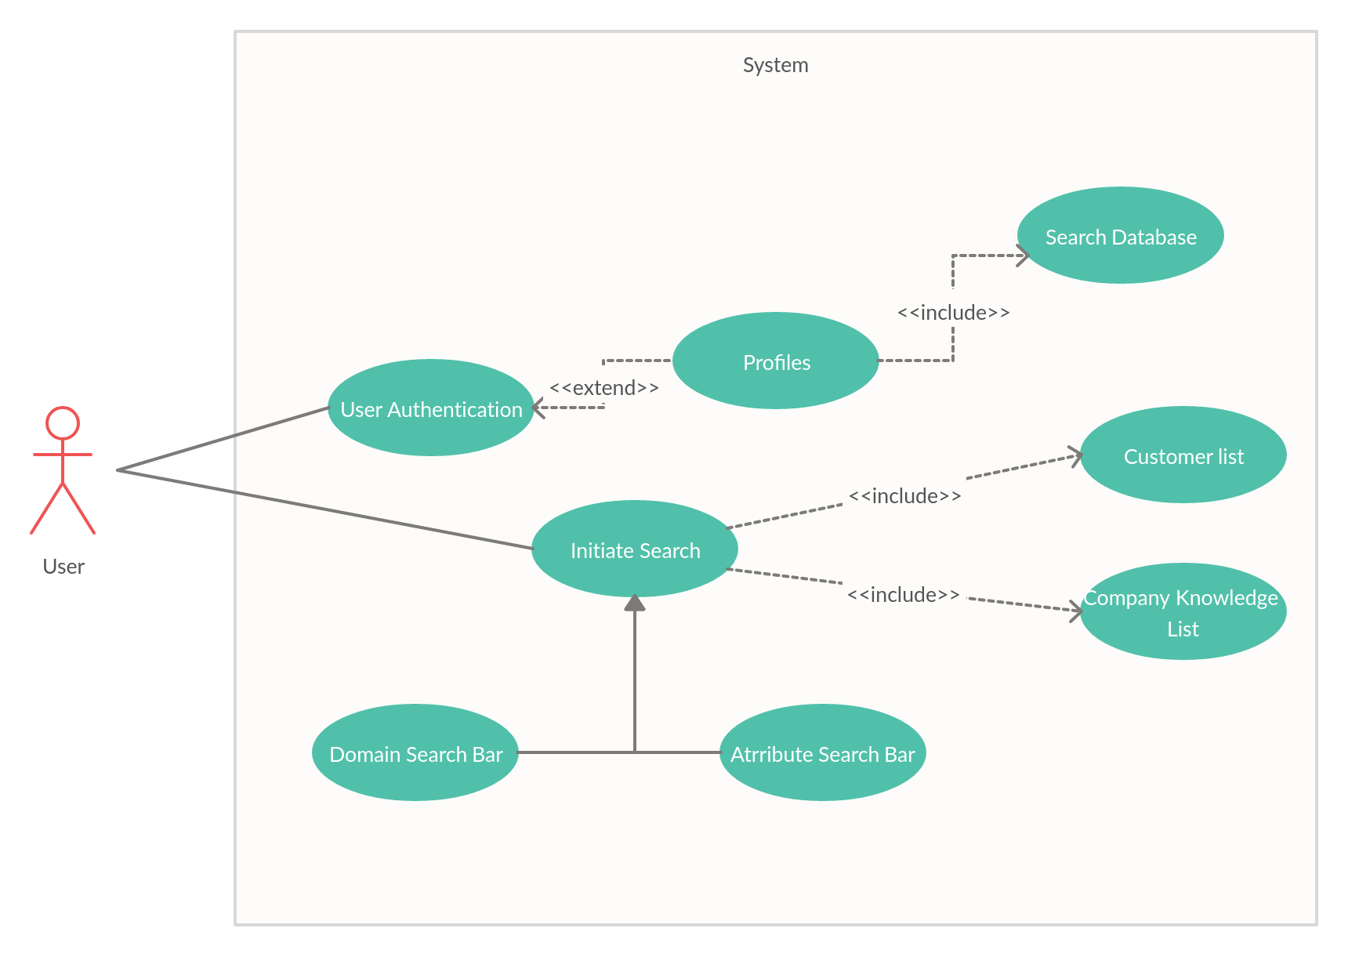

**Use case description**

|  |  |
| --- | --- |
| **Use Case Number:** | UC-1 |
| **Use Case Name:** | User Authentication |
| **Overview:** | Users can login through the portal to their account by SSO. |
| **Actors:** | B2B business and individual users |
| **Pre condition:** | User should have an account for SSO.  (eg: user should have a google account if SSO is GSuite). |
| **Flow:** | Main (success) Flow:   1. Create database holding users 2. Store user details securely 3. Front end support for accepting details and beginning session |
|  | Alternate Flows: Display appropriate error messages. |
| **Post Condition:** | User’s session is now active and can be used to make changes in the user’s stead. |

|  |  |
| --- | --- |
| **Use Case Number:** | UC-2 |
| **Use Case Name:** | Domain Search bar |
| **Overview:** | User can search for customers interested in the provided domain. |
| **Actors:** | B2B business and individual users |
| **Pre condition:** | User should have a valid search phrase to search |
| **Flow:** | Main (success) Flow:   1. Should take search phrase as input. 2. Parse the search phrase. |
|  | Alternate Flows: none |
| **Post Condition:** | Server should store the domain search phrase. |

|  |  |
| --- | --- |
| **Use Case Number:** | UC-3 |
| **Use Case Name:** | Attributes Search bar |
| **Overview:** | Users can filter the searches/results from domain search by applying the input filters. |
| **Actors:** | B2B business and individual users |
| **Pre condition:** | User should mention valid attributes |
| **Flow:** | Main (success) Flow:   1. Should take attributes as input. 2. Store them as a JSON object. |
|  | Alternate Flows: If input is not given we take it as no filters |
| **Post Condition:** | Server should store the attributes. |

|  |  |
| --- | --- |
| **Use Case Number:** | UC-4 |
| **Use Case Name:** | Initiate Search |
| **Overview:** | User can view the list of customers interested in the domain specified and satisfy the attributes specified. |
| **Actors:** | B2B business and individual users |
| **Pre condition:** | There should be some companies satisfying the specified search phrases.Else show a error message |
| **Flow:** | Main (success) Flow:   1. Server takes the parsed input. 2. Spiders crawl through the specified domains using search inputs. 3. Server parse and clean the data. 4. Server uses NLP API and process the data. 5. Data is stored in the database provided for that user. |
|  | Alternate Flows: Display appropriate error messages. |
| **Post Condition:** | Search and it’s results should be stored in the user’s database. |

|  |  |
| --- | --- |
| **Use Case Number:** | UC-5 |
| **Use Case Name:** | Search database |
| **Overview:** | User can view their previous searches and their details which are stored in their database |
| **Actors:** | B2B business and individual users |
| **Pre condition:** | User should have initiated a search before. |
| **Flow:** | Main (success) Flow:   1. Search through the database. 2. Show all the previous results. |
|  | Alternate Flows: Display appropriate error messages. |
| **Post Condition:** | none |

|  |  |
| --- | --- |
| **Use Case Number:** | UC-6 |
| **Use Case Name:** | Profiles |
| **Overview:** | Users stats, private information is viewed in his profile. |
| **Actors:** | B2B business and individual users |
| **Pre condition:** | User should have been logged in. |
| **Flow:** | Main (success) Flow:   1. Store public data of the user in their databases. 2. Show their public data in UI |
|  | Alternate Flows: none. |
| **Post Condition:** | none |

|  |  |
| --- | --- |
| **Use Case Number:** | UC-7 |
| **Use Case Name:** | Customer list |
| **Overview:** | Users can view the customers list to contact from a customer business(eg: CEO,CTO) |
| **Actors:** | B2B business and individual users |
| **Pre condition:** | The company should provide information about their employees. |
| **Flow:** | Main (success) Flow:   1. Spiders extract the contact information from the company's website and other resources. 2. This data is cleaned, processed using NLP API and contact list is updated. |
|  | Alternate Flows: Display appropriate error messages. |
| **Post Condition:** | This should be stored along with the searches. |

|  |  |
| --- | --- |
| **Use Case Number:** | UC-8 |
| **Use Case Name:** | Company Knowledge Base |
| **Overview:** | Users can view the  list of interesting news articles, announcements, etc. about customer companies. |
| **Actors:** | B2B business and individual users |
| **Pre condition:** | The news of the companies should be provided to public |
| **Flow:** | Main (success) Flow:   1. Spiders crawl through companies website and other news resources and collect raw data. 2. This raw data is cleaned and processed and summarized by the NLP API. |
|  | Alternate Flows: none. |
| **Post Condition:** | The data (news) collected should be viewed through UI |