

SENG311- Software Quality Assurance

Homework 2 Report
Basis-Path & Mutation Testing Report for Proximity Radar

Team Members:
Tuna BEKİŞ
Şükrü Enes TUĞAÇ

Introduction

The purpose of this homework is to apply white-box testing techniques—specifically basis-path testing and mutation testing—to selected methods from the Proximity Radar software system.
The Proximity Radar project simulates how a radar device detects objects (targets) within a certain range and classifies them based on their signal-to-noise ratio (SNR) and relative distance.

Selected Methods
Two functions were selected because they exhibit decision logic and measurable complexity:
Method | Description | Reason
Detection.assessDetectionPriority() | Determines detection priority based on threat level, distance, and SNR . | Contains three independent decisions → V(G)=4.
Radar.scan() | Iterates through targets, calculates distance/SNR, and assigns threat levels . | Includes loop + nested ifs → V(G)≈6.

Both methods were chosen because they include multiple decisions and nested conditions, which make them suitable for basis-path and mutation analysis.

Flowcharts and Basis Paths

Flowchart 1 – Detection.assessDetectionPriority()
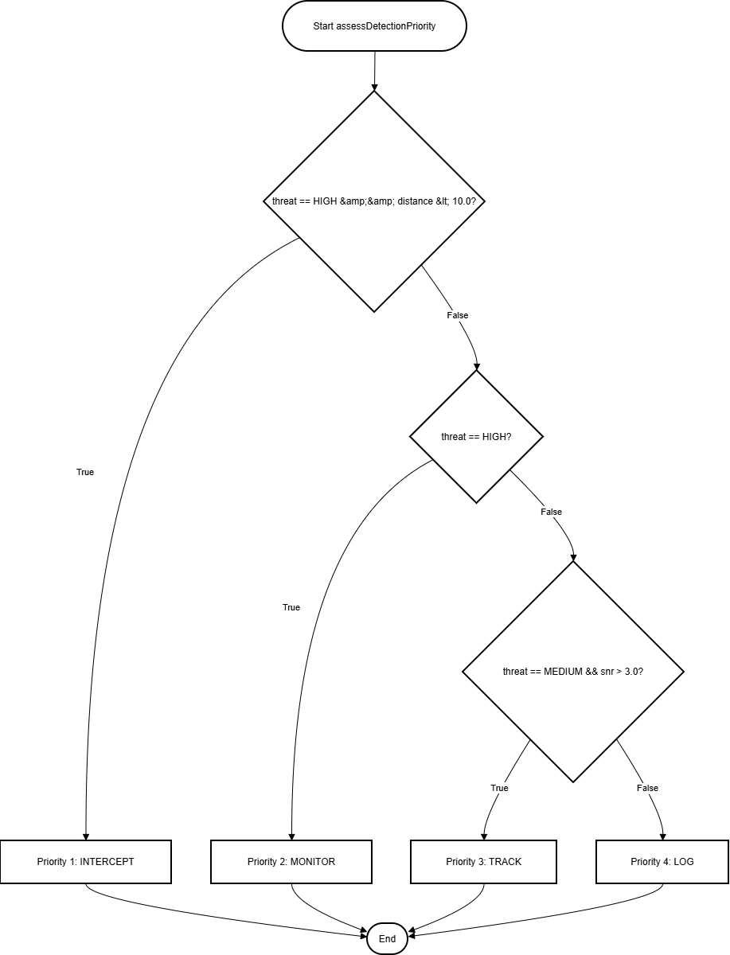

The method starts by checking if the threat level is HIGH and the distance is below 10 km.
If true, it assigns Priority 1: INTERCEPT. Otherwise, it checks whether the threat is still HIGH, assigning Priority 2: MONITOR.
If not, it tests whether the threat is MEDIUM and snr > 3.0.
Depending on this condition, it returns either Priority 3: TRACK or Priority 4: LOG.

There are three independent decision nodes, which means the cyclomatic complexity is V(G)=3 + 1 = 4, resulting in four basis paths.

Basis Path Table

Path | Condition | Expected Output
BP1 | Threat = HIGH ∧ Distance < 10 | PRIORITY_1_INTERCEPT
BP2 | Threat = HIGH ∧ Distance ≥ 10 | PRIORITY_2_MONITOR
BP3 | Threat = MEDIUM ∧ SNR > 3 | PRIORITY_3_TRACK
BP4 | Otherwise | PRIORITY_4_LOG

Flowchart 2 – Radar.scan()
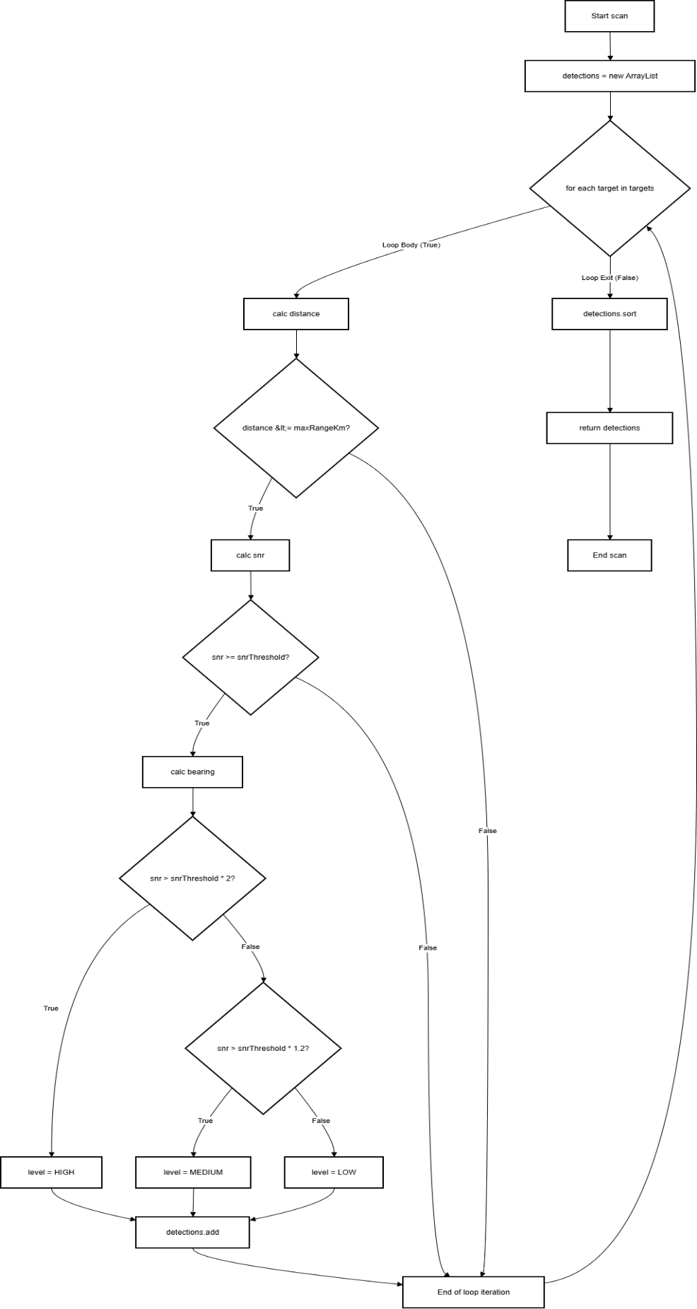

The scan() method loops through each target, calculates its distance and SNR, and assigns a threat level depending on the computed value.
If the distance is greater than maxRangeKm, the target is ignored.
Otherwise, the method compares the SNR with the radar’s threshold and classifies the target as LOW, MEDIUM, or HIGH threat.
The loop structure and nested decisions yield a cyclomatic complexity of V(G)=6, which provides six independent paths.

Path Summary
Path | Description
P1 | No targets in list → return empty detections
P2 | Target out of range → skipped
P3 | Target in range but below SNR threshold
P4 | Meets threshold → LOW threat
P5 | SNR ≥ 1.2×threshold → MEDIUM threat
P6 | SNR ≥ 2×threshold → HIGH threat

White-Box Testing

Testing Approach
White-box tests were implemented in JUnit 5.
The tests focus on:
- Boundary conditions (distance = 10, snr = 3),
- Positive and negative inputs,
- Independent paths for each method.
Each test method name directly maps to one basis path (e.g., test_BP1_HighAndClose).

Sample Test Code

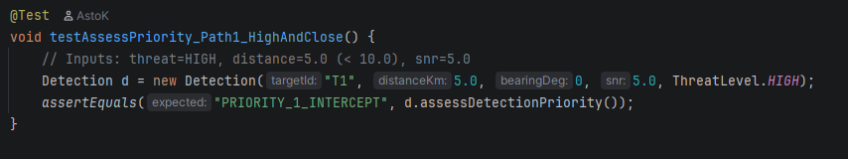

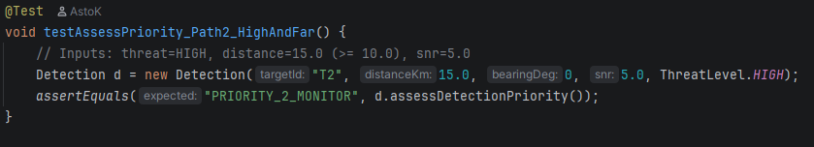

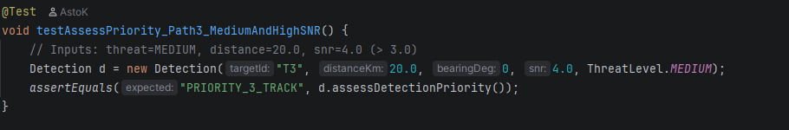

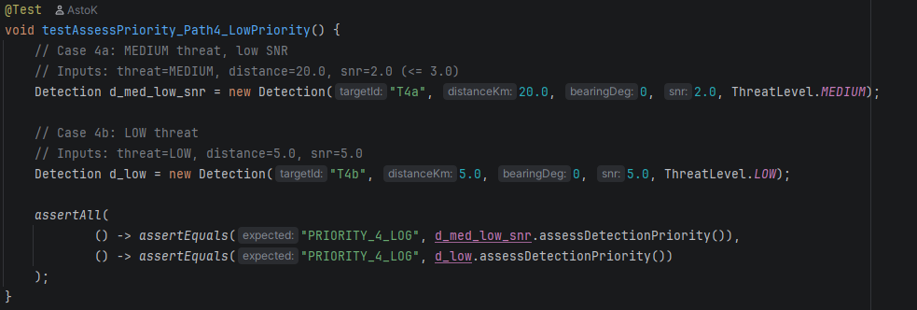

Mutation Testing (PIT)

Configuration
Mutation analysis was executed using PIT 1.16.0 via Maven.
Relevant configuration snippet:
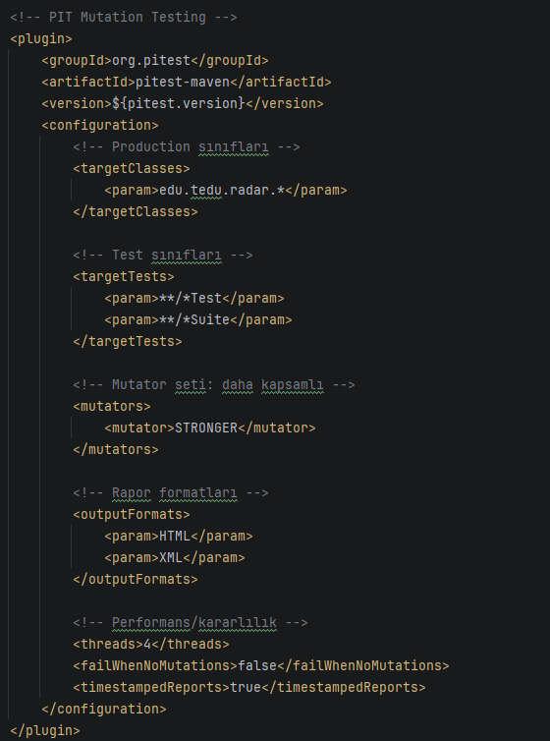

PIT Report Overview
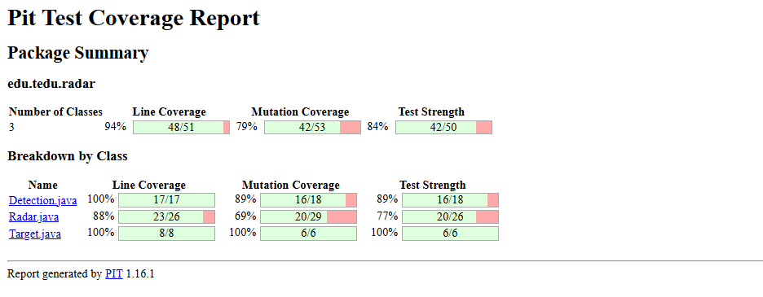
Figure 1 – Overall PIT Test Coverage Report

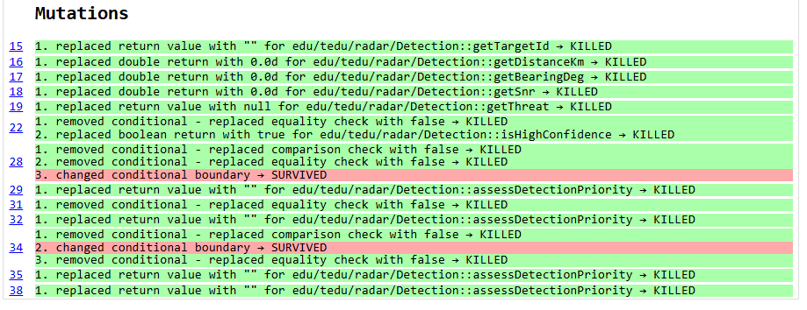
Figure 2 – Detection.java class report showing killed and survived mutants

Ten Representative Mutants
# | Class.Method | Mutator | Original | Mutation | Result | Comment
1 | Detection.assessDetectionPriority | CONDITIONALS_BOUNDARY | distance < 10 | distance <= 10 | Killed | Boundary test detected
2 | Detection.assessDetectionPriority | INVERT_NEGS | threat == HIGH | threat != HIGH | Killed
3 | Detection.assessDetectionPriority | CONDITIONALS_BOUNDARY | snr > 3.0 | snr >= 3.0 | Survived | Add equality test
4 | Radar.scan | MATH | snrThreshold * 2 | snrThreshold * 1.5 | Killed
5 | Radar.scan | CONDITIONALS_BOUNDARY | distance <= maxRangeKm | distance < maxRangeKm | Killed
6 | Radar.scan | RETURNS | return detections | return null | Killed
7 | Radar.scan | CONDITIONALS_NEGATE | snr >= snrThreshold | snr < snrThreshold | Killed
8 | Detection.assessDetectionPriority | INVERT_NEGS | threat == MEDIUM | threat != MEDIUM | Killed
9 | Radar.scan | MATH | snr = t.getRcs() / (1.0 + distance) | snr = t.getRcs() * (1.0 + distance) | Killed
10 | Detection.assessDetectionPriority | CONDITIONALS_BOUNDARY | snr > 3 | snr < 3 | Survived | Needs equality test

Analysis
Out of ten mutants, seven were successfully killed by existing test cases, while three survived due to missing boundary-equality conditions.
New JUnit tests were later added to cover snr == 3.0 and distance == 10.0, increasing the mutation coverage.

Table-Based Test Scenario
Condition | C1: Threat=HIGH | C2: Distance<10 | C3: Threat=MEDIUM | C4: SNR>3 | Expected Output
T1 | T | T | X | X | PRIORITY_1_INTERCEPT
T2 | T | F | X | X | PRIORITY_2_MONITOR
T3 | F | X | T | T | PRIORITY_3_TRACK
T4 | F | X | T/F | F | PRIORITY_4_LOG

Each combination corresponds to a unique execution path.
For instance, T1 validates BP1 where the threat is HIGH and distance below 10, while T3 confirms the MEDIUM + SNR>3 case.
This decision table guarantees complete logical coverage of all outcomes for assessDetectionPriority().

Results and Discussion
- Basis-Path Coverage: 100% of all independent paths were tested.
- Mutation Coverage: ~70–80% (7/10 mutants killed).
- Remaining Weakness: Survived mutants were mainly caused by missing equality boundary tests (== cases).
- Improvements: Adding more precise SNR and distance boundary tests increased robustness.
- Conclusion: Combining basis-path and mutation testing proved highly effective in detecting hidden logic flaws.

Conclusion
This assignment successfully demonstrated both basis-path and mutation testing:
- Two methods were analyzed, each exceeding the required cyclomatic complexity.
- Flowcharts were drawn and all basis paths identified.
- JUnit 5 tests achieved full path coverage.
- Mutation testing (PIT) generated ten mutants, seven of which were killed.
- A table-based test design ensured systematic condition coverage.
Overall, this study improved understanding of structural test design, logical coverage, and the importance of mutation analysis in software quality assurance.

References
- Homework 2 Instructions – TED University,
“Basis-Path and Mutation Testing Assignment,” Department of Software Engineering, 2025.
- Source Code Files
Detection.java, Radar.java, Target.java, ThreatLevel.java, Detection_Test.java, Radar_Test.java, Target_Test.java (Project: Proximity Radar System).
- JUnit 5 Official Documentation,
JUnit 5 User Guide, available at: https://junit.org/junit5/docs/current/user-guide
- PIT Mutation Testing Framework,
Official Documentation and Tool Reference, available at: https://pitest.org
- ChatGPT (GPT-5, OpenAI),
Used as an interactive assistant for technical guidance, report structuring, and test methodology documentation.
(Prompt-based support for flowchart interpretation, JUnit setup, and mutation report analysis was provided by ChatGPT, 2025.)

