ASTONE BANDA
astonbn001@gmail.com |0977838149 | Lusaka

EDUCATION
Bachelor of Science in Computer Science 2 years experience
Mulungushi University • Kabwe 7/2021-11/2025
Core coursework: Data Structures and Algorithms, Database Systems, Operating systems, Artificial Intelligence, Computer
Networks and Security, Software Engineering and Project Management
Thesis: "Smart Lighting System using AI and IOT" s
Examination Council of Zambia School Certificate
Matero Boys Secondary School • Lusaka 1/2018 - 12/2020

EXPERIENCE
Network Intern
Zamtel • Lusaka 06/2024 - 09/2024
Skills
Technical
Network Configuration, Fiber Optic/FTTH knowledge, Router Setup, Hardware troubleshooting
Field Work
Cable Splicing and Racking, Tool Maintenance, Mobile site maintenance.
Soft Skills
Team Coordination, Customer Education, Reporting and documentation, time management.

IT Internship
Mulungushi University • Kabwe 01/2025 - 03/2025
Skills
- Performed hardware installation and software configurations for the university
- Maintained 100% compliance with safety standards while working with electrical components
- Educated Students and staff on product functionality, ensuring they could operate equipment independently
PROJECTS AND SKILLS
- School Managment system: Developed a school management system for Wisdom Dominance
- Lodging Website: Developed a lodging website for Izeni lodge.
- Rental Management: Developed a system that lets landloards that lets them managent there property with tenants effictively .
- Skills: Technical Support, Software Development, Social Media Management
- Languages: proficient in Python, SQL, Javascript, PHP, TypeScrip and Java.

UNIVERSITY CERTIFICATE


HIGH SCHOOL CERTIFICATE

- 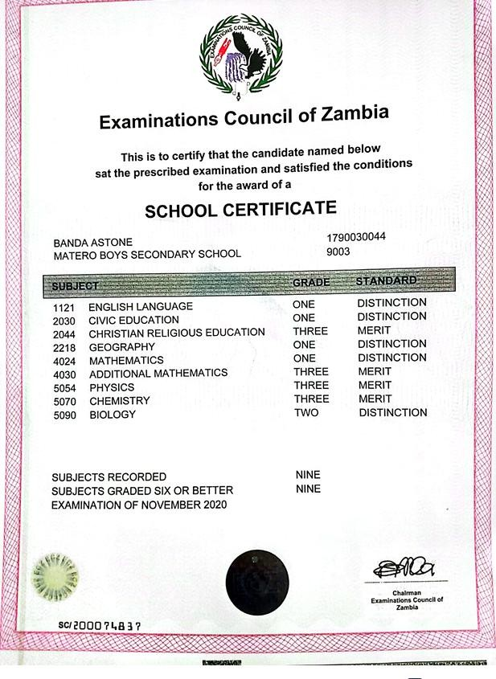

NATIONAL REGESTRATION CARD


