I. Set-Up

On April 29th, I, Oliver, and my group (Anika, Megan, Lexie) took a stroll to the TEG and introduced ourselves to the old MRO spectrograph. The box is propped open with a pencil so as to allow some amount of light, only enough so that the region inside is evenly lit with the slit lamp remains off. We first turn on the camera, ST-10XME, and connect to the computer (Windows XP ew). We start CCDSoft and communicate with the camera and its guider. Turning on temperature regulation turns on the fan, cooling the CCD to -5 degrees Celsius to restrict dark current.
We take initial flats with random exposure times to get a sense of what the image looks like (granules with a slit down the middle). We check the values for 4.5 seconds; max pixel value is only 1,500. Increase time to 90 seconds and get a max value of 48,000, just under what we were told is saturation, although we have an image of a fairly well-defined circle. Increasing exposure time past 100 seconds yields a more solid white circle of saturation with a max value of 50,000 counts. These images were saved with the filename syntax convention “flatx.xx.FIT”, with “x.xx” being the exposure time. Three bias images were taken (zero exposure time), and all exported to my flashdrive.

II. Gain and Read Noise

The CCD can be visualized as a square array of buckets (pixels) which collect the results of photons interacting with the matter (silicon). When a photon is able to be absorbed by the silicon, an electron is excited and produces excess charge which can then be collected by the pixel. At the end of exposure time, the charge is passed from one pixel to another (column by column, then row by row) into the output register where the charge can be measured by an output amplifier. This signal is digitized by an Analog to Digital (A/D) converter, which is not always accurate. The gain refers to the mistakes made in conversion – a lower gain refers to more electrons per data unit (ADU), meaning the amplifier underestimated the amount of photons that actually interacted with the chip.
Taking biases is essential to measuring the noise that results from the pixels just being read out. The standard deviation of the variation between zero exposure time images is the read noise.

σ_{bias} = Read Noise / Gain [in electrons per A/D conversion units, or ADU]

To be able to calculate the gain, we used two flatfield images of exposure time 29.5 seconds. Using numpy in python, I determined the mean pixel values (Ƒ and Ɓ) and standard deviations of our two flats and two bias images.

Gain = (Ƒ₁+Ƒ₂) – (Ɓ₁+Ɓ₂) / σ²_{flat} – σ²_{bias}

By combining these equations, we get:

Read Noise = Gain * σ_{bias} / √2

After calculating these values, I get σ_{bias} of 51.36 ADU, σ_{flat} of 210.36 ADU, a gain of 0.3115 electrons per ADU, and a read noise of 11.3146 electrons RMS, which is fairly close to the manufacturer’s value of 14 electrons RMS. Using a 20 x 20 pixel subregion, I get a gain of 0.4008 e-/ADU and a read noise of 14.41 electrons RMS.

III. Linearity of the CCD

It is essential that only one count is recorded for each photon that hits the chip. If count per photon were to change with time, then images would need to be processed with the exposure time in mind, and values would have to be calculated per pixel across the array (time consuming). The capacity of the CCD can be measured by increasing exposure time incrementally until saturation is reached. During the end of the longest exposure times, linearity becomes disrupted. According to the graph below, linearity falls off around 90s, or 21,000 ADU.
With a 16-bit A/D converter, A/D saturation would theoretically occur at 65,536 [ADU] * gain [0.4 e-/ADU] = 26,214.4 [e-]. This is a different value than the “full-well capacity”, which is the amount of charge the physical pixel can contain in one exposure. The manufacturer states the full-well capacity to be 30,000 [e-], or 75,000 ADU. According to these values, one must be concerned with A/D saturation rather than full-well saturation for this specific camera, as it takes 26,000 mean counts for the amplifier to give inaccurate measurements.
For a different camera, SBIG ST9-XE, it reaches A/D saturation at 65,536 [ADU] * gain [1.6 e-/ADU] = 104,857 [e-], at a full-well capacity of 150,000 [e-], or 93,750 [ADU]. Since A/D saturation is reached with fewer electrons than the full-well capacity, it is the primary concern. However, with 2x2 binning, four adjacent pixel counts are summed before A/D conversion. This process drastically increases A/D saturation limits, but has an opposite effect on the full-well capacity, making the charge able to be contained within a pixel the primary concern in high binning levels.
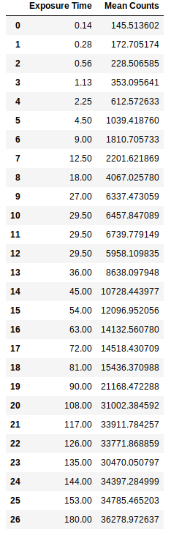
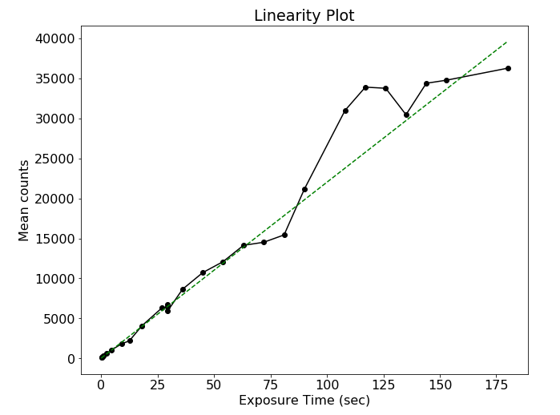
In reference to whether these values vary per filter, one can recall that while a higher frequency like UV is associated with higher energy, this is only due to the higher number of photons hitting the CCD. Each count in essence is treated the same as optical counts. The only thing that may change is the depth at which the photons penetrate the CCD, affecting full-well capacity at different voltage levels.
IV. Dark Current

The kinematic representation for thermal energy is the motion of particles, typically in the form of vibrations. For electrons trapped on the 2D surface of a CCD, this is translated to motion across the face, referred to as dark current. This can be suppressed by cooling the CCD, and measured by estimating the difference in energy between the Fermi level and the location where thermally excited electrons are boosted (the bottom of the conduction band). This value, known from now on as E_{g}, when estimated as 1.3, resulted in a fairly accurate model of dark current when using equation

Dark Current = 2.5 x 10¹⁵ AI_{d}T^{1.5}e^{-Eg / 2kT}
A = pixel area [cm²], I_{d} = dark current at 300K, k = Boltzmann constant [eV]

Using the package scipy.optimize, we use the function curve_fit to model the data given in the lab and relate it to the given equation. Varying the value for predicted E_{g} brings the measured curve closer or farther away from the initial model. Below, the left plot shows measured variation in electron counts when increasing temperature. The plot on the right shows the curve obtained by adjusting the predicted value for E_{g}. Decreasing the value decreased the slope of the exponential term (more convex in shape). After trying values in the interval [0.8,1.5], the converged value of E_{g} which produces the closest fit is 1.22 eV, very close to the manufacturer’s value of 1.1 eV.
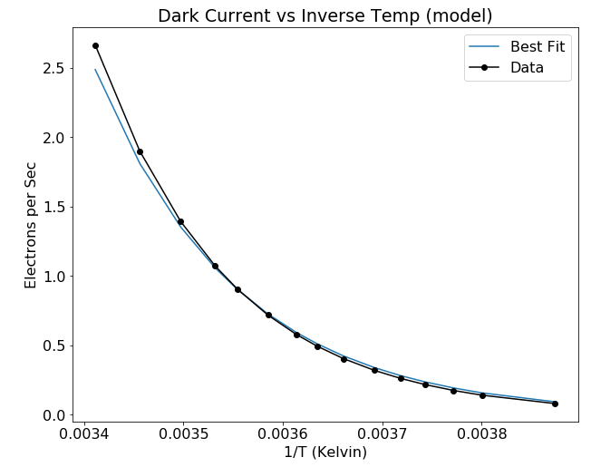
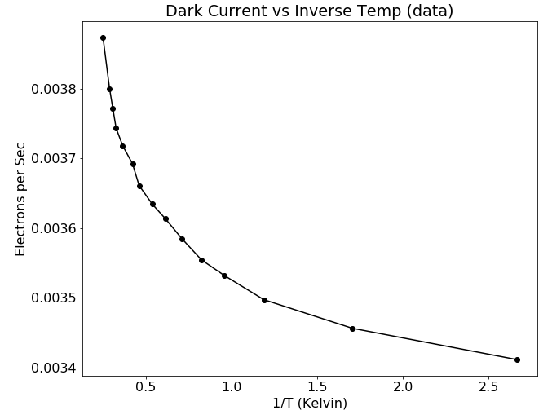

As the temperature increases, dark current logically would increase. Taking the limit as T approaches infinity yields infinity, with an upper limit increased by smaller pixel area and larger E_{g}. At low temperatures, dark current approaches zero, which also makes logical sense – without thermal energy, electron movement is almost completely inhibited. Discrepancies in my model compared to the manufacturer’s given value could be due to the fact that we did not subtract any readout (bias) noise.

VI. Summary

As discussed in past sections, my measured value of readout noise is 14.41 e₋ RMS as compared to the given 13 e₋ RMS, and a bandgap level of 1.22 eV as opposed to 1.1 eV. I spent a lot of time reading about pixel structure, skin depth of photons, and the fact that those weird sparkles you get when you stand up too fast are false photon counts your eyeballs register due to sudden lack of pressure. <3

