Ex4-Gaussian Mixture Models and Expectation-Maximization

Matthis Brocheton

## *Probleme 1:*

*two Gaussian random vectors:*

$$y∼N\left(μ,Σ\right) \\ z∼N\left(μ^{​},Σ\right)$$

*We want:*

$$y+z∼N(μ+\hat{μ}​,Σ+\hat{Σ})$$

**

**

*Calculation :*

$$y+z= μ+\hat{μ}$$

$$Cov(A+B)=Cov(A)+Cov(B)+Cov{\left(A,B\right)}^{T}+Cov(A,B)$$

$$Cov(A,B)=0$$

$$Cov\left(y+z\right)=Cov\left(y\right)+Cov\left(z\right)$$

$$Cov(y+z)=Σ+\hat{Σ}$$

*So : $$y+z= μ+\hat{μ}$$*

$$Cov(y+z)=Σ+\hat{Σ}$$

*We obtain:*

$$y+z∼N(μ+\hat{μ}​,Σ+\hat{Σ})$$

## *Probleme 2:*

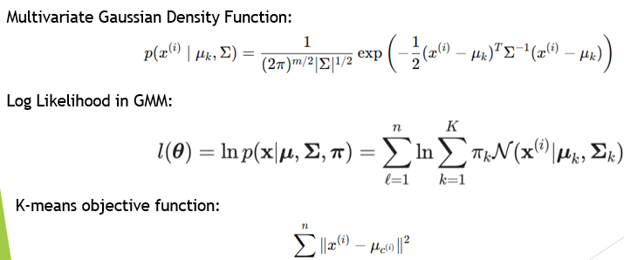

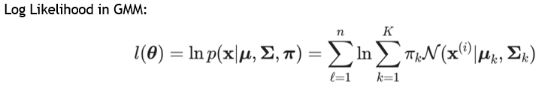

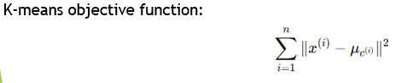

*complete-data log-likelihood*

$$log p(x,z∣μ,ϵ)=\sum{​[\log{π_{zi}}​​-\frac{2}{m}​log\left(2πϵ\right)-\frac{1}{2ϵ}​∥x^{i}-μ_{zi​}​∥^{2}]}$$

*We are interested in (because $ϵ→0$):*

$-\frac{1}{2ϵ}​∥x^{i}-μ_{zi​}​∥^{2}$*-> $-\frac{1}{2ϵ}​\sum{∥x^{i}-μ_{zi​}​∥^{2}}$*

*This is the distortion function of k-means:*

$$​\sum{∥x^{i}-μ_{zi​}​∥^{2}}$$

*If we maximize the log-likelihood the result matches with the function of k-means:*

$$\sum{∥x^{i}-μ_{zi​}​∥^{2}}$$

## *Probleme 3:*

**a)**

if then the model is $λ1^{i}​=λ2^{i​}$ so not identifiable.

So, we need to have $β1​≠ β2$.

If $p$ is equal to 1 or 2 then we use only one model of fish, we need to have $0<p<1$ to identify the model.

If $x^{i}$ is same so the values $λ1^{i} and λ2^{i​}$ will be equal and we won’t have enough information to know the relation with x and y.

So, we must have $x^{i}$ varied.

**b)**

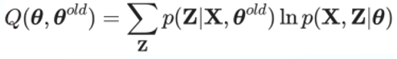

The EM algorithm is an iterative method used to estimate parameters θ in probabilistic models involving latent (hidden) variables Z. It alternates between estimating the distribution of the hidden variables (E-step) and updating the model parameters (M-step) by maximizing a function $Q(θ,θ^{old})$

*General idea*

We estimate that:

visible observations X

hidden variables (or "latent") Z

Since Z is not observed, we estimate its distribution in the E-step, and use it to update parameters in the M-step.

*E-step*

We calculate responsibilities with:

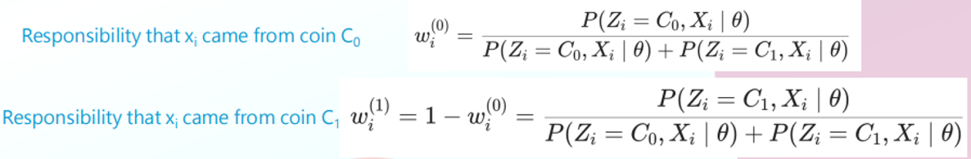

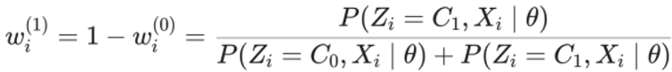

These weights $w_{i}^{(0)}$ and $w_{i}^{(1)}$ represent the probability that the data comes from component 0 or 1.

*M-step (maximization)*

We maximize the function Q (θ, θ Old) to obtain new parameters 𝜃:

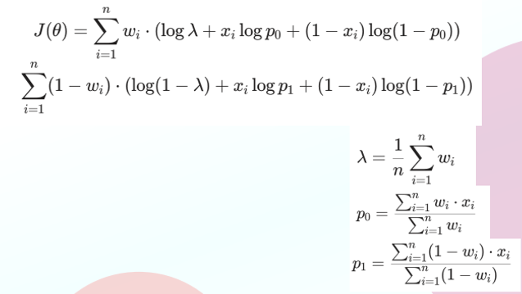

In this example, the Q-function becomes an explicit weighted log-likelihood function $J(θ),$ where each data point is weighted by its probability of coming from component 0 or 1.

These formulas correspond to weighted averages, where each point counts more or less according to its probability of belonging to the class.

*And after?*

We repeat the processus until the parameters converge, E-step, M-step…

**c)**

In the EM algorithm, the function Q is defined as the expected complete log-likelihood:

$$Q\left(θ,θ^{old}\right)=E_{Z|X, θ^{old} ​}[log p(X,Z∣θ)]$$

Which can also be written as a sum over the data:

$$Q\left(θ,θ^{old}\right)=∑\sum{p\left(zi​ ∣ xi​,θ^{old} \right)}l​og p\left(xi​,zi​ ∣ θ\right)$$

This function is differentiable compared to 𝜃, and its derivative gives us the direction in which to adjust the parameters to M-step.

*Derivation of the derivative of $Q\left(θ, θ^{Old}\right)$*

Let's call $γi​(z)$ responsibility (or conditional probability) calculated in step E:

$$γi​\left(z\right):=p(zi​=z∣xi​,θ^{old})$$

So, we have:

$$Q\left(θ,θ^{old}\right)=∑\sum{p\left(zi​ ∣ xi​,θ^{old} \right)}l​og p\left(xi​,zi​ ∣ θ\right)$$

And derivative in relation to θ is:

$$∇_{θ​}Q(θ,θ^{old})=∑∑​γi​\left(z\right)∇_{θ}​logp(x_{i}​,z∣θ)$$

This means that the gradient of 𝑄 Q is a weighted sum of the gradients of the log-likelihood, with the responsibilities $γi​\left(z\right)$ as weight.

In the M-STEP, if we cannot resolve:

$$θ^{new}=argmax​Q(θ,θ^{old})$$

So, we take steps in the direction of the gradient, as in classic automatic learning:

$$θ^{t+1}=θ^{t}+η⋅∇_{θ}​Q(θ^{t},θ^{old})$$

Where 𝜂 η is the learning rate.

This allows us to update the parameters in the right direction, even if we cannot resolve the optimization explicitly.

**d)**

No, the EM algorithm does not always find the global maximum of the likelihood function.  
It is guaranteed to converge to a local maximum (or saddle point), but not necessarily the global one.

*Why not?*

Because the update rule depends on the initial value $θ^{0}$, the EM algorithm might:

Converge to the global maximum (if the initialization is lucky)

Get stuck in a local maximum or saddle point (more common)

At each iteration, the likelihood never decreases:

$$log⁡p(X∣θ^{t+1})≥\log{p\left(X ∣ θ^{t}\right)}$$

n a Gaussian Mixture Model, if you initialize two components too close together, the EM algorithm may:

Assign most data to one component

Leave the other component "empty"

Converge to a poor local optimum

**e)**

The EM algorithm allows you to find a stationary point (a local maximum or a saddle point), but not necessarily the overall maximum of likelihood. Here is how to check if the final parameter actually maximizes the likelihood.

*1. Compute the observed-data log-likelihood:*

After convergence of EM at parameter $θ^{*}$, compute:

$$\log{p\left(X ∣ θ^{*}\right)}$$

This is the actual likelihood you care about (not Q, which approximates it).

*2. Try multiple initializations:*

Because EM is sensitive to initialization, it's common to run it multiple times from different starting points:

If all runs converge to the same likelihood, it's a good sign.

If some runs give a higher log-likelihood, then the current solution is not the maximum global.

*3. Inspect the second derivative (optional):*

To formally check whether θ* is a local maximum, analyze the Hessian matrix of the log-likelihood:

If the Hessian is negative definite, then $θ^{*}$ is a local maximum.

If not, it might be a saddle point or local minimum.

But this is often hard to compute in complex models.