Robocup Rules 2025-2026

This document regroups all the known rules for the challenge Eurobot 2026 as the date of 26th September 2025. The objective of this technical challenge is to create an autonomous robot. The participations to this competition are from January to June.
Eurobot 2026 website

Registration Requirements 1
1. Playing Area 2
2. Description and layout of the playing elements 3
3. Actions 4
4. To find is to keep 5
5. Robot constraints 6

Registration Requirements

- At least 2 members
- At least one robot
- Everything on the robot must be imagine and designed by the team members
- The supervising members cannot modify anything directly on the project
- <30 years
- The team must respect the rules of decency and safety (electrical, noise level, etiquette...) of the country of meeting
- A poster is required for the team and must contain
  - The name of the team
  - The complete names of each team members
  - The country of the team
  - The country flag of the team

Playing Area

Size: 3000*2000mm with 70mm heigh and 22mm thick borders on each side.
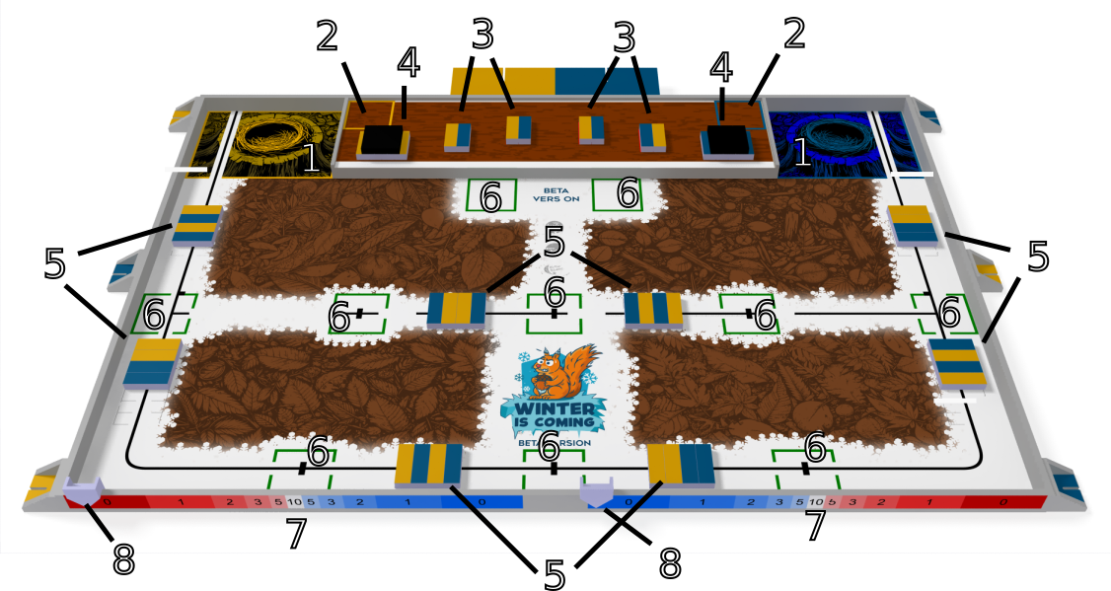
Figure 1: Detailed view of the playing area
1. Squirrels nest
2. SIMA Starting areas in the granary
3. Fridge
4. Loading area
5. Collection area
6. Pantry
7. Thermometer
8. Cursor

The "squirrel nests" are the team’s starting and finishing areas, they are the surfaces of 45 cm by 60 cm. They're delimited by a line on the field
Constraints: Make sure your robot can fully enter its starting area. The lines are parts of the surface of the “nest” area.

Description and layout of the playing elements

- Hazelnut crates: Wooden blocks (15×5×3 cm), painted in team colours on two opposite sides. 48 in total, placed in storage areas.

- Rotten nut crates: Same dimensions, fully painted black. 6 in total, placed in the loading zone.

- Thermometers: Vinyl stickers on the front edge of the table, divided into 11 numbered zones for scoring.

- Cursor: Provided by the organizers (or by the team if compliant). Must not be motorized, must fit within size limits, and readings must be clear.

- Granary: Elevated area (55 mm, 450×1800 mm), contains 4 fridges (100×150 mm) with 2 crates each (1 per colour). Only accessible to the SIMA.

- Loading areas: Located at the front and on each side of the granary. Each contains 7 crates (4 regular on the bottom + 3 rotten on top)

- Pantries: Green-marked zones (200×200 mm) distributed on the table.

- Collection areas: Red-marked zones (150×200 mm), each with 4 crates (2 of each colour) in random order.

- Little squirrels (SIMA): Independent mobile robots built by the teams, placed in their starting area at the beginning of the match.

Actions
The main action involves collecting hazelnut crates and placing them in pantries or the squirrel nest.
Objective: Gather as many crates as possible.
Validity: A crate counts if its vertical projection lies in the zone and it rests flat on the table.

Squirrel nest:
  - Any crate placed here counts for the team, regardless of colour.
  - Maximum of 6 crates; extras are ignored.
  - Cannot be stolen by the opponent.

Pantries:
  - A crate is valid if its top face shows the team’s colour or a neutral side.
  - Unlimited number of crates may be placed.
  - Opponents can steal crates from pantries.
  - A pantry gives end-game interest if a team has most of its colour inside. In case of a tie, no interest is awarded.

Rotten crates: No points.
Controlled elements: Any crate still held by a robot/SIMA at the end of the match does not count.

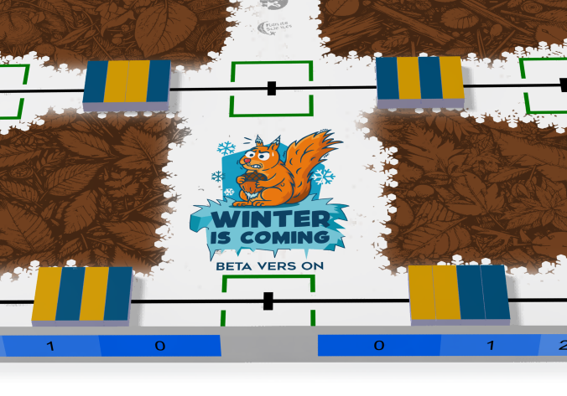
Figure 2: Hazelnut crates in a stock at the start of the match. Figure 3: Various areas of interest for the blue and yellow teams.

To find is to keep
This action uses the SIMA, the granary, and the loading areas.
Actions:
  - A team may deploy one SIMA in the granary.
  - The SIMA must empty the fridges (removing hazelnut crates) and place those crates outside the granary for recovery.
  - The SIMA must then fill the fridges with rotten hazelnut crates from the loading areas.
Constraints:
  - Only one SIMA may start inside the granary, placed in a 20×20 cm starting zone (including lines, table border, and cleat).
  - The SIMA has the entire match duration to complete its task.
  - At the start:
    - Each fridge contains 2 hazelnut crates (1 per colour, random order).
    - Each loading area contains 3 rotten hazelnut crates.
  - A fridge is empty if no hazelnut crate projects into it at match end.
  - A fridge is full if at least one rotten crate projects into it at match end.
  - Elements still under SIMA/robot control at match end do not count.
  - Empty or full fridges score for both teams.
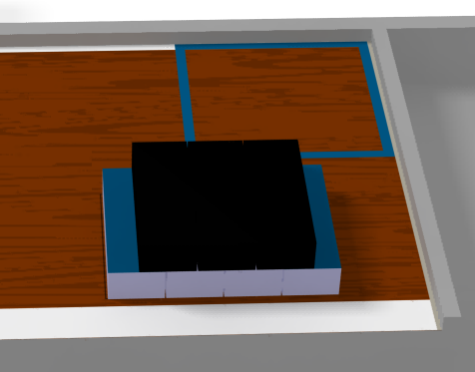
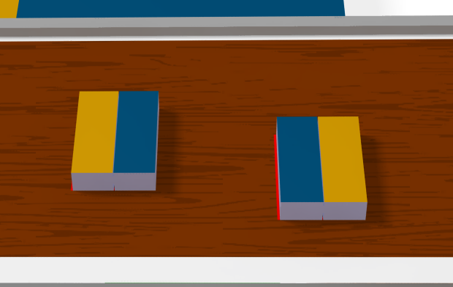

(a) Hazelnuts crates in a fridge at the start of the match. (b) Hazelnut crates in the loading area at the start of the match. Figure 4: Hazelnut crates position.

Robot constraints
5.1 Energy sources
- Chemical batteries must be CE certified
- Springs and elastic
- Compressed air
- Gravitational energy
- All other sources are prohibited
- Max 48V DC and 48V AC peak to peak
- Modify battery are prohibited
- Must be able to play 3 game in a row
Multiple sets of batteries are recommanded (and it implies an easy access to batteries)
Lithium based batteries (bad stability) are authorized:
- Suitable battery charger, need to be homologated
- Kept in certified and unmodified fireproofs bags
- Under voltage detection system

Exception for batteries with BMS (Battery management system) and Lithium-Iron batteries that are not required to respects the constraints above.

5.2 Emergency stop button
- RED emergency button required on the robot
- At least 20mm diameter
- May exceed the system’s height by 25mm
- Must be placed on top of the robot or on an easily accessible side
- Visible
- Pressed by referee or by request of the referee = end of the match, pressed by the team = forfeit
- For fire hazard, pay attention to the diameters of the wires

5.3 Lasers and high-power sources
- 1 and 1M: no restriction
- 2 tolerated if the laser does not exceed the play area and switched off otherwise
- 2M, 3R, 3B and 4 are prohibited
High power light sources are treated the same way as lasers
High power sound sources must not exceed 80 dB at 1m
Compressed air systems must not exceed 4 bars in pressure, and the use of pressurized gas cartridge is prohibited.

