**Renz Collin Capeña**

**Week 1**

In the first week of our OJT sir Noel give us an orientation of what we will do as an OJT after the orientation sir Noel give us time to become familiar and become comfortable with our daily routine  because this is different from attending in the school. Also in the first week sir Noel introduced sir Ike to us, sir Ike is the assistant of sir Noel that will manage us in OJT and also he is a developer. Lastly before the weekend sir noel give us paper works to do but we didn't finish it but we continue it on week 2.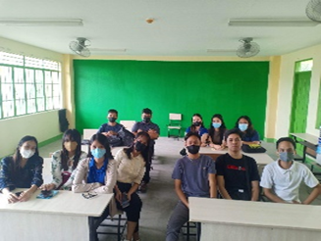

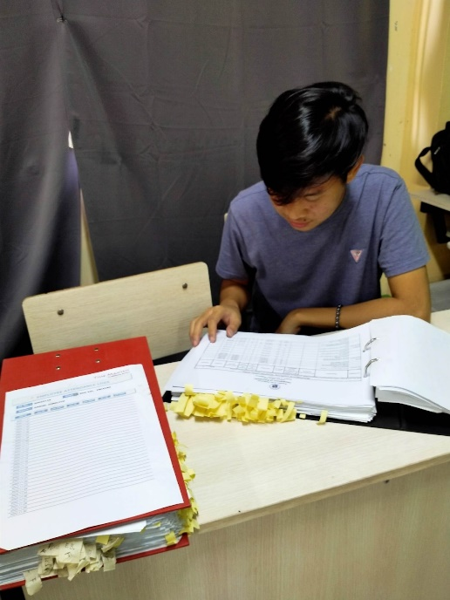

**Week 2**

In the second week we continue the paper works that sir noel give to us . After we finished the paperwork because I applied as a web developer, sir Noel told to me and my partner that we will build an inventory system so that they can easily manage the equipment of the schools. Also Sir Ike will handle me because he knows how to code and build websites and also in this week sir Ike introduced us to the technology that we are using this technology is PHP, Bootstrap, JQUERY, and AJAX. And before the weekend I start studying this technologies.

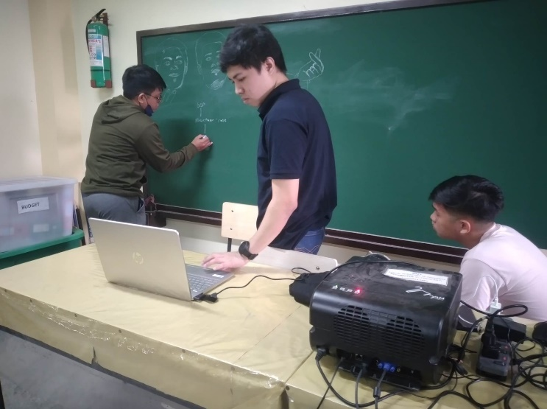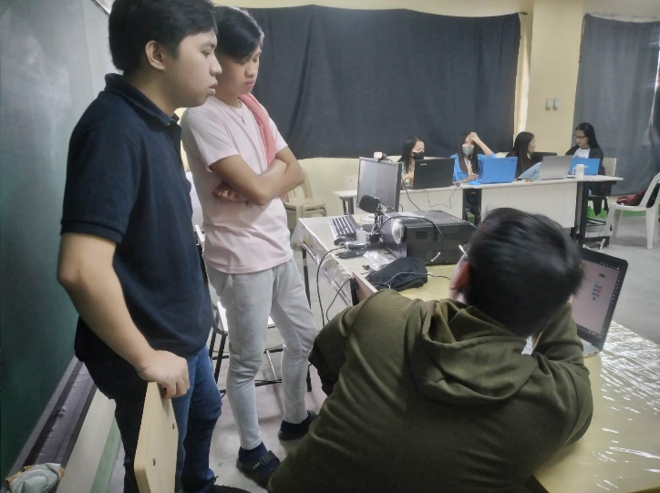

**Week 3**

In the third week of my OJT I continue to study the technology that sir Ike is talking about so that I can fully understand how it is work. At first I struggle because this is the first time that I use the Jquey, Ajax and Bootstrap but as the day has passed I learn it little by little.

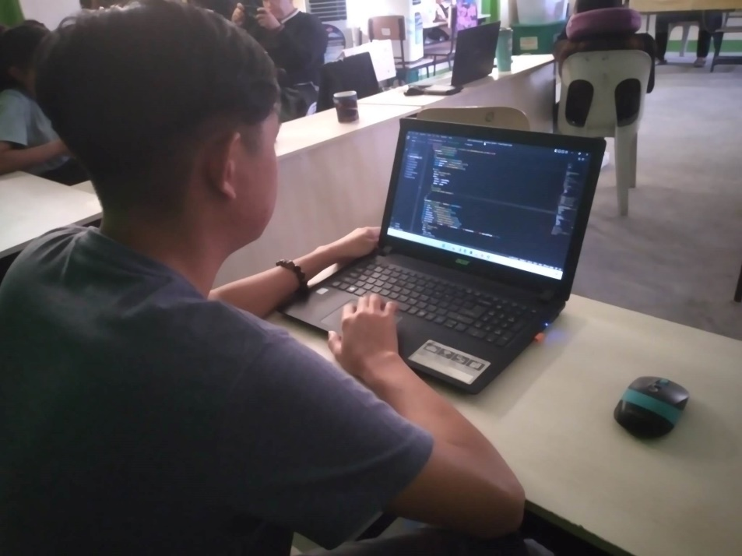

**Week 4**

In week four this is the start of building the inventory system. Also, in this week this is the start of everyday coding so that we can finish it as soon as possible. In this week we code or create the log in and the dashboard for admin and add some functionalities.

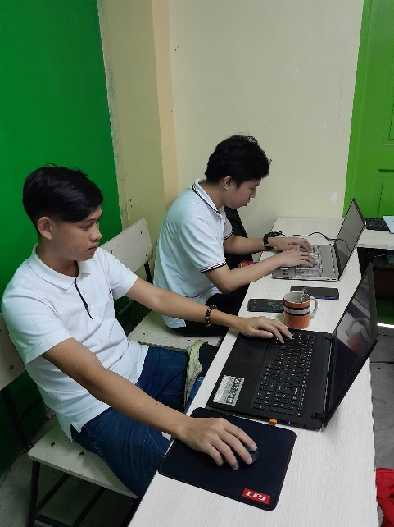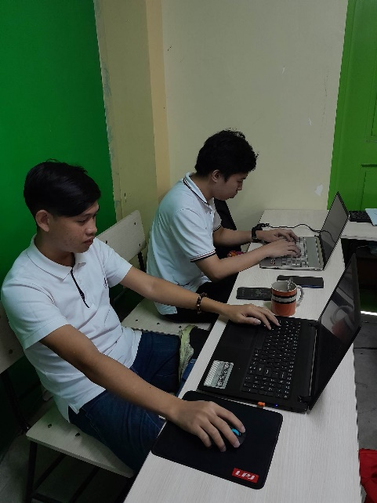

**Week 5**

In week 5 we continue to build the inventory system and add some functionalities and design so that our system will become beautiful. Also in this week we create the client dashboard.

