P167练习1：
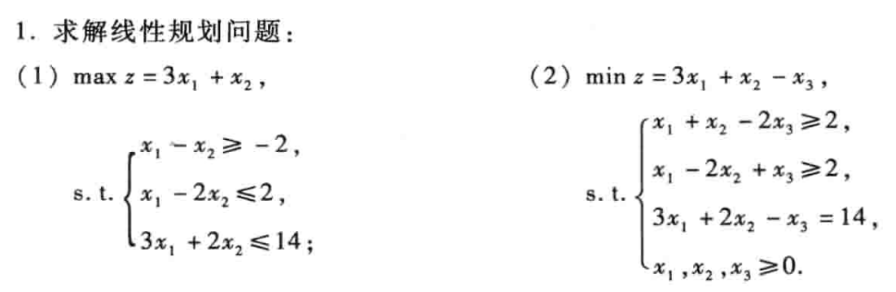
（1）c=[-3,-1];
A=[-1,1;1,-2;3,2];
b=[2,2,14];
[x,min]=linprog(c,A,b);
x
max=-min

输出：
x =
4.0000
1.0000
max =
13

∴$x_{1}=4,x_{2}=1$时，最大值为13

（2）c=[3,1,-1];
A=[-1,-1,2;-1,2,-1];
b=[-2,-2];
aeq=[3,2,-1];
beq=[14];
vlb=[0,0,0];
vub=[];
[x,min]=linprog(c,A,b,aeq,beq,vlb,vub)

输出：
x =
4.0000
2.0000
2.0000
min =
12.0000

∴x₁=4,x₂=2,x₃=2时，最小值为12
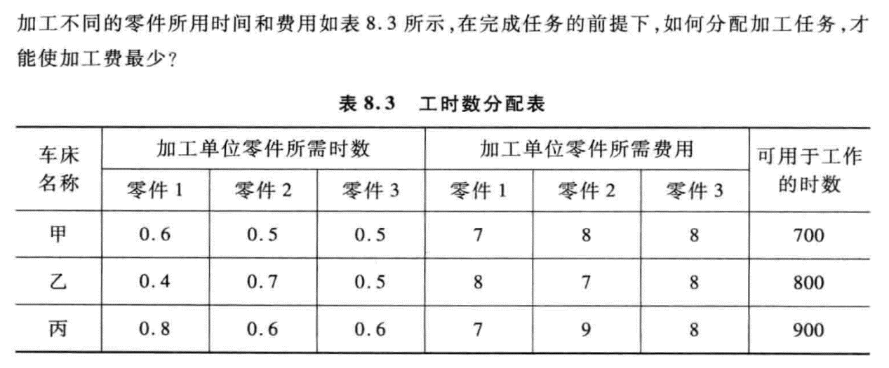
c=[7,8,8,8,7,8,7,9,8];
A=[0.6,0.5,0.5,0,0,0,0,0,0;0,0,0,0.4,0.7,0.5,0,0,0;0,0,0,0,0,0,0.8,0.6,0.6];
b=[700,800,900];
aeq=[1,0,0,1,0,0,1,0,0;0,1,0,0,1,0,0,1,0;0,0,1,0,0,1,0,0,1];
beq=[300,400,500];
vlb=[0;0;0;0;0;0;0;0;0];
vub=[];
[x,min]=linprog(c,A,b,aeq,beq,vlb,vub)

输出：
x =
300
0
500
0
400
0
0
0
0
min =
8900

∴让甲生产300个零件1，乙生产400个零件2和500个零件3，花费为8900元

P270练习一：

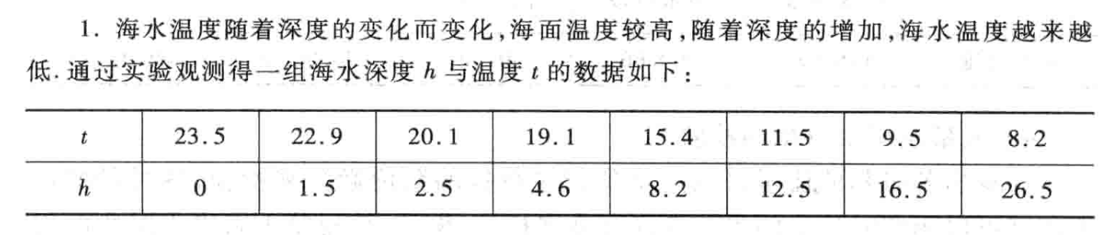
（1）
h=[0,1.5,2.5,4.6,8.2,12.5,16.5,26.5];
t=[23.5,22.9,20.1,19.1,15.4,11.5,9.5,8.2];
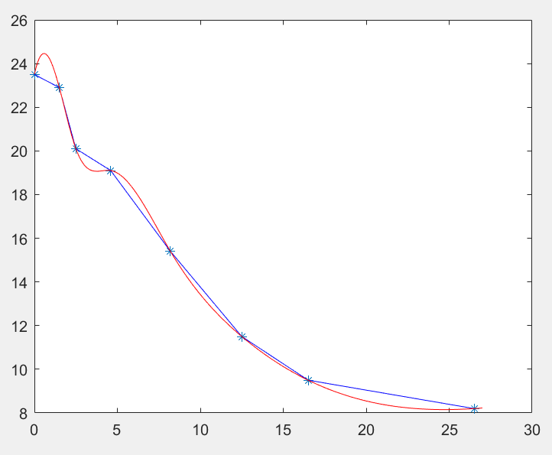
h0=0:0.1:27;
fdxx=interp1(h,t,h0);
scyt=spline(h,t,h0);
plot(h,t,'*',h0,fdxx,'b',h0,scyt,'r')
min=10;
t=0;
for i=1:270
if(fdxx(i+1)-fdxx(i)<min)
min=fdxx(i+1)-fdxx(i);
t=i;
end
end
disp("变化最快的位置：h="+h0(t)+"m")

（2）变化最快的位置：h=1.5m
温度变化快的地方可以用来海水温差发电，且发电效率更高。

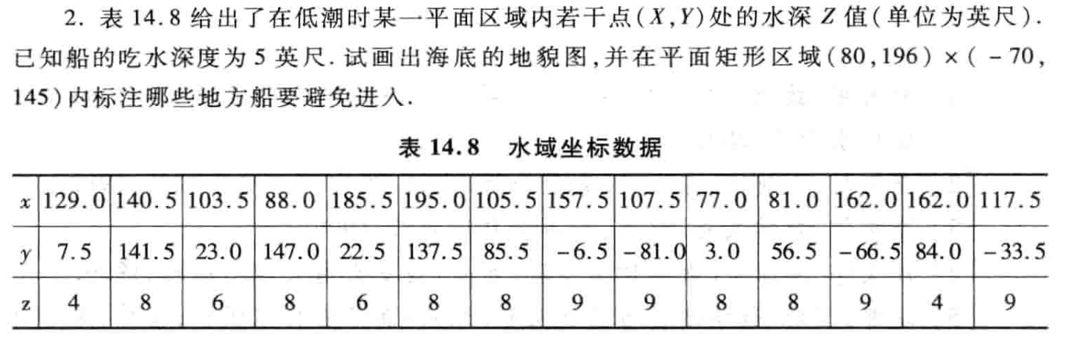
x=[129.0,140.5,103.5,88.0,185.5,195.0,105.5,157.5,107.5,77.0,81.0,162.0,162.0,117.5];
y=[7.5,141.5,23.0,147.0,22.5,137.5,85.5,-6.5,-81.0,3.0,56.5,-66.5,84.0,-33.5];
z=[4,8,6,8,6,8,8,9,9,8,8,9,4,9];
xx=77:196;
yy=-81:145;
[xxx,yyy]=meshgrid(xx,yy);
zzz=griddata(x,y,z,xxx,yyy,'cubic');
figure(1)
mesh(xxx,yyy,zzz);
figure(2)
contourf(xxx,yyy,zzz); %等高线
figure(3)
rectangle('Position',[80,-70,116,215]);
for xi=80:196
for yi=-70:145
if zzz(find(yy==yi),find(xx==xi))>5
hold on
plot(xi,yi,'b.');
end
end
end

地貌图：
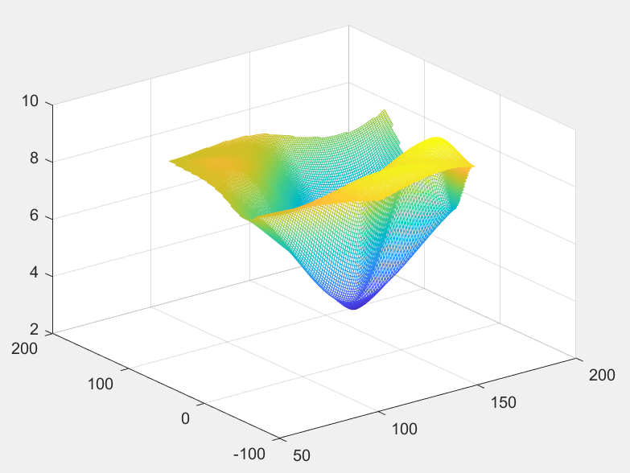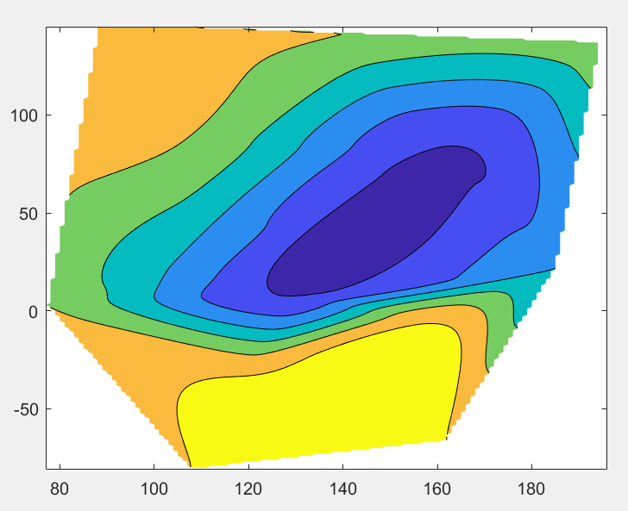
标注：
