APPENDIX

What is UI?

[1]

User interface (UI) design is the process designers use to build interfaces in software or computerized devices, focusing on looks or style. Designers aim to create interfaces which users find easy to use and pleasurable. UI design refers to graphical user interfaces and other forms—e.g., voice-controlled interfaces.

*What is User Interface (UI) design? - updated 2023* (2023) *The Interaction Design Foundation*. Available at: https://www.interaction-design.org/literature/topics/ui-design#:~:text=User%20interface%20(UI)%20design%20is,focusing%20on%20looks%20or%20style (Accessed: 03 December 2023).

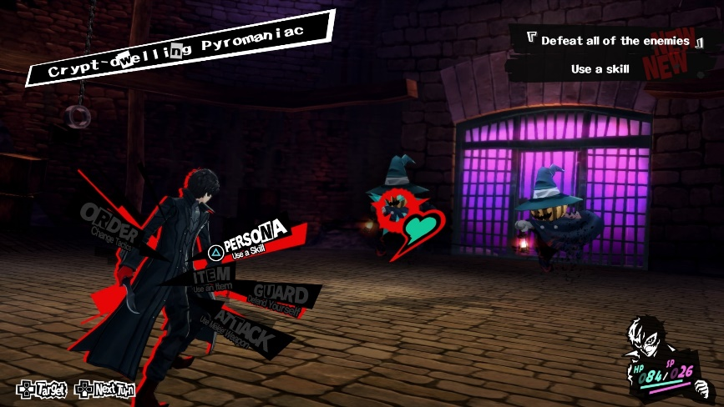[2]

(Author Gabrielle van Welie Share et al., 2022)https://www.sketch.com/blog/game-ui-design/ (Accessed: 03 December 2023).

[3]

*Game ui database* (no date) *Game UI Database*. Available at: https://www.gameuidatabase.com/uploads/Genshin-Impact01032021-021300-20448.jpg/ (Accessed: 03 December 2023).

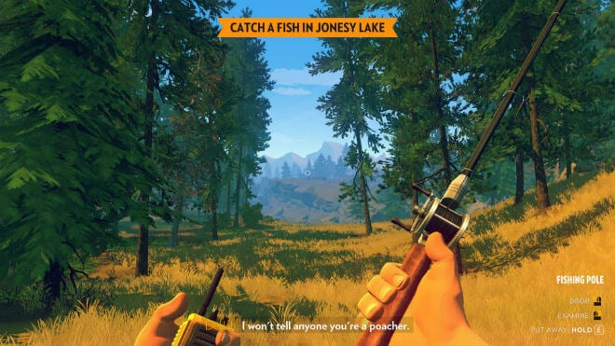[4]

Tyler, D. and About Dustin TylerInitially focused on web dev (2023) *10 inspirational game design user interfaces*, *Video Game Design and Development*. Available at: https://www.gamedesigning.org/gaming/user-interfaces/ (Accessed: 03 December 2023).

[5]

The main 2 questions when it comes to Game UI is, Does it exist in the games story? And does it exist in the games space?

The most common forms of game UI are designed with a Non diegetic style which is that the UI doesn’t exist in the story or space, the most used example of this is features such as stat bars that simply display information to the player. Diegetic style UI exists in the story and space, an example of this is a cars speed that can be displayed to the player on the main HUD instead of being inside the car where it would be too small for the player to see. There is also Spatial UI that is in the games world but isn’t in the story, an example of this is highlighted roads or imagery to take the player in the correct direction. The final method is Meta where the UI is part of the story but isn’t in the world, an example of this when the players view goes red to indicate they have been hurt or low on health.

Bowers, M. (2019) *Level up: A guide to game UI (with infographic): Toptal®*, *Toptal Design Blog*. Available at: https://www.toptal.com/designers/gui/game-ui (Accessed: 03 December 2023).

[6]