**ANJIES ARCADE FYP REPORT**

**INTRODUCTION:**

**What the project is:**

This project is a game development project where the Player can play various minigames in a setting and explore a very bright and colourful world. The player can access a lobby in which they can interact with various objects and minigames. There are 3 different games the player has access to they can play these games over and over again. Each minigame has a different style of gameplay with different themes to keep the experience fresh.

**Intended outcome:**

The main goal for the project is to have a playable character for each of the game scenes that can be controlled. The main player lobby the character should be able to walk around the area and be able to access the different minigames at each of their stations. This also includes being able to interact with different objects around the room such as posters and plants.

For the minigames, each game should be fully playable with individual scoring system. Each game will have its own objectives such as for the Maze game; it will be that the player has to make their way through the maze and collect coins throughout then find the exit. For the endless runner game the player must dodge obstacles and collect coins once again , as the game goes on the player will get faster until the player crashes into an object where the score will be displayed to them. For the final game it’s a 2D arcade game where the player(who is a cat) must escape a dog that’s chasing them while collecting health pickups displayed as fish. They must also collect coins around the map, each time they get a certain interval of coins another dog will show up to make the game harder.

For all the games the scores will be saved and the player can use them in the lobby to purchase different décor in the lobby to make it more lively.

**WHAT IS UI?**

**Diegetic**

**Non diegetic**

**Spatial**

**Meta**

**UI in games:**

User interface in games can be used for various reasons , it can be used to guide the player within the game , allow them to access different features or even be a part of the gameplay itself.  
**Intended UI usage in project:**

The main use of UI within the game will be Non diegetic as it is mainly used to interact with the interface and navigate the game. It will also be used to display scores and allow players to play the different minigames via various popups and animations.

**PROJECT MANAGEMENT**

**Agile:**

For this project the Agile methodology was used as it was the best style for this project, this is due to the nature of the project as it is a very back and forth process where many different changes occur. Multiple occasions during the project the original project plan was revisited to adjust for changes and delays in development, this was mainly due to personal circumstances such as sickness or other module deadlines.

**Trello:**

For this project I have used Trello to organise all my tasks and general project management.

This is my Trello board for this project around halfway through development.

As the project is worked on the Trello is constantly updated with new tasks and adjusting any existing tasks. It also allows me to see which tasks I have already completed without having to re check the whole project to find what I have already completed.

To make things easier, I colour coded each square to relate to a particular aspect of the game:

Blue: General Project tasks

Green: Menu Scene Tasks

Pink: Arcade Room Tasks

Purple: Maze game Tasks

Yellow: Endless Runner game Tasks

Blue: Cat Escape Tasks

Having the colours this way makes it easier to see what aspects need more work to be done on them to allow a more consistent time scale on the progress so certain parts of the game are not massively behind others.

**Gantt Chart**

The Gantt Chart for this project was primarily used for managing time on the project in comparison to the Trello which was used for the development portion of the Timeline itself. It allowed the project to be separated into different chunks to allow for time in each so that tasks didn’t overlap where it wasn’t necessary. It also allowed for good time management at the start of the project where a large portion of it was documentation and planning.

**PROJECT PLAN AND IDEAS:**

**Level Design**

The plan for the level design is aimed to be aminimalistic but simple layout and design with bright colours to bring more life to the game and make it more engaging. Each scene in the project will have a similar style with bold colours that will offset each other to allow important objects to be seen more clearly for example, in a minigame with obstacles they will be a relevant colour to showcase this. **Player Designs**

Each player for the scenes within the game are purely for being able to interact with the rest of the game, as of this moment they are not relevant to the story of the game or its world. The player in the minigames have an aim and that is complete or gain as many coins as possible. The player will have its own camera setting to be able to move around freely in the scenes. Some of the minigames have limited movement such as the endless runner the player only has control over left and right movement while the player slowly accelerates forward. **Gameplay Ideas**

The gameplay will vary between scenes such as the main lobby the player can go around the room and interact with different objects.

The Minigames have different gameplay aspects but also have very similar aspects such as coin collection will be the same throughout

**DEVELOPMENT**

Arcade Room:

The development for the arcade room began with blocking out the layout of the scene, this included the Main Bar area, the games area and the cosy area. By using the basic Unity 3d objects the layout of the lobby was mainly done which I could then plan the 3D models that would be used in the scene.

Character:

The character player for this game was mainly decided as it was a simple design that the player could use as a means to access the different minigames for the project. It is a simple animated character that brings more interest to the main lobby area.

* Design
* Models

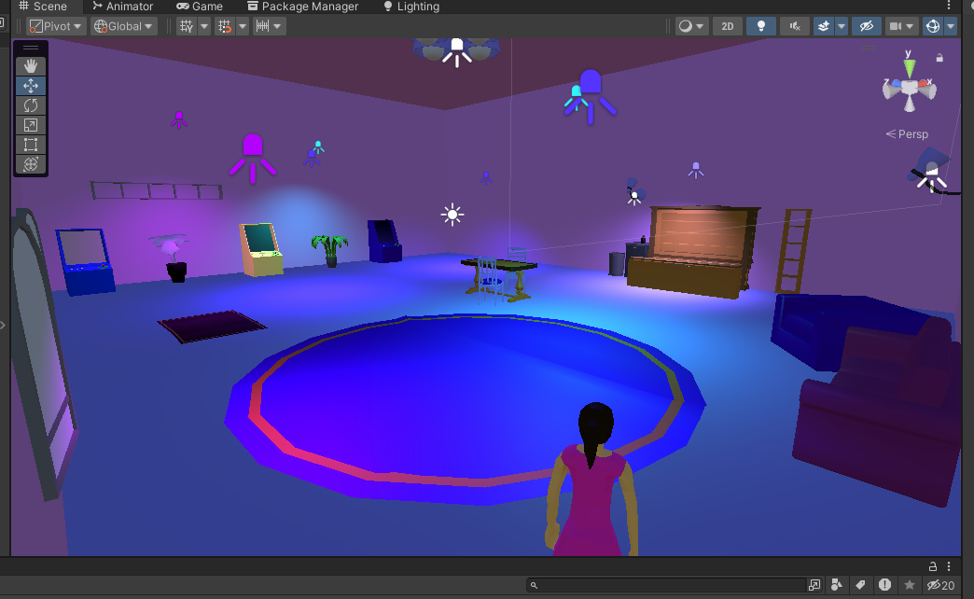

Menu

Cat Escape

Runner

Maze

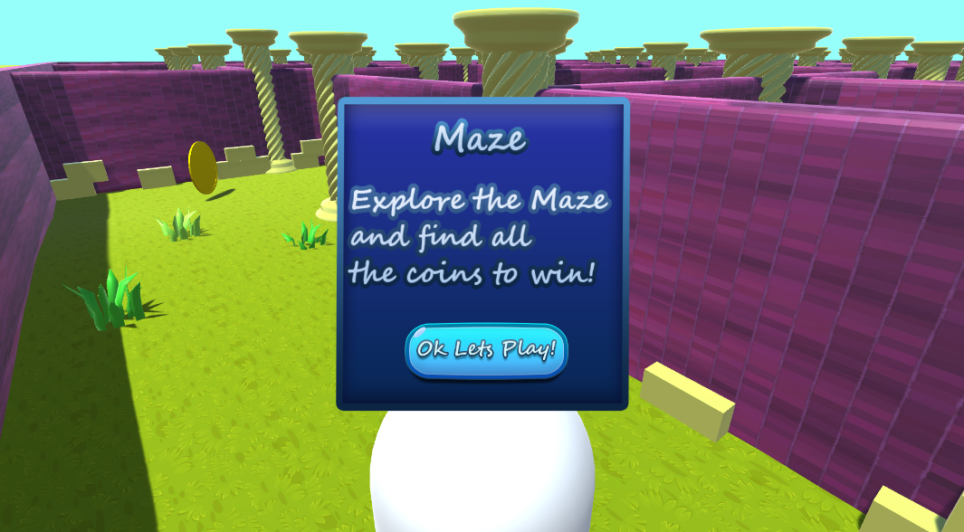

**UI**

Process:

The initial idea for the UI was to have it static so that it would be easier to lay out all the UI placement and Unity Panel settings.

The UI production started when I decided to create all my own assets in photoshop.

After some experimenting in Photoshop I decided the style I wanted the UI to be and made various different Panels and Buttons to use in the game. The general UI style I decided to go for was bubbly and bright so it stands out to the player. I then proceeded to learn more about the different features and tools within Photoshop I could use to make the UI even better.

After creating the Assets and linking them to all the relevant parts , the Canvas was divided into various panels

**Hurdles**

Code Problems:

One of the first initial code problems I had was the Timescale in Unity was not being set properly and the game would freeze whenever the scene changed, after some debugging the problem turned out to be that the timescale was being set to 0 in a separate script.

Time Constraints

Lighting

**Further Research**

**Future Development**

Other minigames

More features

**Conclusion**