# REPORT

# P2656422 ANJUMA ROUF

## INTRODUCTION

OVERVIEW

This project is an UI focussed arcade style game where the player can play different minigames within it. The research for this project will look into different arcade games that have done well such as Minecraft Hypixel which have integrated minigame functionality very well in its areas. The project will also look into UI/UX development and what kinds of UI works well in different games. I will also look at what games have done UI well and what games haven’t, I will discuss the games and what areas have inspired my project and how I will showcase that. Overall, the mains focusses for this project is to learn more about UI/UX development and how it works with different contexts and what roles it can play in the overall experience.

MOTIVATION

The main motivation for this project is that it gives me the chance to work on my strengths and improve my weaknesses. I want to work on my UI within the game development aspect as its what I want to specialise in. I also enjoy arcade games and wish to create one with my own twist and weave my UI skills into this and make something unique.

AIMS AND OBJECTIVES

The goals for the research is to find what kinds of UI does well and how I can use that information to my advantage in my project, to create an immersive and enjoyable experience for the user. I also want to look at different arcade style implementations within games such as Minecraft’s Hypixel server and different games that have done UI well. I want to look at these games and learn from how they engage the player and how they make compelling UI and minigames that players always come back to.

SCOPE

I will be limiting my research to UI in games and different arcade implementations as I want these to be my focus, these areas will help me develop my project the most. UI as a whole can branch out to any device that uses any kind of interface and so has a vast range of different areas and roles. UI is used in various contexts such as; Mobiles, Smart home systems, Medical machines, anything that uses any form of computer that allows the user to access certain features and control aspects and set settings. I have chosen to limit my scope to primarily games and general on screen User Interfaces.

## Literature review

INTRODUCTION

The main focus for my research has been to look into different games and their UI/UX as well as arcade style games that have worked well. A games experience varies based on variety of factors such as usability, genre and difficulty level. The User Interface for these factors can drastically change the whole experience and as such its very important to get it right for an application to work successfully. My research includes looking into what games have succeeded in creating an intuitive and visually pleasing interface, and then what games haven’t done well in these areas. All games have areas and aspects where they did better and worse, part of the research is evaluating where they went wrong and where they did well.

RESEARCH

What is UI/UX:

UI or User Interface is the means that a user can interact with a computer using visual imagery and words. UI designers work on making these interfaces look visually pleasing and easy to understand. Designers should think about how easy to read visuals are and visualise from the perspective of a user. Using appropriate colours also plays a big part into how UI is perceived with different shadows and making certain aspects pop out more to the user. [Appendix (1)].

UI in games:

The most common forms of game UI are Diegetic, Non-Diegetic, Spatial and Meta. [Appendix (5)]

Specifically for games the interface design focusses on visual cues to guide players to take a specified action, this can include highlighted direction signs or on-screen actions such as “Press X to do this”. This can include use of colours and shadows as well as different animations that make certain buttons pop in and out. [Appendix (1)]

Many games use a HUD (Heads Up Display) which houses majority of the key UI elements, it often includes all the information the player needs to see all the time such as health, mana bullets etc. When it comes to UI design making these elements be the most visible plays a huge role in the whole gameplay. [Appendix (2)]

From experience in various games having a simple HUD makes all the difference in the gameplay. Taking elements from this method of UI will allow me to apply them to my project.

Successful UI in Games:

There are many games that have failed in making immersive UI and many that have succeeded, researching these games I’ve found that the games with better UI have focussed on making the player experience much smoother and effortless to explain the gameplay.

Firewatch:

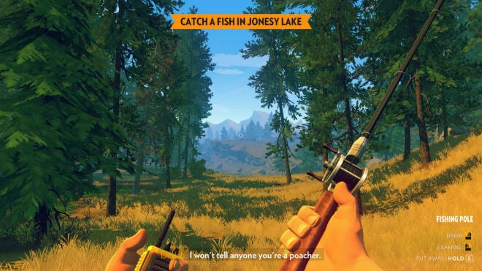A game called Firewatch has received good feedback on its UI as it has a very minimalist design to match the nature of the game. It doesn’t give the player more visuals than it needs to and shows more when the player explores further and completes more actions. It primarily uses Non diegetic UI such as the controls on the corner and Quest panels.

Appendix 4

Genshin:

I also looked at Genshin Impact to research UI as I find this game does it well. From playing this game I found that the UI only shows up to the player when its needed, so it doesn’t clutter the screen. The game itself has many aspects that require display such as damage points, enemy health bars, quest titles and tasks, gameplay tutorials, enemy information, character names and party information. The game goes between using Non-Diegetic UI such as the health bars and using Diegetic Ui such as shining objects to indicate to the player it’s a point of interest as its within the world and story. I like having more shining effects within the game, as it makes the objectives more visible and so helps game progression.

Appendix 3

Many of these aspects only show to the player when needed instead of just a cluster of screens of information which could potentially overload the player and then they can’t retain any of the information. For example, the gameplay tutorial popups for Genshin only show when the player approaches a certain puzzle or world object that requires story or gameplay instructions to it.

I feel this approach to UI works well and will use it in my own project by displaying UI and information when its needed instead of all at once. Firewatch also has a good structure to its UI that is like Genshin which I will take inspiration from.

Minigames:

For minigame style research I looked at Hypixel as it has a base world and then access to more worlds within it, like my project.

Hypixel:

Hypixel is originally a Minecraft server that hosted a variety of different minigames within it from different arcade games like Skywars, Bedwars and The Walls.

From playing these games I found that having access to multiple minigames works well as it gives the player various options to choose from. It uses spatial UI, above the interactable objects to access the game, to display high scores and people currently playing each game. I found that using the UI in this sense makes the world feel more immersive as its not just displaying the Information to the screen but instead involving it in the world.