DSA5205 Project 1
Complexity, Regularization, and Generalization
in Financial Machine Learning
Name: Siyu Gu
Student ID: A0356693M
Email: gusiyu@u.nus.edu
Course: DSA5205
Semester: Fall 2026
Report draft based on completed Tasks 1-4

1. Introduction and Overview
This project studies how model complexity and regularization affect statistical prediction and economic performance in financial machine learning. The analysis begins with a simulation benchmark motivated by Kelly, Malamud, and Zhou (2024, KMZ), where a high-dimensional return-prediction model is deliberately misspecified because the analyst observes only a subset of the true signals. I first evaluate ridge regression across model complexity and shrinkage levels, then replace ridge with Lasso to study how an alternative sparsity-inducing inductive bias changes the results. I next use internal validation to choose models for three hidden-label prediction tasks. Finally, motivated by Montanari and Urbani (2025), I examine how neural-network training time can decouple in-sample fit from out-of-sample generalization in a noisy return-prediction simulation.
The results support a common theme: complexity itself is not necessarily harmful. What matters is how effective complexity is controlled. Ridge shrinkage stabilizes high-dimensional least squares, Lasso can be valuable when predictive structure is sparse, and early stopping can act as implicit regularization for neural networks. Across all tasks, I therefore evaluate both statistical fit and economically meaningful timing performance rather than relying on training loss alone.
Task | Method | Main question
1 | Ridge regression | How do complexity and shrinkage affect OOS R², timing return, Sharpe, and coefficient norm?
2 | Lasso | How does sparsity-inducing regularization change the complexity-performance relationship?
3 | Ridge/Lasso validation | Which model and regularization level best generalize for each hidden-label dataset?
4 | Two-layer neural network | Can prolonged training improve in-sample fit while damaging OOS return prediction?

2. Task 1 - Ridge Regression under Misspecification

2.1 Simulation design
I use the project benchmark with training length T = 100, full feature dimension P = 1,000, and full complexity c = P/T = 10. The true coefficient vector is dense and isotropic, with ||β*||² = b* = 1, signal covariance Ψ = I, and noise variance σ² = 1. Returns follow R = Sβ* + ε. The analyst observes only P1 features, so empirical complexity is cq = P1/T. A single random permutation of the P columns is fixed within each simulation draw and the first P1 permuted columns are used as cq increases. This nesting ensures that changes in performance are attributable to expanding the observed information set rather than changing the feature identity.
The complexity grid is cq ∈ {0.50, 0.75, 0.90, 0.95, 0.98, 1.02, 1.05, 1.10, 1.25, 1.50, 2, 3, 5, 7.5, 10}. Ridge penalties are z ∈ {0, 0.1, 0.25, 0.5, 1, 2, 5, 10, 25, 50, 100}. For z > 0, I estimate β̂ = (X′X + zT I)^(-1)X′y. For z = 0, I use an SVD-based Moore-Penrose solution, which remains well-defined when P1 > T. Results are averaged over 10 fixed random seeds.

2.2 Evaluation metrics
For an independent test sample, predictions are ŷ = Xtest β̂ and timing returns are rπ = ŷ·y. I report the project out-of-sample R², R²paper = 1 - Σ(y-ŷ)²/Σy²; expected timing return E[rπ]; the paper Sharpe ratio E[rπ]/sqrt(E[(rπ)²]); and ||β̂||². The coefficient norm is especially informative near the interpolation boundary because unstable least-squares solutions can have extremely large norm.
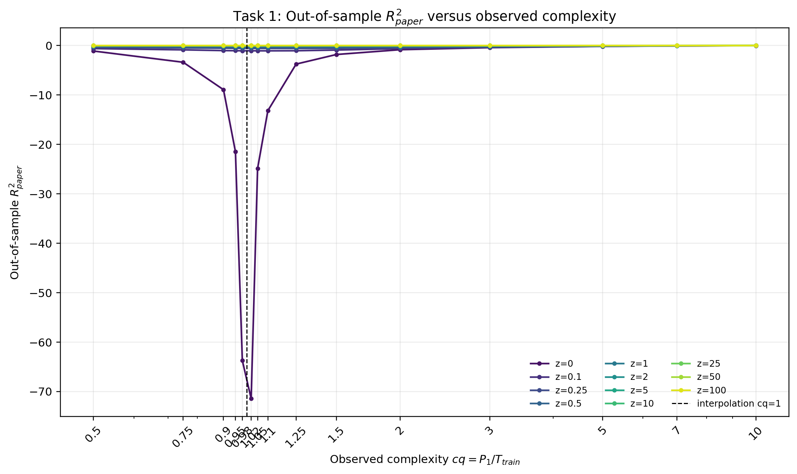
Figure 1. Task 1 out-of-sample R² as a function of observed complexity cq and ridge penalty z.
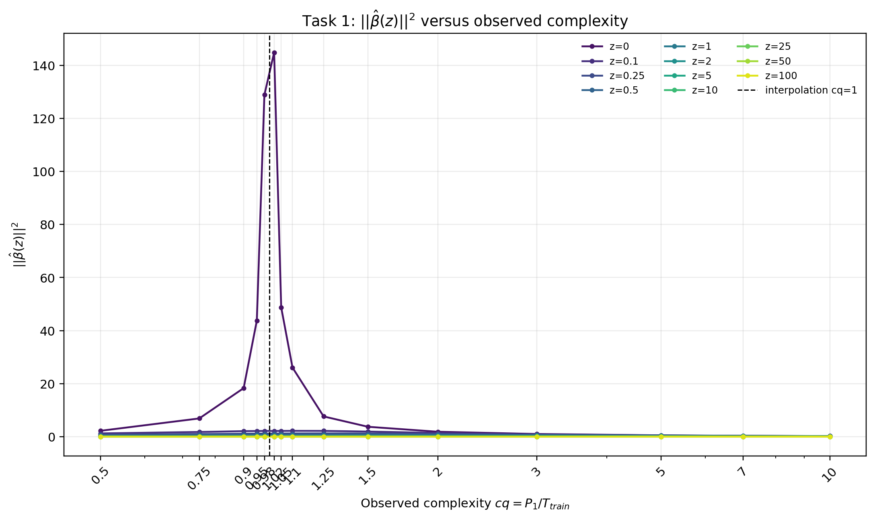
Figure 2. Task 1 squared coefficient norm ||β̂||². The ridgeless estimator becomes extremely unstable near cq = 1.

2.3 Results and interpretation
The clearest feature of the ridge benchmark is the interpolation instability of the ridgeless estimator. As cq approaches one from below, R²paper deteriorates sharply: the 10-seed average is -21.49 at cq = 0.95 and -63.72 at cq = 0.98. Immediately above the boundary it remains extremely poor (-71.46 at cq = 1.02 and -24.87 at cq = 1.05). At the same time, ||β̂||² spikes from 43.74 at cq = 0.95 to 128.88 at cq = 0.98 and 144.87 at cq = 1.02. These patterns are the finite-sample counterpart of the instability KMZ emphasize near P/T = 1.
Positive ridge shrinkage strongly dampens the coefficient explosion and stabilizes OOS behavior. Economically, the timing-return and Sharpe curves also show that statistical forecast quality and trading value need not move one-for-one. This distinction is central in KMZ: a forecast can have weak or even negative OOS R² while still containing directional information that produces positive timing value. In the misspecified setting, adding observed features also improves approximation of the full DGP, so complexity creates both a statistical cost and an approximation benefit.
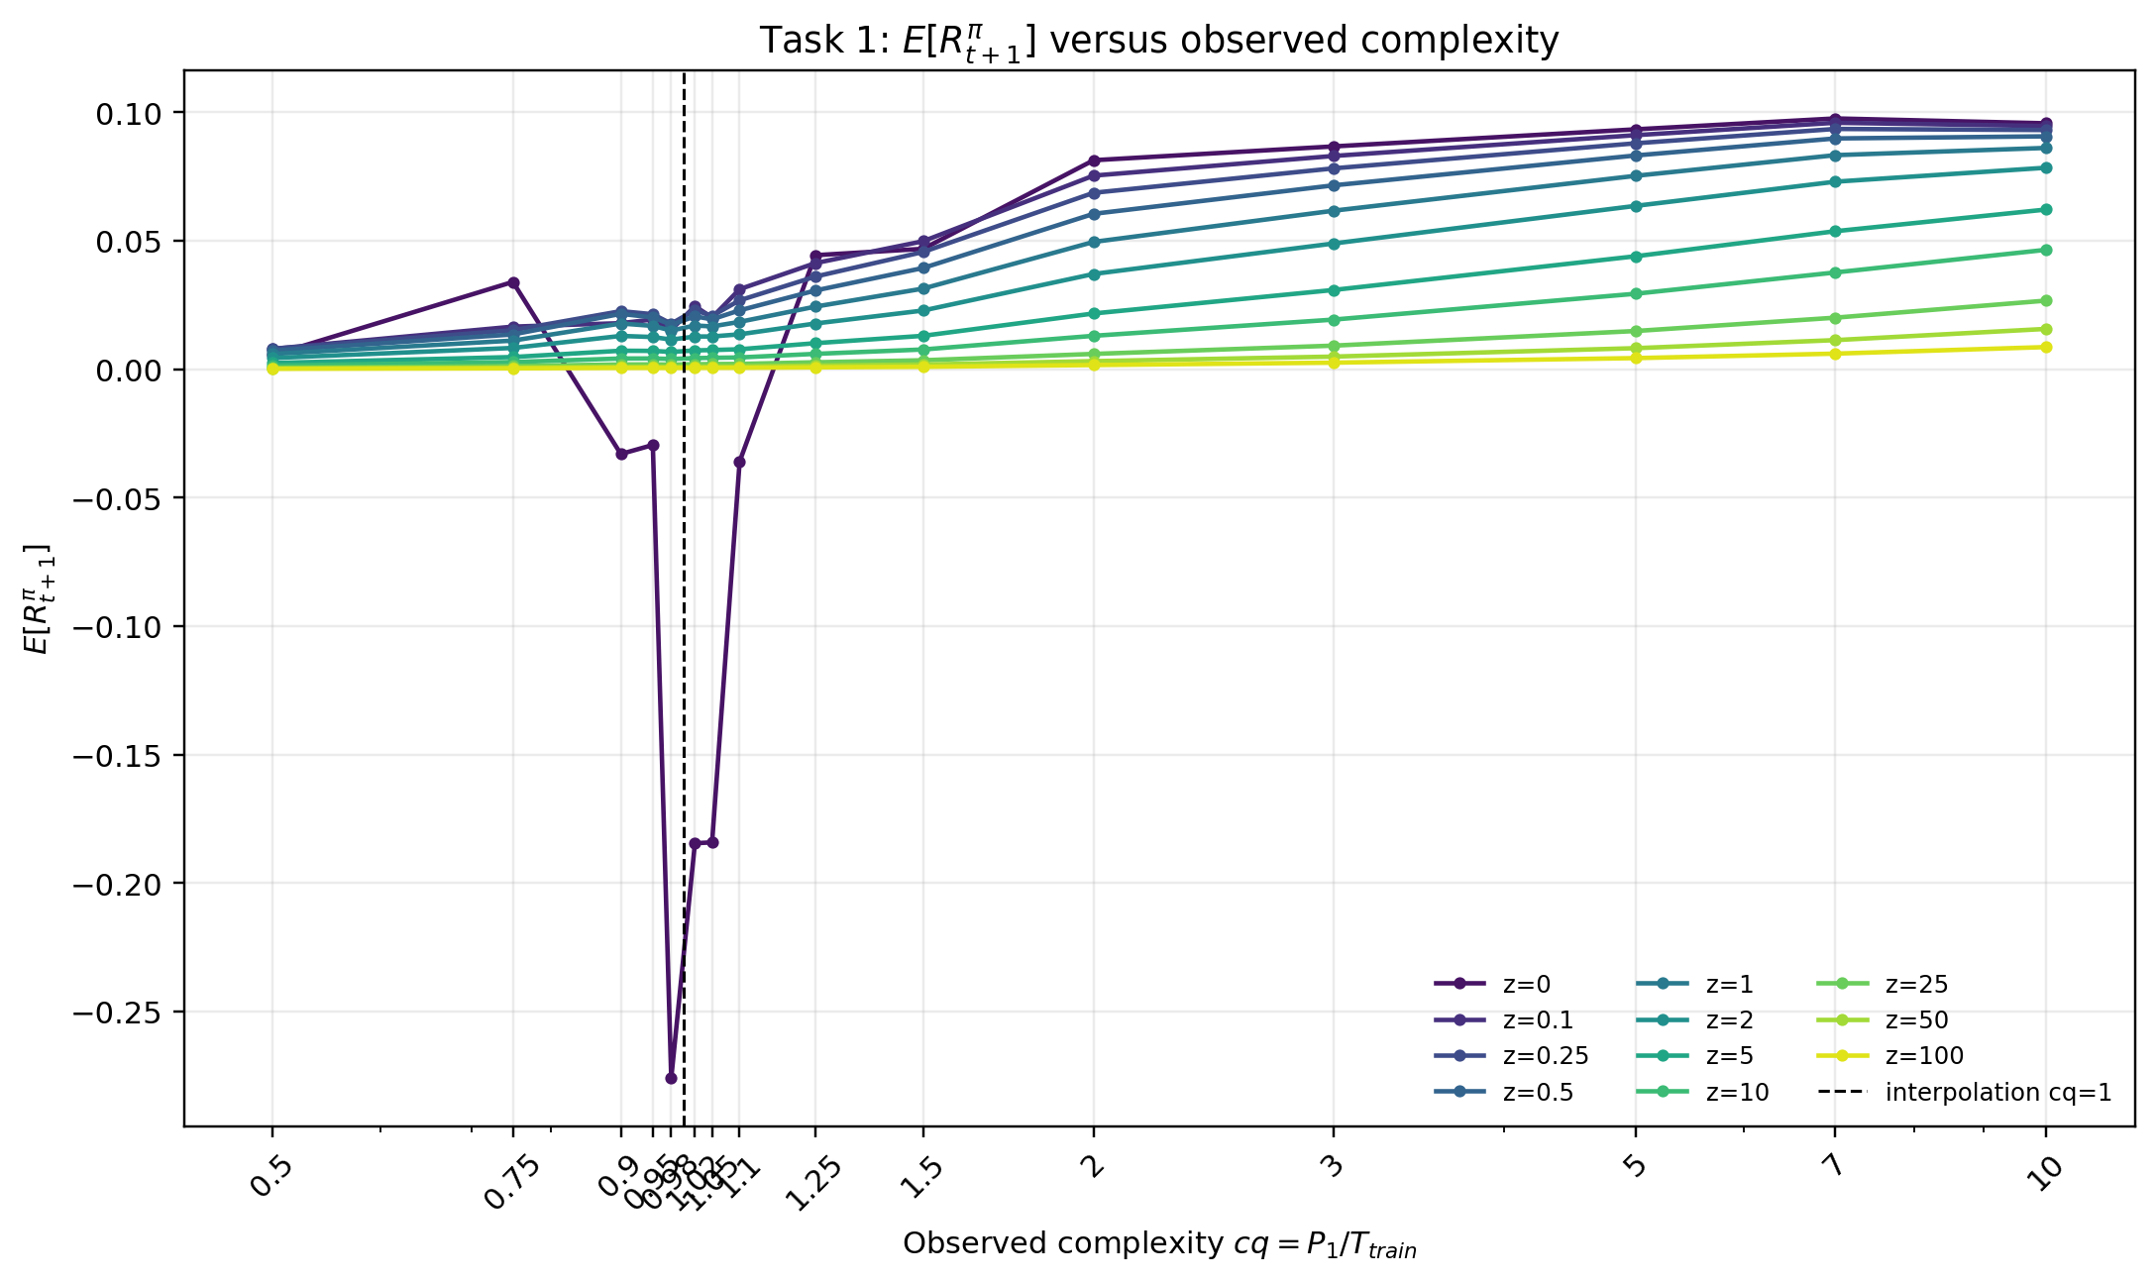
Figure 3. Task 1 expected out-of-sample timing return.
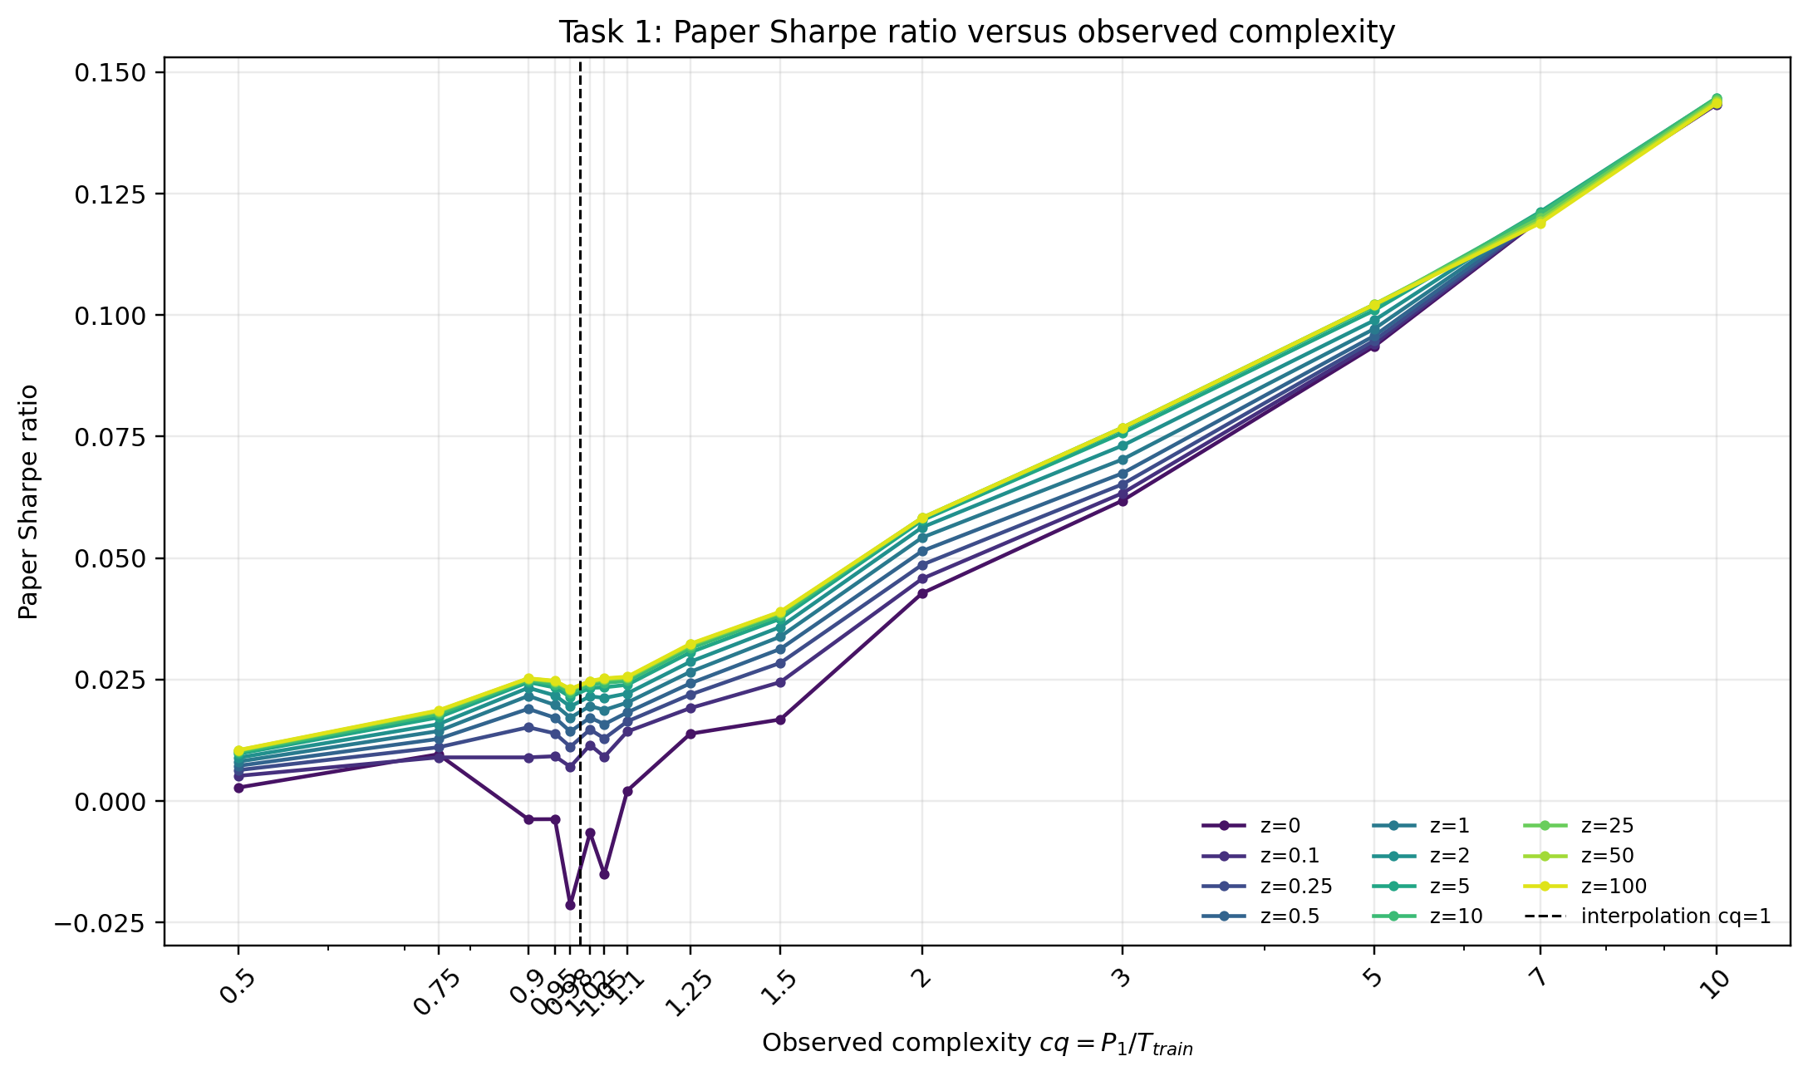
Figure 4. Task 1 paper Sharpe ratio for the timing strategy.

3. Task 2 - Lasso as an Alternative Learning Rule

3.1 Motivation and implementation
Task 2 replaces ridge with Lasso while keeping exactly the same simulated datasets, train/test splits, fixed feature ordering, and cq grid. I use the objective (1/2T)||y-Xβ||² + α||β||₁ with α = 0.05 held fixed across complexity levels. Holding α fixed isolates the effect of increasing observed complexity under a constant sparsity penalty.
Lasso is a deliberately different inductive bias from ridge. Ridge spreads shrinkage across all coefficients, whereas Lasso can set many coefficients exactly to zero. This is potentially useful when the DGP is sparse, but the Task 1 benchmark is intentionally dense and isotropic. Therefore Lasso is structurally misspecified relative to β*: it can reduce variance, but it also discards many individually weak signals that collectively contain predictive information.
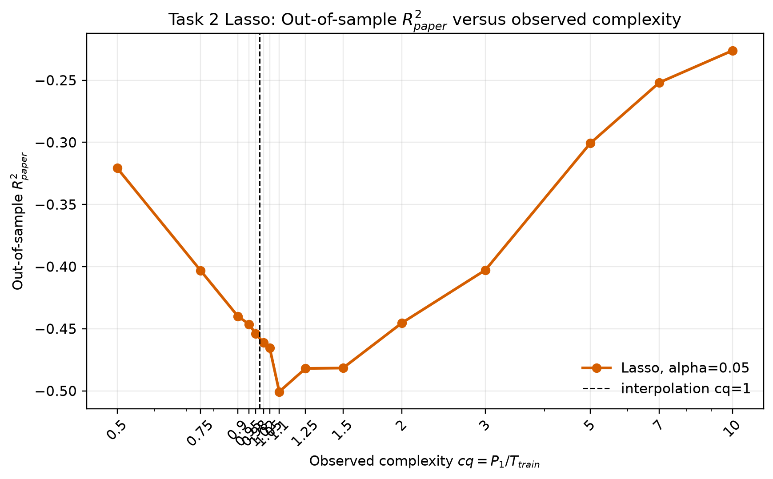
Figure 5. Task 2 Lasso out-of-sample R² across observed complexity.
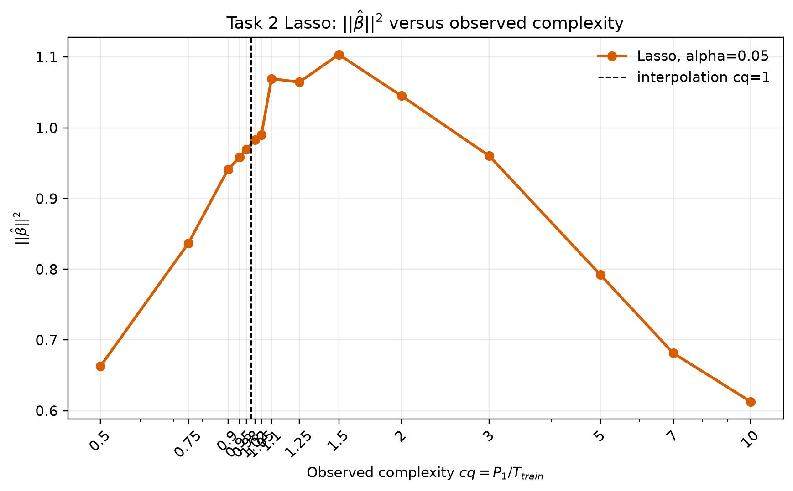
Figure 6. Task 2 Lasso coefficient norm. Unlike ridgeless least squares, Lasso prevents the norm explosion around cq = 1.

3.2 Comparison with ridge
Lasso removes the dramatic interpolation spike seen for ridgeless regression. Around cq = 1, its average coefficient norm remains close to one rather than exploding above 100, and the number of selected predictors rises gradually with P1. For example, at cq = 0.98 the average model retains about 55 nonzero coefficients and has ||β̂||² ≈ 0.97. This variance control makes Lasso much more stable near the interpolation boundary.
However, stability does not imply superior specification. Because the true β* is dense, Lasso imposes sparsity where the DGP has none. The result is a bias-variance trade-off different from ridge: Lasso avoids catastrophic variance but can sacrifice distributed signal. This exercise shows that regularization should be matched to the structure one expects in the predictive relationship. Ridge is naturally aligned with many weak signals, while Lasso is attractive when a small subset of predictors carries most of the signal.
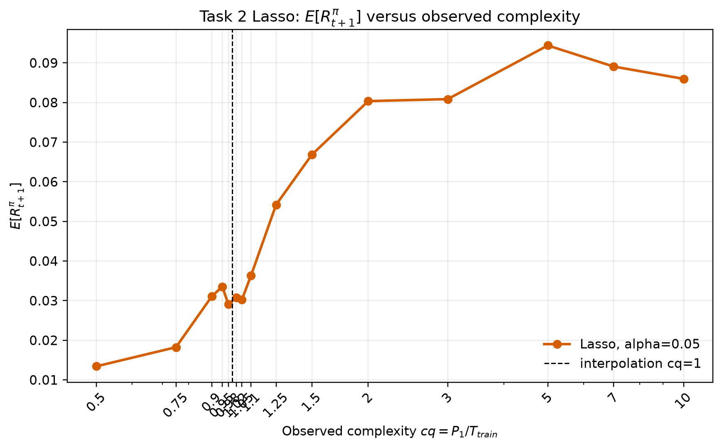
Figure 7. Task 2 expected timing return under Lasso.
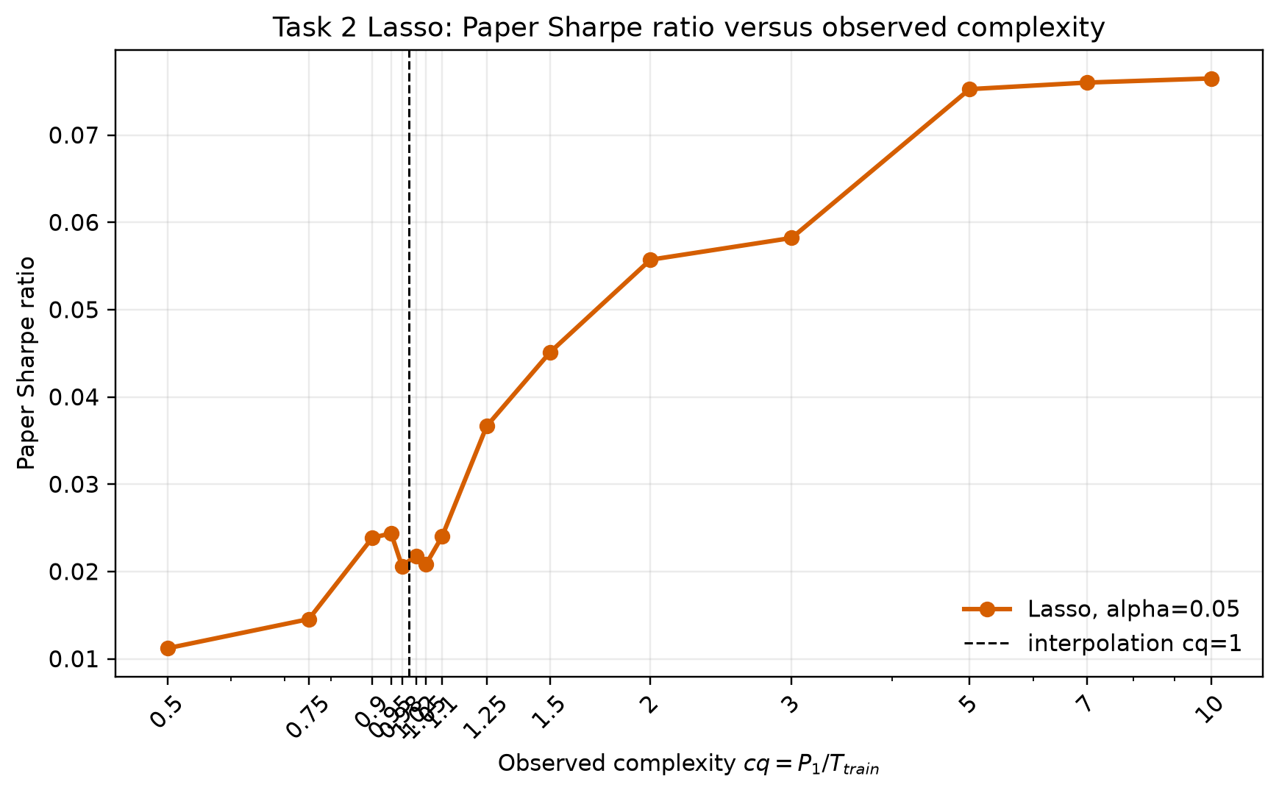
Figure 8. Task 2 paper Sharpe ratio under Lasso.

4. Task 3 - Hidden-Test Prediction

4.1 Validation protocol
For each pair A, B, and C, I use only the provided training file for model selection. Because observations are indexed by t, I use a chronological 80/20 split: the first 80% is the development sample and the last 20% is the validation block. Feature standardization is estimated on the development sample only, preventing validation leakage. I compare ridge and Lasso over prespecified regularization grids and rank candidates primarily by validation paper Sharpe ratio, with expected timing return and R²paper as secondary diagnostics. After selecting the model and regularization level, I refit preprocessing and the model on the full training sample and generate predictions for the public test features in their original t order.
Pair | Train / Features | Selected model | Validation evidence | Full-fit sparsity
A | 600 / 600 | Ridge, z = 2.0 | R² = 0.0294; Sharpe = 0.1733 | 600 nonzero
B | 240 / 2400 | Lasso, α = 0.10 | R² = -0.0159; Sharpe = 0.2179 | 79 nonzero
C | 360 / 1800 | Lasso, α = 0.20 | R² = 0.0040; Sharpe = 0.1498 | 1 nonzero after full refit

4.2 Model choices
Pair A lies exactly at P/T = 1, the interpolation boundary highlighted in Task 1. Ridge with z = 2.0 ranks first on validation Sharpe (0.1733) and also delivers positive validation R² (0.0294). The result is consistent with the need for explicit shrinkage when the feature dimension is comparable to sample size.
Pair B is highly overparameterized (P/T = 10). Lasso with α = 0.10 achieves the highest validation Sharpe (0.2179), narrowly ahead of weaker Lasso penalties and well ahead of ridge candidates, while retaining 79 coefficients after refitting on all 240 training observations. The evidence suggests that a relatively concentrated predictive structure is more useful than a dense linear fit for this dataset.
Pair C provides the strongest evidence for sparsity. Lasso with α = 0.20 is the only candidate in the ranking with clearly positive validation timing return and Sharpe; its validation Sharpe is 0.1498, whereas the next-best Lasso specification has a slightly negative Sharpe. The validation fit retains only four coefficients, and the full-sample refit leaves one nonzero coefficient. This does not prove that the hidden true β* has exactly one nonzero entry, but it indicates that the available training evidence favors a highly sparse predictive rule.
The final deliverables are three CSV files containing exactly the columns t and yhat, with rows kept in the public-test t order. No hidden test labels are used at any stage.

5. Task 4 - Training Dynamics and Early Stopping

5.1 Key discovery in Montanari and Urbani (2025)
Montanari and Urbani study large two-layer neural networks and show that learning and overfitting can occur on different dynamical timescales. With sufficiently small-complexity initialization, an early feature-learning phase discovers the low-dimensional latent structure and reduces both training and test error. On a much slower timescale, network complexity grows, training error continues toward zero, and generalization can deteriorate. In their theoretical setting, this late regime can include feature unlearning: the network progressively loses alignment with the useful latent structure while fitting noisy training observations. A key implication is that training until interpolation is generally suboptimal and that early stopping acts as implicit regularization.

5.2 Financial-ML implication and simulation
The implication is especially relevant for return prediction because realized returns contain substantial unpredictable noise. A neural network can therefore continue reducing historical training loss by fitting idiosyncratic return noise even after it has extracted the persistent predictive component. This suggests treating stopping time as a regularization hyperparameter chosen by genuine validation or OOS performance rather than by training loss.
To illustrate this mechanism, I simulate 600 training and 2,000 test observations with 20 Gaussian predictors. The conditional expected return is nonlinear and depends only on the first five features: μ(X) = 0.8 sin(X1) + 0.6 X2X3 + 0.5(X4²-1) - 0.4 tanh(X5). Realized returns add Gaussian noise with standard deviation 2. I train a two-layer ReLU network with 128 hidden neurons for 1,000 epochs using Adam. Because the DGP is simulated, I can evaluate not only realized-return test error but also error relative to the true conditional mean μ(X).
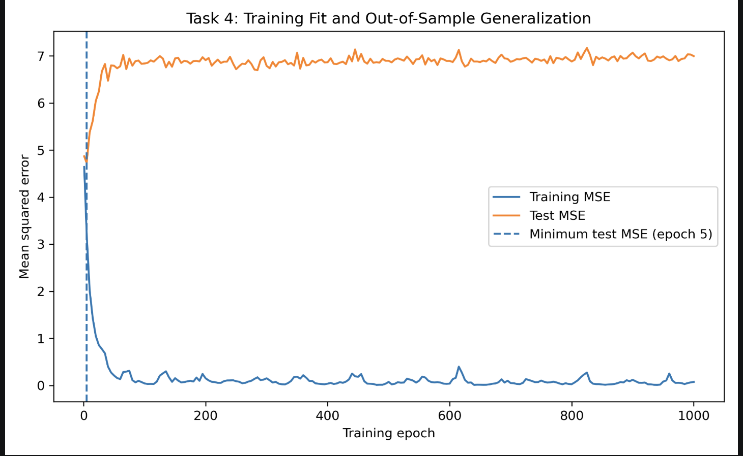
Figure 9. Training and test MSE over neural-network training. Test MSE is minimized around epoch 5, while continued optimization drives training MSE toward zero and test MSE sharply upward.
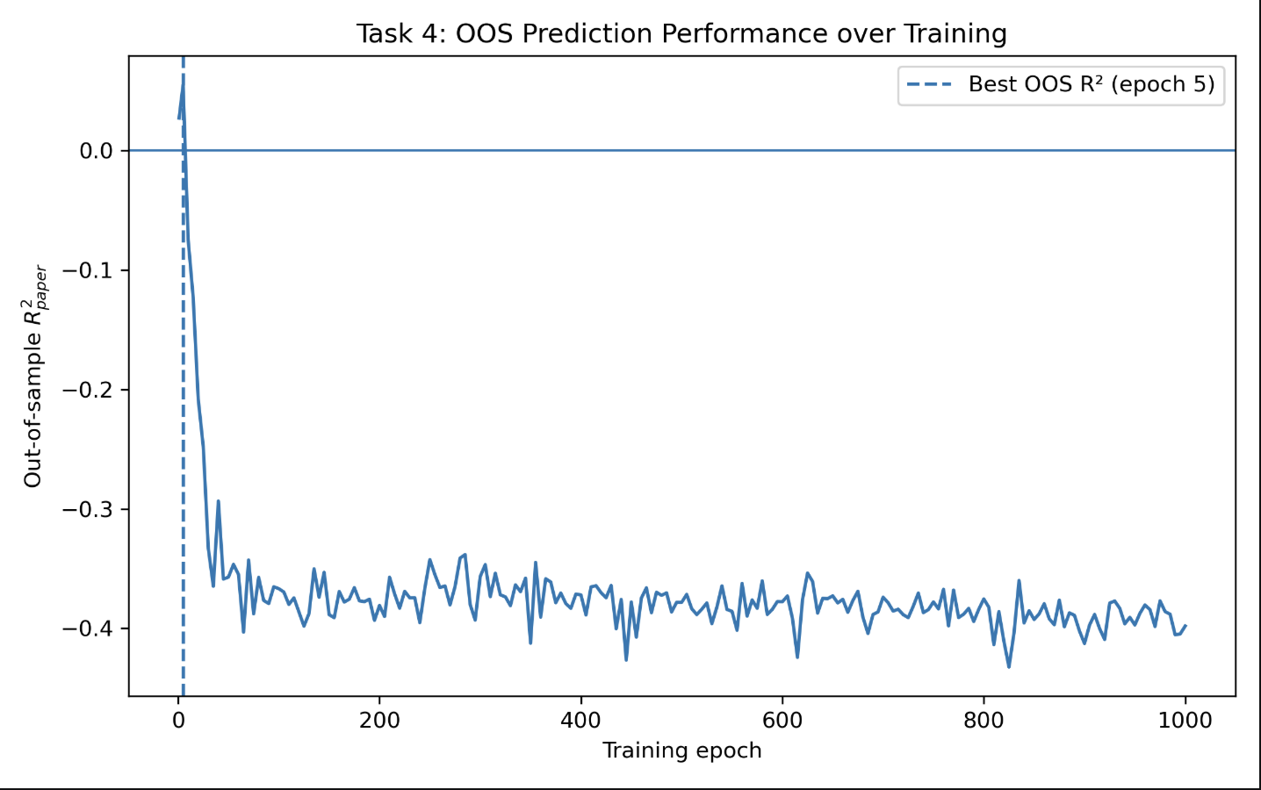
Figure 10. Out-of-sample R² over training. OOS R² is best very early and becomes strongly negative with prolonged training.
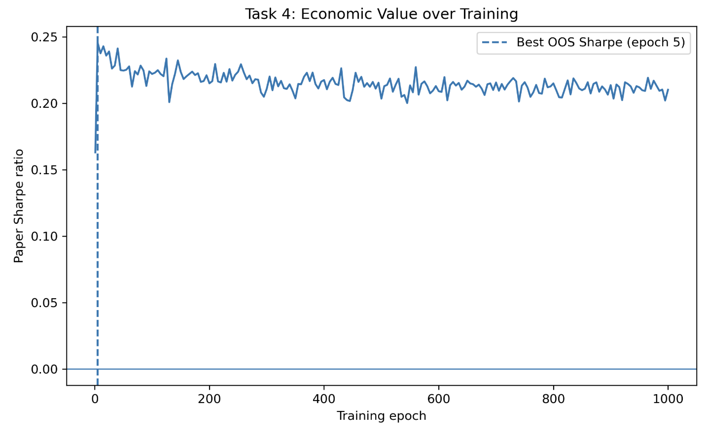
Figure 11. Economic value over training. The paper Sharpe ratio peaks around epoch 5 and then declines despite continued improvement in training fit.
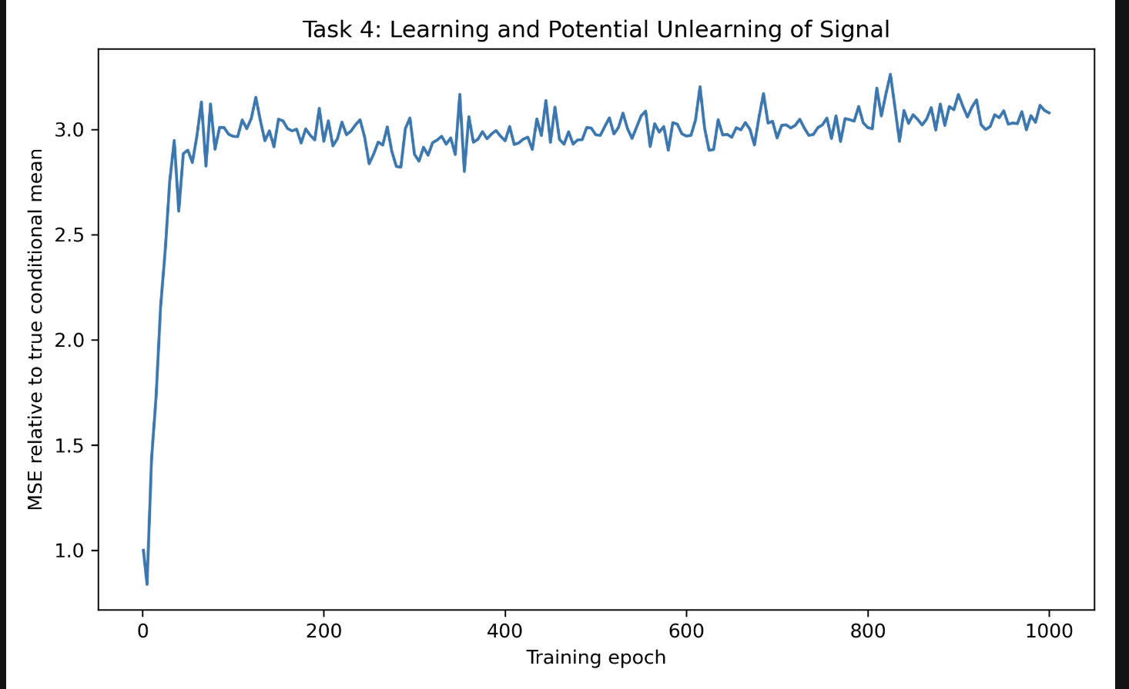
Figure 12. MSE relative to the true conditional mean. Prolonged training moves predictions farther from the true signal even while in-sample fit improves.

5.3 Interpretation and limitations
The simulation produces a sharp decoupling between in-sample fit and OOS performance. The minimum test MSE, maximum OOS R², and maximum timing Sharpe all occur around epoch 5. Continued training drives training MSE close to zero, but test MSE rises to 6.9965 and OOS R² settles -0.3980. The signal-MSE curve also rises substantially, indicating that the network is fitting realized-return noise rather than improving its estimate of the conditional mean. The Sharpe ratio declines more moderately, which again illustrates that statistical and economic metrics need not respond identically.
These results are qualitatively consistent with the learning/overfitting separation emphasized by Montanari and Urbani, but they are not a direct replication of the paper’s feature-unlearning theory. Their analysis uses a specific two-layer architecture, gradient-flow dynamics, Gaussian covariates, a low-dimensional index model, and high-dimensional asymptotics. Real financial predictors are dependent over time, non-Gaussian, non-stationary, and subject to structural breaks. The exact theoretical timescales therefore should not be transferred mechanically to markets. The robust practical lesson is narrower: validation-based early stopping can be an important form of regularization when training flexible models on noisy financial outcomes.

6. Synthesis and Conclusion
Taken together, the four tasks suggest that successful financial machine learning is less about minimizing complexity than about controlling it appropriately. In Task 1, ridgeless least squares becomes unstable around the interpolation boundary, while ridge shrinkage controls coefficient variance. In Task 2, Lasso removes the same instability through sparsity, but its inductive bias is less well matched to a dense DGP. Task 3 shows why model choice should be data-dependent: Pair A favors dense shrinkage through ridge, whereas Pairs B and C favor sparse Lasso solutions. Task 4 extends the same logic from explicit penalties to optimization dynamics: early stopping limits effective neural-network complexity before the model begins fitting noise.
This creates a useful connection between KMZ and Montanari-Urbani. KMZ show that large models can be beneficial when approximation gains dominate statistical costs and shrinkage is used appropriately. Montanari and Urbani show that, even with a fixed large architecture, effective complexity changes during training and can eventually harm generalization. Thus, “complexity itself is not the enemy; uncontrolled effective complexity is.” In financial applications, regularization can be explicit (ridge or Lasso), structural (feature selection), or implicit (early stopping), and the appropriate choice should be judged on genuine OOS statistical and economic performance.

7. Reproducibility and Submission Notes
All simulations use fixed random seeds and relative project paths. Task 1 and Task 2 reuse identical simulated datasets and splits. Task 3 standardization is fitted only on the relevant training/development data, and final models are refitted on the complete training file before public-test prediction. Task 4 fixes the NumPy, Python, and PyTorch seeds. The final code package should include README.md, requirements.txt, the four task scripts, and the required Task 3 prediction CSV files. Generated caches, .DS_Store, __MACOSX, and local plotting-cache folders should be excluded from the submission archive.

References
Kelly, B., Malamud, S., & Zhou, K. (2024). The Virtue of Complexity in Return Prediction. The Journal of Finance, 79(1), 459-503. https://doi.org/10.1111/jofi.13298
Montanari, A., & Urbani, P. (2025). Dynamical Decoupling of Generalization and Overfitting in Large Two-Layer Networks. Advances in Neural Information Processing Systems (NeurIPS 2025).
Tibshirani, R. (1996). Regression Shrinkage and Selection via the Lasso. Journal of the Royal Statistical Society: Series B, 58(1), 267-288.
Yao, Y., Rosasco, L., & Caponnetto, A. (2007). On Early Stopping in Gradient Descent Learning. Constructive Approximation, 26, 289-315.

