AI-Driven Pharmaceutical
Portfolio Analytics
Market Performance, Competitive Dynamics and Demand Forecasting Using Machine Learning
1,730  SKUs | 20  INNs | 60  months | 122.2M  2023 units
Prepared for
IQVIA Commercial Data Scientist Final Interview
Analysis date: 19 September 2026
Public development dataset; results are for interview demonstration and not an IQVIA deliverable.

Executive Summary
Decision | The portfolio remains below its 2021 peak and the validation-selected Damped ETS base case projects 114.4M units in 2024 (-6.4% versus 2023). Commercial attention should be concentrated on molecules with both positive share momentum and forward demand, while high-volume share losers require defensive review.

The 20-INN development sample generated 122.2 million pack-equivalent units in 2023, down 1.3% from 2022 and 22.3% below the 2021 peak. The decline is broad enough that portfolio planning should not assume a simple return to the prior growth path.
The early-warning classifier selected on 2022 validation achieved 58.3% Precision@Top20% and 2.33x lift on the 2023 holdout. Six-month share momentum was the most important out-of-time signal, which supports a monthly leading-indicator process rather than annual retrospective review.
The strongest 2024 percentage-growth outlooks are PREGABALINUM, ACETYLCYSTEINUM, PARACETAMOLUM. IBUPROFENUM combines positive share momentum, scale and forecast growth and is the clearest growth leader. PREGABALINUM and ACETYLCYSTEINUM are lower-share opportunities that merit targeted commercial diagnosis before investment.
Action | Priority | Why now
Invest | IBUPROFENUM; validate PREGABALINUM and ACETYLCYSTEINUM uptake drivers. | Positive momentum plus positive 2024 outlook.
Defend | ACIDUM ACETYLSALICYLICUM, PARACETAMOLUM and DICLOFENACUM. | Large current volume with recent portfolio-share loss.
Plan supply | Use Damped ETS as the governed base case; monitor its -8.4% test bias. | Reduce under-forecast and shortage risk.
Monitor | Refresh share momentum, forecast error, stock-out flags and segments monthly. | Create a commercial early-warning loop.

All values in this report are calculated from the Teva 20-INN public development sample. Units are pack-equivalent sales, not revenue.

1. Business Question and Analytical Design
The case addresses four commercial questions: where demand is growing or declining; which sampled competitors are gaining or losing share; which molecules are most likely to improve over the next six to twelve months; and how forecasting plus portfolio segmentation can guide limited commercial attention.
The analysis follows the decision path from raw SKU sales through feature extraction, market definition, competitive analytics, portfolio segmentation, early-warning classification, demand forecasting and transparent action rules. All validation is time ordered. No result uses a random train/test split.
Scope | The dataset supports unit-demand and sampled portfolio analytics. It does not support revenue forecasting, pricing elasticity, promotion ROI, patient or HCP targeting, market access analysis, profitability decisions or discontinuation recommendations.

1.1 Dataset and data engineering
Element | Implementation
Grain | One row per pharmaceutical SKU (Morion ID).
Coverage | 1,730 SKUs; 20 INNs; 2019-01 to 2023-12.
Sales | 60 monthly columns measuring pack-equivalent unit demand.
Hierarchy | ATC1-ATC5, INN, anonymized brand and SKU.
Text features | Strength, unit, pack size and simplified dosage-form category parsed from Description/NFC.

1.2 Data quality findings
Check | Result
Completeness | 0 missing and 0 negative sales values.
Zero sales | 32.0% of SKU-months; retained as possible availability/intermittency signals.
Text extraction | Strength 98.6%; pack size 97.3%.
Potential stock-outs | 305 zero gaps between two positive months; flagged, not deleted.
Potential spikes | 161 local spikes; retained for aggregate demand and sensitivity review.

1.3 Market definition
The preferred competitive market is ATC4. When an ATC4 group contains fewer than two sampled INNs, the analysis falls back to ATC3. If the fallback still has no sampled peer, competitive share is not reported. Twelve of the 20 INNs have at least one usable ATC4 or ATC3 peer context; the rest are evaluated with explicitly labeled portfolio-share metrics.
Caveat | The file is a purposive 20-INN development sample, not a complete market census. Reported shares are sample shares and must not be interpreted as external market shares.

2. Market Performance and Competitive Dynamics
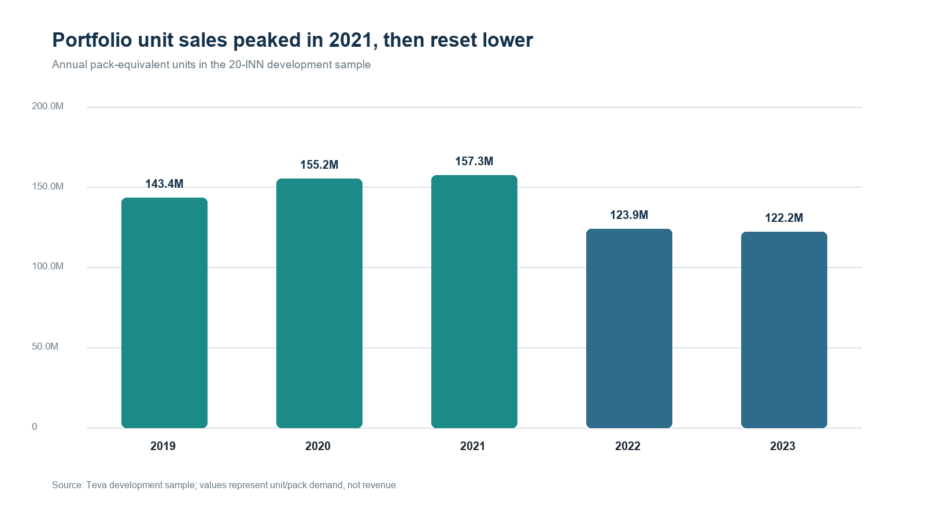
Figure 1. Annual portfolio unit sales, 2019-2023.
Source: author analysis of the Teva 20-INN development sample.
Portfolio demand increased 8.2% in 2020 and 1.4% in 2021, then contracted 21.3% in 2022 and 1.3% in 2023. The apparent stabilization in 2023 masks material molecule-level divergence.

2.1 Molecule performance
INN | 2023 units | YoY | Portfolio share | Share change
ACIDUM ACETYLSALICYLICUM* | 22.4M | -4.1% | 18.3% | -0.5 pp
IBUPROFENUM | 13.4M | 8.4% | 11.0% | 1.0 pp
PARACETAMOLUM | 12.0M | -12.6% | 9.8% | -1.3 pp
DICLOFENACUM | 11.8M | -3.5% | 9.6% | -0.2 pp
BISOPROLOLUM | 10.1M | 2.5% | 8.3% | 0.3 pp
METFORMINUM | 7.7M | -0.5% | 6.3% | 0.1 pp

ACIDUM ACETYLSALICYLICUM was the largest molecule at 22.4M units, but its sample share declined 0.5 percentage points. IBUPROFENUM grew 8.4% and gained 1.0 point of portfolio share, making it the strongest high-volume momentum story. PARACETAMOLUM remained the third-largest molecule but fell 12.6% and lost 1.3 points.

2.2 Sampled peer-market dynamics
INN | Sampled market | Market growth | Share change | Share effect
ROSUVASTATINUM | C10A A HMG CoA reductase inhibitors | 19.0% | 3.0 pp | 156,231
ATORVASTATINUM | C10A A HMG CoA reductase inhibitors | 19.0% | -3.0 pp | -156,231
IBUPROFENUM | M01A ANTIINFLAMMATORY AND ANTIRHEU… | 3.6% | 2.0 pp | 519,327
MELOXICAMUM | M01A ANTIINFLAMMATORY AND ANTIRHEU… | 3.6% | 1.1 pp | 275,892
DICLOFENACUM | M01A ANTIINFLAMMATORY AND ANTIRHEU… | 3.6% | -3.1 pp | -795,219
PREGABALINUM | N02B OTHER ANALGESICS AND ANTIPYRE… | -4.6% | 3.7 pp | 996,852
ACIDUM ACETYLSALICYLICUM* | N02B OTHER ANALGESICS AND ANTIPYRE… | -4.6% | 0.4 pp | 99,463
PARACETAMOLUM | N02B OTHER ANALGESICS AND ANTIPYRE… | -4.6% | -4.1 pp | -1,096,315

Within sampled statins, ROSUVASTATINUM gained 3.0 points of share while ATORVASTATINUM lost the same amount. The statin market grew 19.0%, so both market expansion and competitive mix mattered.
Within systemic NSAIDs, IBUPROFENUM gained 2.0 points and generated a +519k share effect; DICLOFENACUM lost 3.1 points and a -795k share effect. Within other analgesics/antipyretics, PREGABALINUM gained 3.7 points despite a 4.6% market decline, producing a +997k share effect, while PARACETAMOLUM lost 4.1 points and a -1.10M share effect.
Commercial implication | Growth decomposition separates category tailwind from competitive execution. Molecules growing because the sampled market expands should not receive the same diagnosis as molecules gaining share in a declining market.

3. Portfolio Segmentation
INN-level commercial, demand and product-complexity features were standardized and compared across K=3, K=4 and K=5 solutions. K=4 produced the highest silhouette score (0.232 versus 0.208 and 0.211), so it was selected for descriptive archetypes.
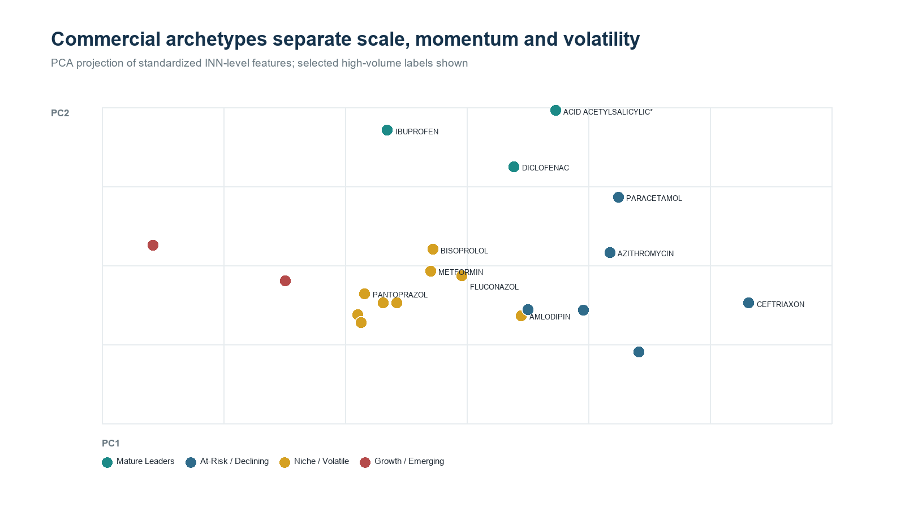
Figure 2. PCA projection of the four commercial archetypes.
Source: standardized INN features; PCA is used for visualization only.
Archetype | INNs | 2023 units | Avg YoY | Avg share change | Avg 2024 growth
Growth / Emerging | 2 | 6.1M | 38.8% | 0.7 pp | 8.1%
Niche / Volatile | 9 | 40.6M | 8.7% | 0.2 pp | -26.4%
Mature Leaders | 3 | 47.5M | 0.2% | 0.1 pp | 0.9%
At-Risk / Declining | 6 | 28.0M | -13.3% | -0.6 pp | -4.3%

The Growth/Emerging cluster contains PREGABALINUM and ROSUVASTATINUM, both with strong recent momentum. Mature Leaders contain the largest established molecules. The At-Risk/Declining group has the highest average volatility and negative historical growth. Clusters remain descriptive; action recommendations use forward-looking rules rather than cluster membership alone.

4. Commercial Opportunity Model
The target is a Future Share Winner: an INN whose six-month-ahead change in portfolio share ranks in the top quartile at a given anchor month. This portfolio-level fallback is necessary because most sampled ATC markets do not contain enough peers for stable market-specific labels.
Period | Anchor months | Purpose
Training | 2020-01 to 2021-12 anchors | Feature learning
Validation | 2022-01 to 2022-06 anchors | Hyperparameter and model selection
Test | 2022-07 to 2023-06 anchors | One-time out-of-time evaluation

Model | Val PR-AUC | Test PR-AUC | Test P@20 | Test Lift@20
Logistic L2 | 70.5% | 69.5% | 68.8% | 2.75x
Elastic Net | 74.3% | 61.6% | 64.6% | 2.58x
Random Forest | 74.4% | 61.3% | 58.3% | 2.33x
Boosted Trees | 76.6% | 64.2% | 60.4% | 2.42x

Random Forest was selected on the validation period and achieved 75.2% ROC-AUC, 61.3% PR-AUC, 58.3% Precision@20% and 2.33x Lift@20% on the holdout. In operational terms, the model more than doubled the concentration of future winners in the top-fifth review list relative to the 25% base rate.
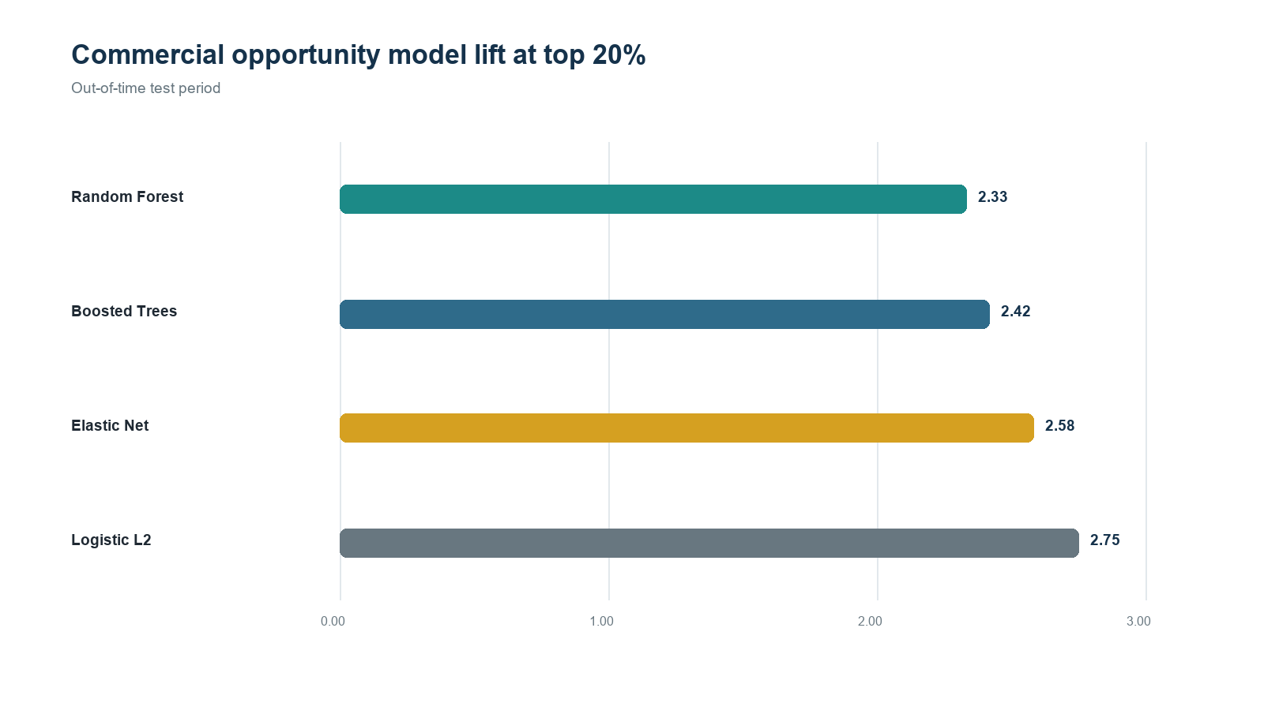
Figure 3. Test-period Lift@20% by opportunity model.
Model selection was based on 2022 validation, not 2023 test performance.
Logistic regression produced the highest test lift, but it was not retrospectively promoted because that would use the test set for selection. This is an important model-governance point: the honest conclusion is that ranking is useful, while model choice should be revisited only after another prospective period.

4.1 Explainability
Feature | Test PR-AUC drop when permuted
share_change6 | 0.175
log_strength_count | 0.020
growth6 | 0.019
share_change3 | 0.015
relative_growth12 | 0.007

Six-month share change was by far the strongest out-of-time signal. Strength breadth, six-month growth and three-month share change also contributed. These importances are predictive, not causal; they identify monitoring signals, not levers guaranteed to create growth.

5. Demand Forecasting
Forecasts were produced at INN-by-month level. Seasonal Naive, damped ETS, a global ridge autoregression with calendar and lag features, shallow global boosted trees and a validation-weighted ensemble were compared. All 2023 forecasts were generated without using 2023 outcomes.
Model | Val WAPE | Test WAPE | Test MASE | Test bias
Seasonal Naive | 44.8% | 22.7% | 0.66 | 1.3%
Damped ETS | 28.4% | 23.1% | 0.67 | -8.4%
Global Ridge ARX | 37.6% | 25.9% | 0.75 | -20.0%
Global Boosted Trees | 39.0% | 19.5% | 0.57 | -7.7%
Validation-weighted Ensemble | 30.1% | 16.3% | 0.48 | -9.1%

Damped ETS won the 2022 validation comparison with 28.4% WAPE and was therefore selected before opening the 2023 holdout. On 2023 it delivered 23.1% WAPE, 0.67 MASE and -8.4% bias. The negative bias indicates under-forecast risk and should be monitored in supply planning.
Model risk | The validation-weighted ensemble achieved a lower 2023 WAPE (16.3%) than the governed Damped ETS model, but it did not win the earlier validation period. Treat this as a hypothesis for the next prospective backtest—not permission to re-select on the holdout.

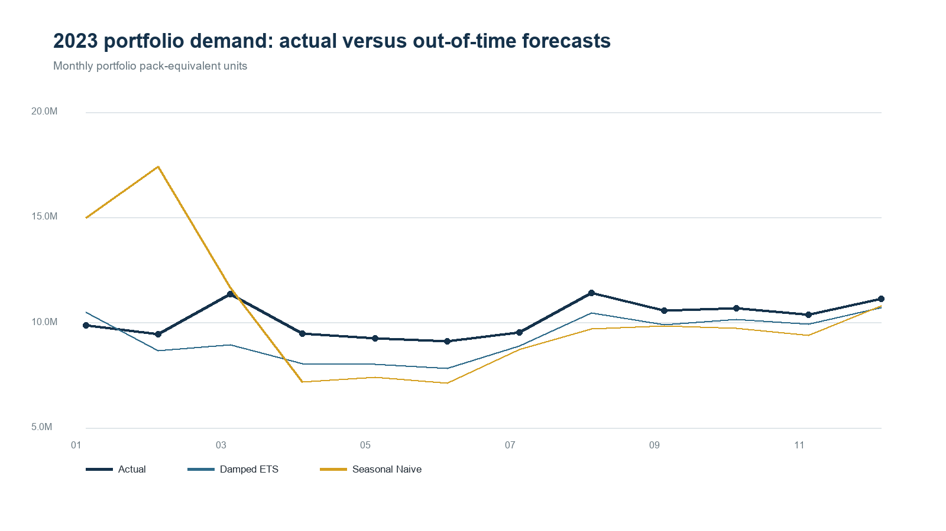
Figure 4. 2023 portfolio demand: actual versus governed forecast and seasonal baseline.
Source: out-of-time forecasts aggregated from INN-level predictions.

5.1 2024 base case
After refitting the validation-selected model on all 2019-2023 data, the bottom-up reconciled 2024 portfolio forecast is 114.4M units, -6.4% below 2023. The empirical 80% ranges are calibrated from 2022 log residuals and reflect historical forecast error, not external event scenarios.
INN | 2023 units | 2024 forecast | Growth | Action
PREGABALINUM | 2.6M | 3.3M | 22.9% | Emerging Opportunity
ACETYLCYSTEINUM | 2.0M | 2.3M | 16.6% | Emerging Opportunity
PARACETAMOLUM | 12.0M | 13.7M | 14.1% | Defend
AZITHROMYCINUM | 4.0M | 4.5M | 12.4% | Market-led Growth
IBUPROFENUM | 13.4M | 14.7M | 9.9% | Growth Leader
ACIDUM ACETYLSALICYLICUM* | 22.4M | 24.4M | 9.3% | Defend
AMBROXOLUM | 3.7M | 3.7M | 1.7% | Emerging Opportunity
ROSUVASTATINUM | 3.5M | 3.3M | -6.6% | Monitor

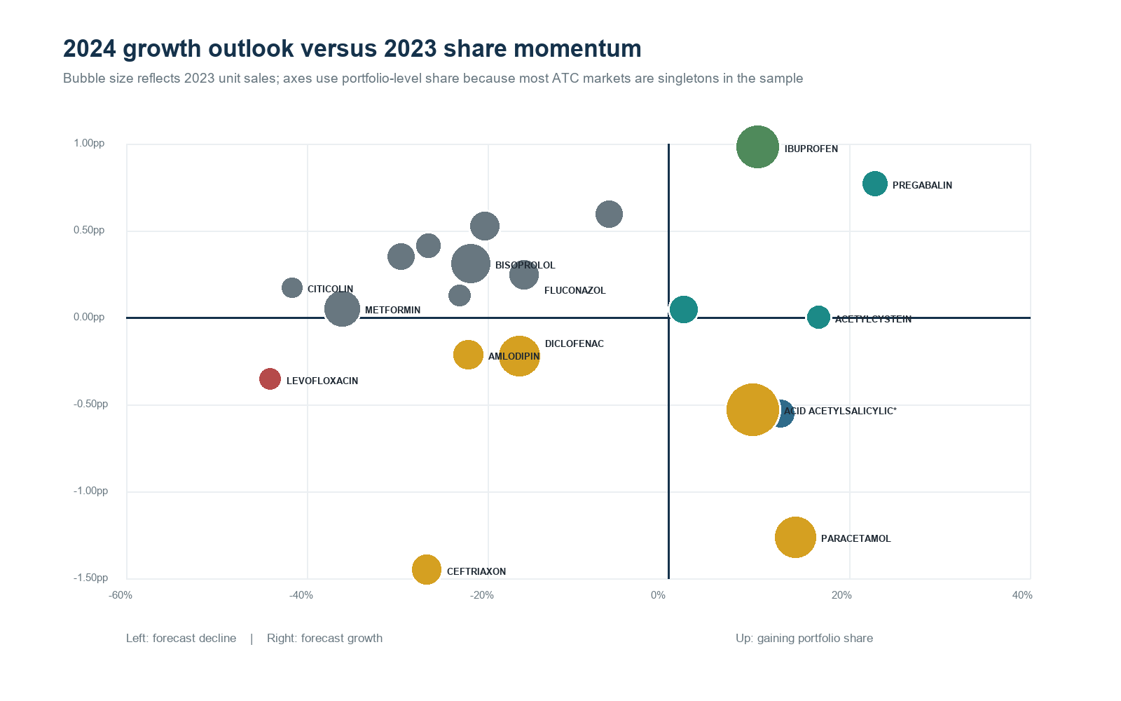
Figure 5. 2024 forecast growth versus 2023 portfolio-share momentum.
Axes use portfolio-level share because most ATC markets are singletons in the development sample.
IBUPROFENUM is the clearest scaled growth leader. PREGABALINUM and ACETYLCYSTEINUM are emerging opportunities. PARACETAMOLUM and ACIDUM ACETYLSALICYLICUM have positive demand outlooks but negative share momentum, so growth should be paired with a competitive-defense diagnosis. LEVOFLOXACINUM has both negative share momentum and the weakest forecast growth and is the clearest at-risk signal.

6. Commercial Recommendations
Recommendation | Scope | Commercial action
1. Prioritize growth leaders | IBUPROFENUM | Maintain commercial support and ensure supply can capture continued demand; investigate which strengths/forms drive the gain.
2. Develop emerging opportunities | PREGABALINUM; ACETYLCYSTEINUM | Validate uptake drivers, distribution and formulation mix before incremental spend.
3. Defend high-volume franchises | Aspirin; PARACETAMOLUM; DICLOFENACUM | Diagnose sampled share loss, competitor substitution and formulation-level displacement.
4. Manage forecast risk | Portfolio | Run Damped ETS as the governed baseline, monitor bias monthly and prospectively challenger-test the ensemble.
5. Build an early-warning loop | All INNs | Refresh growth, sampled share, share change, forecast error and action segment every month.

6.1 Monthly decision cadence
Step | Output
Data refresh | Load the latest month; rerun quality flags and feature extraction.
Performance review | Update unit growth, sampled peer share, share change and decomposition.
Model monitoring | Score future-winner probability; compare forecast error and bias by INN.
Action review | Escalate only molecules that cross transparent growth/share/forecast rules.
Learning loop | Record commercial hypotheses and outcomes so future models can include causal context.

Operating principle | Do not give every molecule the same forecasting or commercial treatment. Stable mature demand, volatile demand and intermittent demand require different monitoring thresholds and planning methods.

7. Limitations and Next Steps
Limitation | Decision consequence
Sample completeness | The 20-INN development file does not represent complete markets; sample shares are not external shares.
Commercial drivers | No price, promotion, access, payer, patient, HCP, supply-policy or competitor-entry features are available.
Outcome interpretation | Predictive importance does not establish causality or specify the intervention that will create growth.
Forecast horizon | Only 60 monthly observations are available. Structural breaks can dominate annual backtests.
Intervals | Empirical ranges reflect historical residuals and omit explicit launch, shortage and policy scenarios.
Profitability | Unit demand cannot support profit, revenue or discontinuation decisions.

The next analytical step should use a fuller market extract with complete competitor coverage, then re-run ATC4 share modeling, add scenario drivers and extend rolling-origin validation. If profitability or field-force decisions are in scope, price, net sales, cost, promotional exposure, payer access and patient/HCP data must be added before optimization.

Appendix A. Technical Definitions
Metric | Definition
YoY growth | (Sales_t - Sales_t-12) / Sales_t-12; undefined when the denominator is zero.
CAGR | (Sales_2023 / Sales_2019)^(1/4) - 1.
Sample market share | INN sales / sampled market sales within a qualifying ATC4 or fallback ATC3 group.
Share effect | Actual sales_t - Market sales_t × Share_t-1.
Seasonality strength | 1 - Var(residual) / Var(seasonal + residual), bounded to [0,1].
Future Share Winner | Top quartile of six-month-ahead portfolio-share change at each anchor month.
Precision@20% | Winner rate among the top 20% of scored observations.
Lift@20% | Precision@20% / overall winner rate.
WAPE | Σ|actual - forecast| / Σactual.
Bias | Σ(forecast - actual) / Σactual.

Appendix B. Reproducibility
Item | Value
Source file | teva_sales_small.csv
SHA-256 | aa88d78417225c15dbb9f8d3592fa2c4c5d1b98cc536be178d53c2fa8f845ac2
Analysis seed | 20260919
Time split | Train through 2021; validate in 2022; final holdout in 2023.
Forecast reconciliation | Bottom-up sum of INN forecasts to portfolio.
Deliverable scope | Analysis workbook, written report and reproducible analysis code.

Sources
Source | URL
Teva pharmaceutical forecasting project | https://github.com/Marchev-Science/case-forecasting-pharmacutical-demand
WHO ATC classification | https://www.who.int/tools/atc-ddd-toolkit/atc-classification
IQVIA Brand and Portfolio Strategy | https://www.iqvia.com/solutions/commercialization/brand-and-portfolio-strategy

