实验内容一
1.输入命令或者寻找文件查看
2.当前终端上启动的所有进程
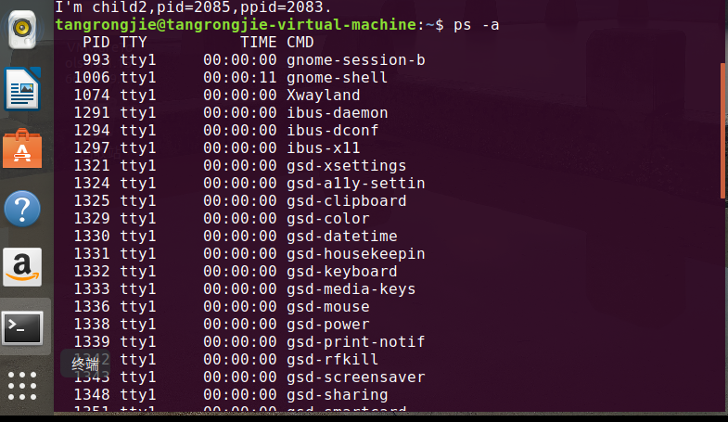

3.fork()验证与理解
(1) 程序代码：
#include<stdio.h>
#include<stdlib.h>
#include<unistd.h>
#include<sys/types.h>

int main()
{
int pid;
printf("Before fork...\n");

pid = fork();
if(pid == -1)
printf("Built process error.\n");
else if(pid == 0)
{
printf("I'm child1,pid=%d,ppid=%d.\n", getpid(), getppid());
exit(0);
}
else
printf("I'm parent,pid=%d,ppid=%d.\n", getpid(), getppid());

sleep(5);

pid = fork();
if(pid == -1)
printf("Built process error.\n");
else if(pid == 0)
{
printf("I'm child2,pid=%d,ppid=%d.\n", getpid(), getppid());
exit(0);
}
else
printf("I'm parent,pid=%d,ppid=%d.\n", getpid(), getppid());
sleep(5);
return 0;
}

结果展示：
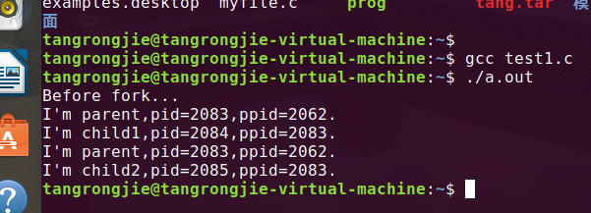
(2)程序代码：
#include<stdio.h>
#include<stdlib.h>
#include<unistd.h>
#include<sys/types.h>

int main()
{
int pid;
printf("Before fork...\n");

system("ps");
pid = fork();
if(pid == -1)
printf("Built process error.\n");
else if(pid == 0)
{
printf("I'm child1,pid=%d,ppid=%d.\n", getpid(), getppid());
system("ps");
exit(0);
}
else
printf("I'm parent,pid=%d,ppid=%d.\n", getpid(), getppid());

sleep(5);

system("ps");
pid = fork();
if(pid == -1)
printf("Built process error.\n");
else if(pid == 0)
{
printf("I'm child2,pid=%d,ppid=%d.\n", getpid(), getppid());
system("ps");
exit(0);
}
else
printf("I'm parent,pid=%d,ppid=%d.\n", getpid(), getppid());
sleep(5);
return 0;
}
结果展示：
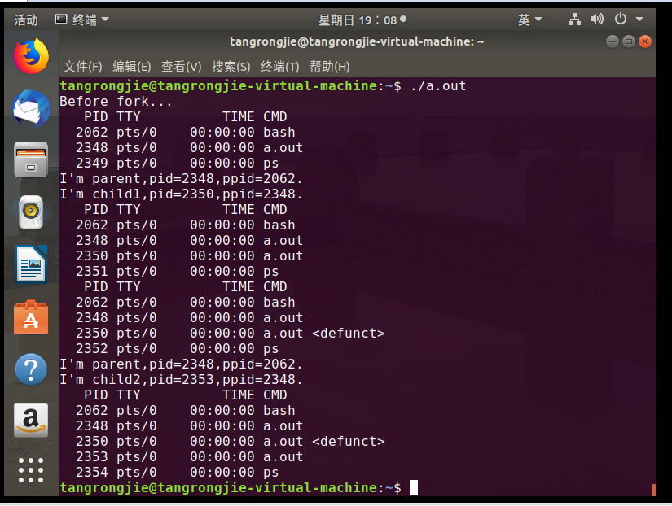

实验内容二
编写简单的shell：父进程获取用户输入，创建子进程来执行用户输入命令，父进程等待子进程结束后输出用户提示符等待用户继续输入命令。

程序代码：
#include<stdio.h>
#include<stdlib.h>
#include<string.h>
#include<unistd.h>
#include<sys/wait.h>
#include<sys/types.h>

int main()
{
int pid;
char command[10];
while(1)
{
printf("Input the command: ");
scanf("%s", command);
if(strcmp(command, "exit") == 0)
{
printf("Exit\n");
return 0;
}

pid = fork();
switch(pid)
{
case -1: printf("Built error."); exit(1);
case 0: system(command); exit(0); break;
default: wait(NULL); break;
}
}
return 0;
}
结果展示：
