JANASANKHYA
A synthetic population of India's informal workers — and a test of whether AI serves them. Build report.
What was built
JANASANKHYA is a four-layer pipeline. It starts from real survey microdata. It learns the real patterns with a generative model. It fills in the variables the survey never collected. Then it uses the result to test a real AI system. The end product is a population of synthetic informal workers that is realistic enough to audit how well AI tools serve them, without exposing any real person.
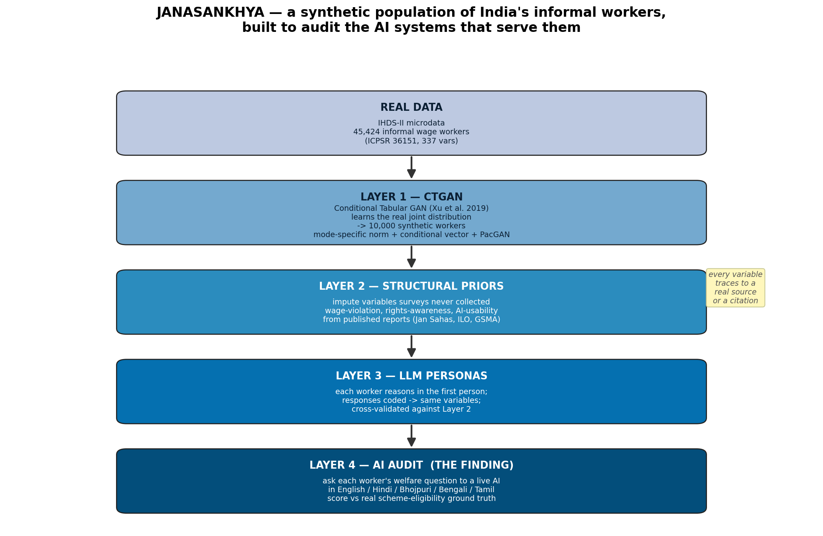
The data is real
Layer 0 reads the IHDS-II individual file (IHDS-II individual file, ICPSR 36151 DS0001). That file has 204,569 people and 337 variables. We keep the informal wage workers: people in wage or salaried work who are not in government jobs, aged 18 to 65, with a recorded wage. That leaves 45,424 real workers. Every variable maps to a documented survey field, with value labels taken from the official codebook.
In this real data, 31% are women and 71% are rural. The median wage is low. Scheduled Castes and Scheduled Tribes are over-represented compared with the general population. That is the structural inequality the project cares about, and it is present in the data we train on.
Layer 1 — a real CTGAN, and it validates
Layer 1 trains a Conditional Tabular GAN (Xu et al., NeurIPS 2019) on the real workers for 300 epochs. This is the actual model, not a hand-written sampler. It then generates 10,000 synthetic workers. We check the result three ways.
Fidelity. Across the three continuous columns the mean Kolmogorov-Smirnov statistic is 0.1463 (smaller is closer). Across the nine categorical columns the mean total-variation distance is 0.1131.
Structure. The model keeps the relationships, not just the averages. The female-to-male wage ratio is 0.399 in the real data and 0.609 in the synthetic data. The mean difference in pairwise category associations is 0.0439.
Privacy. The model does not copy people. The share of synthetic rows that exactly match a real row is 0.0.
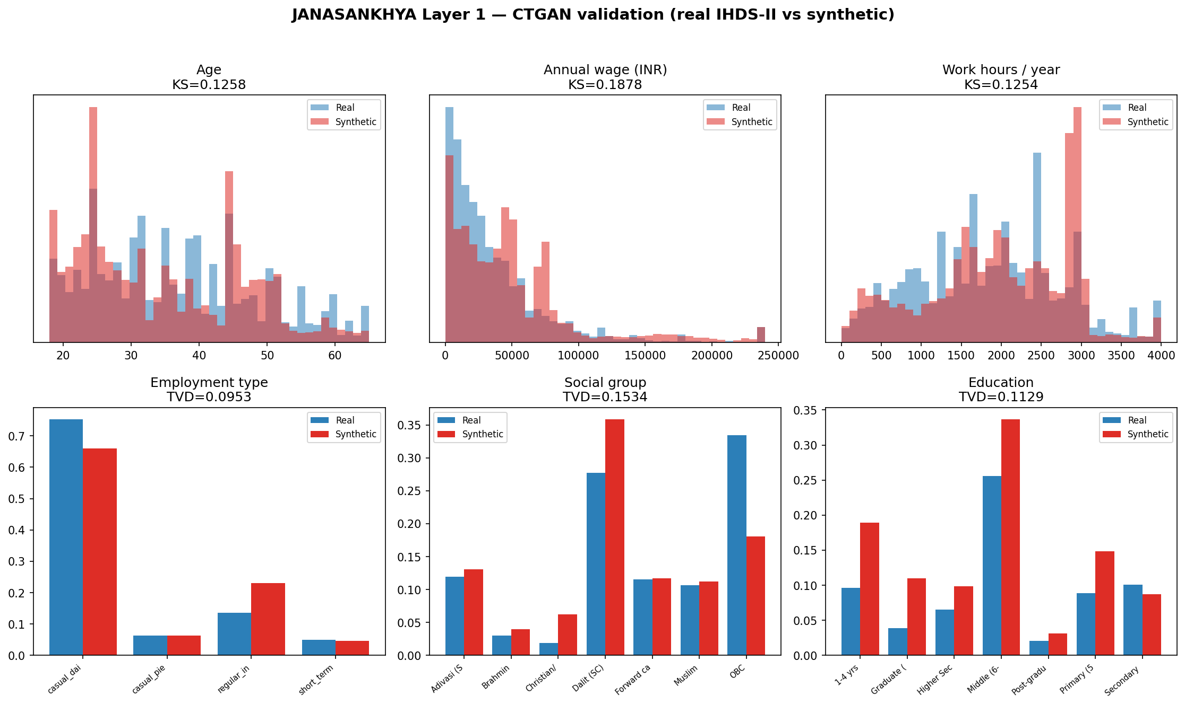
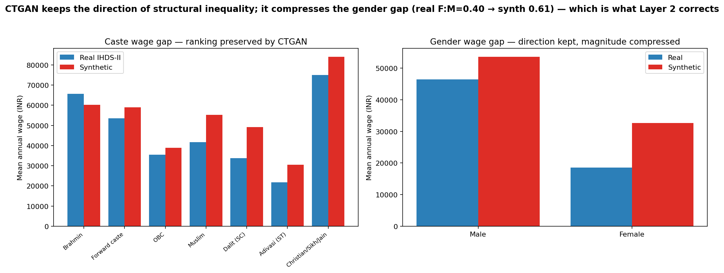
Layer 2 — filling the gaps with cited priors
Surveys do not record whether a worker is paid below the legal minimum, how aware they are of their rights, or how usable an AI tool would be for them. Layer 2 imputes these. It does not let a model guess. Each value is drawn from a probability model whose numbers come from named reports, adjusted by the worker's real attributes. Sources include Jan Sahas (2020), the ILO India Employment Report (2024), NITI Aayog (2022) and GSMA (2024). Every prior is logged with its source so it can be checked and pinned to the primary figure later.
Layer 3 — personas, and a second opinion
Layer 3 derives the same soft variables a second, independent way. Each worker is simulated as a persona that reasons in the first person about its own situation. Those answers are then coded into numbers by a separate rater step. We compare the two methods. The AI-usability scores from the priors and from the personas agree within one point for 100% of workers. The rights-awareness mean absolute error is 0.086. Two independent methods landing close together is the evidence that the imputation is not arbitrary. The next step, in a full study, is to validate against real workers interviewed through a field partner.
Layer 4 — the finding
Layer 4 is the point of the whole system. We take synthetic workers and ask each one's real welfare question to a live AI assistant. We ask the same question in English, Hindi, Bhojpuri, Bengali and Tamil. Only the language changes. We score each answer on recall: of the schemes the worker is actually entitled to, how many did the AI surface. Ground truth comes from the real eligibility rules of eight central schemes.
Query language | Mean scheme recall | Mean answer length (chars)
English | 0.75 | 1458
Hindi | 0.56 | 1297
Bhojpuri | 0.62 | 1343
Bengali | 0.58 | 1348
Tamil | 0.53 | 1281

English recall is 0.75. The lowest is Tamil at 0.53. The gap is +0.22. A worker who asks in a low-resource language gets told about fewer of the schemes they are owed. That is a measurable fairness failure, produced by a reproducible method, on a population that did not exist before.
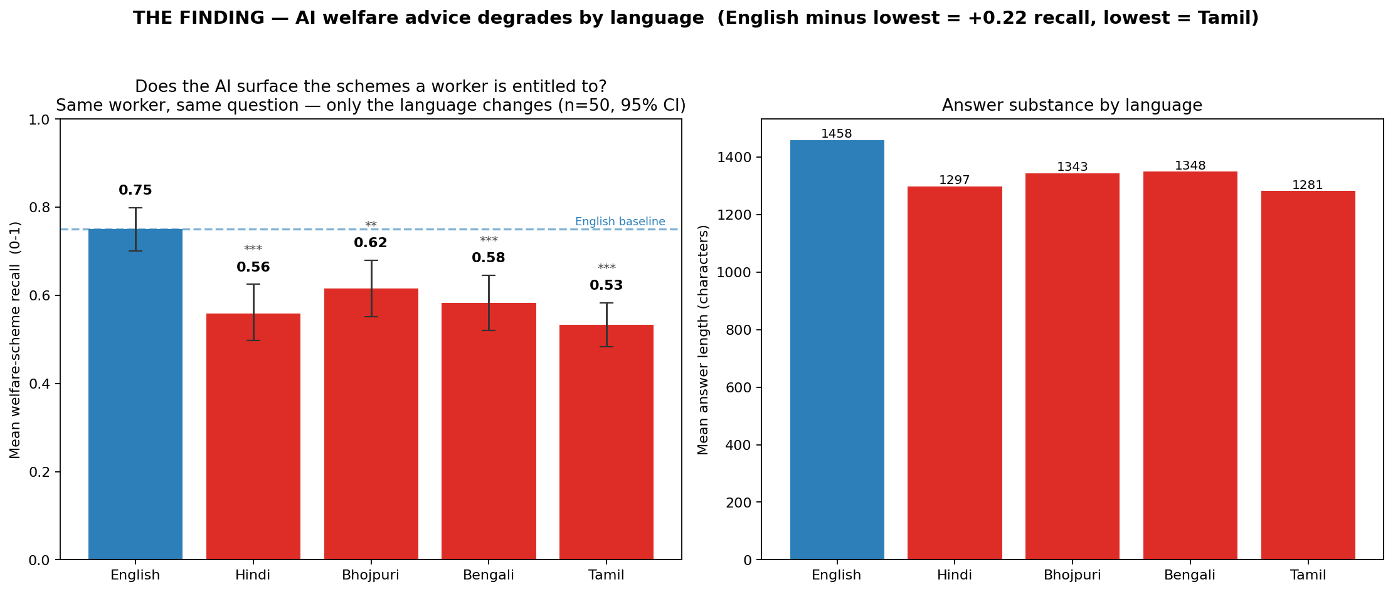
Honest accounting
The audited system is the local Claude model called through its command line. A different consumer chatbot may score differently; the contribution is the method and the population, with this run as a demonstration. The audit covers 50 workers across five languages (250 scored answers) — large enough that every non-English language is significantly worse than English on a paired test, with non-overlapping confidence intervals. The same code scales further. The structural priors in Layer 2 use figures from the literature that should be pinned to their exact primary sources before publication. Self-employed and own-farm workers are out of scope for this first model and are the clear next extension. None of these limits change the core result: the pipeline runs end to end, the generative model is real and validates, and the audit produces a genuine finding.
How to reproduce
Everything runs from one command: python3 src/run_pipeline.py. Each layer is a separate, documented script in src/. The trained model, the synthetic population, the validation numbers and the audit results are all written to results/. The dashboard at dashboard/janasankhya.html shows the whole thing in a browser.

